ISO Datatype Hibernate Mapping Design

Version No: 0.1
Last Modified: 3/27/2010

Author : Satish Patel
Team : caCORE SDK
Client : National Cancer Institute -
Center for Bioinformatics and Information Technology,
National Institutes of Health,
US Department of Health and Human Services

Document History

Revision History
Version Number | Revision Date | Author | Summary of Changes
0.1 | 3/27/2010 | Satish Patel | Initial Draft

Review
Name | Team/Role | Version | Date Reviewed | Reviewer Comments

Related Documents
More information can be found in the following related documents:

Document Name

Table of Contents
1 Introduction 5
2 UML Modeling 5
2.1 Logical Model 5
2.2 Data Model 8
3 Model Mapping Design 9
3.1 Requirements 9
3.2 Hibernate Oriented Design 10
3.2.1 Hibernate Components 10
3.2.2 Hibernate Composite Elements and Nested Composite Elements 10
3.2.3 Hibernate Tuplizers 10
3.2.4 Hibernate Property Accessors 10
3.2.5 Hibernate User Types 11
3.2.6 Java Annotations 11
3.3 Hibernate Oriented Mapping Scenarios 11
3.3.1 Mapping Constants 11
3.3.2 Mapping NullFlavor 11
3.3.3 Mapping Complex Datatype with Simple Attributes 12
3.3.4 Mapping Complex Datatype with Simple and Complex Attributes 14
3.3.5 Mapping Complex Datatype with Collection Attributes 17
3.3.6 Mapping Collection of Complex Datatypes 20
3.3.7 Mapping Collection of Complex Datatypes with Collection Attributes 23
Appendix A – Datatype to Hibernate Mapping Strategy Table 27
Appendix B – Hibernate Feature to Hibernate Mapping Strategy Table 29
Appendix C – Annotations Description 30
Appendix D – UserType Description 30
Appendix E – Constraints and Workarounds 31

Introduction
The purpose of this document is to identify following
- UML Modeling rules for ISO 21090 complex datatypes based system
- ISO 21090 Datatype mapping requirements
- Hibernate mapping for the ISO 21090 datatypes

UML Modeling
The caCORE SDK uses the UML model components in order to generate the entire caCORE like system. The SDK reads 1) Logical Model, 2) Data Model, 3) UML Tag values (GME, documentation etc), and 4) Model Mapping information (tag values). As ISO 21090 complex datatypes are used, the SDK will need to recognize new UML model structures and provide specifications to the users on how to create the UML models.

Logical Model
The Logical Model part of the UML model defines the object structure of the domain. Currently SDK supports following UML elements in the logical model
- UML Class
- UML Attribute
- UML Interface
- UML Association
- UML Generalization
- UML Dependency
- UML Tag Value
Example:
The diagram below shows the basic UML elements as supported by the SDK.
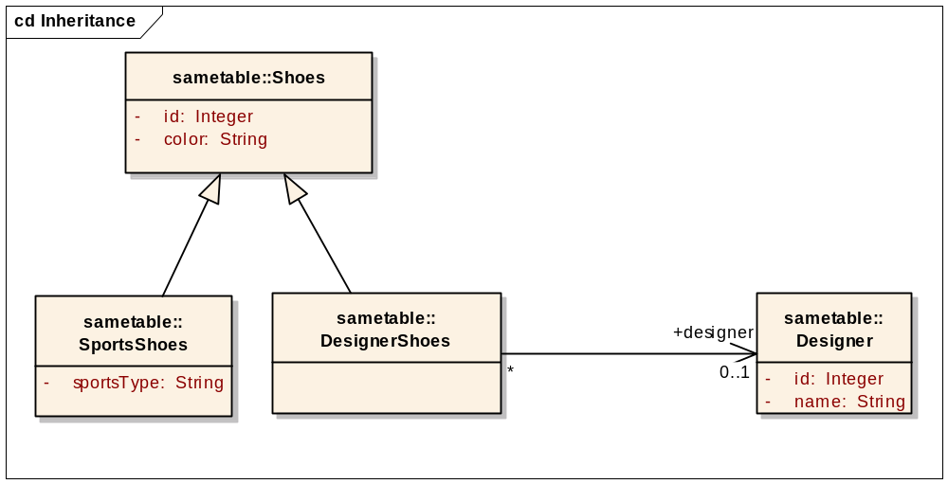
As the caCORE SDK starts supporting ISO 21090 complex datatypes, it needs to specify the UML model format for the same. Currently, the datatypes are specified in SDK in two ways
- Specify attribute type as a String in the “Type” input box in the Attribute dialog box as shown in the screenshot below
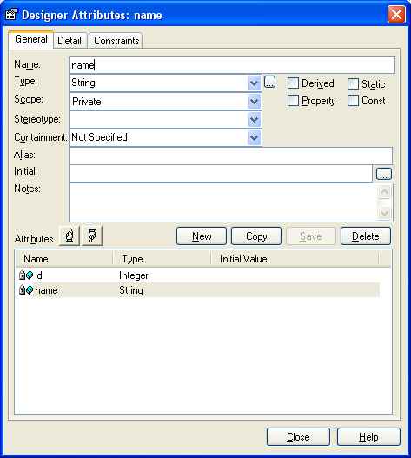
- Specify the attribute type by selecting another UML class from the same model as shown in the screenshot below.
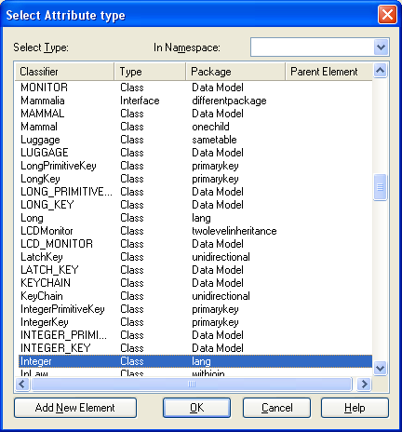
In order to use the complex datatypes in the SDK, both the semantics will be supported.
When the user is using the ISO 21090 complex datatypes, the user will be required to either manually create the ISO 21090 datatype model in the logical model section, or the user will be required to import the ISO 21090 model from the SDK’s model template.
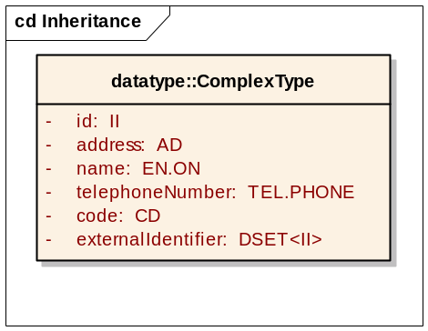
As shown in the diagram above, when creating the logical model, the user will be able to specify the complex datatype as one of the valid datatype for the attribute of the class.

Data Model
The user of the SDK creates the data model in the UML. While creating the data model, one has to consider the mapping ability of the model with the logical model. The SDK currently supports a limited set of structures to map the logical model to the data model. The mapping structures are limited to
- Table per each class
- Column per each attribute in the same table as the parent class
- One to One association with foreign key in the source table
- One to One association with join table
- One to Many association
- One to Many association with join table
- Many to Many association
- Table per class inheritance mapping
- Table per class inheritance mapping with no table for the root classes
- Table per hierarchy inheritance mapping
- Implicit inheritance mapping
- Collection of primitives

As the complex data types are supported in the SDK, additional data model structures will be required specific for each datatype. The detail for each of the structure will be provided in the remaining of the document.

Model Mapping Design

Requirements
Complex datatypes contains one or more attributes which are based on simple datatypes or other complex datatypes. The complex attributes can be mapped to the columns in the table corresponding to the parent class or in a separate table. This subsection specifies the requirements for mapping the complex types to the relational database.

As the ISO 21090 datatypes are being used in the domain model, the system has to support following requirements
- Mapping of complex datatype – User should be able to map the complex datatype to the relational database.
- Mapping of complex datatype simple attributes – User should be able to map the complex datatype’s simple attributes to the database table columns.
- Mapping of complex datatype’s attributes – User should be able to choose to map one or more datatype attributes to the database table columns. User should not have to map all attributes of the datatype’s attributes to the database columns.
- Constant support – The user should be able to specify the constants for certain sub-attributes of the datatypes. These constants represent the static information which does not change overtime for a specific application or specific domain object within the application.
- NullFlavor support – ISO 21090 NullFlavor represents a reason for not having the datatype information available. The user should be able to specify constant NullFlavor or should be able to specify database field for retrieving the NullFlavor information.
- Identity support – II datatype in ISO 21090 represents the identity. This datatype can be used to represent the primary key of the domain object.
- Domain object loading – The domain object when queried should be loaded with information for all of its attributes and returned back to the user.
- Query support – The user should be able to construct and query for the domain object based on the attributes of the domain object.

Hibernate Oriented Design
We use the Hibernate as a persistence tier management technology. Hibernate is one of the most popular O/R mapping technology which allows easier management of the tables and their mappings with the Java objects. Our suggested design involves leveraging the Hibernate O/R mapping framework’s capabilities. In this sub-section, we have outlined the four (3.2.1 thru 3.2.5) elements of the O/R mapping framework and how they are utilized to solve the technical problem that we have. We further utilize the Java annotations to pass metadata to the Hibernate at runtime to complete the solution.

Hibernate Components
In Hibernate “Component” element represents the object whose properties are mapped to the columns in the table of the parent class. Component can be an attribute within the parent class, or identity attribute, or collection element. The component element would allow us to represent the required ISO 21090 datatypes in the Hibernate while meeting the requirements as specified in the subsection above.

Hibernate Composite Elements and Nested Composite Elements
Hibernate allows creating the collection of the components (also known as composite-element). The composite-element is a data structure that maps to a table other than the table of the parent class. The composite-element follows the structure similar to the component and behaves very much like the component. This mapping element would allow us to represent the collection types.
The nested-composite-elements in the Hibernate is an inner element inside the composite-element. This element would allow us to gain fine grained control over the elements of the collection types.

Hibernate Tuplizers
Hibernate provides hooks where the application can get control over the initialization process of the Hibernate mapped objects; these hooks are called Tuplizers. In the ISO 21090 based systems, we would need control over the initialization process of the datatype to specify 1) constants, and 2) NullFlavor. If user has specified that the NullFlavor should not be mapped to the database or certain field attributes are constant then in that case the Tuplizer will obtain control of the datatype initialization process and inject additional values in the datatype object. This mechanism integrates well with the Hibernate based system and would allow us to meet to the system requirements.

Hibernate Property Accessors
Hibernate provides hooks where the application can get control over how the property of the class or attribute is being constructed and set in the Hibernate mapped objects; these hooks are called PropertyAccessor. In the ISO 21090 based systems, we would need control over the initialization process for certain collections of the datatype (e.g. ADXP, ENXP etc) to convert the simple components into the collection elements.

Hibernate User Types
Hibernate provides built-in support for most common database data types and their translation into corresponding Java types. In order to support the ISO 21090 datatypes, we need a mechanism to convert few additional Java types (e.g. Code, Uri, Url, Enum etc) from their String representation into corresponding target type. Hibernate component type is not applicable in this case because the target types do not have the setter methods to set the string value; the target type rather gets initialized from the String representation in a specific manner.

Java Annotations
Java annotations provide metadata about the part of the Java program. They do not have a direct effect on the operation of the code that they annotate. In the ISO 21090 implementation, we will utilize the Java Annotation mechanism to specify the NullFlavor and Constant values as needed by the requirement. These annotations will be used at the system runtime to retrieve needed information for construction of each datatype instance.

Hibernate Oriented Mapping Scenarios

Mapping Constants
The constants will be converted in the Java Annotations as described in the other sub-sections of this document. These annotations will be accessed by the custom Hibernate Tuplizer to determine the constant values which needs to be set on the datatype attributes.

Mapping NullFlavor
The NullFlavor will be converted in the Java Annotations as described in the other sub-sections of this document. These annotations will be accessed by the custom Hibernate Tuplizer to determine the NullFlavor values which needs to be set on the datatype.

Mapping Complex Datatype with Simple Attributes
Following complex datatypes has simple nested sub-attributes. These datatypes will be mapped to the database as Hibernate Components as described in the description that follows the datatype list.
- BL
- BL.NONNULL
- ST
- ST.NT
- II
- TEL
- TEL.PERSON
- TEL.URL
- TEL.PHONE
- TEL.EMAIL
- ED
- ED.TEXT

Example

public class Person implements Serializable
{
@Iso21090DataType(
nullFlavor=NullFlavor.NI,
fields={@Iso21090ConstantAttribute (name=”root”, value=”2.16.116.123.32”)}
)
private II iiValue;.
}
Person.java

CREATE TABLE PERSON (
ID NUMBER(8) NOT NULL,
II_EXTENSION VARCHAR2(50),
)
PERSON Table

<class name=”Person” class=”com.abc.Person” table=”PERSON”>
.
.
<component name=”iiValue” class=”gov.nih.nci.iso21090.Ii”>
<tuplizer class=" gov.nih.nci.iso21090.hibernate.ConstantAndNullFlavorTuplizer"/>
<property name=”extension” column=”II_EXTENSION” type=”string”/>
</component>
</class>
Person.hbm.xml

In the example above, the Person class is mapped to the PERSON table. In the Person class, the “iiValue” is one of the attribute with datatype as “II”. This II datatype has only one attribute named “extension” mapped to a column named II_EXTENSION in the PERSON table.
The datatype component uses the ConstantAndNullFlavorTuplizer class as the Tuplizer. This tuplizer internally will set the iiValue to the preferred NullFlavor when the extension value is retrieved from the database is null. The preferred NullFlavor is determined by looking up the nullFlavor attribute of the “Iso21090DataType” annotation in the iiValue attribute in the Person class. If the nullFlavor is not to be set then in that case the tuplizer will set the “root” attribute of the “iiValue” attribute by looking up the “Iso21090ConstantAttribute” annotation embedded within the “Iso21090DataType” annotation.

Mapping Complex Datatype with Simple and Complex Attributes
Following complex datatypes has simple as well as complex nested sub-attributes. These datatypes will be mapped to the database as Hibernate Components and Nested Components as described in the description that follows the datatype list.
- CD
- SC
- INT (Nested uncertainty sub-attribute is always of type INT)
- TS (Nested uncertainty sub-attribute is always of type TS)
- PQV (Nested uncertainty sub-attribute is always of type PQV)
- REAL (Nested uncertainty sub-attribute is always of type REAL)
- PQ (Nested uncertainty sub-attribute is always of type PQ)
- IVL<TS> (Nested width sub-attribute is always of type <TBD>)
- IVL<PQ> (Nested width sub-attribute is always of type <TBD>)
- IVL<INT> (Nested width sub-attribute is always of type <TBD>)
- IVL<REAL> (Nested width sub-attribute is always of type <TBD>)
- IVL<PQV> (Nested width sub-attribute is always of type <TBD>)

Example

public class Person implements Serializable
{
@Iso21090DataType(
nullFlavor=NullFlavor.NI,
fields={
@Iso21090DataType(name=”code”, nullFlavor=NullFlavor.NI,
fields={@Iso21090ConstantAttribute (name=”codeSystem”,
value=”2.16.116.123.32”),
@Iso21090ConstantAttribute (name=”codeSystemVersion”,
value=”1.0”)
}
)
}
)
private SC scValue;.
}
Person.java

CREATE TABLE PERSON (
ID NUMBER(8) NOT NULL,
SC_VALUE VARCHAR2(50),
SC_CODE_CODE VARCHAR2(50)
)
PERSON Table

<class name=”Person” class=”com.abc.Person” table=”PERSON”>
<component name=”scValue” class=”gov.nih.nci.iso21090.Sc”>
<tuplizer class=" gov.nih.nci.iso21090.hibernate.ConstantAndNullFlavorTuplizer"/>
<property name=”value” column=”SC_VALUE” type=”string”/>
<component name=”code” class=”gov.nih.nci.iso21090.Cd”>
<tuplizer class="
gov.nih.nci.iso21090.hibernate.ConstantAndNullFlavorTuplizer"/>
<property name=”code” column=”SC_CODE_CODE” type=”string”/>
</component>
</component>
</class>
Person.hbm.xml

In the example above, the Person class is mapped to the PERSON table. In the Person class, the “scValue” is one of the attribute with datatype as “SC”. This SC datatype has two attributes mapped to the database columns. The “value” attribute is mapped to the SC_VALUE column. The “code” attribute nested within the SC datatype is also mapped to the database column. As shown in the example above, the “code” attribute is mapped as a nested Component in the Hibernate mapping file. The nested datatype follows the structure similar to the parent level datatype.
The datatype component and the nested datatype component use the ConstantAndNullFlavorTuplizer class as the Tuplizer. This tuplizer internally will set the scValue or code to the preferred NullFlavor when simple attributes retrieved from the database for that datatype are null. The preferred NullFlavor is determined by looking up the nullFlavor attribute of the “Iso21090DataType” annotation in the scValue attribute in the Person class.
The example above demonstrates how the metadata for the nested datatype is maintained in the nested annotation. The “fields” array of the Iso21090DataType annotation stores the annotations for the nested complex datatypes.

Mapping Complex Datatype with Collection Attributes
Following complex datatypes has nested collection of complex datatypes. These datatypes will be mapped to the database as Hibernate Components and Nested Components or Collection Types as described in the description that follows the datatype list.
- AD
- EN
- EN.ON
- EN.PN

Example

public class Person implements Serializable
{
@Iso21090DataType(
nullFlavor=NullFlavor.NI,
collectionFields={
@Iso21090DataType(name=”_name_0”,
fields={
@Iso21090ConstantAttribute (name=”type”,
value=”FAM”),
@Iso21090ConstantAttribute (name=”codeSystem”,
value=”2.16.116.123.32”),
@Iso21090ConstantAttribute (
name=”codeSystemVersion”, value=”1.0”)
}
),
@Iso21090DataType(name=”_name_1”,
fields={
@Iso21090ConstantAttribute (name=”type”,
value=”GIV”),
@Iso21090ConstantAttribute (name=”codeSystem”,
value=”2.16.116.123.32”),
@Iso21090ConstantAttribute (
name=”codeSystemVersion”, value=”1.0”)
}
)
}
)
private EN name;
}
Person.java

CREATE TABLE PERSON (
ID NUMBER(8) NOT NULL,
FAMILY_NAME VARCHAR2(50),
GIVEN_NAME VARCHAR2(50)
)
PERSON Table

<class name=”Person” class=”com.abc.Person” table=”PERSON”>
<component name=”name” class=”gov.nih.nci.iso21090.En”>
<tuplizer class="gov.nih.nci.iso21090.hibernate.ConstantAndNullFlavorTuplizer"/>
<component name=” _part_0” class=”gov.nih.nci.iso21090.Enxp”
access=” gov.nih.nci.iso21090.CollectionPropertyAccessor”>
<tuplizer class="gov.nih.nci.iso21090.hibernate.ConstantTuplizer"/>
<property name=”value” column=”FAMILY_NAME” type=”string”/>
</component>
<component name=” _name_1” class=”gov.nih.nci.iso21090.Enxp”
access=”gov.nih.nci.iso21090.CollectionPropertyAccessor”>
<tuplizer class="gov.nih.nci.iso21090.hibernate.ConstantTuplizer"/>
<property name=”value” column=”GIVEN_NAME” type=”string”/>
</component>
</component>
</class>
Person.hbm.xml
In the example above, the Person class is mapped to the PERSON table. In the Person class, the “name” is one of the attribute with datatype as “EN”. This EN datatype contains collection of ENXP. Each ENXP instance represents the small part of the entity name. In this example, the individual element of the ENXP collection has been given the name as “_” followed by “name of the attribute” followed by “_” followed by “index location” where index location starts at “0” and increments by “1” for each element.
The name attribute (EN datatype) is mapped as a component in the Hibernate mapping file for Person class (Person.hbm.xml). In the mapping file, the individual elements of the ENXP collection are mapped as a nested component with the tuplizer (ConstantTuplizer) and property accessor (CollectionPropertyAccessor). The ConstantTuplizer is responsible for setting constant values in the target object. In our case, the target object is an instance of the ENXP object. The CollectionPropertyAccessor is responsible for setting the elements (ENXP instance) in the collection instead of setting the elements as properties.
The example above also demonstrates how the metadata for the nested collection is maintained in the nested annotation. The “fields” array of the Iso21090DataType annotation stores the annotations for the nested collection of datatypes.

Mapping Collection of Complex Datatypes
Following complex datatypes represent the collection of other complex datatypes. These datatypes will be mapped to the database as Hibernate Components with nested Collection of Components as described in the description that follows the datatype list.
- DSET<II>
- DSET<TEL>
- DSET<CD>

Example

public class Person implements Serializable
{
@Iso21090DataType(
nullFlavor=NullFlavor.NI,
fields={
@Iso21090DataTypeCollection(name=”item”,
type=”CD”
@Iso21090DataType(
nullFlavor=NullFlavor.NI,
@Iso21090ConstantAttribute (name=”codeSystem”,
value=”2.16.116.123.32”),
@Iso21090ConstantAttribute (
name=”codeSystemVersion”, value=”1.0”)

)
)
}
)
private DSET<CD> codes;
}
Person.java

CREATE TABLE PERSON (
ID NUMBER(8) NOT NULL,
)

CREATE TABLE CODES (
PERSON_ID NUMBER(8) NOT NULL,
CODE VARCHAR2(50);
)
PERSON and CODES Table

<class name=”Person” class=”com.abc.Person” table=”PERSON”>
<component name=”codes” class=”gov.nih.nci.iso21090.Dset”>
<tuplizer class="gov.nih.nci.iso21090.hibernate.ConstantAndNullFlavorTuplizer"/>
<set name=”item” lazy=”false”>
<key column=”PERSON_ID”/>
<composite-element class=” gov.nih.nci.iso21090.Cd”>
<tuplizer class="
gov.nih.nci.iso21090.hibernate.ConstantAndNullFlavorTuplizer"/>
<property name=”code” column=”CODE” type=”string”/>
</composite-element>
</set>
</component>
</class>
Person.hbm.xml
In the example above, the Person class is mapped to the PERSON table. In the Person class, the “codes” is one of the attribute with datatype as “DSET<CD>”. This DSET<CD> datatype contains collection of CD. The elements of the CD will be stored in a separate table called CODES.
The contacts attribute (DSET<CD> datatype) is mapped as a component in the Hibernate mapping file for Person class (Person.hbm.xml). In the mapping file, the individual elements of the DSET are mapped using a nested collection with the composite-element structure as supported by the Hibernate.
The example above also demonstrates how the metadata for the nested collection is maintained in the nested annotation. The “fields” array of the Iso21090DataTypeCollection annotation stores the annotations for the nested collection items. Within this annotation, the nested Iso21090DataType annotation contains information on how to initialize the values for the collection elements.
Note: The tuplizer element for the composite-element and nested-composite-element is not supported in Hibernate 3.2.0. In order to use this feature, there are two alternatives; first, change the Hibernate DTD to support this, or second, upgrade the Hibernate version to 3.2.7. Details are available on http://opensource.atlassian.com/projects/hibernate/browse/HHH-3275

Mapping Collection of Complex Datatypes with Collection Attributes
Following complex datatypes represent the collection of other complex datatypes with each element of the Collection having a collection of elements. These datatypes will be mapped to the database as Hibernate Components with nested Collection of composite-elements having nested-composite-lements with custom tuplizers and property accessors. The mapping mechanism is described in the description that follows the datatype list.
- DSET<AD>

public class Person implements Serializable
{
@Iso21090DataType(
nullFlavor=NullFlavor.NI,
fields={
@Iso21090DataTypeCollection(name=”item”,
type=”AD”
@Iso21090DataType(
nullFlavor=NullFlavor.NI,
collectionFields={}
)
)
}
)
private DSET<AD> contacts;
}
Person.java

CREATE TABLE PERSON (
ID NUMBER(8) NOT NULL,
)

CREATE TABLE ADDRESS (
PERSON_ID NUMBER(8) NOT NULL,
ADDRESS_LINE1 VARCHAR2(50),
CITY VARCHAR2(50),
STATE VARCHAR2(50),
ZIP VARCHAR2(50)
)
PERSON and ADDRESS Table

<class name=”Person” class=”com.abc.Person” table=”PERSON”>
<component name=”contacts” class=”gov.nih.nci.iso21090.Dset”>
<tuplizer class="gov.nih.nci.iso21090.hibernate.ConstantAndNullFlavorTuplizer"/>
<set name=”item” lazy=”false”>
<key column=”PERSON_ID”/>
<composite-element class=” gov.nih.nci.iso21090.Ad”>
<tuplizer class="
gov.nih.nci.iso21090.hibernate.ConstantAndNullFlavorTuplizer"/>
<nested-composite-element name=”_item_0”
class=”gov.nih.nci.iso21090.AdxpAl”
access=” gov.nih.nci.iso21090.CollectionPropertyAccessor”>
<property name=”value” column=”ADDRRESS_LINE1” />
</ nested-composite-element >
<nested-composite-element name=”_item_1”
class=”gov.nih.nci.iso21090.AdxpCty”
access=” gov.nih.nci.iso21090.CollectionPropertyAccessor”>
<property name=”value” column=”CITY” />
</ nested-composite-element >
<nested-composite-element name=”_item_2”
class=”gov.nih.nci.iso21090.AdxpState”
access=” gov.nih.nci.iso21090.CollectionPropertyAccessor”>
<property name=”value” column=”STATE” />
</ nested-composite-element >
<nested-composite-element name=”_item_3”
class=”gov.nih.nci.iso21090.AdxpZip”
access=” gov.nih.nci.iso21090.CollectionPropertyAccessor”>
<property name=”value” column=”ZIP” />
</ nested-composite-element >
</composite-element>
</set>
</component>
</class>
Person.hbm.xml
In the example above, the Person class is mapped to the PERSON table. In the Person class, the “contacts” is one of the attribute with datatype as “DSET<AD>”. This DSET<AD> datatype contains collection of AD. The elements of the DSET<AD> will be stored in a separate table called ADDRESS.
This AD datatype contains collection of ADXP. Each ADXP instance represents the small part of the address. In this example, the individual element of the ADXP collection has been given the name as “_” followed by “name of the attribute” followed by “_” followed by “index location” where index location starts at “0” and increments by “1” for each element.
The contacts attribute (DSET<AD> datatype) is mapped as a component in the Hibernate mapping file for Person class (Person.hbm.xml). In the mapping file, the individual elements of the DSET are mapped using a nested collection (Set) with the composite-element structure as supported by the Hibernate.
In the mapping file, the individual ADXP elements of the AD are mapped as a nested-composite-element with the property accessor (CollectionPropertyAccessor). The CollectionPropertyAccessor is responsible for setting the elements (ADXP instance) in the collection instead of setting the elements as properties.
The example above also demonstrates how the metadata for the nested collection is maintained in the nested annotation. The “fields” array of the Iso21090DataTypeCollection annotation stores the annotations for the nested collection items. Within this annotation, the nested Iso21090DataType annotation contains information on how to initialize the values for the collection elements.
Note: The tuplizer element for the composite-element and nested-composite-element is not supported in Hibernate 3.2.0. In order to use this feature, there are two alternatives; first, change the Hibernate DTD to support this, or second, upgrade the Hibernate version to 3.2.7. Details are available on http://opensource.atlassian.com/projects/hibernate/browse/HHH-3275

Mapping Complex Datatypes to Primary Key Column
<TBD>.

Appendix A – Datatype to Hibernate Mapping Strategy Table

No | Datatype | Complex Datatype with Simple Attributes  (1) | Complex Datatype with Simple and Complex Attributes  (2) | Complex Datatype with Collection Attributes  (3) | Collection of Complex Datatypes  (4) | Collection of Complex Datatypes with Collection Attributes  (5)
1 | BL | X
2 | BL.NONNULL | X
3 | ST | X
4 | ST.NT | X
5 | II | X
6 | TEL | X
7 | TEL.PERSON | X
8 | TEL.URL | X
9 | TEL.PHONE | X
10 | TEL.EMAIL | X
11 | ED | X
12 | ED.TEXT | X
13 | CD |  | X
14 | SC |  | X
15 | INT |  | X
16 | REAL |  | X
17 | TS |  | X
18 | PQV |  | X
19 | PQ |  | X
20 | IVL<TS> |  | X
21 | IVL<PQ> |  | X
22 | IVL<PQV> |  | X
23 | IVL<REAL> |  | X
24 | IVL<INT> |  | X
25 | AD |  |  | X
26 | EN |  |  | X
27 | EN.ON |  |  | X
28 | EN.PN |  |  | X
29 | DSET<II> |  |  |  | X
30 | DSET<TEL> |  |  |  | X
31 | DSET<CD> |  |  |  | X
32 | DSET<AD> |  |  |  |  | X

Appendix B – Hibernate Feature to Hibernate Mapping Strategy Table

No | Hibernate Feature | Complex Datatype with Simple Attributes  (1) | Complex Datatype with Simple and Complex Attributes  (2) | Complex Datatype with Collection Attributes  (3) | Collection of Complex Datatypes  (4) | Collection of Complex Datatypes with Collection Attributes  (5)
1 | Component | X | X | X | X | X
2 | Tuplizer | X | X | X | X | X
3 | User Types | X | X | X | X | X
4 | Property Accessor |  |  | X |  | X
5 | Composite Element |  |  |  | X | X
6 | Nested Composite Element |  |  |  |  | X

Appendix C – Annotations Description

Appendix D – UserType Description

Appendix E – Constraints and Workarounds

- Mapping Datatype with intermediate join table
Hibernate do not support composite-elements with the one-to-many association to another composite-element with join table. The details are discussed on Hibernate issue tracker at http://opensource.atlassian.com/projects/hibernate/browse/HHH-572. As a result, the user who is interested in using this type of O/R mapping strategy will have to change the database table structure to support this.
Solution: The user can create a simple view by joining the join table with the target datatype table. From the Hibernate perspective, this will be same as not having a join table.
- CSV

