Owner: caAdapter Development Team
Mapping Scenarios
ISO 21090 Datatype Mapping Module

Last Updated April 8, 2010, 2010
National Cancer Institute
Center for Biomedical Informatics and Information Technology
2115 East Jefferson Street
Rockville, MD 20852

 |   Center for Bioinformatics


DOCUMENT REVISION HISTORY
Version Number | Date | Description
1.0 | 24-March-10 | - Initial Draft
1.1 | 08-April-10 | - Synchronize with caCORE SDK tag spec

Table of Content
1 Introduction 4
1.1 Summary 4
1.2 Overview 4
2 Mapping Components 4
Assumptions 6
Following assumptions apply with the iteration: 6
3 Dependency Mapping Scenario 6
3.1 Map one object to one target table 7
3.2 Map one object to more than one target tables 8
3.3 Map more than one objects to one target table 9
4 Attribute Mapping Scenarios 10
The following assumptions apply to all attribute mapping scenarios: 10
• Each ISO data type attribute can map to one column in the data model. 10
• Each column in the data model can only be mapped once. 10
4.1 Map simple attribute 10
4.2 Map complex data types with simple and complex attributes 10
4.3 Map complex data types with collection attributes 11
4.4 Map collection of complex data types. 13
4.5 Map collection of complex data types with collection attributes 14
5 Non-mapping Annotation 16
5.1 Global constant annotation 16
5.2 Local constant annotation 16
5.3 NullFlavor value annotation 16
6 Appendix - References 18

Introduction

Summary
This document contains the mapping scenarios to be implemented by the caAdapter ISO 21090 Datatype Mapping Module. The described scenarios cover mapping requirements of system modeling using ISO 21090 data types in the following areas:
- One source object can map to one target table
- One source object can map to more than one target tables.
- More than one source objects map to the same one target table.
- Direct attribute of an object with simple ISO data type map to one target table column.
- Sub-attributes of an object attribute with ISO data type map to one target column.
- Direct attribute or sub-attribute map to a function input, and the output is still of input attribute type (TBD).
This document leverages the mapping scenarios and their corresponding mapping rules of caAdapter Model Mapping Service (MMS). For information of these basic MMS mapping scenarios, pleas go to caAdapter Model Mapping Service v4.1.1 user’s guide (https://gforge.nci.nih.gov/frs/download.php/8140/caAdapterMMS4_1_1_UsersGuide.pdf ).

Overview
This document explains all following mapping scenario in the viewer caAdapter users. Users apply these mapping scenarios with their business model (xmi). caAdapter ISO 21090 Data Type Mapping Service will annotate the underlying system model (xmi) with tags and valued defined by caCORE SDK Tag Values Specifications.doc .

Mapping Components
The following mapping components will be used to define each mapping scenario.
Object
Object or class components correspond to objects in object model. An object can have attributes and references to other objects.
Attribute
Attribute components correspond to the attributes of an object component in object model. An attribute always has a name and an ISO 21090 data type. The associated data type can be simple or complex data type.
- Direct attribute: If an attribute has a simple ISO 21090 data type, it is categorized as direct attribute.
- Sub-attribute: If an attribute has a complex ISO 21090 data type, the attributes of the corresponding complex ISO data types are categorized as sub-attribute. If a sub-attribute has complex ISO 21090 data type, the attributes of the nesting complex ISO 21090 data type are next level sub-attribute. Per caCORE SDK definition, up to three level of nesting are allowed.
Table
Table components correspond to in the tables in data model.
Column
Column components correspond to the columns of a table in data model
Function (TBD).
Function components represent certain type of operation in the mapping. It will be detailed once SDK decides its mechanism of function processing.
Link
Link is the basic component of mapping relationships. There are four kinds of links:
- Dependence mapping link: A link from a source object component to a target table component.
- Attribute mapping link: A link from a source attribute to a target column node. The source attribute node can be either a direct attribute or a sub-attribute.
- Function input mapping link(TBD): A link from a source attribute node to a function input port.
- Function output mapping link(TBD): A link from a function out put port to a target attribute node.

Assumptions

Following assumptions apply with the iteration:
- Each ISO data type attribute can map to one column in the data model.
- Each column in the data model can only be mapped once.
- The data types of all attributes (exception width attribute of IVL data type) for all ISO complex data types are predefined.
- Actual data type of width attribute of IVL data type will be determined at running time

Dependency Mapping Scenario
Dependency mapping is the link from a source object component to a target table component. It is specified as a relationship with stereotype of “DataSouce”.
Tag Value Key: N/A
Value: N/A
No caCORE tag is required to create a dependency mapping. The UML modeling tool Enterprise Architect (EA) creates the dependency link with its own tags: “ea_sourceName” with value as the table name; “ea_targetName” with value as the object name.
Example:
<UML:Dependency client="EAID_8B97E70D_FDDE_4c32_8A8A_6A74A24C0960" supplier="EAID_108EADA7_2DB6_4f20_B78F_98B9622502F9" name="dependency" xmi.id="EAID_18CFEBBD_F260_4E80_953D_DD5E8AA68E61">
<UML:ModelElement.stereotype>
<UML:Stereotype name="DataSource" />
</UML:ModelElement.stereotype>
<UML:ModelElement.taggedValue>
<UML:TaggedValue tag="stereotype" value="DataSource" />
<UML:TaggedValue tag="ea_type" value="Dependency" />
<UML:TaggedValue tag="direction" value="Source -&gt; Destination" />
<UML:TaggedValue tag="ea_sourceName" value="GENE" />
<UML:TaggedValue tag="ea_targetName" value="Gene" />
</UML:ModelElement.taggedValue>
</UML:Dependency>
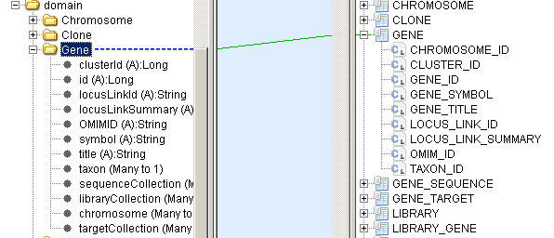
Figure 3.1 Generic dependency mapping from object to table

Map one object to one target table
In this scenario, the source object is mapped to one target table. All the direct attribute of the source object and the sub-attribute of nesting complex ISO data types are mapped to the same target table.
In Figure 3.2, the object Gene is defined with both simple and complex ISO data type of attributes. All these attributes are mapped to the same target GEN table.
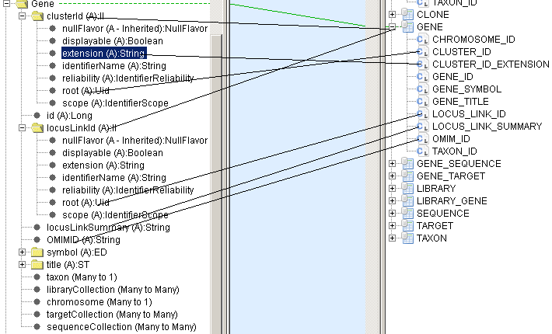
Figure 3.2 Dependency mapping from one object to one table

Map one object to more than one target tables
In this scenario, the source object is mapped to more than one target table. The object itself, its direct attributes and some of the sub-attributes of its nesting complex ISO data types are mapped to the same target table. But other sub-attributes of its nesting complex ISO data types are mapped to different table(s).
In Figure 3.3, the object Gene is defined with both simple and complex ISO data type of attributes. The table GEN is mapped from the object Gene, direct attributes of object Gene, nesting sub-attributes of the complex ISO data with attribute Gene.clusterId and Gene.locusLinkId. However, the attribute Gene.Title and its nesting ISO data type attributes are mapped to a different GENE_ISO_TITLE table. In this example, one source object is mapped to two target tables. But in general, one source object can be mapped to more than two target tables.
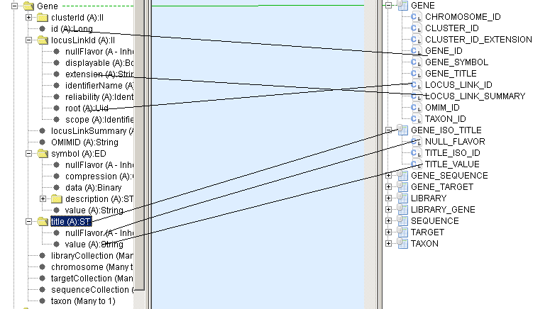
Figure 3.3 Dependency mapping from one object to two tables.

Map more than one objects to one target table
In this scenario, more than one source objects are mapped to the same one target table. The target table defines columns for attributes of all source objects.
In Figure 3.4, two object Target and Taxon are mapped table TARGET_AND_TAXON. All attributes of object Target and object Taxon are mapped to the same target table too. In this example, two source objects are mapped to the same target table. But in general, more than two source objects can be mapped to the same target table.
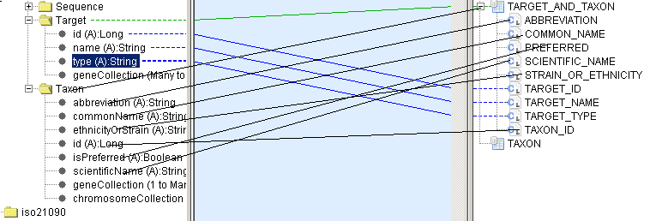
Figure 3.4 Dependency mapping from more than one objects to the same target table

Attribute Mapping Scenarios

The following assumptions apply to all attribute mapping scenarios:

Each ISO data type attribute can map to one column in the data model.

Each column in the data model can only be mapped once.

Map simple attribute
If an attribute has a simple data type, it is a simple attribute. A simple attribute can either be a direct attribute of an object or a sub-attribute of complex data type. A simple attribute is mapped to a single column in the table corresponding to the parent class.
Simple data type includes the Java primitives, Java wrapper types, and the simple data type defined by ISO specification. If an ISO data type does not have any attribute, it is a simple data type.
Tag Value Key: mapped-attributes
Value: <fully qualified name of the attribute>
Example: “gov.nih.nci.cabion.domain.Clone.name”. In Figure 4.1, the object Clone is mapped to table CLONE. The attribute Clone.name is a simple attribute. It is mapped to column CLONE.CLONE_NAME
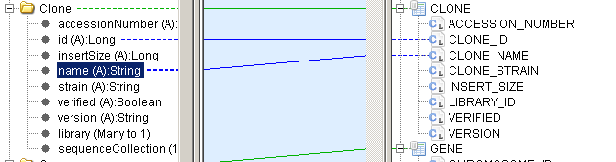
Figure 4.1 Simple attribute mapping

Map complex data types with simple and complex attributes
If an attribute has a complex data type, it is a complex attribute. Complex data type always contains one or more than one attributes. The nested attribute of a complex data type can be a simple data type or other complex data type. A complex data type structure will be recursively mapped to the columns of the same table where other sub-attributes of the parent complex data types are mapped. Two complex attributes of a business object are allowed map to different tables (see 3.2), the nested complex attributes of the same parent complex data type are not allowed map to different tables.
Tag Value Key: mapped-attributes
Value: <fully qualified name of the attribute within the complex structure>
Example: “gov.nih.nci.cabio.domain.Gene.id”,
“gov.nih.nci.cabio.domain.Gene.symbol.compression”
In Figure 4.2, the object “Gene” and its simple attributes are mapped to table “GENE”. The complex data type attribute “Gene.symbol” and nested complex data type attribute “Gene.symbol.description” are mapped to the same table “GENE”. The complex data type attribute “Gene.title” is mapped to a different table “GENE_ISO_TITLE”. All sub-attributes of “Gene.title” and all its nesting complex attributes must be mapped to the same table.
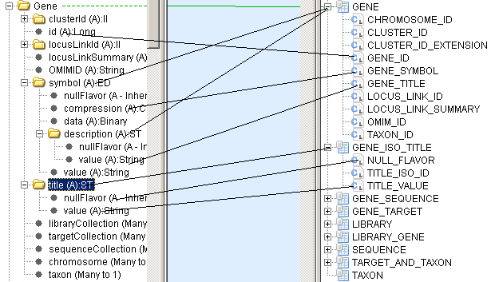
Figure 4.2 Map complex data type with simple and complex attributes

Map complex data types with collection attributes
If an attribute of a complex data type is a collection of complex type, the collection of complex type structure will be iteratively mapped to the columns of the same table where other sub-attributes of the parent object are mapped. (see section 3.3.3 of Tag Values Specification.doc). This iteration supports the following data types with collection attribute.
- AD,
- EN,
- EN.ON,
- EN.PN

Tag Value Key: mapped-attributes
Value: < fully qualified name of the sub-attribute>. The fully qualified name of the sub-attribute is derived as <fully qualified name of attribute>.<name of collection>[index]. <name of sub-attribute>
Location: The mapped column in data model.
In Figure 4.3, object AdDataType has a collection of attributes value1, value2, value3, so on. This collection is mapped table AD_DATATYPE. The sub-attributes of element value1 are mapped to columns VALUE1_AL_VALUE, VALUE1_AL_CODE, so on; The sub-attributes of element value5 are mapped to VALUE5_AL_CODE, VALUE5_AL_CODESYSTEM, VALUE5_AL_VALUE, so on.

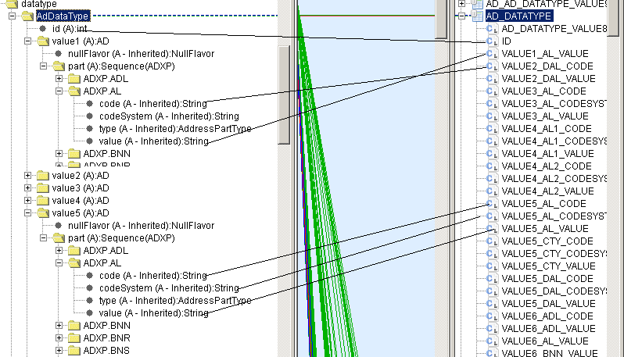
Figure 4.3 Map complex data type with collection attribute

Map collection of complex data types.
In this mapping scenario, the ISO data type of an attribute is a collection of other ISO complex data types. The complex type structure is iteratively mapped to the columns of the collection table. The collection table is separated from the table mapped with domain object. (see section 3.3.4 of Tag Values Specification.doc). This iteration supports collection of the following data types which do not contain other collection attributes.
- DSET<II>
- DSET<TEL>
- DSET<CD>
Two annotation tags are defined for this scenario: “mapped-collection-table” apply to object model; “mapped-attributes” apply to data model.
Tag Value Key: mapped-collection-table
Value: <collection table name >
Location: The collection attribute of the domain object in object model

Tag Value Key: mapped-attributes
Value: <fully qualified name of the collection attribute>.<attribute name of element complex data type in the collection attribute>
Location: Column of the collection table in data model.
In Figure 4.5, object DsetDataType has a collection with element of complex data type TEL. The element attributes are mapped to collection table as value1 to DSET_TEL_VALUE1, value2 to DSET_TEL_VALUE2, value2 to DSET_TEL_VALUE2, so on. The annotation tags “mapped-collection-table” are added attribute value1, value2, and value3 with value as the names of corresponding collection tables.
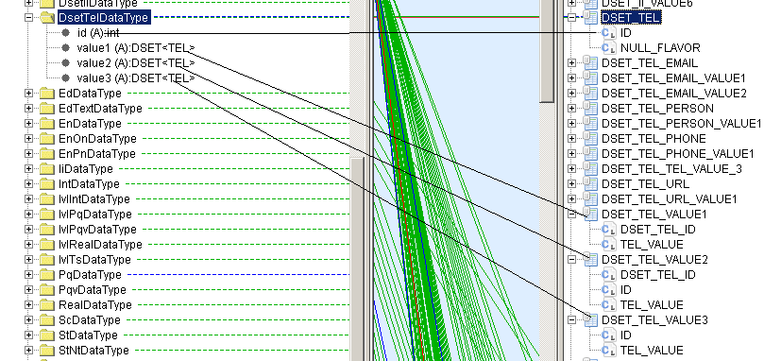
Figure 4.4 Map a collection of complex data types.
Note: The collection table could be associated with the mapping table of domain object with a joint table (see section 3.3.4.2 of Tag Values Specification.doc).

Map collection of complex data types with collection attributes
In this mapping, the ISO data type of an attribute is a collection of other ISO complex data types. The nested data types contain attribute with a collection of ISO data types. (see section 3.3.5 of Tag Values Specification.doc).
Three annotation tags are defined for this scenario. Two tags apply to object model: “mapped-collection-table” and “mapped-collection-element-type”; one tag applies to data model, “mapped-attributes”.
Tag Value Key: mapped-collection-table
Value: <collection table name >
Location: The collection attribute of the domain object in object model

Tag Value Key: mapped-collection-element-type:<name of the inner collection attribute >.<[index of the inner collection element]>
Value: <Class name of the collection element >
Location: The collection attribute of the domain object in object model. In this scenario, multiple tags are added to the same attribute of domain object.

Tag Value Key: mapped-attributes
Value: <fully qualified name of the collection attribute>.<attribute name of element complex data type in the collection attribute>
Location: Column of the collection table in data model.
In Figure 4.5, the object DsetAdDataType has a collection of complex type AD. The complex type AD has collection attributes of type ADXP (Figure 4.3 shows its structure). The object DsetAdDataType is mapped to table DSET_AD_DATATYPE. Each collection element is mapped to its collection table. For example, value1 is mapped to table DEST_AD_VALUE1. The annotation tag “mapped-collection-table" is added to the element value1 with value as “mapped-collection-element-type:part[0]” where “part” is name of the collection attribute of type AD and “0” indicate value1 is the first element of the collection attribute.
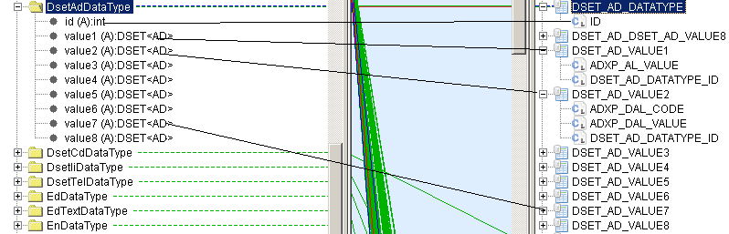
Figure 4.5 Map a collection of complex data types with collection attributes

Non-mapping Annotation
The non-mapping annotation includes the actions to create caCORE SDK annotation tags and values without mapping link between the object model nodes and the data model nodes.

Global constant annotation
Global constant tag applies with an attribute of a complex ISO data type. It annotates the ISO data type logical model. This attribute must be a simple ISO data type. The global constant value applies whenever the complex data type is instantiated.
Tag Value Key: mapped-constant:<fully qualified name of the complex sub-attribute>
Value: <constant value>
Location: The attribute of ISO data type object in object model.
Example: “mapped-constant:II.root=2.16.12.123.456” specified against the “root” attribute in the “II” data type class. Whenever the data type “II” is instantiated, its attribute “root” has the value “2.16.12.123.456”. In the ISO 21090 data type specification, II.root is “Uid” data type which is a simple ISO data type.

Local constant annotation
The local constant tag applies with attribute of the instance of a complex ISO data type. It annotates the domain logical model where the ISO data type is instantiated. This attribute must be a simple ISO data type. This local constant value only applies with the particular instance of that complex data type. If an attribute has its global constant, the local constant overwrites that global constant.
Tag Value Key: mapped-constant:<fully qualified name of the complex sub-attribute>:
Value: <constant value>
Location: The attribute of an instance of an ISO data type object in object model.
Example: “mapped-constant:gov.nih.nci.cacoresdk.domain.datatype.Person.id.root= 2.16.12.456.789”. In this example, the business object “Physician” has an attribute “id” with complex ISO data type “II”. The local constant “2.16.12.456.789” overwrites the global constant with the attribute “II.root” and applies to the attribute “Person.id.root”.

NullFlavor value annotation
If a complex ISO data type is defined with “nullFlavor” attribute and this attribute is ISO data type NullFlavor, it may apply either global constant described in 5.1 or local constant described in 5.2.
Example: “mapped-constant:Any.nullFlavor = INV”. In this example, a global “INV” is assigned with the attribute “Any.nullFlavor”.

Appendix - References
- Tag Values Specifications.doc
- caAdapter Model Mapping Service user’s guide https://gforge.nci.nih.gov/frs/ download.php/8140/caAdapterMMS4_1_1_UsersGuide.pdf

.

