ISO Datatype: Introduce Tutorial

Version No: 1.0
Last Modified: 4/20/2010

Author : Calixto Melean
Team : caGrid
Client : National Cancer Institute -
Center for Bioinformatics and Information Technology,
National Institutes of Health,
US Department of Health and Human Services

Document History

Revision History
Version Number | Revision Date | Author | Summary of Changes
1.0 | 4/20/2010 | Calixto Melean | Initial Draft

Review
Name | Team/Role | Version | Date Reviewed | Reviewer Comments

Related Documents
More information can be found in the following related documents:

Document Name

https://ncisvn.nci.nih.gov/svn/ISO21090/trunk/documents/design_documents/ISO_21090_caGrid_Introduce_Datatype_Support_Design.doc

Table of Contents
1 Overview 4
2 Graphical Use 4

Overview
The purpose of this document is to illustrate how to create an analytical service using introduce and the ISO21090 data type extension. This tutorial covers how to install the extension using the software update tool, and how to use the extension to create a simple analytical service.

Graphical Use
- Launch Introduce and click the Create Service Skeleton button. Enter service information and click the Create button.
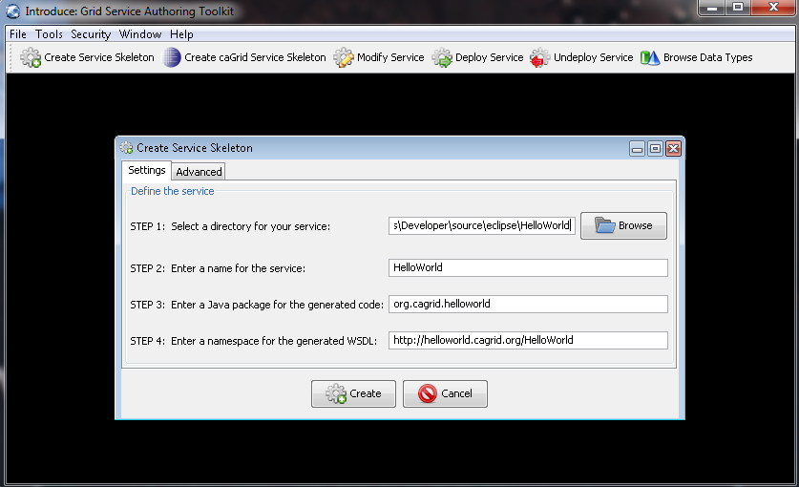
- From the Help menu, choose Introduce Software Update. Click the Look For Updates button to retrieve a list of updates from the default update site (http://software.cagrid.org)
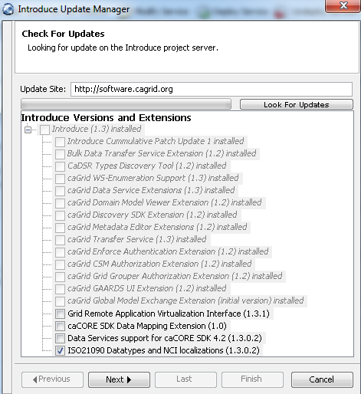
- Check the ISO21090 Datatypes and NCI localizations and click Next
- Introduce proceeds to download and install the extension. Click Next and then Finish to restart Introduce
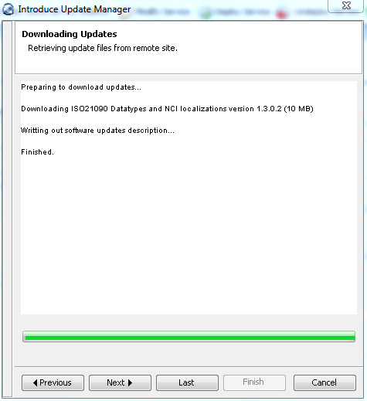
- Once Introduce re-launches, click Modify Service and open the service previously created
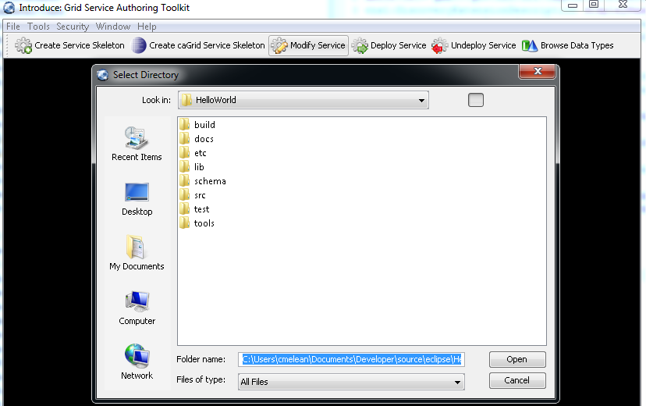
- The Import Data Types area under the Add/Remove Types tab now has a ISO21090 tab. Click on it
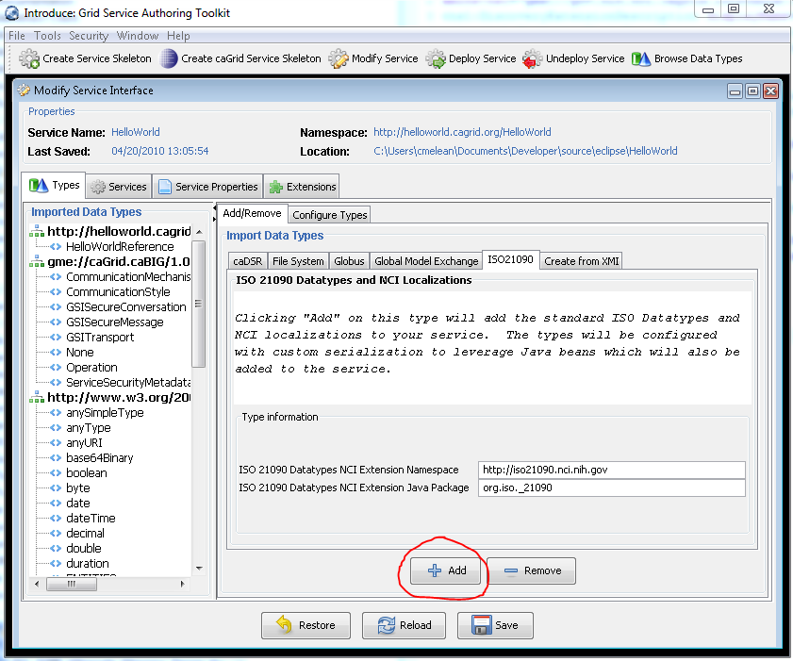
- Click the Add button to add the ISO21090 data types to the service. These will now be listed on the left side column
- Let us now add an operation to the service using one of the ISO21090 types. Click the Services tab. Click Operations, and then the Add Method button to the right
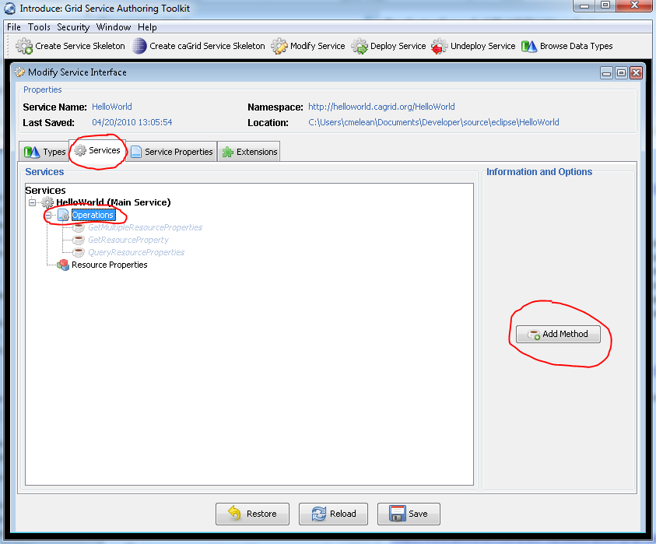
- We define a sendAd operation that takes an Ad object as input and returns an Ad object as output
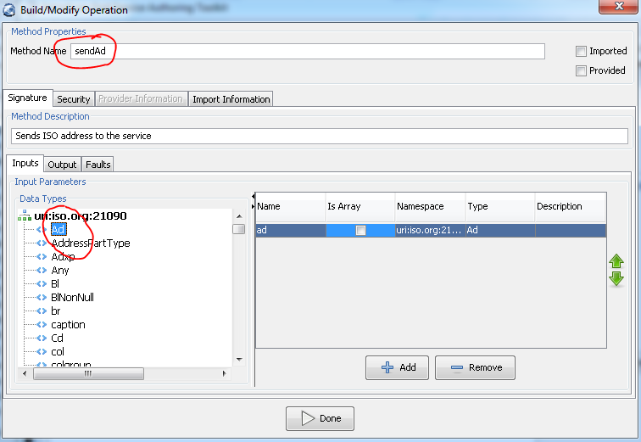
- Click the Done button. The click Save to save the service

