caBIG® Platform Independent Model

ISO 21090 Healthcare Data types

Version 0.1.4

Created 26 February 2010
Last Updated 28 May 2010

Contributors* | Todd C. Parnell¹  John Koisch²  Paul Boyes²  Prasad Konka³  Satish Patel⁴  John Eisenschmidt⁵  Ann Wyley

Document Version | Author | Changes
0.0.1 | Todd C. Parnell | Initial Draft
0.0.2 | Todd C. Parnell | Added unmapped types
0.0.3 | Todd C. Parnell | Removed classes not currently used in localization.
0.1.0 | Todd C. Parnell | Added ED and ED.TEXT mappings.
0.1.1 | Todd C. Parnell | PQ.unit and IVL.originalText updated.
0.102 | Todd C. Parnell | Added diagrams for each group of types. Added REAL localization.
0.1.3 | Abraham Evans-EL | Removing originalText field from QSET and uncertainty, uncertaintyType, and originalText from QTY diagrams
0.1.4 | Prasad Konka, Satish Patel, John Eisenschmidt, Ann Wyley | Removed ED.description and ADXP.INT to be consistent with XSD. Updated ADXP types. Multiple changes to be consistent with model and XSD. Formatting, standardized use of data type, corrected captions under figures

¹ 5AM Solutions, Inc
² Guidewirearchitecture.com
³ SAIC
⁴ Ekagra Software Technologies
⁵ Lantern Three

* The order in which the names are listed do not represent the ownership or importance.

TABLE OF CONTENTS

caBIG® Platform Independent Model 1
1 Introduction 4
1.1 Relationship to Standards 4
1.2 Relation to Conceptual Functional Model 4
1.3 Conformance and Compliance 4
1.4 Normative References 5
2 Data types 6
2.1 Overview and Architecture 6
2.2 Type Definitions 9
2.2.1 Basic Data types 9
2.2.2 Text And Binary Data types 10
2.2.3 Coded Data types (Terminology) 13
2.2.4 Identification and Location Data types 14
2.2.5 Name and Address Data types 17
2.2.6 Quantity Data types 24
2.2.7 Collections Of Data types 27
2.2.8 Continuous Set Data types 28
2.3 Unmapped Data types 30

21090 Platform Independent Model

Introduction

The ISO 21090 Healthcare Data types standard “provides a set of data type definitions for representing and exchanging basic concepts that are commonly encountered in healthcare environments in support of information exchange in the healthcare environment, [and] specifies a collection of healthcare related data types suitable for use in a number of health related information environments.” This document describes the logical localization of those data types, as used by the associated services.

Relationship to Standards

ISO 21090 is a draft international standard currently in the Approval stage of the ISO process. The version of the standard this PIM references is ISO/21090 2007-09-24, committee identification ISO/TC 215/WG 2. A newer version of the standard, dated 2009-06-11 “the 2009 version” is available. Where applicable, conformance to the 2009 version is noted when the earlier version had ambiguity. As detailed in Section 1.3, this document details the Indirect conformance provided by the individual services.

Relation to Conceptual Functional Model

No CFM exists for the 21090 data types. However, each of the Conceptual Functional Service Specification (CFSS) documents has an ISO 21010 Data type conformance profile, which references the standard directly.

Conformance and Compliance

ISO 21090 has two types of conformance: Direct conformance and Indirect conformance. This PIM supports Indirect conformance, as defined in Section 5.3. Indirect conformance is defined is Section 5.3.1 as:

- Providing mappings between internal data types and the healthcare data types
- Specifying for which of the data types an inward mapping is provided, for which an outward mapping is provided, and for which no mapping is provided
- Specifying whether the XML representation described herein is used when the data types are represented in XML, or optionally to provide an alternative namespace for the XML representation

Section 2.2 details the inward and outward mappings. Section 2.3 documents data types for which no mapping is provided. Details about the representation are left to platform specific documents.

In addition, Section 5.3.2 requires additional conformance statements:

- Unicode is the character set and encoding for all String types.
- Equality statements are defined at the same time as inward and outward mappings.
- Cardinality applies for each attribute and collection
- Address part type and name bindings, as described in Section 2.2.5.
- All enumeration values retain their meaning in this localization. However, some values have been omitted. The omissions are documented where applicable. If undocumented, all values from each enumeration are used during inward and outward mappings.

Normative References

The following normative documents contain provisions, which, through reference in this text, constitute provisions of this PIM. For dated references, subsequent amendments to, or revisions of, any of these publications do not apply. However, parties to agreements based upon this PIM are encouraged to investigate the possibility of applying the most recent editions of the normative documents indicated below. For undated references, the latest edition of the normative document referred to applies.

ISO/FDIS 21090:2009(E), Health Informatics – Harmonized data types for information interchange
ISO/IEC 8601:2004, Data elements and interchange formats -- Information interchange -- Representation of dates and times
ISO/IEC 8824:1990(E), Information technology -- Abstract Syntax Notation One (ASN.1): Specification of basic notation
ISO/IEC 11404:2007, Information technology -- Programming languages, their environments and system software interfaces -- Language-independent data types
ISO/IEC 11179, Information technology — Specification and standardization of data elements
ISO/IEC 22220, Health informatics — Identification of subjects of health care
IETF RFC 1738 - Uniform Resource Locators (URL)
IETF RFC 2396 - Uniform Resource Identifiers (URI): Generic Syntax
IETF RFC 2806 - URLs for Telephone Calls
IETF RFC 2978 - IANA Charset Registration Procedures

Data types

Overview and Architecture

For convenience and reference, the following diagram provides an overview in UML Diagrams of the data types defined in this specification.

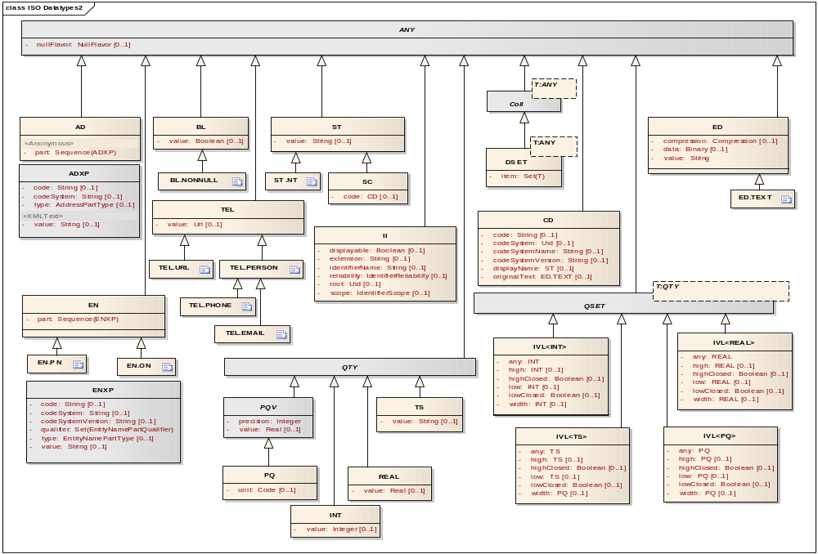
Figure 1 - Localized Classes

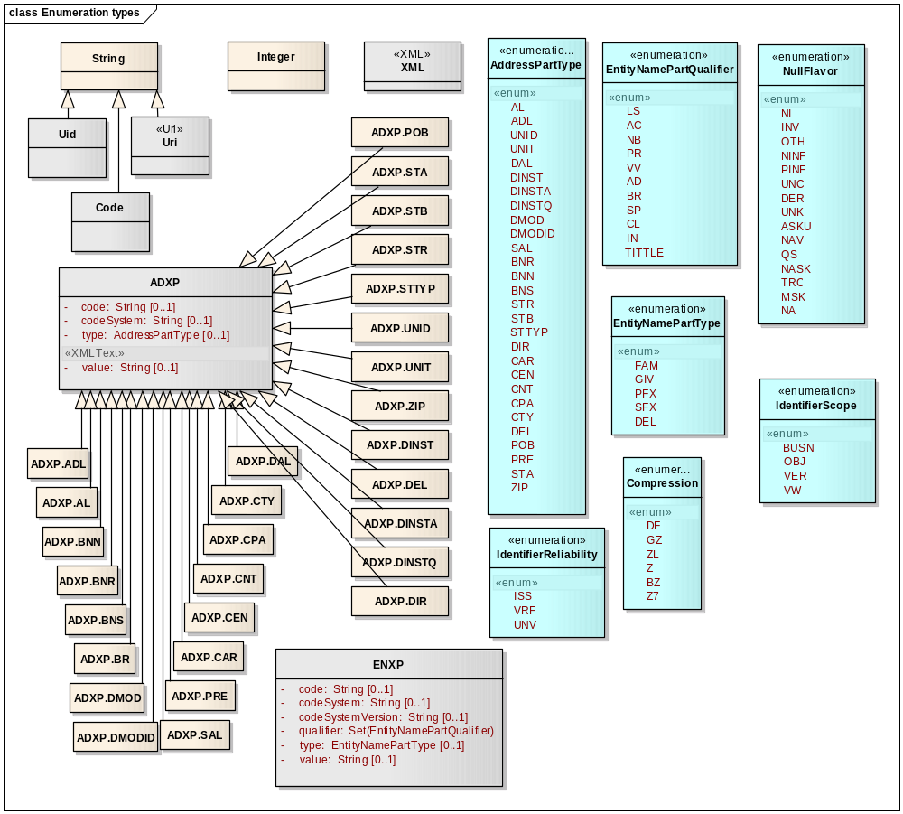
Figure 2 - Localized Enumerations

Type Definitions

This section details the inward and outward mappings for each data type included in the localization. Data types not included in this section have no mapping and are not part of the localization. Inward and outward transformations of localized data types to ISO 21090 data types is not part of this document. This section focuses on how a localized data type is mapped to ISO 21090 data type inward and outward.

Basic Data types

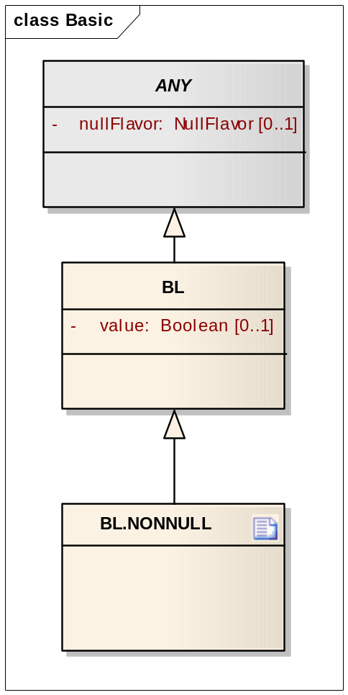
Figure 3 Basic Data types

ANY

ANY does not specialize HXIT, as HXIT is not part of the localization.

ISO 11404 Syntax
type ANY = class (
nullFlavor : NullFlavor
)

Mappings

Inward NullFlavors all map to a single notion of null – all enumerated values are treated equally. Outward null values always map to NullFlavor.NI (no information), if a fixed NullFlavor value is not provided.

BL
Specializes ANY

ISO 11404 Syntax
type BL = class (
nullFlavor : NullFlavor,
value : boolean
)

Mappings

Inward and outward mappings of BL have no special transformation rules.

BL.NONNULL
A flavor that constrains BL

There are no additional mapping rules for BL.NONNULL.

Text And Binary Data types

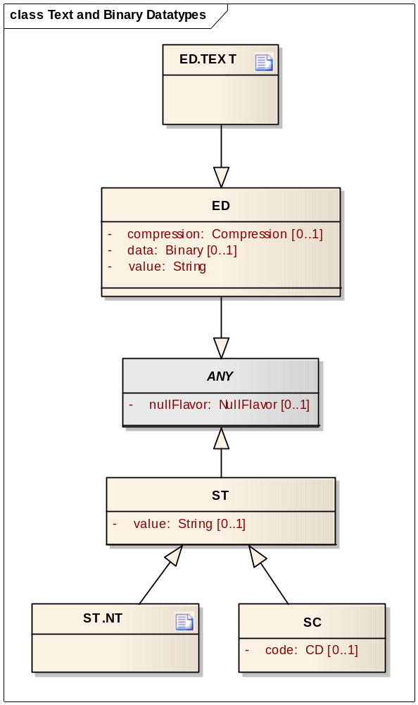
Figure 4 Text and Binary Data types

ED (Encapsulated Data)
Specializes ANY.

ISO 11404 Syntax
type ED = class (
nullFlavor : NullFlavor,
data: Binary,

compression : Compression,
value : characterstring
)

Compression

If compression is NULL the data field is uncompressed. The values understood by this localization are:

CompressionAlgorithm Enumeration localization. OID: 2.16.840.1.113883.5.1009
Number | Type | Name | Notes
1 | GZ | gzip

Compression types outside this enumeration are not understood and may result in errors during inward mapping.

Mappings

Inward and outward mappings of ED have no special rules.

ED.TEXT
A flavor that constrains ED

There are no additional mapping rules for ED.TEXT. The localization does not contain the xml, reference, integrityCheck, thumbnail, translation elements and mediatype, charset, language, integrityCheckAlgorithm attributes.

ST (Character String)
Specializes ANY.

ISO 11404 Syntax
type ST = class (
nullFlavor : NullFlavor,
value : characterstring
)

Mappings

Inward mapping has no special rules. The localization does not contain language and translation attributes.

ST.NT
A flavor that constrains ST

There are no additional mapping rules for ST.NT. The localization does not contain the translation attribute.

SC (Coded String)
Specializes ST

ISO 11404 Syntax
type SC = class (
nullFlavor : NullFlavor,
value : characterstring,
code : CD
)

Mappings

There are no additional mapping rules for SC.

If SC.nullFlavor is null, SC.value is null and SC.code is not null, an error will be generated to set SC.value on non-null SC during inward and outward mapping.

Coded Data types (Terminology)

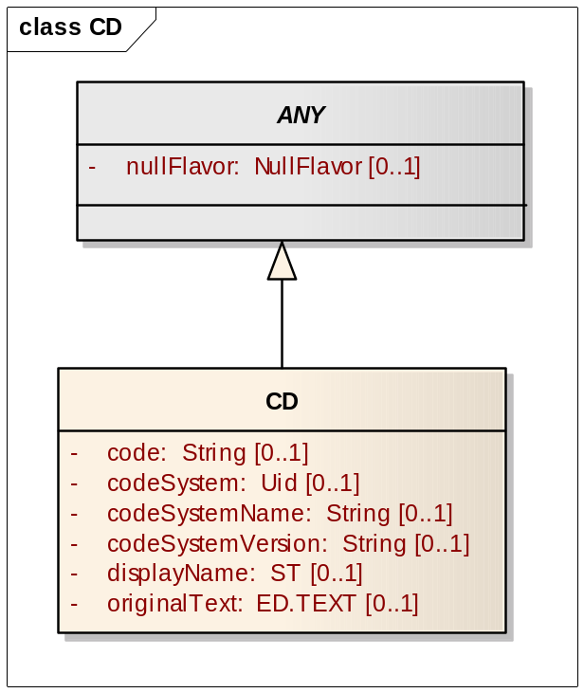
Figure 5 Coded Data types

CD (Concept Descriptor)
Specializes ANY

ISO 11404 Syntax
type CD = class (
nullFlavor : NullFlavor,
code : characterstring,
codeSystem : characterstring,
codeSystemName : characterstring,
codeSystemVersion : characterstring,
displayName : ST,
originalText: ED.TEXT
)

Mappings

There are two types of mapping strategies for CD. Implementations must specify, for each field, which type of mapping is in use.

Type I mappings have fixed internal codeSystem, codeSystemName, and codeSystemVersion values. Thus, during inward mapping, only the code itself is stored. The codeSystem* values should to be identical to the fixed values, though implementations may ignore or reject variations. During outward mapping, the code stored in the system is mapped directly, and the fixed values for codeSystem, codeSystemVersion, and codeSystemName are added. Type I implementations must specify the fixed values.

Type II mappings allow variation for code, codeSystem, codeSystemName, and codeSystemVersion. During inward mapping, each value is stored. During outward mapping, each stored value is mapped directly. Type II implementations may restrict to an enumerated list the valid domain for each attribute. If restricted, the enumerated list must be documented.

The localization does not contain translation, group, source elements and valueSet, valueSetVersion, id, codingRationale attributes.

Identification and Location Data types

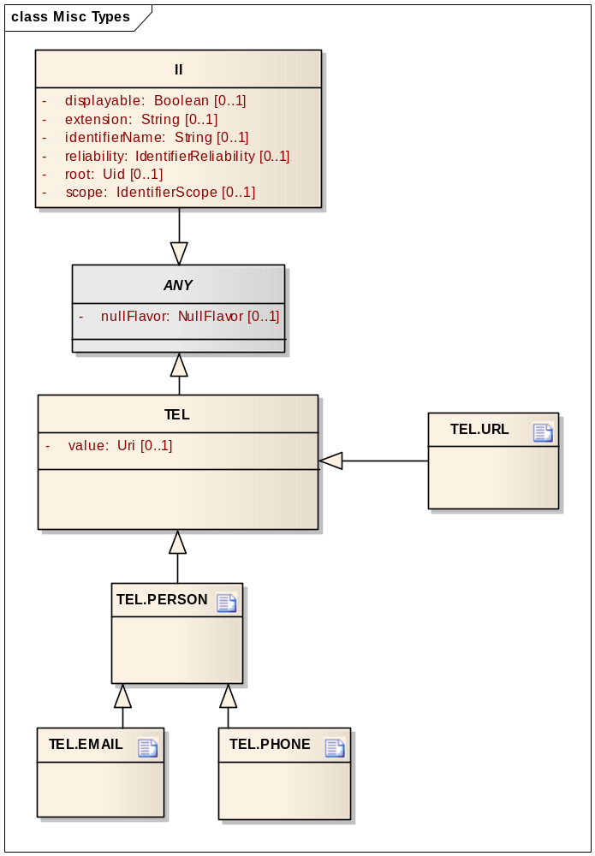
Figure 6 Identification and Location Data types

TEL (Telecommunication Address)
Specializes ANY

ISO 11404 Syntax
type TEL = class (
nullFlavor : NullFlavor,
value : characterstring
)

Mappings

See the constrained versions of TEL for mapping information.

TEL.URL
Constrains TEL

The inward and outward mapping of TEL.URL stores the value attribute directly. An error will be thrown on invalid schema types during inward and outward mapping.

TEL.PERSON
Constrains TEL

Inward mapping store only the <scheme-specific-part> of the URI, as defined by IETF RFC 2396. The stored value will decode any escaped octets. If the <scheme> is unknown, the TEL is treated as NULL with NullFalvor.NI. The outward mapping first escapes (to octets) and characters that cannot be encoded directly in URIs, then adds <scheme>: to the escaped <scheme-specific-part> value. An error will be thrown on invalid schema types during inward and outward mapping.

TEL.PHONE
Constrains TEL

Mappings are specified per TEL.PERSON.

TEL.EMAIL
Constrains TEL

Mappings are specified per TEL.PERSON.

II (Instance Identifier)
Specializes ANY

ISO 11404 Syntax
type II = class (
nullFlavor : NullFlavor,
displayable : boolean,
extension : characterstring,
identifierName : characterstring,
reliability : IdentifierReliability,
root : characterstring,
scope : IdentifierScope
)

Mappings

There are two types of mapping strategies for II. Unless otherwise specified, a Type I mapping is assumed.

Type I mappings are “internal id” mappings. For non-NullFalvored instances, displayable is always true, reliability is always ISS, and scope is always OBJ if no fixed values are specified by the implementation. Type I mappings have fixed internal root and identifierName values. During inward mapping, only the extension is stored. displayable, reliability, scope, root, and identifierName values should to be identical to the fixed values, though implementations may ignore or reject variations. During outward mapping, the extension stored in the system is mapped directly, and the fixed values for displayable, reliability, scope, root, and identifierName are added. Type I implementations must specify the fixed values for root and identifierName.

Type II mappings are “externally generated identifiers” and allow variation for each attribute. During inward mapping, each value is stored. During outward mapping, each stored value is mapped directly. Type II implementations may restrict to an enumerated list the valid domain for each attribute. If restricted, the enumerated list must be documented.

Name and Address Data types

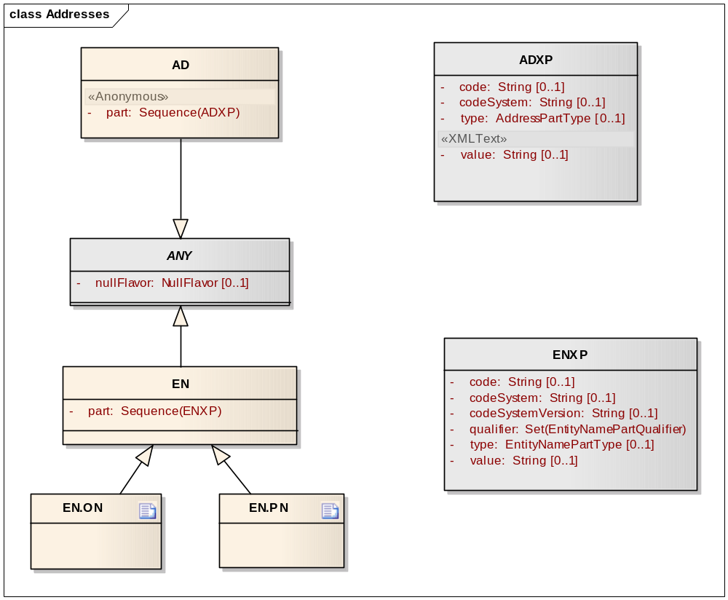
Figure 7 Name and Address Data types

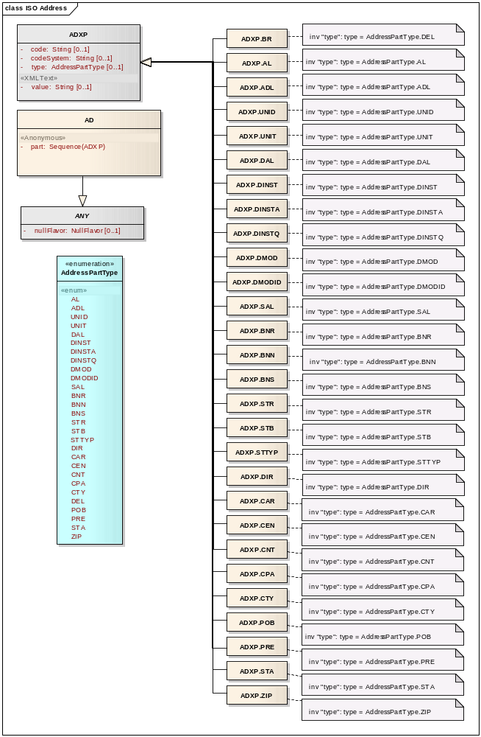
Figure 8 Address Data types

ADXP (Address Part)

ISO 11404 Syntax
type ADXP = class (
value : characterstring,
code : characterstring,
codeSystem : characterstring,
type : AddressPartType
)

AddressPartType

If the type is NULL the address part is unclassified and ignored. The values understood by this localization are:

AddressPartType Enumeration localization. OID: 2.16.840.1.1138883.5.16
Number | Type | Name | Notes
1 | AL | address line
2 | DAL | delivery address line
3 | CNT | country
4 | CTY | municipality
5 | STA | state or province
6 | ZIP | postal code
7 | CAR | care of
8 | ADL | additional locator
9 | DEL | delimiter
10 | POB | post box
11 | BNN | building number numeric
12 | BNR | building number
13 | BNS | building number suffix
14 | CEN | census tract
15 | CPA | county or parish
16 | DINST | delivery installation type
17 | DINSTA | delivery installation area
18 | DINSTQ | delivery installation qualifier
19 | DIR | direction
20 | DMOD | delivery mode
21 | DMODID | delivery mode identifier
22 | PRE | precinct
23 | SAL | street address line
24 | STB | street name base
25 | STR | street name
26 | STTYP | street type
27 | UNID | unit identifier
28 | UNIT | unit designator

Instances of ADXP with a type outside this localization are ignored.

Mappings

See Section 2.2.5.2.2. ADXP is always mapped in relationship to the containing AD. This localization does not contain ADXP.codeSystemVersion attribute.

AD (Address)
Specializes ANY

ISO 11404 Syntax
type AD = class (
nullFlavor : NullFlavor,
part : Sequence(ADXP)
)

Mappings

This localization does not contain useablePeriod, use, isNotOrdered attributes.
As an example, systems conforming to this localization can contain the following fields:
- streetAddressLine
- deliveryAddressLine
- cityOrMunicipality
- stateOrProvince
- postalCode
- country

Aside from country, each field is logically a single string value. For country, this is logically a ISO 3116 country.

During outward mapping, NULL internal representations set nullFlavor = NullFlavor.NI (if no NullFlavor fixed value is specified ) and part is empty. Non NULL internal representations are converted as follows. Null values for an internal field result in the part sequence not containing an ADXP for that type.

Internal Field | ADXP.type | ADXP.value | ADXP.code
streetAddressLine | AL | value | NULL
deliveryAddressLine | DAL | value | NULL
cityOrMunicipality | CTY | value | NULL
stateOrProvince | STA | value | NULL
postalCode | ZIP | value | NULL
country | CNT | official country name, per ISO 3166/MA | three-letter country code, per ISO 3166-1

ENXP (Entity Name Part)

ISO 11404 Syntax
type ENXP = class (
value : characterstring,
code : characterstring,
codeSystem : characterstring,
codeSystemVersion : characterstring,
type : EntityNamePartType,
qualifier : Set(EntityNamePartQualifier)
)

Mappings

See Section 2.2.5.4.2. ENXP is always mapped in relationship to the containing EN

EN (Entity Name)
Specializes ANY

ISO 11404 Syntax
type EN = class (
nullFlavor : NullFlavor,
part : Sequence(ENXP)
)

Mappings

See the mappings section for EN.PN and EN.ON.

EN.PN (Person Name)
Constrains EN

As an example, systems conforming to this localization can contain the following fields:
- lastName
- firstName
- middleName
- prefix
- suffix

During outward mapping, NULL internal representations set nullFlavor = NullFlavor.NI (if no fixed NullFlavor value is specified) and part is empty. Non NULL internal representations are converted as follows, in the order specified. Null values for an internal field result in the part sequence not containing an ADXP for that type. By default, any parts missing part type are mapped to GIV type except for a last part in the given list which will be mapped to FAM type.

Order | Internal Field | ENXP.type
1 | lastName | FAM
2 | firstName | GIV
3 | middleName | GIV
4 | prefix | PFX
5 | suffix | SFX

Inward mapping processes the part sequence in order. Rules:

- type must be non NULL for each part.
- By default, any parts missing part type are mapped to GIV type except for a last part in the given list which will be mapped to FAM type.

EN.ON (Organization Name)
Constrains EN

As an example, systems conforming to this localization can have a single field. During outward and inward mapping, a single ENXP is added to part and the value is populated from the internal representation.

Quantity Data types

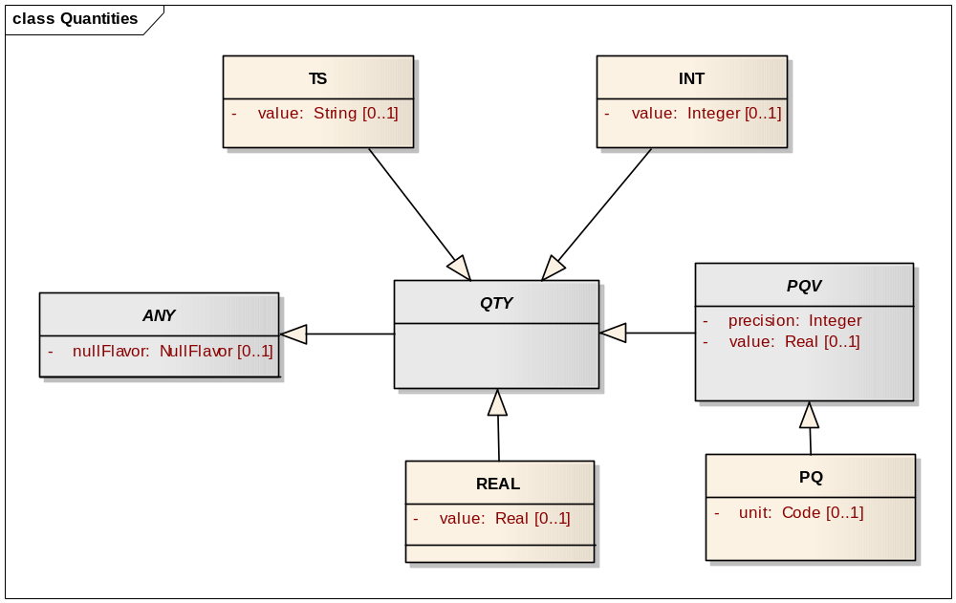
Figure 9 Quantity Data types

QTY (Quantity)
Abstract; specializes ANY

ISO 11404 Syntax
type QTY = class (
nullFlavor : NullFlavor
)

Mappings

See mappings for concrete type implementations.

INT (Integer)
Specializes QTY

ISO 11404 Syntax
type INT = class (
nullFlavor : NullFlavor,
value : integer
)

Mappings

For inward mapping, NULL instances map to NULL. Non-NULL instances use only the value attribute during inward mapping. For outward mapping, NULL maps with nullFlavor set to NullFlavor.NI if a fixed NullFlavor value is not specified. For non-NULL instances, value will be set to the internal value and all other fields will be empty.

PQV (Physical Quantity Value)
Abstract, specializes QTY

ISO 11404 Syntax
type PQV = class (
nullFlavor : NullFlavor,
value : real,
precision : integer
)

Mappings

See section on PQ mappings.

PQ (Physical Quantity)
Specializes PQV

ISO 11404 Syntax
type PQ = class (
nullFlavor : NullFlavor,
value : real,
precision : integer,
unit : Code
)

Mappings

For inward mapping, NULL instances map to NULL. Non-NULL instances use only the value, precision and unit attributes, storing those attributes directly. For outward mapping, NULL maps with nullFlavor set to NullFlavor.NI if a fixed NullFlavor value is not specified. For non-NULL instances, value, precision and unit will be set to the internal values and all other fields will be empty.

Note: unit’s type is Code, which is defined in the 21090 spec as a UNUM code. However, the 21090 XSD treats Code as a xs:string. Internally, this localization treats unit as a characterstring and does no checking during inward or outward mapping that unit corresponds to a valid UNUM code.

TS (Point in Time)
Specializes QTY

ISO 11404 Syntax
type TS = class (
nullFlavor : NullFlavor,
value : characterstring

)

Mappings

For inward mapping, NULL instances map to NULL. Non-NULL instances map the value attribute per the rules in ISO 8824 (ASN.1) under clause 32 (generalized time). For outward mapping, NULL maps to nullFlavor set to NullFlavor.NI if a fixed NullFlavor value is not specified. For non-NULL instances, value will be set to the internal value and all other fields will be empty.

REAL
Specializes QTY

ISO 11404 Syntax
type TS = class (
nullFlavor : NullFlavor,
value : real
)

Mappings
For inward mapping, NULL instances map to NULL. Non-NULL instances map the value attribute to an 8 byte IEEE 794 floating-point “double format”. For outward mapping, NULL maps to nullFlavor set to NullFlavor.NI if a fixed NullFlavor value is not specified. For non-NULL instances, value will be set to the internal value and all other fields will be empty.

Collections Of Data types

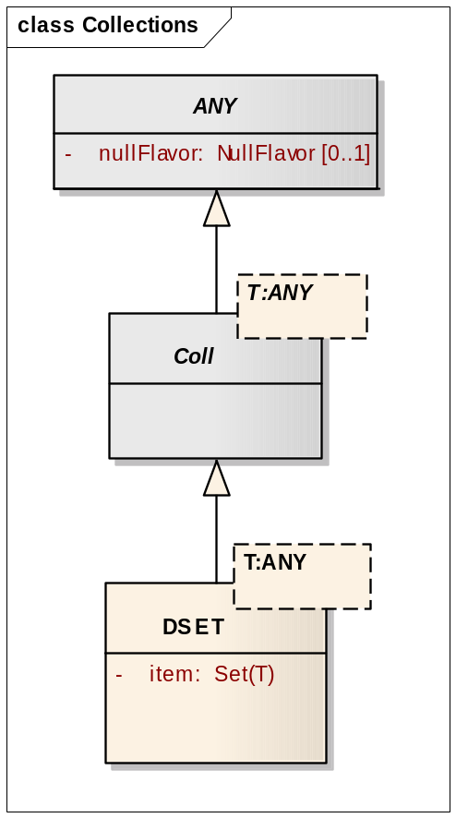
Figure 10 Collections of Data types

COLL
Abstract; specializes ANY
Parameter: T : ANY

See next Section for mapping information.

DSET (Discrete Set)
Specializes COLL
Parameter: T : ANY

ISO 11404 Syntax
type DSET (T : ANY) = class (
nullFlavor : NullFlavor,
item : Set(T)

)

Mappings

During inward mapping, NULL instances map to NULL internal representations. Non-NULL instances map to unordered sets. During outward mapping, NULL or empty sets map with nullFlavor set to NullFlavor.NI if a fixed NullFlavor value is not specified. Non-NULL, non-empty sets map directly to the item attribute.

Continuous Set Data types

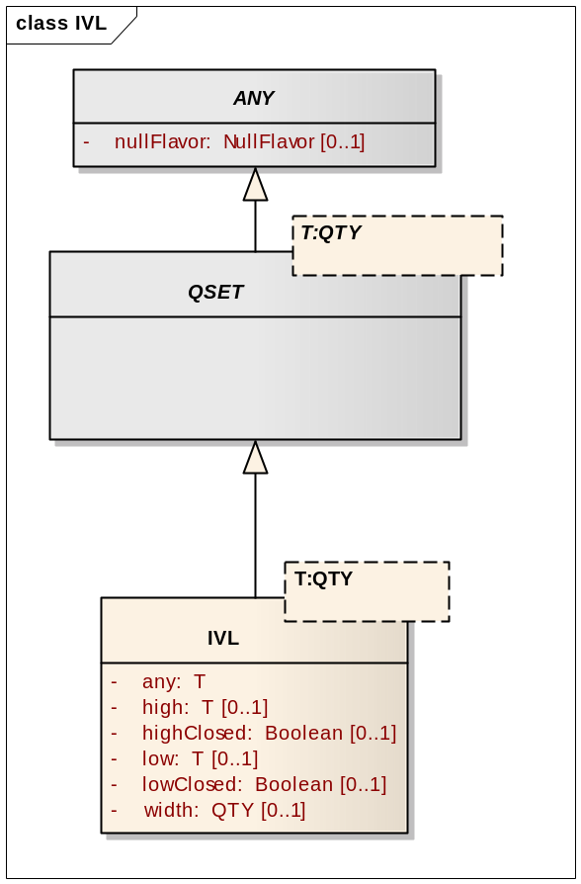
Figure 11 Continuous Set Data types

QSET (Continuous Set)
Abstract; specializes ANY

ISO 11404 Syntax
type QSET (T : ANY) = class (
nullFlavor : NullFlavor
)

Mappings

See next Section for mapping information.

IVL (Interval)
Specializes QSET
Parameter: T : QTY

ISO 11404 Syntax
type IVL (T : ANY) = class (
nullFlavor : NullFlavor,
any : T,
high T,
highClosed : boolean,
low : T,
lowClosed : boolean,
width : QTY
)

Mappings

This localization introduces any attribute to handle high and low values. During inward mapping, NULL instances map to NULL high, low and width elements. If low value is missing or high value equals low value, any value is set with high value. If high value is missing, any value is set with low value. During outward mapping, if any value is not null and if high and low values are null, any value replaces high and low values. It would also set highClosed and lowClosed to true. During outward mapping, if all the values are null, nullFlavor will be NullFlavor.NI if a fixed value is not specified.

As shown in the localized classes diagram above, localization supports IVL<PQ>, IVL<TS>, IVL<INT>, IVL<REAL> types. IVL by itself is an abstract type.

Unmapped Data types

The following data types are defined by ISO 21090 but are not part of this localization:
- HXIT
- ED.IMAGE
- ED.DOC
- ED.DOC.INLINE
- ED.DOC.REF
- ED.SIGNATURE
- ED.STRUCTUREDTEXT
- ED.STRUCTUREDTITLE
- CD.CV
- CS
- EN.TN
- INT.NONNEG
- INT.POS
- CO
- RTO
- PR
- PQR
- PQ.TIME
- MO
- TS.DATE
- TS.DATE.FULL
- TS.DATETIME
- TS.DATETIME.FULL
- TS.BIRTH
- LIST (Sequence)
- GLIST (Generated Sequence)
- SLIST (Sampled Sequence)
- HIST (History)
- BAG (Bag)
- QSU (QSET Union)
- QSI (QSET Intersection)
- QSD (QSET Difference)
- QSP (QSET Periodic Hull)
- QSS (QSET Set)

- IVL.CO
- IVL.RTO
- IVL.MO
- PIVL (PerioticInterval)
- EIVL (Event-Related Periodic Interval of Time)
- GTS.BOUNDEDPIVL
- UVP (Uncertain Value – Probabilistic)
- NPPD (Non-Parametric Probability Distribution)
- URG (Uncertain Range)
- URG.LOW
- URG.HIGH
- StructuredDoc.*

ISO/FDIS 21090:2009(E) – Page 1.
ISO 11404 characterstring and UML Kernel String, as applicable.

