Owner: caAdapter Development Team
Design Document
ISO 21090 Datatype Mapping Module

Last Updated March 10, 2010
National Cancer Institute
Center for Biomedical Informatics and Information Technology
2115 East Jefferson Street
Rockville, MD 20852

 |   Center for Bioinformatics


DOCUMENT REVISION HISTORY
Version Number | Date | Description
1.0 | 10-March-10 | - Initial Draft
1.1 | 10-April-10 | - Synchronize with caCORE SDK tag spec

Table of Content
1 Introduction 4
1.1 Summary 4
1.2 Overview 4
1.3 caAdapter Model Mapping Service (MMS) – Mapping and Annotation Engine 5
2 Core Technology 5
2.1 Requirement Analysis 5
2.2 Assumptions 6
2.3 Matching MMS Existing Features with Requirements 6
3 Software Architecture 9
3.1 Object Model 9
3.2 Core Engines 10
3.3 User Interfaces 10
4 Object Model Design 11
4.1 Mapping Components 11
4.2 Mapping Rules 12
4.2.1 Matching ends 12
4.2.2 Dependence mapping 12
4.2.3 Map simple attribute 12
4.2.4 Map complex data types with simple or complex attribute 13
4.2.5 Map complex data types with collection attributes 13
4.2.6 Map collection of complex data types 13
4.2.7 Map collection of complex data types with collection attributes 14
4.3 Basic Mapping Processing 15
4.3.1 Mapping links 15
4.3.2 Annotation tag 15
5 Appendix A - References 16
7 Appendix B - Rules for XML Representation of ISO 21090 Data Types 17

Introduction

Summary
This document contains the design description for the caAdapter ISO 21090 Datatype Mapping Module. This module provides the following capabilities:
- Model the localized ISO 21090 datatype specification
- Support default values for ISO 21090 datatype at global and instance level
- Provide Graphic UI to map the ISO 21090 compliant object model to data model
- Enforce mapping rules involved with ISO 21090 datatype
- Annotate caCORE UML model (xmi file) with tags defined with SDK tool kits
- Support mapping functions (constant and others) to be defined by SDK tool kits.
In the following sections, we leverage the analysis of SDK ISO Datatype Mapping Specification and the existing features of caAdapter Model Mapping Service Module.

Overview
The National Cancer Institute Center for Biomedical Informatics and Information Technology (NCI CBIIT) developed the open source caAdapter tool with the goal of creating standards-based infrastructure components to facilitate medical research data exchange. caAdapter provides model mapping services and data mapping and transformation services. The Model Mapping Service (MMS) module supports building caCORE-like applications with mapping and annotation from object model to data model. The data Mapping and Transformation Service (MTS) module facilitates data mapping and transformation among different kinds of data formats including generic XML file, HL7 v2 messages, HL7 v3 messages, and Study Data Tabulation Model (SDTM) data sets.
ISO 21090 is a standard jointly balloted between the International Organization for Standardization (ISO) and the Health Level Seven (HL7). This standard provides set of data type definitions for representing and exchanging basic concepts that are commonly encountered in healthcare environments in support of information exchange in the healthcare environment. XML definitions of the ISO 21090 data types are described with XML schema (XSD) derived from the UML representation of the ISO 21090 standard specification using XML encoding rules and mapping between UML primitive types and XML types. The XSD provides a normative XML format for use when instance of these data are represented in XML.
The new caAdapter ISO 21090 Mapping Module will be developed as part of NCI CBIIT ISO 20190 data type enabling project (http://gforge.nci.nih.gov/projects/iso21090/). It will map and annotate an ISO 21090 data type compliant object model with a data model for building the caCORE-like and ISO 21090 compliant system. It uses the localized version of ISO 21090 data type specification, which id derived from the standard ISO 21090 data type specification schema (XSD).

caAdapter Model Mapping Service (MMS) – Mapping and Annotation Engine
caAdapter Model Mapping Service Module enable user map an object model to a data model using drag-and-drop capabilities. It parsers and loads object models and data model from an XMI file, add caCORE SDK required tags and tag values into the XMI file. We will benefit our developing work from the following mapping tool highlights:
- Graphic presentation of source objects model and target data model
- Drag-and-drop functionalities from source node to target node
- Dependence mapping from objects to tables
- Attribute mapping from an object attribute to a table column
- Association mapping between objects
- Polymorphism and inheritance mapping of whole class hierarchy
- Writable API required annotation on data model

Core Technology

Requirement Analysis
The core objective for the ISO 21090 Datatype Mapping Module is to map a source object model which is compliant to the localize ISO 21090 datatype to a data model, and annotate the XMI file with caCORE SDK required tag and tag values. The annotated XMI file will be used for building caCORE-like application.
The mapping process involves:
- Load and parse the model (xmi file) of localized ISO 21090 data types.
- Load and parse domain model (xmi file) using the model of localized ISO 21090 data types.
- Map simple attributes of a data type in object model to a table column.
- Map complex attributes of a data type in object model to table columns. A complex data type contains one or more attributes which are based on simple data types or other complex data types. The complex attributes can be mapped to one or more columns in the table corresponding to the parent class or in a separate class
- Support constant mapping for complex attributes at both global level and local level.
- Map nested complex attributes. The nested elements within the complex data types can be of simple types or other complex types. The nested complex type structure will be recursively mapped to the columns of the same table where other sub-attributes of the parent complex type are mapped (With an exception of the nullFlavor for AD, EN, EN.ON, and EN.PN data types).
- Map complex data type with collection attribute
- Map collection of complex data type with/without a collection attribute
- Apply data manipulation functions to both simple type attribute and complex type attribute.
- Enforce “NullFlavor” rules in mapping and annotation.

Assumptions

Here is a list of assumptions we made for this iteration:
- ISO data types are defined (imported) within each domain model xmi files.
- ISO data types are defined (imported) within package called “iso.datatype”
- ISO data type cannot be changed at runtime
- All attributes (exception width attribute of IVL data type) for data types are predefined. Actual data type of width attribute of IVL data type will be determined at running time.
- Each ISO data type attribute can map to one column in the data model, and each data model column can only be mapped more than once.

Matching MMS Existing Features with Requirements
Matching caAdapter Model Mapping Service (MMS) with ISO 21090 Datatype Mapping Module requirements, we get the following table.
Table 1 – Match caAdapter MMS features against ISO 21090 Encoding Module requirements
ISO 21090 Maping Module Mapping requirement | Available in caAdapter MMS features | Comments
Load and parse the localized ISO 21090 datatype model. | Yes | Extend the existing parsing and loading functionalities of the xmi file use the localized ISO 20190 data type model
Load and parse the object model xmi file supported by the localized ISO 21090 data type model. | No | Resolve the referenced ISO 21090 data type from an object attribute; Recursively resolve all structures of nested complex data type
Map simple attributes of a data type in object model to a table columns | Yes | Existing tag: mapped-attributes
Map complex attributes of a data type in object model to a table columns | No | Existing tag: mapped-attributes
Support constant mapping for complex attributes at both global level and local level | No | New tag: mapped –constant:<full qualified name of the attribute>
Map nested complex attributes | No | Existing tag: mapped-attributes  The nested elements within a complex data type can be of simple types other complex types. The nested complex type structure will be recursively mapped to the columns of the same table where other sub-attributes of the parent complex type are mapped
Map complex data type with collection attribute | No | Existing tag: mapped-attributes  New tag: mapped-correlation-table
Map collection of complex data type with/without a collection attribute | No | Existing tag: mapped-attributes  New tag: mapped-collection-table  New tag: apped-collection-element-type:<name of inner collection>
Apply data manipulation functions to both simple type attribute and complex type attribute | No | New tag: To be detailed.
Enforce “NullFlavor” rules in mapping and annotation. | No | Define and enforce the “NullFlavor” rules in annotation process.

Software Architecture
The architecture design leverages the existing caAdapter Model Mapping Service module. It is organized in a highly modularized fashion enabling easy expansion to adopt any future needs. The architecture also effectively streamlines the main functional modules, so that it can achieve an overall high performance.
The architecture diagram is as following.
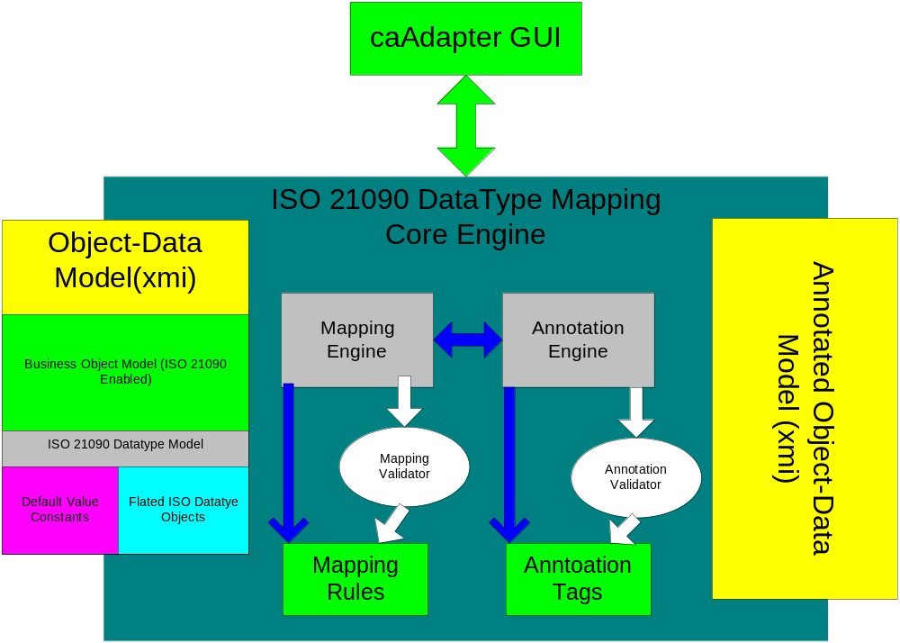
Figure 1 Architecture Diagram

Object Model
This new module will reuse the object model of caAdapter Model Mapping Service module. If any modification is required, it will be detailed at implementation phase.
.

Core Engines
Mapping Engine
The Mapping Engine handles the core task that creates and manages the mapping relationship that associates node of object model and node of data model. It applies mapping rules defined by either SDK or caAdapter MMS module.
Annotation Engine
The Annotation Engine create/update/delete SDK annotation tags and values based on mappings between nodes of object model and nodes of data model. It applies the tag implementation rules defined by SKD.

User Interfaces
The reused caAdapter GUI provides a Java Swing based GUI interface for user to create and manage mappings and perform annotation and validations. It utilizes drag-and-drop technology providing a convenient user interface to perform such tasks.

Object Model Design
The detail of object model is omitted here since it is reused from caAdapter MMS module.

Mapping Components
Based on the object model, we have the following mapping components.
Object
Object or class component correspond to objects in object model. An object can have attributes or references to other objects. The whole object model can be represented in GUI as a tree, and the objectes/classes appear as nodes in the tree.
Attribute
Attribute component correspond to the attributes of an object component in object model. An attribute always has a name and an ISO 21090 data type. The associated data type can be simple or complex data type. A complex type attribute has a set of its own ISO 21090 data type attributes. Attributes are always attached to an object/class appearing as leaf nodes in the object model tree.
Table
Table component correspond to in the tables in data model. A table always has a set of columns. The whole table model can be represented in GUI as a tree, and the tables appear as nodes in the tree.
Column
Column component correspond to the columns of a table in data model. Columns are always attached to a table appearing as leaf nodes in the tree representation.
Link
Link is the basic component of mapping relationships. It has source node and target node. The source node can be object/class or attribute. The target node can be table or column.
Function (TBD).
Function is used to represent certain type of operation in the mapping. It will be detailed once SDK decides its mechanism of function processing.

Mapping Rules
To be able to formalize the mapping relationships and produce precise annotation, the following mapping rules are defined.
Detailed description of tag values can be found in caSDK design documentation.

Matching ends
- One source object can be mapped to one target table
- One source object can be mapped to more than one target tables.
- One source object can be mapped to the same one target table.
- More than one source objects can be mapped to the same one target table.
- One source attribute (direct attribute of an object or sub-attributes of a complex ISO data type) can only be mapped to one target column. The multiple sub-attributes of one complex ISO data type are treated as separate attributes.
- More than one source attributes can be mapped the same one target column in support of mapping the same ISO data type from multiple domain objects into the same target table
- Attribute can link to a function, and the output is still of attribute type (TBD).

Dependence mapping
Dependence mapping is the link from a source object to a target table. It is specified as a relationship with stereotype of “DataSouce”.
Tag Value Key: N/A
Value: N/A

Map simple attribute
Simple data type includes the Java primitives and wrapper types. The simple attribute based attributes are mapped to a single column in the table corresponding to the parent class.
Tag Value Key: mapped-attributes
Value: fully qualified name of the attribute

Map complex data types with simple or complex attribute
Complex data type contains one or more attributes which are based on simple data type or other complex data type. The complex attributes can be mapped to one or more columns in the table corresponding to the parent class or in a separate class
Tag Value Key: mapped -attributes
Value: fully qualified name of the attribute within the complex structure

Map complex data types with collection attributes
If an attribute of a complex data type is a collection of complex type, the collection of complex type structure will be iteratively mapped to the columns of the same table where other sub-attributes of the parent object are mapped.
Tag Value Key: mapped -attributes
Value: fully qualified name of the attribute within the complex structure

4.2.6 Map collection of complex data types
In this mapping scenario, the ISO data type of an attribute is a collection of other ISO complex data types. The complex type structure is iteratively mapped to the columns of the collection table. The collection table is separated from the table mapped with domain object. This iteration supports collection of the following data types which do not contain other collection attributes.
- DSET<II>
- DSET<TEL>
- DSET<CD>
Two annotation tags are defined for this scenario: “mapped-collection-table” apply to object model; “mapped-attributes” apply to data model.
Tag Value Key: mapped-collection-table
Value: <collection table name >
Location: The collection attribute of the domain object in object model

Tag Value Key: mapped-attributes
Value: <fully qualified name of the collection attribute>.<attribute name of element complex data type in the collection attribute>
Location: Column of the collection table in data model.

4.2.7 Map collection of complex data types with collection attributes
In this mapping, the ISO data type of an attribute is a collection of other ISO complex data types. The nested data types contain attribute with a collection of ISO data types. (see section 3.3.5 of Tag Values Specification.doc).
Three annotation tags are defined for this scenario. Two tags apply to object model: “mapped-collection-table” and “mapped-collection-element-type”; one tag applies to data model, “mapped-attributes”.
Tag Value Key: mapped-collection-table
Value: <collection table name >
Location: The collection attribute of the domain object in object model

Tag Value Key: mapped-collection-element-type:<name of the inner collection attribute >.<[index of the inner collection element]>
Value: <Class name of the collection element >
Location: The collection attribute of the domain object in object model. In this scenario, multiple tags are added to the same attribute of domain object.

Tag Value Key: mapped-attributes
Value: <fully qualified name of the collection attribute>.<attribute name of element complex data type in the collection attribute>
Location: Column of the collection table in data model.

Basic Mapping Processing

Mapping links
UI drag-and-drop action invokes the mapping engine to process mapping rule and create mapping link from a source node to target node. Once a mapping link is created, the mapping engine invokes annotation engine to create SDK tag with value and annotate the underlying object/data model (xmi file).

Annotation tag
The annotation engine creates corresponding SDK tag based on the types of the source node and target node. The annotation engine will remove all annotation tags from the underlying annotated object/data model (xmi file) if a mapping link is deleted,.

Appendix A - References
- Tag Values Specifications.doc
- ISO Datatype - Deflated Structure.xls
- ISODataTypeModel.EAP
- PIM_21090.doc Platform Independent Module, NCI CBIIT localized ISO 21090 datatypes
- ISO/DIS 21090, http://www.kith.no/upload/4414/ISODIS21090.pdf, Voting begins on: 2008-04-24; Voting terminates on: 2008-09-24

.

7 Appendix B - Rules for XML Representation of ISO 21090 Data Types
The ISO 21090 specification defined the follow rules, the following content is directly quoted from Section A.2 of Draft International Standard ISO/DIS 21090
- Any valid XML charset can be used as long as it is consistent with the String Character Set as discussed in section 6.7.5. In particular, full round-trip encoding between the String Character Set and the XML charset is required.
- xml:lang must be ignored. For content to which language applies, the Data.language or ST.language attribute must be used instead.
- All elements must be in some namespace, and the namespace must be defined in conformance statements of the information processing entities that claim conformance with this specification. The specification reserves the namespace “uri:iso.org:21090” for direct applications of the datatypes such as testing environments.
- The xml representation (and xml schema) for a type is derived algorithmically from the UML representation.
- Each type the specializes ANY is represented by an XML element.
- UML Attributes with a stereotype of Binary on their type are represented as an element with text content.
  - The format of the text in the element is the format specified for the type based64Binary in W3C schema.
- UML Attributes with a stereotype of XML on their type are represented as XML with single XML element contained.
  - The name of the XML element is the name of the UML attribute
  - This is equivalent of the schema type anyType
- UML Attribute with a stereotype of XML.ID are represented as an XML ID attribute. The name of the attribute is the same as the UML attribute.
- UML Attributes with a stereotype of XML.IDREF are represented as an XML IDREF attribute. The name of the attribute is the same as the UML attribute. If the type of the UML attribute is a UML collection, then the attribute will be a space delimited list of XML IDREF tokens.
- UML Attributes with a stereotype of XML.Text are represented as XML text content. There may be only one UML attribute with this stereotype on a class.
- UML Attributes with a type derived from Classifier are represented as an element
  - The name of the XML element is the name of the UML attribute
  - The format of the element is hat specified bor the type following these rules recursively
- UML Attributes with a type derived from a UML primitive class are represented as an attribute
  - The name of the XML attribute is the name of the UML attribute
  - The attribute has no namespace
  - The content of the attribute must conform to the W3C schema type that matched the UML type.
  - If the value of the attribute is equal to its default value, the attribute does not need to be represented in the XML. The default value for attribute is null unless specified otherwise in the UML diagrams.
- UML Attributes with a type derived from a Collection of UML Classifiers are represented by a sequence of XML elements.
  - The name of the elements is the name of the attribute.
  - There is one element for each item in the collection
  - The format of the element is that specified for the type following these rules recursively.
- UML Attributes with a type derived from a Collection of UML primitives are represented by an XML attribute
  - The name of the attribute is the name of the attribute
  - The attribute has no namespace
  - The content of the attribute must be a space separated list of tokens that conform to the schema type that matches the UML type.
- UML Association with a stereotype of “Anonymous” are not represented by any element at all.
- The xsi:null element may be used to represented null objects as appropriate. If a UML attribute is not represented in the XML, this is identical in meaning to providing an element with xsi:null attribute.
- If the type being represented has a type other than that specified in the UML (i.e. a specialization), then the xsi:type attribute of the element must be provided. Xsi:type may be used at any time.
- The schema type name of a type is the same as its UML name, except for bount parameterized classes.
- For bound parameterized classes (where the class has type parameters) then the actual parameters bound to the class are added to the type using _ as a separator. i.e. SET(AD) becomes SET_AD
- If an attribute is contained by reference, then this is represented using XML ID/IDREF attributes. The reference must be contained within same document. The attribute itself may make other constraints about where the target of the reference might be found. The reference may be a forward reference.

