caXchange – ScenPro, Inc.
Ekagra

ESB for Reliable Messaging
Transaction and Routing
Test Plan

Document Change History
Version Number | Date | Contributor | Description
1.0 | December 2007 | Yogaraj Khanal | Initial Draft
1.1 | January 2008 | Paula Brown | Review
1.2 | January 2008 | Yogaraj Khanal | Second Draft after review
1.3 | January 2008 | Michael Holck | Fixed some formatting issues
1.4 | February 2008 | Kalpesh Patel | Addressed comments from BAH
1.5 | February 2008 | Yogaraj Khanal | Updated index page


Updated Feb 13, 2007
Table of Contents

1 Introduction 4
1.1 Scope 4
1.1.1 In Scope 4
1.1.2 Out of Scope 4
1.2 Quality Objective 5
1.2.1 Primary Objective 5
1.2.2 Secondary Objective 5
1.3 Roles and Responsibilities 5
1.3.1 Developer 5
1.3.2 QA 5
1.4 Assumptions for Test Execution 6
1.5 Constraints for Test Execution 6
1.6 Definitions 7
2 Test Methodology 7
2.1 Purpose 7
2.1.1 Overview 7
2.1.2 Usability Testing 7
2.1.3 Unit Testing (Multiple) 7
2.1.4 Iteration/Regression Testing 8
2.1.5 Final release Testing 8
2.1.6 Testing completeness Criteria 8
2.2 Test Levels 8
2.2.1 Build Tests 8
Level 1 - Build Acceptance Tests 8
Level 2 - Smoke Tests 8
Level 2a - Bug Regression Testing 9
2.2.2 Milestone Tests 9
Level 3 - Critical Path Tests 9
2.2.3 Release Tests 9
Level 4 - Standard Tests 9
2.3 Bug Regression 9
2.4 Bug Triage 9
2.5 Suspension Criteria and Resumption Requirements 9
2.6 Test Completeness 10
2.6.1 Standard Conditions: 10
2.6.2 Bug Reporting & Triage Conditions: 10
3 Test Deliverables 11
3.1 Test Approach 11
3.1.1 CaXchangeGridService 11
3.1.2 CaXchangeResponse Listener 12
3.1.3 CaXchange Service Assembly 12
3.2 Test Cases 12
3.2.1 Test Cases and Requirement Traceability 12
3.2.2 Test Case Description 14
Test Case 1: Client sends valid caXchangeRequestMessage to Grid Node and receives a response 14
Test Case 2:Grid Node produces inbound message caXchangeRequestMessage 14
Test Case 3: Client sends invalid caXchangeRequestMessage to Grid Node and receives a response 15
Test Case 4: Client sends valid caXchangeRequestMessage to Grid Node and Grid Node is not running 15
Test Case 5: Client sends valid caXchangeRequestMessage to Grid Node and Servicemix is not running 15
Test Case 6: Submit a JMS Text Message to the JMS Binding Component and ensure that the message is forwarded to the proper service or endpoint that is deployed 15
Test Case 7: Submit a JMS Text Message to the JMS Binding Component and ensure that the message is forwarded to an invalid service or endpoint 15
Test Case 9: Component doesn't receive credentials from the Delegation service 16
Test Case 10: Component receives credentials from Delegation service 16
Test Case 11: Error message log check in case of failure to receive credentials from grid service 16
Test Case 12: otherwise check the message is passed to the static recipient list with attached credentials 16
Test Case 15: Message with incorrect message types 17
Test Case 16: Sends the message to content based router based on message Type 17
Test Case 17: Sends the message to Listener Aggregrator in case of fault in the original message 17
Test Case 19: Pipe doesn't convert In-Only to In-Out MEPs 17
Test Case 20: In-Out MEP to the Grid Outbound component to invoke a Grid Service with process or rollback operation 18
Test Case 23: Response back to the EIP Aggregrator 18
Test Case 24: Responses from all the target Grid Services as input 18
Test Case 25: Single message to the Grid Node 18
Test Case 26: Response Generator 19
Test Case 27: Grid Node Listener 19
Test Case 28:C3PR Client 19
3.3 Defect Tracking & Debugging 19
3.3.1 Testing Work flow 19
3.3.2 Defect reporting using GFORGE 20
3.4 Reports 21
3.4.1 Testing status reports 21
3.4.2 Test Final Report - Sign-Off 22
3.5 Responsibility Matrix 22
4 Resource & Environment Needs 23
4.1 Testing Tools 23
4.1.1 Tracking Tools 23
4.2 Test Environment 23
4.2.1 Hardware 23
4.2.2 Software 23
4.3 Bug Severity and Priority Definition 24
4.3.1 Severity List 24
4.3.2 Priority List 24
4.4 Bug Reporting 24
5 Terms/Acronyms 26

Introduction
CaXchange is a software component that is primarily responsible for receiving input from various external systems, routing the input to various services that are hosted on the hub, and eventually routing the output of those services to external systems. The Common Logging Module (CLM) provides the audit and logging services under the caCORE set of tools. CaCORE includes a set of tools such as the log-locator web application. Integrating CLM with caXchange for logging enables the use of these tools for caXchange logs. CaXchange is implemented using the Servicemix 3.1.2 enterprise service bus (ESB) for routing and exposing that functionality using a service deployed on caGrid. CaXchange is deployed as a service assembly on Servicemix 3.1.2. The caXchange grid service acts as a proxy to the service assembly. By providing a comprehensive solution to common security objectives, the NCICB Common Security Module (CSM) helps eliminate the need for the development teams to create their own security methodology. The CSM provides application developers with powerful security tools in a flexible delivery. It is flexible enough to allow application developers to integrate security with minimal coding effort.
This documentation describes the test plan for reliable messaging, transactions and routing caXchange provides. Its scope is limited to test cases for reliable messaging, transactions and routing for caXchange, and making this information available to users.

Scope

In Scope
The test scope for reliable messaging, transactions and routing includes the following:
- Testing of all functional, application performance, security and use cases requirements listed in the Use Case document.
- Quality requirements and fit metrics of reliable messaging, transactions and routing
- End-to-end testing and testing of interfaces of all systems that interact with the caXchange reliable messaging, transactions and routing
- Performance test for caXchange reliable messaging, transactions and routing
- Usability Testing for caXchange reliable messaging, transactions and routing

Out of Scope
The following areas for reliable messaging, transactions and routing are Out of Scope:
- Functional requirements testing for systems outside caXchange reliable messaging, transactions and routing
- Testing of Business SOPs, disaster recovery and Business Continuity Plan.

Quality Objective

Primary Objective
A primary objective of testing application systems is to: assure that the system meets the system requirements, including quality requirements (AKA: Non-functional requirements), fit metrics for each quality requirement, satisfies the use case scenarios and maintains the quality of the product. At the end of the project development cycle, the user should find that the project has met or exceeded all expectations as documented in the requirements.
Any changes, additions, or deletions to the requirements document, Functional Specification, or Design Specification will be documented and tested at the highest level of quality allowed within the remaining time of the project and within the ability of the test team.

Secondary Objective
The secondary objective of testing application systems will be to: identify and expose all issues and associated risks, communicate all known issues to the project team, and ensure that all issues are addressed in an appropriate manner before release. This requires careful and methodical testing of the application to first ensure all areas of the system are scrutinized and, consequently, all issues (bugs) found are dealt with appropriately.

Roles and Responsibilities

Developer
An NCI-designated Cancer Center selected and funded by NCICB to participate in a specific Workspace to undertake software or solution development activities. Responsible to:
(a) Develop the system/application
(b) Develop Use cases and requirements
(c) Conduct Unit, system, regression and integration testing
(d) Support user acceptance testing

QA
An NCI-designated Cancer Center selected and funded by NCICB to undertake formal testing, and validation of application products or solutions developed by Workspace Developers. Responsible to:
(a) Contribute to Use case, requirement development through review
(b) Contribute to development and execution of the unit test scripts through review
(c) Conduct Full User Acceptance, regression, and end-to-end testing; this includes identifying test scenarios, building the test scripts, executing scripts and reporting test results

Assumptions for Test Execution

The caXchange – reliable messaging, transactions and routing testing effort has inherent dependencies on the existing NCICB products involved in the architecture and other factors such as business, software, or personnel aspects. These dependencies are documented as assumptions in this section.
- For User Acceptance testing, the Developer team has completed unit, system and integration testing and met all Requirement’s (including quality requirements).
- Test results will be reported on daily basis using GForge. Failed scripts and defect list from GForge with evidence will be sent to the Developer directly.
- Use cases have been developed for Acceptance testing. Use cases are approved by test lead.
- Test scripts are developed and approved.
- GU source data – for containing complete, accurate data, and valid values with respect to HL7 v3 standards. As noted below, it is assumed that some values will be invalid and that this will allow the project to demonstrate how invalid data is handled.
- Web SSO – caGrid Authentication and Authorization: User authentication will be performed by appropriate application (C3PR, caAERS, PSC etc.). User’s grid credential will be used to connect to the caXchange (via Grid node). The user authorization will be performed by Grid Delegation Service by using grid identity passed to the caXchange as part of the user request.
- CLM – for auditing and logging of the actions in the caXchange.
- No data conversion or translation other than format conversion will be performed in caXchange
- Some invalid data will be provided by GU. The data will be considered invalid if it does not match HL7 v3 standards for its intended data element. This invalid data is actually useful for the project to be able to demonstrate how invalid data is handled (e.g. audit logs, etc.).
- Only valid XML instances of the HL7 v3 CT Lab message will be persisted using the CTODS Data Service. This will ensure that the data that is loaded in the database is not incomplete.

Constraints for Test Execution

- Developer will receive consolidated list of request for test environment set up, user accounts set up, data set (actual and mock data), defect list, etc. through GForge after the initial Adopter testing kick off meeting.
- Developer will support ongoing testing activities based on priorities

Definitions
Bugs: A defect is a problem with the software, where the application or system component is not working as designed, causes unexpected behaviors, or is not functioning in accordance with the requirements.

Feature Request:
A feature request is a request to add functionality or enhance current functionality from what was designed and coded.
Features can be added as a new requirement going through the appropriate Change Management process.

Test Methodology

Purpose

Overview

The purpose of the Test Plan is to achieve the following:
- Define testing strategies for each area and sub-area to include all the functional and quality (non-functional) requirements.
- Divide Design Spec into testable areas and sub-areas. Be sure to also identify and include areas that are to be omitted (not tested) also.
- Define bug-tracking procedures.
- Identify testing risks.
- Identify required resources and related information.
- Provide testing Schedule.

Usability Testing
Usability testing will not be conducted on the caXchange-Audit and Logging v1.0 due to time constraints.

Unit Testing (Multiple)
Unit Testing is conducted by the Developer during code development process to ensure that proper functionality and code coverage have been achieved by each developer both during coding and in preparation for acceptance into iterations testing.

Iteration/Regression Testing
At each iteration, a debriefing should be held. Specifically, the report must show that to the best degree achievable during the iteration testing phase, all identified priority 1 and 2 bugs have been communicated and addressed. At a minimum, all priority 1 and priority 2 bugs should be resolved prior to entering the beta phase.

Important deliverables required for acceptance into Final Release testing include:
- Application set up
- Installation instructions
- All documentation (beta test scripts, manuals or training guides, etc.)

Final release Testing
Assuming critical bugs are resolved during previous iteration test cycles - Throughout the Final Release test cycle, bug fixes will be focused on minor and trivial bugs (priority 3 and 4). Testing will continue its process of verifying the stability of the application through regression testing (existing known bugs, as well as existing test cases).

The milestone target of this phase is to establish that the application under test has reached a level of stability, appropriate for its usage (number users, etc.), that it can be released to the end users and caBIG community.

Testing completeness Criteria
The milestone target is to place the release/app (build) into production after it has been shown that the app has reached a level of stability that meets or exceeds the client expectations as defined in the Requirements, Functional Spec., and caBIG Production Standards.

Test Levels
The test categories and test levels are defined below:

Build Tests

Level 1 - Build Acceptance Tests
System will be checked to see if the proper Development Release Document plus other build related information (drop point, etc.) is in place. The objective is to determine if the build process was successful. If any Level 1 test case fails, the build is returned to developers untested.

Level 2 - Smoke Tests
The objective is to determine if the build is ready for functional testing. These test cases will emphasize breadth more than depth. All components will be touched, and every major feature should be tested briefly by the Smoke Test. If any Level 2 test case fails, the build is returned to developers untested.

Level 2a - Bug Regression Testing
Every bug that was “Open” during the previous build, but marked as “Resolved,” needs re-testing. The current build under test will need to be regression tested as well. Once the smoke test is completed regression testing can commence.

Milestone Tests

Level 3 - Critical Path Tests
Critical Path test cases must pass by the end of every 2-3 Build Test Cycles. They will not need to be tested every drop, but must be tested at least once per milestone. Thus, the Critical Path test cases must all be executed at least once during the Iteration cycle, and once during the Final Release cycle.

Release Tests

Level 4 - Standard Tests
Functional test cases may be executed multiple times with each Iteration, as they could be flagged to be included in the regression test suite after their initial execution.
Standard test cases usually include Installation, Data, GUI, and other test areas.

Bug Regression
All bugs that are at a status of ‘Resolved’, Need to be Retested” when the Testing team is notified of the new drop containing the fixes. When a bug passes regression it will be considered “Verified”. If a bug fails regression, the testing team will notify development team by entering notes into GForge. When a critical or high priority bug fails regression, the Testing team should also put out an immediate email to development. The Test Lead will be responsible for tracking and reporting to development and product management the status of regression testing.

Bug Triage

The Test Lead, Product Manager, and Development Lead should all be involved in these triage meetings. The Test Lead will provide required documentation and reports on bugs for all attendees. The purpose of the triage is to determine the type of resolution for each bug and to prioritize and determine a schedule for all “To Be Fixed Bugs’. Project Manager will then assign the bugs to the appropriate person for fixing and report the resolution of each bug back into the GForge bug tracker system. The Test Lead will be responsible for tracking and reporting on the status of all bug resolutions.

Suspension Criteria and Resumption Requirements
A bug report should be filed by the development team. After fixing the bug, the development team will follow the drop criteria (described above) to provide its latest drop for additional testing. At that time, the testing team will regress the bug, and if passes, continue testing the module.

Test Completeness
Testing will be considered complete when the following conditions have been met:

Standard Conditions:
- When testing team and Developers, agree that testing is complete, the app is stable, and the application meets functional requirements.
- Script execution of all test cases in all areas has been executed.
- Automated test cases in all areas have been executed.
- NCI approves the test completion
- Each test area has been signed off as completed by the Test Lead.
- No ‘Critical or High’ Priority bugs that have no definable workaround remain open.

Bug Reporting & Triage Conditions:
- Bug find rate indicates a decreasing trend prior to Zero Bug Rate (no new priority. 1/2 bugs found).
- Bug priority distribution has changed to a steady decrease in Priority. 1 and 2 bugs discovered.
- No ‘Critical or High’ bugs that have no definable workaround remain open.

Test Deliverables
Testing will provide specific deliverables during the project. These deliverables fall into three basic categories: Documents, Test Cases / Bug Write-ups, and Reports. Here is a diagram indicating the dependencies of the various deliverables:

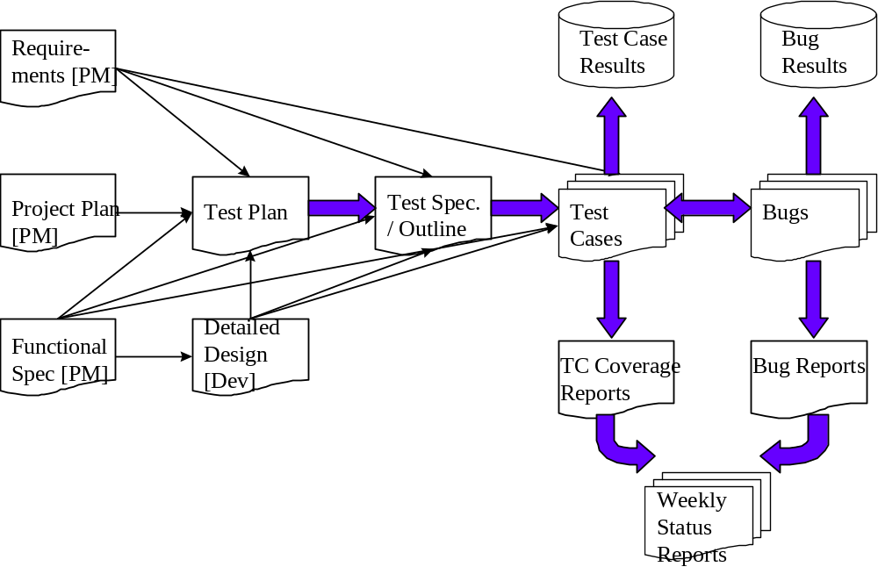

As the diagram above shows, there is a progression from one deliverable to the next. Each deliverable has its own dependencies, without which it is not possible to fully complete the deliverable.

The following page contains a matrix depicting all of the deliverables that Testing will use.

Test Approach
There are multiple components that make up the caXchange process. All these components will be tested to validate the requirements for the reliable messaging, transaction and routing functionality. Grid service requests will be received by external client requests and routed based on message type. Response messages will be received from the target system confirming the message was properly routed in order to complete a full loop of receive, route and confirm message request processing.

CaXchangeGridService
caXchange grid service acts as a proxy for caXchange. It forwards incoming requests to caXchange for processing. To keep track of a request it creates a WS-Resource framework resource. The grid service then returns an Endpoint Reference to the client. The client uses this end point reference to invoke the getResponse operation. The grid service also creates a response listener, which listens for caXchangeResponse and updates the resource.

CaXchangeResponse Listener
The caXchangeResponse listener lives with the caXchange Grid service. It listens for the response on the JMS queue associated with the response outbound component of the caXchange service assembly. Once a response is received from the queue, the resource associated with the corresponding request is updated. The client can then use the getResponse method to get the caXchangeResponse.

CaXchange Service Assembly
caXchange service assembly is deployed on the Servicemix JBI container. The caXchange test cases will elaborate on different components of the service assembly.

Test Cases

Test Cases and Requirement Traceability
Test cases that will be tested for the caXchange ESB for reliable messaging, transactions and routing are defined in the following table.

Test Case No | RQMNT ID | Features to be Tested | Test Cases
1 | 1.0 | Client sends valid caXchangeRequestMessage to Grid Node and receives a response | To ensure that the caXchangeRequestMessage is valid
2 | 1.1 | Grid Node produces inbound message caXchangeRequestMessage | To ensure that grid node is functioning and produce the inbound JMS message
3 | 1.3 | Client sends invalid caXchangeRequestMessage to Grid Node and receives a response. | To ensure that the invalid caXchangeRequestMessage is handled appropriately
4 | 1.4 | Client sends valid caXchangeRequestMessage to Grid Node and Grid Node is not running | Validate client receives notification if GRID Node is not up and running
5 | 1.5 | Client sends valid caXchangeRequestMessage to Grid Node and Servicemix is not running | To ensure that the caXchangeRequestMessage gets into the Servicemix persistence queue
6 | 2.0 | Submit a JMS Text Message to the JMS Binding Component and ensure that the message is forwarded to the proper service or endpoint that is deployed | To ensure that referral endpoint gets the message
7 | 2.1 | Submit a JMS Text Message to the JMS Binding Component and ensure that the message is forwarded to an invalid service or endpoint | To record the error when forwarded to invalid endpoint
8 | 3.0 | Component receives JMS inbound caXchangeRequestMessage from Grid node | To ensure that its pulls message form the JMS persistence queue
9 | 3.1 | Component doesn't receive credentials form the Delegation service | To confirm that message doesn't get forwarded to the content based router in absence of credentials
10 | 3.2 | Component receives credentials from Delegation service | To ensure the meta data of type of JAAS credentials are attached to the caXchangeRequestMessage
11 | 3.3 | Error message log check in case of failure to receive credentials from grid service | To ensure that error message is reported in case component to call delegation service fails either due to the absence of caXchangeRequestMessage or the JAAS credentials
12 | 3.4 | otherwise check the message is passed to the static recipient list with attached credentials | To ensure that caXchangeRequestMessage with credentials makes to the content based router based on the message type
13 | 3.5 | MySql Cache | Cache the original message in the database for generating response and rollback
14 | 4.0 | Receives message with attached grid credentials with the correct message type | Static recipient list receives the message
15 | 4.1 | Message with incorrect message types | To ensure that message type is handled correctly
16 | 4.2 | Sends the message to content based router based on message Type | Content based router receives the message
17 | 4.3 | Sends the message to Listener Aggregrator in case of fault in the original message | Static recipient list sends the message to Listener Aggregrator in case of failure
18 | 5.0 | In-Only or Robust-In-Only MEP from static recipient list | In-Only exchange are received at pipeline
19 | 5.1 | Pipe doesn't convert In-Only to In-Out MEPs | To ensure that proper exchange error is generated when the in-only exchange are not converted to in-out message exchange
20 | 5.2 | In-Out MEP to the Grid Outbound component to invoke a Grid Service with process or rollback operation | To test In-Only MEPs are converted to In-Out MEPs
21 | 6.0 | Grid outbound component to process operation on receivers | To ensure that process operation is triggered in Grid Outbound component
22 | 6.1 | Grid outbound component to rollback operation on receivers | To ensure that rollback operation is triggered in Grid Outbound component
23 | 6.2 | Response back to the EIP Aggregrator | To ensure that all response message sent to the Aggregrator
24 | 7.0 | Responses from all the target Grid Services as input | To ensure that all target grid services are aggregated
25 | 8.0 | Single message to the Grid Node | To ensure that generator sends single message to the Grid node
26 | 9.0 | Response Generator | To create a Response queue to Grid Node
27 | 10.0 | Grid Node Listener | Generates the caXchangeResponseMessage after updating the resources form response queue in the ESB
28 | 11.0 | Client-e.g. C3PR | To send caXchangeRequestMessage to the Grid node and get caXchangeResponseMessage back

Test Case Description

Test Case 1: Client sends valid caXchangeRequestMessage to Grid Node and receives a response
This test case ensures that the grid node produces JMS inbound message of type caXchangeRequestMessage in the persistence queue available to the component to call delegation service. The valid caXchangeRequestMessage responses client with the success response. The prerequisite for this test case is grid node should be running. The expected result for this test case would be caXchangeRequestMessage.

Test Case 2:Grid Node produces inbound message caXchangeRequestMessage
This test case ensures that that grid node is functioning and produces the inbound JMS message.
The prerequisite for this test case is that grid node should be up and running. The end result of executing this test case is that the grid node produces JMS inbound message of type caXchangeRequestMessage in the persistence queue available to the component to call delegation service.

Test Case 3: Client sends invalid caXchangeRequestMessage to Grid Node and receives a response
This test case is failure scenario for the caXchangeRequestMessage. This test also ensures that the invalid caXchangeRequestMessage and handled appropriately. The prerequisite for this test case is that Grid node and the servicemix ESB both should be running. The expected result of this test case will be invalid caXchangeResponseMessage.

Test Case 4: Client sends valid caXchangeRequestMessage to Grid Node and Grid Node is not running
The prerequisite for this test case is that grid node should be down. The client sends the message to the grid node. The reply message should indicate a failure with the grid node.

Test Case 5: Client sends valid caXchangeRequestMessage to Grid Node and Servicemix is not running
The main idea behind this test case is to ensure that the caXchangeRequestMessage gets into the servicemix persistence queue. The prerequisite for this test case are grid node should be up and running and servicemix should be down and not running. The expected output for this test case should be that the proper message should be displayed to indicate that servicemix is down.

Test Case 6: Submit a JMS Text Message to the JMS Binding Component and ensure that the message is forwarded to the proper service or endpoint that is deployed
This test case validates that referral endpoint gets the message. Both the grid node and the servicemix should be up and running for this test case. In this particular test case client sends the JMS message to the grid node. Grid node sends caXchangeRequestMessage to the JMS queue. After this message is forwarded to the endpoint of the component to call delegation service. The expected result of this test case would be that the caXchangeRequestMessage reaches all the way to the component to call delegation service.

Test Case 7: Submit a JMS Text Message to the JMS Binding Component and ensure that the message is forwarded to an invalid service or endpoint
The idea behind this test case is to record the error when forwarded to invalid endpoint. The prerequisite for this test case is that both the grid node and the servicemix ESB are up and running. An invalid endpoint or service name should be configured to the node. Client sends JMS Text message to the to the JMS binding component. . The expected result of this test case would be the error response is generated to the response generator queue.
Test Case 8: Component receives JMS inbound caXchangeRequestMessage from Grid node
This test case ensures that its pulls message from the JMS persistence queue. The prerequisite for the execution of this test case are both the grid node and servicemix ESB are up and running and there should be JMS message on the queue. The expected result for this test case will be that the component receives the caXchangeRequestMessage without JAAS credentials.

Test Case 9: Component doesn't receive credentials from the Delegation service
The idea behind this test case is to confirm that a message doesn't get forwarded to the content based router in absence of credentials. The prerequisite for this test case is that the component receives caXchangeRequestMessage without credentials. Expected result is that the component will report the delegation service credentials error to the response generator.

Test Case 10: Component receives credentials from Delegation service
The purpose of executing this test scenario is that the meta data with a type of JAAS credentials are attached to the caXchangeRequestMessage. The prerequisite for the execution of this test case is that it should receive the caXchangeRequestMessage without credentials up to the component where it calls delegation service for the credentials. The expected result of this test case would be caXchangeRequestMessage with JAAS subject attached after the component receives credentials form the Delegation service.

Test Case 11: Error message log check in case of failure to receive credentials from grid service
This test is done to ensure that error message is reported in case component to call delegation service fails either due to the absence of caXchangeRequestMessage or the JAAS credentials. The prerequisite for this test case would be either the caXchangeRequestMessage is not in JMS queue or insure that the the JAAS credentials do not get logged. The expected result of this test case is that error response is reported to the response generator.

Test Case 12: otherwise check the message is passed to the static recipient list with attached credentials
The purpose of this test is to ensure that caXchangeRequestMessage with credentials makes to the content based router based on the message type. The prerequisite for this test is that caXchangeRequestMessage with credentials doesn't produce error due to unhandled message type but the component to add message property has not yet been called. The expected result of this test case would be content based router gets correct message type.
Test Case 13: MySql Cache
This test case verifies the application correctly cached the original message in the database for generating response and rollback. The prerequisite for the execution of this test case would be both the grid node and servicemix are up and running and the MySql database should be configured for the persistence. The expected result will be that the original message will be stored in MySql database.
Test Case 14: Receives message with attached grid credentials with the correct message type
This test case validates that the Static recipient list receives the message. The prerequisite for the execution of this test case would be Content based router correctly routes content messages to each static recipient list. Expected result is that corresponding message type will be sent in each static recipient list based on the message type.

Test Case 15: Message with incorrect message types
This test checks that message type is handled correctly. The prerequisite for this test case is grid node and servicemix ESB are running and the content based router is configured to check the corresponding message type. The expected output would be unhandled message type error.

Test Case 16: Sends the message to content based router based on message Type
This test verifies the Content based router receives the message. The prerequisite for the execution of this test scenario if that both the grid node and servicemix are up and running and a message is handled properly by the content based router. The expected result of this test case would be corresponding message type would be received in each static recipient list.

Test Case 17: Sends the message to Listener Aggregrator in case of fault in the original message
This test case is the failure test scenario which checks to see that the Static recipient list sends the message to the Listener Aggregrator in case of failure. The prerequisite for this test case is that the content based router receives correct message type and a fault is generated in the original message .Fault generated in the original message set as property.

Test Case 18: In-Only or Robust-In-Only MEP from static recipient list
This test case ensures that In-Only exchange is received at pipeline. The prerequisite for this test case is that grid node and servicemix ESB are up and running. The servicemix-EIP component ‘Static routing slip’ has routed the message based on process or roll back. The expected output for this test case is In-Only MEPs at pipeline component.

Test Case 19: Pipe doesn't convert In-Only to In-Out MEPs
This test case ensures that proper exchange error is generated when the in-only exchange is not converted to in-out message exchange. The prerequisite for this test case is that servicemix-EIP bean has been incorrectly configured. The expected output of this test case is that an exchange error will be generated due to the pipeline configuration.

Test Case 20: In-Out MEP to the Grid Outbound component to invoke a Grid Service with process or rollback operation
This test is done to test that In-Only MEPs are converted to In-Out MEPs. The prerequisite for this test is that servicemix ESB and grid node are up and running and that In-Only MEPs are received at the pipe. The expected result will be In-Out MEPs are generated at the output of the pipeline component.

Test Case 21: Grid outbound component to process operation on receivers
This test verifies that the Grid Client that is a proxy to the grid service is properly invoked. This particular condition verifies that the process operation is triggered in the Grid Outbound component. The prerequisite for the execution for this test case is that grid outbound component receives In-Out MEPs from the pipeline component. The expected output of this test is that invocation result is stored in receiver’s database.

Test Case 22: Grid outbound component to rollback operation on receivers
This test verifies that the Grid Client that is proxy to the grid service is properly invoked. This particular test condition verifies that the rollback operation is triggered in the Grid Outbound component. The prerequisite for the execution of this test case is that grid outbound component doesn't receive In-Out MEPs from the pipeline component. The expected output of this test is that the rollback operation is reported to the EIP-aggregator.

Test Case 23: Response back to the EIP Aggregrator
This test condition ensures that the process operation is triggered in the Grid Outbound component. The prerequisite for this test case is that all the grids process or rollback requests are invoked on the respective grid service. The expected result for this test case is that it Receives responses from all the target grid services.

Test Case 24: Responses from all the target Grid Services as input
This test case ensures that all target grid services are aggregated. The prerequisite for this test case is that servicemix ESB is up and running and that the EIP Aggregator combines all the target grid services. The expected result of this test case is a single Response to the Listener Aggregator component.

Test Case 25: Single message to the Grid Node
This test verifies that response generator sends single message to the Grid node. The prerequisite is that servicemix ESB is up and running and all grid process or rollback requests are invoked on the respective grid service. The expected output is single message to the response generator.

Test Case 26: Response Generator
This test case verifies whether the Response queue is generated in the Grid Node or not. The prerequisite for this test case is that there is an error calling the delegation service to create JAAS subject. A response queue is generated with the name of caXchangeResponseMessage.

Test Case 27: Grid Node Listener
This test verifies the application generates the caXchangeResponseMessage after updating the resources from the response queue in the ESB. The prerequisite is that there should be a response queue in the ESB. The expected result is a caXchangeResponseMessage.

Test Case 28:C3PR Client
This test verifies ability to send caXchangeRequestMessage to the Grid node and get caXchangeResponseMessage back. The prerequisite for this test case is that servicemix ESB process the message through all the corresponding nodes and sends a response back to grid node. The expected output of this test case is caXchangeResponseMessage to the C3PR Client or any other client.

Defect Tracking & Debugging

Testing Work flow
The below work flow illustrates the testing work flow process for Developers and Adopters for User Acceptance and End to End testing.
Note the yellow highlighted process where the Adopter is required to directly send defect list with evidence to the Developer. Similarly, Developer is required to confirm directly with the Adopter after bug fixes along with updating on the GForge.
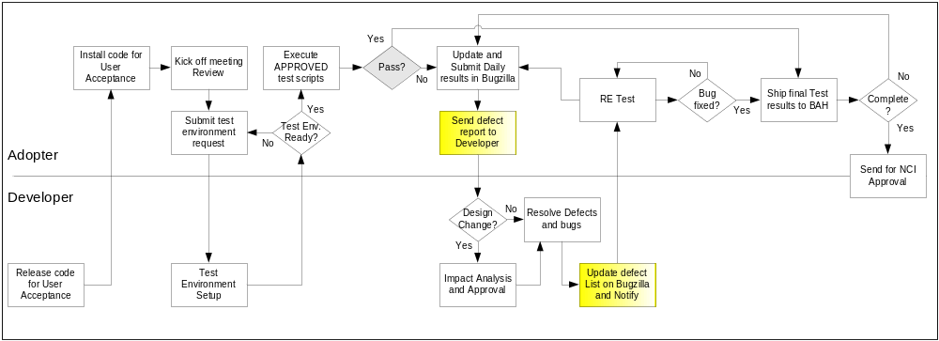

Defect reporting using GFORGE
ALL defects should be logged using ‘GFORGE’, to address and debug defects. Adopters are also requested to send a daily defect report to the developer. Developers will update the defect list on G Forge and notify the requester after the defect has been resolved.
Developers and Adopters are required to request an account on G Forge for the relative workspace. Debugging should be based on Priority –Critical > High > Medium > Low, these priorities are set by the Adopters and are based on how critical is the test script in terms of dependency and mainly based on use case scenario.
Below screen shot displays ‘Add new Defect’ screen, fields marked with ( * ) are mandatory fields and Adopters should also upload the evidence file for all the defects listed.

All High priority defects should be addressed within 1 day of the request and resolved/closed within 2 days of the initial request
All Medium priority defects should be addressed within 2 days of the request and resolved/closed within 4 days of the initial request
All Low priority defects should be resolved/closed no later than 5 days of the initial request.

G Forge URL - http://gforge.nci.nih.gov
User may either search for workspace or select from list of recent project from the bottom right side of the window. E.g. searching for ‘caTIES’.
At the workspace, the user can request Administrators to setup their user account for that workspace.
After login, user can select ‘Tracker’ tab to ‘Submit New’ defect. User can add defect info. As shown in below screen.

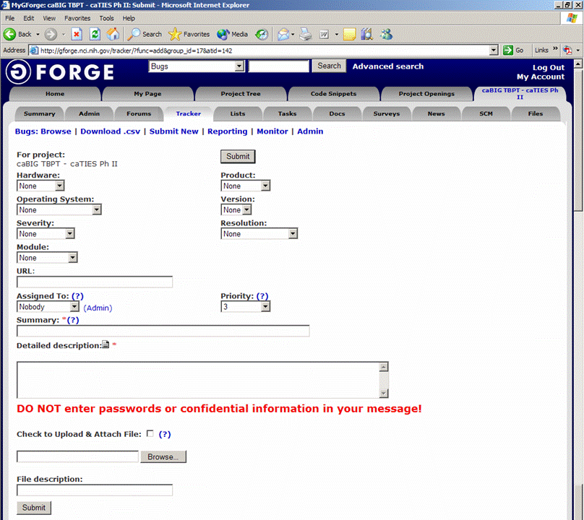
Field Comments
Hardware - List the testing environment hardware. e.g. PC, MAC
Product - Add default to workspace name e.g. caTIES
Operating System - Win 98, Win 2k, Win XP, MAC, etc.
Version - Application version
Severity - If it is an enhancement or a bug with minor to major severity that may not interfere with further testing or completely block any future testing efforts.
Resolution - Only DEVELOPER will update based on the defect
Module - For an application with multiple modules, select appropriate module for the defect reported.
URL - Add URL if any
Assigned to - To be updated by Developer, for whom the ticket is assigned to
Priority - Set a priority based on severity
Summary - Summary of the defect, bug or issue
Detailed Desc. - Details of the defect, bug or issue
Upload file - Attach evidence file
Submit - Submit the bug ticket

Reports
The Test Lead will be responsible for writing and disseminating the following reports to appropriate project personnel as required.

Testing status reports
A weekly or bi-weekly status report will be provided by the Test Lead to project personnel. This report will summarize weekly testing activities, issues, risks, bug counts, test case coverage, and other relevant metrics.

Test Final Report - Sign-Off
A Final Test Report will be issued by the Test Lead. It will certify as to the extent to which testing has actually completed (test case coverage report suggested), and an assessment of the product’s readiness for Release to Production.

Responsibility Matrix
These are the responsibilities of the resources assigned to CaXchange ESB for reliable messaging, transaction and routing test plan.

Role | Name | Responsibility
Project Managers | Kalpesh Patel | Review and approve test materials
Developers | Amit Srivastava | Unit test, review and approve test materials
Testers | Yogaraj Khanal | Write and execute test plans, test cases and other test deliverables

Resource & Environment Needs

Testing Tools

Tracking Tools
GForge bug tracker is used by caBIG to enter and track all bugs and project issues. The Test Lead is responsible for maintaining the GForge database.

Test Environment

Hardware
The following is the hardware requirement for testing caXchange Audit and Logging
- 2G Hard Disk Space
- 2G Ram
- Linux-compatible CPU

Operating System | Linux
Database | Oracle 9i
Browser | Firefox 2.x and Above  Internet Explorer 6 and above
Java | 1.5.x
Container | Servicemix 3.1.2 and Tomcat 5.0.28
Build Tools | Maven 2.0.7

Software
In addition to the application and any other customer specified software, the following list of software should be considered a minimum:

Software/Version:
==========================
Apache 2.2.4 Port 80
Tomcat 5.0.28-non secure
Boss 4.0.5(App server)
Postgres (database)
MySQL (database)
Globus 4.0.2 (embedded in tomcat)
ServiceMix 3.1.2(container)
Maven 2.0.7
Linux (OS)

Bug Severity and Priority Definition
Bug Severity and Priority fields are both very important for categorizing bugs and prioritizing if and when the bugs will be fixed. The bug Severity and Priority levels will be defined as outlined in the following tables below. Testing will assign a severity level to all bugs. The Test Lead will be responsible to see that a correct severity level is assigned to each bug.

The Test Lead, Development Lead and Program Manager will participate in bug review meetings to assign the priority of all currently active bugs. This meeting will be known as “Bug Triage Meetings”. The Test Lead is responsible for setting up these meetings on a routine basis to address the current set of new and existing but unresolved bugs.

Severity List
The tester entering a bug into GForge is also responsible for entering the bug Severity.

Severity ID | Severity Level | Severity Description
1 | Critical | The module/product crashes or the bug causes non-recoverable conditions. System crashes, GP Faults, or database or file corruption, or potential data loss, program hangs requiring reboot are all examples of a Severity. 1 bug.
2 | High | Major system component unusable due to failure or incorrect functionality. Severity. 2 bugs cause serious problems such as a lack of functionality, or insufficient or unclear error messages that can have a major impact to the user, prevents other areas of the app from being tested, etc. Severity. 2 bugs can have a work around, but the work around is inconvenient or difficult.
3 | Medium | Incorrect functionality of component or process. There is a simple work around for the bug if it is Severity. 3.
4 | Minor | Documentation errors or signed off severity 3 bugs.

Priority List
Priority ID | Priority Level | Priority Description
5 | Must Fix | This bug must be fixed immediately; the product cannot ship with this bug.
4 | Should Fix | These are important problems that should be fixed as soon as possible. It would be an embarrassment to the company if this bug shipped.
3 | Fix When Have Time | The problem should be fixed within the time available. If the bug does not delay shipping date, then fix it.
2 | Low Priority | It is not important (at this time) that these bugs be addressed. Fix these bugs after all other bugs have been fixed.
1 | Trivial | Enhancements/ Good to have features incorporated- just are out of the current scope.

Bug Reporting
Testing team recognizes that the bug reporting process is a critical communication tool within the testing process. Without effective communication of bug information and other issues, the development and release process will be negatively impacted.

The Test Lead will be responsible for managing the bug reporting process. Testing’s standard bug reporting tools and processes will be used. GForge is the company-wide standard Bug Logging / Tracking tool. Testing and development will enter their data into the GForge database following the field entry definitions defined below.

Terms/Acronyms

TERM/ACRONYM | DEFINITION
API | Application Program Interface
BAH | Booz Allen Hamilton
BCP | Business Continuity Plan
CAT | Client Acceptance Testing
End-to End Testing | Tests user scenarios and various path conditions by verifying that the system runs and performs tasks accurately with the same set of data from beginning to end, as intended.
ER;ES | Electronic Records; Electronic Signatures
N/A | Not Applicable
NCI | National Cancer Institute
QA | Quality Assurance
RTM | Requirements Traceability Matrix
SME | Subject Matter Expert
SOP | Standard Operating Procedure
TBPT | Tissue Bank and Pathology Tools
TBD | To Be Determined
TSR | Test Summary Report
CTODS | Clinical Trials Object Data System

