caXchange Version 1.0
Title of Publication

Installation Guide

caBIG™ is an initiative of the National Cancer Institute, NIH, DHHS
Table of Contents

1 Introduction 3
1.1 Components 3
1.2 Minimal System Requirements for caXchange 3
1.3 Software and Technology Requirements for caXchange 4
1.3.1 Required Software not included in caXchange 4

2 Installing caXchange 5
2.1 Preliminary Considerations 5
2.2 Downloading caXchange Software 5
2.3 Installing JRE 5
2.4 Installing MySQL 6
2.5 Installing Apache Servicemix 6
2.6 caXchange Configuration 7
2.7 caXchange Deployment 7

3 caXchange Grid Service Setup 8

4 Auditor Setup 11

5 Contacting Technical Support 13

Introduction
This Installation Guide provides software deployment instructions for caXchange. This document will be used as a recommendation and guideline by the deployment team for installation and configuration of the software.
The overall goal of the caXchange project is to build a message router that can be adapted and extended to support multiple data. caXchange is defined as the set of software components that is primarily responsible for receiving input from various external systems, routing the input to various services, and eventually routing the output of those services to external systems.

Components
caXchange v1.0 is comprised of the following components:
- caXchange – The JBI compliant Apache Servicemix ESB on which various routing and transformation services and components will be deployed.

- caXchange Database – The MySQL database instance is used by caXchange to store and retrieve various pieces of information.

Other NCICB application dependency that this solution has include:
- Common Logging Module (CLM) – Logging in LLT in caXchange is provided using Common Logging Module (CLM).

Minimal System Requirements for caXchange
The system requirements for caXchange vary for the main components so they are listed here by component.
- Unix : Red Hat Linux, Fedora 4 and 5, Mac OS X, 1 G RAM
- Windows : Windows XP, Windows 2003, 1G RAM

caXchange has been tested on the platform(s) shown in Error: Reference source not found.

 | Linux Server | Solaris | Windows
Model | HP Proliant DL380G4 | Not Tested | Compaq Presario V6000
CPU | 1 x Intel® Xeon™ 3.4 GHz | NA | Intel Core Duo 2.0 GHz
Memory | 1 GB | NA | 2 GB
Local Disk | System 1 x 25GB | NA | System 1 x 100GB
OS | Red Hat Linux EL 3.0 (kernel 2.6.9-55.0.9) | NA | Windows XP Professional Version 2002 Service Pack 2
Table 1 Platform Testing Environment

Software and Technology Requirements for caXchange

Required Software not included in caXchange
You must download and install the required software that is not included with caXchange (listed in Table 2). The software name, version, description, and URL hyperlinks (for download) are indicated in the table.

Software Name | Version | Description | URL
Java Run Time Edition (JRE) | 1.5_07 | Java Runtime environment for caXchange | java.sun.com
MySQL Database | 4.1 | caXchange database platform used by caXchange for storage and retrieval of data. ServiceMix is also configured to utilize MySQL to provide persistence for messaging combined with ActiveMQ’s (embedded in ServiceMix) high performance journal. | www.MySQL.com
Apache Servicemix | 3.1.2 | ESB Platform for caXchange | http://servicemix.apache.org
Table 2 Required software and technology for caXchange

NOTE | Some of the above software components may not be required depending on the purpose and plan for the new system.

Installing caXchange
This section contains separate instructions for installing each of the components in the appropriate sequence.

Preliminary Considerations
BEFORE YOU BEGIN | caXchange has been tested with the operating systems and hardware specified in section 1.2 of this guide. We cannot guarantee caXchange will work if variations of these operating systems and/or hardware are being used.  To best understand the installation and testing procedures for caXchange, it is recommended that you follow the procedures described in this section with minimal deviation.

Downloading caXchange Software
Complete the following steps to download the caXchange software from GForge:
- caXchange Software can be downloaded from http://gforge.nci.nih.gov/frs/?group_id=411
- Create a folder <CAXCHANGE_DIR> and extract contents of the caxchange.tar using
  - Unix: tar xvf caxchange.tar
  - Windows: winzip utility

For reference, the following table contains the release contents:

Contents | Description
conf/tomcat | contains templates of config files needed for setting up tomcat.
conf/servicemix | contains templates of config files needed for setting up servicemix.
databaseScripts | Contains database scripts
serviceAssemblies | Folder contains Services Assemblies developed by caXchange Team and to be deployed on servicemix as explained below.
Lib | Contains jars for caXchange
War | Contains war for auditing and logging module
Table 3 Release contents of caxchange.tar

Installing JRE
JRE 1.5_07 is required for caXchange. It can be downloaded from http://java.sun.com/javase/downloads/index.jsp.
Please follow the installation instructions provided on this URL for installation.Then set the environment variable “JAVA_HOME” to the folder where JRE 1.5_07 has been installed.

Installing MySQL
MySQL 4.1 is required for caXchange. This database is used by caXchange to store information necessary for storing and also processing the data.
MySQL must be deployed before deploying Apache Servicemix and related services. Please download MySQL 4.1 and follow the standard guide that comes along with MySQL for installation.
Create following databases:
Database Name | Description
servicemixDB | Used by Apache servicemix
caxchange | Used by caXchange
activemq | Used by activemq
Table 4 MySQL databases

Login to the caXchange database and run the caXchangePersistenceStore.sql file as contained in the caxchange.tar to create the database objects.

Installing Apache Servicemix
caXchange has been tested on Apache Servicemix 3.1.2. Follow these instructions for installing it:
- Download Apache Servicemix from http://servicemix.apache.org
- Unzip it in <SERVICEMIX_HOME>
- Open <SERVICEMIX_HOME>/conf/activemq.xml
- Copy the following lines under <beans> tag to add a mysql data-source bean in activemq.xml. A template is also present in <CAXCHANGE_DIR>/conf/servicemix/activemq.xml.
<bean id="mysql-ds" class="org.apache.commons.dbcp.BasicDataSource" destroy-method="close">
<property name="driverClassName" value="com.mysql.jdbc.Driver"/>
<property name="url" value="<<ACTIVEMQ-DB-URL>>"/>
<property name="username" value="<<ACTIVEMQ-DB-USERNAME>>"/>
<property name="password" value="<<ACTIVEMQ-DB-PASSWORD>>"/>
<property name="poolPreparedStatements" value="true"/>
</bean>

- Add following lines to <SERVICEMIX_HOME>/conf/jndi.xml under <util:map id="jndiEntries"> tag to add a mysql datasource bean. Template available in <CAXCHANGE_DIR>/conf/servicemix/jndi.xml
<entry key="java:comp/env/jdbc/servicemixDB">
<bean id="mysql-ds" class="org.apache.commons.dbcp.BasicDataSource" destroy-method="close">
<property name="driverClassName" value="com.mysql.jdbc.Driver"/>
<property name="url" value="="<<SERVICEMIX-DB-URL>>"/>
<property name="username" value="<<SERVICEMIX-DB-USERNAME>>"/>
<property name="password" value="<<SERVICEMIX-DB-PASSWORD>>"/>
</bean>
</entry>

caXchange Configuration
For the following steps, please note that <SERVICEMIX_HOME> is assumed to be the folder where servicemix 3.1.2 is installed.
All the configurable properties of caXchange are defined in <CAXCHANGE_DIR>/conf/servicemix/caxchange.properties file.
- Database Configuration:
  - Open caxchange.properties.
  - Modify caxchangedb.* properties to point them to the correct caXchange database.
- Inbound JMS Queue: This is the ActiveMQ queue location where gridservice drops in the requests and servicemix picks them up.
  - Open caxchange.properties.
  - Modify inbound.jms.brokerURL to point it to correct inbound queue broker URL.
- Outbound JMS Queue: This is where servicemix drops the aggregated response from all the target services and gridservice client picks them up.
  - Open caxchange.properties.
  - Modify outbound.jms.brokerURL to point it to correct outbound queue broker URL.

caXchange Deployment
- Copy <CAXCHANGE_DIR>/conf/servicemix/caxchange.properties to <SERVICEMIX_HOME>/config
- Start servicemix.
- Copy <CAXCHANGE_DIR>/serviceAssemblies/caXchange-servicemix-eip-su-1.0-SNAPSHOT-installer.zip to <SERVICEMIX_HOME>/deploy
- Wait for a minute before proceeding to the next step.
- Copy <CAXCHANGE_DIR>/serviceAssemblies/caXchange-ccts-sa-1.0-SNAPSHOT.jar to <SERVICEMIX_HOME>/deploy

Basic installation of caXchange is complete here. Please follow the following steps if you wish to setup Auditor tool. Auditor helps in monitoring the flow of messages across various components of servicemix.

caXchange Grid Service Setup
Follow these steps to install grid service for caXchange.
- Download caGrid Installer 1.1 zip from http://gforge.nci.nih.gov/frs/?group_id=25
- Unzip the installer in some local directory (say c:\cagrid).
- Open command prompt and change directory to where the installer has been uncompressed (c:\cagrid).
- Type the following command to start the installer.
java –jar caGrid-1.1-installer.jar
- Install caGrid, Ant, Tomcat and Globus.
  - Using Installer, Check the ‘Install caGrid’ checkbox and click next.
  - Install Ant, Tomcat, Globus and caGrid
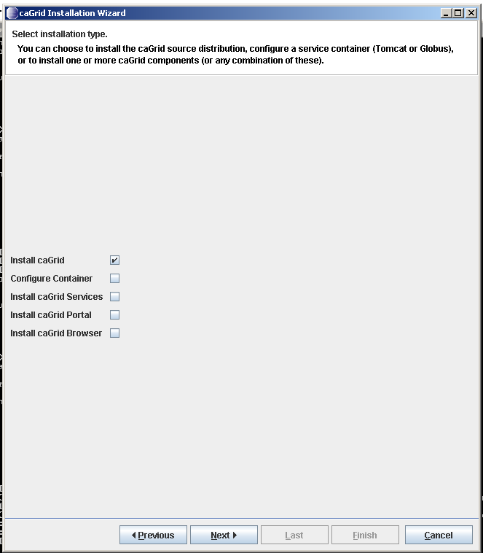
- Click next and select the directory to install ANT
- Click the option to install globus.
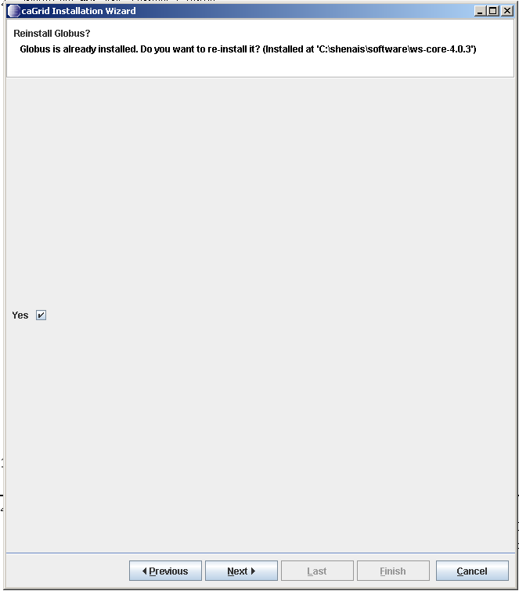
- Provide the directory into which globus is installed and click next
- Provide the directory into which caGrid is installed and click next
- Select the target grid and click next
- Click the start button.
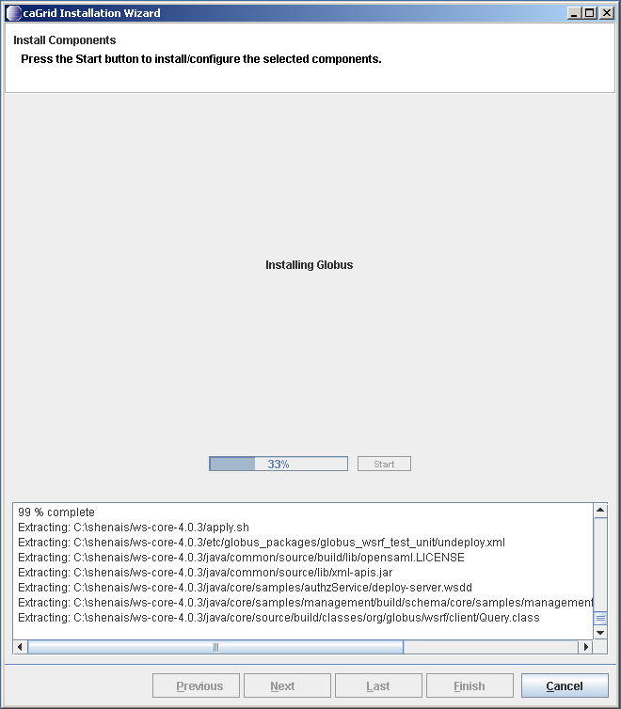
- Once the installation is complete click finish.

- Set Environment variables for Ant, Tomcat, Globus and CaGrid.
  - Right click on My computer -> Properties -> Advanced -> Environment Variables -> New
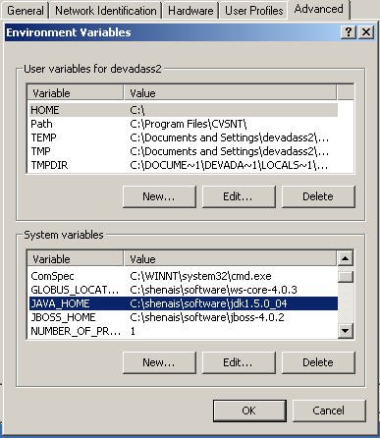
  - Enter the following
    - JAVA_HOME: This should point to the Java 1.5 Java Develop Kit (JDK), not the Java Runtime Environment (JRE).
    - Enter JAVA_HOME in the variable name field and enter the path where your jdk is installed. Follow the above steps for all the four environment variables to set.
    - ANT_HOME: Should point to the Ant 1.6.5 installation directory. The caGrid development environment requires this variable, but running caGrid services do not.
    - GLOBUS_LOCATION: Should point to the caGrid Globus 4.0.3 distribution installation directory. This is required by the caGrid development environment and caGrid services that are running in the Globus container.
    - CATALINA_HOME: Should point to the Jakarta Tomcat 5.0.28 installation directory. This is required by the caGrid development environment and is necessary to run the Tomcat container.
- Open command prompt and go to <CAXCHANGE_DIR>/gridservice/caXchangeInboundService.
- Type the following command to deploy the caXchange gridservice on tomcat.
ant deployTomcat
- Run a test client
  - ant runClient

Auditor Setup
The files related to auditor are in the auditor folder.
- Create databases: Create databases for CSM and CLM. The step is optional and caxchange database can be used for CSM and CLM.
- Create CSM Schema
  - Edit <CAXCHANGE_DIR>/databaseScripts/AuthSchemaMySQL.sql to replace <<database_name>> with the actual database name for CSM.
  - Run the modified SQL script
- Data Priming: Edit <CAXCHANGE_DIR>/databaseScripts/DataPrimingMySQL.sql to replace the following placeholders
  - <<super_admin_login_id>> with the super admin login id for the Log Locator Tool (LLT)
  - <<super_admin_first_name>> with the first name of the super admin
  - <<super_admin_last_name>> with the last name of the super admin
  - <<application_context_name>> with the context name to be used for application (say caxchange)
- Create the CLM Schema: Replace <<database_name>> with the CLM database name in <CAXCHANGE_DIR>/databaseScripts/CLMSchemaMySQL.sql and run it.
- Servicemix Configuration for logging into MySQL
  - Copy <CAXCHANGE_DIR>/lib/clmauditor.jar and <CAXCHANGE_DIR>/lib/clm.jar to the <SERVICEMIX_HOME>/lib.
  - Configure <SERVICEMIX_HOME>/conf/servicemix.xml. Add the following bean under the <beans> tag. Template is present in <CAXCHANGE_DIR>/conf/servicemix/servicemix.xml.
<bean id="caXchangeLogger" class="gov.nih.nci.caxchange.servicemix.jbi.audit.CommonLoggingListener" init-method="doStart" >
<property name="container" ref="jbi" />
<property name="logExchangesSent" value="true" />
<property name="logExchangesAccepted" value="false" />
</bean>

  - Configure <servicemix-dir>/conf/log4j.xml: Add the following snippet under <log4j:configuration> tag in log4j.xml. Template is available in <CAXCHANGE_DIR>/conf/servicemix/ log4j.xml. Replace <<database_name>>, <<db-username>> and <<db-password>> with the CLM database details.
<appender name="CLM_JDBC_Appender" class="gov.nih.nci.logging.api.appender.jdbc.JDBCAppender">
<param name="application" value="caxchange" />
<param name="server" value="localhost" />
<param name="maxBufferSize" value="1" />
<param name="dbDriverClass" value="com.mysql.jdbc.Driver" />
<param name="dbUrl" value="<<database_name>>" />
<param name="dbUser" value="<<db-username>>" />
<param name="dbPwd" value="<<db-password>>" />
<param name="useFilter" value="false" />
<layout class="org.apache.log4j.PatternLayout">
<param name="ConversionPattern" value=":: [%d{ISO8601}] %-5p%c{1}.%M() %x - %m%n" />
</layout>
</appender>
<logger name="gov.nih.nci.caxchange.servicemix.jbi.audit">
<level value="INFO" />
<appender-ref ref="CLM_JDBC_Appender" />
</logger>

  - Restart servicemix. Servicemix will now start logging the events. It can also be verified by checking the MySQL database.

- Create LLT Datasources in Tomcat: LLT required datasources: CLMDS, CLMCSMDS.
  - Modify <CAXCHANGE_DIR>/conf/tomcat/server.xml to replace following place-holders.
    - <<CLM-DATABASE-URL>>, <<CLM-DATABASE-USER>> and <<CLM-DATABASE-PASSWORD>> with the CLM database details.
    - <<CSM-DATABASE-URL>>, <<CSM-DATABASE-USER>> and <<CSM-DATABASE-PASSWORD>> with the CSM database details.
  - Copy <Context path="/llt" docBase="llt">..</Context> section from <CAXCHANGE_DIR>/conf/tomcat/server.xml.
  - Paste it in CATALINA_HOME/conf/server.xml (CATALINA_HOME is assumed to be the path to tomcat installation directory). This will configure datasources for LLT Context.
- Jars: Make sure following jars are present in CATALINA_HOME/common/lib
  - MySQL Driver jar
  - Antlr jar
- LLT Deployment in Tomcat: Copy <CAXCHANGE_DIR>/war/llt.war to CATALINA_HOME/webapps
- View Auditor Logs: Log-in to the LLT console through your browser and browse through the caxchange auditor logs.

Contacting Technical Support
caXchange Application Support | Contact Amit Srivastava, Ekagra Software Technologies, at  - srivastavaa2@mail.nih.gov or  - 301-443-5917

