caXchange
caXchange Interface Specifications

Version No : 1.9
Last Modified : 01/19/2009

Author : Kalpesh Patel
Team : caXchange Team
Client : National Cancer Institute,
National Institutes of Health,
US Department of Health and Human Services

Document History

Document Location
The most current version of this document is located in CVS under <cvsroot>\??.

Revision History
Version Number | Revision Date | Author | Summary of Changes
0.1 | 10/24/2007 | Kalpesh Patel | Initial Draft
1.0 | 10/29/2007 | Kalpesh Patel | Made changes based on the review comments from the CCTS team
1.1 | 11/02/2007 | Kalpesh Patel | Modified request schema to include operation name and included additional metadata.
1.2 | 11/05/2007 | Kalpesh Patel | Changed MetaData to metadata for request and response.
1.3 | 11/11/2007 | Kalpesh Patel | Change the caXchangeResponse to include targetError.
1.4 | 11/19/2007 | John Koisch | Added JBI references and changed language
1.5 | 12/04/2007 | Amit Srivastava | Added Delegated Credential Reference to Inbound Message
1.6 | 08/07/2008 | Harsh Marwaha | Made message type unrestricted so that new message types can be configured.
1.7 | 01/16/2009 | Raghu Chintalapati | Updated Interface Specifications to support additional Services (COPPA)
1.8 | 01/16/2009 | Harsh Marwaha | Updated document changed exception in the method and updated the images.
1.9 | 01/19/2009 | Kalpesh Patel | Final Updates

Review
Name | Team/Role | Version | Date Reviewed | Reviewer Comments
Kalpesh Patel | 08/08/2008 | 1.6 | 08/07/2008

Approval
Name | Team/Role | Version | Date Reviewed | Reviewer Comments

Related Documents
More information can be found in the following related caXchange documents:

Document Name

Table of Contents
1. Introduction 5
2. Problem 5
3. Client Interface Requirements 6
3.1 Inbound Client Requirements 6
3.2 Target Service Requirements 6
4. caXchange Service Interface Specifications 7
4.1 caXchange Message Process Service- 7
4.1.1 Operation processRequestAsynchronously 7
4.1.2 Operation processRequestSynchronously 7
4.2 caXchange Response Service 7
4.2.1 Operation getResponse 7
5. caXchange Message Format Specification 8
5.1 caXchange Request Message 8
5.2 caXchange Response Message 11
5.3 caXchange Context Reference 14
6. Future considerations 15
Appendix 16

Interface Specification for caXchange

Introduction
This document contains the interface specification for Inbound Grid Service for caXchange Message Hub. It contains specification for both the Service Operation as well as the Messages exchanged.

Problem
In the CCTS architecture, caXchange plays the central role of a business integrator for SOA based service integration as well as messaging based integration. Applications transmit their business messages through the medium of caXchange. caXchange will accept these messages, transforming them to the outbound specifications and sending them out to the various service providers. caXchange enables a framework for aggregating the transaction and providing the final status (a.k.a. Reliable Transactions) back.

More importantly, caXchange now facilitates integration of services among many service providers and consumers using hub and spoke architecture. This approach avoids brittle nature of point-to-point service integration by decoupling the service providers and service consumers via a proxy hub based on ESB technologies.

While caXchange receives and utilizes messages, it is not solely a messaging infrastructure. The architecture supported within caXchange is JBI compliant (http://jcp.org/en/jsr/detail?id=208), allowing a high degree of business-oriented extensibility and scalability. Support for these components allows caXchange to play the primary role within CCTS interactions of business proxy. This allows service consumers to rely on caXchange to fulfill the business semantic of their messages, which by necessity extends past the lifecycle of the message itself.

For example, the “Register Patient for Study” message contains the following meaning when sent by the C3PR application:

- C3PR is prepared to associate a patient with a study, and needs other systems to align themselves with this notion
- CTOM should persist the relationship between the patient and the study
- caAERS should persist the relationship between the patient and the study
- PSC should persist the relationship between the patient and the study, and should create a patient study calendar that is accessible and available to all other CCTS applications.
- There is a C3PR user awaiting notification that the patient is registered with the study.

Should these 5 items not be fulfilled, then the business proxy (caXchange) MUST bring all of the systems into a common alignment by rolling back the transaction. Therefore, to fulfill its role as business integrator, caXchange must support both reliable messaging and reliable transactions.

This publication presents a common interface that will be used by all CCTS applications to transmit messages through caXchange. This interface supports asynchronous reliable messaging to support both logically synchronous and asynchronous business processes. Therefore, this interface also supports a polling capability to allow message initiators to discover the status of their business messages at any time after the initial sending.

Client Interface Requirements

Inbound Client Requirements
For design to work following requirements must be met by the service consumers (applications) that will be transmitting messages via caXchange or invoke a remote service via caXchange.

- Client will be responsible for keeping track of relationship of their external id provided as part of the request to the EPR returned by caXchange.

Target Service Requirements
For design to work following requirements must be met by the service providers (applications) that will be receiving messages via caXchange or exposing services to other applications via caXchange.

- The Target Grid Service will return an error as a WS Fault. Everything else will comes as a response will be treated a business response.

In order to fulfill the business semantic, each service provider must also provide the following:

- Target grid service (message recipient service) will implement a method to rollback (compensate). This rollback operation will accept the same message as the original operation.
- Target grid service that receives the rollback() from the caXchange will be able to manage data integrity (i.e. if original commit() failed by that service, it will know that it needs to ignore the rollback(), or manage situations when rollback() is received after data are used by the user, etc.)
- All service providers interacting with the ESB (caXchange) agree to a timeout period of 25 seconds. This is implemented as a worst possible case threshold for determining business semantic failure (e.g., the patient cannot reliably be held to be related to a study among all systems). The following assumptions are made:
  - 4 seconds for each call to a service provider
  - Total 3 tries per service provider
  - 3 second network delay
  - 3 second transaction processing by service provider

If a particular receiver times out after 25 seconds, caXchange will submit a rollback to all other service providers within that transaction. If no rollback is received, service providers can assume
a commit.

caXchange Service Interface Specifications

caXchange Message Process Service-

Operation processRequestAsynchronously

Service Name : CaXchangeRequestProcessor
OperationName : processRequestAsynchronously
Input : caXchange Request Message
Output : caXchange Context Reference
Error : CaXchangeFault

This operation takes in the service call/message which is to be processed asynchronously and routes to the ESB for distribution to the receiving application. The operation name to be invoked for this service is processRequestAsynchronously. It takes in a caXchange Request Message as input and posts the message on ESB. Upon successful posting it creates a resource and returns the End Point Reference (EPR) to that resource wrapped in a caXchange Context Reference message back to the client. The client can now use this EPR to check the status of the response for the transmission. In case of any error a WS-Fault will be transmitted back to the client. A message is considered successfully accepted by the ESB only if there are no WS-Faults and the caXchange Service returns an EPR. Once the client obtains an EPR then it can assume that the message will be transmitted reliably by the ESB and it will provide an appropriate response.

Operation processRequestSynchronously

Service Name : CaXchangeRequestProcessor
OperationName : processRequestSynchronously
Input : caXchange Request Message
Output : caXchange Response Message
Error : CaXchangeFault

This operation takes in the service call/message which is to be processed synchronously and routes it to the ESB for distribution to the receiving application or service. The operation name to be invoked for this service is processRequestSynchronously. It takes in a caXchange Request Message as input and posts the message on ESB. The service returns the caXchange Response Message (please refer to section 5.2 for details) as response to this synchronous call.

caXchange Response Service

Operation getResponse

Service Name : CaXchangeResponseService
OperationName : getResponse
Input : None
Output : caXchange Response Message
Error : CaXchangeFault

This service provides a mechanism for the client to poll and check on any status updates for the resource (only for Asynchronous processing) provided with which was created at the time of message transmission. The operation name is getResponse. It doesn’t require any input as the End Point Reference contains the unique resource identifier which this service will use to locate the resource. It would then return the updated response for that resource back to the client. This response is returned in form of a caXchange Response Message. In case of any error a WS-Fault will be transmitted back to the client.

caXchange Message Format Specification
The Service Interface mentioned in the previous section use these input and output message formats which are defined in separate XSDs.

caXchange Request Message
Following is the message format for the inbound request message

- caXchangeRequestMessage
This is the request message which the client needs to populate and provide to the caXchange Inbound service during a request
  - metadata
It consists of the metadata for the business message payload. It provides additional properties for the message. It consists of attributes like external identifier or the credential object.

    - transactionControl [Type = string]
This is name of the transaction for which the message is to be processed. It can either be “PROCESS”, “ROLLBACK” or “COMMIT”. Client will transmit the message with this field value being “PROCESS”. Internally caXchange will change this field with appropriate transaction control name in case of either a rollback or a commit. Based on this value, the outbound component will call either the actual operation or the rollback/commit operations on the target grid service.

    - serviceType [Type = string|Mandatory]
This is the name of the service (or message) that the client is invoking or sending. The value for this field will be used internally by caXchange to determine the type of message or service call and correspondingly apply the routing and/ or transformations rules. The message types and supported services for which routing is predefined in caXchange are listed in the appendix. Routing for additional message and service types are defined in caXchange as new services/messages are made available. As part of this configuration the schema for the payload corresponding to the message or service type will be specified. This schema will be used to validate the payload within caXchange. In addition to the serviceType an operationName parameter has to be set to identify the operation that will need to be performed on the service.
    - operationName [Type=string | Optional]: Name of the service operation if applicable to be invoked.(ex. getPerson, createPerson, etc).

    - externalIdentifier [Type = string]
This is the external business identifier which is populated by the client to uniquely identify the message from a business perspective. caXchange doesn’t touch this identifier and would return the same as part of the metadata of the response for this request
    - caXchangeIdentifier [Type = string | Optional]
This is used internally by caXchange to uniquely track the message request. A value provided by the client in this attribute will be ignored and replaced. Internally caXchange server will generate a unique id for the message and attach it to this request. It will also be returned to the client application as part of the metadata of the response for this request.
    - credentials [Optional]
Holds the credentials which are to be passed to the caXchange server to authenticate the client if required. It consists of either the username or groupname or gridIdentity and an optional password. This entire element is optional for CCTS and clients don’t have to pass any data for this element.
      - userName [Type = string | Choice of userName/ groupName/ gridIdentity]
The name of the client/ user which is trying to send the message
      - groupName[Type = string | Choice of userName/ groupName/ gridIdentity]
The name of the group which is trying to send the message
      - gridIdentity [Type = string |Choice of userName/ groupName/ gridIdentity]
The grid identity of the user/ client which is trying to send the message. This element is internally populated by the caXchange inbound service when it obtains the grid identity of the user who transmitted the message
      - Password [Type = string | Optional]
An optional password which could be used for the purpose of authentication.
      - delegatedCredentialReference [Type = string | Optional]
An optional endpoint reference pointing to the users delegated credentials. This field will be used to retrieve user's grid credentials which would then be used to invoke outbound services on user's behalf.
  - request
This is the actual business request element which contains the payload that is transmitted to the grid receivers via the ESB. It contains of an XML payload and an URI element which points to the XSD of the XML payload.
    - businessMessagePayload
This is the business message payload which contains the XML message and pointer to its XSD
      - xmlSchemaDefinition [Type : anyURI]
This is the URI to the XSD which defines the message. This should match to the schema caXchange is expecting for the given message type.
      - [Type = any]
The actual business message in form of an XML which is to be transmitted

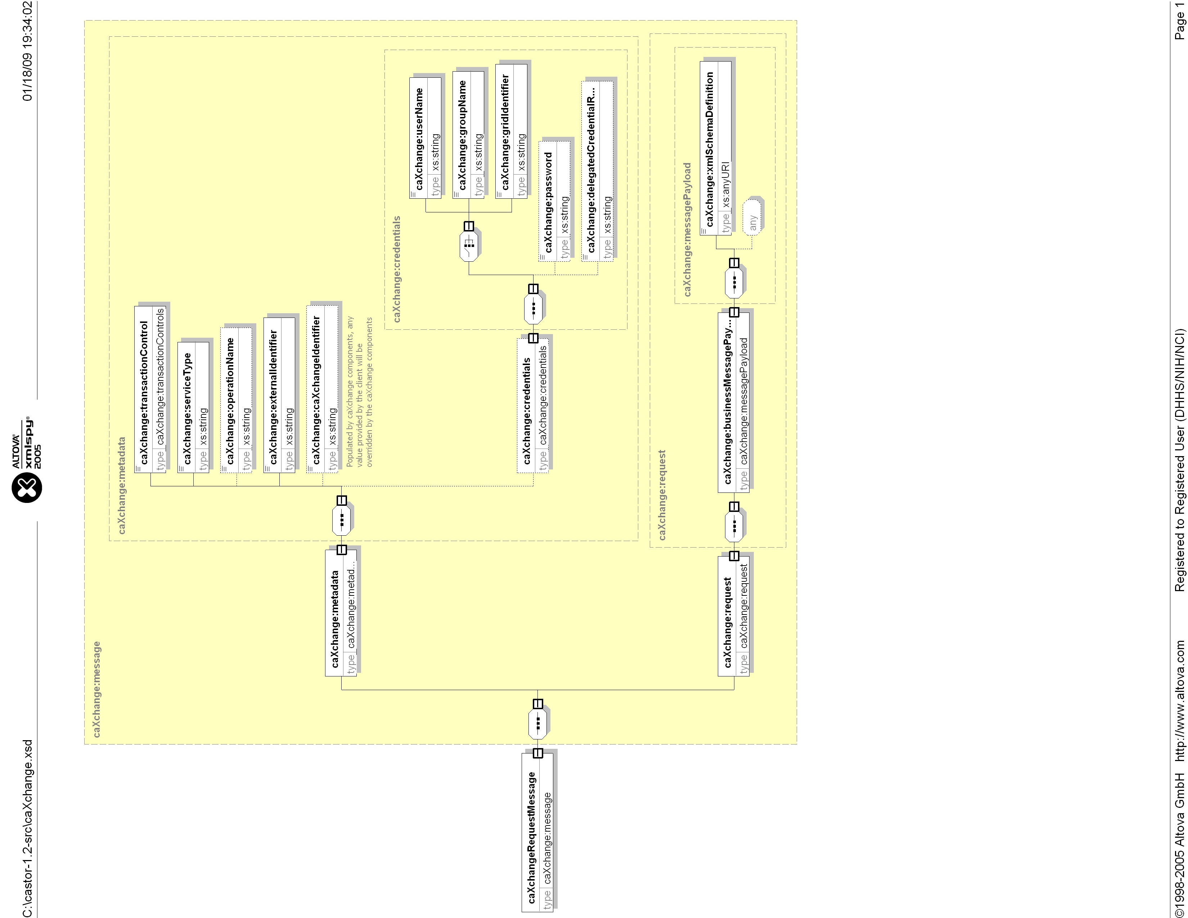

caXchange Response Message
Following is the message format for the outbound response message.

- caXchangeResponseMessage
This is the response message which the client receives when they check the status of the resource which was created for the original message request.
  - responseMetadata
It consists of the metadata for the business message payload. It provides additional properties for the message.
    - externalIdentifier [Type = string]
This is the external business identifier which the client had provided along with the original transmission. caXchange doesn’t touch this identifier and returns the same value as part of the metadata of the response.
    - caXchangeIdentifier [Type = string]
This id is used internally by caXchange to uniquely identify the request. Internally caXchange server will generate a unique id for the message and attach it to this request and send back to the client as part of the response message.
  - response
This is the actual response element which can contain an overall status of that response and an either a caXchange Error or an aggregated Business Response from the destinations.
    - responseStatus
This is overall status of the response. If there is an internal ESB error or any of the target services returned a WS-Fault, then a “FAILURE” is returned else a “SUCCESS” is returned with the Business Responses
    - caXchangeError
This contains the error message which is returned as response to the transmission if there was any error in transmission from caXchange side. It contains an error code and error description. There can be more than one caXchangeError returned based on how many components on ESB reported an error
      - errorCode [Type : string]
This is an error code depicting what type of error has occurred within the ESB. There will be a fixed set of error codes which will be published later
      - errorDescription [Type : string]
This is a detailed error description of the error that has occurred within the ESB
    - targetResponse[Multiple]
These are the response message objects that include the result of invocating the target grid services. This includes name of the target system. It also includes any error that occurred during the invocation process including communication errors. Finally it includes the actual XML response message from the target system. There can be more than one target response object
      - targetServiceIdentifier
This is the name of the Target Service which has originated the response.
      - targetServiceOperation
This is the name operation invoked on the Target Service.
      - targetMessageStatus
This is the status of the message which was received by caXchange from the target grid service. If the target Grid Service resulted in a fault then a “FAULT” is returned else if a response is received then a “RESPONSE” is returned. If there is any error in accessing the Grid Service then an “ERROR” is returned.
      - targetError
The error depicts if there are any errors invocating the target Grid service. It could be an error communicating to the grid service itself or any other type of error which were encountered in the outbound component. This could the basic HTTP errors like 300, 400 or 500s or they could be Remote Exceptions or so. It contains a caXchange defined Error Code and Description
      - errorCode [Type : string]
This is an error code depicting what type of error has occurred during invoking the Grid Serice. There will be a fixed set of error codes, which will be published later
      - errorDescription [Type : string]
This is a detailed error description of the error that has occurred invoking the Grid Service
      - targetBusinessResponse [Type:messagePayload]
This is the actual business response that is generated by the target system
      - [Type = any]
The actual business response message in form of an XML that is to be returned to the client.

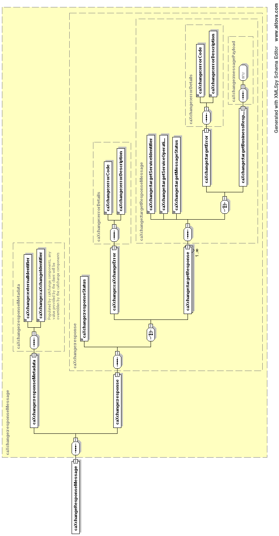

caXchange Context Reference
Following is the format for the caXchange Context Reference that is returned when operation processMessage is invoked.

- caXchangeContextReference
This is the reference to the request from the client. The client will use reference to invoke the getResponse operation to check on the status of the request.
  - endPointReference[Type = WS-Addressing EndPointReference]
The EndPointReference to the WS-Resource created for the client, as their request is being processed.

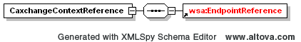

Future considerations
Some of the decisions for the implementation architecture were due to tight timeline for CCTS 1.0 release. However following changes should be considered for future iterations.
- Implement WS-Notification based status notification instead of the polling based status check.
- Implement a service (WS-Notification based or otherwise) that allows message recipients to receive/lookup the final status of the message (from aggregator). In the current implementation the final status is just made available to the message sender.

Appendix

The table below gives a list of caXchange supported message and service types, this table is updated as new messages and services are made available.

Service/Message Type | Operation | Description
STUDY_CREATION | NA | Create Study
REGISTER_SUBJECT | NA | Register Subject
CT_LAB_DATA | NA | Lab data
LOAD_LAB_TO_CDMS | NA | Lab data to CDMS.
LAB_BASED_AE | NA | Lab data for an adverse event.
SCHEDULE_MODIFICATION | NA | Schedule Modification
PERSON | getById | Get a COPPA person.
 | create | Create a COPPA person.
 | validate | Validate a COPPA person.
 | search | Search COPPA persons
 | update | Update a COPPA person
 | updateStatus | Update a COPPA person status.
ORGANIZATION | getById | Get a COPPA organization.
 | create | Create a COPPA organization.
 | validate | Validate a COPPA organization.
 | search | Search COPPA organizations
 | update | Update a COPPA organization
 | updateStatus | Update a COPPA organization status.
CLINICAL_RESEARCH_STAFF | getById | Get COPPA Clinical Research Staff Correlation
 | getByIds | Get COPPA Clinical Research Staff Correlations
 | create | Create COPPA Clinical Research Staff Correlation
 | validate | Validate COPPA Clinical Research Staff Correlation
 | search | Search COPPA Clinical Research Staff Correlation
 | update | Update COPPA Clinical Research Staff Correlation
 | updateStatus | Update COPPA Clinical Research Staff Correlation Status
HEALTH_CARE_FACILITY | getById | Get COPPA Health Care Facility Correlation
 | getByIds | Get COPPA Health Care Facility Correlations
 | create | Create COPPA Health Care Facility Correlation
 | validate | Validate COPPA Health Care Facility Correlation
 | search | Search COPPA Health Care Facility Correlation
 | update | Update COPPA Health Care Facility Correlation
 | updateStatus | Update COPPA Health Care Facility Correlation Status
HEALTH_CARE_PROVIDER | getById | Get COPPA Health Care Provider Correlation
 | getByIds | Get COPPA Health Care Provider Correlations
 | create | Create COPPA Health Care Provider Correlation
 | validate | Validate COPPA Health Care Provider Correlation
 | search | Search COPPA Health Care Provider Correlation
 | update | Update COPPA Health Care Provider Correlation
 | updateStatus | Update COPPA Health Care Provider Correlation Status
IDENTIFIED_ORGANIZATION | getById | Get COPPA Identified Organization Correlation
 | getByIds | Get COPPA Identified Organization Correlations
 | create | Create COPPA Identified Organization Correlation
 | validate | Validate COPPA Identified Organization Correlation
 | search | Search COPPA Identified Organization Correlation
 | update | Update COPPA Identified Organization Correlation
 | updateStatus | Update COPPA Identified Organization Correlation Status
IDENTIFIED_PERSON | getById | Get COPPA Identified Person Correlation
 | getByIds | Get COPPA Identified Person Correlations
 | create | Create COPPA Identified Person Correlation
 | validate | Validate COPPA Identified Person Correlation
 | search | Search COPPA Identified Person Correlation
 | update | Update COPPA Identified Person Correlation
 | updateStatus | Update COPPA Identified Person Correlation Status
ORGANIZATIONAL_CONTACT | getById | Get COPPA Organizational Contact Correlation
 | getByIds | Get COPPA Organizational Contact Correlations
 | create | Create COPPA Organizational Contact Correlation
 | validate | Validate COPPA Organizational Contact Correlation
 | search | Search COPPA Organizational Contact Correlation
 | update | Update COPPA Organizational Contact Correlation
 | updateStatus | Update COPPA Organizational Contact Correlation Status
OVERSIGHT_COMMITTEE | getById | Get COPPA Oversight Committee Correlation
 | getByIds | Get COPPA Oversight Committee Correlations
 | create | Create COPPA Oversight Committee Correlation
 | validate | Validate COPPA Oversight Committee Correlation
 | search | Search COPPA Oversight Committee Correlation
 | update | Update COPPA Oversight Committee Correlation
 | updateStatus | Update COPPA Oversight Committee Correlation Status
RESEARCH_ ORGANIZATION | getById | Get COPPA Research Organization Correlation
 | getByIds | Get COPPA Research Organization Correlations
 | create | Create COPPA Research Organization Correlation
 | validate | Validate COPPA Research Organization Correlation
 | search | Search COPPA Research Organization Correlation
 | update | Update COPPA Research Organization Correlation
 | updateStatus | Update COPPA Research Organization Correlation Status
ORGANIZATION_BUSINESS_SERVICE | getOrganizationByCTEPId | Get the COPPA Organization based on the CTEP Id.

