caXchange CXF Binding component ws security

Design Document

Version No: 0.1
Last Modified: 05/13/2009

Author : Ajay Nalamala
Team : caXchange

Client : National Cancer Institute - Center for Bioinformatics,
National Institutes of Health,
US Department of Health and Human Services

Document History

Document Location
The most current version of this document is located in CVS.

Revision History
Version Number | Revision Date | Author | Summary of Changes
0.1 | 05/13/09 | Ajay Nalamala | Initial draft
0.2 | 05/14/09 | Ajay Nalamala | Updated based on feedback from Reviewers

Review
Name | Team/Role | Version | Date Reviewed | Reviewer Comments

Related Documents
More information can be found in the following related documents:
Document Name

Table of Contents
1. Introduction 4
1.1 Purpose 4
1.2 Scope 4
2. Requirements 4
3. Design 5
3.1 Overall View 5
3.2 Client Side Design 5
3.3 Server Side Design 12

Introduction

The caXchange is defined as the software component that is primarily responsible for receiving input from various client applications and routing to appropriate consumer applications.

caXchange – CXF Binding Component WS Security will provide a secured interface to caXchange. It will provide a configurable transport layer security and a pluggable Authentication capability with options for verifying message integrity and timestamp.

Purpose
This document will provide the design of caXchange– Generic CXF Binding Component WS Security.

Scope
The scope of this document is limited to the design of the caXchange – CXF Binding Component WS Security. For more details on caXchange, please refer to the documents listed under related documents section of this document.

Requirements

Requirements are gathered from various current and prospective clients of caXchange. caXchange will need to provide the following functionalities.

- Secured interface to caXchange including transport layer security.
- Authentication capability without using caGrid.
- Configurable security options like, signed messages and timestamp.
- Design should be easily extendible to provide authorization capability in the future.
- Capability for the clients to be able to send messages synchronously and asynchronously to caXchange.
- Adopters will need to be able to easily change the default security configuration. Provide external configuration file(s) for accomplishing this.
- Sample client implementation with test cases, for easy adoptability.

Design
The design details in the document t will be provided with the help of various artifacts including some UML diagrams (component, sequence etc) and some screen shots where applicable.

Overall View
All the important components (containers, objects, xml files, properties files etc) involved in the design and their interactions are shown with the help of the component diagram in Figure 1. From the diagram, you can clearly see how the components will be wrapped. The interactions between the components and the configurations will be explained in more detail in the following sections.

Figure 1: Overall Component Diagram
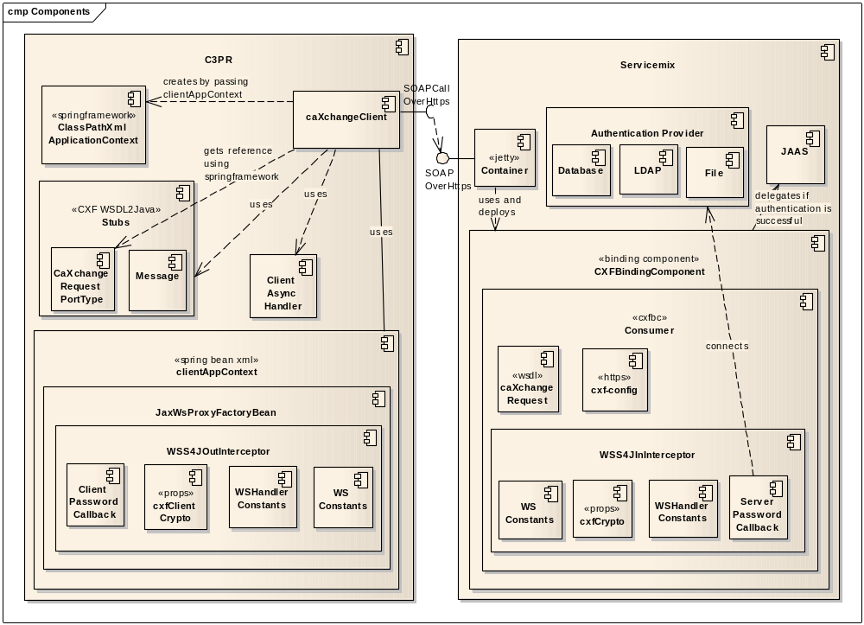

Client Side Design
We will go through the client side design first, to make it easier to understand the components involved in the design. Interaction between various client side components is shown in Figures 2 and 3.

Figure 2: WSSecurity Client 1
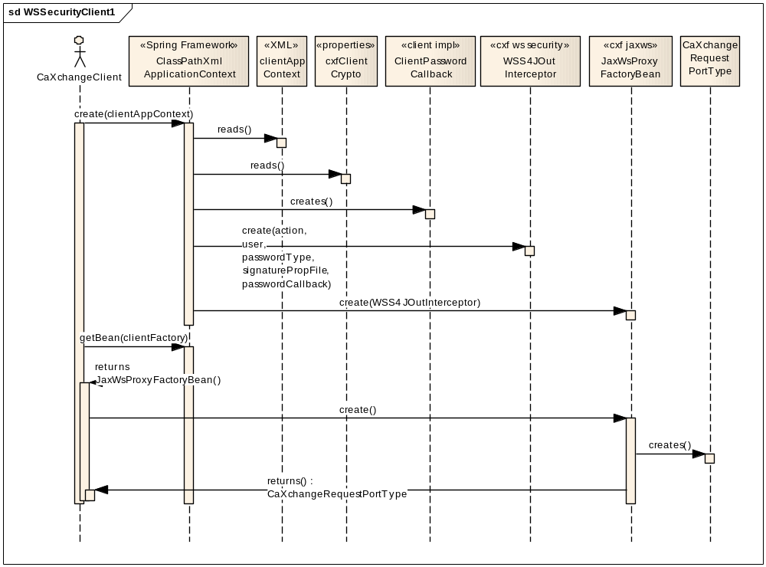
The interactions between objects shown in Figure 2 and the sample contents of the objects, where appropriate, are provided in bulleted form below.
- CaXchangeClient will create a ClassPathXmlApplicationContext object by passing the spring beans configuration file, clientAppContext.xml.
- The contents of clientAppContext.xml file will look like as provided in the following screen shot.
clientAppContext.xml
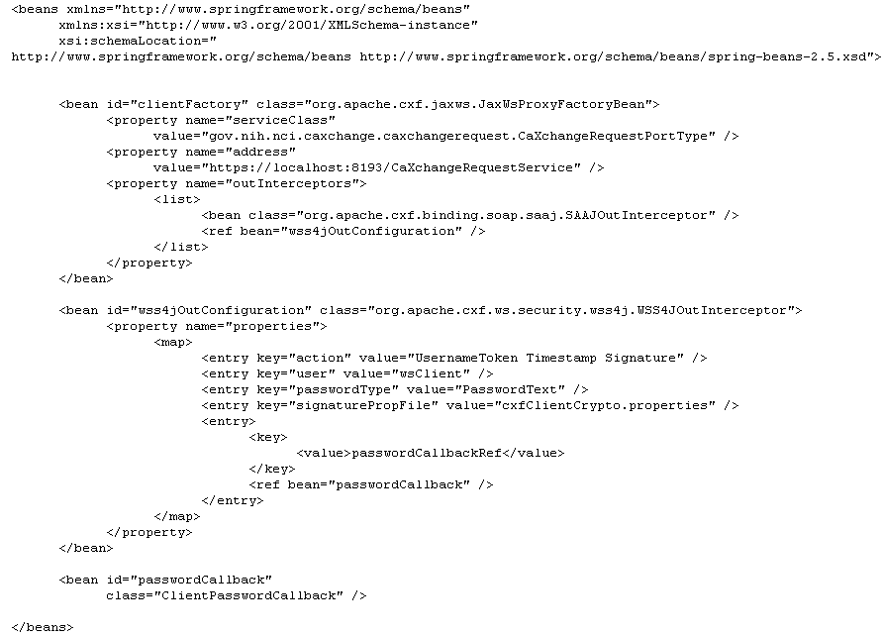
- As per the declarations in the clientAppContext.xml file, with the help of cxfClientCrypto.properties and ClientPasswordCallback.java, WSS4JOutInterceptor will be created.
- The contents of cxfClientCrypto.properties file will look like as provided in the following screen shot.

cxfClientCrypto.properties
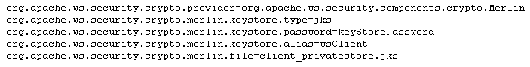
- The java keytool can be used to create the keystore and key as defined in the cxfClientCrypto.properties file. The following screen shot shows the commands that can be used in the development environment. For production systems, a trusted certificate issuing authority like VeriSign should be used.
keytool client side commands
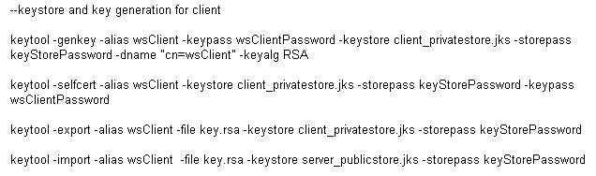
- Note that the last command in the above file can be used to export the public key to the server_publicstore.jks. The above command will create the server_publicstore.jks and will export the key in one go. We will see the usage of the server_publicstore.jks in the section on Server Side Design.
- WSS4JOutInterceptor as shown in clientAppContext.xml is configured with three actions, “UsernameToken, Timestamp, and Signature”. ClientPasswordCallback.java will need to handle two of the above three actions, UsernameToken, and Signature.
- The contents of ClientPasswordCallback.java file will look like as provided in the following screen shot.
ClientPasswordCallback.java
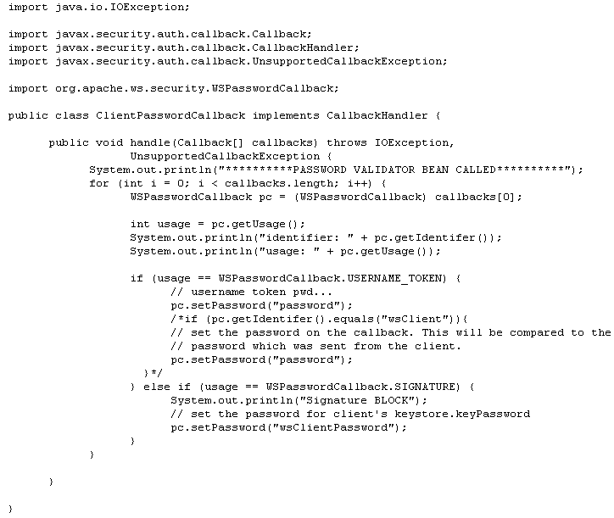
- The above implementation of the ClientPasswordCallback.java is a basic implementation but gives you an idea on how it will need to be implemented by caXchange adopters.
- After successfully creating the WSS4JOutInterceotor, the spring framework will create JaxWsProxyFactoryBean and will return a reference to the CaXchangeClient.
- CaXchangeClient then will invoke create method on JaxWsProxyFactoryBean and gets a reference to the CaXchangeRequestPortType. Further processing on the client side will be as shown in Figure 3.
Figure 3: WSSecurity Client 2
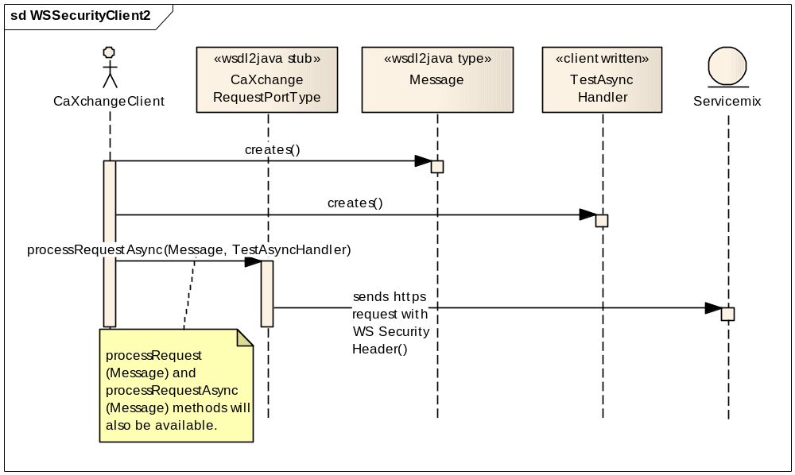
The interactions between objects shown in Figure 3 and the sample contents of the objects, where appropriate, are provided in bulleted form below.
- CaXchangeClient will create and populate the Message and TestAsyncHandler objects. As shown by the stereotype of the respective object, the Message class will be generated by the apache cxf wsdl2Java command based on the WSDL. TestAsyncHandler.java will need to be written by the caXchange adopter.
- The contents of TestAsyncHandler.java file will look like as provided in the following screen shot.
TestAsyncHandler.java
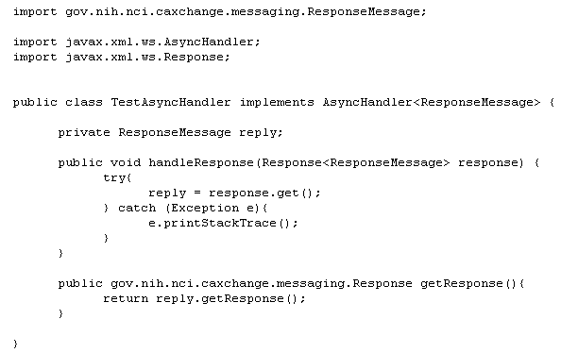
- CaXchangeClient then will send the message asynchronously to the server (jetty/ servicemix) by executing processRequestAsync method on CaXchangeRequestPortType. Note that the transport layer will be secured by https. For the SSL Handshake to happen successfully the client will need to import the public key certificate issued by the server into the keystore used (configured) by the JVM. The example location of this file can be <JRE_HOME>\ lib\security\ cacerts. The details of this import process are beyond the scope of this document but you will easily be able to find the instructions on the import process by googling. The details of the server side processing are provided in the following section.

Server Side Design
Interaction between various server side components is shown in Figures 4 and 5.

Figure 4: WSSecurity Server 1
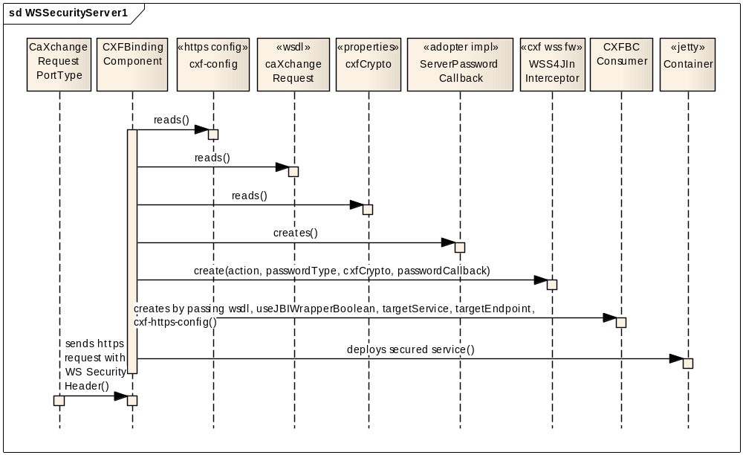
The interactions between objects shown in Figure 3 and the sample contents of the objects, where appropriate, are provided in bulleted form below.
- As shown in Figure 4, first, we will go through the deployment process of the components involved in the CXF security. Then we will go through the details of how the incoming message will be handled.
- CXFBindingComponent (CXFBC) will use cxf-config.xml for securing the transport layer, caXchangeRequest.wsdl for deploying the web service, and cxfCrypto.properties for verifying the signature of the incoming message.
- The contents of the CXFBindingComponent xbean.xml file will look like as provided in the following screen shot.
xbean.xml
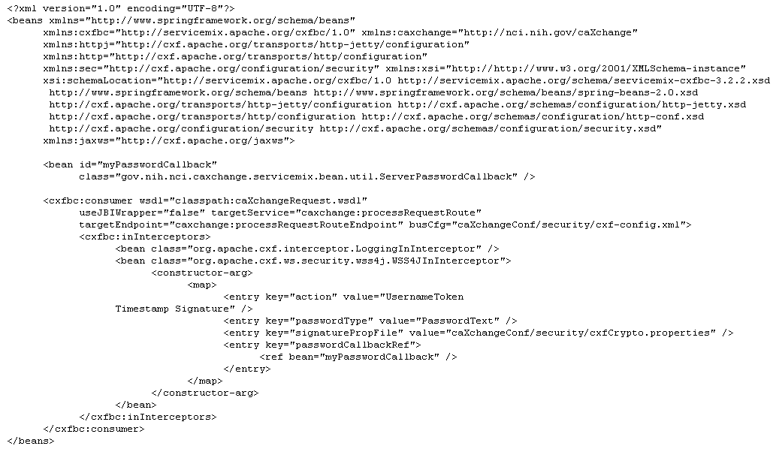
- As used in the above configuration, the contents of the cxf-config.xml file will look like as provided in the following screen shot.
cxf-config.xml
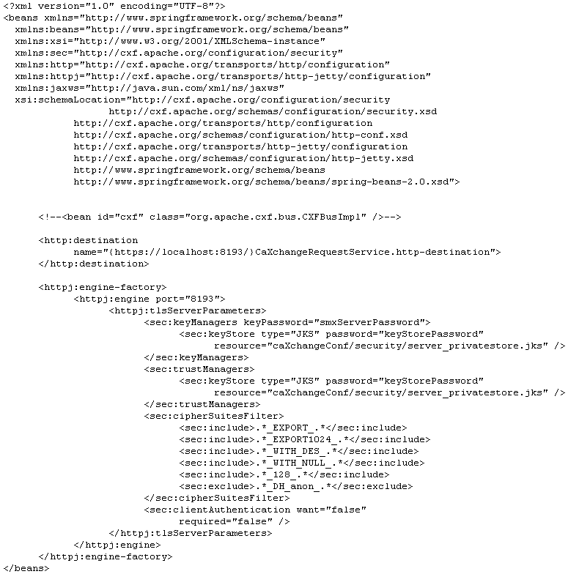
- As used in the above configuration, the server_privatestore.jks and its key, in the development environment, will be generated with the help of the java keytool commands as shown in the screen shot below.
keytool server side commands
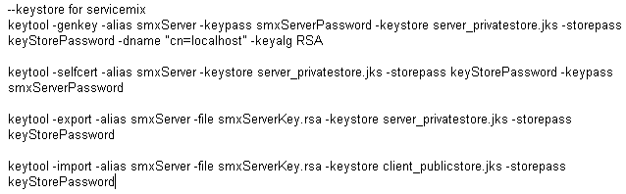
- As used in the xbean.xml configuration, the contents of cxfCrypto.properties file will look like as provided in the following screen shot.
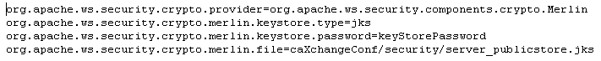
- An excerpt from caXchangeRequest.wsdl as used in xbean.xml configuration, pertaining to security, will look like as provided in the following screen shot.

excerpt from caXchangeRequest.wsdl
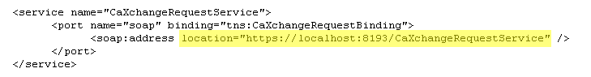
- Going back to Figure 4, based on the configuration in xbean.xml file and by using cxfCrypto.properties and the ServerPasswordCallback.java, the CXFBindingComponent will create WSS4JInIntercepotor object.
- The contents of the ServerPasswordCallback.java file will look like as provided in the following screen shot.

ServerPasswordCallback.java
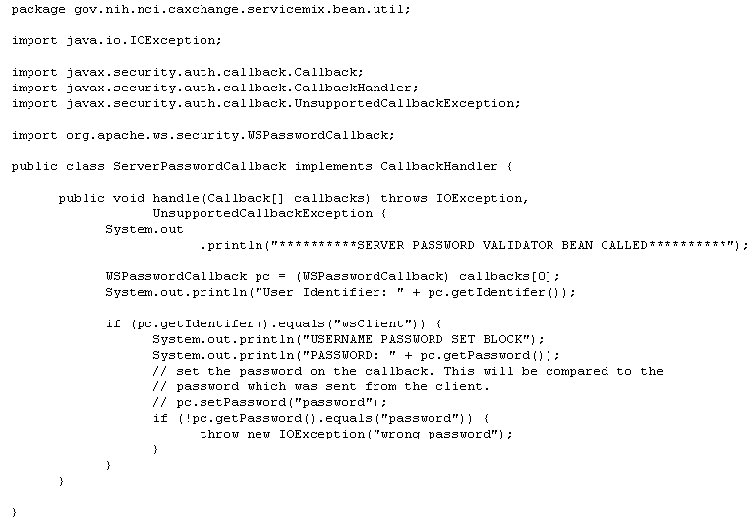
- The above shown implementation is a very basic implementation of the ServerPasswordCallback.java. In the real world production system, this class will either need to connect to a database, LDAP or some other Authentication source to validate the authentication credentials.
- Based on the configuration in xbean.xml, by using the WSS4JInInterceptor created above and by using the configuration files cxf-config.xml and caXchangeRequest.wsdl, the CXFBindingComponent will create the Consumer (part of CXFBindingComponent framework).
- The Consumer will then be deployed to the container (Jetty). The details of the incoming message processing are provided with the help of Figure 5.
Figure 5: WSSecurity Server 2
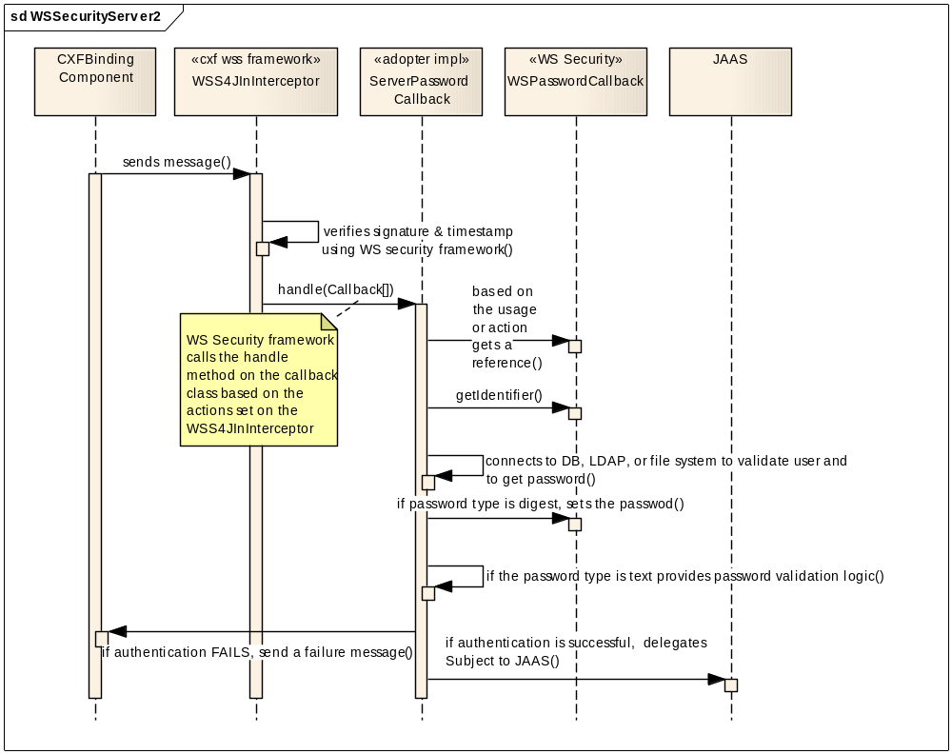
The interactions between objects shown in Figure 5 and the sample contents of the objects, where appropriate, are provided in bulleted form below.
- The CXFBindingComponent will forward the incoming message to WSS4JInInterceptor.
- By using WS Security framework, WSS4JInInterceptor will verify the signature and timestamp of the incoming message. These actions will be performed based on the actions that are set in the xbean.xml file.
- If the above actions are successfully verified, the WSS4JInInterceptor (WS Security Framework) will call the handle method of the ServerPasswordCallback object.
- Depending on the Authentication Service at an adopter site, ServerPasswordCallback will need to connect to either a database, LDAP, or some other source to verify the credentials.
- If the password type in the xbean.xml configuration is set as PasswordDigest, the password retrieved for the user will need to be set in the WSPasswordCallback. WS Security framework is responsible for verifying the password.
- If the password type is set as PasswordText, the password verification logic will need to be provided in the ServerPasswordCallback or some other dependent class.
- If the authentication FAILS, a failure message will need to be sent back to the CXFBindingComponent and eventually to the caller (client).
- If the authentication is SUCCESSFUL, the WS Security framework will create a security Subject with the Principal and will delegate the request to the JAAS implementation provided by servicemix.

