caXchange Generic Consumer Grid Service

Design Document

Version No: 0.1
Last Modified: 09/08/2008

Author : Mukesh Mediratta
Team : caXchange

Client : National Cancer Institute - Center for Bioinformatics,
National Institutes of Health,
US Department of Health and Human Services

Document History

Document Location
The most current version of this document is located in CVS.

Revision History
Version Number | Revision Date | Author | Summary of Changes
0.1 | 09/08/08 | Mukesh Mediratta | Initial draft

Review
Name | Team/Role | Version | Date Reviewed | Reviewer Comments

Related Documents
More information can be found in the following related documents:
Document Name

Table of Contents
1. Introduction 4
1.1 Purpose 4
1.2 Scope 4
2. Requirements 4
3. Component View 5
4. Logical design 5
4.1 Type: caXchangeConsumerResponse 6
4.2 Message Classes 6
4.3 External configuration file 6
4.4 caXchange generic Consumer Grid grid service 6
4.5 Java Interface 7
4.6 Sequence Diagram 8
5. Data 9
6. Deployment 10
7. Test Cases and Scenarios 10
8. Appendix A – Message Classes 11
9. Appendix B – Configuration File Sample 11

Introduction

The caXchange is defined as the software component that is primarily responsible for receiving input from various client applications and routing to appropriate consumer applications.

caXchange – Generic Consumer Grid Service provides a simplified and standard way for the external systems to integrate with caXchange.

Purpose
This documents the design of caXchange– Generic Consumer Grid Service

Scope
The scope of this document is limited to design of the caXchange –Generic Consumer Grid Service. For more details on caXchange please refer to the documents listed under related documents section of this document.

Requirements
Please refer to the caXchange – Generic Consumer Grid Service Use case document for details.

Component View
Figure 3-1
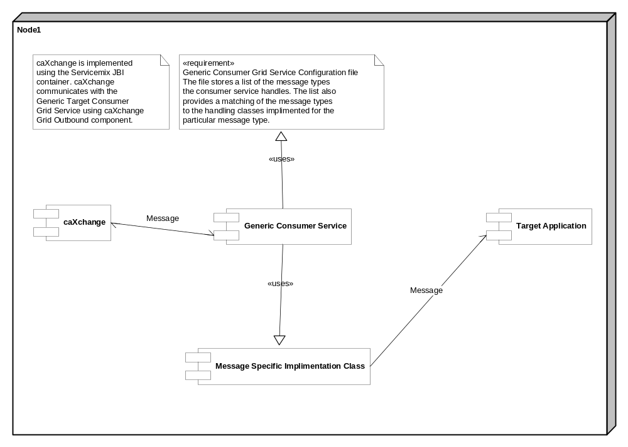

Logical design

Message Classes
One message class per message type is to be defined to handle the specific messages being routed to the caXchange generic Consumer Grid grid service. A list of classes currently defined for this purpose is attached in the Appendix A of this document.

External configuration file
One external configuration file would specify which message class handles specific message types being routed to the caXchange Consumer Grid grid service. Additionally all the message types being routed to the caXchange Consumer Grid grid service are to be included in this external configuration file. A sample configuration file is attached in the Appendix B of this document.

caXchange generic Consumer Grid grid service
caXchange generic Consumer Grid grid service should be build based on the caGrid standards. caXchange generic Consumer Grid grid service should be able to be invoked by the caXchange Grid outbound component

The caXchange generic Consumer Grid grid service will have the following operations:

Operations

Operation | Notes | Parameters | Exceptions thrown
CaXchangeConsumerResponse process | process operation performs following steps :  - Extract the payload  - get the message type  - get the implementation class  - invoke the implementation class  - construct response  - return. | CaXchangeRequestMessage request | RemoteException
void rollback | rollback operation performs following steps :  -Extract the payload  - get the message type  - get the implementation class  - invoke implementation  class  - return | CaXchangeRequestMessage request | RemoteException

Java Interface

caXchange generic Consumer Grid grid service should expose a java interface which has to be implemented by the Consumer Grid clients so that they can integrate with the caXchange generic Consumer Grid grid service. This interface should support following methods.

Operations

Method | Parameters | Exceptions Thrown | Description
public Node process | Node Payload | caXchangeConsumerException | -Validates the input payload  -Processes the payload  -Creates the response,  -returns.
Public void commit | Node Payload | caXchangeConsumerException | - Validates the input payload  - Commits the payload  - returns.
Public void rollback | Node Payload. | caXchangeConsumerException | - Validates the input payload  - Rollbacks the payload  - returns.

Fig 4.1

Sequence Diagram

Successful Scenario of the sequence of the flow is depicted below:

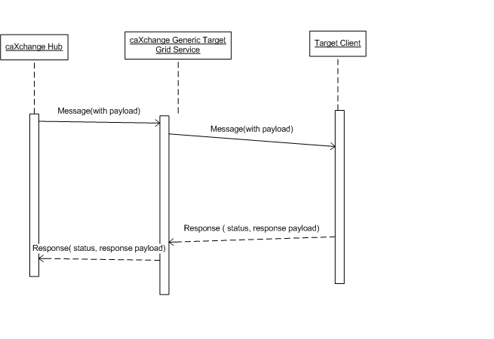

Data

None

Deployment
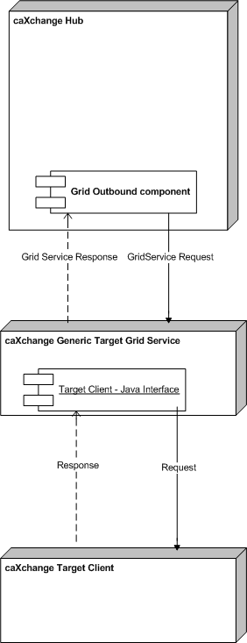

Test Cases and Scenarios
Please refer to the caXchangeTesting Approach Document for test cases.

Appendix A – Message Classes
TBD

Appendix B – Configuration File Sample
TBD

