CCTS
caXchange Interface Specifications

Version No : Initial Draft
Last Modified : 08/20/2008

Author : Harsh Marwaha
Team : caXchange Team
Client : National Cancer Institute,
National Institutes of Health,
US Department of Health and Human Services

Document History

Document Location
The most current version of this document is located in CVS under <cvsroot>?.

Revision History
Version Number | Revision Date | Author | Summary of Changes
0.1 | 08/12/2008 | Harsh Marwaha | Initial Draft
0.2 | 8/14/2008 | Kalpesh Patel | Edited the content
0.3 | 8/19/2008 | Harsh Marwaha | Incorporated feedback as appropriate from the CCTS team

Review
Name | Team/Role | Version | Date Reviewed | Reviewer Comments
Kalpesh Patel | Architect | 0.1 | 08/12/2008

Approval
Name | Team/Role | Version | Date Reviewed | Reviewer Comments

Related Documents
More information can be found in the following related caXchange documents:

Document Name

Table of Contents
1 Goals 4
2 Description 4
3 Tests initiated from Applications to caXchange 4
3.1 What does the test ant script do? 5
3.2 What is needed for this Integration Smoke Test? 6
3.2.1 Script to configure caXchange 6
3.2.2 Sample data for sending to caXchange 6
3.2.3 Script to send a message to caXchange 7
3.2.4 Reset caXchange 7
4 End to End tests 7
4.1 What does the test script do? 7
4.1.1 Success Flow – No rollbacks issued. 7
4.1.2 Failure Flow – Rollbacks issued. 8
4.2 What is needed for this Integration Smoke Test? 9
4.2.1 Script to configure caXchange. 10
4.2.2 Script to configure target application. 10
4.2.3 Sample data for sending to caXchange 10
4.2.4 Invoke applications and sending message to caXchange 10
4.2.5 Test verification scripts 10
4.2.6 Test cleanup scripts 10
4.2.7 Reset Target Application 10
4.2.8 Reset caXchange 11

Integration Smoke Test Design

Goals
The goal of the integration smoke test is to ensure that a given CCTS installation is configured properly and all the interoperability scenarios are working correctly. Additionally the design and implementation should ensure that all CCTS components are brought back to the pretest state once the testing is complete. The integration scenarios will interchange the interoperability messages (dummy data) via caXchange. These dummy data messages can corrupt production systems if they are not rolled back properly. The design and implementation of the tests should make sure that the tests do not corrupt production systems.

Prerequisite/related tests:
It is assumed that application (such C3PR) is tested to ensure it can invoke caXchange services.

Description

This document describes the design of the smoke tests needed to verify integration points within a CCTS installation. Integration points within CCTS are where different applications within CCTS talk to each other through caXchange. These are the key points where failure can occur, and therefore these should be verified after a CCTS installation.

These tests are divided into two sets.
- First set of tests will be initiated from applications to test integration with caXchange. caXchange is configured in this case not to invoke target applications.
- End-to-end test where the complete scenario is tested. These tests are initiated from server where applications are installed. caXchange is configured in this case to route messages to target applications.

Tests in set 1 and 2 above require configuration changes to caXchange that need to be undone in the environment being tested. caXchange needs to provide scripts to reset the configuration to bring it to original install state.

Tests initiated from Applications to caXchange (Set – 1)

The goal here is to validate that applications are integrated with caXchange. The test messages sent to caXchange will NOT be routed to the target applications. The following integration points need to be tested:

- C3PR to caXchange
- LabViewer to caXchange
- CCHC (Cancer Center Hub Client) to caXchange
- caAERS to caXchange

These tests will be initiated from the server where the initiating application is deployed. They will be implemented as ant scripts. caXchange has already implemented test scripts using ant which will be leveraged for these tests.

caXchange will provide two configuration scripts
- Configure caXchange such that the applications can run these tests without invoking target services
- Configuration script to reset the caXchange back to its initial state

For each message type this test script will invoke caXchange service to submit the dummy message for that message type. The script will be run from the application server where the message originating application is installed.

Additionally (and optionally) a manual test can be performed from the initiating application where the application user interface is used to send the message to caXchange. The tester manually verifies the response from caXchange. However in this if the dataset is different from the dummy set used in the script based testing, a separate data cleanup effort is required on the initiating and target applications once the test is complete.

What does the test ant script do?

- Update caXchange server configuration for smoke test.
- Login to grid using user_id/password.
- Delegate credentials to caXchange.
- Send a dummy message to caXchange from the originating server such as C3PR.
- Verify that the response from caXchange is as expected.
- No data cleanup required as caXchange is configured to send response without invoking target applications.
- Report the results of the test.
- Reset caXchange server to the pre test state.

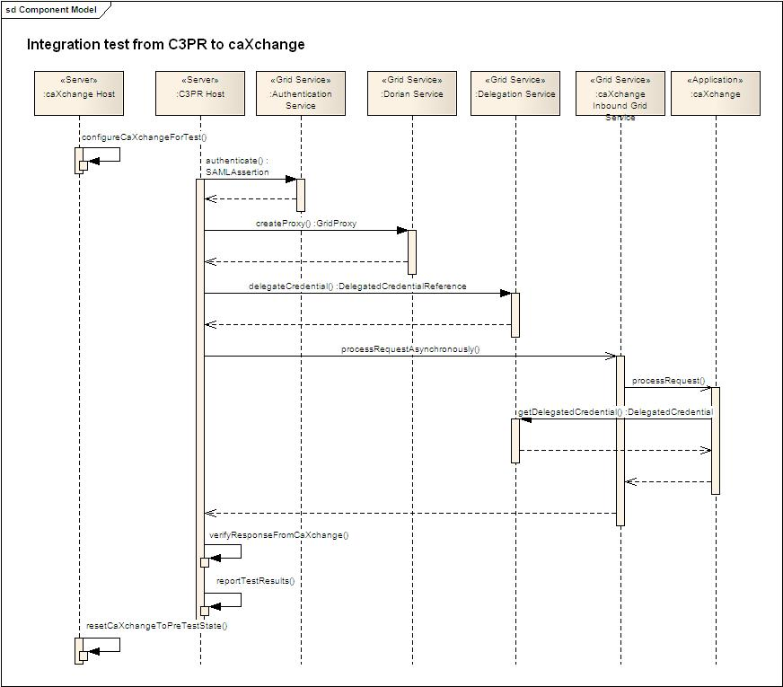
Figure 1 Sample flow for test initiated from C3PR

What is needed for this Integration Smoke Test?

Script to configure caXchange
This script configures caXchange so that messages are not routed forward.

Sample data for sending to caXchange
Each application that initiates the message should create sample data for sending to caXchange. Please see table 1 below which shows which application initiates which message type.

Message Type | caAERS | C3PR | LabViewer | CCHC
STUDY_CREATION |  | X
REGISTER_SUBJECT |  | X
CT_LAB_DATA |  |  |  | X
LOAD_LAB_TO_CDMS |  |  | X
LAB_BASED_AE |  |  | X
SCHEDULE_MODIFICATION | X
Table 1 Applications which initiate a message type.

Script to send a message to caXchange
A script is required to login to the grid, obtain a grid proxy, delegate credentials to caXchange and send the message to caXchange. They can be implemented as ant scripts. caXchange has already implemented test scripts using ant which will be leveraged for these tests.

This is required for the following applications:

- C3PR
- LabViewer
- CCHC
- caAERS

Reset caXchange
This script resets caXchange to the pretest stage.

End to End tests (Set – 2)

These tests perform the complete integration and interoperability within CCTS. In this case caXchange is configured as it would be in the production environment. All messages sent to caXchange will be routed to the target applications.

The test scripts are designed to test each integration point individually. Additionally for message types (STUDY_CREATION, REGISTER_SUBJECT) where the message is routed to more than one target applications a ramp up test should be conducted. In this case a target application is added to the test one at a time and the test conducted again with this configuration. This is continued until integration with all the target applications is tested.

For message types STUDY_CREATION, and REGISTER_SUBJECT which participate in reliable transactions, the rollback functionality needs to be tested. Each target application need to provide an ability to configure (and reset it back) it such that they return a WS-Fault on receiving the sample message to test rollback functionality. In this case caXchange will automatically send rollback to the target applications. To validate the rollback processing each target application should also provide scripts to verify that they processed rollback appropriately.

What does the test script do?

Success Flow – No rollbacks issued.
- Update caXchange server configuration for smoke test.
- Login to grid using user_id/password.
- Delegate credentials to caXchange.
- Send a message to caXchange.
- Verify that the response from caXchange is as expected.
- Verify data in the target applications.
- Invoke a script to clean up the data in the target application. This script brings the target application in the pre-test state.
- Report the results of the test.
- Reset caXchange server to pre test state.

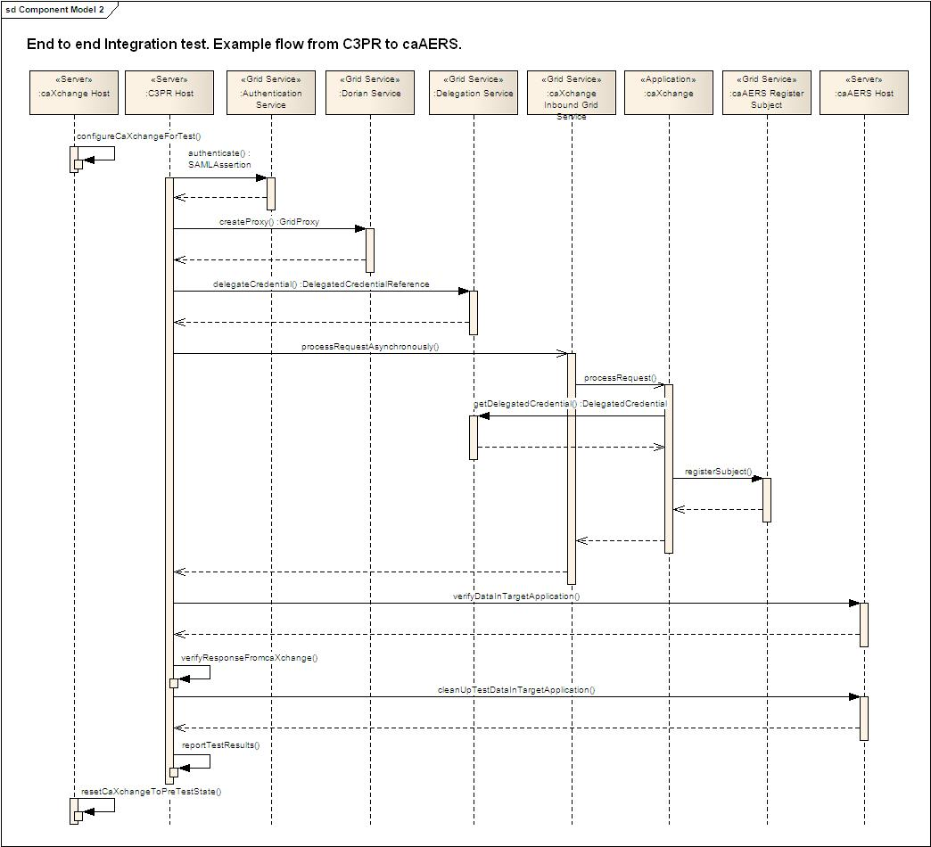
Figure 2 End to End test. Example flow from C3PR to caAERS.

Failure Flow – Rollbacks issued.
- Update caXchange server configuration for smoke test.
- Configure target application to throw a WS-Fault on receiving the sample message.
- Login to grid using user_id/password.
- Delegate credentials to caXchange.
- Send a message to caXchange.
- Verify that the target application has received the data and the rollback.
- Verify that the response from caXchange is as expected.
- Invoke a script to clean up the data in the target application. This script brings the target application in the pre-test state.
- Report the results of the test.
- Configure target application to the pre test state.
- Reset caXchange server to pre test state.

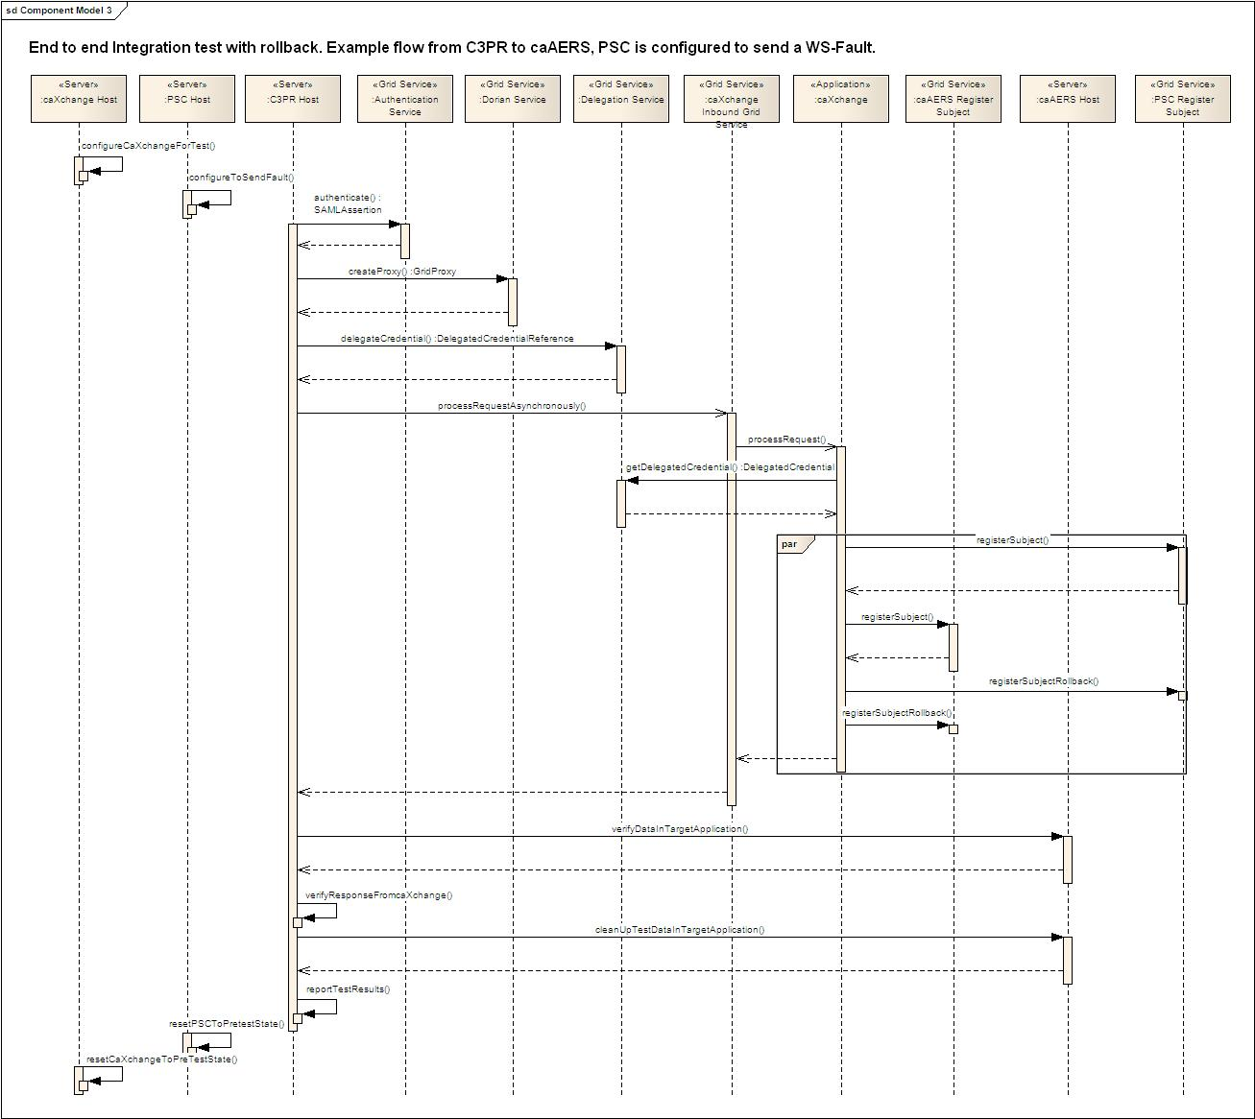
Figure 3 End to end test with Rollback. Example flow from C3PR to caAERS. PSC sends a WS-Fault.

What is needed for this Integration Smoke Test?

Script to configure caXchange.
This script configures caXchange so that messages are routed forward only to the target applications to which the integration is being tested.

Script to configure target application.
This script configures a target application to send a WS-Fault on receiving a particular message. This is needed for rollback testing only. If a target application for example PSC is configured to send a WS-Fault for REGISTER_SUBJECT messages, then caXchange should send rollbacks to other target applications.

Sample data for sending to caXchange
Each application that initiates the message should create sample data for sending to caXchange. Table 1 above shows which message type is initiated from which application.

Invoke applications and sending message to caXchange
A script is required to login to the grid, obtain a grid proxy, delegate credentials to caXchange and send the message to caXchange. They can be implemented as ant scripts. (caXchange has already implemented test scripts using ant which can be leveraged for these tests.)

Test verification scripts
Each of the target application needs to provide test verification script for each of the message types they receive. These scripts verify that the target applications have in fact received the data. The table 2 below shows which applications receive a message type. These applications need to provide scripts for cleaning up data each message type they receive.

Message Type | caAERS | PSC | C3D | C3PR | LabViewer
STUDY_CREATION | X | X |  |  | X
REGISTER_SUBJECT | X | X | X |  | X
CT_LAB_DATA |  |  |  |  | X
LOAD_LAB_TO_CDMS |  |  | X
LAB_BASED_AE | X
SCHEDULE_MODIFICATION |  | X
Table 2 Applications which receive a message type.

Test cleanup scripts
Each of the target application needs to provide test cleanup script for each of the message types they receive. These scripts bring the target application to the pretest state. The table 2 above shows which application receives which message type. Clean up scripts are required from applications for each message type they receive.

Reset Target Application
This script resets target application to the pretest stage. This script is only required in case of rollback testing.

Reset caXchange
This script resets caXchange to the pretest stage.

