caXchange-Audit and Logging

Test Plan

Document Change History
Version Number | Date | Contributor | Description
1.0 | December 2007 | Yogaraj Khanal | Initial Draft
1.1 | January 2008 | Paula Brown | Review
1.2 | January 2008 | Yogaraj Khanal | Second Draft after review


Updated Dec 9, 2007

Table of Contents

1 Introduction 4
1.1 Scope 4
1.1.1 In Scope 4
1.1.2 Out of Scope 4
1.2 Quality Objective 4
1.2.1 Primary Objective 4
1.2.2 Secondary Objective 5
1.3 Roles and Responsibilities 5
1.3.1 Developer 5
1.3.2 QA 5
1.4 Assumptions for Test Execution 5
1.5 Constraints for Test Execution 6
1.6 Definitions 7
2 Test Methodology 7
2.1 Purpose 7
2.1.1 Overview 7
2.1.2 Usability Testing 7
2.1.3 Unit Testing (Multiple) 7
2.1.4 Iteration/Regression Testing 7
2.1.5 Final release Testing 8
2.1.6 Testing completeness Criteria 8
2.2 Test Levels 8
2.2.1 Build Tests 8
Level 1 - Build Acceptance Tests 8
Level 2 - Smoke Tests 8
Level 2a - Bug Regression Testing 8
2.2.2 Milestone Tests 9
Level 3 - Critical Path Tests 9
2.2.3 Release Tests 9
Level 4 - Standard Tests 9
2.3 Bug Regression 9
2.4 Bug Triage 9
2.5 Suspension Criteria and Resumption Requirements 9
2.6 Test Completeness 10
2.6.1 Standard Conditions: 10
2.6.2 Bug Reporting & Triage Conditions: 10
3 Test Deliverables 10
3.1 Test Approach 11
3.1.1 Log Locater tool 11
Login 11
Query Section 12
Query Results 12
3.2 Test Cases 12
3.2.1 Test Cases and Requirement Traceability 12
3.2.2 Test Case Description 13
Test Case 1: Login with the valid user name and password and application name 13
Test Case 2: Login with the invalid user name password and application name 13
Test Case 3: Login with blank user name password and application name 13
Test Case 4: Login with valid user name but invalid password and valid application name 13
Test Case 5: Login with invalid user name and valid password and valid application name 13
Test Case 6: Login with the valid user name and valid password but invalid application name 13
Test Case 7: Return the query result with specified search criteria 14
Test Case 8: Give the information about the validation of user input 14
Test Case 9:Query doesn't return result and give the appropriate message 14
Test Case 10: Display the log in given date frame 14
Test Case 11: Display the log in given time frame 14
Test Case 12: Display the number of logs according to input 14
Test Case 13: New logs in the database 14
Test Case 14: Recent date searches for the new log 15
3.3 Defect Tracking & Debugging 15
3.3.1 Testing Work flow 15
3.3.2 Defect reporting using GFORGE 15
3.4 Reports 17
3.4.1 Testing status reports 17
3.4.2 Test Final Report - Sign-Off 17
3.5 Responsibility Matrix 17
4 Resource & Environment Needs 18
4.1 Testing Tools 18
4.1.1 Tracking Tools 18
4.2 Test Environment 18
4.2.1 Hardware 18
4.2.2 Software 18
4.3 Bug Severity and Priority Definition 19
4.3.1 Severity List 19
4.3.2 Priority List 19
4.4 Bug Reporting 20
5 Terms/Acronyms 20

Introduction
CaXchange is the software component that is primarily responsible for receiving input from various external systems, routing the input to various services that are hosted on the hub, and eventually routing the output of those services to external systems. The Common Logging Module (CLM) provides the audit and logging services under the caCORE set of tools. CaCORE includes a set of tools such as the log-locator web application. Integrating CLM with caXchange for logging enables the use of these tools for caXchange logs.
This documentation describes the test plans for the audit functionality caXchange provides. Its scope is limited to test plans for capturing/logging audit information from caXchange, and making this information available to users.

Scope

In Scope
The test scope for caXchange-Audit and Logging includes the following:
- Testing of all functional, application performance, security and use cases requirements listed in the Use Case document.
- Quality requirements and fit metrics of Audit and Logging
- End-to-end testing and testing of interfaces of all systems that interact with the caXchange Audit and Logging
- Performance test for Audit and Logging functionality
- Usability Testing for Audit and Logging Functionality

Out of Scope
The following areas for Audit and Logging are Out of Scope:
- Functional requirements testing for systems outside caXchange Audit and Logging
- Testing of Business SOPs, disaster recovery and Business Continuity Plan.

Quality Objective

Primary Objective
A primary objective of testing application systems is to: assure that the system meets the system requirements, including quality requirements (AKA: Non-functional requirements), fit metrics for each quality requirement, satisfies the use case scenarios and maintains the quality of the product. At the end of the project development cycle, the user should find that the project has met or exceeded all expectations as documented in the requirements.

Any changes, additions, or deletions to the requirements document, Functional Specification, or Design Specification will be documented and tested at the highest level of quality allowed within the remaining time of the project and within the ability of the test team.

Secondary Objective
The secondary objective of testing application systems will be to: identify and expose all issues and associated risks, communicate all known issues to the project team, and ensure that all issues are addressed in an appropriate manner before release. This requires careful and methodical testing of the application to first ensure all areas of the system are scrutinized and, consequently, all issues (bugs) found are dealt with appropriately.

Roles and Responsibilities

Developer
An NCI-designated Cancer Center selected and funded by NCICB to participate in a specific Workspace to undertake software or solution development activities. Responsible to:
(a) Develop the system/application
(b) Develop Use cases and requirements
(c) Conduct Unit, system, regression and integration testing
(d) Support user acceptance testing

QA
An NCI-designated Cancer Center selected and funded by NCICB to undertake formal testing, and validation of application products or solutions developed by Workspace Developers. Responsible to:
(a) Contribute to Use case, requirement development through review
(b) Contribute to development and execution of the unit test scripts through review
(c) Conduct Full User Acceptance, regression, and end-to-end testing; this includes identifying test scenarios, building the test scripts, executing scripts and reporting test results

Assumptions for Test Execution

The caXchange– Audit and Logging testing effort has inherent dependencies on the existing NCICB products involved in the architecture and other factors such as business, software, or personnel aspects. These dependencies are documented as assumptions in this section.
- For User Acceptance testing, the Developer team has completed unit, system and integration testing and met all Requirement’s (including quality requirements).
- Test results will be reported on daily basis using GForge. Failed scripts and defect list from GForge with evidence will be sent to the Developer directly.
- Use cases have been developed for Acceptance testing. Use cases are approved by test lead.
- Test scripts are developed and approved.
- GU source data – for containing complete, accurate data, and valid values with respect to HL7 v3 standards. As noted below, it is assumed that some values will be invalid and that this will allow the project to demonstrate how invalid data is handled.
- Web SSO – caGrid Authentication and Authorization: User authentication will be performed by appropriate application (C3PR, caAERS, PSC etc.). User’s grid credential will be used to connect to the caXchange (via Grid node). The user authorization will be performed by Grid Delegation Service by using grid identity passed to the caXchange as part of the user request.
- CLM – for auditing and logging of the actions in the caXchange.
- No data conversion or translation other than format conversion will be performed in caXchange
- Some invalid data will be provided by GU. The data will be considered invalid if it does not match HL7 v3 standards for its intended data element. This invalid data is actually useful for the project to be able to demonstrate how invalid data is handled (e.g. audit logs, etc.).
- Only valid XML instances of the HL7 v3 CT Lab message will be persisted using the CTODS Data Service. This will ensure that the data that is loaded in the database is not incomplete.

Constraints for Test Execution

- Developer will receive consolidated list of request for test environment set up, user accounts set up, data set (actual and mock data), defect list, etc. through GForge after the initial Adopter testing kick off meeting.
- Developer will support ongoing testing activities based on priorities

Definitions
Bugs: A defect is a problem with the software, where the application or system component is not working as designed, causes unexpected behaviors, or is not functioning in accordance with the requirements.

Feature Request:
A feature request is a request to add functionality or enhance current functionality from what was designed and coded.

Features can be added as a new requirement going through the appropriate Change Management process.

Test Methodology

Purpose

Overview

The purpose of the Test Plan is to achieve the following:
- Define testing strategies for each area and sub-area to include all the functional and quality (non-functional) requirements.
- Divide Design Spec into testable areas and sub-areas. Be sure to also identify and include areas that are to be omitted (not tested) also.
- Define bug-tracking procedures.
- Identify testing risks.
- Identify required resources and related information.
- Provide testing Schedule.

Usability Testing
Usability testing will not be conducted on the caXchange-Audit and Logging v1.0 due to time constraints.

Unit Testing (Multiple)
Unit Testing is conducted by the Developer during code development process to ensure that proper functionality and code coverage have been achieved by each developer both during coding and in preparation for acceptance into iterations testing.

Iteration/Regression Testing
At each iteration, a debriefing should be held. Specifically, the report must show that to the best degree achievable during the iteration testing phase, all identified priority 1 and 2 bugs have been communicated and addressed. At a minimum, all priority 1 and priority 2 bugs should be resolved prior to entering the beta phase.

Important deliverables required for acceptance into Final Release testing include:
- Application set up
- Installation instructions
- All documentation (beta test scripts, manuals or training guides, etc.)

Final release Testing
Assuming critical bugs are resolved during previous iteration test cycles - Throughout the Final Release test cycle, bug fixes will be focused on minor and trivial bugs (priority 3 and 4). Testing will continue its process of verifying the stability of the application through regression testing (existing known bugs, as well as existing test cases).

The milestone target of this phase is to establish that the application under test has reached a level of stability, appropriate for its usage (number users, etc.), that it can be released to the end users and caBIG community.

Testing completeness Criteria
The milestone target is to place the release/app (build) into production after it has been shown that the app has reached a level of stability that meets or exceeds the client expectations as defined in the Requirements, Functional Spec., and caBIG Production Standards.

Test Levels
The test categories and test levels are defined below:

Build Tests

Level 1 - Build Acceptance Tests
System will be checked to see if the proper Development Release Document plus other build related information (drop point, etc.) is in place. The objective is to determine if further testing is possible. If any Level 1 test case fails, the build is returned to developers untested.

Level 2 - Smoke Tests
The objective is to determine if further testing is possible. These test cases will emphasize breadth more than depth. All components will be touched, and every major feature should be tested briefly by the Smoke Test. If any Level 2 test case fails, the build is returned to developers untested.

Level 2a - Bug Regression Testing
Every bug that was “Open” during the previous build, but marked as “Resolved,” needs re-testing. The current build under test will need to be regression tested as well. Once the smoke test is completed regression testing can commence.

Milestone Tests

Level 3 - Critical Path Tests
Critical Path test cases must pass by the end of every 2-3 Build Test Cycles. They will not need to be tested every drop, but must be tested at least once per milestone. Thus, the Critical Path test cases must all be executed at least once during the Iteration cycle, and once during the Final Release cycle.

Release Tests

Level 4 - Standard Tests
Functional test cases may be executed multiple times with each Iteration, as they could be flagged to be included in the regression test suite after their initial execution.
Standard test cases usually include Installation, Data, GUI, and other test areas.

Bug Regression
All bugs that are at a status of ‘Resolved’, Need to be Retested” when the Testing team is notified of the new drop containing the fixes. When a bug passes regression it will be considered “Verified”. If a bug fails regression, the testing team will notify development team by entering notes into GForge. When a critical or high priority bug fails regression, the Testing team should also put out an immediate email to development. The Test Lead will be responsible for tracking and reporting to development and product management the status of regression testing.

Bug Triage

The Test Lead, Product Manager, and Development Lead should all be involved in these triage meetings. The Test Lead will provide required documentation and reports on bugs for all attendees. The purpose of the triage is to determine the type of resolution for each bug and to prioritize and determine a schedule for all “To Be Fixed Bugs’. Project Manager will then assign the bugs to the appropriate person for fixing and report the resolution of each bug back into the GForge bug tracker system. The Test Lead will be responsible for tracking and reporting on the status of all bug resolutions.

Suspension Criteria and Resumption Requirements
A bug report should be filed by the development team. After fixing the bug, the development team will follow the drop criteria (described above) to provide its latest drop for additional testing. At that time, the testing team will regress the bug, and if passes, continue testing the module.

Test Completeness
Testing will be considered complete when the following conditions have been met:

Standard Conditions:
- When testing team and Developers, agree that testing is complete, the app is stable, and the application meets functional requirements.
- Script execution of all test cases in all areas has been executed.
- Automated test cases have in all areas have been executed.
- NCI approves the test completion
- Each test area has been signed off as completed by the Test Lead.
- No ‘Critical or High’ Priority bugs that have no definable workaround remain

Bug Reporting & Triage Conditions:
- Bug find rate indicates a decreasing trend prior to Zero Bug Rate (no new priority. 1/2 bugs found).
- Bug priority distribution has changed to a steady decrease in Priority. 1 and 2 bugs discovered.
- No ‘Critial or High’ bugs that have no definable workaround remain.

Test Deliverables
Testing will provide specific deliverables during the project. These deliverables fall into three basic categories: Documents, Test Cases / Bug Write-ups, and Reports. Here is a diagram indicating the dependencies of the various deliverables:

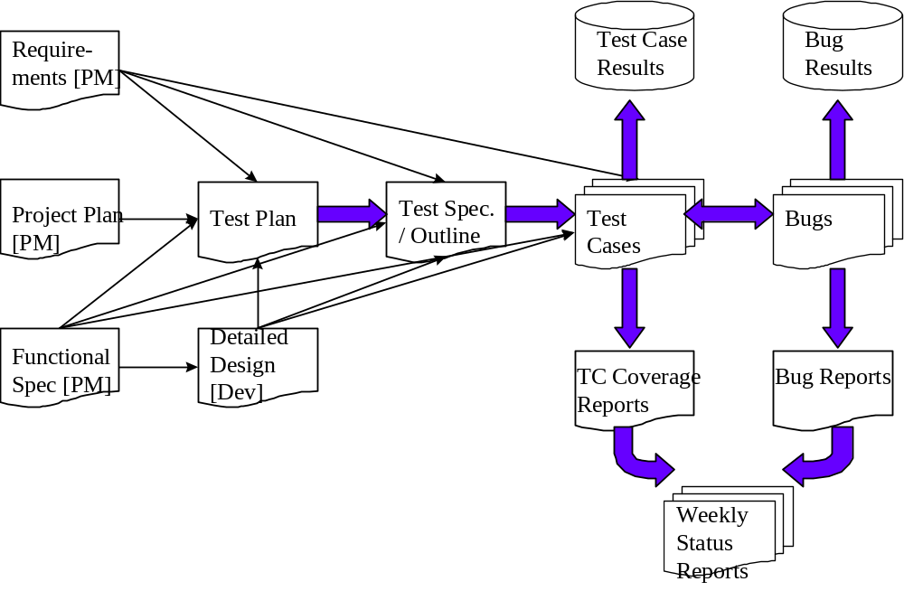

As the diagram above shows, there is a progression from one deliverable to the next. Each deliverable has its own dependencies, without which it is not possible to fully complete the deliverable.

The following page contains a matrix depicting all of the deliverables that Testing will use.

Test Approach

Log Locater tool
The Log Locater tool of CLM is a web application that allows users to view all of the events that occur within a program. It can be used to review changes made by users, reveal login date/times, expose malicious attempts at entering the system, audit a user, and identify and resolve production support issues. Users can filter the log messages by searching for content within any field of the message including: date and time that the event occurred, Log Level/Type, user, etc. By using these filters, users can view only the message relevant to their needs. The Log Locator can only be used by applications that use CLM APIs to look for audit and logging.

Login
Authenticates users and gathers necessary information before allowing the viewing of log messages

Query Section
It allows the user to provide a Search Criteria to filter the messages that will be retrieved and displayed on the Search Results Page.

Query Results
Displays the log messages retrieved from the log database based on the Search Criteria.. Paging is available for viewing configurable messages per page.

Test Cases

Test Cases and Requirement Traceability
Here are some of the test cases that will be tested for the caXchange Audit and Logging. The test cases are sequential in the order of dependency.

Test Case No | RQMNT ID | Features to be Tested | Test Cases
1 | 1.0 | User must be able to login LLT using valid credential | Login with the valid user name and password and application name
2 | 1.1 | User must not be able to login LLT using invalid credential | Login with the invalid user name password and application name
3 | 1.3 | User must not be able to login LLT using invalid credential | Login with blank user name password and application name
4 | 1.4 | User must not be able to login LLT using invalid credential | Login with valid user name but invalid password and valid application name
5 | 1.5 | User must not be able to login LLT using invalid credential | Login with invalid user name and valid password and valid application name
6 | 1.6 | User must not be able to login LLT using invalid credential | Login with the valid user name and valid password but invalid application name
7 | 2.0 | Query LLT using valid keyword entries | Return the query result with specified search criteria
8 | 2.1 | Query LLT using valid keywords entries but doesn't return result | Give the information about the validation of user input
9 | 2.2 | Query LLT using invalid keywords entries | Query doesn't return result and give the appropriate message
10 | 2.4 | Query LLT using different date options | Display the log in given date frame
11 | 2.5 | Query LLT using different time options | Display the log in given time frame
12 | 2.6 | Query LLT using different result per page | Display the no of log according to input
13 | 3.0 | Insert new data in log by executing the grid client | New logs in the database
14 | 3.1 | View new data in log from LLT | Recent date searches for the new log

Test Case Description

Test Case 1: Login with the valid user name and password and application name
This test case will verify that user can log into log locater tool using valid credentials. In this particular test case user logs into LLT using valid credentials and system should display the successful message and enable user to perform operations such as querying the database.

Test Case 2: Login with the invalid user name password and application name
This test case will verify that user can not log into log locater tool using invalid credentials. In this particular test case user log into LLT using invalid credentials and system should display the appropriate message for missing or wrong fields entered by the user.

Test Case 3: Login with blank user name password and application name
This test case will verify that user can not log into log locater tool using invalid credentials. In this particular test case user log into LLT using invalid credentials and system should display the appropriate message for missing or wrong fields entered by the user.

Test Case 4: Login with valid user name but invalid password and valid application name
This test case will verify that user can not log into log locater tool using invalid credentials. In this particular test case user log into LLT using invalid credentials and system should display the appropriate message for missing or wrong fields entered by the user.

Test Case 5: Login with invalid user name and valid password and valid application name
This test case will verify that user can not log into log locater tool using invalid credential. In this particular test case user log into LLT using invalid credentials and system should display the appropriate message for missing or wrong fields entered by the user.

Test Case 6: Login with the valid user name and valid password but invalid application name
This test case will verify that user can not log into log locater tool using invalid credentials. In this particular test case user log into LLT using invalid credentials and system should display the appropriate message for missing or wrong fields entered by the user.

Test Case 7: Return the query result with specified search criteria
This test case will exercise retrieving different search result by changing the keywords in different fields. The precondition for the execution of test case is that user must be logged in LLT using valid credentials.

Test Case 8: Give the information about the validation of user input
This test is done to find out if the LLT gives the error message based on incorrect entries made in corresponding fields. The prerequisite for this test is that user must be logged in with valid credentials. Then user views logs under some valid criteria. After that user enters invalid input to check if the error message is customized according to the input or not.

Test Case 9:Query doesn't return result and give the appropriate message
This test is done to find out if the LLT gives the error message based on incorrect entries made in corresponding fields. The prerequisite for this test is that user must be logged in with valid credentials. Then user views logs under some valid criteria. User fires some queries to get results and results and displayed. After user tries different options, on the query to check that when query is not right system provides the reason for failure.

Test Case 10: Display the log in given date frame
This test case is done to find out if you can view the log based on a date criteria
The precondition is that user must log in with valid credentials. Then user enters a particular date in given format to view the log of that particular date.

Test Case 11: Display the log in given time frame
This test case is done to find out if you can view the log based on a time criteria.
The precondition is that user must log in with valid credentials. Then user enters a particular time in given format to view the log of that particular time.

Test Case 12: Display the number of logs according to input
This particular test case checks the number of logs that we can view simultaneously per page in LLT for the servicemix. The precondition for this test case is that the servicemix is configured properly for auditing and logging. This test case checks that the user can customize the LLT application to view the no of logs per page.

Test Case 13: New logs in the database
This test case is done to make sure that the user can add some more logs to the database. Precondition is user should run grid client to add some more data in the mysql database for logging. Then user search the data for that particular date and time to ensure that user can log that particular data. It creates new log for the servicemix caXchange messages other than those already created before.

Test Case 14: Recent date searches for the new log
The idea behind this test case is that user should be able to view the message that he puts in log. The procedure is the user log with the valid credentials and logs the message to MySql database. After that user runs the query in LLT to verify that he can retrieve that log. This case validates that the user can view his log created by him by querying LLT.

Defect Tracking & Debugging

Testing Work flow
The below work flow illustrates the testing work flow process for Developers and Adopters for User Acceptance and End to End testing.
Note the yellow highlighted process where the Adopter is required to directly send defect list with evidence to the Developer. Similarly, Developer is required to confirm directly with the Adopter after bug fixes along with updating on the GForge.
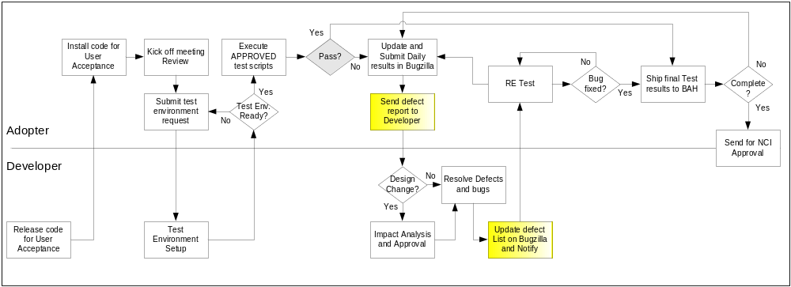

Defect reporting using GFORGE
ALL defects should be logged using ‘GFORGE’, to address and debug defects. Adopters are also requested to send a daily defect report to the developer. Developers will update the defect list on G Forge and notify the requester after the defect has been resolved.
Developers and Adopters are required to request an account on G Forge for the relative workspace. Debugging should be based on Priority –Critical > High > Medium > Low, these priorities are set by the Adopters and are based on how critical is the test script in terms of dependency and mainly based on use case scenario.
Below screen shot displays ‘Add new Defect’ screen, fields marked with ( * ) are mandatory fields and Adopters should also upload the evidence file for all the defects listed.

All High priority defects should be addressed within 1 day of the request and resolved/closed within 2 days of the initial request
All Medium priority defects should be addressed within 2 days of the request and resolved/closed within 4 days of the initial request
All Low priority defects should be resolved/closed no later than 5 days of the initial request.

G Forge URL - http://gforge.nci.nih.gov
User may either search for workspace or select from list of recent project from the bottom right side of the window. E.g. searching for ‘caTIES’.
At the workspace, the user can request Administrators to setup their user account for that workspace.
After login, user can select ‘Tracker’ tab to ‘Submit New’ defect. User can add defect info. As shown in below screen.

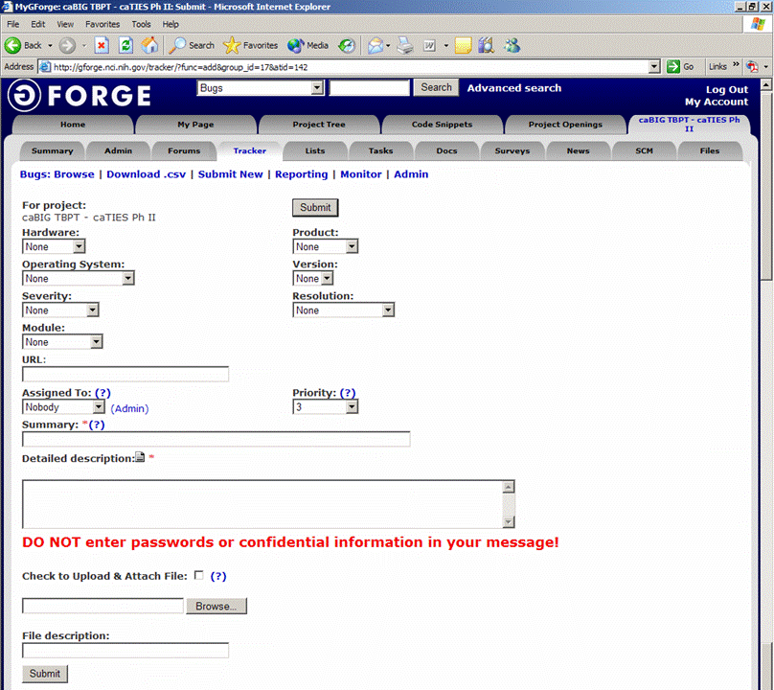
Field Comments
Hardware - List the testing environment hardware. e.g. PC, MAC
Product - Add default to workspace name e.g. caTIES
Operating System - Win 98, Win 2k, Win XP, MAC, etc.
Version - Application version
Severity - If it is an enhancement or a bug with minor to major severity that may not interfere with further testing or completely block any future testing efforts.
Resolution - Only DEVELOPER will update based on the defect
Module - For an application with multiple modules, select appropriate module for the defect reported.
URL - Add URL if any
Assigned to - To be updated by Developer, for whom the ticket is assigned to
Priority - Set a priority based on severity
Summary - Summary of the defect, bug or issue
Detailed Desc. - Details of the defect, bug or issue
Upload file - Attach evidence file
Submit - Submit the bug ticket

Reports
The Test Lead will be responsible for writing and disseminating the following reports to appropriate project personnel as required.

Testing status reports
A weekly or bi-weekly status report will be provided by the Test Lead to project personnel. This report will summarize weekly testing activities, issues, risks, bug counts, test case coverage, and other relevant metrics.

Test Final Report - Sign-Off
A Final Test Report will be issued by the Test Lead. It will certify as to the extent to which testing has actually completed (test case coverage report suggested), and an assessment of the product’s readiness for Release to Production.

Responsibility Matrix
These are the responsibilities of the resources assigned to caXchange Audit and Logging .

Role | Name | Responsibility
Project Managers | Kalpesh Patel | Review and approve test materials
Developers | Amit Srivastava | Unit test, review and approve test materials
Testers | Yogaraj Khanal | Write and execute test plans, test cases and other test deliverables

Resource & Environment Needs

Testing Tools

Tracking Tools
GForge bug tracker is used by caBIG to enter and track all bugs and project issues. The Test Lead is responsible for maintaining the GForge database.

Test Environment

Hardware
The following is the hardware requirement for testing caXchange Audit and Logging
- 2G Hard Disk Space
- 2G Ram
- Linux-compatible CPU

Operating System | Linux
Database | Oracle 9i
Browser | Firefox 2.x and Above  Internet Explorer 6 and above
Java | 1.5.x
Container | Servicemix 3.1.2 and Tomcat 5.0.28
Build Tools | Maven 2.0.7

Software
In addition to the application and any other customer specified software, the following list of software should be considered a minimum:

Software/Version:
==========================
Apache 2.2.4 Port 80
Tomcat 5.0.28-non secure
Boss 4.0.5(App server)
Postgres (database)
MySQL (database)
Globus 4.0.2 (embedded in tomcat)
ServiceMix 3.1.2(container)
Maven 2.0.7
Linux (OS)

Bug Severity and Priority Definition
Bug Severity and Priority fields are both very important for categorizing bugs and prioritizing if and when the bugs will be fixed. The bug Severity and Priority levels will be defined as outlined in the following tables below. Testing will assign a severity level to all bugs. The Test Lead will be responsible to see that a correct severity level is assigned to each bug.

The Test Lead, Development Lead and Program Manager will participate in bug review meetings to assign the priority of all currently active bugs. This meeting will be known as “Bug Triage Meetings”. The Test Lead is responsible for setting up these meetings on a routine basis to address the current set of new and existing but unresolved bugs.

Severity List
The tester entering a bug into GForge is also responsible for entering the bug Severity.

Severity ID | Severity Level | Severity Description
1 | Critical | The module/product crashes or the bug causes non-recoverable conditions. System crashes, GP Faults, or database or file corruption, or potential data loss, program hangs requiring reboot are all examples of a Severity. 1 bug.
2 | High | Major system component unusable due to failure or incorrect functionality. Severity. 2 bugs cause serious problems such as a lack of functionality, or insufficient or unclear error messages that can have a major impact to the user, prevents other areas of the app from being tested, etc. Severity. 2 bugs can have a work around, but the work around is inconvenient or difficult.
3 | Medium | Incorrect functionality of component or process. There is a simple work around for the bug if it is Severity. 3.
4 | Minor | Documentation errors or signed off severity 3 bugs.

Priority List
Priority ID | Priority Level | Priority Description
5 | Must Fix | This bug must be fixed immediately; the product cannot ship with this bug.
4 | Should Fix | These are important problems that should be fixed as soon as possible. It would be an embarrassment to the company if this bug shipped.
3 | Fix When Have Time | The problem should be fixed within the time available. If the bug does not delay shipping date, then fix it.
2 | Low Priority | It is not important (at this time) that these bugs be addressed. Fix these bugs after all other bugs have been fixed.
1 | Trivial | Enhancements/ Good to have features incorporated- just are out of the current scope.

Bug Reporting
Testing team recognizes that the bug reporting process is a critical communication tool within the testing process. Without effective communication of bug information and other issues, the development and release process will be negatively impacted.

The Test Lead will be responsible for managing the bug reporting process. Testing’s standard bug reporting tools and processes will be used. GForge is the company-wide standard Bug Logging / Tracking tool. Testing and development will enter their data into the GForge database following the field entry definitions defined below.

Terms/Acronyms

TERM/ACRONYM | DEFINITION
API | Application Program Interface
BAH | Booz Allen Hamilton
BCP | Business Continuity Plan
CAT | Client Acceptance Testing
End-to End Testing | Tests user scenarios and various path conditions by verifying that the system runs and performs tasks accurately with the same set of data from beginning to end, as intended.
ER;ES | Electronic Records; Electronic Signatures
N/A | Not Applicable
NCI | National Cancer Institute
QA | Quality Assurance
RTM | Requirements Traceability Matrix
SME | Subject Matter Expert
SOP | Standard Operating Procedure
TBPT | Tissue Bank and Pathology Tools
TBD | To Be Determined
TSR | Test Summary Report
CTODS | Clinical Trials Object Data System

