caXchange Version 1.1

caXchange Itinerary Based Routing


Updated August 4, 2008

Revision History
Author | Date | Description | Version
Harsh Marwaha | 05/08/2009 | Initial draft | 0.1

Table of Contents
Revision History 1
Author 2
Date 2
Description 2
Version 2
Table of Contents 3
1 Description 3
2 Related Documents 4
3 Actors 4
4 Priority 4
5 Assumptions 4
6 Pre-Conditions 4
7 Trigger Event 4
8 Basic Flow 4
8.1 Client would like to route a message dynamically through caXchange. 4
9 Alternate Flows 7
9.1 Client would like to know the target endpoints configured in caXchange. 7
9.2 Client would like to configure a new target endpoint in caXchange. 7
10 Exception Flows 8
10.1 Routing information is not valid. 8
10.2 Target services return a fault. 8
11 Post-Conditions 8

Description
This use case describes the requirements for caXchange to route messages dynamically to a predefined set of end points. Current caXchange routing mechanisms allow for static routing of messages. For example for CCTS caXchange routes the Register Subject message to the following four defined endpoints:
- PSC
- caAERS
- C3D
- Lab Viewer

This routing can be reconfigured to add or remove new endpoints. However all Register Subject messages will be routed to configured endpoints. This requirement is to enable caXchange to include routing information in the caXchange request and caXchange to route messages to the endpoints included in the caXchange request.

Related Documents
Document Name | Location
caXchange Interface Specification

Actors
- Administrator – caXchange Administrator configures caXchange to add additional end points.
- Client – Sends a request to caXchange for processing.
- caXchange Inbound Service – The caXchange Grid Service that serves as a proxy interface to caXchange for processing incoming requests.
- caXchange – The caXchange ESB software that routes messages to the target services and routes responses from target services to the client.

Priority
Normal

Assumptions
- The caXchange Inbound Service is implemented as a caGrid service.

Pre-Conditions
- caXchange is up and running.
- caXchange Inbound Service is up and running.

Trigger Event

Client sends a request for processing to the caXchange Inbound grid services.

Basic Flow

Client would like to route a message dynamically through caXchange.

Client – Client creates a caXchange request message with the service type defined for routing messages dynamically. The client sends this request to the caXchange Inbound service for processing. The client request includes the following information:
- Routing Information: Routing information for caxchange to the target endpoints. For each end point the name of the operation to be invoked is included.
- Payload: Payload for invoking the target services.

caXchange Inbound service – caXchange Inbound service forwards the request for processing to caXchange.

caXchange – caXchange uses the message service type to route the request to the component configured to process requests of this service type.

caXchange – caXchange routes the message as per the routing information included in the message. The routing could be invoking a single group of services. For example the client may require invoking two services in order. Following image depicts how caXchange will invoke these services:

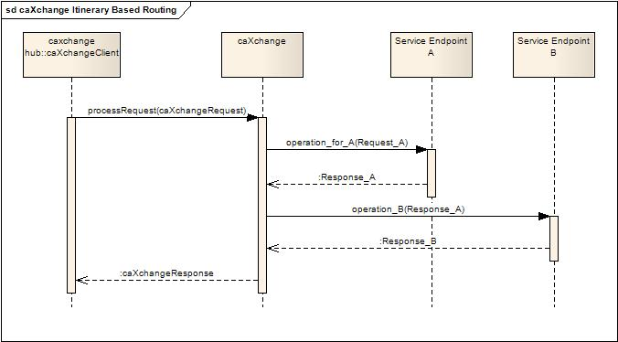
Figure 1 An example of caXchange Itinerary Based Routing invoking a single group of services.

caXchange client can also request routing to multiple groups of services. For example the client can request invoking the following two groups in parallel:
- service A and use the response to invoke service B.
- service C and use the response to invoke service D.

caXchange can route messages to multiple such routes in parallel. The response from all the routes is aggregated to create a caXchange response message. Following image depicts an example of routing in parallel to a number of service endpoints:

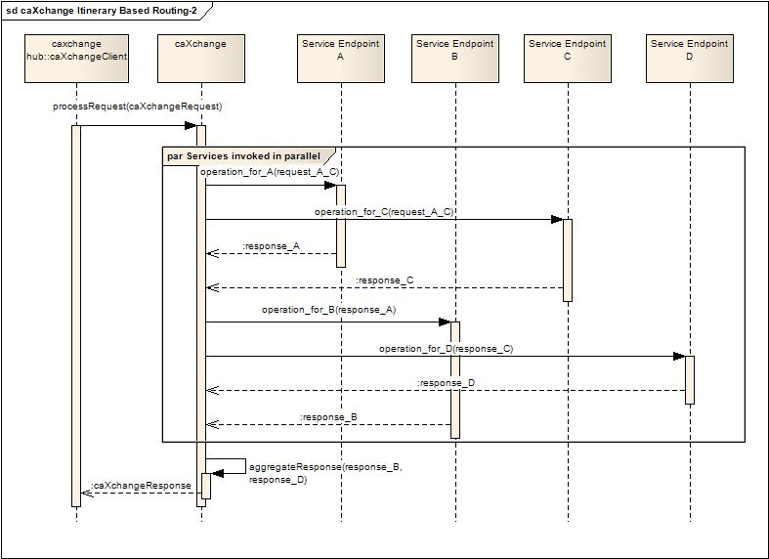
Figure 2 An example of caXchange Itinerary based routing invoking multiple groups of services.

caXchange – caXchange routes the response to the caXchange Inbound Service.

caXchange Inbound service – caXchange Inbound service makes the response available to the client.

Alternate Flows

Client would like to know the target endpoints configured in caXchange.

Client – Client creates a caXchange request message with the service type defined for requesting available target end points. Client sends this request to the caXchange Inbound service for processing.

caXchange Inbound service – caXchange Inbound service forwards the request for processing to caXchange.

caXchange – caXchange uses the message service type to route the request to the component configured to process requests of this service type.

caXchange – caXchange queries the endpoints configured for dynamic routing and constructs a response to the client. Following information is included for each configured endpoint:
- Id: A unique identifier for the end point.
- URI: A uri configured for the end point.

caXchange – caXchange routes the response to the caXchange Inbound Service.

caXchange Inbound service – caXchange Inbound service makes the response available to the client.

Client would like to configure a new target endpoint in caXchange.
I am not sure if this is needed for C3PR. It has to be clarified whether they need dynamic configuration? or can all the sites be pre-configured once.

Client – Client creates a caXchange request message with the service type defined for adding a new target end point. The client sends this request to the caXchange Inbound service for processing. The client request includes the following information:
- Id(optional): Id needs to be specified if this is an update to an existing end point.
- URI: A uri for invoking the target end point.
- Target Grid Service Client: Information about the client for invoking the target service.

caXchange Inbound service – caXchange Inbound service forwards the request for processing to caXchange.

caXchange – caXchange uses the message service type to route the request to the component configured to process requests of this service type.

caXchange – caXchange adds the configuration for the new endpoint. caXchange creates a unique identifier for the endpoint configuration. A caXchange response message is created with the following information:

- Id: A unique identifier for the end point.

caXchange – caXchange routes the response to the caXchange Inbound Service.

caXchange Inbound service – caXchange Inbound service makes the response available to the client.

Exception Flows

Routing information is not valid.

caXchange sends a response – caXchange sends a response with the responseStatus as described in the caXchange Interface Specification indicating a FAILURE. Additionally the caXchangeError field in the response is populated with the validation error details.

Target services return a fault.

caXchange sends a response – caXchange sends a response with the responseStatus as described in the caXchange Interface Specification indicating a FAILURE. Additionally the caXchangeError field in the response is populated with the validation error details.

Post-Conditions
Client gets a response from caXchange.

