Good Afternoon everybody,

I am Deepak Sharma and I am here to talk about
How we can integrate Ontologies in Protégé to Eclipse modeling framework (EMF)? How we can represent LexGrid model into EMF and with model in EMF to persist the content in different ways.

SLIDE 2 (Outline)

During this we are going to talk about:
The LexGrid Model, which is the representation model for the ontology content.

For those who do not know about EMF, A quick introduction about Eclipse Modeling Framework (EMF).

After that we will talk about how we generated Java classes from the LexGrid model using EMF and also talk about how we use it – when we have a project in protégé like FMA.
After that we will talk about what were the main consideration points or criteria that we used to understand and Map FMA content to LexGrid Model.

SLIDE 3 (LexGrid Model)

LexGrid Model defines how terminologies should be represented and formatted programmatically.

It is a formal model of terminology that explicitly defines the entities and objects like the coding schemes, concepts, relations, etc. All these entities have been used in writing LexGrid tools.

Model supports non-semantic entities as key-value pair which is very helpful from writing a toolkit perspective. For example a concept has an attribute/property and its value.

SLIDE 4 (LexGrid Model – Top Level)

Now I will go through some of the important parts of the LexGrid Model that will make you somewhat familiar with it.

At top we have service node – which is a set of coding schemes and value domains.

SLIDE 5 (LexGrid Model) – Information Model (partial))

Each coding schemes has concepts and relations. All concepts are defined under the “Concepts” as a coded Entry. Each coded entry can have basic attributes and properties. The properties are nothing but key value pairs. Some of the properties like Presentation, comment, definition, instruction have property name set to specific strings, otherwise a property can have any name and its value.

Another important group is for relations. Relations can have associations and one association type can exist between many sources and targets. An association instance is an instance of relationship between a source concept and a target concept or target value.

SLIDE 6 (LexGrid Model – Coding Scheme Node)

A coding scheme node is a root node for a coding scheme. It identifies and forms context for the concept that it is going to contain. If you closely see , you should be able to see that it has useful and interesting attributes like names (format and local), what version it belongs to and what is the default language is for concepts to display their credentials in.

It defines set of supported languages, formats, source and associations.

SLIDE 7 (LexGrid Model – Coding Scheme Node) FMA example shown

Since we are using FMA transformation as an example in this presentation. You can see that when FMA content is transformed into LexGrid model … the coding scheme node looks like shown here.

It has its formal name supported languages properties and data types and associations. This is a snapshot from the LexGrid XML file when viewed in an editor.

SLIDE 8 (LexGrid Model – Coded Entry Node)

Coding schemes has concepts. A concept is a type is defined as a coded entry in the model which consists of concept code and has a set of other properties as we saw earlier, some built-in property types like definition, presentation etc,

SLIDE 9 (LexGrid Model – Coded Entry Node) FMA example shown

In this slide we display the protein node in the transformed FMA. You can clearly see that concept “Protein” with concept code “67257” has properties and their values defined here.

SLIDE 10 (LexGrid Model – Association Node)

Another important part of the model is relations. Relations are set of associations. An association has a name like “hasSubtype” or “part of” etc. and association instances define instances of this association between a concept and its target. A target can be another concept or a data value from the supported data types for this coding scheme.

SLIDE 11 (LexGrid Model – Association Node) FMA example shown

This is a snapshot of how an association looks like in LexGrid Model. You can see that it intelligently defines association with its forward and reverse name and set of sources and targets, who participate in that relation.

SLIDE 12 (LexGrid Model ) components

LexGrid model also consists of components that forms support for revisions and version of concept and coding schemes.

We can define value domains and pick lists

URI are used to map the local namespaces. For example “English”, “en” are synonyms and share the same URI.

LexGrid Model uses URI to namespaces for Supported Languages, Sources, Associations, and properties, etc.

SLIDE 13 (LexGrid Model ) components

To get more information about LexGrid Model, Please visit

http://informatics.mayo.edu

SLIDE 14 (EMF)

We use Eclipse for Java at Mayo and as everybody knows that Eclipse is one of the most popular open source IDE available and more and more people are using it. Eclipse Modeling Framework is a tool that is available with Eclipse. In short EMF is a Java Framework and a code generation tool.

It unifies three main representation of development work Java, UML and XML. You could represent you work in any one of those forms and generate other two. Here when we talk about LexGrid Model, we maintain the master copy of the model in XML schema document and generate Java code from it.

EMF sits somewhere in the middle of modeling and programming and is a good tool to please both extremes. EMF uses XMI (XML Metadata Interchange) format to represent model.

Once the model is specified, EMF generator can generate corresponding Java classes. We can edit or extend these classes into user defined. There are ways to keep the user defined section which will not be overwritten when code is regenerated.

SLIDE 15 (Protégé + EMF) with picture

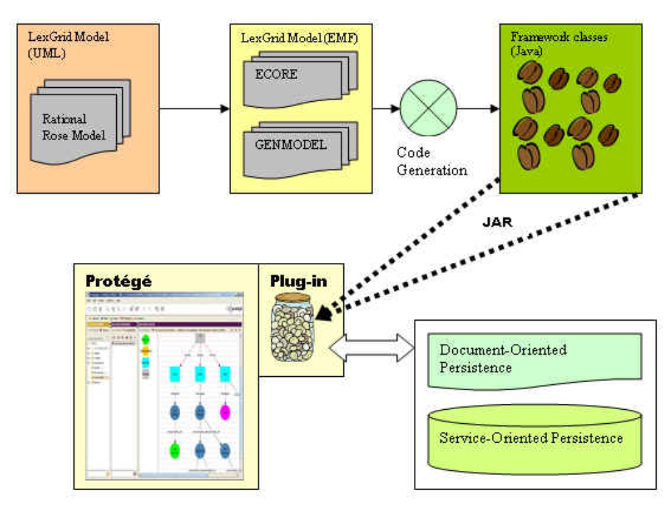

This diagram illustrates how we can use power of EMF with Protégé. Here the LexGrid Model is created (for example Rose) and then we create an EMF project based on this model. The EMF project will generate two sub frameworks -- one is ECORE – which is the core framework which will support basic generation and runtime support to create Java classes for the model. This will create two files .ecore and .genmodel. .ecore is XMI serialization of the model and .genmodel for generating the Java implementation classes.

After you have the implementation classes you can make an archive files as a plugin to Protégé. Since we already have the model in protégé, and now we have added the LexGrid EMF classes, we are ready to use it and either generates other formats that LexGrid EMF offers. LexGrid EMF implementation supports Document-oriented and server-oriented persistence. The example that we will show today generates an XML representation of the FMA contents (which is generated using the document-oriented persistence), but we could have directly commit them into a ontology database like LDAP DB or Relational Database.

SLIDE 16 (Transformation)

We use FMA project that is available at their site, as an example here. We already have FMA as a protégé project. We transformed FMA from its existing protégé structure to its equivalent in LexGrid Model (In memory). But to do this we have map what is there in FMA to their corresponding concepts, terms and relationships. That was the most difficult task to do.

SLIDE 17 (LexGrid in Protégé)

This slide shows the LexGrid model template and classes in Protégé. This particular slide has SemanticNet contents loaded into the LexGrid using the CTS Backend plug-in. If you see the Terminology Entities nodes has coded concept for main concepts for a terminology like SemanticNet here. You also see Definition, Annotation and Designation nodes and unresolved concept have an entry under concept references. So when we mapped FMA into this model we have to go through the task of mapping (as I told you earlier) to the LexGrid Model objects and entities.

SLIDE 18 (FMA in Protégé)

This slide shows how the top FMA concept classes looks like in Protégé. We have top four root nodes “Dimensional Entity”, “Anatomical Entity”, “Attribute Entity” and Anatomical Transformation Entity”. These four nodes we also identify top four nodes when we execute transformation program. You also see that there is a concept class name as “Concept Name”. We found that this class has lots of instances.

SLIDE 19 (FMA Protégé) Observations

Before we actually go ahead and map FMA elements into LexGrid Model Components, we would like to go through some of the observations about FMA structure.

We observed that Protégé Classes or Instances both actually define a concept. First we got confused because there were Protégé instances that are viewed as concepts.

Another thing we noticed that instances of a Protégé Class “Concept Name” essentially lists of all concepts in FMA. This node has 110,000 instances and name of each match with an existing concept. What these instances do is to add more information to those concepts and they may include some additional relations.

We also found some anonymous instances whose names are like “fm_live_****” or “FM_live_****”. After carefully looking at them we found out that those look like composite relationships (based on other concept or existing relationships). We will take another look at them later in this presentation.

SLIDE 20 (FMA Mapping)

Now we come to the challenging part of this whole transformation. How do we decide which element maps to which LexGrid component? Initially it seems to be a difficult task because we started looking at all slots and concepts and their entries and eventually we came up with following rules:

- We will have to treat all protégé classes and instances as concepts and define them as Protégé Class object in LexGrid Model. But we will exclude the instances of “Concept Name” node because they are just names of the concepts. We will process them later for adding more information to these concepts.
- We listed out all the slots and found out that their type may be a key to decide which category they belong to. If they have String type and slot names is something like UWDAID (concept code), “Preferred name”, “name” etc are presentation properties.
- Slot “definition” will have corresponding definition type in LexGrid Model.

SLIDE 21 (FMA Mapping) Contd...

- “Documentation” will be a comment.
- If it is a Protégé Class or Instance then it will be treated as an association and corresponding association/relation will be crated in LexGrid Model.
- Any other type will be a property and is added as a key-value pair to the concept.

SLIDE 22 (FMA Mapping)

After we are done traversing all other classes and instances except “Concept Name” node’s instances. We now traverse them and apply the similar rules on all its instances – find existing concepts and add more information to them by looking at some new slots that these instances have:

Authority, Source, language, Eponym (name of this entity (or concept) based on somebody who invented it or refers to) etc. We found them most of them are presentation attributes. So we go the concept and adjust their presentation properties or create a new one, if one does not exist.

SLIDE 23 FMA (LexGrid XML Snapshot)

This slide shows, how the generated XML file looks like when transformation is complete. Now this LexGrid XML file can be fed to a LexGrid tool to process it or can be distributed to other who are interested.

SLIDE 24 FMA Mapping (Anonymous instances)

We talked about some anonymous instances which appear as “fm_live_****”. We could not decide how to treat them. In this transformation we have treated them as any other class or instance. But if you take a look at them most of them are relations, based of other concepts or existing relations between concepts.

I present two examples of those and parts of those are defined as a concept. Should we treat them special?

SLIDE 25 Current Status (Transformation Tool)

Currently this tool exist as a Java application that successfully converts example FMA protégé to LexGrid XML format using Framework generated classes of EMF.

We were able to resolve some minor issues like multilingual representation of a term and identifying forward reverse association names.

This java application maps FMA to LexGrid components and prepares EMF objects, The task of mapping still a challenge for any other terminology like FMA. There was a separate workshop in this conference that discussed it. But we can separate two things – Mapping and loading LexGrid in EMF and provide a plug-in to Protégé to connect with EMF.

SLIDE 26 (Questions)

Questions ???

