Java Application (Transforms FMA)
LexGrid XML Document
FMA
LexGrid
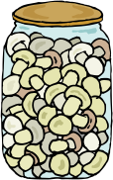
EMF JAR
FMA in Protégé
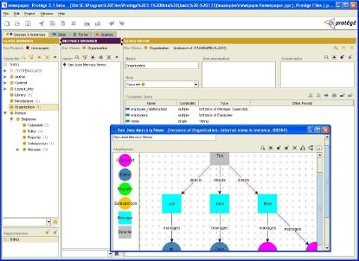

FMA to LexGrid Model Mapping

