Model
ECORE
GENMODEL
Documented-Oriented Persistence
Service-Oriented Persistence

LexGrid Model
(UML)
LexGrid Model
(EMF)
Framework Classes
(Java)

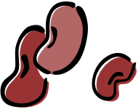
Code Generation


Archive
Application



