Design and Implementation Specification 1.0
for
LexEVS ValueDomain service

Last Updated: July 29, 2009

Owner: Sridhar Dwarkanath
Telephone: (507) 538-1549
Email: Dwarkanath.sridhar@mayo.edu

Mayo Clinic
200 1st St. SW
Rochester, MN 55905



Revision History
Content changes to this document from the previous to the current level are indicated by revision bars (|) unless a complete rewrite is indicated.

Date | Version | Description | Author
07/29/2008 | 1.0 | Initial document | Sridhar Dwarkanath
08/13/2009 | 1.1 | Added brief model description | Sridhar Dwarkanath
Note: If this document has been inspected, please indicate the inspection date that each version is based on in the “Change Description and Explanation” area. Entries in this log must be maintained for at least 3 years.

1 Revision History 2
2 Document Purpose 6
3 Implementation Overview 7
3.1 Team Members 7
3.2 Description 7
3.3 Scope 7
3.4 Architecture 7
3.4.1 LexGrid Value Domain model 7
3.4.1.1 Value Domain Definition 8
3.4.1.2 Value Domain Definition Entry 8
3.4.1.3 Coding Scheme Reference 9
3.4.1.4 Value Domain References 9
3.4.1.5 Entity Reference 9
3.4.1.6 Definition Operator 9
3.4.2 LexGrid Pick List Model 9
3.4.2.1 Pick List Definition 10
3.4.2.2 Pick List Entry Node 11
3.4.2.3 Pick List Entry 11
3.4.2.4 Pick List Entry Exclusion 11
3.5 Value Domain Definitions Possible Forms 11
3.6 Value Domain Resolution 11
3.7 Pick List Definitions Possible Forms 12
3.8 Pick List Resolution 12
4 LexEVS Value Domain and Pick List Service Class Diagram 13
4.1.1 Common Services Class Diagram 13
4.1.2 Value Domain Class Diagram 14
4.1.3 Pick List Class Diagram 16
4.2 LexBIG Services Class Diagram 17
5 Main Service API 18
5.1 LexBIG API 18
5.2 LexEVS Value Domain Service API 18
5.2.1 Loading Value Domain 18
5.2.1.1 loadValueDomain(ValueDomainDefinition vddef, String systemReleaseURI) 18
5.2.1.2 loadValueDomain(InputStream inputStream, boolean failOnAllErrors) 19
5.2.1.3 loadValueDomain(String xmlFileLocation, boolean failOnAllErrors) 20
5.2.2 Validate XML resources 20
5.2.2.1 validate(URI uri, int valicationLevel) throws LBParameterException 20
5.2.3 Query Value Domain 21
5.2.3.1 isConceptInDomain(String entityCode, URI valueDomainURI) 21
5.2.3.2 isConceptInDomain(String entityCode, URI entityCodeNamespace, CodingSchemeVersionOrTag csvt, URI valueDomainURI) 21
5.2.3.3 resolveValueDomain(URI valueDomainURI, AbsoluteCodingSchemeVersionReferenceList csVersionList) 22
5.2.3.4 isSubDomain(URI childValueDomainURI, URI parentValueDomainURI) 22
5.2.3.5 getValueDomainDefinition(URI valueDomainURI) 23
5.2.3.6 listValueDomains(String valueDomainName) 23
5.2.3.7 getAllValueDomainsWithNoNames() 24
5.2.3.8 getValueDomainEntitiesForTerm(String term, URI valueDomainURI, String matchAlgorithm) 24
5.2.3.9 getCodingSchemesInValueDomain(URI valueDomainURI) 25
5.2.3.10 isDomain(String entityCode, String codingSchemeName, CodingSchemeVersionOrTag csvt) 25
5.2.4 Remove Value Domain Definition 26
5.2.4.1 removeValueDomain(URI valueDomainURI) 26
5.2.4.2 removeAllValueDomains() 26
5.2.5 Drop Value Domain tables 27
5.2.5.1 dropValueDomainTables() 27
5.3 LexEVS Pick List Service API 27
5.3.1 Loading Pick List 27
5.3.1.1 loadPickList(PickListDefinition pldef, String systemReleaseURI) 27
5.3.1.2 loadPickList(InputStream inputStream, boolean failOnAllErrors) 28
5.3.1.3 loadPickList (String xmlFileLocation, boolean failOnAllErrors) 28
5.3.2 Validate XML resources 29
5.3.2.1 validate(URI uri, int valicationLevel) throws LBParameterException 29
5.3.3 Query Pick List 29
5.3.3.1 getPickListDefinitionById(String pickListId) 29
5.3.3.2 getPickListDefinitionsForDomain(URI valueDomainURI) 30
5.3.3.3 getPickListValueDomain(String pickListId) 30
5.3.3.4 listPickListIds() 31
5.3.3.5 resolvePickList(String pickListId, boolean sortByText) 31
5.3.3.6 resolvePickListForTerm(String pickListId, String term, String matchAlgorithm, String language, String[] context, boolean sortByText) 31
5.3.4 Remove Pick List Definition 32
5.3.4.1 removePickList(String pickListId) 32
5.4 Resolved Value Domain Objects 32
5.4.1 ResolvedValueDomainCodedNodeSet 32
5.4.2 ResolvedValueDomainDefinition 33
5.5 Resolved Pick List Objects 33
5.5.1 ResolvedPickListEntry 33
5.5.2 ResolvedPickListEntryList 33
5.6 Error Handling 33
6 Load Scripts 34
6.1 Value Domain Loader 34
6.2 Pick List Loader 34
7 Sample XML files 35
7.1 Value Domain Definitions 35
7.2 Pick List Definitions 36
8 Database structure 39
8.1 Value Domain Tables 39
8.2 Pick List Tables 40
9 Installation / Packaging 41
10 System Testing 42
10.1 Value Domain Service 42
10.2 Pick List Service 42
DOCUMENT APPROVAL 43

List of TABLES
Table 1 – Team Members 7

Document Purpose

This document provides the detailed design and implementation of LexBIG Enterprise Vocabulary Service (LexEVS) Value Domain and Pick List Service.

Implementation Overview

Team Members
Table 1 – Team Members
Role | Name
Development Lead | Sridhar Dwarkanath
Documentation Lead | Sridhar Dwarkanath
Project Manager | Traci St Martin

Description
The LexEVS Value Domain and Pick List service will provide ability to load Value Domain and Pick List Definitions into LexGrid repository and provides ability to apply user restrictions and dynamically resolve the definitions during run time. Both Value Domain and Pick List service are integrated part of LexEVS core API.

Scope
The LexEVS Value Domain and Pick List service will provide programmatic access to load Value Domain and Pick List Definitions using the domain objects that are available via the LexGrid logical model.

The LexEVS Value Domain and Pick List service will provide ability to apply certain user restrictions (ex: pickListId, valueDomain URI etc) and dynamically resolve the Value Domain and Pick List definitions during the run time.

Architecture
The LexEVS Value Domain and Pick List Service meant to expose the API particularly for the Value Domain and Pick List elements of the LexGrid Logical Model. For more information on LexGrid model see http://informatics.mayo.edu

LexGrid Value Domain model
Here is a UML representation of Value Domain with in LexGrid 200901 model :
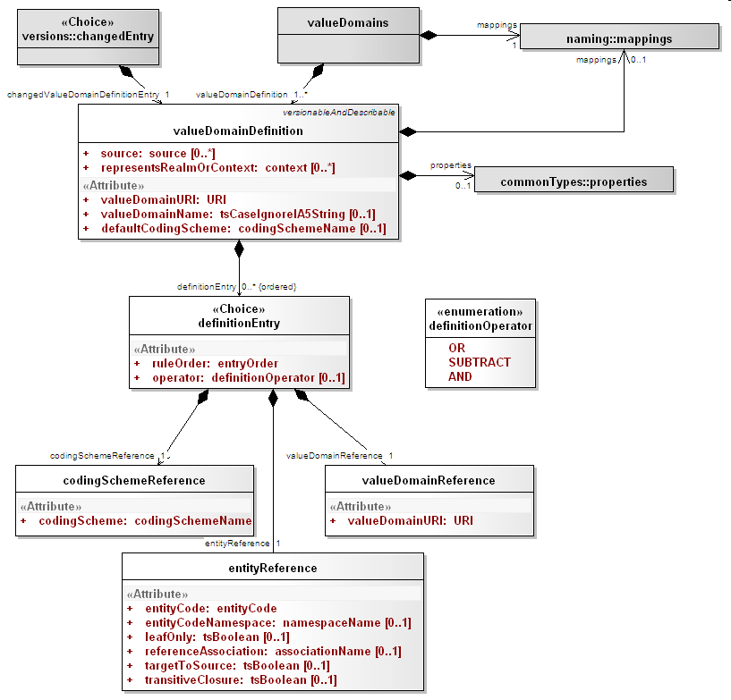

Value Domain Definition
A definition of a given value domain. A value domain can be a simple description with no associated value domain entries, or it can consist of one or more definitionEntries that resolve to an enumerated list of entityCodes when applied to one or more codingScheme versions.

Attributes of Value Domain Definition :
Source : The local identifiers of the source(s) of this property. Must match a local id of a supportedSource in the corresponding mappings section.
representsRealmOrContext : The local identifiers of the context(s) in which this value domain applies. Must match a local id of a supportedContext in the corresponding mappings section.
valueDomainURI : The URI of this value domain.
valueDomainName : The name of this domain, if any.
defaultCodingScheme : Local name of the primary coding scheme from which the domain is drawn. defaultCodingScheme must match a local id of a supportedCodingScheme in the mappings section.

Value Domain Definition Entry
A reference to an entry code, a coding scheme or another value domain along with the instructions about how the reference is applied. Definition entrys are applied in entryOrder, with each successive entry either adding to or subtracting from the final set of entity codes.

Attributes of Value Domain Definition Entry :
ruleOrder : The unique identifier of the definition entry within the definition as well as the relative order in which this entry should be applied
operator : How this entry is to be applied to the value domain

Coding Scheme Reference
A reference to all of the entity codes in a given coding scheme.

Attributes of Coding Scheme Reference :
codingScheme : The local identifier of the coding scheme that the entity codes are drawn from . codingSchemeName must match a local id of a supportedCodingScheme in the mappings section.

Value Domain References
A reference to the set of codes defined in another value domain.

Attributes of Value Domain Reference :
valueDomainURI : The URI of the value domain to apply the operator to. This value domain may be contained within the local service or may need to be resolved externally.

Entity Reference
A reference to an entityCode and/or one or more entityCodes that have a relationship to the specified entity code.

Attributes of Entity Reference :
entityCode : The entity code being referenced.
entityCodeNamespace : Local identifier of the namespace of the entityCode. entityCodeNamespace must match a local id of a supportedNamespace in the corresponding mappings section. If omitted, the URI of the defaultCodingScheme will be used as the URI of the entity code.
leafOnly : If true and referenceAssociation is supplied and referenceAssociation is defined as transitive, include all entity codes that are "leaves" in transitive closure of referenceAssociation as applied to entity code. Default: false
referenceAssociation : The local identifier of an association that appears in the native relations collection in the default coding scheme. This association is used to describe a set of entity codes. If absent, only the entityCode itself is included in this definition.
targetToSource : If true and referenceAssociation is supplied, navigate from entityCode as the association target to the corresponding sources. If transitiveClosure is true and the referenceAssociation is transitive, include all the ancestors in the list rather than just the direct "parents" (sources).
transitiveClosure : If true and referenceAssociation is supplied and referenceAssociation is defined as transitive, include all entity codes that belong to transitive closure of referenceAssociation as applied to entity code. Default: false

Definition Operator
The description of how a given definition entry is applied.

Attributes of Definition Operator :
OR : Add the set of entityCodes described by the currentEntity to the value domain. (logical OR)
SUBTRACT : Subtract (remove) the set of entityCodes described by the currentEntity to the value domain. (logical NAND)
AND : Only include the entity codes that are both in the value domain and the definition entry. (logical AND)

LexGrid Pick List Model
Here is a UML representation of Pick List with in LexGrid 200901 model :
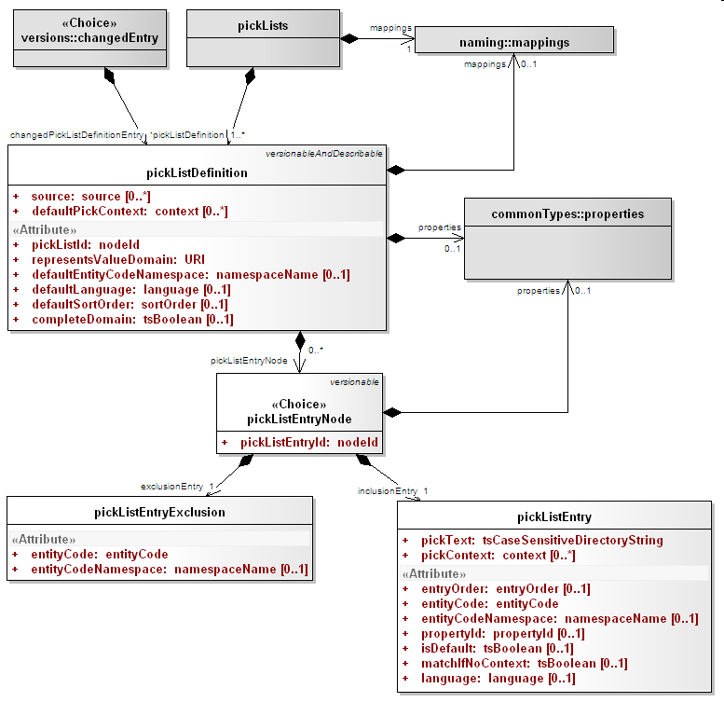

Pick List Definition
An ordered list of entity codes and corresponding presentations drawn from a value domain.

Attributes of Pick List Definition :
Source : The local identifiers of the source(s) of this pick list definition. Must match a local id of a supportedSource in the corresponding mappings section.
pickListId : An identifier that uniquely names this list within the context of the collection.
representsValueDomain : The URI of the value domain definition that is represented by this pick list
defaultEntityCodeNamespace : Local name of the namespace to which the entry codes in this list belong. defaultEntityCodeNamespace must match a local id of a supportedNamespace in the mappings section.
defaultLanguage : The local identifier of the language that is used to generate the text of this pick list if not otherwise specified. Note that this language does NOT necessarily have any coorelation with the language of a pickListEntry itself or the language of the target user. defaultLanguage must match a local id of a supportedLanguage in the mappings section.
defaultSortOrder : The local identifier of a sort order that is used as the default in the definition of the pick list
defaultPickContext : The local identifiers of the context used in the definition of the pick list.
completeDomain : True means that this pick list should represent all of the entries in the domain. Any active entity codes that aren't in the specific pick list entries are added to the end, using the designations identified by the defaultLanguage, defaultSortOrder and defaultPickContext. Default: false

Pick List Entry Node
An inclusion (pickListEntry) or exclusion (pickListEntryExclusion) in a pick list definition

Attributes of Pick List Entry Node :
pickListEntryId : Unique identifier of this node within the list.

Pick List Entry
An entity code and corresponding textual representation.

Attributes of Pick List Entry :
pickText : The text that represents this node in the pick list. Some business rules may require that this string match a presentation associated with the entityCode
pickContext : The local identifiers of the context(s) in which this entry applies. pickContext must match a local id of a supportedContext in the mappings section
entryOrder : Relative order of this entry in the list. pickListEntries without a supplied order follow the all entries with an order, and the order is not defined.
entityCode : Entity code associated with this entry.
entityCodeNamespace : Local identifier of the namespace of the entity code if different than the pickListDefinition defaultEntityCodeNamespace. entityCodeNamespace must match a local id of a supportedNamespace in the mappings section.
propertyId : The property identifier associated with the entityCode and entityCodeNamespace that the pickText was derived from. If absent, the pick text can be anything. Some terminologies may have business rules requiring this attribute to be present.
isDefault : True means that this is the default entry for the supplied language and context.
matchIfNoContext : True means that this entry can be used if no contexts are supplied, even though pickContext ispresent.
Language : The local name of the language to be used when the application/user supplies a selection language matches. If absent, this matches all languages. language must match a local id od of a supportedLanguage in the mappings section.

Pick List Entry Exclusion
An entity code that is explicitly excluded from a pick list.

Attributes of Pick List Entry Exclusion:
entityCode : Entity code associated with this entry.
entityCodeNamespace : Local identifier of the namespace of the entity code if different than the pickListDefinition defaultEntityCodeNamespace. entityCodeNamespace must match a local id of a supportedNamespace in the mappings section.

Value Domain Definitions Possible Forms
- Code system/concept code + relationship + additional rules (leaf only, immediate children, etc)
- Code system – all concept codes in the system
- Code system/concept code – individual code
- Combination of any of the above with OR/AND/SUBTRACT operators

Value Domain Resolution
- A value domain definition has to be made against a specific version of a code system. But it doesn’t have to be resolved against the same version.
- Even a simple list (a,b,c,d) needs to be resolved as, at some future date, “c” might be retired.
- Resolution does not create static artifact.

Pick List Definitions Possible Forms
- Value Domain – all concept codes in the value domain
- Code system/concept code – individual code (inclusion and exclusion)

Pick List Resolution
- A picklist definition has to be made against a specific value domain.
- Even a simple list (a,b,c,d) needs to be resolved as, at some future date, “c” might be retired.
- Resolution does not create static artifact.

LexEVS Value Domain and Pick List Service Class Diagram

Common Services Class Diagram
These are the classes that are used commonly across Value Domain and Pick List implementation.

Class Name | Description
VDEntryTypeServices | Class to handle Entry Type objects to and fro database .
VDEntryStateServices | Class to handle Entry State objects to and fro database.
VDPropertyServices | Class to handle Property objects to and fro database.
VDMappingServices | Class to handle supported Mappings objects to and fro database.
VDServiceHelper | Helper class containing methods that are commonly used.
VDBaseSQLServices | Class to handle SQL Services.
VDBaseService | Base service class to handle all Value Domain and Pick List related objects to and fro database.

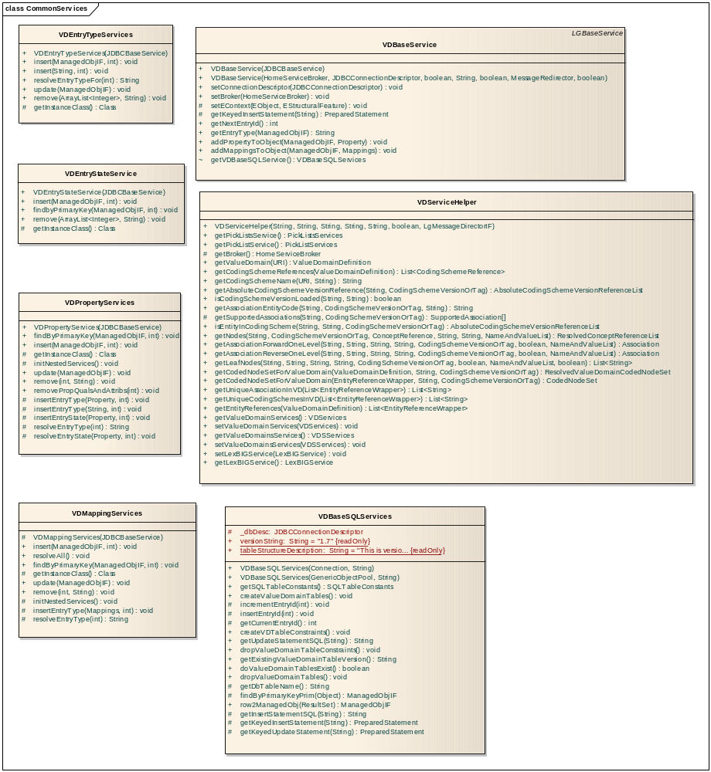

Value Domain Class Diagram
Classes that implements LexEVS Value Domain API

Class Name | Description
VDSServices | Class to handle list of Value Domain Definitions Object to and fro database
VDServices | Class to handle individual Value Domain Definition objects to and fro database.
VDEntryServices | Class to handle Value Domain Entry objects to and fro database.
LexEVSValueDomainServices | Primary interface for LexEVS Value Domain API
LexEVSValueDomainServicesImpl | Implementation of LexEVSValueDomainServices which is primary interface for LexEVS Value Domain API.
LoadValueDomain | Imports the value Domain Definitions in the source file, provided in LexGrid canonical format, to the LexBIG repository.
ResolvedValueDomainCodedNodeSet | Contains coding scheme version reference list that was used to resolve the value domain and the coded node set.
ResolvedValueDomainDefinition | A resolved Value Domain definition containing the coding scheme version reference list that was used to resolve the value domain and an iterator for resolved concepts.

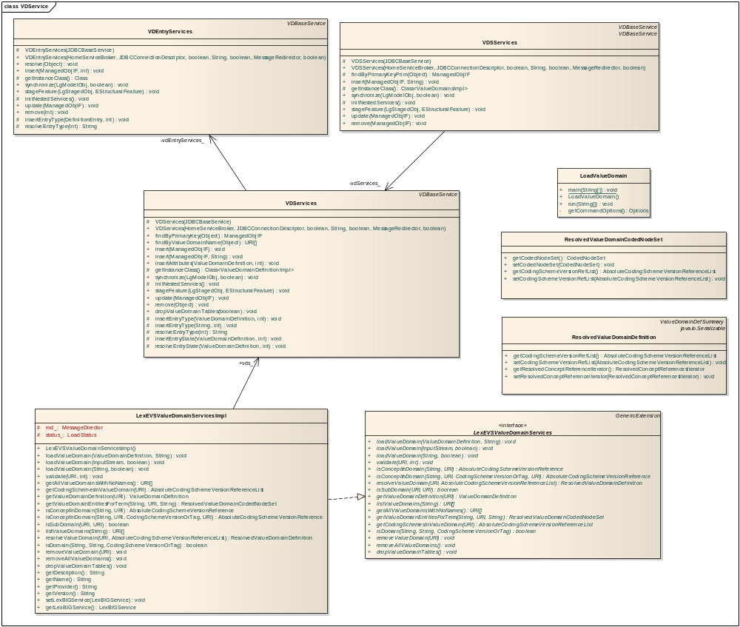

Pick List Class Diagram
Classes that implements LexEVS Pick List API

Class Name | Description
PickListsServices | Class to handle list of Pick List Definitions.
PickListServices | Class to handle individual Pick List Definition objects to and fro database.
PLEntryServices | Class to handle Pick List Entry objects to and fro database.
LexEVSPickListServices | Primary interface for LexEVS Pick List API.
LexEVSPickListServicesImpl | Implementation of LexEVSPickListServices which is primary interface for LexEVS Pick List API.
LoadPickList | Imports the Pick List Definitions in the source file, provided in LexGrid canonical format, to the LexBIG repository.
ResolvedPickListEntyList | Class to hold list of resolved pick list entries.
ResolvedPickListEntry | Bean for resolved pick list entries.

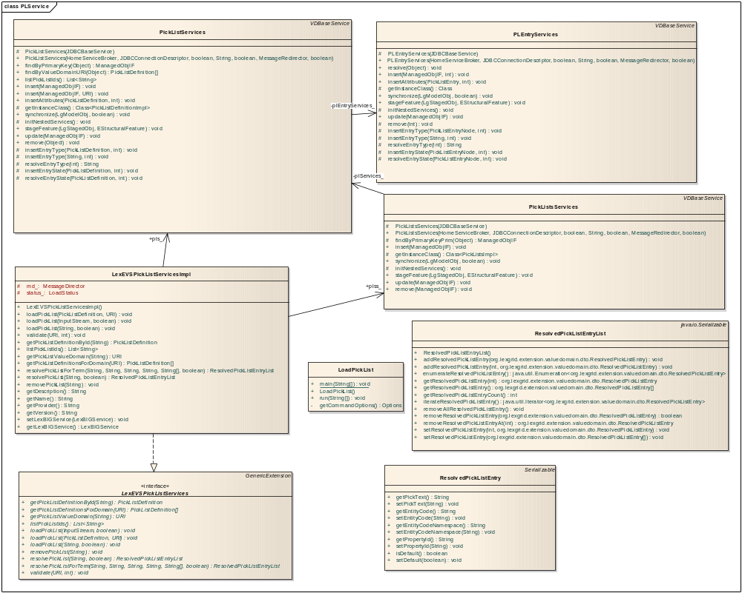

LexBIG Services Class Diagram
An interface to LexEVS Value Domain and Pick List Services could be obtained using an instance of LexBigService.

Method Name | Description
getValueDomainService() | Returns an interface to LexEVS Value Domain API
getPickListService() | Returns an interface to LexEVS Pick List API.

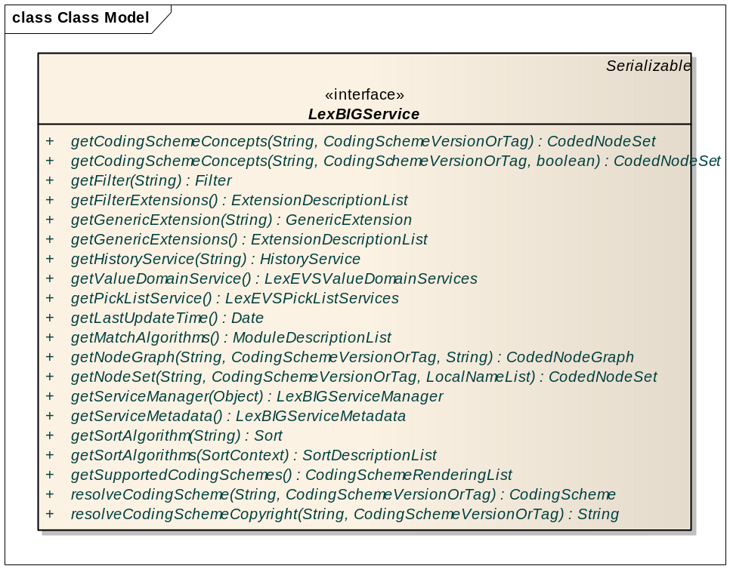

Main Service API

LexBIG API
An interface to LexEVS Value Domain and Pick List Services could be obtained using an instance of LexBigService.

getValueDomainService()
Description: | Returns an interface to LexEVS Value Domain API.
Input: | none
Output: | org.lexgrid.valuedomain.LexEVSValueDomainServices
Exception: | LBException
Implementation Details: | Implementation:  Step 1: Call this method on the associated LexBIG Service instance.  Sample Call:  Using LexBIGService instance :  org.lexgrid.valuedomain.LexEVSValueDomainServices vds = lbs.getValueDomainService();

getPickListService()
Description: | Returns an interface to LexEVS Pick List API.
Input: | none
Output: | org.lexgrid valuedomain.LexEVSPickListServices
Exception: | LBException
Implementation Details: | Implementation:  Step 1: Call this method on the associated LexBIG Service instance.  Sample Call:  Using LexBIGService instance :  org.lexgrid.valuedomain.LexEVSPickListServices vds = lbs.getPickListService();

LexEVS Value Domain Service API

Loading Value Domain
There are three methods that could be used to load Value Domain Definitions :

loadValueDomain(ValueDomainDefinition vddef, String systemReleaseURI)

loadValueDomain(ValueDomainDefinition vddef, String systemReleaseURI)
Description: | Loads supplied valueDomainDefinition object
Input: | org.LexGrid.emf.valueDomains.ValueDomainDefinition,  String
Output: | none
Exception: | LBException
Implementation Details: | Implementation:  Step 1: Call this method on the associated LexEVS Value Domain Service instance to load a Value Domain Definition object and the System Release URI this definition belongs to.  Sample Call:  Step 1 : Using LexBIGService instance, get the LexEVSValueDomainServices interface :  org.lexgrid.valuedomain.LexEVSValueDomainServices vds = lbs.getValueDomainService();  Step 2 :Create and populate the ValueDomainDefinition object  ValueDomainDefinition can be created using :  org.LexGrid.emf.valueDomains.ValueDomainDefinition valueDomain = org.LexGrid.emf.valueDomains.ValuedomainsFactory.eINSTANCE.createValueDomainDefinition();  And data for valueDomain object can be populated by using set methods :  valueDomain.setValueDomainURI(uri);  valueDomain.setValueDomainName(name);  valueDomain.setDefaultCodingScheme(cs);  valueDomain.setEntityDescription(ed);  Similarly, DefinitionEntry, Property, Mapping objects can be created and assign to the valueDomain object.  valueDomain.getDefinitionEntry.add(vdEntry);  valueDomain.setProperties(propertisObject);  valueDomain.setMappings(mappingsObject);  Step 3 : call the load method by passing the Value Domain Definition object and the System Release URI :  vds.loadvalueDomain(valueDomain,”Release 2009”);

loadValueDomain(InputStream inputStream, boolean failOnAllErrors)
loadValueDomain(InputStream inputStream, boolean failOnAllErrors)
Description: | Loads valueDomainDefinitions found in inputStream
Input: | java.io.InputStream  boolean
Output: | none
Exception: | Exception
Implementation Details: | Implementation:  Step 1: Call this method on the associated LexEVS Value Domain Service instance to load all Value Domain Definitions from the inputstream.  Sample Call:  Step 1 : Using LexBIGService instance, get the LexEVSValueDomainServices interface org.lexgrid.valuedomain.LexEVSValueDomainServices vds = lbs.getValueDomainService();  Step 2 :Call load method by passing the inputSteam and boolean flag whether to stop on load errors. :  vds.loadvalueDomain(inputStream, true);

loadValueDomain(String xmlFileLocation, boolean failOnAllErrors)
loadValueDomain(String xmlFileLocation, boolean failOnAllErrors)
Description: | Loads valueDomainDefinitions found in input xml file
Input: | java.lang.String  boolean
Output: | none
Exception: | Exception
Implementation Details: | Implementation:  Step 1: Call this method on the associated LexEVS Value Domain Service instance to load all Value Domain Definitions found in an XML file that is in LexGrid format.  Sample Call:  Step 1 : Using LexBIGService instance, get the LexEVSValueDomainServices interface org.lexgrid.valuedomain.LexEVSValueDomainServices vds = lbs.getValueDomainService();  Step 2 :Call load method by passing the inputfile location and boolean flag whether to stop on load errors. :  vds.loadvalueDomain(inputXMLFile, true);

Validate XML resources

validate(URI uri, int valicationLevel) throws LBParameterException
validate(URI uri, int valicationLevel) throws LBParameterException
Description: | Perform validation of the candidate resource without loading data.
Input: | java.net.URI  int
Output: | none
Exception: | Org.LexGrid.LexBIG.Exceptions.LBParameterException
Implementation Details: | Implementation:  Step 1: Call this method on the associated LexEVS Value Domain Service instance to validate the XML file that is in LexGrid format. This call will not load the data in XML file.  Sample Call:  Step 1 : Using LexBIGService instance, get the LexEVSValueDomainServices interface org.lexgrid.valuedomain.LexEVSValueDomainServices vds = lbs.getValueDomainService();  Step 2 :Call validate method for validation by supplying URI of the XML file and validation level:  Supported validationLevels includes :  0 = Verify document is well-formed  1 = Verify document is valid  vds.validaten(uriOfXMLFile, true);

Query Value Domain

isConceptInDomain(String entityCode, URI valueDomainURI)
isConceptInDomain(String entityCode, URI valueDomainURI)
Description: | Determine if the supplied entity code is a valid result for the supplied value domain and, if it is, return the particular codingSchemeVersion that was used.
Input: | java.lang.String,  java.net.URI
Output: | org.LexGrid.LexBIG.DataModel.Core. AbsoluteCodingSchemeVersionReference
Exception: | org.LexGrid.LexBIG.Exceptions.LBException
Implementation Details: | Implementation:  Step 1: Call this method on the associated LexEVS Value Domain Service instance to determine if the supplied entity code is a valid in the supplied Value Domain URI. If it is, return Coding Scheme URI and the Version that was used to resolve, other wise, returns null.  Sample Call:  Step 1 : Using LexBIGService instance, get the LexEVSValueDomainServices interface org.lexgrid.valuedomain.LexEVSValueDomainServices vds = lbs.getValueDomainService();  Step 2 :Call isConceptInComdin method:  AbsoluteCodingSchemeVersionReference acsvr = vds.isConceptInDomain(“conceptA”,”valueDomainURI”);

isConceptInDomain(String entityCode, URI entityCodeNamespace, CodingSchemeVersionOrTag csvt, URI valueDomainURI)
isConceptInDomain(String entityCode, URI entityCodeNamespace, CodingSchemeVersionOrTag csvt, URI valueDomainURI)
Description: | Similar to previous method, this method determine if the supplied entity code and entity namespace is a valid result for the supplied value domain when resolved against supplied Coding Scheme Version or Tag.
Input: | java.lang.String,  java.net.URI,  org.LexGrid.LexBIG.DataModel.Core. CodingSchemeVersionOrTag  java.net.URI
Output: | org.LexGrid.LexBIG.DataModel.Core. AbsoluteCodingSchemeVersionReference
Exception: | org.LexGrid.LexBIG.Exceptions.LBException
Implementation Details: | Implementation:  Step 1: Call this method on the associated LexEVS Value Domain Service instance to determine if the supplied entity code and its entity namespace is a valid in the supplied Value Domain URI when resolved against supplied Coding Scheme Version or Tag. If it is, return Coding Scheme URI and the Version that was used to resolve, other wise, returns null.  Sample Call:  Step 1 : Using LexBIGService instance, get the LexEVSValueDomainServices interface org.lexgrid.valuedomain.LexEVSValueDomainServices vds = lbs.getValueDomainService();  Step 2 :Call isConceptInDomain method:  AbsoluteCodingSchemeVersionReference acsvr = vds.isConceptInDomain(“conceptA”,”conceptAEntityNamespace”,  ”codingSchemeVersion”,”valueDomainURI”);

resolveValueDomain(URI valueDomainURI, AbsoluteCodingSchemeVersionReferenceList csVersionList)
resolveValueDomain(URI valueDomainURI, AbsoluteCodingSchemeVersionReferenceList csVersionList)
Description: | Resolve a value domain using the supplied set of coding scheme versions.
Input: | java.net.URI,  org.LexGrid.LexBIG.DataModel.Core. AbsoluteCodingSchemeVersionReferenceList
Output: | org.lexgrid.valuedomain.dto.ResolvedValueDomainDefinition
Exception: | org.LexGrid.LexBIG.Exceptions.LBException
Implementation Details: | Implementation:  Step 1: Call this method on the associated LexEVS Value Domain Service instance to resolve supplied value domain against list of Coding Scheme versions if supplied. If Coding Scheme Versions list is not supplied, API will resolve against any version of the loaded Coding Scheme that is referenced by the Value Domain. Returns, object ResolvedValueDomainDefinition which contains AbsoluteCodingSchemeVersionReferenceList which tells which all Coding Scheme and the versions were used for this resolve, plus the ResolvedConceptReferencesIterator, which is an iterator for all the valid concepts that belongs to the Value Domain and Value Domain Definition itself.  Sample Call:  Step 1 : Using LexBIGService instance, get the LexEVSValueDomainServices interface org.lexgrid.valuedomain.LexEVSValueDomainServices vds = lbs.getValueDomainService();  Step 2 :Create AbsoluteCodingSchemeVersionReferenceList:  AbsoluteCodingSchemeVersionReferenceList csvList = new AbsoluteCodingSchemeVersionReferenceList();  csvList.addAbsoluteCodingSchemeVersionReference(Constructors.  createAbsoluteCodingSchemeVersionReference("Automobiles", "2.0"));  csvList.addAbsoluteCodingSchemeVersionReference(Constructors.  createAbsoluteCodingSchemeVersionReference("AutomobilesParts", "2.0"));  Step 3 :Call resolveValueDomain method:  ResolvedValueDomainDefinition rvdDef = vds.resolveValueDomain (“valueDomainURI”,csvList);

isSubDomain(URI childValueDomainURI, URI parentValueDomainURI)
isSubDomain(URI childValueDomainURI, URI parentValueDomainURI)
Description: | Check whether childValueDomainURI is a child of parentValueDomainURI.
Input: | java.net.URI,  java.net.URI
Output: | boolean
Exception: | org.LexGrid.LexBIG.Exceptions.LBException
Implementation Details: | Implementation:  Step 1: Call this method on the associated LexEVS Value Domain Service instance to determine if all the concepts that gets resolved from supplied Child Value Domain URI is children of concepts that gets resolved from Parent Value Domain URI. Return true, if it is otherwise return false.  Sample Call:  Step 1 : Using LexBIGService instance, get the LexEVSValueDomainServices interface org.lexgrid.valuedomain.LexEVSValueDomainServices vds = lbs.getValueDomainService();  Step 2 :Call isSubDomain method:  boolean isSubDomain = vds.isSubDomain (childValueDomainURI, parentValueDomainURI);

getValueDomainDefinition(URI valueDomainURI)
getValueDomainDefinition(URI valueDomainURI)
Description: | Returns value domain definition for supplied value domain URI.
Input: | java.net.URI
Output: | org.LexGrid.emf.valueDomains.ValueDomainDefinition
Exception: | org.LexGrid.LexBIG.Exceptions.LBException
Implementation Details: | Implementation:  Step 1: Call this method on the associated LexEVS Value Domain Service instance to get the Value Domain Definition of supplied Value Domain URI.  Sample Call:  Step 1 : Using LexBIGService instance, get the LexEVSValueDomainServices interface org.lexgrid.valuedomain.LexEVSValueDomainServices vds = lbs.getValueDomainService();  Step 2 :Call getValueDomainDefinition method:  ValueDomainDefinition vdDef = vds.getValueDomainDefinition (valueDomainURI);

listValueDomains(String valueDomainName)
listValueDomains(String valueDomainName)
Description: | Return the URI's for the value domain definition(s) for the supplied domain name. If the name is null, returns everything. If the name is not null, returns the value domain(s) that have the assigned name.  Note: plural because there is no guarantee of valueDomain uniqueness. If the name is the empty string "", returns all unnamed valueDomains.
Input: | java.lang.String
Output: | java.net.URI[]
Exception: | org.LexGrid.LexBIG.Exceptions.LBException
Implementation Details: | Implementation:  Step 1: Call this method on the associated LexEVS Value Domain Service instance to get the list of Value Domain URI that matches the supplied name.  Sample Call:  Step 1 : Using LexBIGService instance, get the LexEVSValueDomainServices interface org.lexgrid.valuedomain.LexEVSValueDomainServices vds = lbs.getValueDomainService();  Step 2 :Call listValueDomains method:  URI[] uris = vds.listValueDomains(“someValueDomainName”);

getAllValueDomainsWithNoNames()
getAllValueDomainsWithNoNames()
Description: | Return the URI's of all unnamed value domain definition(s).
Input: | none
Output: | java.net.URI[]
Exception: | org.LexGrid.LexBIG.Exceptions.LBException
Implementation Details: | Implementation:  Step 1: Call this method on the associated LexEVS Value Domain Service instance to get the list of Value Domain URI that have no names.  Sample Call:  Step 1 : Using LexBIGService instance, get the LexEVSValueDomainServices interface org.lexgrid.valuedomain.LexEVSValueDomainServices vds = lbs.getValueDomainService();  Step 2 :Call getAllValueDomainsWithNoNames method:  URI[] uris = vds.getAllValueDomainsWithNoNames();

getValueDomainEntitiesForTerm(String term, URI valueDomainURI, String matchAlgorithm)
getValueDomainEntitiesForTerm(String term, URI valueDomainURI, String matchAlgorithm)
Description: | Resolves the value domain supplied and restricts to the term and matchAlgorith supplied. Return object ResolvedValueDomainCodedNodeSet contains the codingScheme URI and Version that was used to resolve and the CodedNodeSet.  Note : the CodedNodeSet is unresolved
Input: | java.lang.String,  java.net.URI,  java.lang.String
Output: | org.lexgrid.valuedomain.dto.ResolvedValueDomainCodedNodeSet
Exception: | org.LexGrid.LexBIG.Exceptions.LBException
Implementation Details: | Implementation:  Step 1: Call this method on the associated LexEVS Value Domain Service instance to get the resolved Value Domain Entries as CodedNodeSet that is restricted to supplied term and the match algorithm. Returned CodedNodeSet is not resolved.  Sample Call:  Step 1 : Using LexBIGService instance, get the LexEVSValueDomainServices interface org.lexgrid.valuedomain.LexEVSValueDomainServices vds = lbs.getValueDomainService();  Step 2 :Call getValueDomainEntriesForTerm method:  ResolvedValueDomainCodedNodeSet vdvns = vds.getValueDomainEntriesForTerm("General Motors", new URI("AUTO:AllDomesticANDGM"), MatchAlgorithms.exactMatch.name());

getCodingSchemesInValueDomain(URI valueDomainURI)
getCodingSchemesInValueDomain(URI valueDomainURI)
Description: | Returns list of coding scheme summary that is referenced by the supplied value domain.
Input: | java.net.URI
Output: | org.LexGrid.LexBIG.DataModel.Collections. AbsoluteCodingSchemeVersionReferenceList
Exception: | org.LexGrid.LexBIG.Exceptions.LBException
Implementation Details: | Implementation:  Step 1: Call this method on the associated LexEVS Value Domain Service instance to get List of all Coding Scheme URI and Versions the supplied Value Domain URI references.  Sample Call:  Step 1 : Using LexBIGService instance, get the LexEVSValueDomainServices interface org.lexgrid.valuedomain.LexEVSValueDomainServices vds = lbs.getValueDomainService();  Step 2 :Call getCodingSchemesInValueDomain method:  AbsoluteCodingSchemeVersionReferenceList csvList = vds.getCodingSchemesInValueDomain( new URI("AUTO:AllDomesticANDGM"));

isDomain(String entityCode, String codingSchemeName, CodingSchemeVersionOrTag csvt)
isDomain(String entityCode, String codingSchemeName, CodingSchemeVersionOrTag csvt)
Description: | Determine if the supplied entity code is of type valueDomain in supplied coding scheme and, if it is, return the true, otherwise return false.
Input: | java.lang.String,  java.lang.String  org.LexGrid.LexBIG.DataModel.Core. CodingSchemeVersionOrTag
Output: | boolean
Exception: | org.LexGrid.LexBIG.Exceptions.LBException
Implementation Details: | Implementation:  Step 1: Call this method on the associated LexEVS Value Domain Service instance to check if supplied entity code is of type valueDomain in supplied Coding Scheme.  Sample Call:  Step 1 : Using LexBIGService instance, get the LexEVSValueDomainServices interface org.lexgrid.valuedomain.LexEVSValueDomainServices vds = lbs.getValueDomainService();  Step 2 :Call isDomain method:  boolean isDomain = vds.isDomain ("VD005", "Automobiles", Constructors.createCodingSchemeVersionOrTag(null, "2.0")));

Remove Value Domain Definition

removeValueDomain(URI valueDomainURI)
removeValueDomain(URI valueDomainURI)
Description: | Removes supplied value domain definition from the system.
Input: | java.net.URI
Output: | none
Exception: | org.LexGrid.LexBIG.Exceptions.LBException,  org.LexGrid.managedobj.RemoveException
Implementation Details: | Implementation:  Step 1: Call this method on the associated LexEVS Value Domain Service instance to remove Value Domain Definition from the system that matches the supplied URI.  Sample Call:  Step 1 : Using LexBIGService instance, get the LexEVSValueDomainServices interface org.lexgrid.valuedomain.LexEVSValueDomainServices vds = lbs.getValueDomainService();  Step 2 :Call removeValueDomain method:  vds.removeValueDomain ( new URI("AUTO:AllDomesticANDGM"));

removeAllValueDomains()
removeAllValueDomains()
Description: | Removes all value domain definitions from the system.
Input: | none
Output: | none
Exception: | org.LexGrid.LexBIG.Exceptions.LBException,  org.LexGrid.managedobj.RemoveException
Implementation Details: | Implementation:  Step 1: Call this method on the associated LexEVS Value Domain Service instance to remove all the Value Domain Definitions that are loaded in the system.  Sample Call:  Step 1 : Using LexBIGService instance, get the LexEVSValueDomainServices interface org.lexgrid.valuedomain.LexEVSValueDomainServices vds = lbs.getValueDomainService();  Step 2 :Call removeAllValueDomains method:  vds.removeAllValueDomains();

Drop Value Domain tables

dropValueDomainTables()
dropValueDomainTables()
Description: | Drops value domain tables only if there are no value domain and pick list entries.
Input: | none
Output: | none
Exception: | org.LexGrid.LexBIG.Exceptions.LBException,  org.LexGrid.managedobj.RemoveException
Implementation Details: | Implementation:  Step 1: Call this method on the associated LexEVS Value Domain Service instance to drop both Value Domain and Pick List tables. The tables will be dropped only if there are no entries in both Value Domain and Pick List tables.  Sample Call:  Step 1 : Using LexBIGService instance, get the LexEVSValueDomainServices interface org.lexgrid.valuedomain.LexEVSValueDomainServices vds = lbs.getValueDomainService();  Step 2 :Call dropValueDomainTables method:  vds.dropValueDomainTables();

LexEVS Pick List Service API

Loading Pick List
There are three methods that could be used to load Pick List Definitions :

loadPickList(PickListDefinition pldef, String systemReleaseURI)

loadPickList(PickListDefinition pldef, String systemReleaseURI)
Description: | Loads supplied Pick List Definition object
Input: | org.LexGrid.emf.valueDomains.PickListDefinition,  String
Output: | none
Exception: | LBException
Implementation Details: | Implementation:  Step 1: Call this method on the associated LexEVS Pick List Service instance to load Pick List Definition object and the System Release URI this definition belongs to.  Sample Call:  Step 1 : Using LexBIGService instance, get the LexEVSPickListServices interface :  org.lexgrid.valuedomain.LexEVSPickListServices pls = lbs.getPickListService();  Step 2 :Create and populate the PickListDefinition object  PickListDefinition can be created using :  org.LexGrid.emf.valueDomains.PickListDefinition pickList = org.LexGrid.emf.valueDomains.ValuedomainsFactory.eINSTANCE.createPickListDefinition();  And data for pickList object can be populated by using set methods :  pickList.setPickListId(pickListId);  pickList.setRepresentsValueDomain(vdURI);  pickList.setCompleteDomain(true);  pickList.setDefaultEntityCodeNamespace(ecns);  pickList.setDefaultLanguage(“en”);  pickList.setDefaultSortOrder(“asc”);  pickList.setIsActive(true);  pickList.setEntityDescription(ed);  Similarly, PickListEntryNode, Property, Mapping objects can be created and assign to the pickList object.  pickList.getPickListEntryNode.add(pickListEntry);  pickList.setProperties(propertisObject);  pickList.setMappings(mappingsObject);  Step 3 : call the load method by passing the Pick List Definition object and the System Release URI :  pls.loadPickList(pickList,”Release 2009”);

loadPickList(InputStream inputStream, boolean failOnAllErrors)
loadPickList(InputStream inputStream, boolean failOnAllErrors)
Description: | Loads Pick List Definitions found in inputStream
Input: | java.io.InputStream  boolean
Output: | none
Exception: | Exception
Implementation Details: | Implementation:  Step 1: Call this method on the associated LexEVS Pick List Service instance to load all Pick List Definitions from the inputstream.  Sample Call:  Step 1 : Using LexBIGService instance, get the LexEVSPickListServices interface org.lexgrid.valuedomain.LexEVSPickListServices pls = lbs.getPickListService();  Step 2 :Call load method by passing the inputSteam and boolean flag whether to stop on load errors. :  pls.loadPickList(inputStream, true);

loadPickList (String xmlFileLocation, boolean failOnAllErrors)
loadPickList (String xmlFileLocation, boolean failOnAllErrors)
Description: | Loads Pick List Definitions found in input xml file
Input: | java.lang.String  boolean
Output: | none
Exception: | Exception
Implementation Details: | Implementation:  Step 1: Call this method on the associated LexEVS Pick List Service instance to load all Pick List Definitions found in an XML file that is in LexGrid format.  Sample Call:  Step 1 : Using LexBIGService instance, get the LexEVSPickListServices interface org.lexgrid.valuedomain.LexEVSPickListServices pls = lbs.getPickListService();  Step 2 :Call load method by passing the inputfile location and boolean flag whether to stop on load errors. :  pls.loadPickList(inputXMLFile, true);

Validate XML resources

validate(URI uri, int valicationLevel) throws LBParameterException
validate(URI uri, int valicationLevel) throws LBParameterException
Description: | Perform validation of the candidate resource without loading data.
Input: | java.net.URI  int
Output: | none
Exception: | Org.LexGrid.LexBIG.Exceptions.LBParameterException
Implementation Details: | Implementation:  Step 1: Call this method on the associated LexEVS Pick List Service instance to validate the XML file that is in LexGrid format. This call will not load the data in XML file.  Sample Call:  Step 1 : Using LexBIGService instance, get the LexEVSPickListServices interface org.lexgrid.valuedomain.LexEVSPickListServices pls = lbs.getPickListService();  Step 2 :Call validate method for validation by supplying URI of the XML file and validation level:  Supported validationLevels includes :  0 = Verify document is well-formed  1 = Verify document is valid  pls.validate(uriOfXMLFile, true);

Query Pick List

getPickListDefinitionById(String pickListId)
getPickListDefinitionById(String pickListId)
Description: | Returns pickList definition for supplied pickListId.
Input: | java.lang.String
Output: | org.LexGrid.emf.valueDomains.PickListDefinition
Exception: | org.LexGrid.LexBIG.Exceptions.LBException
Implementation Details: | Implementation:  Step 1: Call this method on the associated LexEVS Pick List Service instance to get Pick List Definition for supplied pickListId.  Sample Call:  Step 1 : Using LexBIGService instance, get the LexEVSPickListServices interface org.lexgrid.valuedomain.LexEVSPickListServices pls = lbs.getPickListService();  Step 2 :Call getPickListDefinitionById method:  PickListDefinition plDef = pls.getPickListDefinitionById("AUTO:DomesticAutoMakers”);

getPickListDefinitionsForDomain(URI valueDomainURI)
getPickListDefinitionsForDomain(URI valueDomainURI)
Description: | Returns all the pickList definitions that represents supplied valueDomain URI.
Input: | java.net.URI
Output: | org.LexGrid.emf.valueDomains.PickListDefinition[]
Exception: | org.LexGrid.LexBIG.Exceptions.LBException
Implementation Details: | Implementation:  Step 1: Call this method on the associated LexEVS Pick List Service instance to get all the Pick List Definitions that are represented by supplied Value Domain URI.  Sample Call:  Step 1 : Using LexBIGService instance, get the LexEVSPickListServices interface org.lexgrid.valuedomain.LexEVSPickListServices pls = lbs.getPickListService();  Step 2 :Call getPickListDefinitionsForDomain method:  PickListDefinition[] plDefs = pls.getPickListDefinitionsForDomain(valueDomainURI);

getPickListValueDomain(String pickListId)
getPickListValueDomain(String pickListId)
Description: | Returns an URI of the represented valueDomain of the pickList.
Input: | java.lang.String
Output: | java.net.URI
Exception: | org.LexGrid.LexBIG.Exceptions.LBException
Implementation Details: | Implementation:  Step 1: Call this method on the associated LexEVS Pick List Service instance to get an Value Domain URI represented by supplied pickListId.  Sample Call:  Step 1 : Using LexBIGService instance, get the LexEVSPickListServices interface org.lexgrid.valuedomain.LexEVSPickListServices pls = lbs.getPickListService();  Step 2 :Call getPickListValueDomain method:  URI vdURI = pls.getPickListValueDomain (“AUTO:DomesticAutoMakers”);

listPickListIds()
listPickListIds()
Description: | Returns a list of pickListIds that are available in the system.
Input: | none
Output: | java.util.List<java.lang.String>
Exception: | org.LexGrid.LexBIG.Exceptions.LBException
Implementation Details: | Implementation:  Step 1: Call this method on the associated LexEVS Pick List Service instance to get all the PickListIds that are loaded in the system.  Sample Call:  Step 1 : Using LexBIGService instance, get the LexEVSPickListServices interface org.lexgrid.valuedomain.LexEVSPickListServices pls = lbs.getPickListService();  Step 2 :Call listPickListIds method:  List<String> plList = pls.listPickListIds();

resolvePickList(String pickListId, boolean sortByText)
resolvePickList(String pickListId, boolean sortByText)
Description: | Resolves pickList definition for supplied pickListId.
Input: | java.langString,  boolean
Output: | org.lexgrid.valuedomain.dto.ResolvedPickListEntryList
Exception: | org.LexGrid.LexBIG.Exceptions.LBException
Implementation Details: | Implementation:  Step 1: Call this method on the associated LexEVS Pick List Service instance to get the resolved Pick List Entries for the supplied pickListId. Optionally, if sortByTests is true, sort the pickText in the list.  Sample Call:  Step 1 : Using LexBIGService instance, get the LexEVSPickListServices interface org.lexgrid.valuedomain.LexEVSPickListServices pls = lbs.getPickListService();  Step 2 :Call resolvePickList method:  ResolvedPickListEntryList pleList = pls.resolvePickList (“AUTO:DomesticAutoMakers”, true);

resolvePickListForTerm(String pickListId, String term, String matchAlgorithm, String language, String[] context, boolean sortByText)
resolvePickListForTerm(String pickListId, String term, String matchAlgorithm, String language, String[] context, boolean sortByText)
Description: | Resolves pickList definition by applying supplied arguments.
Input: | java.lang.String,  java.lang.String,  java.lang.String,  java.lang.String,  java.lang.String[],  boolean
Output: | org.lexgrid.valuedomain.dto.ResolvedPickListEntryList
Exception: | org.LexGrid.LexBIG.Exceptions.LBException
Implementation Details: | Implementation:  Step 1: Call this method on the associated LexEVS Pick List Service instance to get list of Pick List Entries that matches the term supplied and meets other supplied restrictions.  Sample Call:  Step 1 : Using LexBIGService instance, get the LexEVSPickListServices interface org.lexgrid.valuedomain.LexEVSPickListServices pls = lbs.getPickListService();  Step 2 :Call resolvePickListForTerm method:  ResolvedPickListEntryList pleList = pls.resolvePickListForTerm (“AUTO:DomesticAutoMakers”,”Jaguar”, MatchAlgorithms.exactMatch.name(), “en”, null, true);

Remove Pick List Definition

removePickList(String pickListId)
removePickList(String pickListId)
Description: | Removes supplied Pick List Definition from the system.
Input: | java.lang.String
Output: | none
Exception: | org.LexGrid.LexBIG.Exceptions.LBException,  org.LexGrid.managedobj.RemoveException
Implementation Details: | Implementation:  Step 1: Call this method on the associated LexEVS Pick List Service instance to remove Pick List Definition from the system that matches the supplied pickListId.  Sample Call:  Step 1 : Using LexBIGService instance, get the LexEVSPickListServices interface org.lexgrid.valuedomain.LexEVSPickListServices pls = lbs.getPickListService();  Step 2 :Call removePickList method:  vds.removePickList ("AUTO:AllDomesticANDGM");

Resolved Value Domain Objects

ResolvedValueDomainCodedNodeSet
Contains Coding Scheme Version reference list that was used to resolve the Value Domain and the CodedNodeSet.
The CodedNodeSet is not resolved.

ResolvedValueDomainDefinition
A resolved Value Domain Definition containing the Coding Scheme Version reference list that was used to resolve the Value Domain and an iterator for resolved concepts.

Resolved Pick List Objects

ResolvedPickListEntry
Contains resolved Pick List Entry Nodes

ResolvedPickListEntryList
Contains the list of resolved Pick List Entries. Also provides helpful features to add, remove, enumerate Pick List Entries.

Error Handling
Both LexEVS Value Domain and Pick List services uses org.LexGrid.LexBIG.Impl.loaders.MessageDirector to direct all fatal, error, warning, info messages with appropriate messages to the LexBIG log files in the ‘log’ folder of LexEVS install directory.

Along with MessageDirector, the services will also make use of org.LexGrid.LexBIG.exception.LBException to throw any fatal and error messages to the log file as well as to console.

Load Scripts
Scripts to load Value Domain and Pick List Definitions into LexEVS system will be located under ‘Admin’ folder of LexEVS install directory. This loader scripts will only load data in XML file that is in LexGrid format.

Value Domain Loader
LoadValueDomain.bat for Windows environment and LoadValueDomain.sh for Unix environment.
Both these scripts takes in following parameters :
-in | Input <uri> URI or path specifying location of the source file.
-v | Validate <int> Perform validation of the candidate resource without loading data.  Supported levels of validation includes :  0 = Verify document is well-formed  1 = Verify document is valid

Example: sh LoadValueDomain.sh -in “file:///path/to/file.xml”

Pick List Loader
LoadPickList.bat for Windows environment and LoadPickList.sh for Unix environment.
Both these scripts takes in following parameters :
-in | Input <uri> URI or path specifying location of the source file.
-v | Validate <int> Perform validation of the candidate resource without loading data.  Supported levels of validation includes :  0 = Verify document is well-formed  1 = Verify document is valid

Example: sh LoadPickList.sh -in “file:///path/to/file.xml”

Sample XML files

Value Domain Definitions
Below is a sample XML file containing Value Domain Definitions in LexGrid format that can be loaded using LexEVS Value Domain Service.

<?xml version="1.0" encoding="UTF-8"?>
<systemRelease xmlns:xsi="http://www.w3.org/2001/XMLSchema-instance"
xsi:schemaLocation="http://LexGrid.org/schema/2009/01/LexGrid/versions http://LexGrid.org/schema/2009/01/LexGrid/versions.xsd"
xmlns="http://LexGrid.org/schema/2009/01/LexGrid/versions" xmlns:lgVer="http://LexGrid.org/schema/2009/01/LexGrid/versions"
xmlns:lgCommon="http://LexGrid.org/schema/2009/01/LexGrid/commonTypes" xmlns:data="data"
xmlns:lgVD="http://LexGrid.org/schema/2009/01/LexGrid/valueDomains" xmlns:lgNaming="http://LexGrid.org/schema/2009/01/LexGrid/naming"
releaseURI="http://testRelease/04" releaseDate="2008-11-07T14:55:51.615-06:00">
<lgCommon:entityDescription>Sample value domains</lgCommon:entityDescription>
<lgVer:valueDomains>
<lgVD:mappings>
<lgNaming:supportedAssociation localId="hasSubtype" uri="urn:oid:1.3.6.1.4.1.2114.108.1.8.1">hasSubtype</lgNaming:supportedAssociation>
<lgNaming:supportedCodingScheme localId="Automobiles" uri="urn:oid:11.11.0.1">Automobiles</lgNaming:supportedCodingScheme>
<lgNaming:supportedDataType localId="testhtml">test/html</lgNaming:supportedDataType>
<lgNaming:supportedDataType localId="textplain">text/plain</lgNaming:supportedDataType>
<lgNaming:supportedHierarchy localId="is_a" associationNames="hasSubtype" isForwardNavigable="true" rootCode="@">hasSubtype</lgNaming:supportedHierarchy>
<lgNaming:supportedLanguage localId="en" uri="www.en.org/orsomething">en</lgNaming:supportedLanguage>
<lgNaming:supportedNamespace localId="Automobiles" uri="urn:oid:11.11.0.1" equivalentCodingScheme="Automobiles">Automobiles</lgNaming:supportedNamespace>
<lgNaming:supportedProperty localId="textualPresentation">textualPresentation</lgNaming:supportedProperty>
<lgNaming:supportedSource localId="lexgrid.org">lexgrid.org</lgNaming:supportedSource>
<lgNaming:supportedSource localId="_111101">11.11.0.1</lgNaming:supportedSource>
</lgVD:mappings>
<lgVD:valueDomainDefinition valueDomainURI="SRITEST:AUTO:DomesticAutoMakers" valueDomainName="Domestic Auto Makers" defaultCodingScheme="Automobiles" effectiveDate="2009-01-01T11:00:00Z" isActive="true" status="ACTIVE">
<lgVD:properties>
<lgCommon:property propertyName="textualPresentation">
<lgCommon:value> Domestic Auto Makers</lgCommon:value>
</lgCommon:property>
</lgVD:properties>
<lgVD:definitionEntry ruleOrder="1" operator="OR">
<lgVD:entityReference entityCode="005" referenceAssociation="hasSubtype" transitiveClosure="true" targetToSource="false" leafOnly="false"/>
</lgVD:definitionEntry>
</lgVD:valueDomainDefinition>
<lgVD:valueDomainDefinition valueDomainURI="SRITEST:AUTO:AllDomesticButGM" valueDomainName="All Domestic Autos But GM" defaultCodingScheme="Automobiles" effectiveDate="2009-01-01T11:00:00Z" isActive="true" status="ACTIVE">
<lgVD:properties>
<lgCommon:property propertyName="textualPresentation">
<lgCommon:value> Domestic Auto Makers</lgCommon:value>
</lgCommon:property>
</lgVD:properties>
<lgVD:definitionEntry ruleOrder="1" operator="OR">
<lgVD:entityReference entityCode="005" referenceAssociation="hasSubtype" transitiveClosure="true" targetToSource="false" leafOnly="false"/>
</lgVD:definitionEntry>
<lgVD:definitionEntry ruleOrder="2" operator="SUBTRACT">
<lgVD:entityReference entityCode="GM" referenceAssociation="hasSubtype" transitiveClosure="true" targetToSource="false" leafOnly="false"/>
</lgVD:definitionEntry>
</lgVD:valueDomainDefinition>
<lgVD:valueDomainDefinition valueDomainURI="SRITEST:AUTO:AllDomesticANDGM" valueDomainName="All Domestic Autos AND GM" defaultCodingScheme="Automobiles" effectiveDate="2009-01-01T11:00:00Z" isActive="true" status="ACTIVE">
<lgVD:properties>
<lgCommon:property propertyName="textualPresentation">
<lgCommon:value> Domestic Auto Makers AND GM</lgCommon:value>
</lgCommon:property>
</lgVD:properties>
<lgVD:definitionEntry ruleOrder="1" operator="OR">
<lgVD:entityReference entityCode="005" referenceAssociation="hasSubtype" transitiveClosure="true" targetToSource="false" leafOnly="false"/>
</lgVD:definitionEntry>
<lgVD:definitionEntry ruleOrder="2" operator="AND">
<lgVD:entityReference entityCode="GM" referenceAssociation="hasSubtype" transitiveClosure="true" targetToSource="false" leafOnly="false"/>
</lgVD:definitionEntry>
</lgVD:valueDomainDefinition>
<lgVD:valueDomainDefinition valueDomainURI="SRITEST:AUTO:DomasticLeafOnly" valueDomainName="Domestic Leaf Only" defaultCodingScheme="Automobiles" effectiveDate="2009-01-01T11:00:00Z" isActive="true" status="ACTIVE">
<lgVD:properties>
<lgCommon:property propertyName="textualPresentation">
<lgCommon:value>Domestic Leaf Only</lgCommon:value>
</lgCommon:property>
</lgVD:properties>
<lgVD:definitionEntry ruleOrder="1" operator="OR">
<lgVD:entityReference entityCode="005" referenceAssociation="hasSubtype" transitiveClosure="true" targetToSource="false" leafOnly="true"/>
</lgVD:definitionEntry>
</lgVD:valueDomainDefinition>
</lgVer:valueDomains>
</systemRelease>

Pick List Definitions
Below is a sample XML file containing Pick List Definitions in LexGrid format that can be loaded using LexEVS Pick List Service.
<?xml version="1.0" encoding="UTF-8"?>
<systemRelease xmlns:xsi="http://www.w3.org/2001/XMLSchema-instance"
xsi:schemaLocation="http://LexGrid.org/schema/2009/01/LexGrid/versions http://LexGrid.org/schema/2009/01/LexGrid/versions.xsd"
xmlns="http://LexGrid.org/schema/2009/01/LexGrid/versions" xmlns:lgVer="http://LexGrid.org/schema/2009/01/LexGrid/versions"
xmlns:lgCommon="http://LexGrid.org/schema/2009/01/LexGrid/commonTypes" xmlns:data="data"
xmlns:lgVD="http://LexGrid.org/schema/2009/01/LexGrid/valueDomains" xmlns:lgNaming="http://LexGrid.org/schema/2009/01/LexGrid/naming"
releaseURI="http://testRelease/04" releaseDate="2008-11-07T14:55:51.615-06:00">
<lgCommon:entityDescription>Sample value domains</lgCommon:entityDescription>
<pickLists>
<lgVD:mappings>
<lgNaming:supportedCodingScheme localId="Automobiles" uri="urn:oid:11.11.0.1">Automobiles</lgNaming:supportedCodingScheme>
<lgNaming:supportedLanguage localId="en" uri="www.en.org/orsomething">en</lgNaming:supportedLanguage>
<lgNaming:supportedNamespace localId="Automobiles" uri="urn:oid:11.11.0.1" equivalentCodingScheme="Automobiles">Automobiles</lgNaming:supportedNamespace>
<lgNaming:supportedProperty localId="textualPresentation">textualPresentation</lgNaming:supportedProperty>
<lgNaming:supportedSource localId="lexgrid.org">lexgrid.org</lgNaming:supportedSource>
<lgNaming:supportedSource localId="_111101">11.11.0.1</lgNaming:supportedSource>
</lgVD:mappings>
<lgVD:pickListDefinition pickListId="SRITEST:AUTO:DomesticAutoMakers" representsValueDomain="SRITEST:AUTO:DomesticAutoMakers" isActive="true" defaultEntityCodeNamespace="Automobiles" defaultLanguage="en" completeDomain="false">
<lgCommon:owner>Owner for Domestic Auto Makers</lgCommon:owner>
<lgCommon:entityDescription>DomesticAutoMakers</lgCommon:entityDescription>
<lgVD:mappings>
<lgNaming:supportedCodingScheme localId="Automobiles" uri="urn:oid:11.11.0.1">Automobiles</lgNaming:supportedCodingScheme>
<lgNaming:supportedDataType localId="texthtml">text/html</lgNaming:supportedDataType>
<lgNaming:supportedDataType localId="textplain">text/plain</lgNaming:supportedDataType>
<lgNaming:supportedLanguage localId="en" uri="www.en.org/orsomething">en</lgNaming:supportedLanguage>
<lgNaming:supportedNamespace localId="Automobiles" uri="urn:oid:11.11.0.1" equivalentCodingScheme="Automobiles">Automobiles</lgNaming:supportedNamespace>
<lgNaming:supportedProperty localId="textualPresentation">textualPresentation</lgNaming:supportedProperty>
<lgNaming:supportedSource assemblyRule="rule1" uri="http://informatics.mayo.edu" localId="lexgrid.org">lexgrid.org</lgNaming:supportedSource>
<lgNaming:supportedSource localId="_111101">11.11.0.1</lgNaming:supportedSource>
</lgVD:mappings>
<lgVD:pickListEntryNode pickListEntryId="PLGMp1" isActive="true">
<lgCommon:owner>Owner for PLGMp1</lgCommon:owner>
<lgCommon:entryState containingRevision="R001" relativeOrder="1" changeType="NEW" prevRevision="R00A"/>
<lgVD:inclusionEntry entityCode="GM" entityCodeNamespace="Automobiles" propertyId="p1">
<lgVD:pickText>General Motors</lgVD:pickText>
</lgVD:inclusionEntry>
<lgVD:properties>
<lgCommon:property propertyName="textualPresentation" isActive="true" language="en" propertyId="p1" propertyType="presentation" status="active" effectiveDate="2001-12-17T09:30:47Z" expirationDate="2011-12-17T09:30:47Z">
<lgCommon:owner role="role" subRef="subref">General Motors</lgCommon:owner>
<lgCommon:entryState containingRevision="R001" relativeOrder="1" changeType="NEW" prevRevision="R00A"/>
<lgCommon:source subRef="subref1" role="role1">General Motors</lgCommon:source>
<lgCommon:value dataType="textplain">Property for General Motors</lgCommon:value>
</lgCommon:property>
</lgVD:properties>
</lgVD:pickListEntryNode>
<lgVD:pickListEntryNode pickListEntryId="PLGMp2" isActive="true">
<lgCommon:owner>Owner for PLGMp2</lgCommon:owner>
<lgCommon:entryState containingRevision="R001" relativeOrder="1" changeType="NEW" prevRevision="R00A"/>
<lgVD:inclusionEntry entityCode="GM" entityCodeNamespace="Automobiles" propertyId="p2">
<lgVD:pickText>GM</lgVD:pickText>
</lgVD:inclusionEntry>
</lgVD:pickListEntryNode>
<lgVD:pickListEntryNode pickListEntryId="PLJaguarp1" isActive="true">
<lgCommon:owner>Owner for PLJaguarp1</lgCommon:owner>
<lgCommon:entryState containingRevision="R001" relativeOrder="1" changeType="NEW" prevRevision="R00A"/>
<lgVD:inclusionEntry entityCode="Jaguar" entityCodeNamespace="Automobiles" propertyId="p1">
<lgVD:pickText>Jaguar</lgVD:pickText>
</lgVD:inclusionEntry>
</lgVD:pickListEntryNode>
<lgVD:pickListEntryNode pickListEntryId="PLChevroletp1" isActive="true">
<lgCommon:owner>Owner for PLChevroletp1</lgCommon:owner>
<lgCommon:entryState containingRevision="R001" relativeOrder="1" changeType="NEW" prevRevision="R00A"/>
<lgVD:inclusionEntry entityCode="Chevy" entityCodeNamespace="Automobiles" propertyId="p1">
<lgVD:pickText>Chevrolet</lgVD:pickText>
</lgVD:inclusionEntry>
</lgVD:pickListEntryNode>
</lgVD:pickListDefinition>
<lgVD:pickListDefinition pickListId="SRITEST:AUTO:DomasticLeafOnly" representsValueDomain="SRITEST:AUTO:DomasticLeafOnly" completeDomain="true" defaultEntityCodeNamespace="Automobiles" defaultLanguage="en" isActive="true">
<lgCommon:entityDescription>Leaf Only Nodes of Domastic AutoMakers</lgCommon:entityDescription>
</lgVD:pickListDefinition>
</pickLists>
</systemRelease>

Database structure

Value Domain Tables
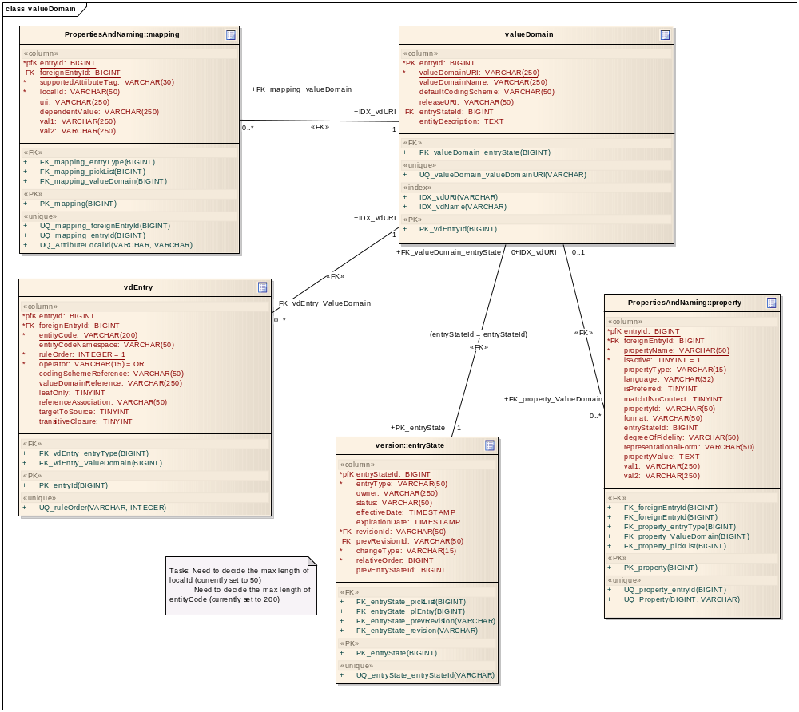

Table Name | Description
valueDomain | Will contain Value Domain Definition information
vdEntry | Contains Value Domain Entries information and its rules
entryState | Contains entry state details of every entry
mappings | Contains supported mapping information for a Value Domain Definition
property | Contains Property informations for Value Domain Definition

Pick List Tables
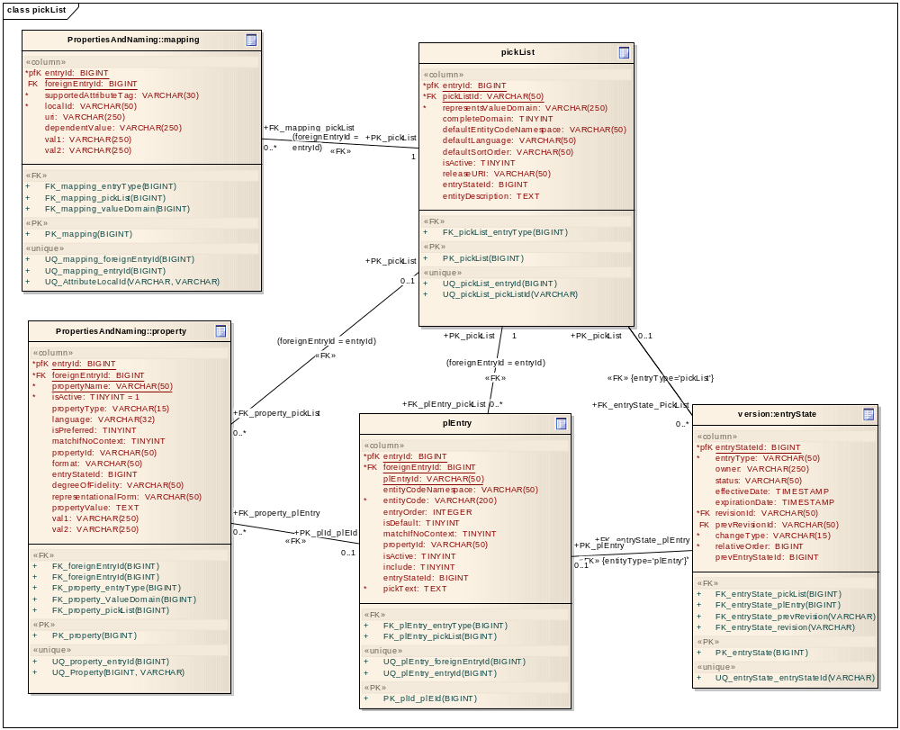

Table Name | Description
pickList | Will contain Pick List Definition information
plEntry | Contains Pick List Entry Nodes information
entryState | Contains entry state details of every entry
mappings | Contains supported mapping information for a Pick List Definition
property | Contains Property informations for Pick List Definition and its Nodes

Installation / Packaging
Both LexEVS Value Domain and Pick List services are integrated part of core LexEVS API and will be packaged and installed with other LexEVS services.

System Testing

Value Domain Service
The System test case for the LexEVS Value Domain service is performed using the JUnit test suite:

org.LexGrid.LexBIG.Impl.testUtility.VDAllTests

This test suite will be run as part of regular LexEVS test suites AllTestsAllConfigs and AllTestsNormalConfigs.

Pick List Service
The System test case for the LexEVS Value Domain service is performed using the JUnit test suite:

org.LexGrid.LexBIG.Impl.testUtility.PickListAllTests

This test suite will be run as part of regular LexEVS test suites AllTestsAllConfigs and AllTestsNormalConfigs.

DOCUMENT APPROVAL
Approvers List
The individuals listed in this section constitute the approvers list for the LexEVS Value Domain and Pick List Service Design and Implementation document. Formal approval must be received from all approvers prior to the initiation of the next steps in the process.

Title | Name
Project Manager
Development Manager

END OF DOCUMENT

