NBIA Saved Query
Last Revised: | Dec 08 2010
Produced By: | NBIA Team
Version: | 1.0

Document Approvals
The list contains the name and contact information for the core project team and any key stakeholders who have an interest in the success of the project. An “S” identifies persons responsible for approval from the stakeholder groups. Sign off of the document would be required when a decision is made not to take action for defined gaps.

S | Name | Role
S | Robert Shirley | NCICBIIT
S | Peter Yan | COTR/PM
 | Eric Kascic | Technical Lead
Revision History
When you make a change to a document, you must add an entry to this Revision History table and you must manually type the Last Revised Date on the front cover.

Date | Version | Description | Revised by
Copyrights and Trademarks
© Copyright 2010 by CBIIT, caBIGTM. All rights reserved.

Table of Contents
1. Introduction 1
2. Summary of Module 1
3. Architectural Diagram 1
4. Example 1 1
5. Example 2 1

Introduction
The purpose of this document is to describe the design & architecture by discussing about the classes and the XHTML files being used to retrieve, View, edit and search using the saved queries. The document also talks about the domain models being used to store and retrieve the saved queries.

Summary of Feature
In this module, 4 options are available.
- View Saved Queries
- Resubmit Query
- Edit Saved Query
- Remove Selected Items

    - Resources used
      - Managed Bean – SavedQueryBean.java
      - View – savedQueries.xhtml
      - Domain Model – saved_query, saved_query_attribute

    - View Saved Queries
The list of saved queries is retrieved via the QueryStorageManager interface using the retrieveSavedQueries() method. savedQueries.xhtml uses the <h:dataTable> to list the saved queries.

    - Resubmit Query
The resubmitQuery() method is called within the SavedQueryBean class. This in turn, retrieves the SearchWorkFlowBean class and kicks off the search internally by calling the SearchWorkFlowBean. asynchronousQuery() method. Finally, it redirects the view to searchResultMain.xhtml.

    - Edit Saved Query
The editQuery()method is called within the SavedQueryBean class. This in turn, calls the repopulateSearch () method which retrieves the SearchWorkFlowBean class and populates the Search parameters. Finally, it redirects the view to searchMain.xhtml.

    - Remove Selected Items
The deleteQueries() method is called within the SavedQueryBean class. This in turn calls the deleteQueries() method in the QueryStorageManager. This method deactivates the saved query records in the domain model saved_query for the given IDs.

Architectural Diagram
The following diagrams provide the work flow process while saving a Query or while editing/resubmitting a query. 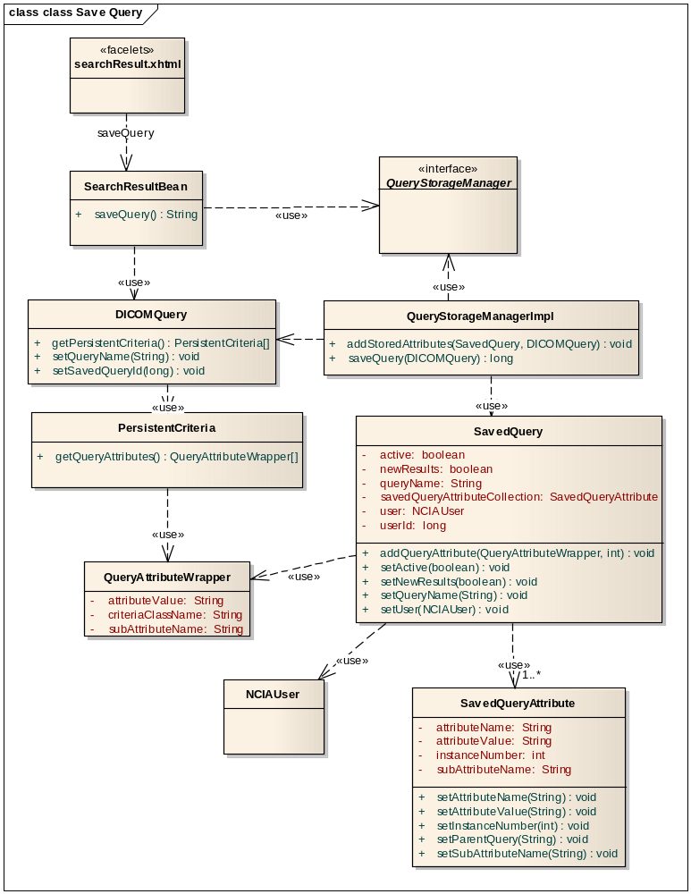

For saving and retrieving Saved Queries, QueryStorageManager Interface is used. While saving the query, QueryStorageManager accepts a DICOMQuery object via the SaveQuery() method. DICOMQuery object holds all the criteria selected by the user as a list of PersistentCriteria objects. Next, the attribute wrapper for each criteria is retrieved as QueryAttributeWrapper object. Finally, a SavedQuery Domain object is created and each attribute wrapper is updated in the SavedQueryAttribute Domain object. This SavedQuery object is persisted into the database using the Spring’s HibernateTemplate.

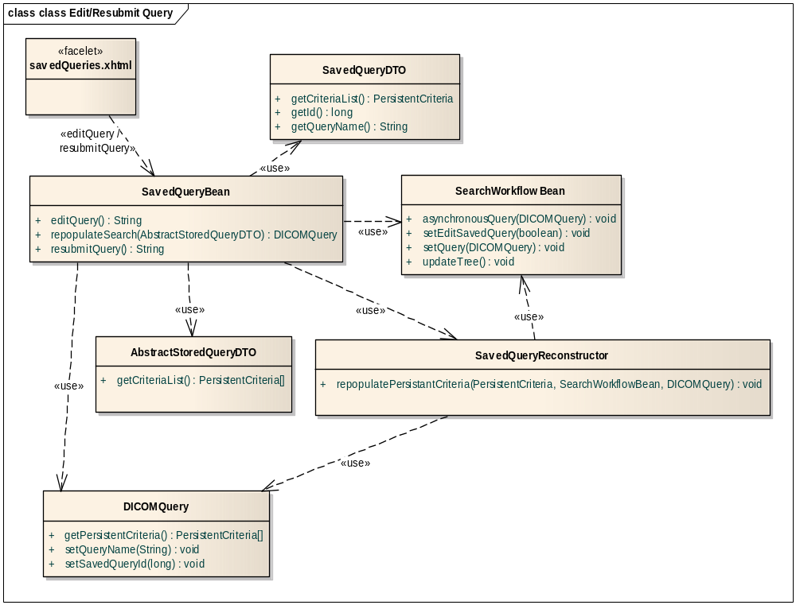
For both Resubmit Query and Edit Saved Query, the process to pass the saved query criteria to SearchWorkFlowBean is as follows:
A DICOMQuery object is created and is populated with the saved query criteria via the SavedQueryBean.repopulateSearch() method. A DICOMQuery object bundles up all the criteria selected from both the simple and advanced search. Based on the instance of the Criteria, different methods are called to populate the DICOMQuery and SearchWorkFlowBean objects. This is handled by the SavedQueryReconstructor.repopulatePersistantCriteria method. Finally, SearchWorkFlowBean. asynchronousQuery(DICOMQuery query) method is called to perform the search.

Change Example 1
Describe in very deep detail the act of making some small (artificial, simplified) change against this feature.

Change Example 2

