Quality CONTROL (qC) tool

Type
The QC tool is a functional module of the NCIA application.

Purpose
The functionality described in this section allows users to change the Quality Control (QC) status of images in NCIA. The QC status determines whether or not the image is available for download (“visible”).
This module implements the requirements described in the “Images and Annotation File Quality Control” section of the use cases document.

Dependencies
The QC status of images can only be managed after images have been submitted to NCIA.
The functionality to view a DICOM header is dependent on the DCM4CHE DICOM utilites.

Preconditions
The user must have security rights to access the QC Tool. See section 1.1.12.

Interfaces
N/A

APIs
N/A

Processing
The following sequence diagram shows the processing that occurs when the QC status is changed.
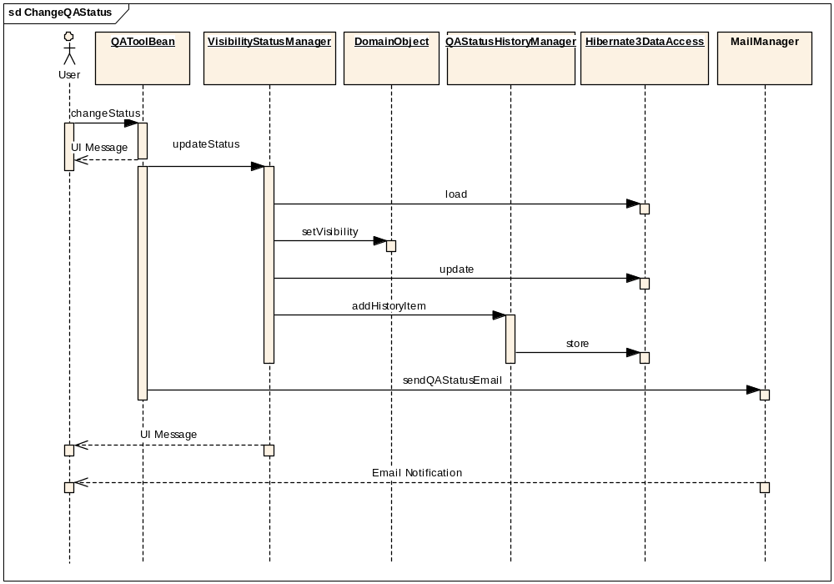
The following sequence diagrams illustrates the processing that occurs when a user access data using the QC tool.
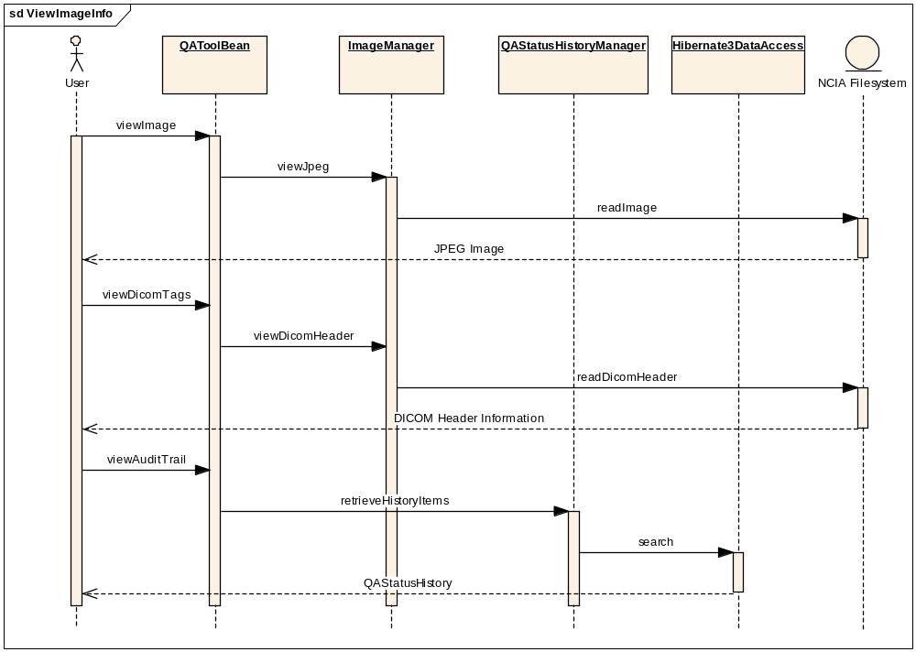

QAToolBean
The QAToolBean is the backing bean that is responsible for holding all of the data that is relevant to the QC Tool on the JSF side. It contains the tree representation (as a TreeModelBase object) of all of the data the user is able to work with in the QC tool. It also contains various methods called from the UI using JSF to perform various actions such as viewing an image, viewing the DICOM tags of an image, expanding a node, and viewing the QC status history. It includes a semaphore “workInProgress” to sync the visibility changing process with the tree navigation process.

VisibilityStatusManager
The VisibilityStatusManager changes the visibility status of an item by using Hibernate3DataAccess. It uses optimistic locking in Hibernate to make sure that another user has not changed the status of an image since it was initially loaded.
The changeStatus() method takes in a domain object and an integer representing the status that the object should be changed to. It will attempt to change the visibility of that object. If the object has already been changed, Hibernate should throw a StaleObjectStateException. It will catch this exception and pass it up to the user interface, with the message: “Could not change status of the image because another user has made a status change to the same image.” Once the status has been changed on the image, it will be highlighted in the tree, and all of the levels above the changed image will also be highlighted. When an image is changed to QC status “visible”, the curationTimestamp will be updated.

QAStatusHistoryManager
This class adds a QAStatusHistoryItem for an image for auditing purposes. It will take in a GeneralImage PK ID, an old QC Status, a new QC Status and a comment. It will then create a record for that particular GeneralImage.
The class also has a method retrieveHistoryItems() that takes in a GerneralImage PK ID as a parameter and return a list of QAStatusHistoryItems for that image to be displayed on the UI.

ImageManager
The ImageManager will perform all of the reading of image files and DICOM files from the file system. It will allow the user to view the full size JPEG image and also the DICOM header info. The viewDicomHeader() method takes in an ID from the registered Ids and then will return a hash map of key value pairs representing the DICOM header information where the key is the tag number and the value is the actual value for the image. Will open the DICOM image from the file system and parse it using dcm4che library.

QATreeManager
This class’s getChildren() method will take in a String representing an identifier of a node and return a list of strings that are the identifiers of the children nodes for that node so that the children nodes can be built. It will use Hibernate3DataAccess to retrieve the domain objects with the correct visibilities. It will make sure that the user has the MANAGE_VISIBILITY_STATUS privilege for the protection elements in question.

MailManager
A method sendQAStatusEmail() is added into the class to send the user notification that the user’s request for changing the visibility of patients, studies or series is completed successfully.

Data
Data is retrieved using the QA_STATUS_SUMMARY view into a set of nodes that are displayed on the user interface.
To make updates to QC status, the system uses several domain classes in the updateabledomain package. These classes are:
- QAStatusHistoryItem
- TrialDataProvenance
- Patient
- Study
- GeneralSeries
- GeneralImage

Presentation

QC Tool Navigation Page
There will be a new link on the left hand navigation bar that will appear for users that have the MANAGE_VISIBILITY_STATUS privilege for at least one protection element.
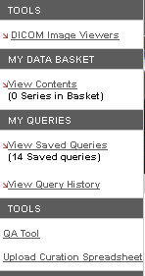

QC Tool Page
On the QC Tool page, the side submenu will be removed and be replaced with a tree structure that will allow the user to navigate through the different visibility statuses, trials, patients, studies and series. When a user clicks on a node in the tree, relevant information to that item will be displayed in the main section of the page. However, the tree navigation is disabled when the application is processing the user’s request to change the visibility status of patients, studies and series. The navigation will be enabled again when the job is completed.
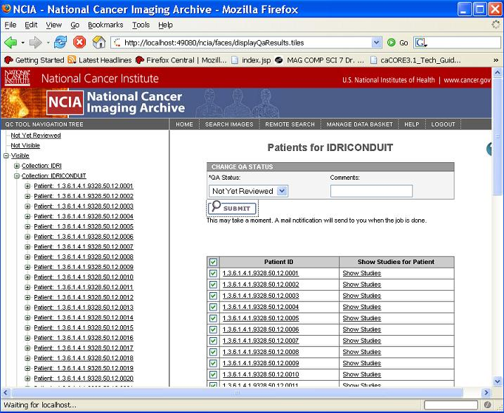
In the main section of the page is where the user will be able to perform the actions that allow them to change the visibility status of that item. A message will show up on the page after the user click the Submit button to inform the user it may take a moment to process the request. The user will be notified by email when the job is completed if the status change request is at patient, study or series level which may involve a lot of image files and takes long time. And a job completion message will also be displayed on the page under the Submit button.
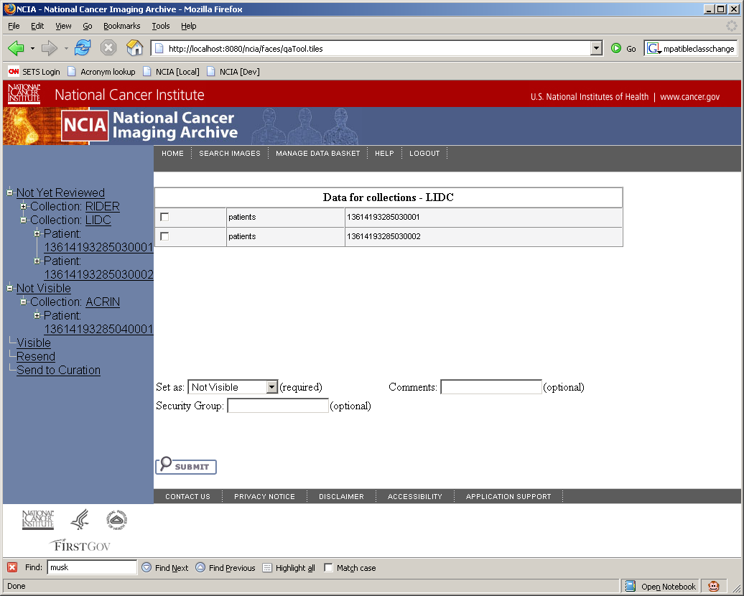

When a user clicks on a series, a page with all of the images will be displayed. On this page, a user will be able to view the full sized jpeg image, which will open in another window.
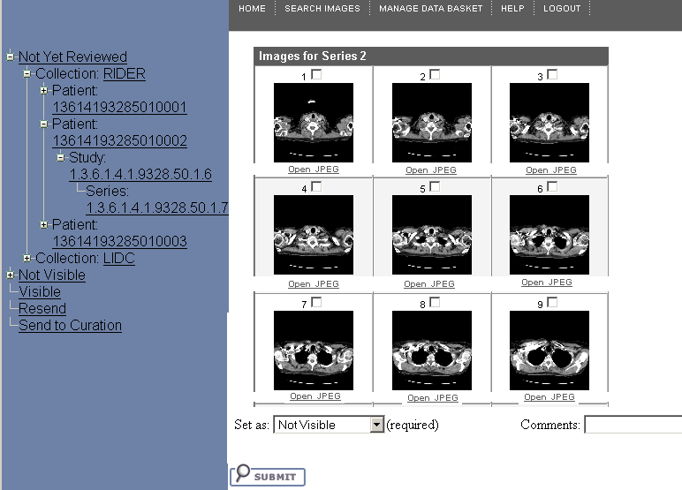

DICOM Header Page
They will also be able to view the DICOM header information, which will also open in another window. In that window, the information will be displayed in a table that looks similar to the DICOM information page displayed by MIRC:
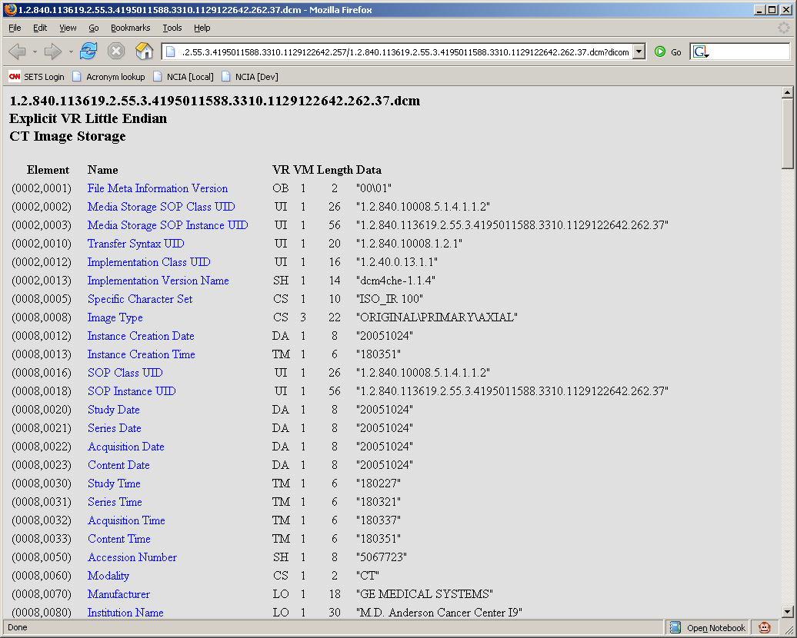

QC Status Page
Also on the image page, a user will be able to view the audit trail of the image and see who has made the changes to the visibility status, as well as when they were made. When the click on the View QC Status History link, a new page will open up, displaying a table similar to this:

Date | User | Comment | Old Value | New Value
7/6/2006 7:15 AM | John Doe | Make Visible | Not Yet Reviewed | Visible

References to Other Documents
Refer to the NCIA use cases document for more details of the functionality.

Impact to Other Components
There QC status as set in the QC tool determines whether images appear as results in the search functionality.

System Security
The link for the QC Tool only appears if the user has been granted the MANAGE_VISIBILITY_STATUS role for at least one collection, site, or series security group.
Once the user is accessing the QC tool, the user interface will only include data for which the user has been granted the MANAGE_VISIBILITY_STATUS role. This applies at the collection, site and series security group level.

Error Handling
The only errors handled by this functionality relate to multiple users changing the same data. There is a risk that two users could access the same data resulting in one user’s changes being overwritten by another’s. This is handled using an optimistic locking strategy. Depending on the context, the following messages appear when changes the user has just made would overwrite another user’s changes:
- Could not change status of the image because another user has made a status change to the same image
- Could not change status of the image with SOP instance UID {0} because another user has made a status change to the same image
This is implemented using Hibernate’s optimistic locking features by adding a version attribute to each class that could be modified as part of the QC tool. If data has been changed by another user, a StaleObjectStateException is thrown by Hibernate.

Performance
The view QA_STATUS_SUMMARY (see Appendix B for details) was added to increase the performance of accessing NCIA data based on QC status.

Migration
N/A

