

MIRC NCIA Database Adapter Reorganization

Software Design Description

Release 3.0


Document Change Record
Version Number | Date | Description
1.0 | August 8, 2007 | Initial document
1.1 | August 23, 2007 | New template applied and additional content added

TABLE OF CONTENTS
1. Introduction 1
1.1 Project Background 1
1.1.1 MIRC 1
2. System Architecture 2
3. components 3
3.1 MIRC NCIA Database Adapter 3
3.1.1 Provide rollback mechanism when an error or exception occurs 3
3.1.1.1 Current Problems and Risks: 3
3.1.1.2 Technical Solution 3
3.1.1.3 Sequence Diagrams 4
3.1.2 SOP Instance UID is unique 6
3.1.2.1 Current Problem 6
3.1.2.2 Technical Solution 6
3.1.2.3 Anticipated Benefits of Technical Solution 8
3.1.2.4 Risks of Technical Solution 8
3.1.3 Upgrade MIRC code base to version T32 8
3.1.3.1 Current Problem 8
3.1.3.2 Technical Solution 8
3.1.3.3 Anticipated Benefits of Technical Solution 8
3.1.4 Insert/update project rule has changed. 8
3.1.4.1 Current Problem 8
3.1.4.2 Technical Solution 9
3.1.4.3 Anticipated Benefits of Technical Solution 9
3.1.5 Reorganize the NCIADatabase class. 9
3.1.5.1 Current Problem 9
3.1.5.2 Technical Solution 9
3.1.5.3 Anticipated Benefits of Technical Solution 10
3.1.6 Annotation inserted could link to wrong series. 10
3.1.6.1 Current Problem 10
3.1.6.2 Technical Solution 10
3.1.6.3 Anticipated Benefits of Technical Solution 11
3.1.7 Add better logging. 11
3.1.7.1 Current Problem 11
3.1.7.2 Technical Solution 11
3.1.7.3 Anticipated Benefits of Technical Solution 12
Appendix A – acronym List 13

Introduction
The purpose of this document is to describe the design for the enhancements and issues relating to the current NCIA Database Adapter for release 3.0 of NCIA.

Project Background

MIRC
Medical Imaging Resource Center (MIRC) software was developed by the Radiological Society of North America (RSNA). The goal of MIRC is to provide tools for sharing radiological images for education and research purposes. MIRC offers a simple way to identify, index and retrieve images, teaching files and other radiology information.
For NCIA, MIRC handles the submission of images, storing images in the file system, and exporting images to the database. After images are submitted to the database, the private DICOM fields are anonymized so that they are not available to users who download the images.
MIRC runs on Tomcat, an open source servlet container developed by the Apache Software Foundation.

System Architecture
Please refer to NCIA Architecture Overview.doc at https://gforge.nci.nih.gov/plugins/scmcvs/cvsweb.php/ncia-docs/design/NCIA%20Architecture%20Overview.doc?cvsroot=ncia for more information.

components

MIRC NCIA Database Adapter
The MIRC Database Service provides a hook for developers to include custom code to export the DICOM information to a database. This functionality is provided through extending a adapter class, which for the NCIA is implemented as the NCIA Database Adapter class. This class extracts selected data from the DICOM header fields and stores it in the NCIA table structure.
Hibernate 3 is used to interact with the database. Mapping files are generated using the caCORE SDK but are then modified to allow for updates instead of reads.
The Database Adapter does not implement certain business logic, a deficiency that has caused issues for the image submission process that need to be resolved. These details are elaborated in the subsections below.

Provide rollback mechanism when an error or exception occurs

Current Problems and Risks:
The current implementation closes a session when it is done with an update or insert into the database. In this close session action, it calls commit to the database. This works fine when there is no error or exception. However, when an error or exception occurs a record is still being updated or inserted into the database, rather than being rolled back.

Technical Solution
1. Transaction management is available in the current implementation. However, it is missing the rollback mechanism to abort a transaction when an error or exception occurs. Add a rollback method that uses this mechanism to prevent statements from being committed to the database.
2. Correct the current implementation so that commits are not automatically called when a session is closed.
3. The following modifications are needed to complete this effort:
- Add new method called rollback() to IDataAcess interface
- Add new method called rollback() DataAccessProxy class
- Add new method called rollback() to HibernateDataAccess class and add implementation for the method.
- Call this rollback() method when an exception or error occurs.
- Testing: Since NCIA cannot get data directly from different collections. Test data such as dicom image file will be created and JUnitTestCase will be written to simulate an submission with the following scenarios to test this effort:
    - Dicom image that has good data which means it will pass the parsing and insert into NCIA data without any error.
    - Same dicom image in (a) to be resubmit to NCIA database to test for updating of image.
    - Dicom image contains bad data such as having SeriesNumber as double value where NCIA expects an integer value. This will result in NumberFormatException. In this case, the rollback of transaction must occur to ensure none of the tables will be updated.
IDataAcess interface class. Interface contains method declarations for database transaction.
New Methods | Type | Description
Public abstract void rollback() | void | Method definition
DataAccessProxy class. It provides methods for searching and storing data. Each instance of DataAccessProxy is initialized to use the appropriate DataAccess class based on the way in which data is being accessed. In this case, Hibernate 3 is used. So the DataAccessProxy creates the HibernateDataAccess instance.
New Methods | Type | Description
Public void rollback() | void | Uses as proxy
HibernateDataAccess class. This class provides details implementation for methods that are declared in IDataAcess class.
New Methods | Type | Description
Public void rollback() | void | Rollback a transaction to database

Modify Methods | Type | Description
Public void close() | void | This method close the current session to the database. Modify this method to remove the commit() call.

Sequence Diagrams
Figure 1 shows the sequence of an insert/update to the database when there is no error or exception occurs. When image already exists in NCIA database, the information related to this image is updated. When image is new to NCIA database, its information is inserted.
Figure 2 shows the sequence of a rollback to the database when an error or exception occurs. This ensures that records are not committed to the database.
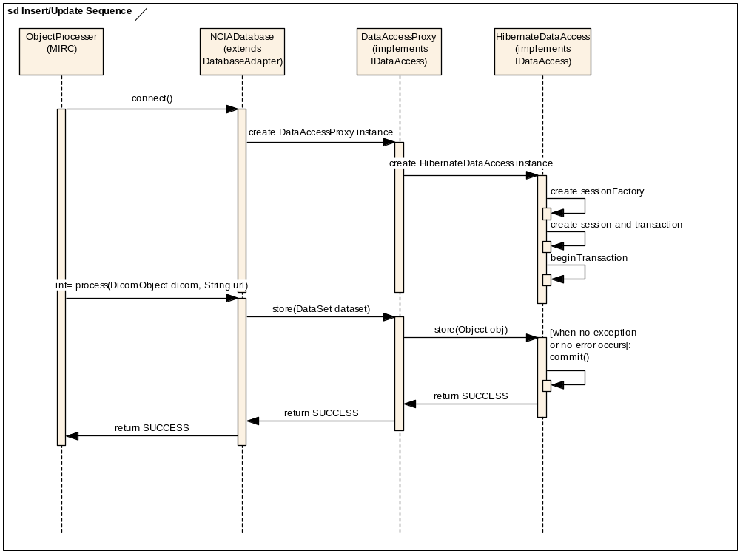
Figure 1: Insert/Update Sequence Diagram.

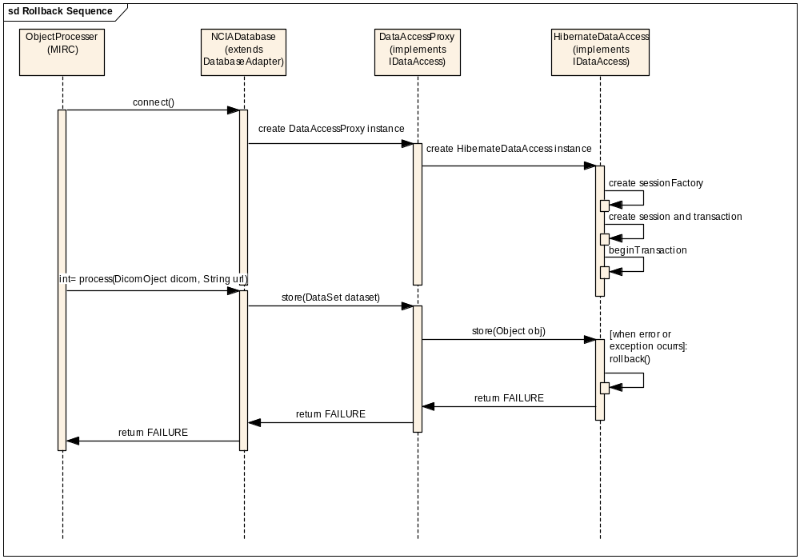
Figure 2: Rollback Sequence Diagram

SOP Instance UID is unique

Current Problem
SOP instance UID is unique for every image. The NCIA Database Adapter uses this to query and update data in the database.
Current implementation uses SOP Instance UID as criteria to check for image which already exists in NCIA repository. This logic works fine when a user attempts to update this record with the same patient id, study instance UID, series instance UID, project and site name. However, it’s possible that a user could send an image with same SOP Instance UID but with different patient id, study instance UID, series instance UID, project or site name. This will result in a new record with same SOP Instance UID being inserted into NCIA database table structure. This scenario can be mitigated base by implementing the technical solution described below.

Technical Solution
- Modify the current implementation to check for patient, study, series, project name, and site to ensure that the image being updated has the same patient, study, series, project and site as it is in the repository. The approach is to use SOP Instance UID as criteria to query the database for existing records. Based on the number of records return from the query, do the following:
  - If the number of record returns is zero, proceed to insert the information related to the image to the database as this is a new submission.
  - If the number of record returns is one, this is an update to an existing record. Add logic to check for patient, study, series, project and site information before doing update. If this check fails, provide an error the message to log file as to why it fails and quarantine the image.
  - If the number of record turn is more than one, this should not happen when all duplicate records in database have been resolved. If it happens, quarantine the file and provide error message to the log file as why this dicom image is quarantined.

Note that it is not feasible to simply use SOP Instance UID, patient, study, series, project, and site as criteria to query the database. This approach will not work if any of the criteria fields are different when compared to a record in the database. In this scenario, zero records would be returned and the system would consider this as a new submission – an adverse condition that would create a duplicate record with the same SOP Instance UID.

- GeneralImageOperation class. This class contains methods that query NCIA database to check for existing records prior to insert or update of the record.
The following methods need modifications to add additional logic to ensure the correct SOP Instance UID, Patient ID, Study Instance UID, Series Instance UID, project name and site name are updated.

Modify Methods | Return Type | Description
validate() | GeneralImage | This method queries the database for records with same SOP Instance UID of the image. Modify this method to find the correct record returns from the query to update if the record exists in the database as mentioned on technical solution above.

- Testing: Create test data and using JUnitTestCase in section 3.1.1.2 above to test this effort:
  - Find good dicom image in NCIA database. Modify patient id value to be different and resubmit this image. The new code base should catch this, quarantine the file and provide an error message to log file as the reason this image is quarantined.
  - Repeat the test in (a) with each of the following fields: study instance UID, series, project, site.
- Add unique constraint to SOP_Instance_UID column in General_Image table

Anticipated Benefits of Technical Solution
This will eliminate many potential problems regarding image submission such as duplicate images with same sop instance UID.

Risks of Technical Solution
Adding logic to check for patient, study, series, project, site information will result in additional time to process the request. It’s anticipated at this time that this additional computation time will not significantly impact the image submission processing time.

Upgrade MIRC code base to version T32

Current Problem
Current NCIA MIRC code based contains mixed of version T29 and T30 of MIRC. It has been difficult to figure out which portion of T30 is used in T29. T32 contains the latest version of MIRC which have many fixes in the past year.

Technical Solution
- Get version T32 of MIRC based on tag T32kappa-nci that John Perry provided.
- Modify the build file to build MIRCSite installer using this code base.
- Testing: test version T32 with new NCIA Database Adapter with the following scenarios:
  - Find Good Dicom images from NCIA Database
  - Create new test collection, dicom-anonymized.properties file, and submit the images using Field Center.
  - Using same set of images in (b), set the patient id to be different and resubmit them. This scenario should fail and the log file will provide proper message as the reason it fails
  - Using JUnitTestCase in section 3.1.1.2 and run test for new MIRC NCIA Adapter.

Anticipated Benefits of Technical Solution
Using version T32 ensure that NCIA use the latest code based that MIRC provided.

Insert/update project rule has changed.

Current Problem
NCIA Database Adapter inserts project as Project –TRIAL-x where x is trial data provenance ID.

Technical Solution
- Remove the current implementation where project column is inserted as mentioned above.
- The following method in GeneralImageOperation class needs modification to insert project as it is.

Modify Methods | Return Type | Description
validate() | GeneralImage | GeneralImage object is being built as a result of the method. This is then used to either update or insert into the database. Modify this method to remove the “-TRIAL-x” as part of value for this column.

3. Testing: Use the same JUnitTestCase in section 3.1.1.2 to test this effort. Check database for value of project name in project column of General_Image table.

Anticipated Benefits of Technical Solution
This will allow query to get project directly from General Image without having to join with Trial Data Provenance. This will save time on any query that needs the join between General Image and Trial Data Provenance. However, when this change is in place, developers need to change their queries to make use of this feature.

Reorganize the NCIADatabase class.

Current Problem
This class has become too long. This class should be broken into sub classes with similar categories.

Technical Solution
The NCIADatabase class is broken into three main categories of functionality:
- Methods that implement the DatabaseAdapter class provided by MIRC.
- Methods that query the NCIA database and builds the domain objects.
- Utility methods that are used by the NCIADatabase and BuildQueries classes.

The methods that query NCIA database and build the domain objects can potentially become very large again.
In order to prevent this, a BuildQueriesMediator class, based on the Mediator design pattern (http://en.wikipedia.org/wiki/Mediator_pattern), will be implemented to send and receive information to the concrete DomainOperation class to perform operation specific to that class. The concrete classes are
- PatientOperation
- StudyOperation
- SeriesOperation
- TrialDataProvenanceOperation
- TrialSiteOperation
- ClinicalTrialOperation
- GeneralEquipmentOperation
- GeneralImageOperation
- CTImageOperation
- AnnotationOperation
These concrete classes inherit from DomainOperation abstract class and implement the validate method where it checks for existing domain records in NCIA repository prior to update or insert and perform business logic and dependency validations. The advantage of the mediator design pattern is that all of the procedural logic for each operation becomes decoupled into the concrete subclasses of the abstract DomainOperation class.

With this approach, the NCIADatabase class has approximately 400 lines of code, AdapterUtil has approximately 200 lines of code, BuildQueriesMediator has approximately 100 lines of code, each concrete class has approximately 100 lines of code and DomainOperation abstract class has less than 100 lines of code.

Figure 3 shows a new class diagram that contains new classes. The XOperation is concrete domain class that will perform specific validation and query for that class. As new domain is introduced in the future, new concreteOperation is created.

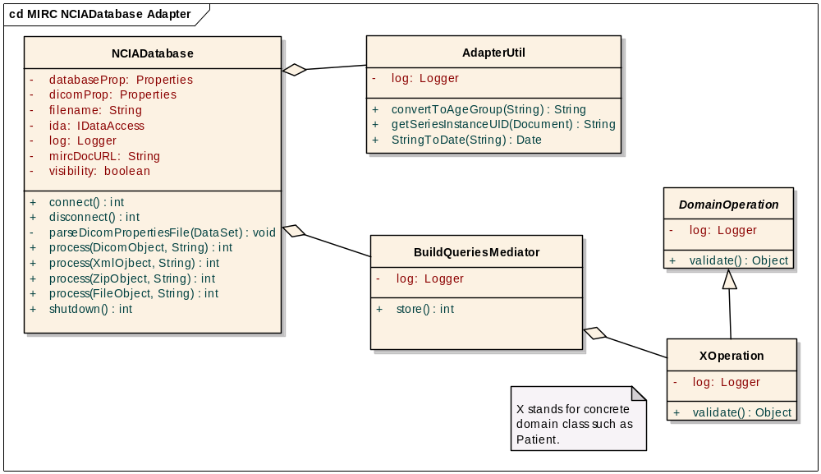
Figure 3. Class diagram

Anticipated Benefits of Technical Solution
By breaking up this class, it will become easier to read, maintain, and understand. As new methods are needed in the future, a developer will then be able to add those into appropriate class.

Annotation inserted could link to wrong series.

Current Problem
Current implementation selects the first annotation series returned from query. This selected series could have a different study instance UID or Patient ID with the annotation’s study instance UID or patient ID. This problem is also a result of problem described in section 3.1.2 above

Technical Solution
- Using Series Instance UID to query for GeneralSeries. Get Study information to check with series returns from the query to find the correct one before associating series with annotation.
- The following method in AnnotationOperation class needs modifications

New Methods | Return Type | Description
insertOrReplaceAnnotation() | void | This method saves the annotation and finds the series with which it is associated and updates the series flag. Need to add logic to compare study and patient information with the image’s study and patient, respectively, and select the associated series to be updated.

- Testing: Find in NCIA Database an annotation file that associates with a wrong series and resubmit this file to test a new code based. If an annotation file associates with wrong series could not be found. Create new annotation file based on an existing one, modify the study Instance UID to be different and submit this annotation file. The annotation file should link to the series and study instance UID that has been modified.

Anticipated Benefits of Technical Solution
This will eliminate the problem where an annotation gets linked to an incorrect series.

Add better logging.

Current Problem
Currently very minimal logging is done. It’s hard to troubleshoot when any problem occurs. The log file also gets very large over time.

Technical Solution
Log4J is being used to log errors, warnings or information to a log file that can be examined later to find causes of a problem. In each class, add more meaningful messages using log4j to the log file when an exception or error occurs.
For example: In GeneralImageOperation.validate method, the image being updated has a different patient id with record stores in NCIA database, add the following message to the log file: Fill in values in parenthesis’s with appropriate values.
“BuildQueriesMediator class: GeneralImageOperation – image quarantined because it has different patient id (given the image patient id) with patient id (given patient id from database) in database. SOP instance UID is (given SOP Instance UID), Study Instance UID is (given study instance UID).”

Modify the log4j.properties file to create new log file as it gets to 5MB in size and keep the most recent 5 log files.

Anticipated Benefits of Technical Solution
The additional logging will save a tremendous amount of time in the diagnosis of problems when an exception or error occurs.

Appendix A – acronym List
Acronym | Description
MIRC | Medical Imaging Resource Center
NCIA | National Cancer Imaging Archived
SOP | Service-Object Pair
UID | Unique Identifier

