Persistence and Retrieval of Image Markups
With Cedara IRW

Software Design Description

Version 1.0

[Insert approval date of document]

Document Change Record
Version Number | Date | Description
1.0 | [insert approval date of document] | Initial document

TABLE OF CONTENTS
1. Introduction 1
1.1 Requirements Traceability 1
1.1.1 Relevant Statement of Work Tasks 1
1.1.2 GForge Task Track 1
1.2 Project Background 1
1.2.1 Cedara IRW 2
1.2.2 Cedara ISG 2
1.2.3 System Overview 2
2. System Architecture 3
2.1 System Architecture Overview 3
2.2 Interfaces 4
2.2.1 The Request NCIA Sent to IRW 4
2.2.2 The Query IRW Sent to NCIA MarkupQuery Servlet 5
2.2.3 The Response MarkupQuery Servlet Sent to IRW 5
2.2.4 The Query IRW Sent to NCIA MarkupRead Servlet 6
2.2.5 The Response MarkupRead Servlet Sent to IRW 6
2.2.6 The Query IRW Sent to NCIA MarkupSave Servlet 6
2.3 Database Design 6
2.3.1 Database Changes for Image Markup Data 8
2.3.2 Database Tables Reused for Security Data 8
3. Components 13
3.1 Changes in Web.xml 13
3.2 Changes in Search Result Bean 13
3.3 Servlet Classes and the helper class 14
3.3.1 MarkupServlet Class 15
3.3.2 MarkupQueryServlet Class 15
3.3.3 MarkupReadServlet Class 15
3.3.4 MarkupSaveServelt Calss 15
3.3.5 ImageMarkup Class 16
3.3.6 MarkupDTO Class 16
3.3.7 MarkupDelegate Class 16
3.3.8 MarkupManager Class 17
Appendix A – acronym List 18
APPENDIX B – DATABASE 19

Introduction
This Software Design Description (SDD) describes the design decisions, architectural design, and the detailed design needed to implement the image markup persistence and retrieval feature being developed for Release 3.0 of the NCIA. This enhancement will provide new functionality to allow users to persist and retrieve image markups using Cedara I-Response software.

Requirements Traceability

Relevant Statement of Work Tasks
The NCIA Statement of Work (SOW) Task Description contains items that will be implemented in this design. Please refer to NCIA Release 3.0-3.1 SOW FY007_FY008_Tasks_List.doc for relevant information.

GForge Task Track
The NCIA GForge Task Track contains the following items that will be implemented as part of this design:
Task Number | Task Summary
1411 | Create 3 servlets for Cedara software integration
1413 | Design sequence, DB schema, and mechanism for markup persistence
1396 | Evaluate CSM mechanism for providing Cedara markup authorization
Table 1 Task Track Items

Project Background
The National Cancer Imaging Archive (NCIA) is a searchable repository of in vivo cancer images. The system provides the cancer research community with public access to images in DICOM format as well as rich metadata and annotations. The upcoming release 3.0 will support retrieval and persistence of image markup with the Cedara I-Response, an image viewing tool.

Cedara IRW
The Cedara I-Response Workstation (IRW) is a client application for the Cedara Imaging Service Grid Server.

Cedara ISG
Cedara Imaging Service Grid Server (ISG) is a web application server which provides distributed image rendering service.

System Overview
NCIA integrates with Cedara IRW and IGS, a third party software, to provide the user the capability to visualize images identified on the NCIA Search Result page. When the user makes a request to view the images on the search result page, NCIA sends the list of series UIDs, user credential information, and Cedara Imaging Grid Server (ISG) address to a HTTP endpoint established by IRW. IRW relays the request to ISG. ISG ensures the number of concurrent users does not exceed the licensed value and then queries NCIA for each requested series. NCIA validates user credentials and returns a file path list of the DICOM files associated with the series. ISG loads the DICOM data, prepares rendering engine, and sends DICOM header information of the loaded data back to IRW. IRW then displays the image the user requested. In release 3.0, IRW will provide additional functionalities to support image markup which will be persisted and retrieved by NCIA.

System Architecture

System Architecture Overview
NCIA, Cedara IRW and ISG are designed to be a HTTP endpoint and communicate with a set of predefined protocols. Upon receiving the request from IRW and ISG, NCIA will retrieve the requested data from database and send them back or save the data user created using IRW to database. The Figure 2-1 captures architecture design for integration of NCIA with Cedara IRW and IGS.
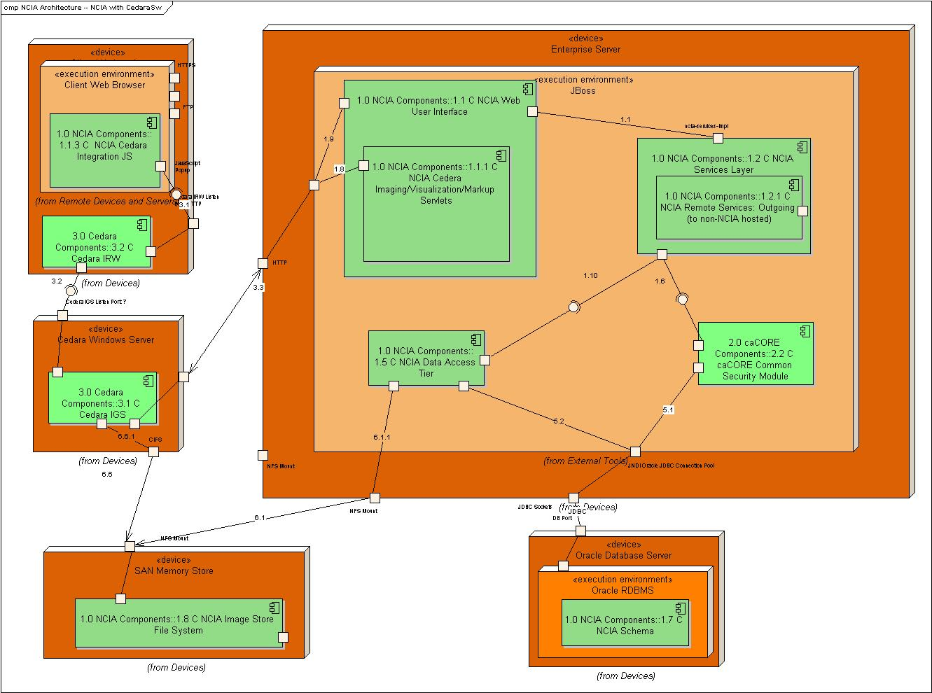
Figure 2-2 Architecture Diagram
NCIA Cedara Imaging Visualization/Markup Servlets Component, in release 3.0, will be expanded to include three new servlets to accommodate the markup query, markup read and markup save functionalities. All markup contents will be saved into database. Users’ credential for accessing existing markups and creating new one will be checked using common security module.

Interfaces
This section describes the communication interface between NCIA and Cedara I-Response workstation (IRW). The Figure 2-3 illustrates how NCIA and IRW interact with each other using http protocols. The label of each message in the diagram is the title of a section in which the protocol used is described in detail.
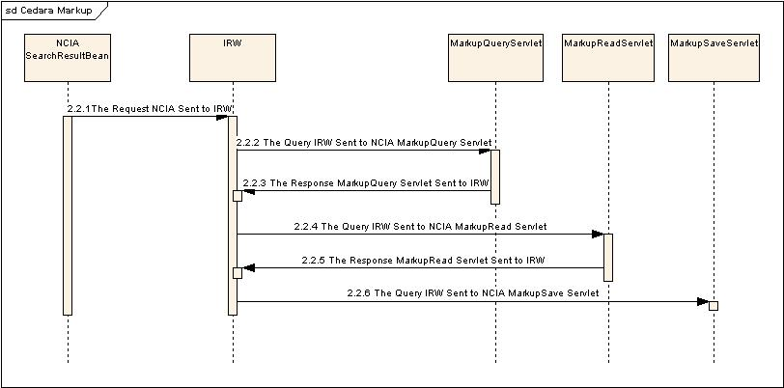
Figure 2-4 NCIA and IRW Communication Sequence Diagram

The Request NCIA Sent to IRW
When the user makes a request to view the images/markups on the search result page of NCIA portal, NCIA sends the list of series UIDs, user credential information, and Cedara Imaging Grid Server (ISG) address to a HTTP endpoint established by IRW. The request is submitted in the following format:
host = <IRW url>?usr=<user loging name>&uid=<series-uid>&host=<IGS url>&archive =<Markup servlet url>
For example:
http://localhost:8889/?usr=gwb@mail.nih.gov&uid=1.3.6.1.4.1.9328.50.1.7&host=http://137.187.182.176:8080&archive=http://imaging.nci.nih.gov/ncia/MarkupQuery
Note: the characters in green indicate that this is added for reading/saving Markups.

The Query IRW Sent to NCIA MarkupQuery Servlet
After receiving the request from NCIA, IRW relays the request to IGS and simultaneously queries the MarkupQuery servlet on the NCIA archive. The HTTP request method is GET and the query string format is as follows:
&~usr=<user loging name>&>&uid=<series-uid>
For example:
&~usr=gwb@mail.nih.gov&uid=1.3.6.1.4.1.9328.50.1.81

The Response MarkupQuery Servlet Sent to IRW
NCIA archive sends IRW a query response which contains URLs for reading and saving markups on the NCIA, current user and his/her privileges to see markups created by other users. The response content type is "text/plain;charset=UTF-8." The response content is as follows:
uid=<series-uid>& - series instance UID
readURL=<MarkupRead servlet url>& - optional. Contains the context path of the MarkupRead servlet's URL used for reading markup. If specified it means the markup for this series can be read from the archive using this URL.
writeURL=<MarkupSave servlet url> - contains the context path of the MarkupSave servlet's URL used for saving markup.
user=<user loging name >&writable=<y/n> - current user name/alias and his/her writable privilege (y for “yes”, n for “no”)
other_user=<name>&readable=<y/n> - a privilege of the current user to read markups (if any) previously created by this user ( y for “yes”, n for “no”)
…
other_user=<name>&readable=<y/n> - a privilege of the current user to read markups (if any) previously created by this user ( y for “yes”, n for “no”)
IRW supports * wild-card character in <name> which means “all other users except explicitly specified”.
The example of the response is as follows:
uid=1.3.6.1.4.1.9328.50.1.81&
readURL=/ncia/MarkupRead&
writeURL=/ncia/MarkupSave
user=gwb@mail.nih.gov&writable=y
other_user=abc&readable=y
other_user=efg&readable=y
other_user=hij&readable=y

In case of failure, the servlet should send an HTTP error code. The error response body (if any) should be encoded as "plain/text".

The Query IRW Sent to NCIA MarkupRead Servlet
IRW queries the MarkupServlet on the NCIA. The HTTP request method is GET and the query string format is as follows:
&~usr=<user loging name>&>&uid=<series-uid>
For example:
&~usr=gwb@mail.nih.gov&uid=1.3.6.1.4.1.9328.50.1.81

The Response MarkupRead Servlet Sent to IRW
MarkupRead servlet sends IRW a response to the markup read query. The content type is "text/xml; charset=UTF-8." It contains serialized markup in XML format. The schema for the XML stream sent to IRW can be found in GForge: http://gforge.nci.nih.gov/plugins/scmcvs/cvsweb.php/ncia-docs/Image%20Markup%20and%20Persistence/markup.xsd?cvsroot=ncia.
In case of failure the servlet will send an HTTP error code. The error response body (if any) should be encoded as "plain/text".

The Query IRW Sent to NCIA MarkupSave Servlet
When user decides to save markups she/he created, IRW sends the markup serialized in XML format to MarkupSave servlet on the NCIA. The schema for the XML stream received can be found in GForge: http://gforge.nci.nih.gov/plugins/scmcvs/cvsweb.php/ncia-docs/Image%20Markup%20and%20Persistence/markup.xsd?cvsroot=ncia.

Database Design
The image markup retrieval and markup persistence features will add two types of data to NCIA database: the image markup data and the security data which specify the user’s privilege for viewing existing markups and saving the new one. The Figure 2-5 shows the database tables will be used for image markup persistence and retrieval features.
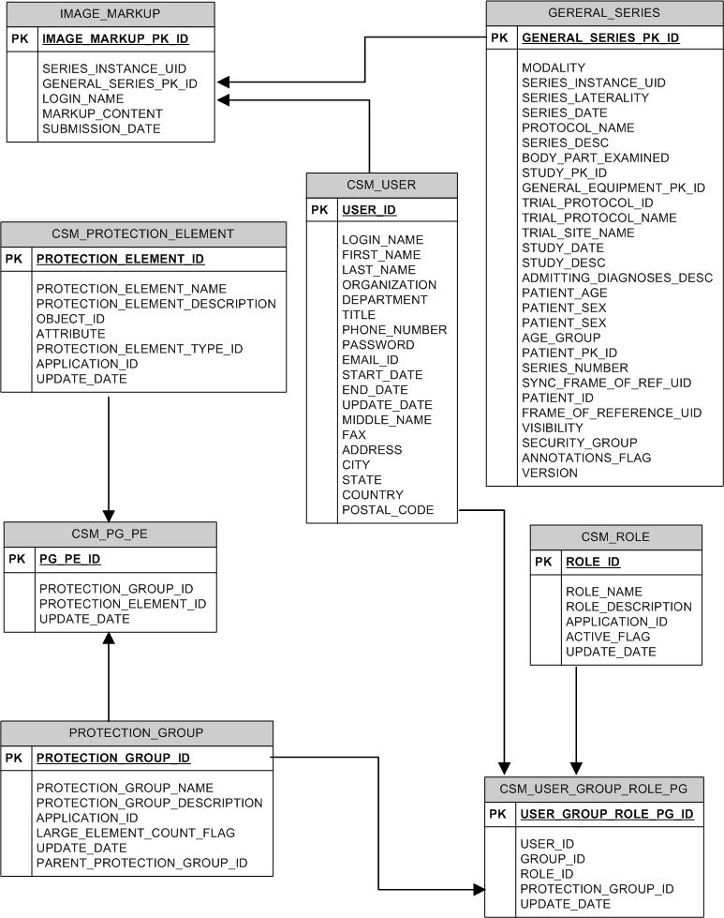
Figure 2-6 Database Tables Used in the Image Markup P&R Features

Database Changes for Image Markup Data
A new database table IMAGE_MARKUP will be created in the NCIA database schema to store the markup context in a CLOB column. The following table will show the columns names, data types and the descriptions of the data stored in each column.

Column Name | Data Type | Description
IMAGE_MARKUP_PK_ID | NUMBER | Primary key
SERIES_INSTANCE_UID | VARCHAR2(64) | The series instance UID
GENERAL_SERIES_PK_ID | NUMBER | The foreign key corresponding to the series instance UID in the GENERAL_SERIES table
LOGIN_NAME | VARCHAR2(300) | The login name of the user who creates the markup
MARKUP_CONTENT | CLOB | The content of the image markup
SUBMISSION_DATE | DATE | The date of the markup is created/updated

Table 2. IMAGE_MARKUP Table
Note the structure of IMAGE_MARK table implies that different user’s markups for same series are stored in different rows. The LOGIN_NAME will denote who is the originator of the markup. The reason behind this design decision is that two different users might be doing markups on the same series simultaneously. The above database design will help to keep data synchronization simple. However, for release 3.0, the markups done by different users for the same series will be kept in one data base record since current Cedara software does not support parsing multiple users’ markup and later merging each user’s markup for same series into the xml stream used by IRW. The multiple concurrent users marking up same series will be supported in release 3.1 or later.

Database Tables Reused for Security Data
Reading and writing markups from and to database will go through the security check which is the part of the new image markup and markup persistence features. To accommodate the security data which specify the user’s privilege for viewing existing markups and saving the new one, four CSM tables in NCIA database schema can be reused. The five tables include: CSM_ROLE, CSM_PROTECTION_ELEMENT, CSM_PROTECTION_GROUP, CSM_PG_PE, and CSM_USER_GROUP_ROLE_PG. The following tables show how each CSM table is reused to hold the necessary security information to protect the markup data from unauthorized access.

CSM_ROLE
Two roles are needed to add to CSM_ROLE table for the image markup feature: NCIA.MARK_READ for reading image markup privilege and NCIA.MARK_WRITE for saving the markup privilege.
The following table shows the data sample stored which will be used in the security checking for markup retrieval.
Column Name | Sample New Data | Description
ROLE_ID | 6 | Primary key
ROLE_NAME | NCIA.MARK_READ | New role name for reading image markup.
ROLE_DESCRIPTION | View image markup | New role description
APPLICATION_ID | 1 | Just follow the old convention
ACTIVE_FLAG | 0 | Just follow the old convention
UPDATE_DATE | 09/04/07 | The role creation/update date

Table 3. CMS_ROLE Table

CSM_PROTECTION_ELEMENT
Each user’s markup for a specific image series is defined as a protection element. The format is NCIA.[SERIES_INSTANCE_UID]//[LOGIN_NAME]. Note the information after “//” is optional. If it is omitted with “//”, it means the protection element includes all markups in the specific series. The following table shows a sample protection element defined for the image markup retrieval and persistence.
Column Name | Sample New Data | Description
PROTECTION_ELEMENT_ID | 1234567 | Primary key
PROTECTION_ELEMENT_NAME | NCIA. 1.3.6.1.4.1.9328.50.1.3//panq@mail.nih.gov | Protection element name for image markup. The format is : NCIA.[SERIES_INSTANCE_UID]//[LOGIN_NAME]
PROTECTION_ELEMENT_DESCRIPTION | NCIA.IMAGE_MARKUP | This description should apply to all image markups specified as protection elements.
OBJECT_ID | NCIA. 1.3.6.1.4.1.9328.50.1.3//panq@mail.nih.gov | Protection element for image markup. The format is : NCIA.[SERIES_INSTANCE_UID]//[LOGIN_NAME]
ATTRIBUTE | NCIA. SERIES_INSTANCE_UID//LOGIN_NAME | Attributes used for identifying the a protection element
PROTECTION_ELEMENT_TYPE_ID |  | Not used
APPLICATION_ID | 1 | Just follow the old convention.
UPDATE_DATE | 09/04/07 | The element creation/update date

Table 3. CMS_PROTECTION_ELEMENT Table

CSM_PROTECTION_GROUP
Protection groups need to be created for holding the protection elements for the image markup retrieval and persistence.
Column Name | Sample New Data | Description
PROTECTION_GROUP_ID | 456789 | Primary key
PROTECTION_GROUP_NAME | NCIA. 1.3.6.1.4.1.9328.50.1.3//panq@mail.nih.gov | Protection Group Name
PROTECTION_GROUP_DESCRIPTION | Markup protection group 1 | Protection group description
APPLICATION_ID | 1 | Just follow the old convention
LARGE_ELEMENT_COUNT_FLAG | 0 | Just follow the old convention
UPDATE_DATE | 09/04/07 | The role creation/update date
PARENT_PROTECTION_GROUP_ID |  | Not used
Table 4. CMS_PROTECTION_GROUP Table

CSM_PG_PE
Protection elements can be grouped into a protection group. A protection group can contain a single protection element.
Column Name | Sample New Data | Description
PG_PE_ID | 678910 | Primary key
PROTECTION_GROUP_ID | 456789 | Foreign key of the protection group data
PROTECTION_ELEMENT_ID | 1234567 | Foreign key of protection element data
UPDATE_DATE | 09/04/07 | The creation/update date of the association
Table 5. CMS_PG_PE Table

CSM_USER_GROUP_ROLE_PG
The user’s ability to view or save markup is defined in CSM_USER_GROUP_ROLE_PG table.
Column Name | Sample New Data | Description
USER_GROUP_ROLE_PG_ID | 901234 | Primary key
USER_ID | 1234 | Foreign key of the user’s data
GROUP_ID |  | Not used
ROLE_ID | 6 | Foreign key of the role data
PROTECTION_GROUP_ID | 456789 | Foreign key of the protection group.
UPDATE_DATE | 09/04/07 | The data creation/update date
Table 5. CSM_USER_GROUP_ROLE_PG Table

Components
The image markup persistence and retrieval enhancement will add three new servlets to NCIA portal based on the NCIA and I-Response NIH/ISG Interface Specification. The names of three servlets are required to be mapped to MarkupQuery, MarkupRead and MarkupSave.

Changes in Web.xml
web.xml must be modified for runing the three new servlets in NCIA portal. The following entries will be added to web.xml:
<servlet>
<servlet-name>MarkupQueryServlet</servlet-name>
<servlet-lass>gov.nih.nci.ncia.viewer.MarkupQueryServlet</servlet-class>
</servlet>
<servlet>
<servlet-name>MarkupReadServlet</servlet-name>
<servlet-class>gov.nih.nci.ncia.viewer.MarkupReadServlet</servlet-class>
</servlet>
<servlet>
<servlet-name>MarkupSaveServlet</servlet-name>
<servlet-class>gov.nih.nci.ncia.viewer.MarkupSaveServlet</servlet-class>
</servlet>
<servlet-mapping>
<servlet-name>MarkupQueryServlet</servlet-name>
<url-pattern>/MarkupQuery</url-pattern>
</servlet-mapping>
<servlet-mapping>
<servlet-name>MarkupReadServlet</servlet-name>
<url-pattern>/MarkupRead</url-pattern>
</servlet-mapping>
<servlet-mapping>
<servlet-name>MarkupSaveServlet</servlet-name>
<url-pattern>/MarkupSave</url-pattern>
</servlet-mapping>

Changes in Search Result Bean
The Search Result Bean will be modified to add the following method for providing the required MarkupQuery url to IRW.
.
New Fields/Methods | Type | Description
getArchieveValue() | String | Construct MarkupQuery url and return it as a String.

Servlet Classes and the helper class
MarkupQueryServlet, MarkupReadServlet and MarkupSaveServlet will be created as they required by the NCIA and I-Response NIH/ISG Interface Specification. Each servlet will be required to override doGet and doPost method provided by its superclass HTTPServlet and pass the request got from doPost or doGet to method processRequest. Since all three serves have some common attributes and operations, a super class which inherits from HTTPServlet and contains all common attributes and methods will be created to reduce the amount of duplicate code. A utility class is also designed to provide MarkupServlet class the required database access functionalities. Figure 3-1 shows classes designed for performing image markup persistence and retrieval functionalities.
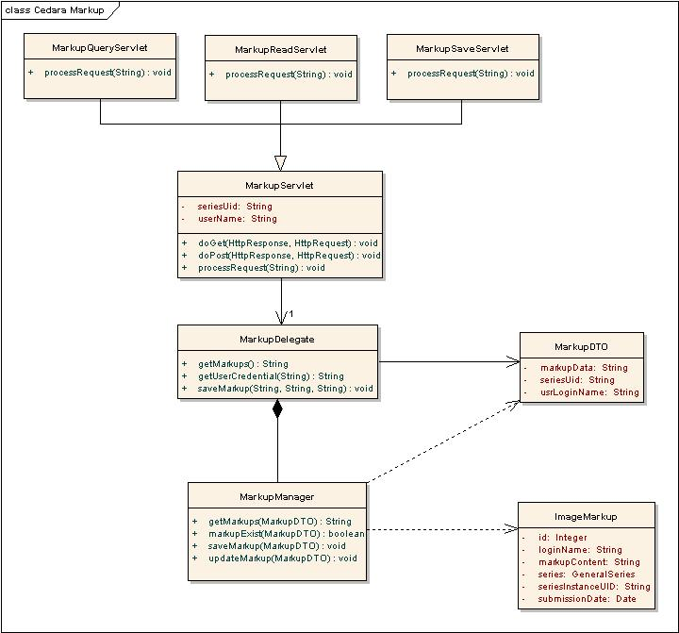
Figure 3-7 Class Diagram for Image Markup Persistence and Retrieval

MarkupServlet Class
MarkupServlet class is an abstract class. It inherits from HTTPServlet and contains all common attributes and methods needed in MarkupQueryServlet, MarkupReadServlet and MarkupSaveServlet.
New Fields/Methods | Type | Description
seriesUid | String | Image Series UID
userName | String | User login name
doGet() | void | Overrides the method provided by its superclass HTTPServlet and calls processRequest().
doPost() | void | Overrides the method provided by its superclass HTTPServlet and calls processRequest().
processRequest() | void | Abstract method.

MarkupQueryServlet Class
MarkupQueryServlet is a subclass of MarkupServlet and provides IRW user credentials and urls for MarkupReadServlet and MarkupSaveServlet.
New Fields/Methods | Type | Description
processRequest() | void | It will parse the query stream, check if any image markup exist for the given series uid, get the user credentials for the given series uid and pass the information back to IRW.

MarkupReadServlet Class
MarkupReadServlet is a subclass of MarkupServlet and provides IRW image markups for given series uid.
New Fields/Methods | Type | Description
processRequest() | void | It will parse the query stream, get all markup content from the database for the given series uid, serialize them in XML format and send back to IRW.

MarkupSaveServelt Calss
MarkupSaveServlet is a subclass of MarkupServlet and saves image markups IRW sent to NCIA database.
New Fields/Methods | Type | Description
processRequest() | void | It will parse the input stream, save the user’s markup content to database table.

ImageMarkup Class
ImageMarkup is a domain class that Hibernate uses it to map java object to the database record.
New Fields/Methods | Type | Description
id | Integer | Primary key.
seriesInstanceUID | String | Series Instance UID.
series | GeneralSeries | General Series.
loginName | String | User’s login name.
markupContent | String | Markup data.
submissionDate | Date | Submission date

MarkupDTO Class
MarkupDTO is a class designed for transferring data between Markup servlets and the MarkupManager.
New Fields/Methods | Type | Description
seriesUid | String | Series Instance UID.
usrLoginName | String | User’s login name.
markupData | String | Markup data.

MarkupDelegate Class
MarkupDelegate class constructs a DTO object and hands it over to manager class for data processing.
New Fields/Methods | Type | Description
getMarkups() | String | Construct a DTO and call the corresponding method in MarkupManager class.
saveMarkup() | void | Construct a DTO and call the corresponding method in MarkupManager class.
markupExist () | String | Construct a DTO and call the corresponding method in MarkupManager class.

MarkupManager Class
MarkupDelegate is a class performing the data processing.
New Fields/Methods | Type | Description
getMarkups() | String | Get all markup contents from the database for the given series uid.
updateMarkup() | void | Update the user’s markup content in database table.
saveMarkup() | void | Save the user’s markup content to database table.
markupExist () | String | Check if the markup for the given series uid is in database already.

Appendix A – acronym List
Acronym | Description
IRW | Cedara I-Response Workstation
ISG | Cedara Imaging Service Grid Server

APPENDIX B – DATABASE
Overview – This section describes changes needed for NCIA database to support image markups and markup persistence. The image markup and markup persistence features will add two types of data to NCIA database: the markup image data and the security data specify the user’s privilege for viewing existing markups and saving the new one. Security data will be placed on existing CSM tables. A new table IMAGE_MARKUP is created for persist the markup context in a CLOB column. The script used for creating the new table is included below.
CREATE TABLE IMAGE_MARKUP
(
IMAGE_MARKUP_PK_ID NUMBER NOT NULL,
SERIES_INSTANCE_UID VARCHAR2(64),
GENERAL_SERIES_PK_ID NUMBER,
LOGIN_NAME VARCHAR2(300),
MARKUP_CONTENT CLOB,
SUBMISSION_DATE DATE
)
TABLESPACE NCIA
PCTUSED 0
PCTFREE 10
INITRANS 1
MAXTRANS 255
STORAGE (
INITIAL 64K
MINEXTENTS 1
MAXEXTENTS 2147483645
PCTINCREASE 0
BUFFER_POOL DEFAULT
)
LOGGING
LOB (MARKUP_CONTENT) STORE AS
( TABLESPACE NCIA
ENABLE STORAGE IN ROW
CHUNK 8192
PCTVERSION 10
NOCACHE
STORAGE (
INITIAL 64K
MINEXTENTS 1
MAXEXTENTS 2147483645
PCTINCREASE 0
BUFFER_POOL DEFAULT
)
)
NOCACHE
NOPARALLEL;

CREATE UNIQUE INDEX PK_IMAGE_MARKUP ON IMAGE_MARKUP
(IMAGE_MARKUP_PK_ID)
LOGGING
TABLESPACE NCIA
PCTFREE 10
INITRANS 2
MAXTRANS 255
STORAGE (
INITIAL 64K
MINEXTENTS 1
MAXEXTENTS 2147483645
PCTINCREASE 0
BUFFER_POOL DEFAULT
)
NOPARALLEL;

ALTER TABLE IMAGE_MARKUP ADD (
CONSTRAINT PK_IMAGE_MARKUP PRIMARY KEY (IMAGE_MARKUP_PK_ID)
USING INDEX
TABLESPACE NCIA
PCTFREE 10
INITRANS 2
MAXTRANS 255
STORAGE (
INITIAL 64K
MINEXTENTS 1
MAXEXTENTS 2147483645
PCTINCREASE 0
));

CREATE SEQUENCE SEQ_IMAGE_MARKUP INCREMENT BY 1 START WITH 2 MINVALUE 1 NOCYCLE NOCACHE NOORDER;

