National Cancer Imaging Archive
(NCIA)

Architecture Refactoring Proposal
(release 2.5)

For

NCIA

Version 1.0 - Last Updated: June 5, 2007

Owner: NCIA team

National Cancer Institute Center for Biomedical Informatics and Information Technology
2115 East Jefferson Street
Rockville, MD 20852



Table of Contents

Overview of Architectural and Organizational Changes 4
Effort 1: Reorganization of CVS Modules to Address NCIA Internal Dependencies 6
Current Problems and Risks 6
Technical Solution 6
Anticipated Benefits of Technical Solution 7
Effort 2: Separate Toolkit from Portal Code 8
Current Problem 8
Risks of Current Implementation 8
Summary of Technical Solution for Phase I 8
Anticipated Benefits for Implementation of Phase I 8
Summary of Technical Solution for Phase II 9
Anticipated Benefits for Implementation of Phase II effort 9
Effort 3: Isolation and Brokering of Internal Calls to Remote NCIA Nodes 10
Current Problem 10
Technical Solution 10
Anticipated Benefits of Technical Solution 10

Purpose of this Document
This document outlines and details the critical path for a refactoring effort that is intended to create a more extensible, transparent, and maintainable code base for the NCIA. These proposed architectural and internal design pattern changes will enable necessary modifications, whether for bug fixes or new features, to be designed, implemented and tested in less time and effort than is possible with the current code base.

The focus of this refactoring effort is to establish clear application boundaries for currently existing functional components within NCIA. It is our hope that these new physical and logical application boundaries, will establish clearer dependencies allowing the development team to provide a system that can more efficiently address common requirements for a system deployed in a federated manner, such as backward compatibility and version control.

This effort touches key functional areas of the application such as data transfer through the application, grid enabled services, and data access by the application. In addition it also involves a reorganization of the codebase into smaller better change control managed CVS modules.

It is important to point out that some portions of these proposed designs are already in the application and only need to be completed or extended to leverage their intended purposes.

We should also point out that this refactoring effort does not address any direct work products as it relates to image submission and the tools and APIs associated with this aspect of the NCIA application. However, it is our intention that this when this work is completed it will also provide a clearer critical path when designing and implementing the shared components for the image submission dependencies as well.

Overview of Architectural and Organizational Changes
The current architecture shown in , is the current architecture as implemented and as it relates to the NCIA Portal and Grid Services. This diagram shows the functional components of the application as well as the current structure within CVS. This is presented here to illustrate several driving factors for the effort.

To begin, it should be pointed out that at the present time within a single CVS module and build script we source control manage 8 different key components. Each of these loosely related pieces of code is a potential area for major enhancement, refinement and failure that are difficult to be worked on with out currently affecting the other 7.

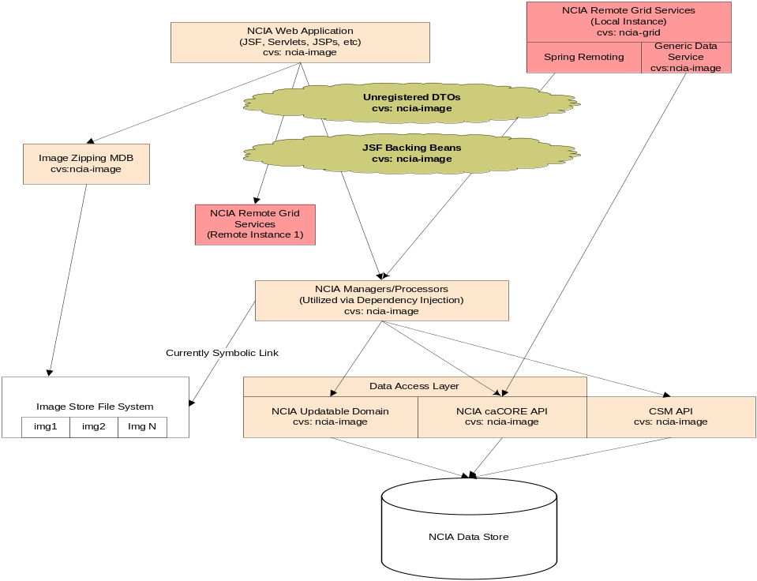
Figure 1: Current NCIA Architecture and Organization (sans Image Submission)

Also of note is that with in the same codebase, we maintain at least three different DB access strategies. Although they all share a common theme, OR/M utilizing Hibernate, we are required to handle three different versions of this API and it’s associated supporting libraries. Experience has shown that this can make leveraging the abilities of hibernate, critical abilities such as caching, difficult as you are often greeted by singleton class issues that require extensive class loading considerations.

Another point of interest is that there is currently no single design pattern for handling data transfer between multiple clients of the rudimentary service layer. Currently, JSF backing beans are utilized as DTOs between the UI and the Service Tier as well as between the remote Grid Nodes for the NCIA Grid Query Service. These backing beans contain multiple special considerations for viewing this data in the UI, that often alter key pieces of information required to operate further on the encapsulated data. Obviously this can cause seemingly random and difficult to track issues not only in the UI, but has also ostensibly disabled our remote capabilities.

The proposed architectural and organizational changes can be represented by the diagram shown in Figure 2. The diagram reflects the creation of five new CVS modules to hold functional components of the system.
Also shown is the creation of a second, registered NCIA service data model that represents a course grained manifestation of the fine grained registered NCIA domain model. This service data model will provide the means of data encapsulation as it relates to leveraging the services that are provided by a more robust and clear set of service interfaces. This new set of interfaces and service DTOs, accompanied by the clearly managed and controlled implementations of those interfaces. These implementations can be leveraged by multiple flavors of clients without the concerns of tightly coupled but unrelated behavior and design considerations as related to issues such as performance.

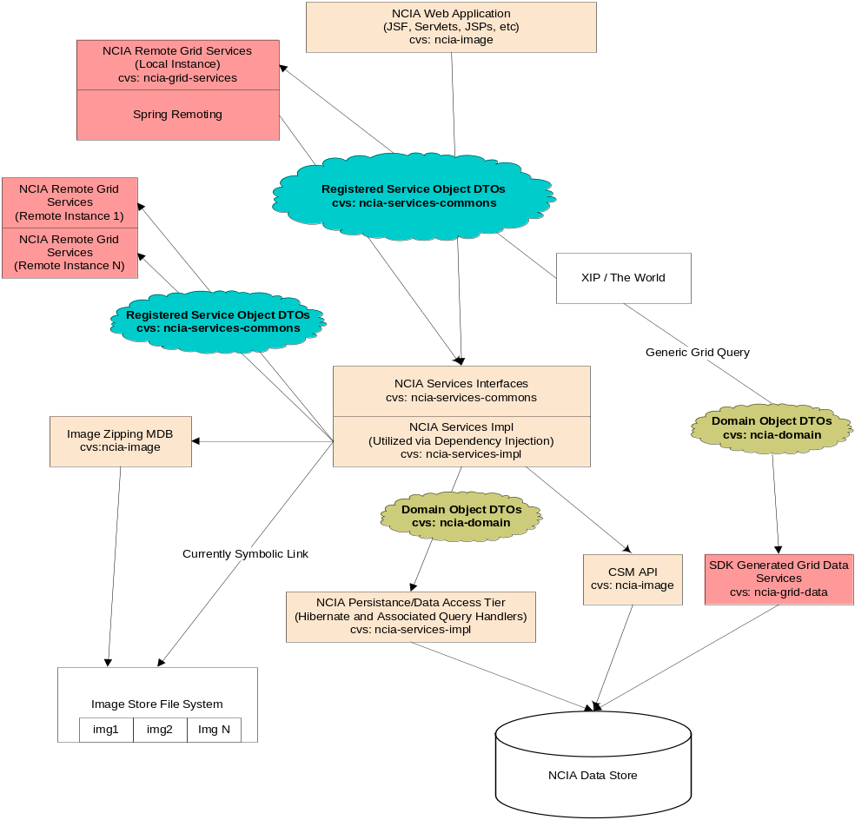
Figure 2: Architecture and Organization at Completion of Refactoring

It should also be apparent that only one data access strategy is contained in each functional module. That is to say, we separate the different Hibernate layers removing the obfuscation that is inherent when extensively mixing generated and hand coded data access approaches.

Effort 1: Reorganization of CVS Modules to Address NCIA Internal Dependencies

Current Problems and Risks
The NCIA source code is overly complex, requiring software builds to resolve over 90 dependencies and numerous circular references. The improper use of Data Transport Objects (DTOs) connecting disparate components threatens the stability and componentization of otherwise unrelated functional modules. The details and associated risks are outlined below.

- The NCIA build process is very complex, with dependencies and versions of those dependencies not readily available or clear.

- The complexity of our build process makes it very difficult to build and test individual functional components via automated build and testing tools such as CruiseControl.

- In the current development environment we currently have 95 jar file dependencies. These dependencies are a result of using a single CVS module for code that implements loosely related (but sometimes tightly coupled) functionality. This functionality includes the following:

- NCIA Web Application
- NCIA Remote Node GridQueryService
- NCIA Generic Data Service
- An “updatable domain” set of Hibernate mappings and associated objects
- The SDK generated Hibernate mappings with accompanying custom HQL injection classes and associated objects

- Our build scripts are overly complex as required to accommodate the building, merging and filtering of multiple configuration files and projects. For instance, the generated SDK toolkit.war file is built by hand, and then checked into CVS. At build time this war file is copied out and unzipped into a folder where it is broken into separate pieces that are then merged with the ncia-image.war to create a final deployable war file.

- The NCIA CVS tree contains circular dependencies between ncia-grid and ncia-image. For example, NCIA ACRIN experienced downtime at the initially after the release of version 2.3 as a result of a modification to a JSF backing bean that was also being used as a web service Data Transfer Object (DTO). To be more specific, a simple change to the backing bean to accommodate spacing in the UI resulted in modifying an instance variable that was being used for further queries on the resultset by the middle tier. When this was discovered, a separate accessor method was added that did not modify the underlying instance variable. This seemingly benign change, in turn, resulted in a class file change, causing the ACRIN Grid Services to fail based on an incompatible Class file version utilized by the NCIA Query Service.

- At the current time a system build is nearly an all or nothing proposition. This makes supporting multiple NCIA nodes difficult to manage as there is currently very little distinction in regards to the required steps to implement either large or small solutions for the remote nodes tech stack versions when a change is necessary.

Technical Solution
- Determine and document all dependencies between the grid services and the NCIA web application.
- Complete the definition of service based DTOs that will be utilized by the 5 current spring remoting services and UI to encapsulate data that is sent to and received by the middle tier service layer.
- Break out the service DTOs and service interfaces that are shared by the UI, the NCIA Query Service, and middle tier into two new CVS modules that will become dependencies for ncia-grid-services (formerly ncia-grid) and ncia-image. These modules will be called ncia-services-commons, and ncia-services-impl.
- Where appropriate, extract or create granular service interfaces that will be committed to the new CVS module, “ncia-commons”. These service interfaces will recieve and return the service DTOs mentioned above.
- Add impls of the service interfaces where missing and add/commit to the new ncia-commons-impl cvs module.
- Create a new build script for the ncia-commmons, that compiles the service DTOs and service interfaces creating a jar that clearly denotes the version number.
- Modify the existing build scripts for ncia-grid and ncia-image to refer to the remote depenedency repository created by Doug Kanoza and the SCM team for the ncia-commons jar.
- Modify the existing JSF backing beans to use the new ncia-commons and ncia-commons-impl.
- Modify dependent middle tier classes to recieve and return the new DTOs.

Anticipated Benefits of Technical Solution
By separating out the DTOs and service interfaces from the underlying implementations, as well as establishing tighter versioning control of smaller functional components, we will be able to take a more modular approach to new development and bug fixes. This should greatly minimize the need for wholesale builds of the entire project for any one particular problem. This will also direct us on a path for more efficient support of local and external instances of the NCIA, by reducing the time and effort to recognize, isolate and resolve problems as they are presented. Doing so will allow NCIA deployments to be pushed to NCIA remote nodes in smaller packages that are easier to understand and explain.

Effort 2: Separate Toolkit from Portal Code

Current Problem
The NCIA application uses two separate strategies to access and manipulate data in the database; the caCORE toolkit generated domain, which is used for many (but not all read-only operations) and the updateable domain, which is used for all insert and update operations. Use of the caCORE generated domain has led to the following problems:
- Performance challenges encountered by previous system designers led to the implementation of HQL statements embedded in class files which are executed against the caCORE API. In many cases, the queries are quite simple and should be candidates for query by example (QBE) style query operations or named queries.
- The main image search feature implements an HQL statement which is built dynamically as a String based on criteria selected from the search page. This results in an overly complicated object which has proven to be difficult to maintain and extend.
- The NCIA code reflects inconsistent use of data access strategies.
- The NCIA build is complicated by the use of the caCORE toolkit because the toolkit generated war file is extracted and integrated into the NCIA war file. This was done specifically to alleviate remote serialization of objects to maximize the performance of caCORE API calls by keeping them within the same JVM.

Risks of Current Implementation
The most significant risk of the current implementation is that as the domain model becomes more complex and additional search terms are required of the main search feature, the HQL String generator found in gov.nih.nci.ncia.queryhandler.DICOMQueryHandler will become difficult and time-consuming to extend and maintain. The enhancement of the domain model should have little bearing on the difficulty of implementing the main search query. In addition, the design of the search logic should make the process of adding criteria to the search page quick and straightforward.

Summary of Technical Solution for Phase I
The NCIA team proposes the following technical solution to be implemented in Phase I of this effort
1. Remove the caCORE toolkit generated domain from the NCIA build.
2. Find and catalog broken dependencies.
3. Implement a consistent data access strategy for the image submission and portal by leveraging the currently implemented updatable domain. 4 out of the 7 query handlers, shown below, will be refactored to use QBE:

a. gov.nih.nci.ncia.queryhandler.ContentTypeQueryHandler
b. gov.nih.nci.ncia.queryhandler.DataBasketAnnotationsQueryHandler
c. gov.nih.nci.ncia.queryhandler.DataBasketQueryHandler
d. gov.nih.nci.ncia.queryhandler.LatestCurationDateQueryHandler
4. Implement the caCORE tookit generated domain and caGRID generic data service as a distinct module to be used by only non-NCIA grid enabled applications.

Anticipated Benefits for Implementation of Phase I
- Clear distinction of application boundaries between the generic grid services and NCIA portal.
- Ability to enhance and extent the NCIA object model.
- Reduce the overhead associated with adding additional criteria to the search UI.
- Ability to optimize and enhance data access strategies based on their particular use case (e.g. grid optimization vs. NCIA application performance optimization).
- Reducing dependencies of the NCIA application through modularization of functional components required to support all use cases.

Summary of Technical Solution for Phase II
For Phase II of this refactoring, the NCIA team proposes to reorganize the Hibernate-based updateable domain to use the DAO design pattern and Hibernate templates provided by the Spring Framework. Use of this pattern will facilitate a clear separation of concerns between the business and data access tiers. Using Spring will also allow us to capitalize on dependency injection between the MVC implementation, business tier, and data access tier. The conversion of the system to a DAO pattern does not need to happen all in a single release. The conversion should begin with certain key system elements like the image search and download. Eventually, all elements of the NCIA can and should be converted to this design pattern. Initially, major system features will be addressed first, such as the search and download components.

Anticipated Benefits for Implementation of Phase II effort
- Consistent data access architecture.
- Better estimation of work required for future enhancements.
- Time required to implement changes relating to NCIA search capabilities is significantly reduced.
- Ability to push smaller, more manageable changes to either the domain model, codebase, or NCIA remote node community.

Effort 3: Isolation and Brokering of Internal Calls to Remote NCIA Nodes
Current Problem
Currently the NCIA Web Application makes remote calls both directly from the UI and Middle Tier via synchronous coding. This synchronous approach to calling web services causes hang ups in many processes that are critical to the NCIA application. For instance, the login module currently calls remote instances of NCIA to acquire keyword search terms. If the remote nodes grid services have any issue communicating with the remote instance of NCIA, and there is no grid exception sent back, the call waits until a timeout occurs. This timeout is currently set to ten minutes and has given the appearance to the user trying to log in that either their login was unsuccessful, or the application is down, either assumption being incorrect.

Technical Solution
- Remove all direct grid calls from UI related classes such as JSF backing beans.
- Replace these calls with references to a new Remote Broker (see the Broker Pattern) that will allow the session to get a handle on a remote service invocation.
- Remote Broker utilizes the “Worker Thread” pattern, enabling threading capability within the middle tier that lies between the remote calls and the application. This brokered working thread will create and track via unique identifiers (such as the http session key) which session the remote call belongs to. If a synchronous call fails to happen in a time limit that is configured via a property file, the broker can roll over to an asynchronous threaded mode allowing the application to abort the operation, or proceed on, and await an non-obtrusive asynchronous notification that the remote service call is completed and ready for further processing.
- If an exception is thrown the broker will also handle and encapsulate and exceptions or error conditions, notifying the caller that the call has failed.

Anticipated Benefits of Technical Solution
By modifying outgoing grid service communication through the removal of direct grid dependencies in workflow logic within the NCIA code, NCIA workflow becomes more stable, predictable, and reliable. Maintaining a single point for making remote web service calls not only allows for better transparency in logging usage statistics and potential performance tuning efforts, but also a single point for adding or removing access to services as needed. This approach should clearly address the Quality of Service issues that we have experienced in the past.

