

Software Design Description:
Introduction of Grid Brokering

Release 3.0

September 25, 2007

Table of Contents
i. Document Revision History ii
1. Introduction 1
Purpose of this Document 1
Requirements - GForge Task Tracking 1
2. System Architecture 2
Components 2
Interfaces – Self Explanatory 2
3. Technical Overview 3
4. Grid Calls as Built in versions 2.4 and Previous 4
Incoming Grid Calls 4
Outgoing Grid Calls 5
5. Design Changes for version 3.0 7
Incoming Grid Calls version 3.0 7
Outgoing Grid Calls version 3.0 7
ii. NCIA Query Service Request and Response 9
a. NCIAQueryServiceRequestReceipt 9
b. NCIAQueryServiceResponse 9
iii. NCIAQueryServiceBrokerIF and NCIAQueryServiceBrokerImpl 10
iv. Callable Hierarchy 11
v. Putting It All Together 11
a. Diagrams 11
b. Code Examples 14
6. Proposed Enhancements 16
Event Driven Mechanism 16

Document Revision History

Change Record

Date | Author(s) | Document  Version | Change Reference  (Major Changes)
09/19/2007 | David C Bauer | 1.0

Introduction

Purpose of this Document
The purpose of this document is to describe the creation of an addition to the NCIA codebase that provides a means of separating the current and future synchronous calls to grid resources from within the NCIA Portal. The author has expended much effort to ensure that the design and implementation complies with J2EE best practices and as such has used known patterns where applicable to facilitate the communication of the design in this document and as well as in the code as simply as possible. If at any time something is not clear and an errata or addendum is required, please let the author know and he will make whatever changes are needed.

Requirements - GForge Task Tracking
This task was defined and approved through the NCIA GForge Feature Request Tracker Items 7327 and 7349 and is intended to be implemented and released for the NCIA 3.0 release.

System Architecture
The following is a list of NCIA system components and interfaces that are modified, mentioned or of general concern for this design document and are shown in Figure 1 - Grid Related NCIA System Components. For detailed descriptions please refer to the NCIA System Architecture Document located in GForge at the following URL:
https://gforge.nci.nih.gov/plugins/scmcvs/cvsweb.php/ncia-docs/design/3.0/?cvsroot=ncia

Refer to the Architectural drawing located at:
Model/Architectural View/NCIA-Architecture

Components
1.2 C NCIA Service Layer: Is maintained with the ncia-services-commons CVS repository and represents the data transfer objects (DTOs), services, managers, data access code for the NCIA System.

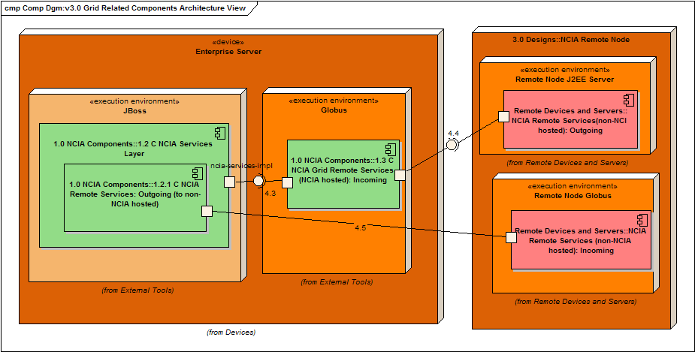
Figure 1 - Grid Related NCIA System Components

1.2.1 C NCIA Grid Remote Services (Outgoing): This component resides in the same CVS repository of the services layer, but has a dependency on the caGrid NCIAQueryServiceClient and the supporting caGrid libraries.

1.3 C NCIA Grid Remote Services: This represents the code that is responsible for handling incoming calls from remote instances of the NCIA. A good portion of this code is generated. It is maintained in the ncia-grid CVS repository.

Interfaces – Self Explanatory
4.3 I NCIA Remote Services (NCIA Hosted) to the NCIA Services Layer
4.4 I Any NCIA Remote Node to the Globus Server: NCIA Remote Service
4.5 I NCIA Remote Services: Outgoing (to non-NCIA hosted services) Remote Services

Technical Overview
The NCIA Portal has the ability to communicate with remote instances of itself through caGrid via the NCIAQueryServiceClient. This query service currently provides 14 over the grid service calls that are received and responded to by a remote node, whose specified URL is acquired either through a database lookup or the caGrid discovery service. When this feature was first put in place in release 2.1, the feature was intended to be a prototype implementation and some of the production concerns, such as Quality of Service (QoS), were not addressed. However as the prototype was written well enough it was integrated into future builds and QoS problems began to emerge.

The first manifestation of an issue was that the NCIA login was unable to complete until an established grid node returned searchable criteria or timed out. If one of these nodes was not responding, we were tied to an approximate 10 minute caGrid call timeout before the user was shown that they had logged in successfully. This happened more frequently as the only other standing NCIA node at ACRIN was continually brought up and down without prior notification.

A second manifestation of problems was found when seemingly minor changes to the UI JSF backing beans getter and setter methods were breaking grid communication. We discovered quickly that these beans were also being utilized by the grid services as DTOs.

Grid Calls as Built in versions 2.4 and Previous

Incoming Grid Calls
A requirement of the caGrid service for NCIA is the ability to receive the incoming grid calls that are produced by the mechanism described in the following section, .

Looking at Figure 2 – Class Diagram: Incoming Grid Calls v2.4 and Prior, the path starts with the invocation of the NCIAQueryServiceClient_2.4 to the NCIAQueryServiceProviderImpl over caGrid. It completes with the use of Spring Remoting to call the four Grid Facades whose implementations and underlying support lay in the NCIA Node being called.
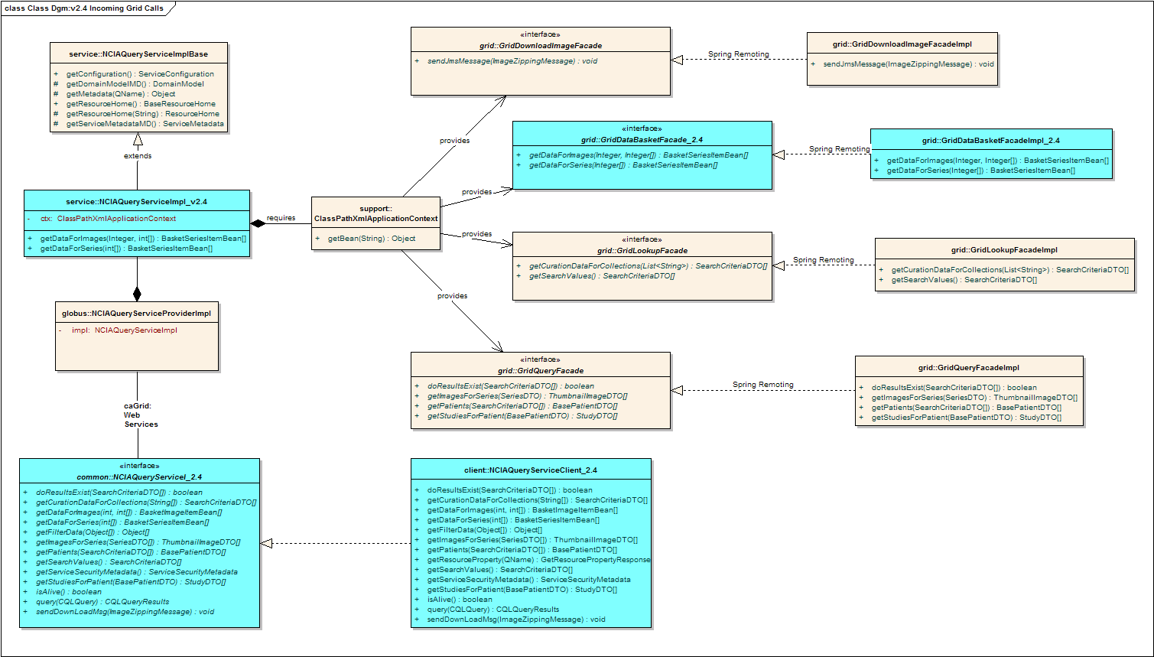
Figure 2 – Class Diagram: Incoming Grid Calls v2.4 and Prior
The only point of concern for the incoming services classes are the use of the BasketImageItemBean, and the BasketSeriesItemBean throughout the entire call structure. The classes in blue that you see in Figure 2 – Class Diagram: Incoming Grid Calls v2.4 and Prior need to be modified, as well as any web services or caGrid related configuration files, to accommodate the change from using JSF backing beans as DTOs to using just DTOs. Table 1 reflects the changes that will be made to the classes related to incoming NCIA grid services. Other than these changes to accommodate the change in Data Transfer Objects, no other changes will be required to these classes for this release.

Class File | Method | Return Type v2.4 | Return Type v3.0
NCIAQueryServiceI | getDataForImages | BasketImageItemBean[] | ThumbnailImageDTO[]
 | getDataForSeries | BasketSeriesItemBean[] | SeriesDTO[]
NCIAQueryServiceImpl | getDataForImages | BasketImageItemBean[] | ThumbnailImageDTO[]
 | getDataForSeries | BasketSeriesItemBean[] | SeriesDTO[]
GridDataBasketFacade | getDataForImages | BasketImageItemBean[] | ThumbnailImageDTO[]
 | getDataForSeries | BasketSeriesItemBean[] | SeriesDTO[]
GridDataBasketFacadeImpl | getDataForImages | BasketImageItemBean[] | ThumbnailImageDTO[]
 | getDataForSeries | BasketSeriesItemBean[] | SeriesDTO[]
Table 1 - Incoming NCIA Query Service Modifications (DTO)

Outgoing Grid Calls

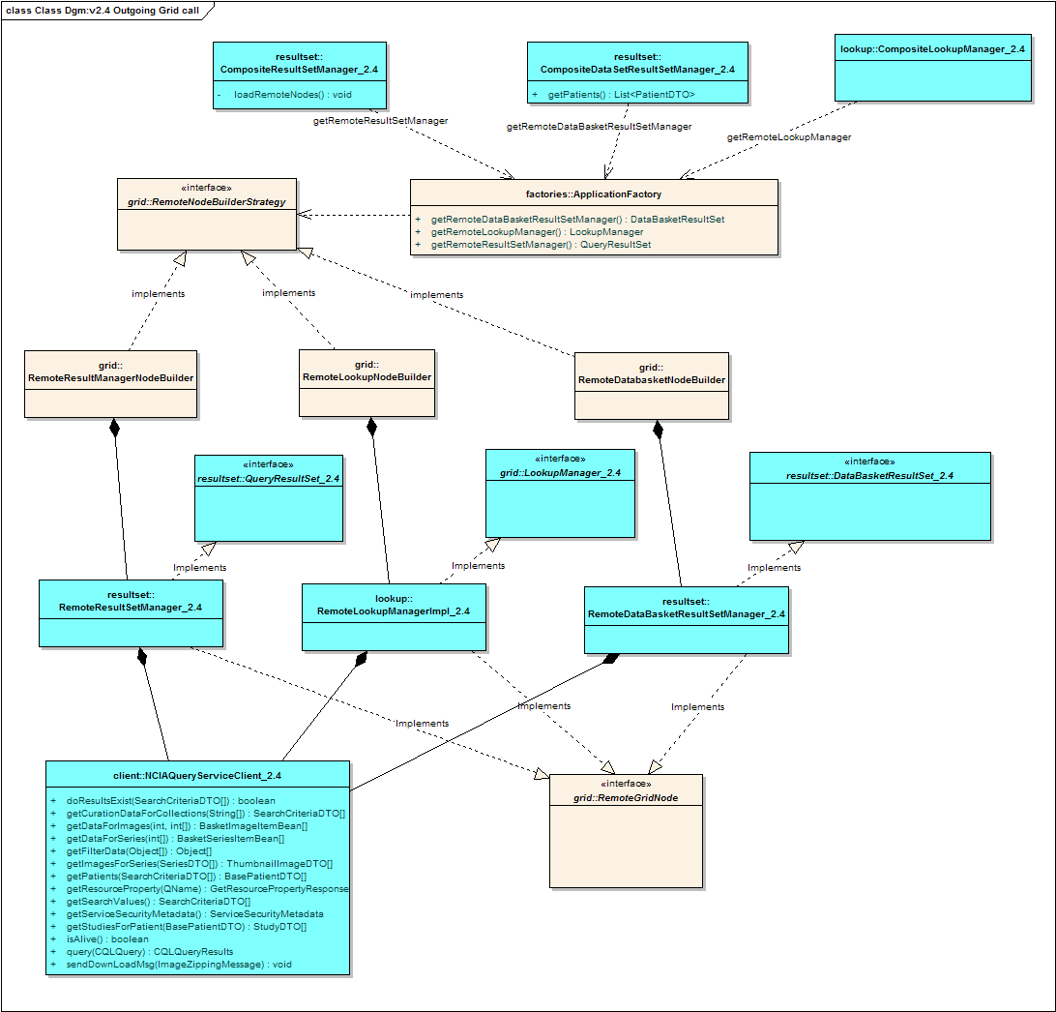
Figure 3- Class Diagram: Outgoing Grid Call Class Diagram v2.4 and prior

A current outgoing grid call and the associated classes would be initiated by the user selecting to search remote nodes of the NCIA. From this point forward the difference between local and remote is not immediately apparent to the user as the implementation of the merge of remote and local data is hidden behind three Composite Managers shown in Figure 3- Class Diagram: Outgoing Grid Call Class Diagram v2.4 and prior. The Composite Managers then rely on three Remote Managers to make the remote service calls required to access the data the UI has asked for.

In Figure 3- Class Diagram: Outgoing Grid Call Class Diagram v2.4 and prior, what is important to note is the reliance of the NCIAQueryServiceClient_2.4 on two backing beans BasketImageItemBean and BasketSeriesItemBean in the service methods getDataForImages() and getDataForSeries(), respectively. This dependency runs completely through the class structure back to the JSF backing beans that support the UI. All classes marked in blue require modification to accommodate the removal of the backing bean dependency.

Another known problem, again mentioned briefly in the introduction, was that there was no fall back mechanism in the instance a caGrid call was not adequately responsive or was dropped during the call. In short, the current calls to caGrid were all made synchronously within the NCIA and as such any further processing was dependent on timely returns. To alleviate this problem a brokering solution was designed that will be covered in the following section.

Design Changes for version 3.0
As mentioned earlier, the changes required to address the QoS issues will involve both the removal of the use of JSF backing beans as well as brokering the caGrid request calls from within the NCIA portal code. The DTO change though extensive is easy to explain and understand and was listed in the above sections. However the addition of Brokering layer requires a bit more explanation.

Incoming Grid Calls version 3.0
There are no significant design changes required for the incoming service classes. However Figure 4 – Class Diagram: Incoming Grid Calls version 3.0 is provided here to show the changes reflected in modifying the Data Transfer Objects used in the service calls by highlighting those changes in pink.

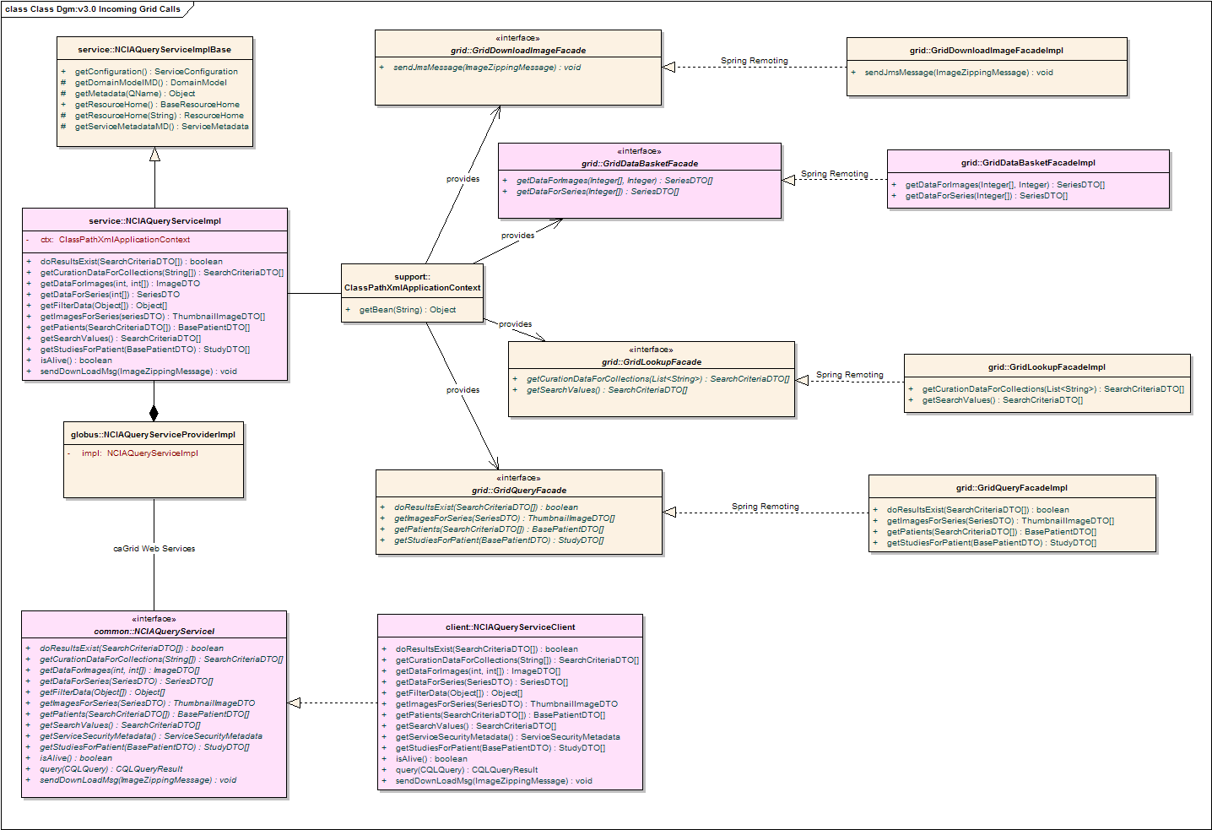
Figure 4 – Class Diagram: Incoming Grid Calls version 3.0

Outgoing Grid Calls version 3.0
The outgoing calls required extensive additional support class introduction to accommodate the use of a grid broker. However, because the architectural design of the Composite Managers and their Remote Managers accommodates a significant and working separation of concerns between the UI code and the NCIA services code it was felt that there was no reason to retool this aspect of the implementation. Rather, introducing the new broker should lay between the Remote Managers and the NCIAQueryServiceClient which actually acts as the connection point to the NCIAQueryServiceProvider shown in Figure 4 – Class Diagram: Incoming Grid Calls version 3.0.

Figure 5 – Class Diagram: Introduction of Grid Brokerbelow shows the insertion point of the broker that will lay between the Remote Managers and the NCIAQueryServiceClient. This class diagram introduces three new classes and two new interfaces to the outgoing grid calls.

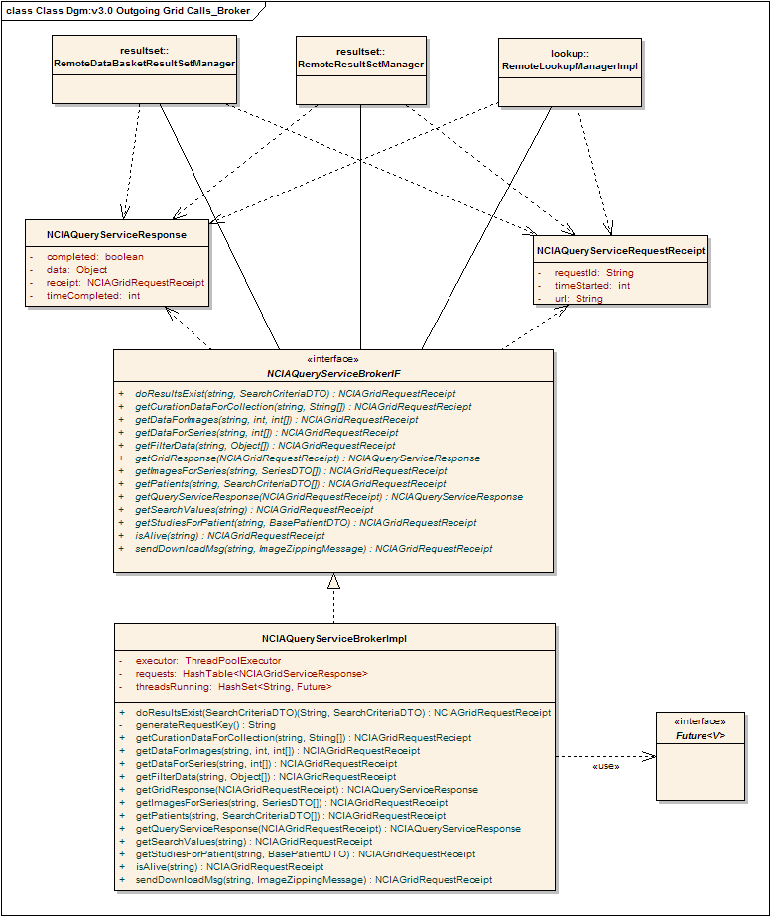
Figure 5 – Class Diagram: Introduction of Grid Broker

NCIA Query Service Request and Response
First, to introduce asynchronous calling between the Remote Managers and the new NCIAQueryServiceBroker objects that can contain information about the requested service call and the associated response were needed. For this reason the NCIAQueryServiceResponse and NCIAQueryServiceRequestReceipt were created.

NCIAQueryServiceRequestReceipt
This class holds the basics of the request. It provides the means of the calling class to return and retrieve the results from the request that they issued. It also used by the broker to find the specific thread and its associated state.

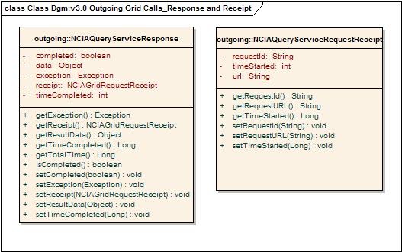
Figure 6 – Class Diagram: NCIAQueryService Request and Receipt

NCIAQueryServiceResponse
This class encapsulates the response coming from the grid and makes it known to the calling class whether or not the call is actually complete. It also provides for total time to call as well as whether an exception was thrown.

NCIAQueryServiceBrokerIF and NCIAQueryServiceBrokerImpl
By far the most interesting class in this design is the broker itself. The NCIAQueryServiceBrokerIF and its implementing class will be a singleton that is served out through the ApplicationFactory. It is intended that all operations will be called through the interface, though of course it is difficult to ensure this.

The point of introducing the NCIAQueryServiceBrokerImpl is to encapsulate each of the grid calls into separate managed and traceable threads. This gives us the ability to check status, gather return values, exceptions or kill as needed by the client utilizing the services. To accommodate the varied and asynchronous threads the JDK 1.5 Concurrency package will be utilized namely the ThreadPoolExecutor class, and the Callable and Future interfaces.

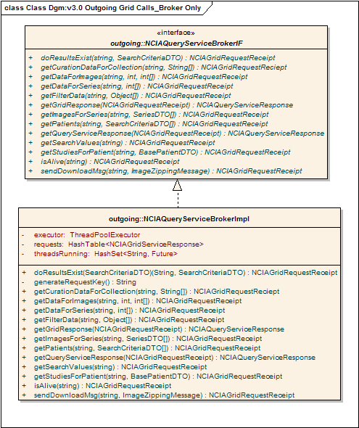
Figure 7 – Class Diagram: NCIAQueryServiceBroker and Impl

Callable Hierarchy
So as to accommodate the isolation of each call to the NCIAQueryServiceClient to specific thread and also provide a call back mechanism that allows us to attempt to retrieve values from the returned service calls a java.util.concurrent.Callable interface and class hierarchy needed to be established. By using the ThreadPoolExecutor with a Callable class we can inspect the thread to see if it has finished and there is a return value present via the java.util.concurrent.Future interface.

Each Callable class represents a specific return type, as well as a specific service call to the NCIAQueryServiceClient. This means that each Callable class will have its own instance of the NCIAQueryServiceClient and will provided at construction time with the URL of the specific NCIA Grid Client that it wishes to call. See Figure 8 – Class Diagram: The NCIA Callable Hierarchy for specific calls implemented.

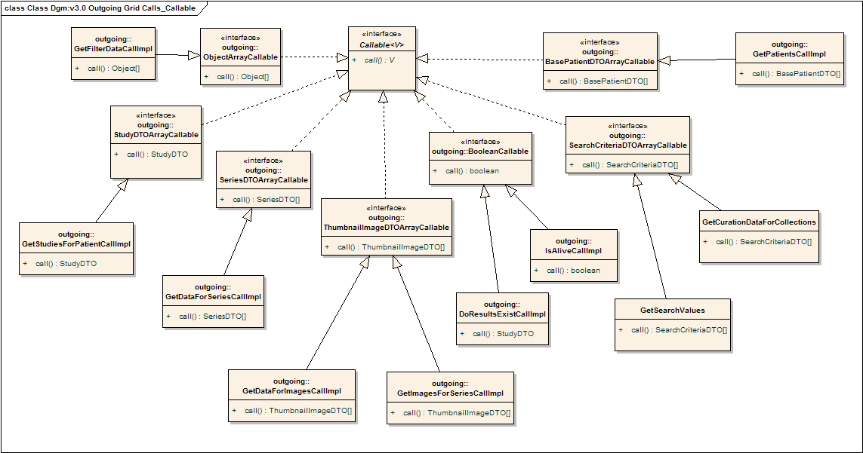
Figure 8 – Class Diagram: The NCIA Callable Hierarchy

Putting It All Together

Diagrams
Now that we have introduced the specific classes involved, a sequence diagram and a class diagram are presented to show the relationships between the Callable classes and the two main classes NCIAQueryServiceClient and NCIAQueryServiceBrokerImpl.

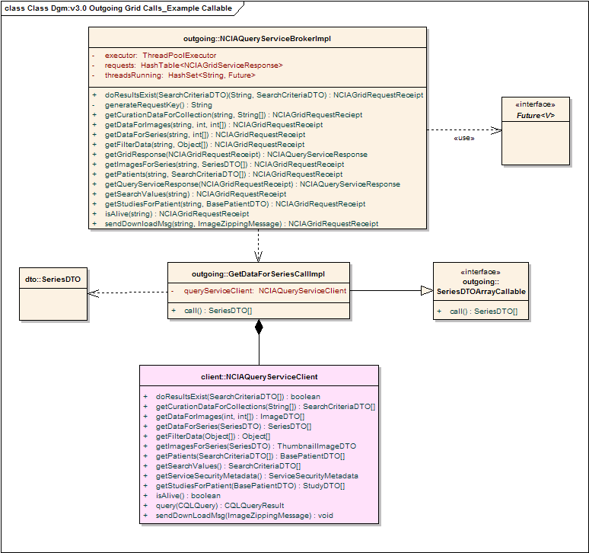
Figure 9 – Class Diagram: Broker, Client, Callable, DTO and Future

The sequence diagram below shows the interaction between the Remote Manager and the NCIAQueryServiceBrokerImpl. What is difficult to depict is the asunchronous behavior of the Callable class making the call to the NCIAQueryServiceClient.

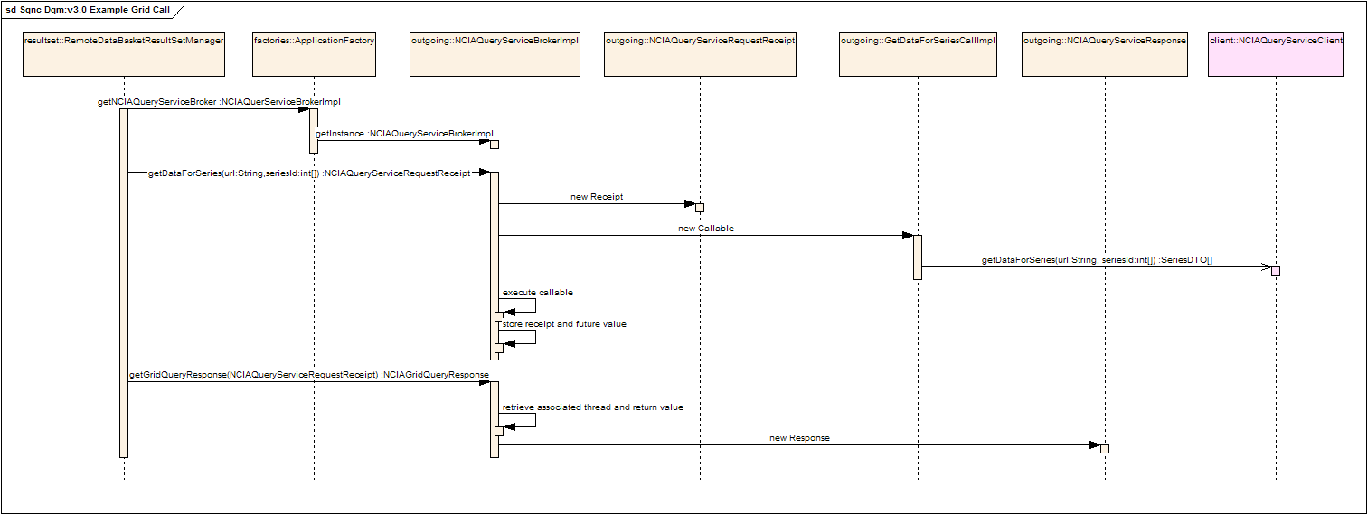
Figure 10 - Sequence Diagram: Example Brokering

Code Examples
The following is an example from the NCIAQueryServiceBrokerImpl showing the use of the ThreadPoolExecutor, a Future, and the Callable.

Table 2 represents the code that would be called by the Remote Managers to initiate the request to begin a NCIAQueryServiceClient call. The Remote Managers provide the specific URL of the node they would like to call, which is available via the current caching and DB store mechanism in 2.4, and the required parameters for the actual grid call. In this instance, that would be the int[] of seriesIds that they would like more information about.

Table 2 - NCIAQueryServiceBrokerImpl.getDataForSeries
public class NCIAQueryServiceBrokerImpl implements NCIAQueryServiceBrokerIF{
private static ThreadPoolExecutor;
private static HashMap<String,Future<V>> futures;
/***
Constructor and other methods establishing the ThreadPool
and HashMap would go here
***/

public synchronized NCIAQueryRequestReceipt getDataForSeries(String url, int[] series){
/**
Setup the return
**/
NCIAQueryRequestReceipt receipt = new NCIAQueryRequestReceipt();
String reqId = generateUniqueRequestId();
receipt.setRequestId(reqId);
receipt.setURL(url);

/**
Create the new Callable
**/
GetDataForSeriesCallImpl callable = new GetDataForSeriesCallImpl(url, series);

/**
Execute the Callable Thread
**/
Future<SeriesDTO[]> future = executor.submit(callable);
long startTime = System.currentTimeMillis();
receipt.setStartTime(startTime);
/**
Store the Future for later retrieval
**/
futures.put(reqId,future);

return receipt;
}

}

The second methods of interest are the “getGridResponse” methods which provide the mechanism of retrieval and information gathering about the thread for the Remote Managers. Because the Future<V> interface provides methods to determine if the thread was cancelled, is completed, and other interesting information any return from the calling Remote Manager to check on its request is acceptable.

Table 3 - NCIAQueryServiceBrokerImpl.getGridResponse
public synchronized NCIAQueryServiceResponse getGridResponse(NCIAQueryRequestReceipt receipt){
/**
Setup the return
**/
NCIAQueryServiceResponse response = new NCIAQueryServiceResponse ();
String reqId = receipt.getRequestId();
/**
Retrieve the future and check on the thread;
In the interest of space and clarity some condition checking is
omitted and some redundancy is present
**/
Future f = futures.get(reqId);
Boolean done = f.isDone();
Boolean cancelled = f.cancelled();
if(done&!cancelled){
response.setComplete(done);
response.setResultData(f.get());
futures.remove(reqId);
}else(done&&cancelled){
response.setComplete(done);
response.setCancelled(cancelled);
}

return response;
}

This leaves the business logic associated with the actual call, such as when to time out, whether to cancel it or wait entirely in the hands of the caller and not the broker. However, it does give the broker the ability to manage and control the use of the grid services and handle any abnormalities as they present with maintenance methods and checks.

Proposed Enhancements

Event Driven Mechanism
I believe that in future releases to enable more responsive UI interaction, an event mechanism with listeners and specific grid call events could allow the Remote Managers to be updated as soon as their result is returned. But for now it is not within the scope of this release.

