NCIA/External Data Basket Implementation

Software Design Description

Version 1.0

01/27/2009

Document Change Record
Version Number | Date | Description
1.0 | 01/27/2009 | Initial document

TABLE OF CONTENTS
1. Introduction 1
2. System Architecture 2
3. Components 4
4. Security 6
4.1 The Goal 6
4.2 Problems 6
4.3 Possible solutions 6
4.3.1 FORM-based Login 6
4.3.2 ISPY Interface 6
4.3.3 General Principles 6
4.3.4 Request saving+PrettyFaces 7
4.4 Complications 7
4.5 Comparisons 8
4.6 Postscript 8
5. Sequence diagram 9
Appendix A – acronym List 13

Introduction
The purpose of this implement is to provide a generic approach for other applications to connect to NCIA. Through this connection, the user can obtain the search results by providing search criteria. The NCIA will add results into NCIA data basket. From data basket, the user can view images, search images, add/delete images into/from data basket and download selected images from NCIA application. The connection could be URL format.
URL parameters include three parameters
- list of patient IDs
- list of study IDs
- list of series IDs

System Architecture
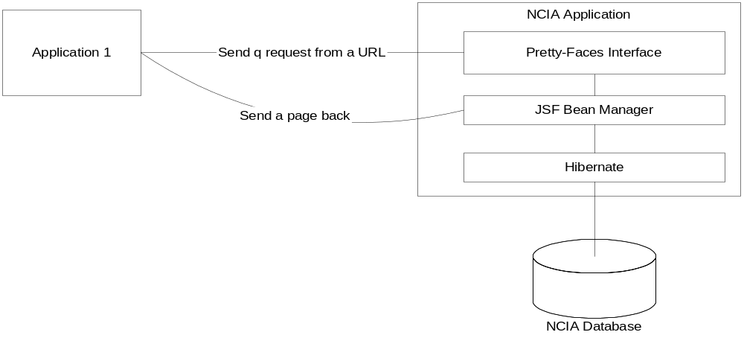
Figure 1: Data Basket Workflow
Figure 1 indicates how the other application connects to NCIA application. In this example, application 1 sends a request through a URL with the parameters. Of course we know the parameters include list of patient ids, list of study ids, list of series ids and stage. Before displaying a page, pretty-faces will pick up the control by invoking an action class to process this request. The action class will base on the three lists to perform search and add the result into data basket bean and display the data basket page.
Through the data basket page, application 1 still can remove unwanted data or search more data and add them into data basket.
In addition, the security check will apply to this process. Application 1 needs log into NCIA application before searching. If login fails, application will not get an error page.

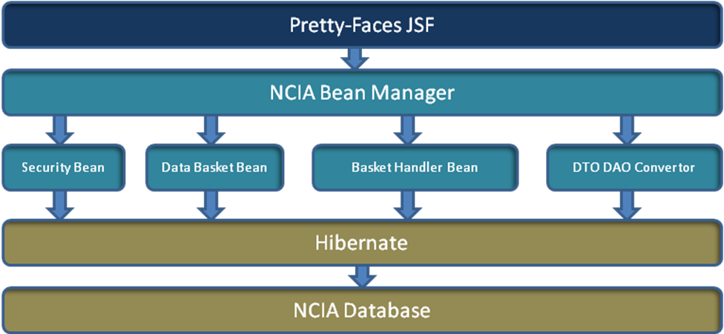
Figure 2: High level Design Structure
Figure 2 is the high level design structure for data basket implementation. When NCIA application receives a request from other applications, the request will be forwarded to an action class (bean class) by pretty-faces interface. Then action class parses request parameters, and authenticates the user. If the user is valid, action class will invoke basket handler bean to perform search with given data (patient ids, or/and study ids, or/and series ids). When the result comes back, data convertor converts DAO to DTO and basket handler adds DTOs into data basket through data basket bean. Basket handler also needs to initial all necessary elements for displaying data basket page.

Components
- Pretty-faces configuration
Pretty-config.xml provides a function to inject JSF managed beans from URL connection. It controls page-load actions, the integration with faces navigation, dynamic view-id assignment, and managed parameter parsing.

<pretty-config xmlns="http://ocpsoft.com/prettyfaces-xsd"
xmlns:xsi="http://www.w3.org/2001/XMLSchema-instance"
xsi:schemaLocation="http://ocpsoft.com/prettyfaces-xsd
http://ocpsoft.com/xml/ns/prettyfaces/pretty-1.0.xsd">

<url-mapping id="databasket">
<pattern> /databasket </pattern>
<view-id> /dataBasketDisplay.jsf </view-id>
<query-param
name="basketContents">#{dataBasketPopulatorBean.basketContents}
</query-param>
<action>#{dataBasketPopulatorBean.populateBasket}</action>
</url-mapping>

</pretty-config>
Figure 3: Example of pretty-faces.xml

- Security Check Filter
SecurityCheckFilter class will get all parameters through HTTP request if the user logged into application. The parameters include patient list, study list and series list, plus servlet URL and servlet path. Eventually, it puts parameter into HTTP session for future use.

- Security Bean
Security Bean provides the user authentication service. It checks either from LDAP or local database to see if the user is valid or not.

- Data Basket Populate Management Bean
After passing Security Bean, the data basket populate management bean will be invoked. This class provides several functions, such as search function, converting series data into data transfer objects, and adding them into data basket.

- Data Basket Handler
This class performs the search based on given three lists that the user provides. Three main functions are implemented in it, search by patient list, search by study list, and search by series list. Three functions return one type of hibernate object which is Series POJO object. Result will be converted into Series DTO objects.

- Data Basket Bean
This class receives the result from Data Basket Handler, and it adds them into data basket.

- Data Convertor
When Data Basket Handler query from NCIA data base, a series hibernate mapping object (POJO) will return back. This POJO object will not be used in middle tier. Data Convertor class is needed as a utility class to transfer this object into DTO object. Therefore, Data Basket Bean class can add results into Data Basket Bean.

Security

The Goal
The goal is to allow outside clients to securely link to existing pages with minimal fanfare. Further, the client should be able to pass parameters to customize the behavior of the existing page. After going to the "landing page", the client should be able to use the web application as if having logged in “normally”.

Problems
- The current security check filter redirects all page requests to login page, throwing out original request.
- Pages within the system depend upon session state and there is no natural "page loading" event in JSF.

Possible solutions

FORM-based Login
The textbook way to provide for webapp security with a login form page is to rely upon container managed "FORM-based" login. A client requests a URL within a protected domain, and the container knows whether the client is authenticated and redirects to the login page if not authenticated. When the user completes authentication, the container then redirects the user to the originally requested page. This is "better" than the security check filter because it allows the user to request any resource within the application, preserving the request through the login page redirect. On the other hand, the FORM based login is ornery to configure with CSM and more importantly, it doesn't allow any "login event handling". When the submit button is pressed it points to j_security_check so a custom login method can't be invoked. This also doesn't solve the page-loading problem.

ISPY Interface
The ISPY "referencedImages" page is one possible way to solve the problem. A custom filter is mapped to the page to make externally available. This filter pulls request parameters and saves them in the session. Then the security filter kicks in bringing the conversation to the login page. After the user logs in, the "login method" has a hard-coded conditional to look for special parameters in the session. If these parameters exist, then the conversation is forwarded to a hardcoded page (referencedImages).

General Principles
This solution demonstrates the necessary features of any solution:
- Request parameters must be saved before the security filter wipes them out.
- Page initialization code must run as or before the page is loaded, populating the session with the necessary artifacts for the page to render.
- Any solution will require making a decision about which page to forward to after passing the security challenge.

Request saving+PrettyFaces
One possible solution is to modify the existing security check filter to behave more like how "FORM-based" login behaves. Instead of depending upon a custom filter per page to save request parameters, the security check filter itself can save the request parameters. Additionally, the security filter can save the originally requested URI. Then afterward, the "login method" can consult this saved URI and redirect to the URI instead of hardcoding a decision for where to go based upon something that is hardcoded.
The next problem to solve is handling page initialization. JSF doesn't have a natural way to do this. Filters are really the only way to do something like this. The page initializer must run after the login method is invoked. The ISPY solution would require a second filter then, one to save parameters, and then another filter after login is executed.
A library called PrettyFaces provides a filter that provides a more high-level infrastructure for page-loading. With PrettyFaces, an EL/action can be associated with a page load. This will always run as the page is loaded so it avoids any possible problems with running initialization "too early" with the bonus that it more naturally fits in with how a JSF developer would prefer to do things (with EL+actions).

Complications
There are extra complications to allowing external links into the application.
First, after the request parameters are processed by the page initialization logic, they must be removed or else the page initialization logic will keep trying to process those parameters at each page load which could happen in the normal course of using the application. In JSF, when landing on page X, the postbacks for any navigation or action will be sent to page X, so the page initialization code will keep running. This problem applies to both solutions #1 and #2.
Second, the next time the client requests the same URI within the same session, the security check filter WON'T be executed. The parameters won't be saved in the session; they will go straight to the resource. In the ISPY/filter model, this wouldn't be a problem because the filter that converts parameters to session state runs no matter what and before the security filter. In the PrettyFacces model, PF will populate a bean with those parameters if instructed to. The "populator bean" will have to choose between the "saved request" and the populated parameters.

The first complication applies to when both there is a "saved request" and when the parameters came directly to the resource.

Comparisons
Possible solution #0 isn't going to work well with the way the application currently is. If design was starting fresh, it might be applicable with a more careful structuring of pages and their state dependencies.
The main comparison is between solution #1 and solution #2. Solution #2 is more generic, but in some ways it may be considered as more complex. Solution #1 may run into issues with the initializers running too early? Solution #1 also requires hardcoding certain things which is less desirable. Some of the hardcoding could be removed by defining a registry of sorts and moving the configuration into a DD or XML file, but past a certain point, this starts to become like what PrettyFaces is already doing.
With all that said, the complexity of solution #2 (all the saving/restoring/removing) can be hidden within an abstract superclass for "populator beans". Assuming the underlying "machinery" works as advertised, a user adds a "populator bean", updates the configuration in pretty-config.xml, and everything is hooked up. Adding the "patient display" page after implementing the data basket prototype took about 10 minutes to hook up, and the majority of the work was figuring out the magic incantation to initialize the state for the page.
There is one "feature" of solution #2 that can be viewed as a negative or a positive that is worthy of discussion. Currently, if a user attempts to bookmark an NCIA page and then come back to it later, the security filter will always send the user back to the home page throwing away the fact that a specific page was selected (except for referencedImages).
With solution #2, that information is NOT lost. This enables bookmarking.... but if a page isn’t properly initialized by a populator bean, the bookmark will likely show a page with an exception.
All that said, solution #2 seems like the way to go for the data basket and to provide for similar functionality in the future as necessary (Peter Yan wanted a link to patient or study?)

Postscript
Neither solution #1 or #2 is terribly great given the complexity involved one way or the other. JSF by itself helps to create the difficulties of linking to pages not to mention the security constraints. JSF 2.0 is rumored to help address some of these problems in the future. A JSF framework called Seam may also help to alleviate some of these issues. Short of throwing out JSF and re-architecting the whole web application along more REST-like principles (to accommodate this use case) JSF2 and Seam are avenues for further research.

Sequence diagram
See http://gforge.nci.nih.gov/svnroot/ncia/trunk/docs/analysis_and_design/4.2/ExternalDatabasket.eap for the original diagrams.
The following diagram indicates how external data basket works.
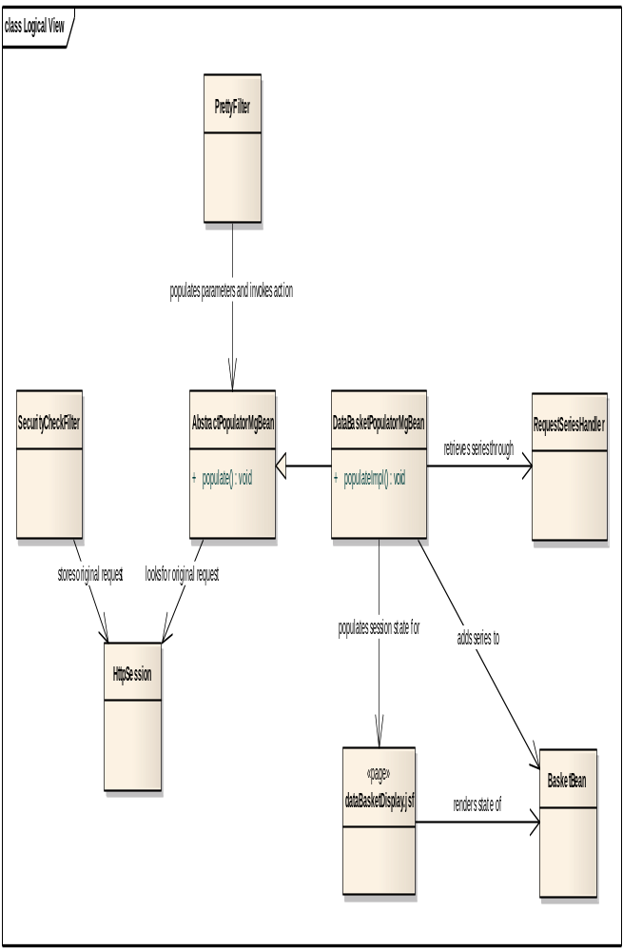
Figure 4.1: External Data Basket Object Diagram
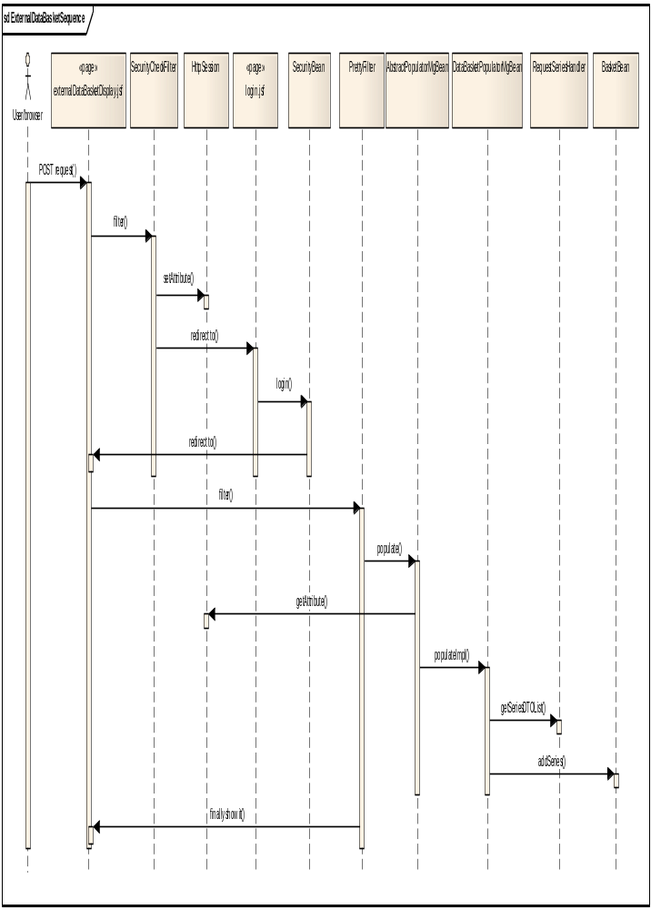
Figure 4.2: Sequence Diagram for External Data Basket

Alternative:
Alternative 1:
When Security Bean failed to authenticate the user, Security Bean will send a redirect to NCIA login Page.
Alternative 2:
If users did not provide any list, or when errors happen during search, there is no result will put into data basket. Empty result will be displayed.

Appendix A – acronym List
[Insert an alphabetical listing of all acronyms, abbreviations, and their meanings as used in this document.]
Acronym | Description
[????] | [Insert Project Name acronym]
[????] | [Insert Project all other project Software Design Description specific acronyms and resort the table]
CI | Configuration Item
DBA | Database Administrator
MS | Microsoft
PM | Project Manager
RM | Requirements Manager
RTM | Requirements Traceability Matrix
SCM | Software Configuration Management
SDD | Software Design Description
SDLC | Software Development Lifecycle
SDP | Software Development Plan
SE | Software Engineering
SEPG | Software Engineering Process Group
SPE | Software Product Engineering
SM | Software Manager
SOP | Standard Operating Procedure
SPI | Software Process Improvement
SQA | Software Quality Assurance
SRS | Software Requirement Specification
SW | Software
TM | Test Manager

