NBIA Download Manager

Software Design Description

Version 1.1

06/23/2009

Document Change Record
Version Number | Date | Description
1.0 | 06/19/2009 | Initial document
1.1 | 06/23/2009 | Updated after team review

Table of Content

1. Introduction 1
2. System Architecture 2
3. Components 3
3.1 DynamicJNLPServlet 3
3.2 DownloadServlet 3
3.3 Download Manager Application 3
3.4 Configurations 5
4. CLASS diagram 6
5. SEQUENCE DIAGRAMS 7

1. Introduction
The purpose of this implementation is to allow the user to download data from NBIA data basket page with NBIA download client. Currently user can download from data basket by either HTTP request when the data basket size is less than 3GB or by FTP when data in the data basket is larger than 3GB.
This download client allows user to download their current data basket regardless of size directly to a user’s specified location.
The requirement for this implementation,
- Download client is launched from data basket page when user clicks the “Launch Download Client” button. The current basket data is shown in the launched download client.
- User downloads data by clicking the “Start” button.
- User has the opportunity to remove any series from the list of data prior to “Start” downloading. Once the “Start” is clicked, user will not allow to remove any from the list of download data.
- User is allowed to “Paused” the entire download by clicking the “Pause” button.
- User is allowed to “Resume” the “Paused” download by clicking the “Resume” button.

2. System Architecture
Data Basket Page
NBIA App Server
DynamicJNLPServlet
BasketSeriesItemBean
* to get data from basket
* apply to jnlp-template
and generate jnlp file
NBIA Download Manager
Display data
from basket
NBIA
DB
File System
NBIA App Server
or Download Server
DownloadServlet
Authorization user for the series
and get images file path.
Access file system to get the files.

User clicks Launch Download Client button
Launch jnlp file
with Webstart
HTTP requests/responses

Figure 1: Workflow of the download manager. It indicates how NBIA application launches the NBIA download manager and how download manager communicates with server to get data.
From the data basket page, when user clicks the “Launch Download Manager” button, the BasketBean will set userId and BasketSeriesItemBean to the request object and redirect to the DynamicJNLPServlet.

3. Components

3.1 DynamicJNLPServlet
The request to this servlet is from the BasketBean with a sendRedirect and userId and BasketSeriesItemBean as parameters. This servlet gets the data basket data and build the jnlp file using the jnlp-template file. The response of the servlet is the jnlp file which will launch the NBIA Download Manager application using Web Start. This servlet will be part of the ncia-web project

  - DownloadServlet
DownloadServlet will listen to request from the Download Manager application and retrieve the images/annotation files from the database and file system to return back to the client in stream. This servlet retrieves images data based on seriesInstanceUid.
This servlet will be deployed to the current NBIA application server as a separate download.war. ncia-download project will be created to serve this servlet so that it can be easily deploy to a different container in the future.
The parameters that this servlet expect are:
  - userId – this is used to check whether this user has permission to see the series data
  - seriesInstanceUid – is used to get images file paths for this series.
  - sopInstanceUids – this is a list of sopInstanceUids for this series so that we can keep track of the “Paused” and “Resume” download from the client. This value is null the first time the request is sent for this series. When this is not null, the response will exclude the images for these sopInstanceUids.
  - includeAnnotation – this indicates that user wants to include annotation files if there is any for this series
  - hasAnnotation – this indicates whether this series has annotation or not. This information is available from the data basket bean so that we do not need to query database for this. The client will pass the value for this.

  - Download Manager Application

This is a standalone Java application. This application is launched from the NBIA data basket page using Java Web Start technology. The JNLP (Java Network Launching Protocol) is dynamically generated by the DynamicJNLPServlet.

GUI

Application

This class contains the main method that creates and show the GUI.

DownloadManagerFrame

This class contains method to build the GUI of the application that extends JFram and implements Observer interface.

ProgressRenderer

This class renders the JProgressBar table cell for each download to show the progress of the download

DownloadsTableModel

This class extends AbstractTableModel and implements Observer. It manages the download table data list.

Download/Model

SeriesDownloader

This class extends the Observable object and implements the Runnable interface. The run method will perform the download for a series. The downloaded files are stored in the local specified location with the following structures: collection/patient/study/series.

JnlpArgumentsParser

This class parses the arguments that come from the jnlp file and store them in the SeriesData object. This information is later used to populate the download table data list and for each SeriesDownloader.

Pooling

ThreadPool

ThreadPool is the main class of the thread pool. It contains the array of threads that need to run at once. It also contains a WorkerThread which makes up the thread pool. Each task in the thread pool implements Runnable interface and its run method is executed when it runs.

The thread to be run is assigned to the ThreadPool using the assign method. In this case, the SeriesDownloader is assigned to the ThreadPool.

Done

This class is an objct that allows the ThreadPool to determine when a thread is complete. This object implements a simple lock that the ThreadPool class can wait on the determine completion. Doen is defined as the ThreadPool having no more work to complete.

  - Configurations
    - Web.xml for DynamicJNLPServlet
<servlet>
<servlet-name>DynamicJNLPServlet</servlet-name>
<servlet-class>gov.nih.nci.ncia.servlet.DynamicJNLPServlet
</servlet-class>
</servlet>
<servlet-mapping>
<servlet-name>DynamicJNLPServlet</servlet-name>
<url-pattern>/servlet/DynamicJNLPServlet</url-pattern>
</servlet-mapping>

    - Web.xml for DownloadServlet

<servlet>
<servlet-name>DownloadServlet</servlet-name>
<servlet-class>gov.nih.nci.nbia.servlet.DownloadServlet
</servlet-class>
</servlet>
<servlet-mapping>
<servlet-name>DownloadServlet</servlet-name>
<url-pattern>/servlet/DownloadServlet</url-pattern>
</servlet-mapping>

    - Signing the application jars file

In order to use Web Start and JNLP technologies, the Download Client Application will need a digital signature. All the library that is required in this application will need to be signed as well.

Below are steps to generate key and sign the jars.

>keytool –genKey –keystore downloadClientKey –alias clientKey

Follow the instruction to enter your name, organizational unit, organization, city, state, country code, and password for <clientKey>

>keytool –selfcert –alias clientKey –keystore downloadClientKey

Follow the instruction to enter the same password you have entered above.

>jarsigner –keystore downloadClientKey NBIADownloadClient.jar clientKey

Follow the instruction to enter the same password again here.

The self sign certificate is valid for 6 months. This is for testing only.

4. CLASS diagram
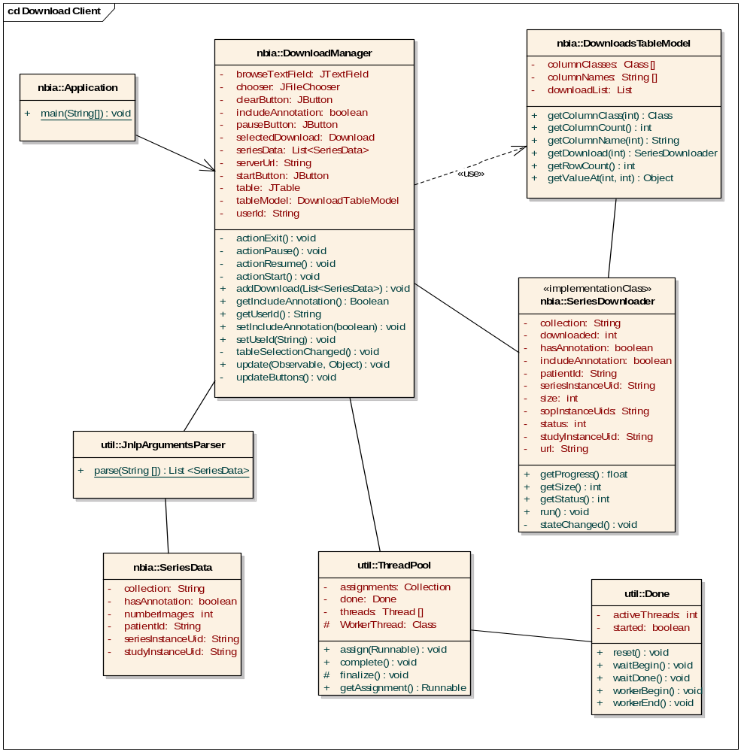

5. SEQUENCE DIAGRAMS
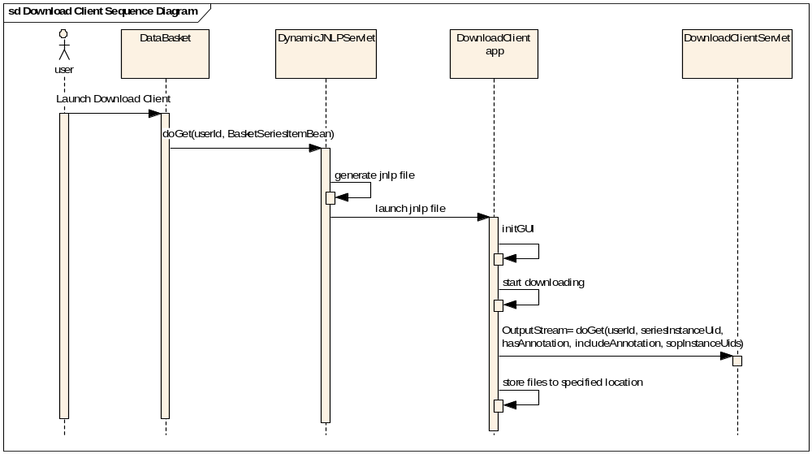
Figure 2: shows the flow of the download using download manager

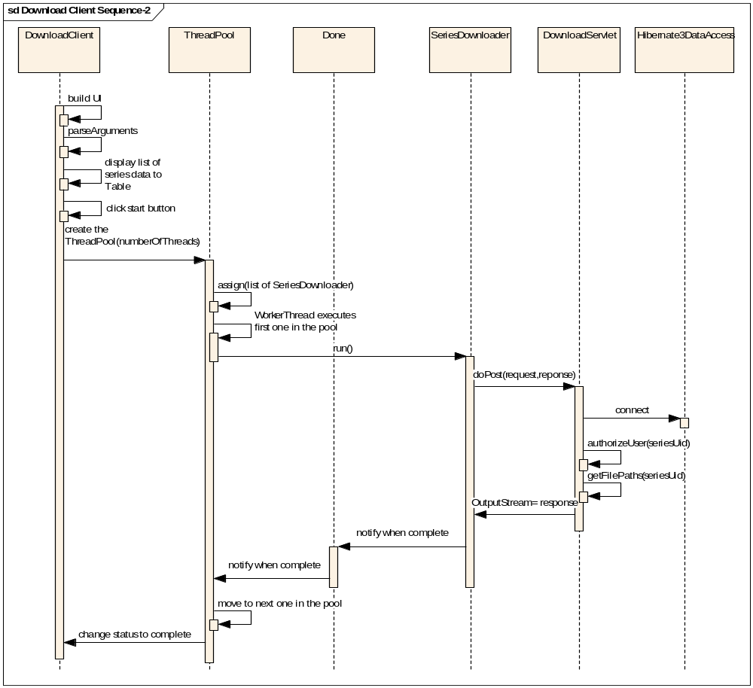
Figure 3: shows the flow of download manager application.

