NBIA Remote Search

Software High-Level Design Description
For NBIA Release 4.4

Document Change Record
Version Number | Date | Description
1.0 | 11/2009 | Initial document

Table of Content
Introduction 1
REFERENCES 2
DISCOVERY 3
Testing STRAtegy 4
SEARCH FORM 5
Testing STRAtegy 5
SEARCH EXECUTION 6
Basics FOR PATIENT SEARCH 6
Flow FOR PATIENT SEARCH 6
THREAD CREATION 7
RESULTS PER NODE 8
DRILL-DOWN To study and series 8
THUMBNAILS 9
DICOM TAGS 10
I-spy 11
GRID SERVICE CHANGES 12
DTO 12
New Methods 12
Miscellaneous Changes 14
DATA BAsKET and DOWNLOADING OF DICOM FILES 15
DOWNLOAD MANAGER 15
CLASSIC DOWNLOAD 15
BUILD 18
Saved query AND QUERY History 19

Introduction
This feature is a redesign of the existing remote search functionality. There are several factors driving the need to redesign:

- The existing remote search doesn’t deal well with timeouts or nodes that are down.
- It is impossible to view partial search results.
- It does not utilize the caGrid Discovery API to find other nodes. All nodes must be pre-configured directly in the underlying RDBMS without even a UI.
- The selection of remote nodes is divorced from the point of search issuance.

Additionally, the existing remote search code is coupled with (complex) presentation (managed bean) code in a way such that it is easy to break remote search by making a presentation change.

The original goal for this redesign was to make remote search completely transparent to the presentation code (like caNanoLab does), but the enhanced requirements to provide partial/asynchronous results will likely make this impossible.

That said, a design goal is to make the coupling easy and clear using factories and interfaces. For example, a LookupManager interface that deals with multiple “searchable” nodes will be necessary. On the other hand, the implementation should be “pluggable” and could deal with only one (local) node or many (remote) nodes. This way the remote/grid code can be quarantined in a separate project without too much explicit coupling (and totally removed at a later date even).

REFERENCES
The requirements for this feature are specified at:
https://ncisvn.nci.nih.gov/svn/nbia/trunk/docs/requirements/4.4%20Release/remote_search_fd.doc
caGrid 1.3 Developer Guides:
http://wiki.cagrid.org/display/caGrid13/Home
Java Tutorial on Concurrency:
http://java.sun.com/docs/books/tutorial/essential/concurrency/

DISCOVERY
- A singleton object RemoteNodes will use the caGrid Discovery API to talk to an Index server.
- A Quartz job will fire periodically to update RemoteNodes (NodeDiscoveryJob)
- The RemoteNodes object will additionally capture all “lookup information” for each discovered node. After a node is discovered, RemoteNodes will use the NCIACoreGridServiceClient to talk to the node to retrieve the lookup information (and cache it). The UI will use this information to populate the available modalities, collections, etc.
- The discovery process may take a while and the application should be able to retrieve the most recent copy of nodes while discovery is ongoing. Therefore, discovery will build up a new set of nodes while the old set is still available. The only part that needs to be synchronized is when the new set is “copied over” the old set. In other words, callers/clients to RemoteNodes will only block when the copy process is occurring.
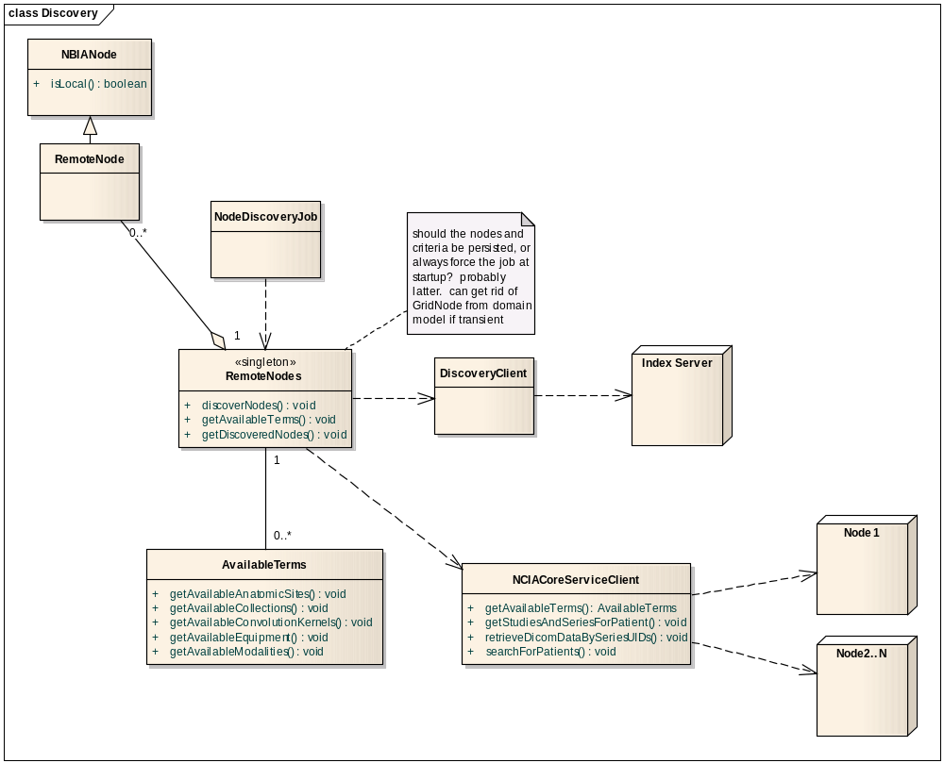

Testing STRAtegy
Mocking the discovery client and index server may be very difficult….
For actual functional testing, an index server will be set up.
- Advertisement? Through hand written code? Or setup NBIA nodes?
- The RemoteNodes object will be configured to point to it, and then assert the results returned.

SEARCH FORM
The search terms for the search form need to be populated by the local node and by all the available remote nodes. The existing LookupManager interface will be enhanced to return information by node, but to hide the details of remote v. local implementations. The SearchWorkflowBean will use this information to display all the choices on the searchBody page. Additionally, the “available search terms” link under the remote node chooser will rely on the LookupManager to tell which terms are available on which nodes.
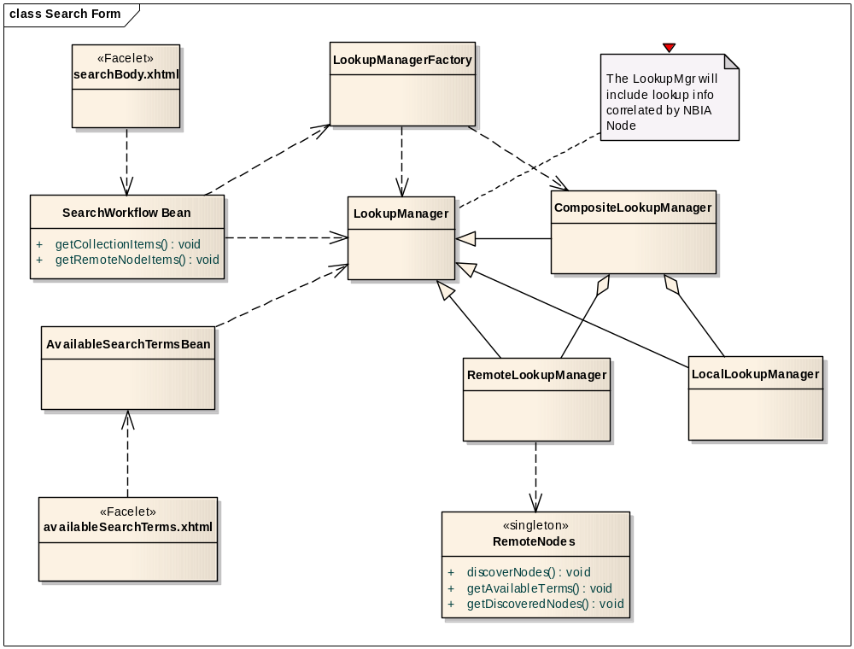

Testing STRAtegy
- Presentation beans - Devise Selenium Tests
- RemoteLookupMgr - Try to mock RemoteNodes.
- LocalLookupMgr - Already testing via dbUnit. Will have to tweak tests a bit.

SEARCH EXECUTION

Basics FOR PATIENT SEARCH
The most fundamental change to search execution is that (patient) results are no longer returned in a synchronous fashion. In other words, when execution is started by a given method (SearchWorkflowBean.submitSearch) the results are NOT ready for display by the time the method returns control. Instead of showing the “waiting” indicator on the search page, the search results page will show up immediately and the waiting indicator will show there instead.
Layered above that is that zero or one searches happen locally against the database (low latency), while zero to N searches happen against remote nodes (high latency).
At a primitive level, a thread will executed for each node/search. The JDK provides some higher-level abstractions for dealing with this sort of execution than plain threads. Two abstractions that are used for search are: ExecutorService and CompletionService.
The ExecutorService allows “submitting” a piece of code to execute. Then depending on the service implementation, a synchronous executor, or an asynchronous thread, or threads could be allocated to execute the code. An ExecutorService can take a Runnable or a Callable. In this case, the search will issue Callable objects that return the results. So, the executor service will accept the Callables and return patient search results.
On top of the ExecutorService is the concept of a CompletionService. A CompletionService is basically an ExecutorService combined with a blocking queue. A client can submit a job or jobs to it, and then block on the queue until the next job and all jobs are complete.

Flow FOR PATIENT SEARCH
- The SearchWorkflowBean will submit the search to the PatientSearcher object with a DICOMQuery object and a list of nodes to search.
- The PatientSearcher object will create the CompletionService, submit the jobs, and return the CompletionService.
- The SearchWorkflowBean will wire the CompletionService object to the SearchResultBean.
- If a search is already ongoing, the result bean will throw away any state for that search.
- For each node in the search, the SearchResultBean creates a presentation bean/wrapper to encapsulate the results for that node.
- The SearchResultBean starts a single Thread (AsyncResultsWaiter) to block on the CompletionService.
  - As each result comes in, the Thread uses the IceFaces push mechanism to refresh the user’s browser. (A result could be a timeout exception too).
  - The Thread terminates when N results have been received.
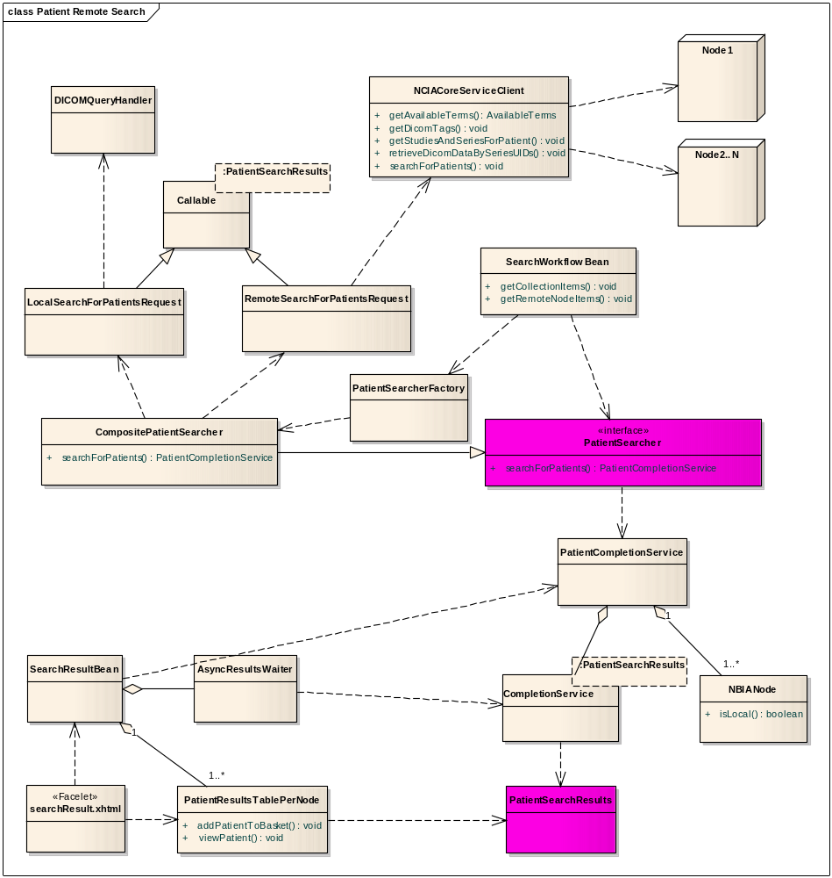

THREAD CREATION
The system will have N fixed threads pre-allocated in a pool for the entire application. The number N can be configured in properties-service.xml.
When a search is initiated, a CompletionService is created that allocates threads from the pool. The search will retain a Future for each submission to the CompletionService.
A user/session can only have one outstanding search at a time. If a search is ongoing while a new one is initiated, the retained Future objects are iterated over in order to issue a cancellation.
If the system is under load and there are no threads available in the pool, the search will block until a thread becomes available.

RESULTS PER NODE
Each node will have its own patient results table. The basic principle is that just about every operation that used to be in SearchResultsBean will be moved into PatientResultsTablePerNode. Then SearchResultsBean will just organize the collection of these objects. This is necessary because binding the values for multiple tables through a single bean is either impossible, or really difficult. In other words, one table->one bean, and then have a master bean organize all those other beans.
Note: it appears impossible to do a component binding to a bean that is not defined in faces-config.xml.

DRILL-DOWN To study and series
The “search” is really about retrieving patient results asynchronously. Drill-down to retrieve the details for a patient will still be synchronous, i.e. the user has to wait to retrieve the information. If a drill-down fails, the user is notified with an error message and stays on the current page.
If a node’s results return quickly and the user drills down on those results, the (top-level) patient search will continue. This is because the user may return to the patient results through the bread crumbs. The only thing that can terminate a patient search is to start a new one, or to finish retrieving all results.
The Searcher object will support the necessary methods to retrieve the data for drill-down. It will insulate the remote v. local aspects of drill-down from the UI.
The PatientSearcher and Searcher could be merged conceptually, but because of the complexity of the PatientSearcher, they will be kept separate.
(Maybe Searcher isn’t the best name? DrillDownManager instead?)
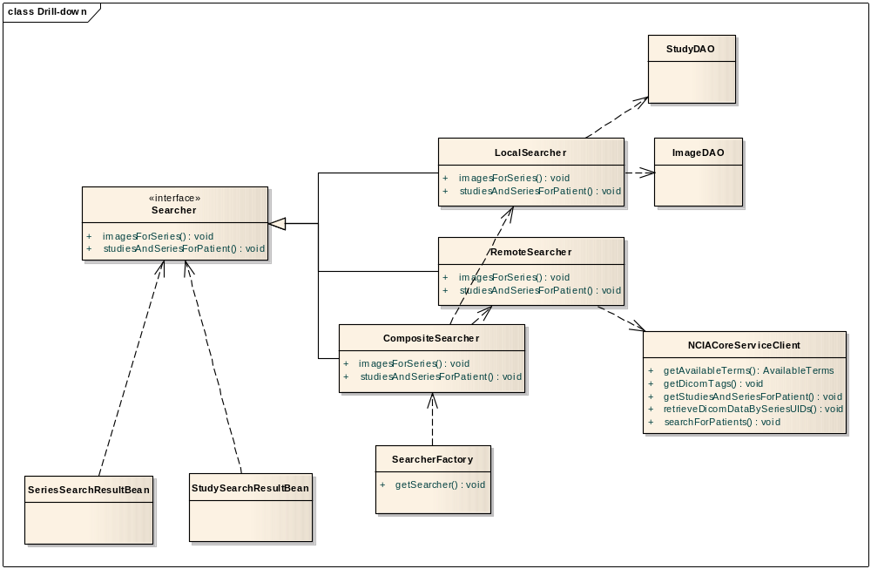

THUMBNAILS
The existing thumbnail server has a security flaw and the existing remote search is/was dependent upon this security flaw to operate. As it stands, the data access layer talks “up” to the application/presentation layer to register a viewed thumbnail with a number. That number is embedded on a page and then used to ask a servlet for the image for that number. Besides having no concept of proper “layering” (data access v. presentation), the problem is that the registration map is application-wide instead of session-based. Example:
- User X has authorization to view collection A.
- X views a series in A.
- The system registers a thumbnail as 1.
- User X logs out even.
- User Y doesn’t even login. He does not have authorization to view collection A.
- User Y issues a request for thumbnail 1 (thumbnailViewer?location=1). The request is granted.
To deal with the security issue, the ImageRegisterMap will be moved to be session-based. This approach also solves a small memory leak in that an id is mapped to a string/filename for the life of the application until it is shutdown. With the existing implementation, even if the same image is re-requested, it will occupy a new entry in the map.
Remote search can no longer depend on retrieving remote thumbnails (exactly) this way because the thumbnails will be session-based.
There are two possible solutions for delivering thumbnails for remote search.
- The grid service could return a TAR with all the thumbnails for a given series instance UID.
This may be needlessly complex because the appserver will have to download the thumbnails locally and then make them available through a local thumbnail servlet and clean them out after the session is done.
- A similar approach to the old method could be used. A new thumbnail servlet would respond to SOP instance UID and ignore requests for private images. Basically the same as the old servlet, but instead of using “side effect” identifiers, use real identifiers, and then not allow private images to be referenced.
This is probably the easiest thing. There will be a performance hit for checking security, but it is necessary.
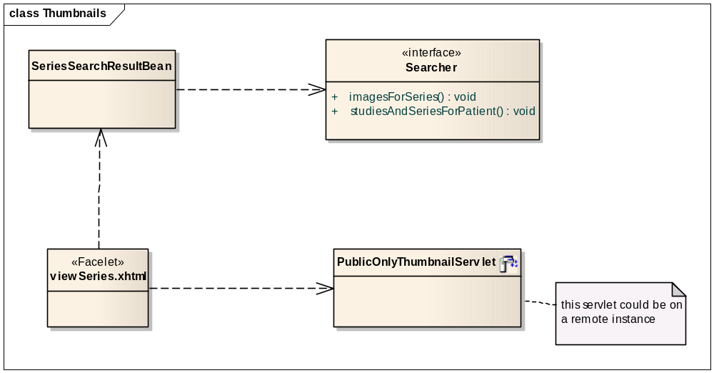

DICOM TAGS
The grid service needs an extra method to return DicomTagDTO objects, or something like it. The UI needs to be insulated from the database v. grid implementation through the DicomTagViewer interface.

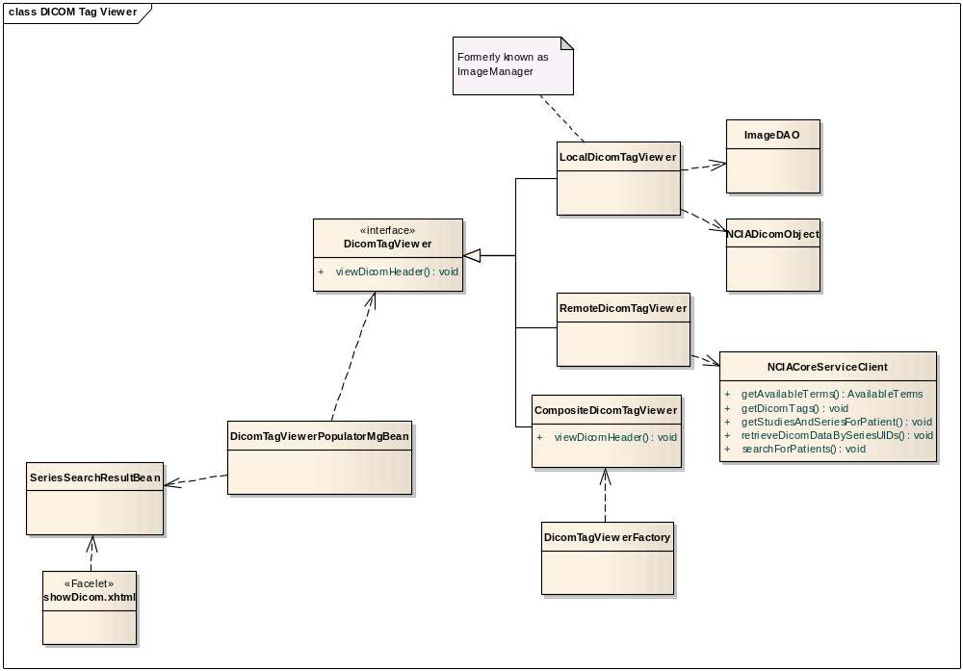

I-spy
The ISPY portal relies upon the SearchWorkflowbean.query(DICOMQuery) to run synchronously, so this old code will be preserved. The method query will be split into synchronousQuery and asyncronousQuery. The former will support ISPY while the latter will support the new UI.

GRID SERVICE CHANGES
The existing grid service is a data service with some miscellaneous analytic operations and caGrid Transfer operations.
The same grid service will be expanded to include analytic operations that support the retrieval of available search terms, patient search, patient drill-down, and retrieval of DICOM tags.
The underlying objects used by the appserver for these operations will be re-used by the grid service, forcing some changes to the build and deployment of the grid service.
Some new objects will have to be created in order to return the values for these operations. These objects will be registered with the GME.

DTO
A major design decision is what objects to use to return data from the grid service. Traditionally, the so-called “DTO” objects were used to return data from the database and to send data across the wire for the grid service. It is not an obvious choice (to the author) for whether to have these objects do double-duty for the database and the grid.
Other drawbacks: change in one, changes in both whether you like it or not.
For example, the PatientDTO that comes back from PatientDAO and the one that would come back from the grid would have a lot of state in common. However, they would also have divergent state. For example, the DTO coming back from the DAO would likely have a primary key identifier, but the grid one would NOT. The DTO coming back from the grid might indicate where it came from, whereas the one from the database would NOT.
If a DTO sometimes has a property set, and other times it does not, it becomes confusing to client code for when that property can be utilized. A typical solution for this situation is to have a common base class, with two derivatives containing the extra state.
In the presentation layer, there is a large amount of code that depends on the xDTO objects as-is. This code would have to be changed to respect only the base class, and then the code that is specifically remote v. local would deal with the concrete subclasses.
What about grid stuff that shows up in presentation?

New Methods
- getAvailableSearchTerms
Input: None
Pre-conditions: None
Behavior: Calls the LocalLookupMgr and creates an instance of AvailableSearchTerms to return. Introduce can generate the object from XML Schema.
Output: Return instance of AvailableSearchTerms.
- searchForPatients
Input: Array of SearchCriteriaDTO objects
Pre-Conditions: The criteria class referred to by the GridSearchCriteriaDTO must exist.
Behavior: Constructs a DICOMQuery object from the criteria objects and passes it to the DICOMQueryHandler.
Output: Return array of GridPatientDTO.
- getStudiesAndSeriesForPatient
Input: Patient ID.
Pre-conditions: Patient ID must exist in the database.
Behavior: If a series of a patient is not public, it will not be returned. If the patient doesn’t exist, return an empty array. Otherwise, call the StudyDAO.findStudiesByPatientId.
Output: Return array of GridStudyDTO objects. Can be zero-length.
- getImagesForSeries
Input: Series Instance UID.
Pre-conditions: Series Instance UID must be for a public series. Series Instance UID must exist in the database.
Behavior: If series is not public, return an empty array. If the series doesn’t exist, return an empty array. Otherwise, call the ImageDAO.findImagesBySeriesInstanceUid.
Output: Return array of GridThumbnailImageDTO objects. Can be zero-length.
- getDicomTags
Input: SOP Instance UID.
Pre-conditions: SOP Instance UID must be from a public series. SOP Instance UID must exist in the database.
Behavior: If series is not public, return an empty array. If the series doesn’t exist, return an empty array. Otherwise, call the LocalDicomerViewer to get the tags.
Output: Return array of DicomTagDTO objects. Can be zero-length.

Miscellaneous Changes
- Drop the gridServiceUrl “callback” from the service back to the service. Extra overhead for serialization plus yet another property to deal with in deployment.
- Change zips->tars for performance. The download manager already wants tars, so this will dovetail nicely (behave like the download servlet in nbia-download-mgr).

DATA BAsKET and DOWNLOADING OF DICOM FILES
BasketSeriesItemBean will contain a URL that points to the grid service where the series came from.

DOWNLOAD MANAGER
The SeriesDownloader will use retrieveDicomDataBySeriesUIDs+grid transfer to download the zip directly to the client box.
The “download manager” download servlet sends tars while the grid service sends zips. The grid service should switch to tars to enhance performance, and then the SeriesDownloader can probably accommodate remote and “local” conditions more easily.
Possibly there will be two SeriesDownloader objects with shared pedigree, and one is constructed for remote v. local.
Note: the two approaches can’t be completely unified because the “local” case can access private data.

CLASSIC DOWNLOAD
The historical feature doesn’t support HTTP download plus remote search. For FTP download, it sends the request to each remote node to zip independently and then each node sends a separate completion email to the downloader. The zip is stored at each remote node. This is probably the most scalable approach.
An alternative is to have the “point of search” node aggregate all the content from the remote search nodes on the point of search node, and then store one zip file on the FTP site. There are benefits and drawbacks to this alternate approach:
Benefits
- The user only has to deal with one completion email which is less confusing to grok.
- The same interface that the download manager uses to retrieve DICOM files can be reused here (instead of a new interface).
Drawbacks
- Extra trip from the remote node to the local node, and then to the user via FTP.
- For massive data sets, the zip file could become unmanageable (either to fill up the local node’s storage or to create a zip file size that pushes the limits of the file system).
Given that we are trying to focus users on using the download manager, we are going to ignore potential scalability problems with classic download and focus on ease of development.
The method BasketBean.downloadBasket initiates the retrieval and zipping of the DICOM files. The BasketBean does a lot of heavy lifting in regard to orchestrating this process. This logic will be pushed down into a new object called BasketDownloader that will handle most of the details and also handle issuing remote requests to retrieve data.
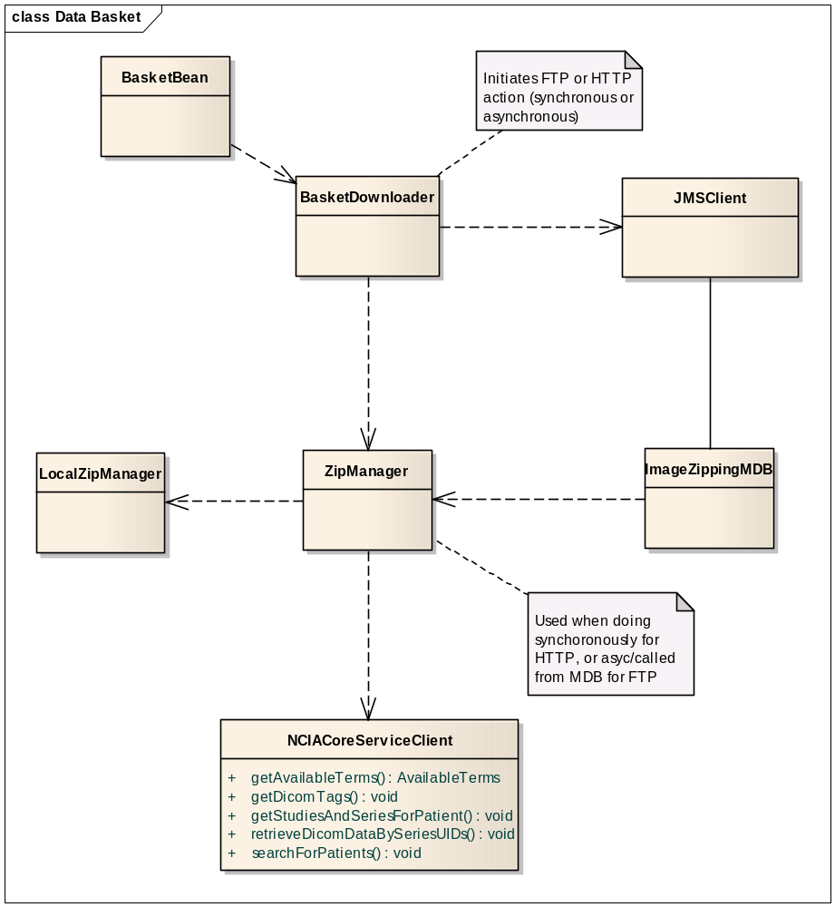

BUILD
The main change to project structure is that the ncia-core-grid-transfer project will depend on the search and lookup objects that currently reside in ncia-services-commons.
Additionally, the (remote) search and lookup objects will depend on the client to the grid service.
So, the client must be built before the commons project, and the commons project must be built before the full grid service.
The inclusion of the ncia-services-commons and ncia-domain project into the classpath of the grid service requires that the “internal” domain objects be in a different package from the “external” domain objects that area already being used by the grid service.
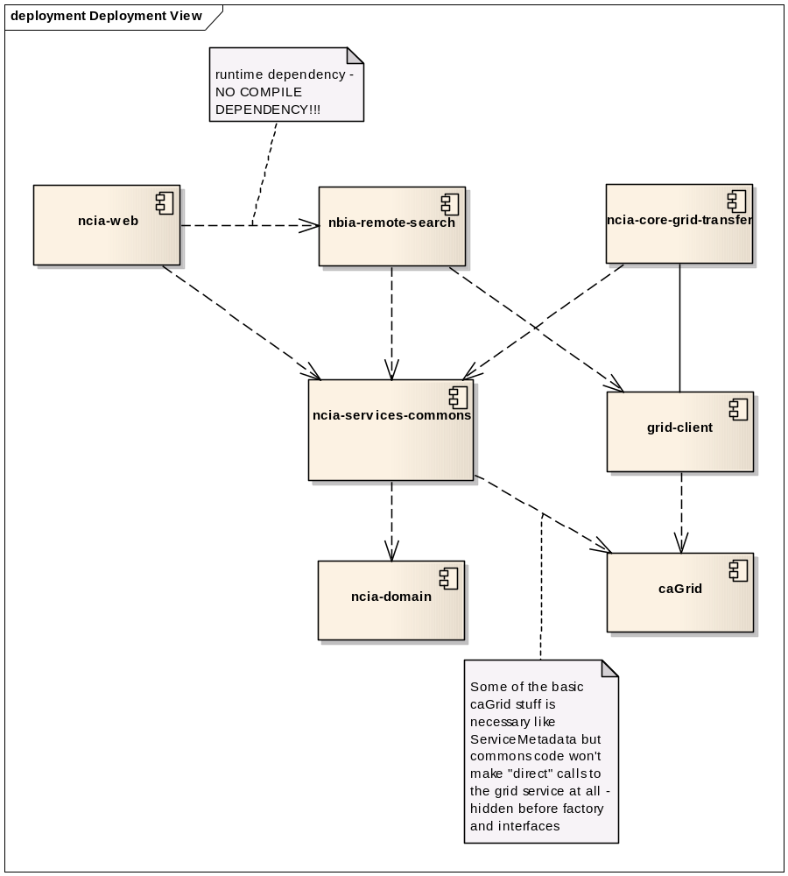

Saved query AND QUERY History
TBD. Leaving this for Jim.

Additionally, these objects had some presentation state stored in them (very bad). All of the blatant presentation state has been removed from these objects.

