NCIA Automated Build and Deployment
Design Guide
This document is designed to provide design insight into the NCIA build automation system. It targets architects, developers and build engineers who will use, maintain and potentially extend the system.
Produced by the Build and Deployment Automation Team
4/21/2008
Document Approvals
The list contains the name for the core project team and any key stakeholders who have an interest in the success of the project. An “S” identifies persons responsible for approval from the Business and Development. Sign off of the document would be required when a decision is made not to take action for defined gaps.

S | Name | Role | S | Name | Role
S | Anand Basu | NCICB Engineering Manager
 | David Palmer | Development Project Manager
Revision History
When you make a change to a document, you must add an entry to this Revision History table and you must manually type the Last Revised Date on the front cover.

Date | Version | Description | Revised by
4/21/08 | 1.0 | Initial draft | Levent Gurses
Copyrights and Trademarks
© Copyright 2007 by NCICB, caBIGTM. All rights reserved.

Table of Contents
1. Introduction 3
1.1. Purpose 3
1.2. Scope 3
2. Build and Deployment Automation (BDA) Utilities 3
2.1. BDA Features 4
3. Database Incremental Build Process 5
3.1.1. Description 5
3.1.2. General flow 5
3.1.3. Points of interest 6
3.1.4. Build.xml 6
3.1.5. Install.xml 6
3.1.6. Other db related targets 7
4. NCIA AntHill Pro Configuration 7
4.1. ncia-properties project 7
4.2. ncia-properties project 8

Introduction

Purpose
This document is designed to provide design insight into the NCIA build automation system. It targets architects, developers and build engineers who will use, maintain and potentially extend the system.

Scope
This document describes the building blocks of the NCIA automated build and deployment system. An important part of the build system is the tools and the configuration settings. The document explains the technical stack and the key configurations needed to operate and extend the system.

Build and Deployment Workflow

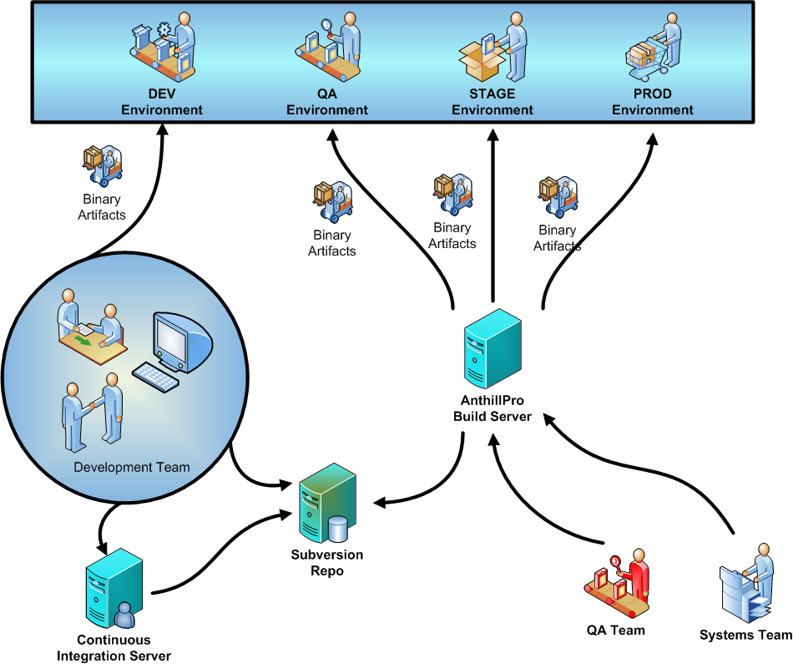
Figure 1 General workflow of NCIA build and deployment system

Build and Deployment Automation (BDA) Utilities
The Build and Deployment Automation (BDA) team has written a suite of Ant macros to simplify automated builds and deployments. This suite of tools is called BDA-UTILS. BDA-UTILS is distributed via the BDA Ivy Repository. There are three files (a ant build script and two ivy config files) that are required in your repository to facilitate downloading and usage of the bda-utils package. In addition you need to add a code block similar to below to integrate the download of bda-utils into your build process. This is already complete in the NCIA project.
BDA Download utilities
https://gforge.nci.nih.gov/svnroot/automation/trunk/bda/ivy/bda-ivy-build.xml - This file is called by your build script, it downloads ivy jar files, then uses ivy to download bda-utils module (including dependent libraries).
https://gforge.nci.nih.gov/svnroot/automation/trunk/bda/ivy/ivy-bda-settings.xml - This file controls what url it tries to retrieve the ivy files from.
https://gforge.nci.nih.gov/svnroot/automation/trunk/bda/ivy/ivy-bda.xml - This file indicates the version of bda-utilities to retrieve
How to Use download Utilities (add below to your build.xml)
<property name="bda-utils.dir" value="bda-utils"/>
<property name="lib.dir" value="lib"/>
<mkdir dir="lib"/>
<ant inheritAll="false" inheritRefs="false" antfile="bda-ivy-build.xml"
target="retrieve-bda">
<property name="bda-utils.dir" value="${bda-utils.dir}"/>
<property name="lib.dir" value="${lib.dir}"/>
</ant>

BDA Features
- run-junit-tests - not used by ncia
- run-sql-script - used by most of our scripts to run sql
- remote-ssh - used by ncia for ssh tasks
- remote-scp - used by ncia for scp tasks
- jboss-stop-jboss - used by ncia to stop jboss
- jboss-check-if-jboss-is-running - not used by ncia
- jboss-start-jboss - used by ncia to start jboss
- jboss-update-shutdown - used by ncia to update the jboss shutdown process based on using different ports
- jboss-update-runconf - not used by ncia
- validate-pre-install - used by ncia at install time to make sure that it should be able to install
  - validate-environment - Checks ant and java versions, also ensures not running as root
  - validate-database - checks version of database and connectivity to it
  - validate-properties- Fails if REPLACE is present in prop file, warns if replace is in properties file, ensures that database.system.user and any other @database@user do not have the same value, checks connectivity to any prop that ends in hostname and prints status of connection,
  - compare-properties- Compares properties.file against template to ensure that all required properties exist
  - check-direct-child-directory- Verifies that sub directory is direct child of parent directory, currently jboss.home needs to be a direct child of application.base.path
  - check-not-child-directory - Verifies that one directory is not child of another directory, currently being used to make application.base.path is not a parent of the current working directory because it gets deleted as part of the install
  - check-valid-directory-name - Ensures that directory is not a root dir (x:\ /) a system directory (c:/windows /usr) and does not have spaces in name (c:/Program Files)
  - check-application-exists - Checks if jobss is already install and if force.reinstall property is not set will warn the user about backups and prompt them to proceed
  - check-database-exists - Checks if database exists and if force.reinstall property is not set will warn the user about backups and prompt them to proceed
- validate-ports-preinstall- checks to make sure ports configured in properties are not listening, should run after shutdown of application servers
- validate-post-install - used by ncia after install and start-up to check things are up and print warnings and errors from jboss log files
  - validate-ports-postinstall - checks ports from properties file to make sure they are listening
  - validate-jboss-logs-postinstall - prints errors and warnings from jboss server.log and boot.log
- database-create - used by mysql to create database and user (not needed for oracle)
  - database-create-control-table - creates control table for incremental build process
- database-identify-scripts - install time target that creates dynamic ant build file for running in incremental database scripts, compares version on files to current state of database, files old than current version not applied
- database-build-filelist- build time target that generates a list of files and their versions for use by install time process
- database-update-version-table - this updates the control table with the current repository version after all incremental scripts have been applied
- tomcat-stop - used by ncia to stop tomcat
- tomcat-start - used by ncia to start tomcat
- properties-exist - takes a property name list (comma delimited) and verifies properties are set
- svn-co - checks out svn based on tag to a directory
- report-grand - makes grand graphs of build file
- jboss-bindings - configures ports used by jboss server
- jboss-read-dbconfig - reads database properties from existing jboss *-ds.xml file

Database Incremental Build Process

Description
The BDA-UTILS incremental database build process can be used to apply incremental scripts to the database. This process uses the svn revision number of the whole checkout and the last modified svn revision number on each of the database scripts. This process will also store the version of the repository into a build_control table (which it creates if it is missing). This process will loop through each file it is planning to apply, compare it's version to the version in the database, if the file is greater it will run that sql. When all sql scripts have been applied the build_control table in the database will be updated with the latest svn revision number of the whole checkout.
- Requires a single directory with all incremental scripts (per type of database)
- Requires all database incremental files are checked in
- Uses current checkout's svn revision at build time
- Uses each database incremental file's svn version at build time
- Creates a build_control table, if it does not exist
- Uses build_control table in database to check the current revision of database

General flow
- call macro: database-build-filelist [build time] - This macro will produce two output files based on one input directory. It will get the version of the current version of the repository at build time and write that to build.properties.file. Second it will get a list of files from the incr.sql.dir, get the version for each file and write the complete list to sqlfiles.list file. sqlfiles.list.file will be ordered alphabetically (ordinally).
  - incr.sql.dir - directory for incremental database files
  - sqlfiles.list.file - file with list or each database file and it's svn last modified version
  - build.properties.file - file with the version of the repository from the checkout you built on
- call macro: database-identify-scripts [install time] - This macro will dynamically populate db-integrate.xml with which file to apply. First it will read the latest version from the database build_control table. It will then read the sqlfiles.list file and process entries one by one. It will compare the version on the file with the version from the database, if the file is greater than the database it will add the file to the db-integrate.xml.
  - sqlfiles.list.file - file with list or each database file and it's svn last modified version
  - build.properties.file - file with the version of the repository from the checkout you built on
  - database.sql.dir- directory where sql will be applied from
- ant call: database-integrate (from db-integrate.xml) [install time] - This will execute each of the scripts that were added db-integrate.xml from macro database-identify-scripts.
- database-update-version-table [install time] - This process will update the build_control table with the version from the build.properties.file

Points of interest
- Order of scripts is based on alphabetical sorting of name, thus it is key to include an ordinal value in the name. My preferred method is to begin the file name with a date. (2008-04-22-addVDateToGITbl.sql)
- The nature of databases is very ordinal. If you had an old snapshot of a database and you wanted to take it forward to the current image and you had all the transactions between the snapshot and now, you could apply them in order and you would get the same database (many databases use redo/archive logs to recover a database). If you change the order or contents of the updates you will not have the same database. Since each incremental script is an update, to guarantee you get the same results you should apply the changes in exactly the same order with exactly the same contents. What this means is do not update incremental files once they are "committed" they do not change. If you want to change a "committed" file then create a new one that undoes the previous changes and add things the way you want (if you added a column but miss-spelled the name, then create backup of table, drop the bad column name, add the correct column name and update the modified table with data from the backup table, this is just an example).
- Since versioning was not used prior in the database, all databases must be brought to a certain minimal level before the automated process can be used on it. This process would have to be manual. Let’s say a user has 2.0 version of the app and they want to upgrade to 4.0 and that 3.5 is the version they need to start using the automated process. The person would have to bring the database to 3.5 manually, and then the automated process could bring it from 3.5 to 4.0.
- Because you support different database types you need to call "database-build-filelist" twice, once with arguments for MySQL and once for oracle.
- To test out sql scripts you will need a scratch database that you can run the scripts manually (or automated through the build). Scripts should never be manually applied in dev, qa, stage or production environments.

Build.xml
<database-build-filelist
sqlfiles.list.file="${ncia.dist.dir}/${db-incr.mysql.list.file}"
build.properties.file="${ncia.dist.dir}/${db-incr.mysql.conf.file}"
incr.sql.dir="${ncia-db-incr.artifact.dir}/mysql" />
<database-build-filelist
sqlfiles.list.file="${ncia.dist.dir}/${db-incr.oracle.list.file}"
build.properties.file="${ncia.dist.dir}/${db-incr.oracle.conf.file}"
incr.sql.dir="${ncia-db-incr.artifact.dir}/oracle" />
<!-- added for incremental database build -->
<copy tofile="${ncia.dist.dir}/db-integrate.xml" file="${bda-utils.dir}/resource/template-db-integrate.xml"/>

Install.xml
<copy todir="${database-incr.dir.target}">
<filterset>
<filtersfile file="${properties.file}" />
</filterset>
<fileset dir="${database-incr.dir.src}" includes="**/*.sql" />
</copy>

<database-create-control-table
database.url="${database.url}"
database.user="${database.user}"
database.password="${database.password}"/>

<database-identify-scripts
sqlfiles.list.file="${db-incr.list.file}"
build.properties.file="${db-incr.conf.file}"
database.sql.dir="${database-incr.dir.target}"/>

<antcall target="database-integrate" />

<database-update-version-table
database.driver="${database.driver}"
database.url="${database.url}"
database.user="${database.user}"
database.password="${database.password}"/>

Other db related targets
- database-create
  - database-create-control-table

NCIA AntHill Pro Configuration

ncia-properties project
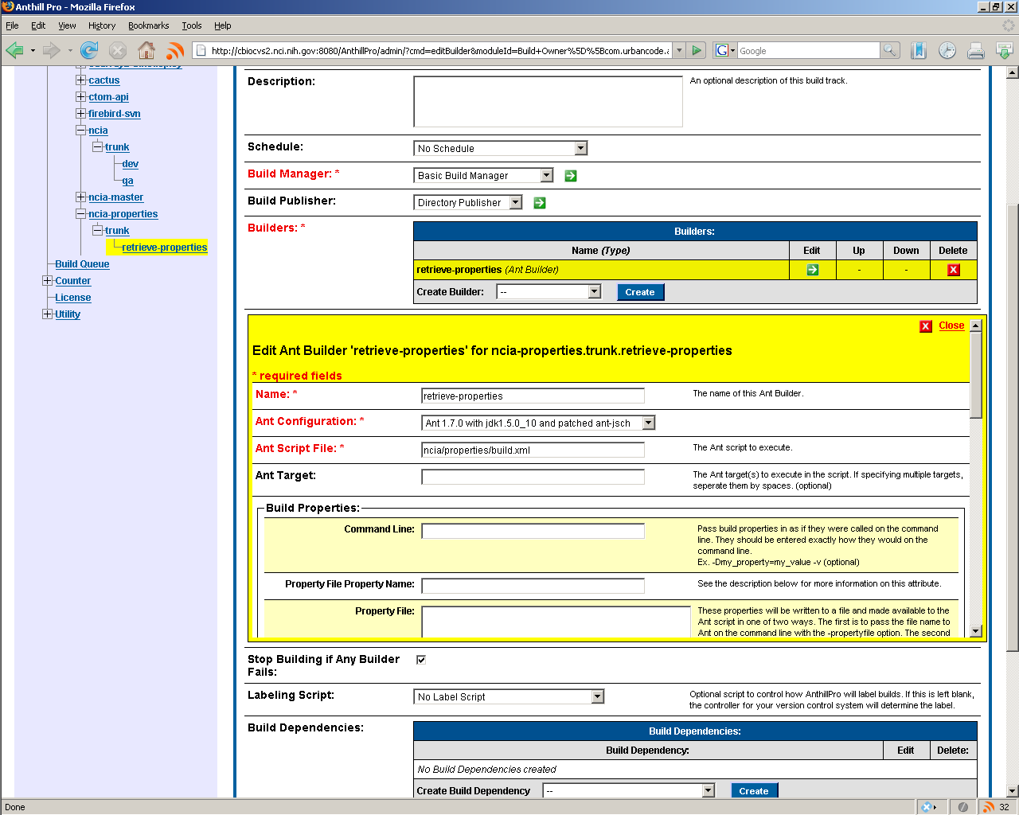
Figure 2 NCIA properties project. The NCIA build project depends on properties to be automatically updated before each build
- ncia-properties project
  - name - ncai-properties
  - Do not allow parallel builds - unchecked
  - Repository Driver - svn
    - Project URL - svn://cbioapp520.nci.nih.gov/svnroot/scm-private/trunk
    - Tags URL - svn://cbioapp520.nci.nih.gov/svnroot/scm-private/tags
    - SVN User - svnuser
    - SVN Pass - svn#use
    - SVN Command path - [empty]
    - Determine Working Directory Script- SVN Working Directory
    - Delete Files on Clean-up - false
    - Versioning Strategy - Property Versioning Strategy
  - Branch - Trunk
- Branch Trunk
  - Name- trunk
  - Repository branch - [empty]
  - Build Tracks - retreive-properties
- Build Track- Retrieve Properties
  - Name - retreive-properties
  - Description - [empty]
  - Schedule - no sched
  - Build Manager- Basic Build Manager
    - Labeling Preference - never
    - Always build tag- [empty]
    - Increment Version number only on sucess - unchecked
  - Build Publisher - Directory Publisher
    - Publish Directory - [empty]
    - Clean Publish Directory - checked
    - Publish URL - [empty]
    - Activate Retention Policy - unchecked
    - Number build Sucesses to keep - 100
    - Number of build failures to keep - 100
    - Existing Filters
      - Base Source Directory
        - create a new filter - [empty]
        - include patterns - [empty]
        - exclude patterns - [empty]
  - Builders - retrieve-properties
    - name - retrieve-properties
    - Ant configuration- ant 1.7.0 with jdk1.5.0_10 and ant.jsh
    - Ant script - ncia/properties/build.xml
    - Ant target- [empty]
    - Build Properties
      - command line - [empty]
      - property file name - [empty]
      - property file - [emptpy]
      - Use Anthill Namespace - checked
      - jvm properties -[empty]
      - environment variables - [empty]
  - stop building if any builder fails - checked
  - labeling script - no label script
  - Build Dependencies - none
  - Build event listeners 0 ncia.trunk.dev Listener
    - Add Dependency Project - null
    - Manage ncia.trunk.dev Depenencies
      - dependency project - ncia-properties.trunk.retrieve.properties
      - always rebuild dependency - checked
      - force rebuild dependency - checked
      - rebuild when dependency is sucessfully built - not checked
      - remove depenency - not checked

ncia project
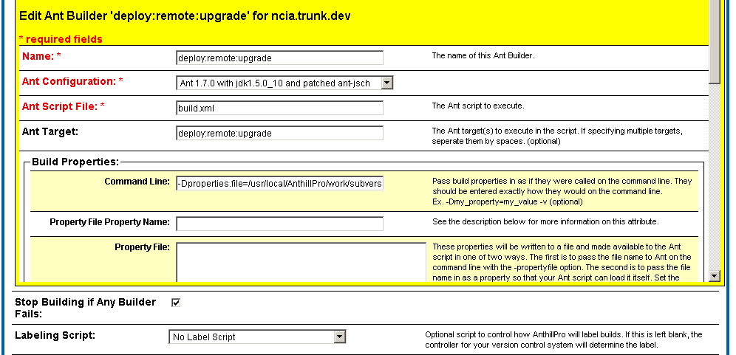
Figure 3 NCIA build configuration in AnthillPro
- ncia project
  - name - ncia
  - Do not allow parallel builds - unchecked
  - Repository Driver - svn
    - Project URL - svn://cbioapp520.nci.nih.gov/svnroot/ncia/trunk/software
    - Tags URL - svn://cbioapp520.nci.nih.gov/svnroot/ncia/trunk
    - SVN User - svnuser
    - SVN Pass - svn#use
    - SVN Command path - [empty]
    - Determine Working Directory Script- SVN Working Directory
    - Delete Files on Clean-up - false
    - Versioning Strategy - Property Versioning Strategy
  - Branch - Trunk
- Branch Trunk
  - Name- trunk
  - Repository branch - [empty]
  - Build Tracks - dev
- Build Track- dev
  - Name - dev
  - Description - NCIA Automated Build and Deployment Track for DEV
  - Schedule - no sched
  - Build Manager- Basic Build Manager
    - Labeling Preference - never
    - Always build tag- [empty]
    - Increment Version number only on sucess - unchecked
  - Build Publisher - Directory Publisher
    - Publish Directory - [empty]
    - Clean Publish Directory - checked
    - Publish URL - [empty]
    - Activate Retention Policy - unchecked
    - Number build Sucesses to keep - 100
    - Number of build failures to keep - 100
    - Existing Filters
      - Base Source Directory
        - create a new filter - [empty]
        - include patterns - [empty]
        - exclude patterns - [empty]
  - Builders - deploy:remote:upgrade
    - name - deploy:remote:upgrade
    - Ant configuration- ant 1.7.0 with jdk1.5.0_10 and ant.jsh
    - Ant script - build.xml
    - Ant target- deploy:remote:upgrade
    - Build Properties
      - command line - -Dproperties.file=/usr/local/AnthillPro/work/subversiondriver/ncia-properties.trunk.retrieve-properties/trunk/ncia/properties/dev-upgrade.properties
      - property file name - [empty]
      - property file - [emptpy]
      - Use Anthill Namespace - checked
      - jvm properties -[empty]
      - environment variables - GLOBUS_LOCATION=/usr/local/ws-core-4.0.3
  - stop building if any builder fails - checked
  - labeling script - no label script
  - Build Dependencies
    - Add Dependency Project - null
    - Manage ncia.trunk.dev Depenencies
      - dependency project - ncia-properties.trunk.retrieve.properties
      - always rebuild dependency - checked
      - force rebuild dependency - checked
      - rebuild when dependency is sucessfully built - not checked
      - remove depenency - not checked
  - Build event listeners - none

