Architectural Review Checklist

NCIA
Release 4.0

Revision Document History
Date | Version | Description | Author
09/10/03 | 1.0 | First draft | NCICB Dedicated Support
11/07/03 | 1.0 | Final version 1.0. | NCICB Dedicated Support
05/12/04 | 2.0 | Redesign to incorporate developer answer phase followed by a systems interview phase. | NCICB Dedicated Support

Table of Contents
1. Introduction 6
1.1 Purpose 6
1.2 Guidelines for Completing the ARC 6
2. Project Details (To be answered by development team) 6
2.1 General Information 6
2.1.1 Project Description 6
2.1.2 Contact Information 7
2.1.3 Major Deployment Milestones (for Reengineering Release 4.0 only) 7
2.2 Architectural Details 7
2.2.1 High level architectural description: 7
2.2.2 High Level Design Diagram (If available): 8
2.2.3 Implementation language(s) used? 8
2.2.4 Will connections/requests to the application be session based (i.e. statefull versus stateless)? If so, is there any reason why application would not support “sticky session” load balancing? 8
2.2.5 Will the application be caching data? If so, what is being cached and how much data will be cached? 8
2.2.6 What data files will be created (if any)? How much data will be saved on an on going basis? 8
2.2.7 Will this application need a database schema(s) created on the NCICB infrastructure? If so, what is the maximum number of objects to be stored? 9
2.2.8 Are there any external/non-NCICB data sources that will be accessed by the application? 9
2.2.9 If this is a web-based application, what are the preferred virtual hosts names to be registered? 9
2.2.10 Any additional architectural details that may be of significance to the needed deployment environment. 9
2.3 Performance Requirements 9
2.3.1 Total number of users for this application? 9
2.3.2 Peak number of concurrent users? 9
2.3.3 Peak number of requests/minute? 9
2.3.4 Up time requirements? 9
2.3.5 Acceptable down time when recovering from major systems disaster? 9
2.4 NCICB Project Dependencies 9
2.5 Configuration Management Details 9
2.5.1 Version Control 9
2.5.2 Change Control 9
2.5.3 Migration to CVS 9
2.5.4 Users 10
2.5.5 Build Process 10
2.5.6 Other CM Needs 10
2.6 Additional Notes 10
3. System Requirements (To be answered by both development & systems team) 10
3.1 Operating System 10
<<Solaris/LINUX/Windows 2000/…>> 10
3.2 Software (Technology Stack) 10
3.2.1 Web Server: <<Apache/Tomcat/ZOPE/…>> 10
3.2.2 App Server: <<Tomcat/JBoss/Oracle 9iAS/…>> 10
3.2.3 Database Server: <<Oracle[with JVM component]/MySQL/PostgreSQL/…>> 10
3.2.4 Other software components: <<PERL x.x, Python x.x, …>> 10
3.3 Server Hardware 10
3.3.1 Server: <<type, model, …>> 10
3.3.2 Minimum processor speed: 10
3.3.3 Minimum memory: 10
3.3.4 Minimum local drive space: 10
3.4 Storage 10
3.4.1 Expected file server disk storage (in MB): 10
3.4.2 Expected database storage (in MB): 10
3.4.3 Expected ftp storage (in MB): 10
3.4.4 Expected media/image storage (in MB): 10
3.5 Load Balancing/Fault Tolerance 11
3.5.1 Does the application support load balancing? 11
3.5.2 Implement load balancing – YES/NO 11
3.6 Networking 11
3.6.1 Any application specific port assignments? 11
3.6.2 Any additional configuration? 11
3.7 Additional Notes 11
4. Proposed NCICB Deployment Environment (To be answered by systems team) 11
4.1 Hardware 11
4.2 Technology Stack 11
4.3 File Server 11
4.4 Database 11
4.5 Networking 11
4.6 Other Resources 11
5. Impact Assessment (To be answered by systems team) 11
5.1 Overview 11
5.2 Cost 11
5.3 Timeline to implement 11
5.4 Additional Notes 12
6. Acceptance 12
7. Appendix 1 - Future Systems Requirements 13
7.1 New Architecture Diagram 13
7.2 Notes on the design change 13
7.3 Hardware 13
7.3.1 Servers 13
7.3.2 Processor speed 13
7.3.3 Memory 13
7.3.4 Drive Space 13
7.4 Software (Technology Stack) 13
7.4.1 Web Server 13
7.4.2 App Server 13
7.4.3 Other components 13
7.5 Fault Tolerance (Redundancy) 13
7.5.1 Does the application support load balancing? 13
7.5.2 Implement load balancing – YES/NO 13
7.5.3 Load balancing requirements 13
7.5.4 Fault tolerance solution suggested 13
7.5.5 Additional requirements (if any) 13
7.6 Performance Enhancements 13
7.6.1 Processing Power 13
7.6.2 Memory 13
7.6.3 I/O 13
7.6.4 Other needs 13

Introduction

Purpose
The purpose of the Architectural Review Checklist (ARC) is to help identify the deployment environment (both hardware and software components) necessary for an application to execute optimally within the NCICB IT infrastructure. The ARC is considered to be a dynamic artifact for any NCICB project and should be maintained in the configuration library (i.e. CVS) for each project. For new projects, this document template will be automatically checked into the projects repository by the SCM team upon project initiation. The ARC should be reviewed on at least a quarterly basis to capture any application design changes that may effect the deployment environment necessary for optimal performance.

Guidelines for Completing the ARC
The ARC is divided into 4 main sections. The first section (Project Details) is meant to capture general information about the project. The project development team should fill out the Project Details section and return it to the systems team. The second section (Systems Requirements) is meant to capture details of specific system requirements for the project. Both the development and system teams will preferably answer the Systems Requirement section jointly. However, depending on the development teams familiarity with the NCICB infrastructure, they may choose to answer either all or parts of this section on their own. The third section (Planned Deployment Environment) specifies the proposed deployment environment for the application and is to be answered by the systems team based on the response to section 1 & 2. Finally, the last section (Impact Assessment) describes the impact (additional hardware/software costs, staffing resources…) to the existing NCICB IT infrastructure in order to support this application. Upon completion of the Deployment Environment and Impact Assessment sections, the systems team will return the ARC to the development team for final review and comments.

Project Details (To be answered by development team)

General Information

Project Description
The National Cancer Imaging Archive (NCIA) provides access to in vivo cancer images. The goal of the NCIA is to provide the cancer research community, industry, and academia with access to an imaging data archive that will assist in the development and validation of analytical software tools supporting: lesion detection and classification, accelerated diagnostic imaging decision throughput, and quantitative imaging assessment of drug response. The repository aims to provide access to imaging resources that will improve the use of imaging in today's cancer research and practice by: increasing the efficiency and reproducibility of imaging supporting cancer detection, improving the accuracy of imaging supporting cancer diagnosis, leveraging imaging to provide an objective assessment of therapeutic response, and ultimately enabling the development of imaging resources that will lead to confident clinical decisions in patient care.

Contact Information
Title | Name | Phone | Email
Project Manager | Dave Palmer | 301-443-6136 | palmerda@mail.nih.gov
Team Lead/Architect | Jennifer Zeng | 301-451-2119 | zengje@mail.nih.gov
Technical Manager | Carl Blake | 301-443-6119 | blakec@mail.nih.gov

Major Deployment Milestones (for Reengineering Release 4.0 only)
Milestone | Date
First Planned Release to QA | July 30th 2008
Second Planned Release to QA | August 5th 2008
Planned Release to Staging | September 26th 2008
Planned Release to Production | October 1st 2008

Architectural Details

High level architectural description:

3-tiered J2EE system consisting of Apache, JBoss, and Database components. Additional components include image submission component (MIRC), caGrid services, and Cedara client/server systems.

High Level Design Diagram (If available):
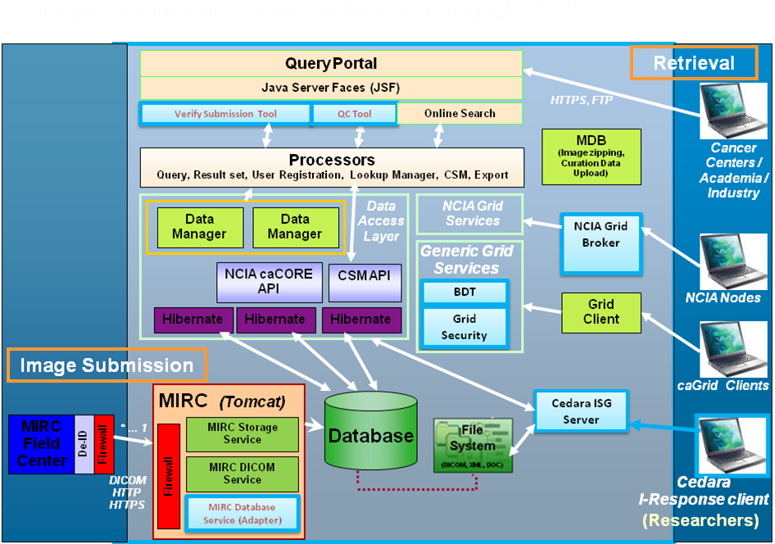

Implementation language(s) used?
NCIA web application, caGrid services, and RSNA MIRC are all J2EE systems. Cedara I-Response is a .NET application.

Will connections/requests to the application be session based (i.e. statefull versus stateless)? If so, is there any reason why application would not support “sticky session” load balancing?
Stateful.

Will the application be caching data? If so, what is being cached and how much data will be cached?
The system uses the Hibernate data persistence mechanism for object-relational mapping (ORM). Hibernate caches database data internally. Data is also persisted in the HTTPSession for the life of the session.

What data files will be created (if any)? How much data will be saved on an on going basis?
The RSNA MIRC system received, processes, and stores DICOM (.dcm) files in a filessystem. .zip files are also created on-the-fly for users downloading bundles of images >3GB.

Will this application need a database schema(s) created on the NCICB infrastructure? If so, what is the maximum number of objects to be stored?
Yes, Yeon Choi has already setup the MySQL schema based on the app support request sent for the Dev tier.

Are there any external/non-NCICB data sources that will be accessed by the application?
The federated search capability built in to the web application could potentially connect to a caGrid service outside NCICB for image data queries.

If this is a web-based application, what are the preferred virtual hosts names to be registered?
imaging2.nci.nih.gov, where the additional “2” will be the only difference between the new tiers and the existing tiers.

Any additional architectural details that may be of significance to the needed deployment environment.

This request is essentially a need to replicate the existing NCIA tiers in support of a MySQL-backed reengineered system.
The new VM's will become the permanent VM's following the NCIA Reengineering Work.
The (existing) old VM's can be retired in October timeframe.

-Apache frontend will stay the same. No extra firewall exceptions will be needed.

All tiers will use the new "current" tech stack: JBoss 4.0.5 / JDK 1.5_010 / RHEL 4 / 64-bit OS
We will need the following VMs:
JBoss VM (4.0.5)
Tomcat VM - MIRC (tomcat 5.5.17)
Cedara VM - clone current Cedara
Grid VM (tomcat 5.0.28)
*Carl will need MAC address to request Cedara ISG license
*Carl will request another build track from Wayne
*Cuong will setup SSH keys for BDA

Performance Requirements

Total number of users for this application? Currently, 417 users.

Peak number of concurrent users? unknown

Peak number of requests/minute? unknown

Up time requirements? 24x7 availability with downtime optional for system upgrades.

Acceptable down time when recovering from major systems disaster? 24 hours maximum

NCICB Project Dependencies
CSM project for UPT and role-based security

Configuration Management Details
Briefly describe your current configuration management practices here.

Version Control
SVN

Change Control
Currently using the System’s Group standard templates for Deployment Requests and Database Deployment Requests.

Migration to CVS
Migrated from CVS to SVN earlier in 2008.

Users
All existing NCIA Dev team members must retain access to the repository modules.

Build Process
Using the Build and Deployment processes setup by the Stelligent team. The current AntHill build tracks will need to be replicated to support the new tiers.

Other CM Needs
N/A

Additional Notes

System Requirements (To be answered by both development & systems team)

Operating System

<<Solaris/LINUX/Windows 2000/…>>

Software (Technology Stack)

Web Server: <<Apache/Tomcat/ZOPE/…>>

App Server: <<Tomcat/JBoss/Oracle 9iAS/…>>

Database Server: <<Oracle[with JVM component]/MySQL/PostgreSQL/…>>

Other software components: <<PERL x.x, Python x.x, …>>

Server Hardware

Server: <<type, model, …>>

Minimum processor speed:

Minimum memory:

Minimum local drive space:

Storage

Expected file server disk storage (in MB):

Expected database storage (in MB):

Expected ftp storage (in MB):

Expected media/image storage (in MB):

Load Balancing/Fault Tolerance

Does the application support load balancing?

Implement load balancing – YES/NO

Networking

Any application specific port assignments?

Any additional configuration?

Additional Notes

Proposed NCICB Deployment Environment (To be answered by systems team)

Hardware
<<dev, qa, staging, production servers to be used>>

Technology Stack
<<specific technology stack to be used>>

File Server
<<space allocation on big IP, NFS mount points, initial size allocation…>>

Database
<<database server to used, schema names to be created, initial size, maximum size…>>

Networking
<<e.g. any BigIP configuration necessary, …>>

Other Resources
<<e.g. ftp server access, media server access, …>>

Impact Assessment (To be answered by systems team)

Overview

Cost

Timeline to implement

Additional Notes

Acceptance
Project Lead ( ) | Project Coordinator – NCICB ( )
Systems Team | SCM Administrator

Appendix 1 - Future Systems Requirements
In this section, describe any projected future anticipated requirements for your system.

New Architecture Diagram

Notes on the design change

Hardware

Servers

Processor speed

Memory

Drive Space

Software (Technology Stack)

Web Server

App Server

Other components

Fault Tolerance (Redundancy)

Does the application support load balancing?

Implement load balancing – YES/NO

Load balancing requirements

Fault tolerance solution suggested

Additional requirements (if any)

Performance Enhancements

Processing Power

Memory

I/O

Other needs

