FieldCenter Software
Installation Guide






Center for Bioinformatics
Table of Contents

Introduction 1
FieldCenter Installation Prerequisites 1
Required Software—Not Included with FieldCenter 1
FieldCenter Software 1
Installing FieldCenter Software 1
Configuring FieldCenter Software 3
Contacting Technical Support 7
NCICB Application Support 7

Introduction
The FieldCenter Software Installation Guide provides the procedures to install and configure the FieldCenter software. This component, available from Medical Imaging Resource Center (MIRC), allows sites to submit images to the National Cancer Imaging Archive (NCIA). It is the client in the submission process. This guide is intended for system administrators at a new site.

FieldCenter Installation Prerequisites
Required Software—Not Included with FieldCenter | You must download and install the Java software in Table 1

Software Name | Version | URL
Java JDK or JRE | 5.0 | http://java.sun.com/j2se/1.5.0/download.jsp
Java Advanced Imaging Image I/O Tools (clibwrapper_jiio.jar, jai_imageio.jar) | 1.1 | https://gforge.nci.nih.gov/plugins/scmsvn/viewcvs.php/trunk/software/ncia-mirc/JVM-image-processor-lib-v1.1/?root=ncia
Table 1 Required software for FieldCenter
FieldCenter Software | You must download the FieldCenter installer or build it from source code.

Installing FieldCenter Software
Complete the following steps to install the FieldCenter software.

Step | Action
1 | Run FieldCenter-installer.jar.
2 | Browse the installation destination directory and click Open. For example, select C:\ as the installation destination directory.  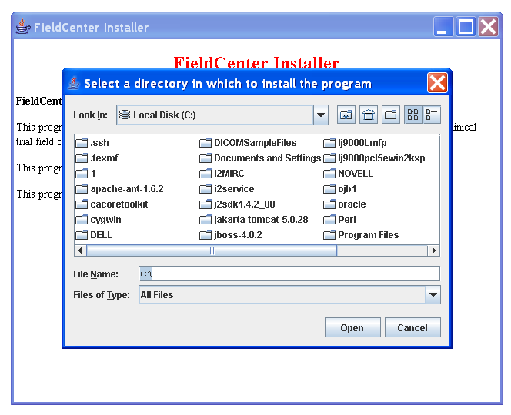
3 | An Installation Complete dialog displays.  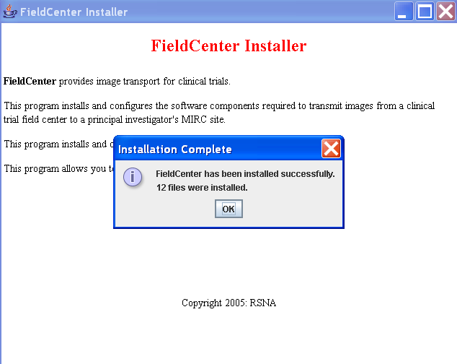
- 5  4 | The FieldCenter Installer installs all files into a FieldCenter directory under the selected installation destination directory (for example, C:\FieldCenter).  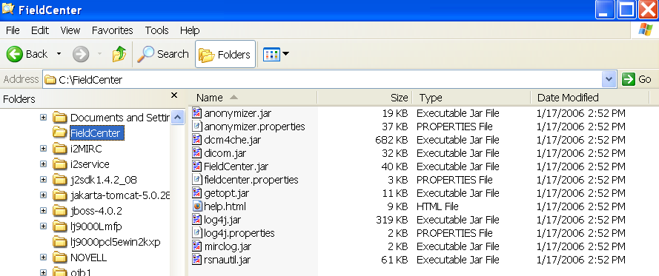

Configuring FieldCenter Software
Complete the following steps to configure the FieldCenter software.
Step | Action
1 | Run FieldCenter.jar under the FieldCenter directory.
2 | Select Parameters tab and click Cancel to use the default key.  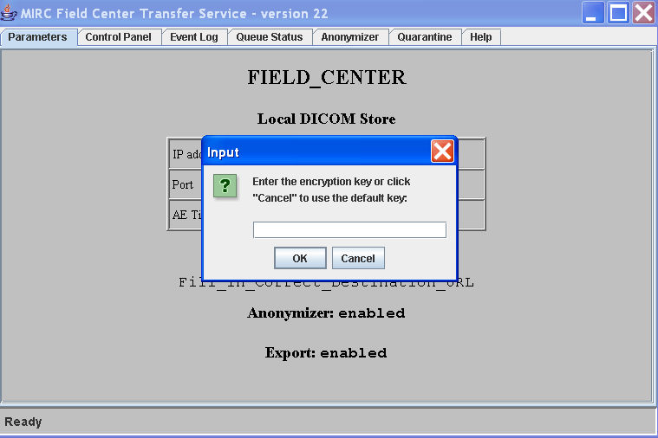
3 | Select Control Panel tab and then select Trial tab.
4 | Enter the following information:  - Trial name: The trial name for current FieldCenter  - Destination URL: The destination MIRC server URL  - Export enabled: This option is checked by default. Leave this option checked.  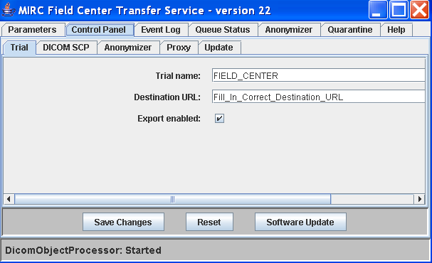
5 | Click Save Changes to save all modifications.
6 | From the Control Panel tab select Anonymizer tab.
7 | Enter the following information:  - Anonymizer enabled: This option is checked by default. Uncheck it if anonymization is not required.  - Anonymizer force IVRLE: The Anonymizer Implicit Value Representation-Little Endian (IVRLE) option should not be checked by default.  - Anonymizer script saving enabled: If de-identification is required, check this option for how to configure anonymization script.  - Central Remapper Enabled: This option is checked if central remapping is used.  - Central Remapper URL: Enter remapper URL if central remapper enabled is checked.  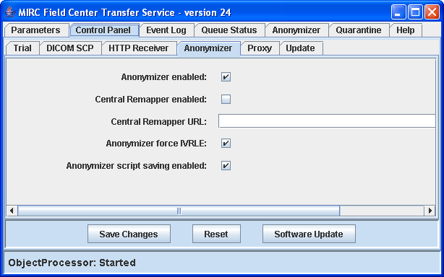
8 | Click Save Changes to save all modifications.
9 | From the Control Panel tab select the Update tab to setup the update service.
10 | To fill out the following information, refer to How to Use the Update Service for Clinical Trials (http://mirc.rsna.org/mircstorage/documents/documentation/HowToUseTheUpdateService.doc) from Radiological Society of North America (RSNA) Medical Imaging Resource Center (MIRC) website (http://mirc.rsna.org/mircstorage/documents/documentation/MIRCdocumentationindex.xml)  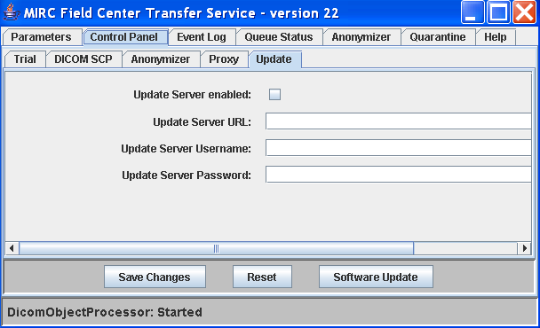
11 | Click Save Changes to save all modifications.
12 | Click Anonymizer tab if anonymization is required (indicated in step 7).
13 | Based on the de-identification requirement, the anonymization script must be updated (for example, PROJECTNAME, TRIALNAME, SITENAME, SITEID, UIDROOT, BASEDATE and other Digital Imaging and Communications in Medicine (DICOM) fields must be entered). For more information on how to configure the anonymization, refer to How to Configure the Anonymizer for MIRC Clinical Trial Services (http://mirc.rsna.org/mircstorage/documents/documentation/HowToConfigureTheAnonymizer.doc) from the RSNA website (http://mirc.rsna.org/mircstorage/documents/documentation/MIRCdocumentationindex.xml).  Specific NCIA de-identification parameters required for setting up a new collection are found among the “NCIA New Collections Submission SOP.doc” procedures located on CVS,  https://gforge.nci.nih.gov/plugins/scmcvs/cvsweb.php/ncia-docs/SOPs/SOPs%20Approved/NCIA%20New%20Collection%20Submissions%20SOP.doc?cvsroot=ncia  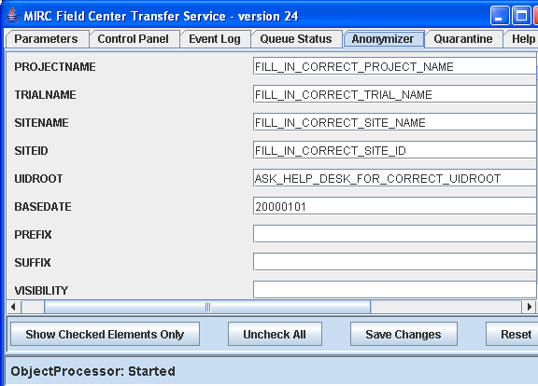
14 | To set the UIDROOT, contact the technical support group (see NCICB Application Support on page 7.
15 | Click Save Changes to save all modifications.

Contacting Technical Support
NCICB Application Support | http://ncicbsupport.nci.nih.gov/sw/  Telephone: 301-451-4384  Toll free: 888-478-4423

