MIRCsite
Installation Guide






Center for Bioinformatics
Table of Contents

Introduction 1
MIRCsite Installation Prerequisites 1
Required Software—Not Included with MIRCsite 1
Required Hardware 1
MIRCsite Software 1
Installing MIRCsite Software 2
Upgrade MIRCsite Software 12
Configure MIRCsite in NCICBIMAGE Storage Service Admin 23
Contacting Technical Support 34
NCICB Application Support 34

Introduction
The MIRCsite Installation Guide provides the procedures to install and configure the Medical Imaging Resource Center (MIRC) software. MIRC is a project of the Radiological Society of North America (RSNA), creating an online community of medical imaging resources. The MIRCsite Installer installs and configures the software components required to run a MIRC site on an existing instance of Tomcat. This program allows you to upgrade an existing MIRC site or to install a new one.

MIRCsite Installation Prerequisites
Required Software—Not Included with MIRCsite | You must download and install the software in Table 1.

Software Name | Version | URL | Installation Note
Java JDK or JRE | 1.5.0 | http://java.sun.com/j2se/1.5.0/download.jsp | Recommend to use JDK 1.5.0_14
Java Advanced Imaging Image I/O Tools (clibwrapper_jiio.jar, jai_imageio.jar) | 1.1 | https://gforge.nci.nih.gov/plugins/scmsvn/viewcvs.php/trunk/software/ncia-mirc/JVM-image-processor-lib-v1.1/?root=ncia | Download these two jars to /usr/jdk1.5.x/jre/lib/ext
Apache Tomcat | 5 | http://tomcat.apache.org/download-55.cgi
Java Cryptography Extension (JCE) Unlimited Strength Jurisdiction Policy Files (jce_policy-1_5_0.zip) | 1.1 | http://java.sun.com/javase/downloads/index.jsp | Unzip the file and extract local_policy.jar from it and replace this jar file with the one under /usr/jdk1.5.x/jre/lib/security.  Note: this jar only required for JDK version lower than 1.5.0_14
Table 1 Required software for MIRCsite
Required Hardware | A common PC is required (for example, a Pentium 4 with 512MB memory). The space requirement depends on your storage requirement since all the images are saved under MIRC software.

MIRCsite Software | MIRCSite-installer will be built and copied to the /target/ncia-mirc during the build process  You can either download the MIRCsite installer or build it from the build.xml script in the source code. The build can be done using the following command:  ant build-prod -Ddb_user=<database_username> -Ddb_pass=<database_password> -Ddb_url=<connection_string> -Ddb_dialect=<database_dialect> -Ddb_driver=<database_driver> -Ddb_location=<database_location>  where  <database_username> is the username for the database account created for the MIRC application  <database_password> is the password for the database account created for the MIRC application  <connection_string> is the database JNDI connection string, such as jdbc:mysql://<host>.nci.nih.gov:<port#>/ncia  <database_dialect> is org.hibernate.dialect.MySQLDialect  <database_driver> is com.mysql.jdbc.Driver  <database_location> is the location where logs should be written, such as /usr/local/tomcat-5.5.17-lsd/
.

Important Before you install MIRCSite Software, change your tomcat port to 58080 in server.xml file. This is required because we found a bug in MIRC Version T32, eXist database use this port to build MIRC index.

Installing MIRCsite Software
Complete the following steps to install the MIRCsite software.

Step | Action
1 | Start MIRCsite Installer. (In Linux, use java –jar /path/to/MIRCSite-Installer.jar after using a tool such as Cygwin X to port the display to your Windows desktop.  Steps:  - Download Cygwin/X to your windows desktop.  - Install Cygwin/X following instruction provided by Cygwin.  - Start Cygwin and type command “win –ac –multiwindow  - On the linux, type command “export DISPLAY=your_desktop_IP:0.0”  - On the linux, type java –jar /path/to/MIRCsite-installer.jar”  - Follow MIRC installation guide to install MIRC.  )  Important Note: In order to avoid filesystem permission issues on a Linux installation, be sure to be install MIRC using the same user that will be executing the system.
2 | The MIRCsite Installer dialog displays. Make sure Tomcat is not running. Click Next.  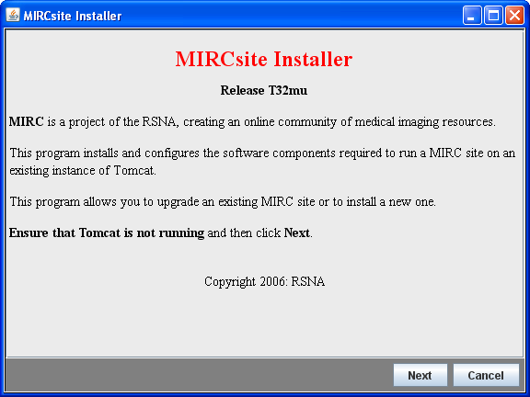
3 | Verify if the instance of Tomcat is correct. If not, click Browse to find the right one. Once correct, click Next.  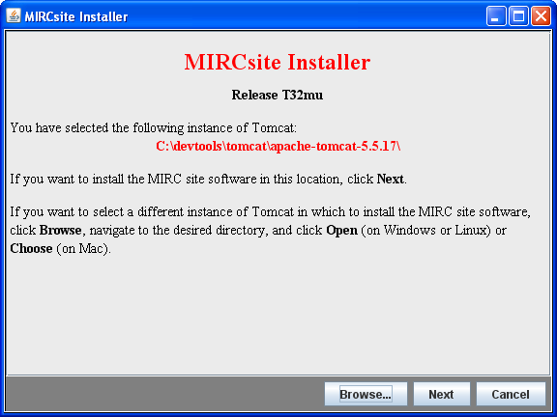
- 5  4 | Click Install to install a new MIRC query service.  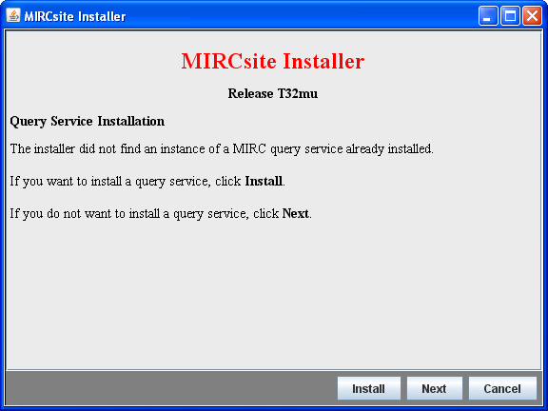
- 5  5 | Type a description for the name of the MIRC site. Click OK.  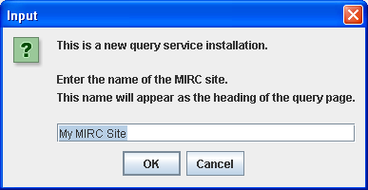  Example: NCICBIMAGE MIRC Site
- 5  6 | Click No to use static siteurl. Otherwise, click Yes.  Click No  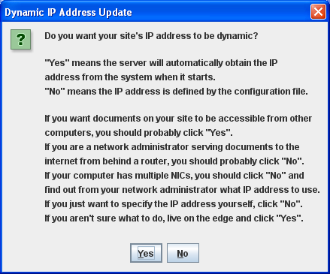  Enter the URL for this site. It will be imagerepository.nci.nih.gov or imagerepository-dev or qa or stage.nci.nih.gov.  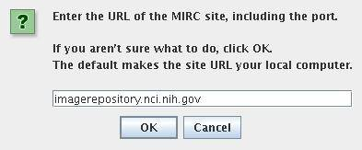
- 5  7 | Click Install to install a new Storage Service.  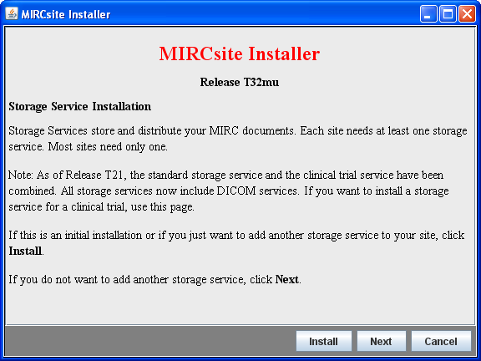
8 | Enter a new one-word storage service servlet name. Click OK.  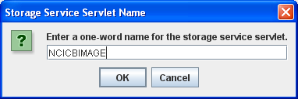  Example: NCICBIMAGE
9 | Enter a descriptive name for the new storage service. Click OK.  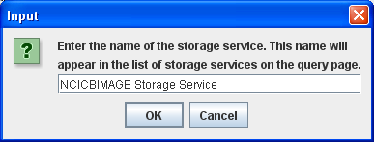  Example: NCICBIMAGE Storage Service. This is a descriptive name for the storage service you enter in step 8 above.
10 | Type SS for the standard designator. Click OK.  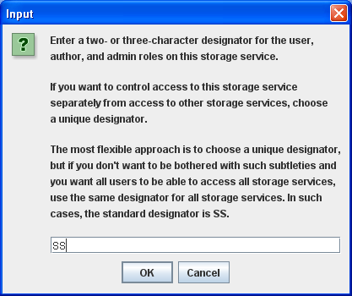
11 | Leave the one-line site description as blank. Click OK.  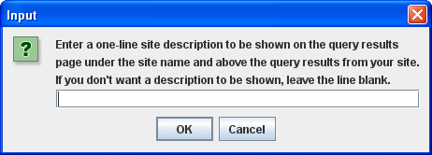
12 | Click Yes for automatic indexing. Click Yes.  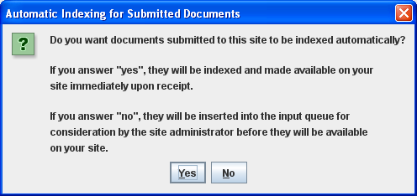
13 | Click Next.  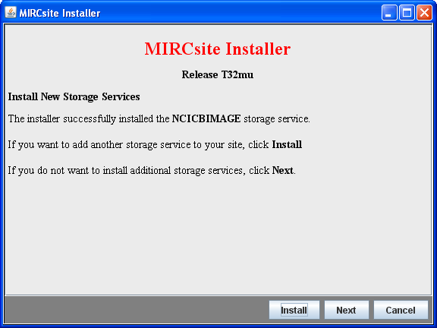
14 | Click Next to skip installing a testing storage service.  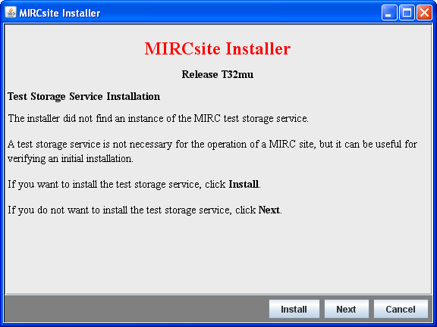
15 | Click Create to create or update a Tomcat user.  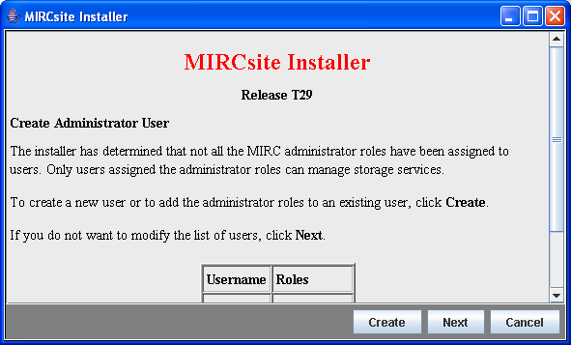
16 | Enter a user name for the administrator roles. For example, enter admin to update user admin to have MIRC administrator roles. Click OK.  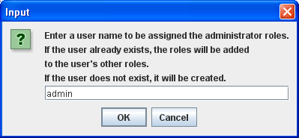
17 | Enter a password. For example, enter a password admin. Click OK.  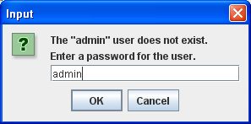
18 | Confirm previous password. For example, enter the password admin again and click OK.  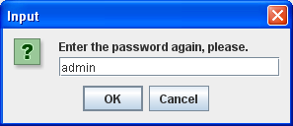  Note down the username and password you have created as you will need it later to login to your service.
19 | As a result, the admin user has all the MIRC roles highlighted in red. Click Next.  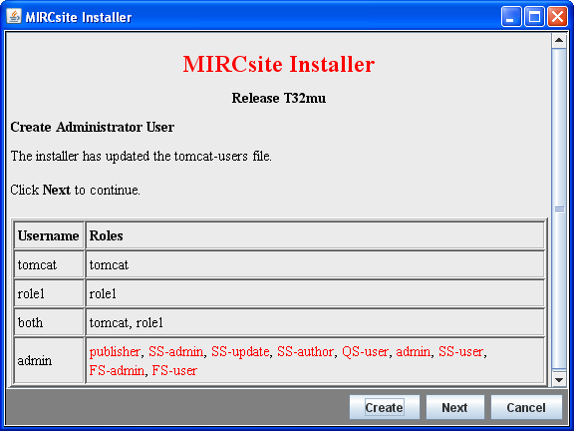
20 | Click Next to enable Tomcat Smart Memory Realm.  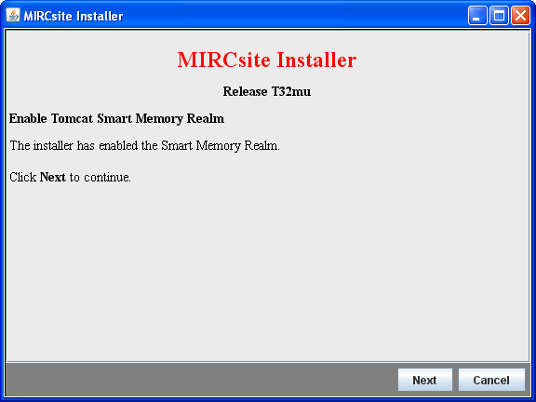
21 | Click Next to enable Tomcat Single Sign On Authenticator.  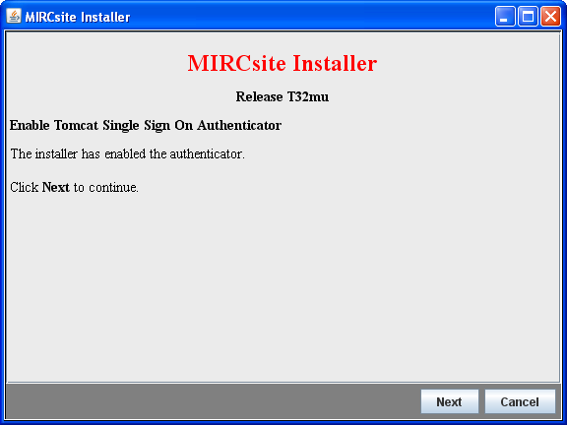
20 | Click Next. This will not set up a redirector.  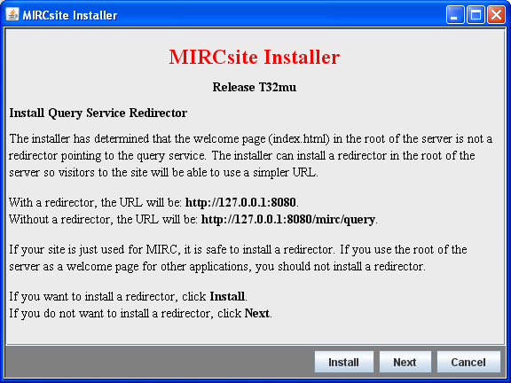
21 | Click Finished. This completes the installation.  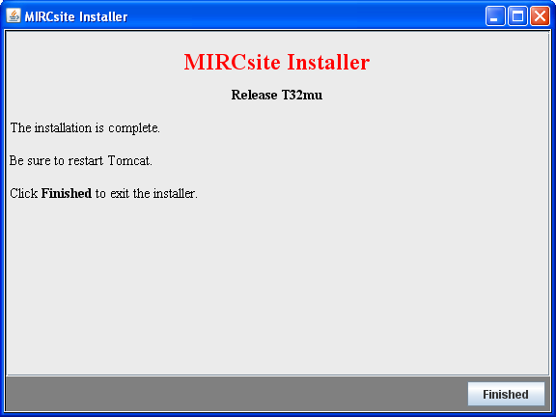
22 | Restart tomcat.

Upgrade MIRCsite Software
Complete the following steps to upgrade to the latest MIRCsite software

Step | Action
1 | Start MIRCsite Installer.
2 | The MIRCsite Installer dialog displays. Make sure Tomcat is not running. Click Next.
3 | Verify if the instance of Tomcat is correct. If not, click Browse to find the right one. Once correct, click Next.
- 5  4 | MIRC Software has found an existing MIRC Site at this tomcat. Click Upgrade to upgrade your current MIRC Software.  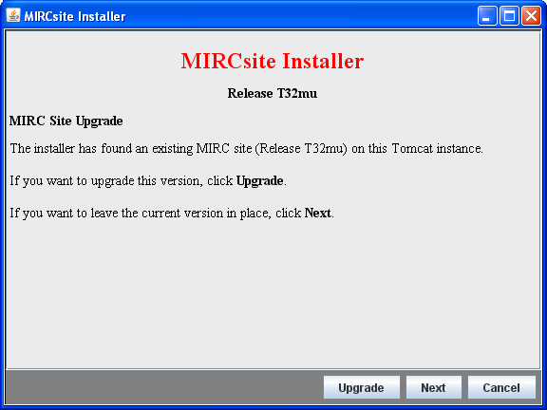
- 5  5 | Click Install if you want to install a new Storage Service beside the storage service you already have; otherwise, click Next.
6 | Click Next to skip installing a testing storage service.
7 | Click Next. This will not set up a redirector.
8 | Click Finished. This completes the installation.  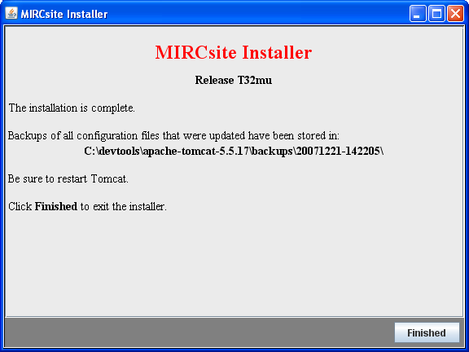
9 | Restart tomcat.

Configure MIRCsite in NCICBIMAGE Storage Service Admin
Complete the following configuration steps to after installing MIRCsite software.

Step | Action
 | Make sure you have replaced local_policy.jar in MIRC system. Please refer to the “MIRCsite Installation Prerequisites” session on page 1 of the documentation for installation information. This step occurs one time only on the MIRC server system.
1 | Mount drive K to a system where the generated keyfile.txt located. Assume the key file path is K:\keyfile.txt.  Perform this step only if you are using Central Remapping feature of MIRC software; otherwise, you cans skip to step 3.
2 | If you do update MIRC, you need to remove Tomcatx.x.x\webapps\YourStorageName\trial\idtable.properties. If you install MIRC, you can skip this step and go to step 3.
3 | Start tomcat, and go to the query service that you have just installed. For example, if you install in your local PC machine with port 58080, your url will be http://localhost:58080/mirc/query  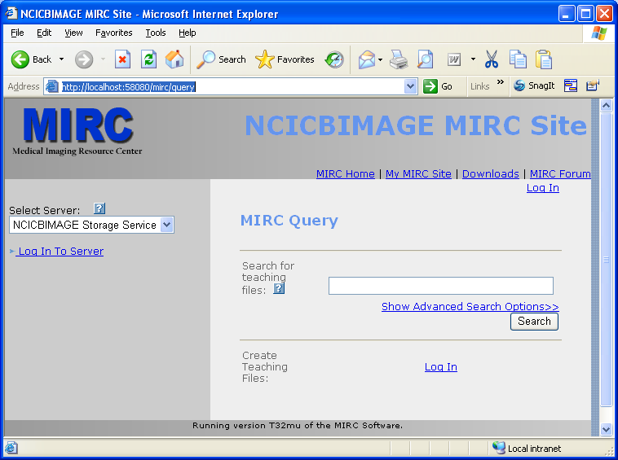 click “Log In To Server” link on the right, a window pops up for accepting userId and password  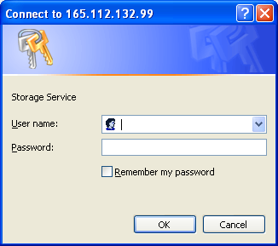  Enter username and password you have created in step 16 – 18 above and click OK
4 | The following page will be displayed  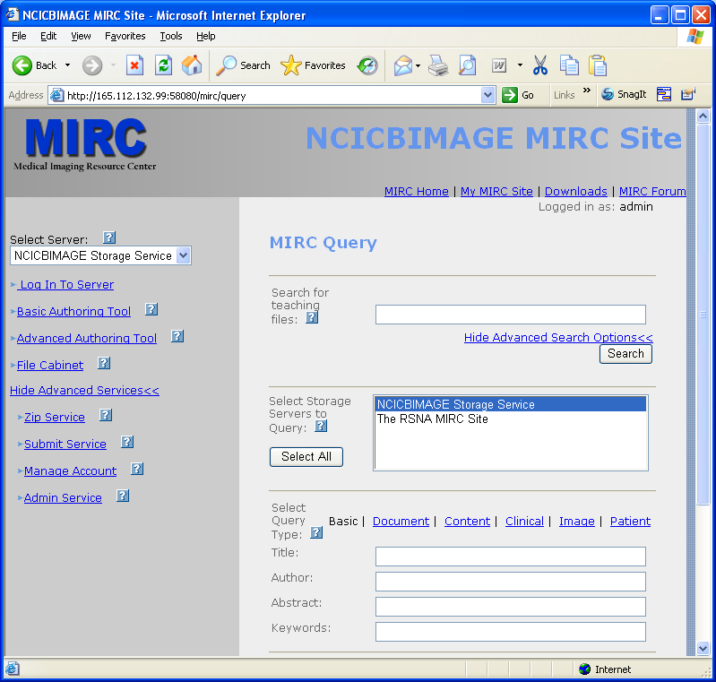
5 | Click on the “Admin Service” link, NCICBIMAGE Storage Service Admin window will be displayed as:  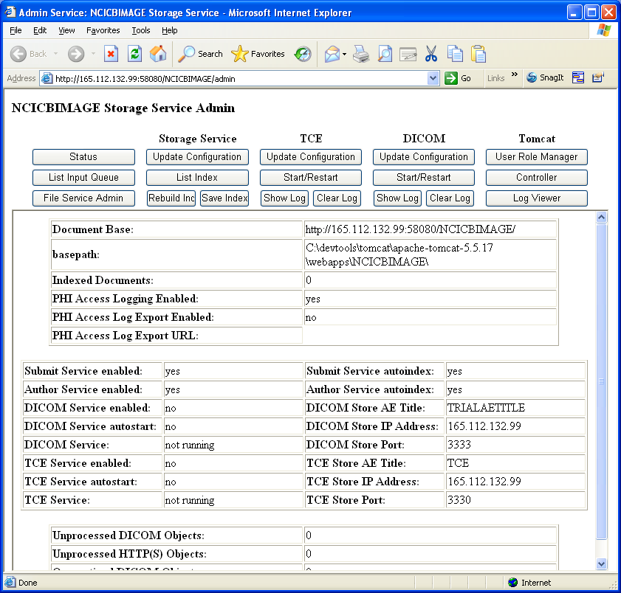
6 | Click Update Configuration button under DICOM, “DICOM Service Configurator” window pops up.
- 5  7 | In top section, set Autostart to yes, Log to yes then click Update the Anonymizer button, DICOM Anonymizer Configurator window will pop up (see step 8)  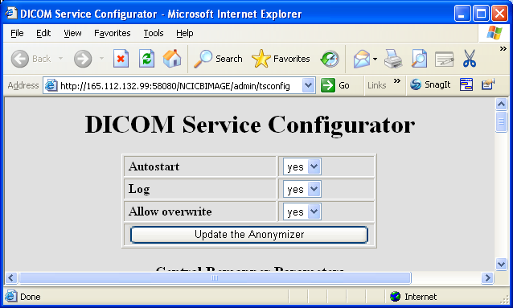
- 5  8 | Make sure all checkboxes are unchecked except following 4 checkboxes.  Fill @remove() in the text fields for these 4 elements.  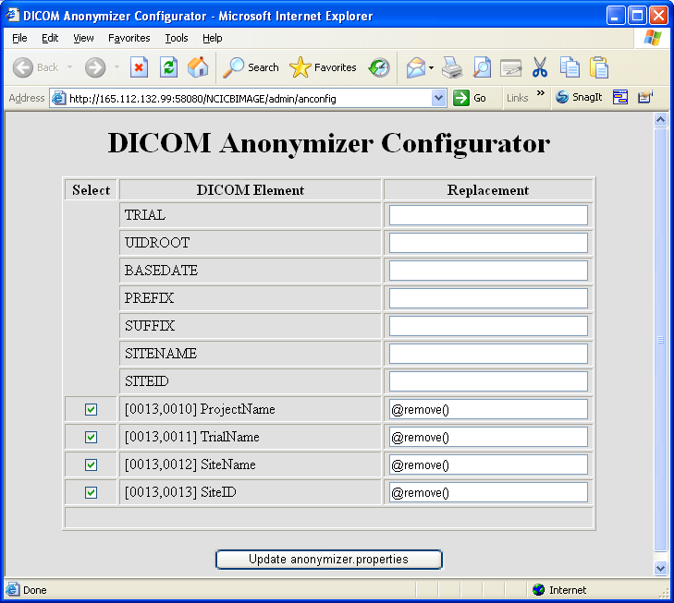  Move the scrollbar to the bottom and click Update anonymizer properties tab. Close the window.
- 5  9 | Move down to Central Remapper Parameters section, set key file path in External key file field: Set these value only if you use Central Remapping feature of MIRC Software, otherwise, you can skip to this step.  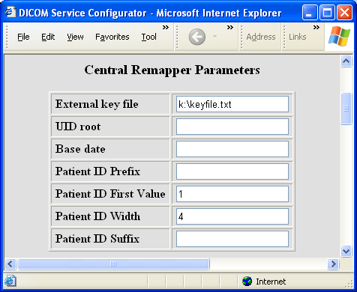
- 5  10 | DICOM Import Service and Export Service Use Default Values.  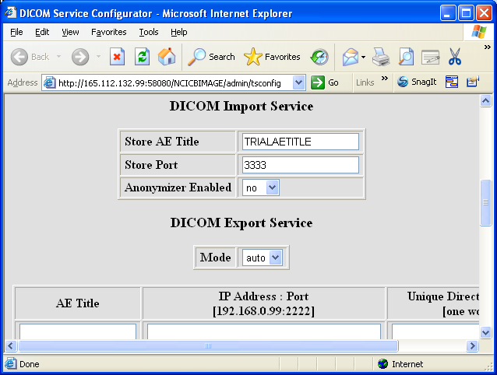
- 5  11 | HTTP Import Service and Expert Service Use Default Values.  Unless you have any preprocessor for your HTTP Import Service, than set the Preprocessor enabled to yes and enter the name of the Preprocessor class name  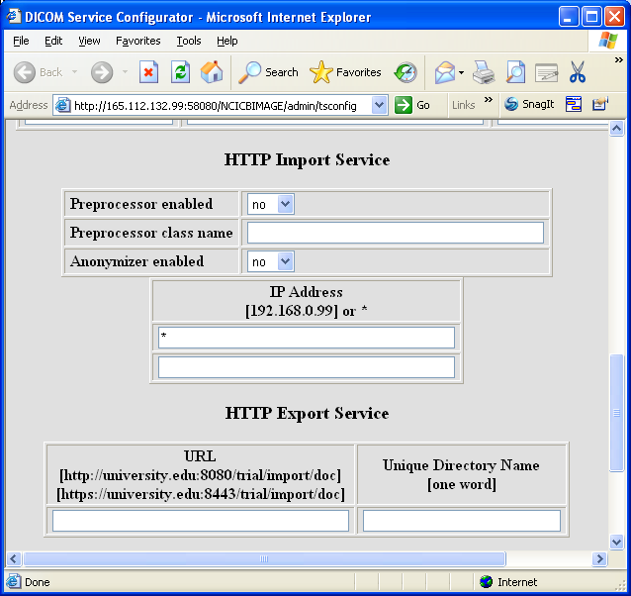
- 5  12 | Move down to Database Export Service section, set Mode to auto, set Anonymizer enabled to yes, change sleep interval(ms) to 10000, and enter gov.nih.nci.ncia.util.NCIADatabase in Database class name field.  Click Update trial.xml button.  Close DICOM Service Configurator by click window red close icon.  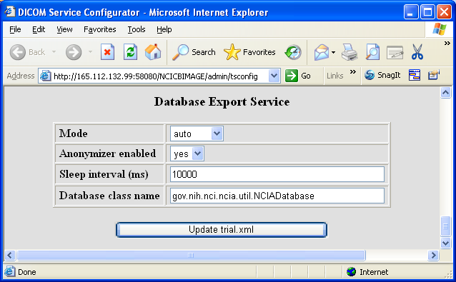
- 5  13 | Now you come back to NCICBIMAGE Storage Service Admin window. In Storage Service column, click Update Configuration button:  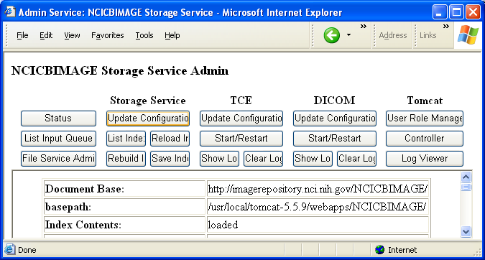
14 | Storage Service Configurator pops up, scroll the window down to the area below:  Change DICOM Service Enabled value to yes, then click Update storage.xml button.  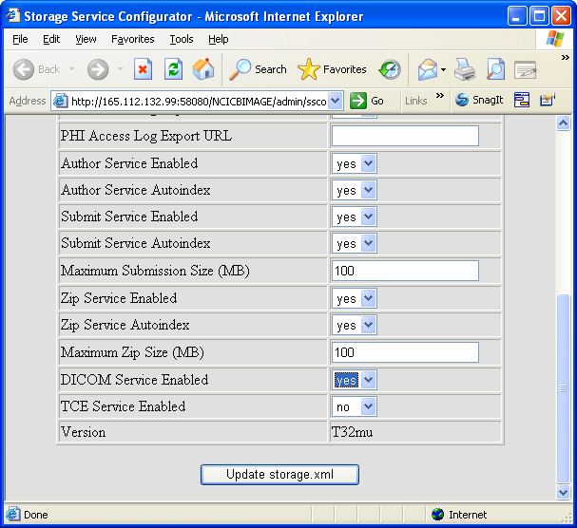
15 | Close Storage Service Configurator window, click the Start/Restart button in DICOM column, wait for a couple of seconds, click the Status button on the top left window in SAIC MIRC Storage Service Admin, the status table will be updated as below. Check following parameters to confirm the MIRC service is running properly.  - Submit Service enabled: yes  - Author Service enabled: yes  - DICOM Service enabled: yes  - DICOM Service autostart: yes  - DICOM Service: running  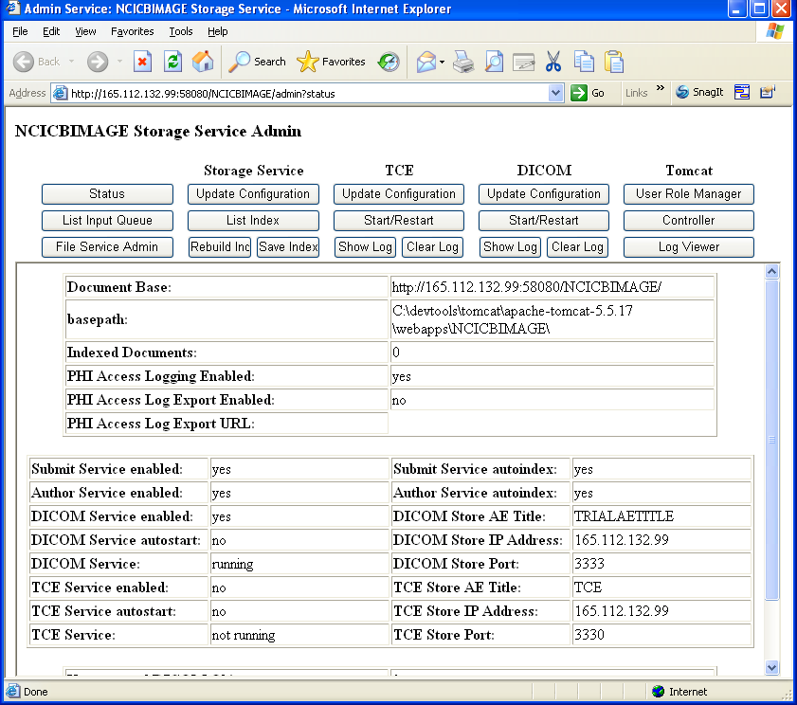
16 | Restart Tomcat. You must do this step to ensure the keyfile.txt is read by MIRC service.
17 | Unmount the drive K from MIRC service system.
18 | Done.

Contacting Technical Support
NCICB Application Support | http://ncicbsupport.nci.nih.gov/sw/  Telephone: 301-451-4384  Toll free: 888-478-4423

