 | I-Response NIH  Teleconference Minutes  May 18, 2007

(c) Cedara Software Corp., all rights reserved.

Author: | Jim Stapleton

Attendees:
NIH Team |  | Cedara Team
Carl Blake (Project Manager) | X | Pinar Crombie (Engineering Manager) | X
Anand Basu (Program Manager) |  | Pavel Farberov (Developer) | X
Thai Le (Developer) |  | Leigh-Ann Hogan (Customer Operations)
Scott McCrimmon (Team Lead) | X | Firdaous Mirzoev (CTO Architect)
Qinyan Pan (Developer) |  | Jim Stapleton (Team Lead) | X
John Freymann (CIP Imaging Informatics Manager) | X | Steve Moore (Business Development Manager)
Carl Jaffe (CIP) | X | Stuart Bennett (Architect IResponse) | X
 |  | Carlos Leitao (Director Technology & Architecture) | X
 |  | Doug Hussey (Subject Matter Expert) | X

Legend:
Items in black are agenda items from the meeting.
Items in red are action items.

Purpose
A WebEx was scheduled with NIH to present the markup management feature as implemented in the I-Response NIH project.

Markup Management
- The current user is displayed in the right hand panel of the UI.
- Lesion and Crosshair tools are greyed out if the user does not have permission to create lesions and contours.
- There are no longer radio buttons in the top right. When compare is pressed, all measurements are displayed in the table at the bottom.
- There is now an export button that allows the user to save the table so that it can be loaded into MS Excel. This was requested by NIH on May 4th.
- Manage Layers dialog allows the user to view layers that were created by other users.
- Blue is being used as the coloring for markups from non-active users.
- NCIA asked if there was audit trail with which user viewed which measurements. NCIA described a scenario where 3 people were asked to measure the same target lesion. How would this be indicated to each user? Doug proposed a workaround where a small cross hair marker could be drawn in a separate layer that is visible to all users. Sounds good to NCIA.
- NCIA would like the user name to appear in the measurement table. It is necessary to know which user created which measurement. Cedara will handle. (mr#1896)
- Layer names can be configured in a text file.
- John Freymann asked about the storage of measurements in the XML. In the current implementation, Cedara saves the markup co-ordinates and the pixel spacing to XML. The specification was sent to NIH last Friday for review. If the design does not meet the needs of NCIA then Cedara is willing to address during the warrantee period beginning June 1st.
- NCIA asked if export only dumped the current user’s markups. There was a further question about an automatic e-mail. Stuart explained that the user can dump the complete table to wherever they want on the local file system. The user could then e-mail the file to whomever they wish.

Non Target Lesions
- Cedara cleaned this up based on NCIA suggestions. The feature was not available in the demo build but was explained by Doug. The e-mail below describes the changes in detail.

_____________________________________________
From: Simona Condescu
Sent: Friday, May 18, 2007 10:06 AM
To: Mirror-Triggers
Subject: handling for non-target lesions has just been checked in, build will follow

Hi All

Here's how this works now:

A new GraphicAnnotation type for the new non-target lesions has been defined.
If old non-target lesions or crosshairs are loaded from PR series, they'll be ignored by the interactors; they old non target lesions or crosshairs are deleted when deleting all the graphics in the current layer.

The old non-target lesion and crosshair items in the image context menu and on the toolbar have been removed. The lesions and crosshair tools are state button tools.
A non-target item has been added in the image context menu. A corresponding state button tool has been added on the toolbar.
The non-target lesion is handled by the Lesion interactor.

The non target lesion is drawn as an ellipse and it is associated with a special non target layer. A property has been added for the non target layer name, the default value being NT.
The non target layer name should be modified after installation if desired and should never be changed again.

The non target layer corresponding to the selected user is always active, along with the current layer.
The non target layer remains active when the current layer changes.
The non target lesions in the non target layer are shown in the measurements table, but are not included in the report and are not exported to file.
The non target lesions are cleared too when clearing the graphics in the current layer.
The non-target lesions are cleared too when clearing the graphics in the current image.

The non-target layer name does not appear in the layers combo box in the layer control.
It appears in the layers combo box in the manage layers dialog in order to make it possible to hide a non target layer for a user that's not current.
It is not possible to make the non-target layer active ( the non-target layer for the active user will be made active automatically if the active user changes).
It is not possible to hide the active non-target layer.

The lesion, crosshair and non-target context menu have only two items now:
Delete - deletes the selected graphic
Delete All <selected graphic lesion type> - deletes all the graphics with the same type as the selected graphic, in the same layer.

Simona

Studylist
- Carl Blake asked about Cedara’ studylist referenced by Doug. Doug and Jim provided an overview.
- Cedara has written a sample mockup web page for the purpose of testing. It simulates the NCIA action from the checkout basket.
- Users log in through the first page.

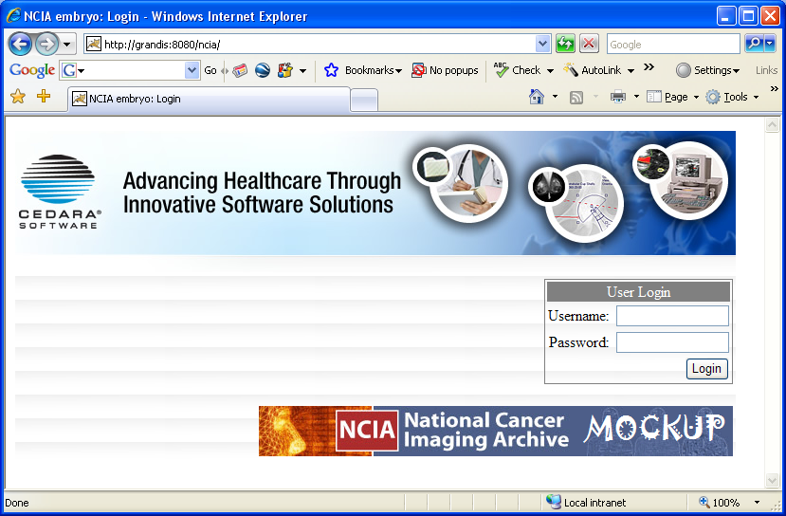

- The user then selects one or two series to be loaded. The data, along with the user ID and unparsed user credentials are sent to the application on each load action. User management is delegated to NCIA as confirmed by Scott.
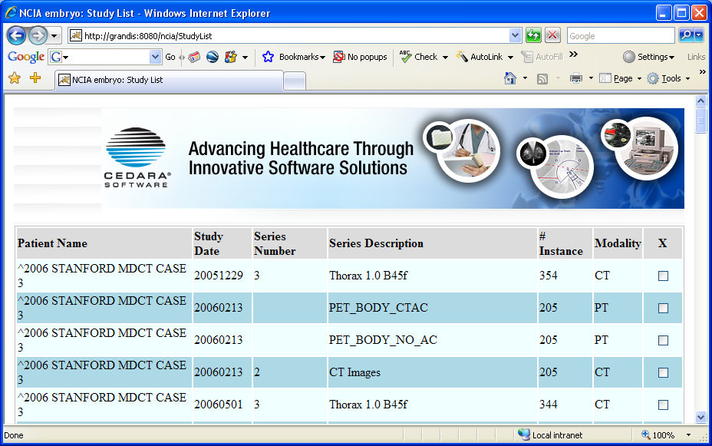

Post meeting voice mail from Carl Blake
- Carl Blake left Jim a voice mail, indicating that comparing two series is an acceptable workflow. In the meeting on May 4th, NCIA was concerned that the number of supported series needed to be greater than two to be useful. On this occasion, Carl asked if Cedara supported the loading of more than two series into an application and then allowed the user to select two to view at a time.
This requirement is not mentioned in the Statement of Work between Cedara and NIH. Typically Cedara applications have handled this type of feature in the past through a thumbnail bar. It is suggested that this request be reviewed by Carl with Leigh-Ann Hogan (NIH’s Customer Operations Manager).

