Submit DICOM and Annotation Files Use Case
NCIA

Last Revised: | 7/11/2008
Produced By: | NCIA team

Document Approvals
The list contains the name and contact information for the core project team and any key stakeholders who have an interest in the success of the project. An “S” identifies persons responsible for approval from the stakeholder groups. Sign off of the document would be required when a decision is made not to take action for defined gaps.

S | Name | Role
S | Anand Basu | NCICB Engineering Manager
 | David Palmer | Project Manager
 | Jennifer Zeng | Technical Lead
 | Larry Holeman | Requirements Analyst
S | John Freymann | Customer Liaison
Revision History
When you make a change to a document, you must add an entry to this Revision History table and you must manually type the Last Revised Date on the front cover.

Date | Version | Description | Revised by
7/11/2008 | 0.1 | Initial version | Larry Holeman
Copyrights and Trademarks
© Copyright 2008 by NCICB, caBIGTM. All rights reserved.

Table of Contents
1.0 Use Case ID: 5
2.0 Primary Actor 5
2.1 Secondary Actors 5
3.0 Brief Description 5
3.1 References 5
3.1.1 Associated Use Cases 5
4.0 Conditions 5
4.1 Pre-Conditions 5
4.2 Post Conditions 5
5.0 Flow of Events 5
6.0 Data Description 5
7.0 Notes 5

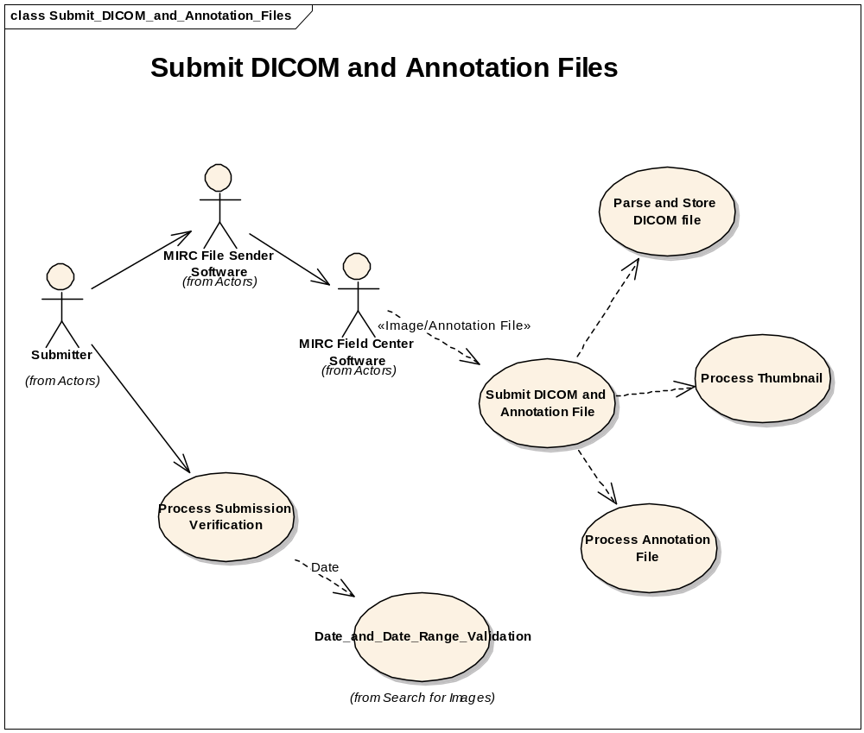
Use Case ID: |  |  |  |  |  | Use Case Name: |  | Submit DICOM and Annotation File
2.0 Primary Actor |  |  | MIRC Field Center

2.1 Secondary Actors
3.0 Brief Description |  |  | When the Parsing software receives a submitted file, it first parses the file. Then, it places the file on the file system and indexes it. The database adapter stores data in a database.  To properly process a submitted image, the database adapter needs to know the trial data provenance for the image. This includes project and site information. In some cases, the information is present because it was added during the image submission process. In other cases (such as direct submission for a PACS after editing by a curator) it may not be present. When it is not present and another version of the image already exists, it must be determined the trail data provenance by looking up existing images.

3.1 References
3.1.1 Associated Use Cases |  |  | 1. Submit DICOM and Annotation File  2. Parse and Store DICOM File  3. Process Annotation  4. Process Submission Verification  5. Process Thumbnail  6. Date and Date Range Validation
4.0 Conditions |  |  | State of the system before and after execution of this use case

4.1 Pre-Conditions

4.2 Post Conditions
5.0 Flow of Events |  | Trigger |  |  | Actor |  | System |  | Exception
 | 1 | New Image and/or Annotation file |  |  | MIRC Field Center transmit DICOM file to NCIA |  | Invoke the Parse and Store DICOM file UC
 | 2 |  |  |  |  |  | Process Thumbnails
 | 3 |  |  |  |  |  | Process Annotation File
 | 4 |  |  |  |  |  | Process Submission Verification
 |  |  |  |  |  |  | Date and Date Range Validation
6.0 Data Description |  |  |  | Image file and annotation file
7.0 Notes |  |  |  | None

