NCIA/View Images in Data Basket Implementation

Software Design Description

Version 1.0

02/24/2009

Document Change Record
Version Number | Date | Description
1.0 | 02/24/2009 | Initial document

Software Design Description i
1. Introduction 1
2. System Architecture 2
3. Components 3
4. Sequence diagram 4

Introduction
The purpose of this implementation is to allow the user to view images from data basket. Current application provides a function to the user to add images into data basket, but it won’t allow the user to view images from data basket.
The requirement for this implementation,
- Provide a link on series id in Data Basket page
- Display a series images page after clicking on the link with the series information

System Architecture
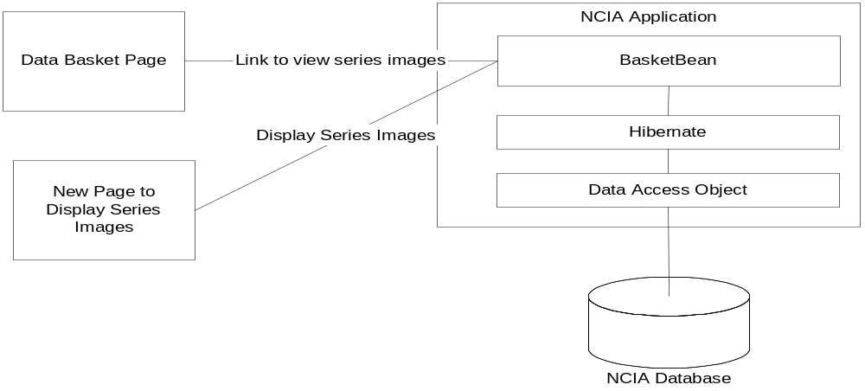
Figure 1: Workflow for a link to view Images
Figure 1 indicates how NCIA application provides a link in Data Basket to display series images. The user clicks on the link, NCIA application will open a new pop up window and display all images for the selected series.
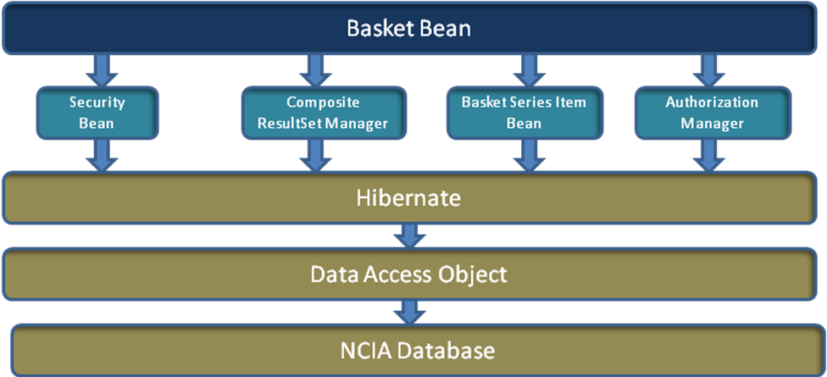
Figure 2: High level Design Structure
Figure 2 is the high level design structure for the link to view series images in data basket implementation. When the user clicks on link in Data Basket page to view series images, the Data Basket Manager Bean will be invoked to handle this action. It also call Security Bean to check this user, call Authorization Manager Bean to check if the user has privileges to see search result or not. BasketSeriesItemBean will find all series images based on given series ID.

Components
- Faces configuration
By adding the following rule into faces-config.xml file, it will provide a link to display series images based on “from-outcome” tag.

<navigation-rule>
<navigation-case>
<from-outcome>popupForViewSeriesImage</from-outcome>
<to-view-id>/viewSeriesImages.jsf</to-view-id>
</navigation-case>
</navigation-rule>
Figure 3: Example of faces-config.xml

- Data Basket Bean
Data Basket Bean class will listen to the link action. When action occurs, Data Basket Bean will invoke getSeriesData() method to get all related series images. And then forward the page to viewSeriesImages.jsf.

- Security Bean
By using the Security Bean, we can get who is current user. With current user, when displaying series images, it knows which image data the user can view.

- Basket Series Item Bean
This class can provide a function to fetch series ID from selected item on the GUI.

- Composite ResultSet Manager
This class performs the search based on given series ID that the user selects. The list of thumbnail images for this series will be returned. It determines what images will be displayed on the data basket popup page.

- General Series Data Access Layer
This class has a method called getSeriesDTOList() that can return list of series DTOs by given series ID. The result will be added into data basket.

- List Data Model
This class will provide a list of thumbnail images by given a user specified a series id. These images will be displayed on pop up window for data basket.

- Slideshow pages
The existing markup for the link to bring up the slide show page and the slide show page itself will be reused. This will be accomplished by turning the existing pages into templates that are parameterized by the “calling” page/template.

Sequence diagram
The following diagram indicates how external data basket works.
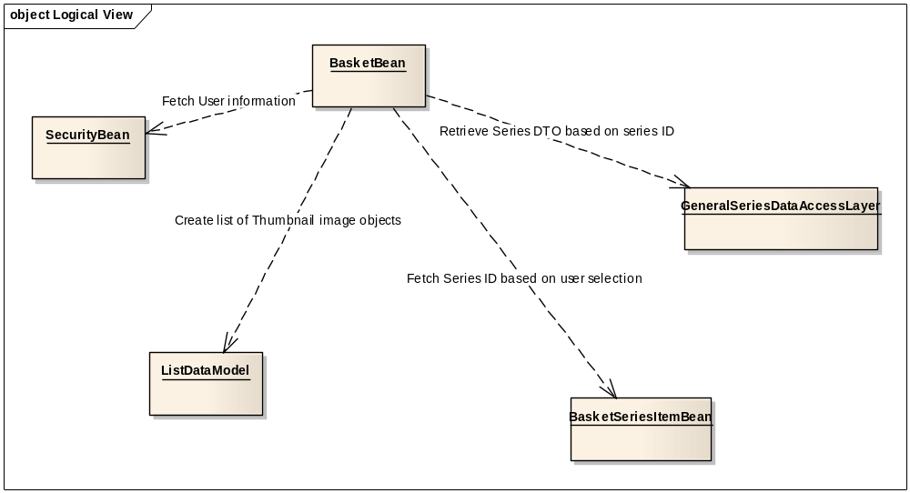
Figure 4.1: External Data Basket Object Diagram

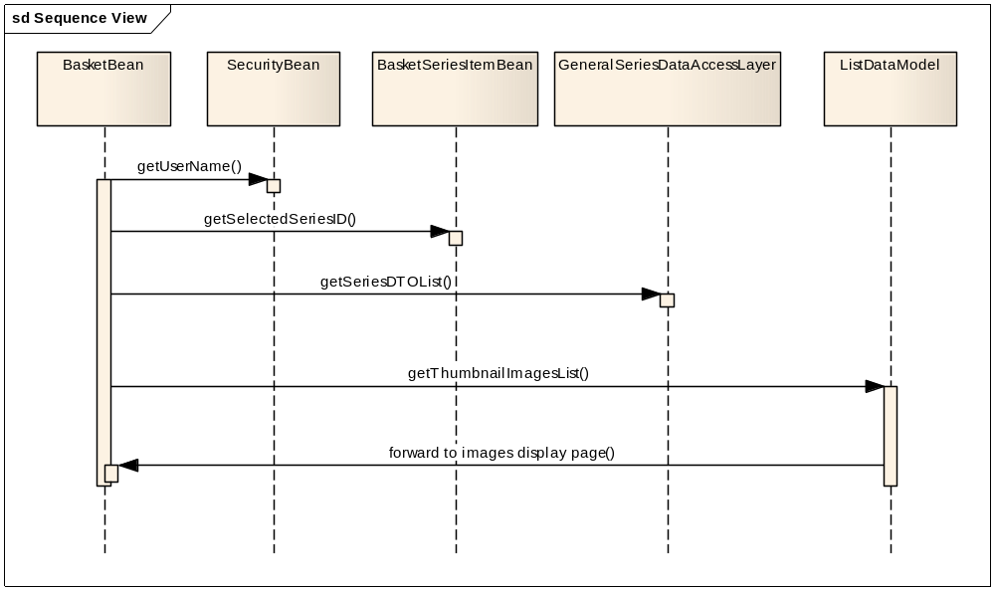
Figure 4.2: Sequence Diagram for External Data Basket

Alternative:
Alternative 1:
If errors occur in Data Basket Bean, the error page will be displayed back to the user. Errors could be like series ID doesn’t exist, series ID exists, but no images under this series, etc.

