NCIA/Images Visualization from Data Basket Implementation

Software Design Description

Version 1.0

03/12/2009

Document Change Record
Version Number | Date | Description
1.0 | 02/24/2009 | Initial document

Software Design Description i
1. Introduction 1
2. System Architecture 2
3. Components 3
4. Sequence diagram 4

Introduction
The purpose of this implementation is to allow the user to visualize images from data basket by using third party software called I-Response.
The requirement for this implementation,
- Provide a function on in Data Basket page to visualize selected series images
- Invoke I-Response application to display selected images.

System Architecture
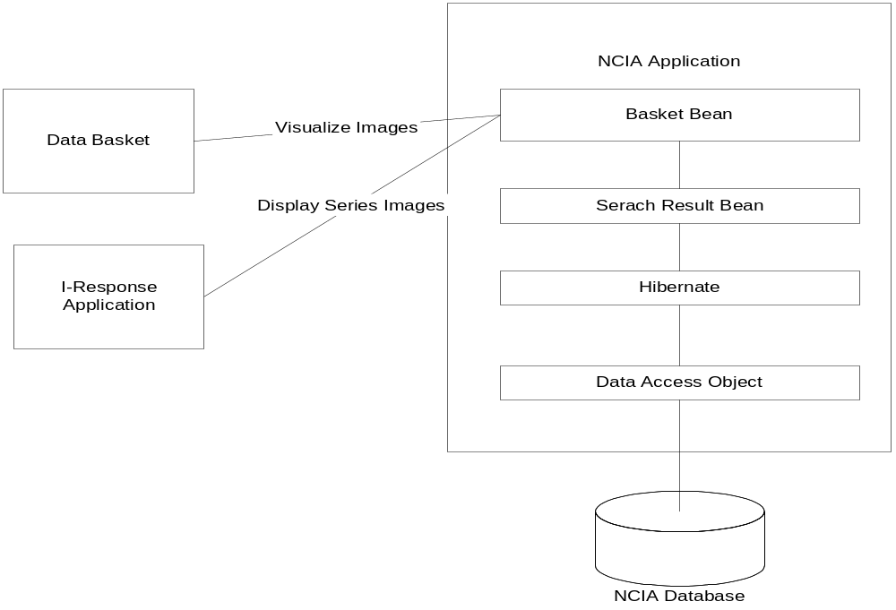
Figure 1: Workflow for a link to view Images
Figure 1 indicates how NCIA application provides a button in Data Basket to invoke I-Response to view images. The user clicks on the button, NCIA application will open a new pop up window and display all images for the selected series.
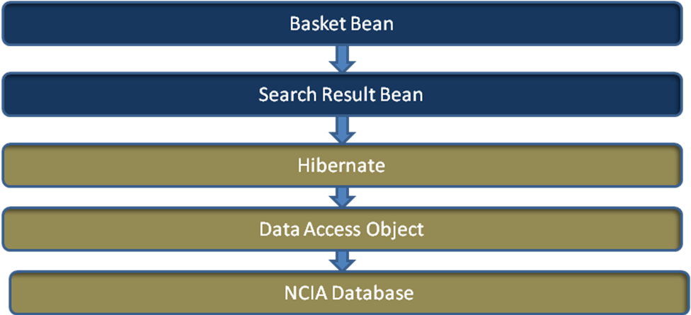
Figure 2: High level Design Structure
Figure 2 is the high level design structure for visualizing series images in data basket. When the user clicks on button “Visualize Images” in Data Basket page, the Data Basket Manager Bean will be invoked to handle this action. It fetches the user selected series ids, creates a string with all ids, and sets this string for search result bean. After setting all parameters, Basket Bean forward control to the “checkIRW” page.

Components
- Data Basket Bean
Data Basket Bean class will listen to the button action. When action occurs, Data Basket Bean will invoke createuidLinkForIRWVersion() method to get all selected series image IDs and use them to create a string as uid. Then forward the page to checkIRW.jsf.

- Search Result Bean
When the checkIRW.jsf loads, it will depend on some parameters from the Search Result Bean. Therefore, before NCIA shows checkIRW.jsf page, some parameter must be set from Basket Bean class.

Sequence diagram
The following diagram indicates how external data basket works.
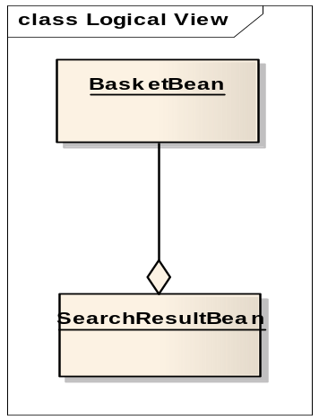
Figure 4.1: Object Diagram

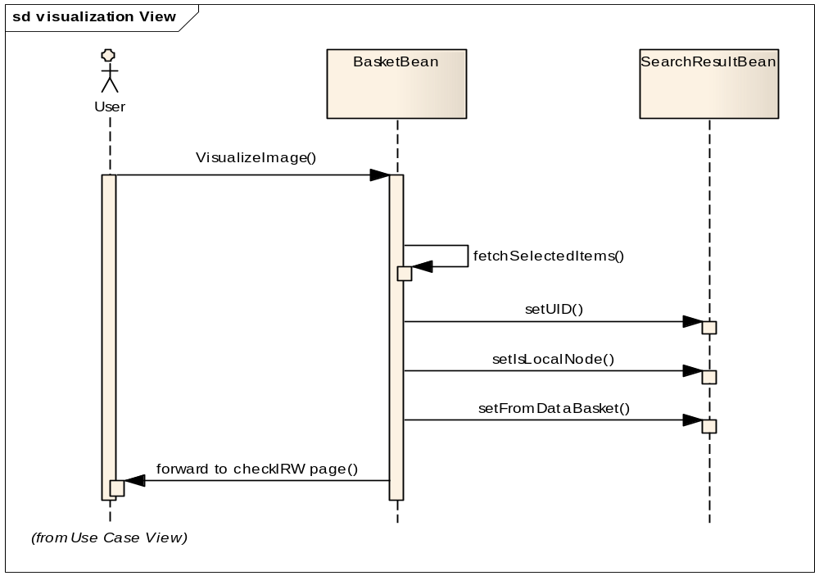
Figure 4.2: Sequence Diagram

