NBIA Submission Reports

Software Design Description

For NBIA Release 4.3

07/13/2009

Document Change Record
Version Number | Date | Description
1.0 | 07/13/2009 | Initial document

Table of Content

Introduction 1
REFERENCES 2
Database Performance 3
Database Migration 4
System Architecture 5
SEQUENCE DIAGRAMS 6

Introduction
This feature is a redesign of the existing “Verify Submission” functionality. There are several factors driving the need to redesign:

- Improved UI from the UCD consultants.
- Need for reliable submission counts.
- Need for reduced query response time.

The AJAX toolkit ICEFaces was chosen to implement the improved UI recommended by the UCD consultants. It provides some fancy components to enhance the look and interactivity of the application.

In order to accommodate reliable counts with performant queries, the system was redesigned with a more explicit division of labor between a data access layer, business logic and presentation logic. Theoretically each piece can be tested independently and rigorously (using JUnit and DbUnit).

Finally, some of processing for the reports was broken up into pieces so that the user wouldn’t have to wait a very long time to see the results. This should help work around the five minute proxy timeout issues at NCICBIIT. The AJAX-ish nature of the ICEfaces components also provides assistance in allowing the breakdown of some operations.

REFERENCES
For more information on ICEFaces’ impact on the NBIA system, see:
http://gforge.nci.nih.gov/svnroot/ncia/trunk/docs/analysis_and_design/4.3/IceFaces Integration.doc
For a discussion on the data access and the problems with the existing system, see:
http://gforge.nci.nih.gov/svnroot/ncia/trunk/docs/analysis_and_design/Streamlining the Data Access.doc
The requirements for this feature are specified at:
http://gforge.nci.nih.gov/svnroot/ncia/trunk/docs/requirements/use_cases/4.3/submission_reports.doc

Database Performance
Generally speaking, the queries for the reports aren’t terribly difficult to deal with, especially after isolating them with the DAO pattern. There are two aspects of database performance that are worth discussing in more detail: querying by date range and the accrual queries.
- Querying by date range
MySQL 5.0.x seems to have bad performance when querying for a date range, even when the date field is indexed. The explain plan always seemed to display way more rows than was necessary. It’s possible this could be because: MySQL is mis-configured (indexes?), the query is “badly” written, or MySQL just sucks.
The previous version of Verify Submission allowed querying by date range to return all submissions from all collections. This way of thinking about the feature dominated early development. Once it became clear that the same query that relied upon the project/site was way faster, the feature was focused to be project/site based first, and date range second.
- Accrual Queries
The Accrual Queries are somewhat complex in that they require returning rows based upon comparing data in two date ranges (new v. updated).
MySQL does not implement the INTERSECT or MINUS SQL operators so the queries are written with inner joins and outer joins (respectively) to achieve the same result set. See: http://www.bitbybit.dk/carsten/blog/?p=71
These queries are written with SQL (as opposed to HQL) and handled as named queries inside the Hibernate mapping file. This seemed the safest way to ensure the results would be exactly as expected. It may be possible to re-work these as cross-platform HQL queries? (which is low priority so didn’t bother).

Database Migration
In prior releases, the submission_date field of the general_image table was the basis for the verify submission report. A big problem with this approach is that the data in this table is “live”. As images are re-submitted, the row in general_image is replaced. Therefore the facts of the image from when it was originally submitted are lost. In other words, this table doesn’t behave as a true log as it can be modified.
Additionally, the general_image table is very big and has a large number of indexes already. Getting away from this table can likely help performance one way or the other.
Therefore, there is a new table submission_history that is a true log whereby old entries aren’t modified by the application. For each existing row in general_image there will be a row in submission_history. Going forward this table can capture corrections so the number of rows in general_image and submission_history will ultimately diverge.

System Architecture
This feature is broken up into three reasonably well-defined layers: Presentation, Business Logic and Data Access. Isolating these layers should lead to code that is easier to understand, easier to maintain, and easier to unit test.
The breakdown is illustrated in Figure 1.
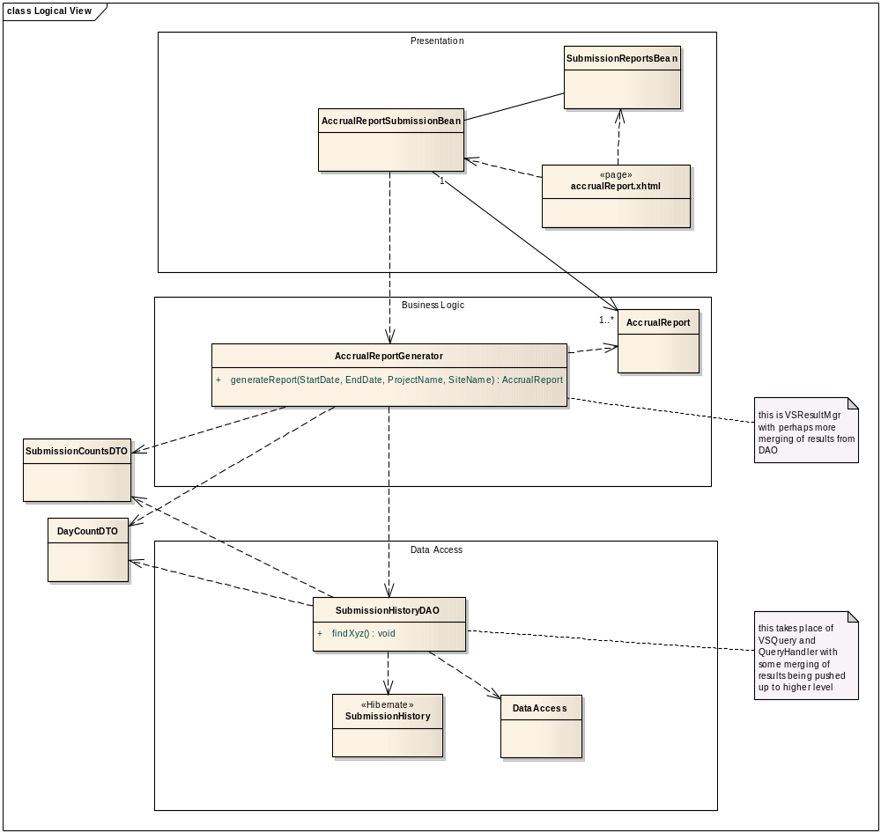
Figure 1Accrual Report Class Diagram

SEQUENCE DIAGRAMS

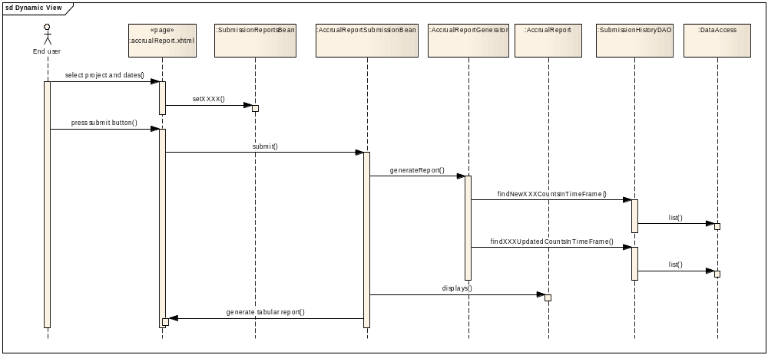
Figure 2 Accrual Report Submission. This flow is similar to all three reports.

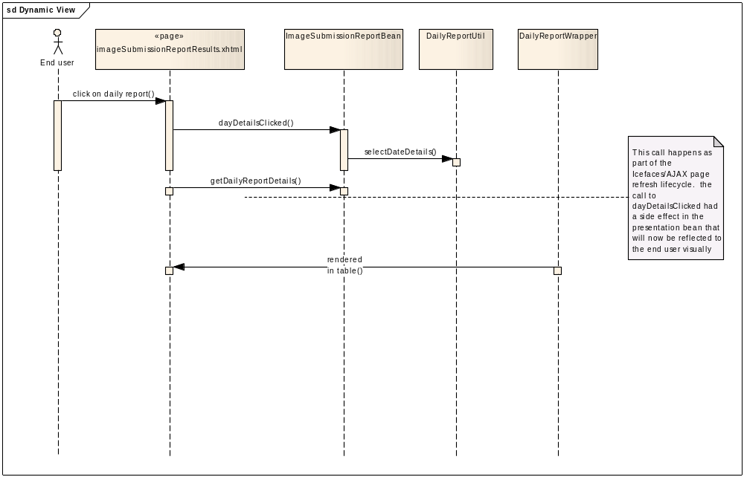
Figure 3 Flow for when a user clicks and the details for a day (in an image submission report).

