NBIA Customized Image Series List

Software Design Description

NBIA Release 4.4

10/14/2009

Document Change Record
Version Number | Date | Description
1.0 | 10/19/2009 | Initial document

Table of Content
Introduction 1
REFERENCES 2
Database Design 3
GUI Design 4
impact on simple search & data basket 9
System Architecture 10
SEQUENCE DIAGRAMS 11

Introduction
This feature allows researchers to search NBIA for published named list on other proved research. NBIA registered user can create custom named list by uploading a file that contains tab or comma separated series instance uid (.csv) or from content of NBIA data basket page.
The system will also allow registered user to make correction to their named list by uploading the series instance uid list from a file (.csv), the comment and link to their publication.

REFERENCES
For more information on ICEFaces’ impact on the NBIA system, see:
http://gforge.nci.nih.gov/svnroot/ncia/trunk/docs/analysis_and_design/4.3/IceFaces Integration.doc
The requirements for this feature are specified at:
https://wiki.nci.nih.gov/display/Imaging/Customized+Image+Series+List

Database Design
New database tables are needed to store information regarding the created named list. The ddl for the new tables are shown below:
Table: custom_series_list:
CREATE TABLE `custom_series_list` (
`CUSTOM_SERIES_LIST_PK_ID` bigint(20) NOT NULL,
`NAME` varchar(200) NOT NULL,
`COMMENT` varchar(200) default NULL,
`LINK` varchar(200) default NULL,
`CUSTOM_SERIES_LIST_DATE` date default NULL,
`STATUS` varchar(20) default NULL,
`USER_NAME` varchar(20) default NULL,
PRIMARY KEY (`CUSTOM_COLLECTION_PK_ID`)
) ENGINE=InnoDB DEFAULT CHARSET=latin1;

Table custom_series_list_attribute
CREATE TABLE `custom_series_list_attribute` (
`CUSTOM_SERIES_LIST_ATTRIBUTE_PK_ID` bigint(20) NOT NULL,
`SERIES_INSTANCE_UID` varchar(64) NOT NULL,
`CUSTOM_SERIES_LIST_PK_ID` bigint(20) NOT NULL,
PRIMARY KEY (`CUSTOM_SERIES_ATTRIBUTE_PK_ID`),
KEY `FK_CUSTOM_SERIES_LIST_PK_ID` (`CUSTOM_SERIES_LIST_PK_ID`),
CONSTRAINT `FK_CUSTOM_SERIES_LIST_PK_ID` FOREIGN KEY (`CUSTOM_SERIES_LIST_PK_ID`) REFERENCES `custom_series_list` (`CUSTOM_SERIES_LIST_PK_ID`) ON DELETE CASCADE ON UPDATE NO ACTION
) ENGINE=InnoDB DEFAULT CHARSET=latin1;

The system will automatically update the status and date columns based on the following scenarios:
- When user creates a new list, the status is set to “created” and the date column is set to the current date.
- When user updates a list record, the status is set to “updated” and the date is set to the current date.
User is allowed to update their created list, the system will retrieve this list based on the user_name.
Once a name is created, it stays with that user. Other users will get error message if they try to use this same name.

GUI Design
- Create a new list
a. Create new list with content of data basket:
NBIA registered user can create new list by searching NBIA and add series to the data basket page. The user then clicks the “CREATE A NAMED LIST” button from the data basket page. This will bring user to the “create customized series list” page. The user is presented with some input text fields to enter the name of the list, the comment and hyperlink. The user’s data basket is displayed on the screen as well. The user will click the “SUBMIT” button upon completing all the fields. The system will validate the name of the list to ensure its unique. This can be done using ICEfaces partial submit on the name input field to validate against the server side values. Figure 1 shows the snapshot of this page.

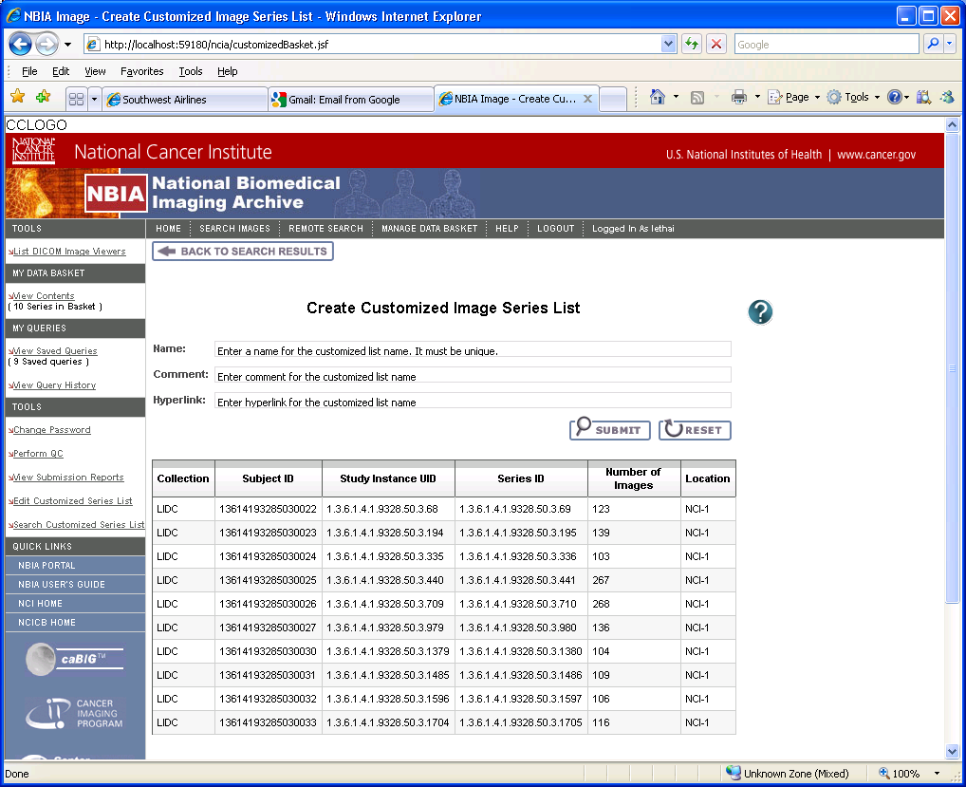
Figure 1: Create new customized series list with content of data basket.
b. Create new list by uploading file:
NBIA registered user can create new list by uploading a file that contain list of series instance uid that user want for this list. The link “create named list” under the tool side menu will bring user to this page. The user is presented with some input text fields to enter the name of the list, the comment and hyperlink. The user will click the “SUBMIT” button upon completing all the fields. The system will validate the name of the list to ensure its uniqueness. This can be done using ICEfaces partial submit on the name input field to validate against the server side values. The file type that NBIA accepts is any .csv file.
The system will parse the file and display the list of series instance uid at the bottom of the page. This area is collapsible.

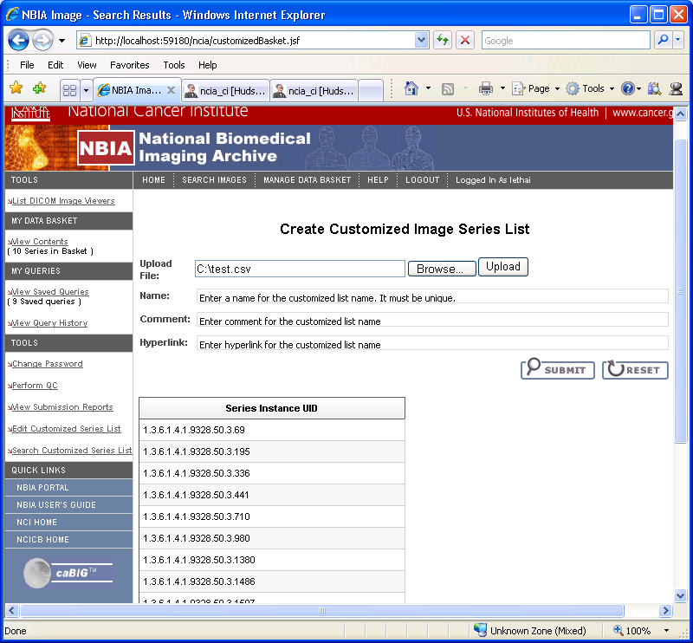
Figure 2: Create new customized series list by uploading file.

- Edit the named list
NBIA registered user clicks on the Edit link from the side menu. The system will display list of named list that this user has created. The user can choose one to edit by clicking on the name. User is allowed to modify the following fields: comment, hyperlink and upload a file that contain list of series instance uid. This list will replace the list they have. Figure 3 and 4 shows the screens for the editing page.
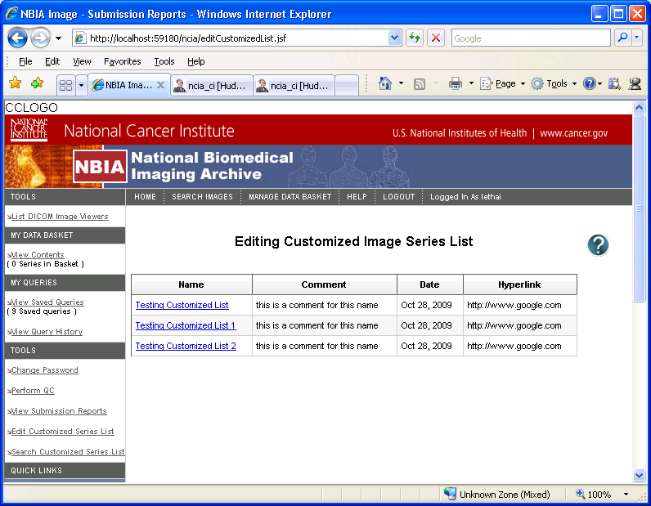
Figure 3: Edit Customized Named List Page

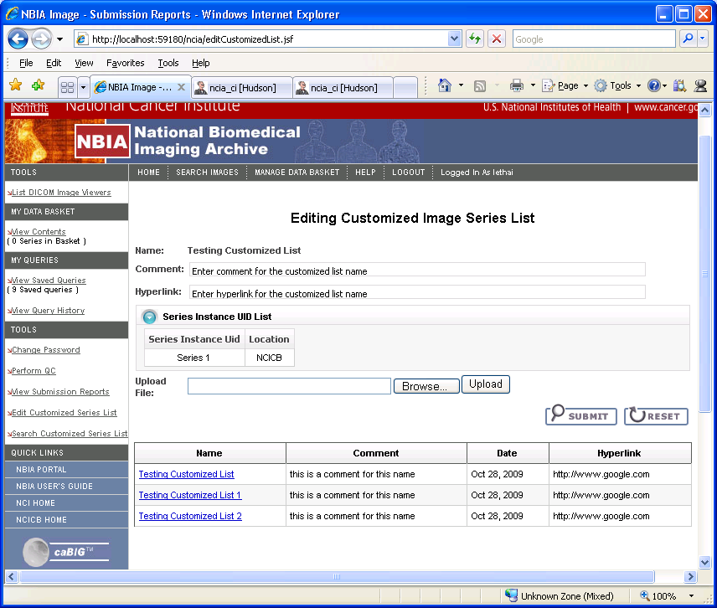
Figure 4: Edit Customized Named List Page
- Search for a named list
NBIA user can also search NBIA for a named list created by himself or another researcher. The user must have permission to see all the series in the named list in order to see the result from the search. Otherwise, the system will display an error message that contains the series instance uid that the user does not have permission to see. The successful search data will be displayed on the data basket page. Figure 5 shows the search criteria screen for this page.
Notes: To search for an existing named list, the system does not required user to be NBIA registered user.
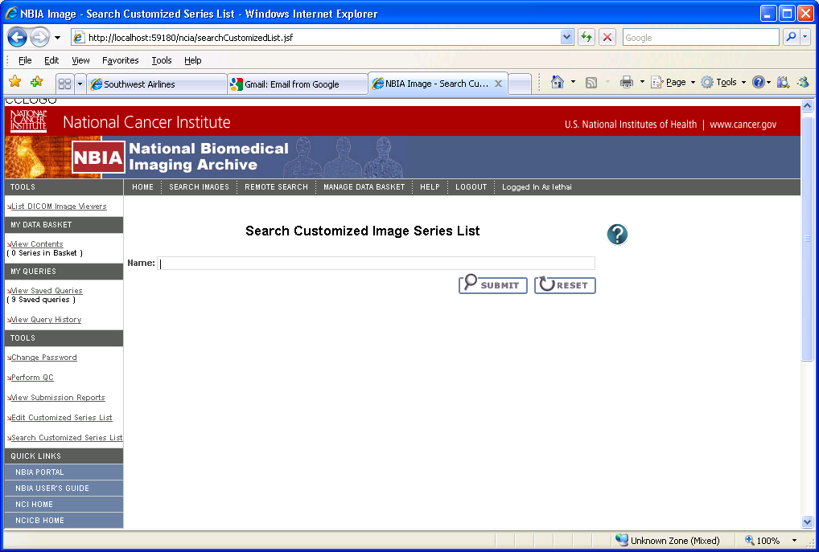
Figure 5 Search for Customized Image Series List Page

impact on simple search & data basket
1. Search for named list:
When user searches for a named list, the system will retrieve all the information for this list including the list of series instance uids. The system will validate user’s permission to access these series. Prior to display the results on the data basket page, the SeriesUidCriteria is constructed with the list of series instance uid and passed to the current search to query to other information regarding the series such as collection, patient, study, number of images. The current search query handler, DICOMQueryHandler, will be modified to add the processing for SeriesUidCriteria.
The data basket page and bean will also be modified to display the returned result from the named search to show the name of the list, the comment and hyperlink fields.
2. Create a named list
A new button is added to the data basket page to allow user to create series list with the content of the data basket.
Another button is also added to the data basket to allow user to export the series instance uid to a file. So another modification to the data basket to add this logic.

System Architecture
This feature is broken up into three reasonably well-defined layers: Presentation, Business Logic and Data Access. Isolating these layers should lead to code that is easier to understand, easier to maintain, and easier to unit test.
The breakdown is illustrated in Figure 7.
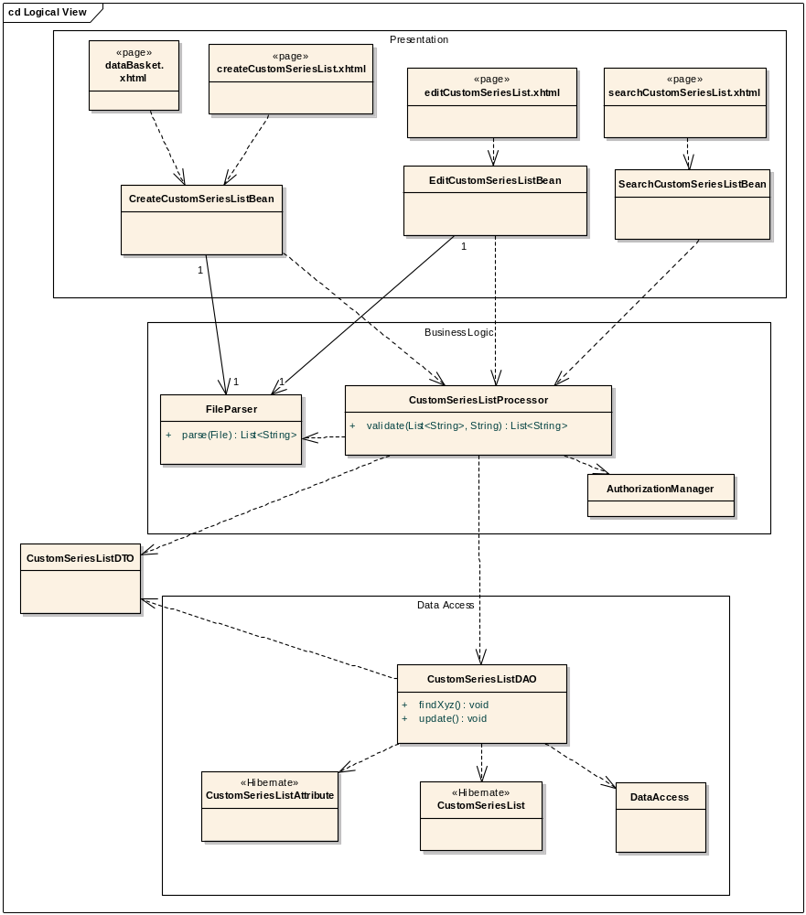
Figure 6: Class Diagram

SEQUENCE DIAGRAMS
Search NBIA for a custom series list by name
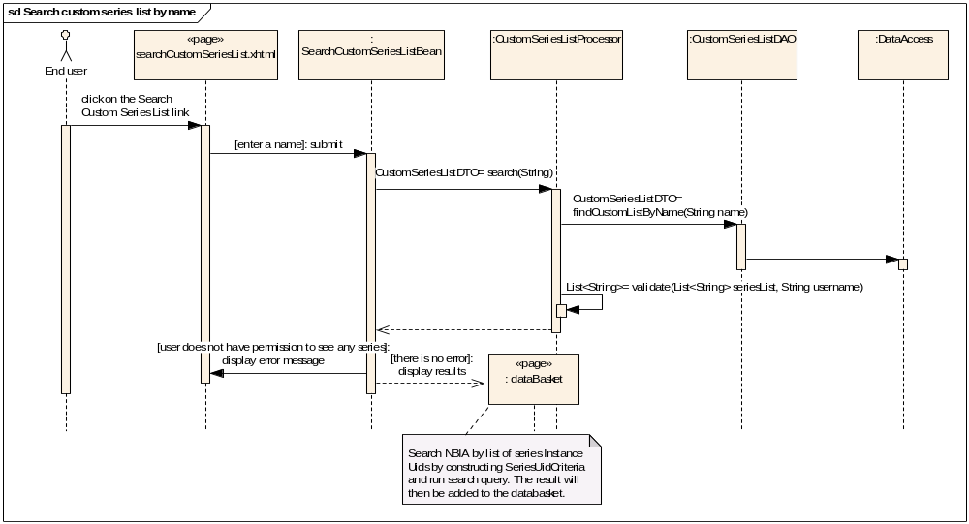
Figure 7: Search a named list.
Create custom series list by uploading a file.
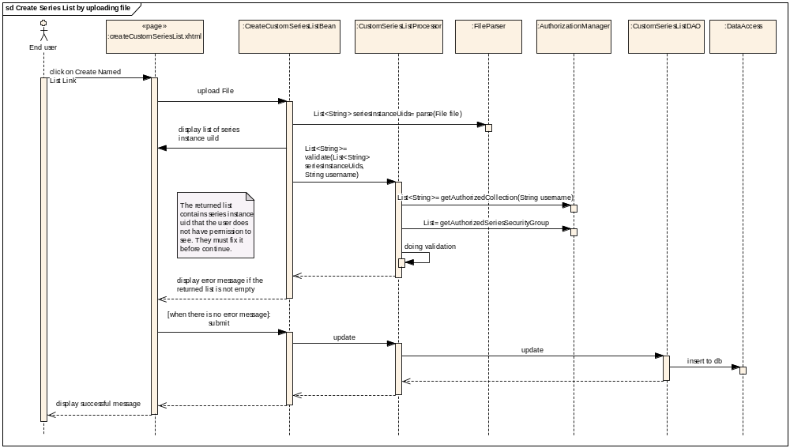
Figure 8 Flow for creating a named list by uploading file.
Create custom series list based on content of data basket page
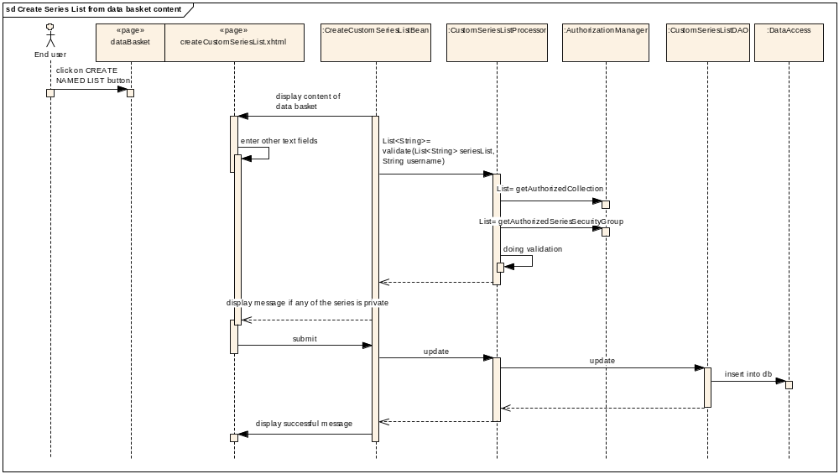
Figure 9 Flow for creating a named list by content of data basket

Edit the custom series list
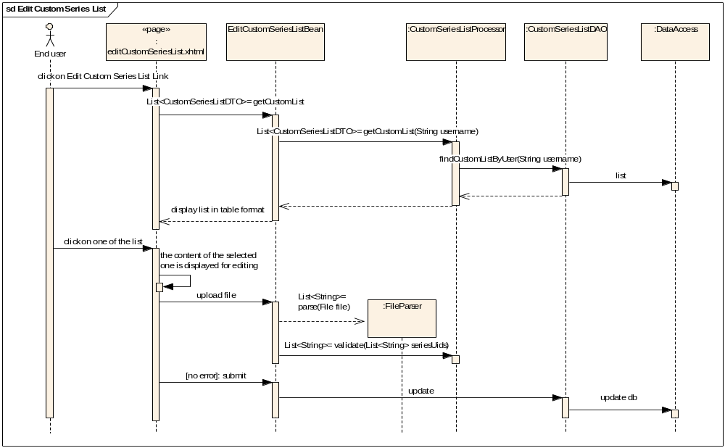
Figure 10: Flow for when a user requests to edit a named list.

