National Cancer Institute
2008
NCIA Build and Deployment Automation
List of Features
Prepared by the CBIIT Build and Deployment Automation Team
Rockville, MD
The Build and Deployment Automation team collaborated with the NCIA team to rework and modernize its build and deployment system. The end result is an automated system which slashes deployment time from two days to less than an hour for any given deployment tier. The build system supports NCI internal build and deployments as well as cancer center installations. It is flexible, extensible and it supports current and future NCI technology stacks.

Overview
As a result of the collaboration of the NCIA-BDA teams, the NCIA project today is more efficient and the development team spends more time creating software than working on build-related issues.
The new build system is constructed on top of the existing NCIA infrastructure; however many legacy build components are discarded for modern replacements or heavily reworked to support the new toolset. All builds support Windows and Linux build and deployments. All builds are designed to work from a command prompt or a build management server such as AnthillPro or a continuous integration server such as CruiseControl or Hudson. The build system supports the current tech stack; however it is designed to support any future tech stacks.

General Workflow

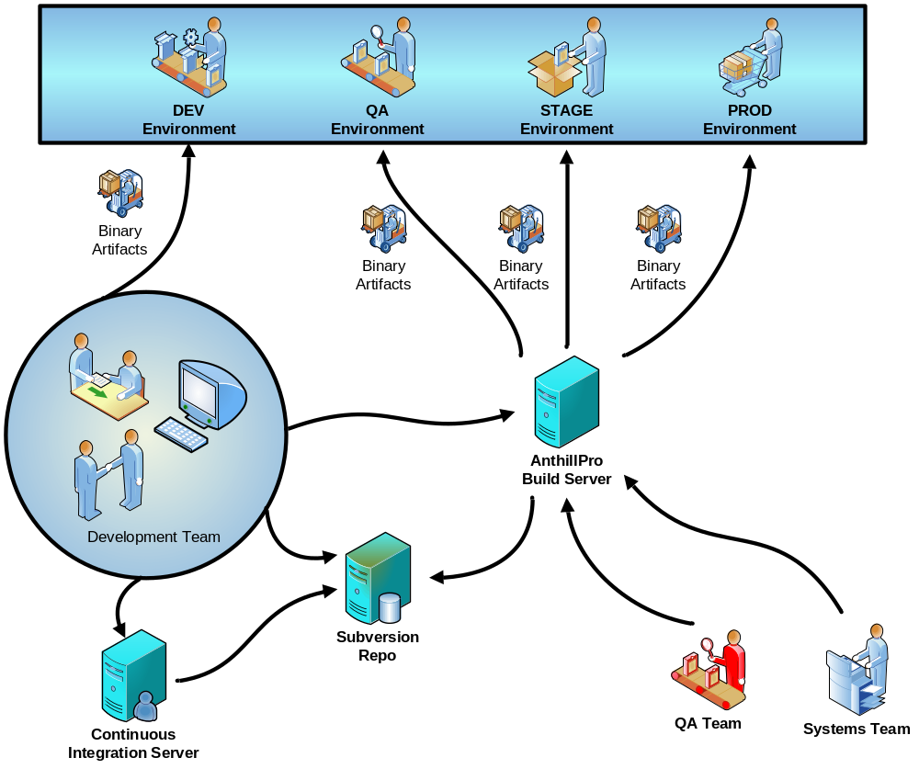

List of Features
Listed below are the features delivered as part of the build and deployment automation work for NCIA.
- General Features
  - Ability to build the system from a single command or click of a button
  - Complete rework of the existing project folder structure
  - Subproject reorganization – main build script delegates to subproject scripts
  - Property template checks to ensure consistency among tiers
  - Ability to build on multiple tiers with virtually no script changes except property files
  - Added large number of pre- and post-deployment checks
    - Database server existence
    - Database connectivity
    - File system check
    - Property checks
    - Port availability checks
  - Ivy – dependency management tool
  - Hudson – continuous integration server
  - TRAC – a pilot project management and tracking server with WIKI support. This was employed mainly as a tracking tool for the NCIA BDA project.
  - AnthillPro –dedicated, systems-managed build and promotion system
  - Database integration
    - Support multiple databases, i.e. MySQL, Oracle
    - Clean database install
    - Database upgrades (DDL + DML)
  - Automated testing
    - Running of the tests with every build
    - Added sample unit tests to sub-projects where there were none
    - Generating test reports
    - Failing the build if broken tests
    - Test coverage reports
  - Eclipse project reorganization
  - Static analysis tools run with every build
    - Cobertura test coverage
    - Simian code duplication
    - JavaNCSS
    - PMD
    - Checkstyle

- Local Deployments (Developer Workstations/CI)
  - Compilation of the code
  - Upgrade of existing systems
  - Creation of a distribution zip files
  - Automatic installation and configuration of project artifacts
  - Upgrade database
  - Clean installation and configuration of project artifacts to a local workstation
  - Installation and configuration of JBoss and Tomcat binary distributions
  - Recreation of the database and upgrade as needed
  - Clean any transient artifacts
- Remote Deployments (NCI Internal)
  - Ability to execute from a command line or a build server
  - Clean installs or upgrades
  - Uses SSH with RSA keys to remotely access target environments
  - Creates a deployment zip, copies the zip and required properties file to the remote system and executes the build remotely
  - Installs will install and configure the binaries for JBoss and Tomcat
  - Installs project artifacts, configures project artifacts
  - Recreates the database and upgrade as needed
- External Deployments (Cancer Centers)
  - A distribution ZIP is added to project’s GForge files area for the community to download
  - The installer is a simple-to-use command line utility built on Ant
  - The installer supports clean installs and upgrades
  - Support for Windows and Linux
  - No root access needed

Conclusion
The BDA team, helped by the NCIA team, made some significant changes to an important project. During the development of the build system the teams infused a number of new tools and technologies to gain efficiencies and improve the reliability and the consistency of the delivery process. For instance, this project was the first in the BDA’s portfolio to make use of Ivy as a dependency management tool. This was done in order to cope with the ever increasing number of external dependencies. The team spent considerable amount of time refactoring the existing project structure, identifying all dependencies, removing duplicates or conflicting libraries and making the build use a newly created NCI enterprise repository for dependent libraries. The result is a flexible build system consistent with NCI’s technology roadmap and open to future extensions.

