NCIA Automated Build and Deployment
User Guide
This document provides a comprehensive overview of the NCIA build system from a user perspective. In the context of this document a user is defined as someone who builds and deploys the system using the automated build tools provided by the Build and Deployment Automation team.
Produced by the Build and Deployment Automation Team
4/21/2008
Document Approvals
The list contains the name for the core project team and any key stakeholders who have an interest in the success of the project. An “S” identifies persons responsible for approval from the Business and Development. Sign off of the document would be required when a decision is made not to take action for defined gaps.

S | Name | Role | S | Name | Role
S | Anand Basu | NCICB Engineering Manager
 | David Palmer | Development Project Manager
Revision History
When you make a change to a document, you must add an entry to this Revision History table and you must manually type the Last Revised Date on the front cover.

Date | Version | Description | Revised by
4/21/08 | 1.0 | Initial draft | Levent Gurses
Copyrights and Trademarks
© Copyright 2007 by NCICB, caBIGTM. All rights reserved.

Table of Contents
1. Introduction 5
1.1. Purpose 5
1.2. Scope 5
1.3. Definitions, Acronyms, and Abbreviations 5
2. Local Build and Deployment 6
2.1. Developer Workspace 6
2.2. Automated Build (Developer Workstations/CI) 6
3. Remote Build and Deployment (CBIIT) 6
4. Automated Installers (Cancer Center) 7
5. Important Build Properties 7
6. Automated Build 8
6.1.1. Overview 8
6.2. Dynamic build properties 8
6.3. Default Target 9
6.4. Database Integration 9
6.5. Testing 9
6.6. Inspections 9
6.7. Remote Deployment 9
6.8. Build Promotion 9
6.9. Project Dependencies 9
6.10. Build Dependencies 10
6.10.1. Internal Dependencies 10
6.10.2. External Dependencies 10
6.10.2.1 Developer Workstation 10
6.10.2.2 Build Machine 11
7. Derived Requirements 11
8. Target Environments 12
8.1. Properties files 12
8.2. Developer Workstation 13
8.2.1. Installation 13
8.3. Development Integration 14
8.3.1. Hudson 14
8.4. Build Machine 14
8.4.1. AntHill Pro 15
8.5. DEV 18
8.6. QA 18
8.7. STAGE 19
8.8. PROD 19
9. Promoting a Build through Target Environments 19
10. Troubleshooting FAQ 20
10.1. My build is failing at the command line 21
10.2. What if the AntHill Pro build fails? 21
10.3. Database Errors 21
10.4. How do I build a tag from an SVN revision? 21
11. Maintaining the Build 21
11.1. Ensuring AntHill environment configuration is consistent 22
12. Appendix B – Creating diagrams of Ant scripts 22
13. Appendix E – JBoss 4.0.4/Globus 23
14. Appendix F – Configuring Globus 24
15. Appendix G – Promoting a Build 24
15.1. DEV 24
15.2. Checklist 24
15.3. QA 25
15.4. STAGE 25

Introduction

Purpose
This document provides a comprehensive overview of the NCIA build system from a user perspective. In the context of this document a user is defined as someone who builds and deploys the system using the automated build tools provided by the Build and Deployment Automation team.

Scope
This document describes how to use NCIA’s automated build and deployment scripts to build and promote a working system locally, on any tier within the CBIIT, or as an installer at a cancer center.

Definitions, Acronyms, and Abbreviations
Ant – XML-based build scripting tool capable of building software in a platform-independent manner.
AntHill Pro – A build management server capable of running and scheduling builds. This is used by CBIIT to promote NCIA builds through Dev, QA, Stage and Production tiers.
Automated Build – a scripted build capable of running from the command line using a build tool and connection to a version control repository. For NCIA, this is implemented using Ant and Subversion.
Build Machine – The machine that runs the automated build. For ncia, this can be any machine running Windows XP, Windows 2003 or RedHat Linux Enterprise (EL3O04). In the NCICB environment, there is a centralized build machine running AntHill Pro that is used to run on-demand and scheduled builds. The build machine is capable of running remote builds.
Continuous Integration (CI) – running an automated build with every change applied to the ncia Subversion project.
Hudson – A server that builds software with every change applied to a version control repository. Hudson runs an Ant build and reports feedback (via email and other mechanisms) upon the completion of every build.
Installation Environment – The environment which hosts and runs the ncia software. This environment will include the installation of MySQL, Globus, JBoss and the application software.
Properties File – Build data contained in attribute/value pairs specific to target environments. Properties files help externalize build data from build behavior.
Property Validation – Verify that the attributes in an [environment]-upgrade.properties matches a pre-defined set of key attributes. The purpose is to validate the same attributes in each target environment.
Subversion – (SVN) – version control system used by NCIA project.
Target Environment – An environment that a build deploys to. This includes the developer workstation, integration, Dev, QA, Stage and Production.
Tag - A unique name generated to label a source artifact or tree. NCIA uses tags to uniquely label a source tree after a successful build. The root URL for these tags is http://gforge.nci.nih.gov/svnroot/ncia/tags. Tags are sometimes referred to generically as labels.

Local Build and Deployment

Developer Workspace
The NCIA build architecture is represented in this document and using various tools as a set of views of the system from different but complementary perspectives. These views are:
The Automated Build View – Illustrates and describes the targets as implemented in the Ant build scripts.

Automated Build (Developer Workstations/CI)
- Who should use this
  - Developer on Windows or Linux desktops
  - Possibly CI servers
- Targets
  - build-all - This will compile all the code
  - deploy:local:upgrade
    - This target will create a distribution area (root/target) and then install from it, it does not create zip files.
    - This target does not install any binaries or change configurations related to those binaries.
    - This target will install the project artifacts and configure project artifacts.
    - This target will upgrade the database.
    - This target is the target that will be used on most developer desktop builds.
    - This target uses linux-install.properties or windows-install.properties
  - deploy:local:install
    - This target will create a distribution area (root/target) and then install from it, it does not create zip files.
    - This target will install and configure the binaries for jboss and tomcat
    - This target will install the project artifacts, configure project artifacts
    - This target will recreate the database and upgrade as needed.
    - This target should be used when you want a clean environment.
    - This target uses linux-install.properties or windows-install.properties

Remote Build and Deployment (CBIIT)
- Who should use these targets
  - AntHillPro?
  - Someone testing these tasks
- Targets
  - deploy:remote:upgrade -Dproperties.file=@property.file@
    - This target requires having the following properties set in the props file passed in above
      - ssh.server.username
      - ssh.server.hostname
      - ssh.port
      - ssh.key.file
      - ssh.dir.temp
    - This target will create the upgrade zip
    - This target will copy the zip and required properties file to remote system
    - This target will extract the archive
    - This target will run "ant -Dproperties.file=@property.file@ upgrade"
    - This target does not install any binaries or change configurations related to those binaries.
    - This target will install the project artifacts and configure project artifacts.
    - This target will upgrade the database.
    - This target uses linux-install.properties or windows-install.properties
  - deploy:remote:install -Dproperties.file=@property.file@
    - This target requires having the following properties set in the props file passed in above
      - ssh.server.username
      - ssh.server.hostname
      - ssh.port
      - ssh.key.file
      - ssh.dir.temp
    - This target will create the install zip
    - This target will copy the zip and required properties file to remote system
    - This target will extract the archive
    - This target will run "ant -Dproperties.file=@property.file@ install"
    - This target will install and configure the binaries for jboss and tomcat
    - This target will install the project artifacts, configure project artifacts
    - This target will recreate the database and upgrade as needed.
    - This target uses linux-install.properties or windows-install.properties

Automated Installers (Cancer Center)
- Who uses these targets
  - Distribution creators
  - Anyone who wants to manually deploy to an environment from a downloaded archive
- Targets
  - dist
    - creates installer bundle
    - creates upgrade bundle
    - creates source bundle (future)

Important Build Properties
- install.target - which install target below is called from deploy:local/remote:install
- upgrade.target - which upgrade target below is called from deploy:local/remote:upgrade
- authentication.type - determines whether jboss login-config.xml will be configured to use ldap or database for authentiation
- database.type - determines hibernate settings, driver file, which sub directory is used under db and db_incr.
- force.re-install (bda-utils) - Will run install or upgrade targets without prompting, currently some checks were added to bda-utils to prompt if finds that a database or jboss home exist.
- exclude.database - skips database targets in install.xml
- exclude.jboss - skips jboss targets in install.xml
- exclude.mirc -skips mirc targets in install.xml
- exclude.ncia-core-grid - skips ncia-core-grid targets in install.xml
- exclude.ncia-query-grid - skips ncia-query-grid targets in install.xml

Automated Build
The NCIA automated builds and deployments are accomplished through a set of Ant scripts. There are five distinct processes that make up the automated build: compilation, database integration, tests, inspections and deployment. A continuous-integration target acts as a driver to execute these five key build processes.

Overview
build.xml – The main build script written in Ant responsible for running the key build processes.
[environment]-upgrade.properties – List of properties for the target environments. The attributes in this file must match the ncia-key.properties file. Examples include:
dev-upgrade.properties
qa-upgrade.properties
stage-upgrade.properties
prod-upgrade.properties
properties.template – list of required attributes to be used by each [environment]-upgrade.properties file. Supplied to the PropertyValidator custom Ant task to compare with [environment]-upgrade.properties.
install.xml – contains deployment and installation targets. This file is executed by build.xml independently.
bda-ivy-build.xml – Used by the build and deployment automation to get common build libraries.

Dynamic build properties
The standard way to pass properties to an Ant script is through a property file. You can also pass runtime properties on the command prompt using the –D option. The following are the –D properties one can pass to the automated build and deployment script:
properties.file – the environment property file. Has to be a fully qualified file name, e.g. c:\temp\ncia\dev-upgrade.properties
svn.project.base.url – project SVN URL, e.g. http://gforge.nci.nih.gov/svnroot/ncia
svn.project.name – project name for checkout, e.g. ncia
svn.tag – tag to be used for checkout, e.g. TAG_XXX, trunk
svn.co.base.dir – local working directory for SVN checkout, e.g. ${user.home}/tmp

Default Target
The build-all target is the default target for the build.xml. This target calls other targets to clean old artifacts, reinitialize the database, compile, and run tests and inspections.

Database Integration
The database integration targets are responsible for rebuilding the MySQL database schema (DDL) and inserting test data (DML) into the ncia database.

Testing
The test targets are responsible for running unit, component and functional tests against the NCIA software. These tests use JUnit, Selenium, and (for some) a populated database.

Inspections
The inspection (check) targets are responsible for running coding standard checks against the NCIA source code to verify compliance to project standards. Currently NCIA employs Simian as a code duplication analysis tool and Cobertura as a test coverage tool. The build scripts are designed to accommodate additional static analysis tools should the development team determine any future needs.

Remote Deployment
The deploy:remote:upgrade targets remotely deploy the NCIA software into the target environment. This includes deploying to MySQL, Grid Service and JBoss.

Build Promotion
For NCIA, the concept of build promotion is defined as building the system components based on an SVN tag on a build machine and copying the resulting build artifacts to a local container(s) or using remote calls to deploy to a target environment. With NCIA, the source tree is tagged during the DEV build and this tag is used to run through the same build process in the subsequent target environment builds.

Project Dependencies
To run NCIA in the DEV, QA and other target environments, there is a loose dependency on the properties and private key located in the https://gforge.nci.nih.gov/svnroot/scm-private/trunk/ncia SVN repository. These files are used to perform a remote build in the different target environments. The AntHill Pro build tracks for NCIA have been established to check out the latest files from this SVN project so that the latest information is used to run the build.

Build Dependencies
There are two types of dependencies for a build to run successfully. They are internal and external dependencies. Internal dependencies refer to binaries (e.g. jar files) that have been committed to SVN. External dependencies are tools/frameworks that must be manually installed in the target environment prior to running the build.

Internal Dependencies
Internal dependencies are dependent frameworks and tools that are checked into two SVN repositories: A common build and deployment automation repository (https://gforge.nci.nih.gov/svnroot/automation) and an Ivy libraries repository (https://gforge.nci.nih.gov/svnroot/commonlibrary). The Ivy framework resolves project dependencies and creates a local cache for the libraries downloaded from the enterprise repository.

External Dependencies
External dependencies are heavyweight dependencies that are not installed as part of the build process. One such tool for NCIA is the MIRC system. The lack of unattended installer prevents the automatic installation of MIRC, however the build will continue installing other tools and dependencies regardless of MIRC. The external dependencies for a developer workstation, integration, and target environments are essentially the same. The build machine is different as it requires less external dependencies to setup the environment.

Developer Workstation
The tools/frameworks in the following list be installed prior to running an Ant build on a developer workstation.

- Globus Toolkit 4.0.3
- MySQL 5.0.27
- JBoss 4.0.4
- Tomcat 5.x
- SVN Client
- Ant 1.7.0
- Java SDK 1.5.0_10

Build Machine
The build machine has a subset of tools/frameworks used by the Developer Workstation and Target Environment(s). Figure 2 illustrates the external dependencies for the build machine. A private key to connect through SSH must be installed on the build machine to perform remote operations. The private key can be downloaded from the SVN repository.

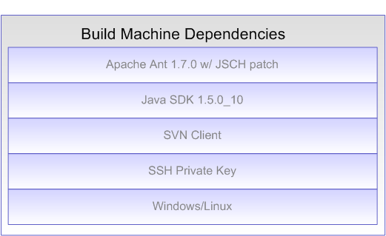
Figure 1 – Build machine dependencies

Derived Requirements
As the Automated Build and Deployment team was initiated, there was a single, general goal: accelerate the delivery of application software. This was communicated as “a one-click process for moving application software artifacts between target environments”. The table below describes more specific requirements that were derived as part of the discovery process during the implementation of the NCIA automated build and deployment project.

Derived Requirement | Description
Single command execution of build | Given certain external dependencies, a build master should be able to type a single command to run a successful build
Run a build from an SCM label | A build master should be able to build from a previously generated SCM tag
Remotely configure a deployment binary | The build should be capable of generating a binary in one environment and configuring it in another (e.g. build machine to STAGE environment)
Same build should run in any target environment | Build behavior should be the same regardless of the specific target environment
All variable information between target environments is externalized into .properties files | There should be no target-specific information in source code. Data that varies from one environment to the next should be pulled from a .properties file
Same build should be capable of running from command line and centralized build server (e.g. AntHill Pro) | There should be no build server specific dependencies
Application software shall be capable of installing/building for six different installation platforms | Local Windows, Local Linux, Remote Windows, Remote Linux, Remote Build Server, Bundle
Build shall avoid the use of environment variables | Environment variables limit portability
Build shall be capable of rebuilding a database remotely | Successfully run DDL from the build machine to a target environment
Build shall be capable of inserting test data remotely | Successfully run DML from the build machine to a target environment
Build shall be capable of enabling non-technical staff to run a build in target environments | AntHill Pro and single-command execution
Generate an SCM label at the successful completion of a build | The build should generate a unique SCM source tree tag based on the build master’s input
Build shall be capable of securely copying files from one environment to the next | Using Java Secure Channel tool (SSHExec and SCP Ant tasks)

Target Environments
A target environment is an environment where NCIA will be deployed to. There are six different target environments. They are developer workstation(s), Integration Build, DEV, QA, STAGE and PROD. To ensure consistency between the environments, [environment]-upgrade.properties (e.g. dev-upgrade.properties) are used to host the environment-specific values for these machines.

Properties files
DEV and QA property files are stored into a private SVN repository at https://gforge.nci.nih.gov/svnroot/scm-private/trunk . When building from the command prompt, developers with the proper access authorization should update their local environment property files from this repository. When building from AnthillPro, there is no special step needed. In fact, there is a separate AnthillPro project, ncia-properties, defined as a dependent project to autodeploy-dev and autodeploy-qa, which automatically updates the environment property files for DEV and QA in AnthillPro. Refer to the following project tree for more information about the AnthillPro projects.

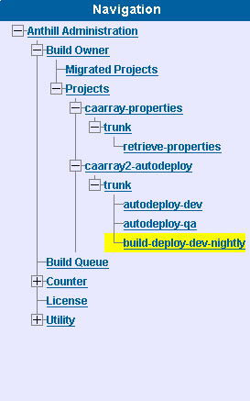
Figure 2 – NCIA AntHill deployment projects and tracks

Developer Workstation

Installation
The following steps describe how to run a NCIA build on your local workstation.

Install Java SDK 1.5.0_10 - Download from http://java.sun.com/javase/downloads/index_jdk5.jsp
After installing the JDK, create a JAVA_HOME environment variable (which points to the location of your JDK installation) and add %JAVA_HOME/bin% to the front of the System PATH environment variable
To test proper installation, open a new command prompt and type java –version.
Install Apache Ant 1.7.0
Download from http://ant.apache.org/
After installing Ant, create an ANT_HOME environment variable (which points to the location of your Ant installation) and add %ANT_HOME/bin% to the front of the System PATH environment variable.
To test proper installation, open a new command prompt and type ant –version. Apache Ant version 1.7.0 compiled on December 13 2006 should be displayed.
Install the Subversion command line client
Download from http://subversion.tigris.org/project_packages.html
After installing Subversion, create an SVN_HOME environment variable (which points to location of your Subversion installation) and add %SVN_HOME% to the front of the System PATH environment variable.
To test Subversion, open a command prompt and type svn help. A list of SVN commands should be displayed.
Perform a check-out the project from the NCI GForge repository, e.g. from https://gforge.nci.nih.gov/svnroot/ncia/trunk to a local working directory
Download JBoss 4.0.4GA from http://www.jboss.org/jbossas/downloads
Start the JBoss server by opening a command prompt at the location of the JBoss installation. Go the bin directory and type run (.bat or .sh)
Open http://localhost:8080/ and verify JBoss is running properly
Download MySQL from http://dev.mysql.com/get/Downloads/MySQL-5.0/mysql-5.0.45-win32.zip/from/pick#mirrors
Step through the installation process.
From Windows, start the MySQL server, by going to the MySQL installation location, then the bin directory. Open a command prompt and type mysqld-nt.exe
Download Globus from http://www.globus.org/toolkit/downloads/4.0.3/. Create environment variable GLOBUS_LOCATION pointing to the GLOBUS installation directory
Open the command prompt and type ant build-all.

Development Integration
The NCIA development team has established an integration build environment on an extra Windows machine. All of the dependencies are similar to a Developer Workstation setup. The Integration environment runs a Hudson continuous integration server and runs a build every time a change has been committed to SVN. All of the External Dependencies are installed in the integration environment. This makes it different from running a remote build as is performed by the Build Machine. The purpose of the Development Integration environment is to catch any errors early in the development process prior to the bi-weekly iteration completion.

Hudson
To view the Hudson dashboard, go to http://cbv-ciweb-base.nci.nih.gov:48080/hudson

Build Machine
The following steps describe how to run a NCIA build remotely from another machine.

AntHill Pro

See Appendix C – AntHill Pro configuration for the steps of setting up AntHill Pro. The table below describes the specific information for NCIA.
Field | Value
Ant Script File | -Dproperties.file=/usr/local/AnthillPro/work/ncia-properties.trunk.retrieve-properties/trunk/ncia/properties/[environment]-upgrade.properties
Ant Configuration | Ant 1.7.0 with jdk1.5.0_10 and patched ant-jsch
Build Properties Command Line | -Dnotest=true –Dproperties.file=/usr/local/AnthillPro/work/ncia-properties.trunk.retrieve-properties/trunk/ncia/properties/dev-upgrade.properties
Ant target | deploy:remote:upgrade
Environment variable | GLOBUS_LOCATION=/usr/local/ws-core-4.0.3
Build Manager | Basic Build Manager
Build Publisher | Directory Publisher
Counter | Root
Build Dependency | ncia-properties.trunk.retrieve-properties

The following steps describe how to run a NCIA build remotely from a centralized build management server (AntHill Pro).

- Go to http://cbiocvs2.nci.nih.gov:8080/AnthillPro/admin/
- Login with the ncia user. Password is ncia
- To build the DEV environment without a tag, select ncia.trunk.dev. Then, select the Build tab. Once on the Build tab, select the Force Build checkbox and click the Build button. See the figures below for additional information.

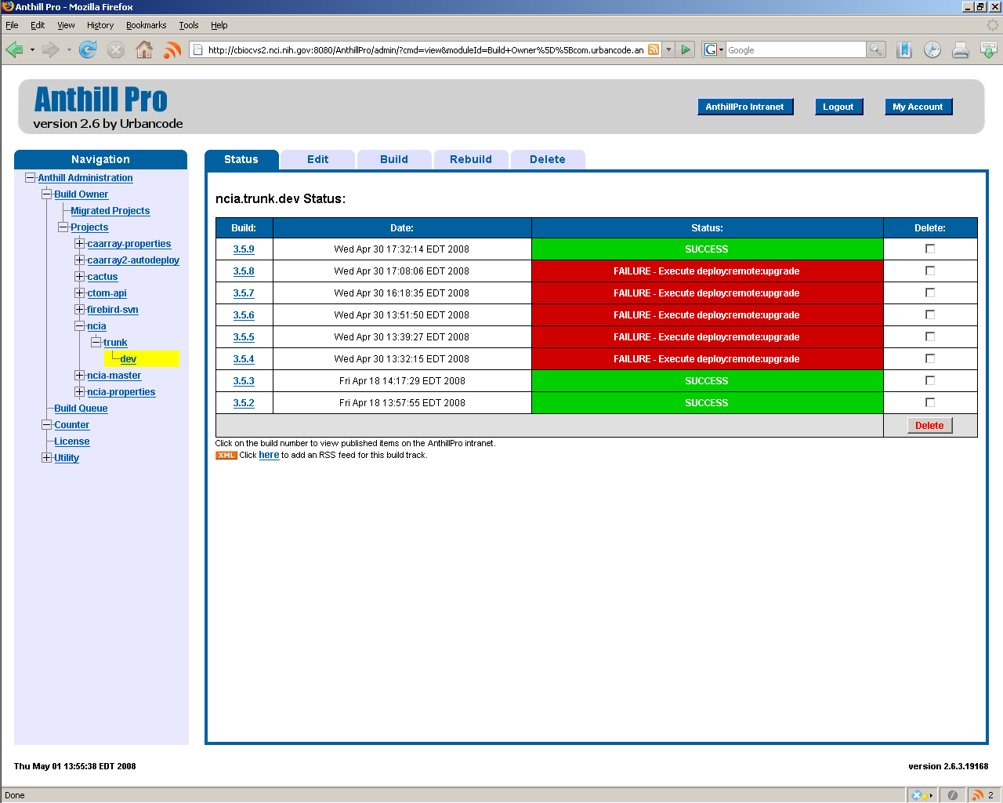
Figure 3 – Selecting the Build tab within an AntHill build track
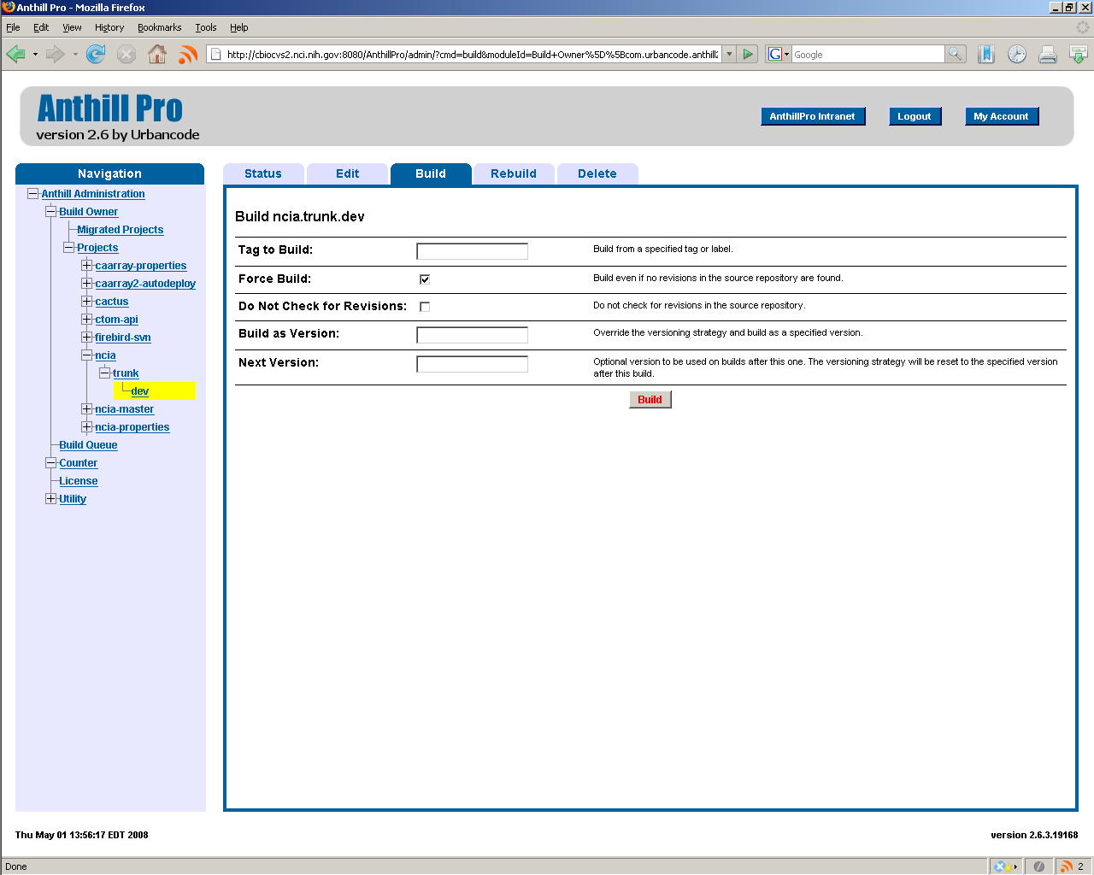
Figure 4 – Building the NCIA trunk from AntHill Pro without a tag (e.g. DEV track)

- To build the DEV environment to generate a new tag, select ncia.trunk.dev. Then, select the Build tab. Enter the tag name in the Build as Version text box. Select the Force Build checkbox and click the Build button. See the figure below.

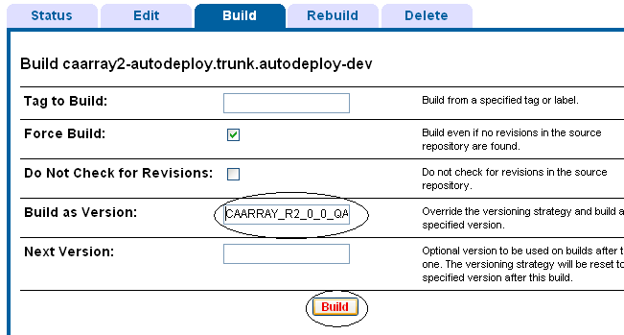
Figure 5 – Generating an SVN tag from AntHill Pro (e.g. DEV track)

- To build from a tag, select a build track such as ncia.trunk.qa. Then, select the Build tab. Enter the tag name in the Tag to Build text box. Select the Force Build checkbox and click the Build button.

DEV
The DEV AntHill build track has a build dependency on the Ncia-properties.trunk.retrieve-properties project which retrieves the Dev-upgrade.properties and QA.properties for NCIA. In order to get the latest file and associated property values, the Ant Script File value must be updated as seen below.
Ant Script File | -Dproperties.file=/usr/local/AnthillPro/work/ncia-properties.trunk.retrieve-properties/trunk/ncia/properties/dev-upgrade.properties

QA
The QA AntHill build track has a build dependency on the ncia-properties.trunk.retrieve-properties project which retrieves the Dev-upgrade.properties and QA.properties for NCIA. In order to get the latest file and associated property values, the Ant Script File value must be updated as seen below.
Ant Script File | -Dproperties.file=/usr/local/AnthillPro/work/ncia-properties.trunk.retrieve-properties/trunk/ncia/properties/qa-upgrade.properties

STAGE
The configuration for the Staging target environment is the same as the DEV and QA target environments. The obvious exception is that all of the locations will be different. Further, the NCIA development team will not be able to make any changes to the Staging environment. These changes must go through the Systems team. One exception could be that Staging will be the environment to properly test data migration prior to production release.

PROD
The configuration for the Production target environment is the same as the DEV, QA and STAGE target environments. The obvious exception is that all of the locations will be different. Further, the NCIA development team will not be able to make any changes to the Production environment. These changes must go through the Systems team.

Promoting a Build through Target Environments
To make software available to production, it must go through six environments: developer workstation, integration build, Development, QA, Staging and finally into Production. The build architecture supports a model that ensures that the same build can be run in each of these environments. This approach minimizes errors. The architecture is implemented through:
Same build script is run in each tier with no environments-specific targets
Builds are executed remotely to minimize build-specific dependencies in target environments
The only difference between build environment execution is the environment-specific .properties file used (e.g. dev-upgrade.properties, qa-upgrade.properties, etc.)
The heavy-weight dependencies (e.g. MySQL, JBoss, etc.) must be installed in each environment, with minor configuration changes (This is a risk). However, much of the configuration is automated and run remotely and, therefore, many of these risks have been minimized.

Troubleshooting FAQ
The build system for NCIA has many moving parts. There are over 100 Ant targets, multiple external dependencies, close to 100 internal dependencies, 10 target environments and 10 installation environments – each with different configurations. In other words, it’s complex. Many techniques and diagnostic capabilities have been applied to reduce this complexity, but to paraphrase the saying, “stuff happens”. This section identifies some of the more common errors that may occur in managing the build system.
Error | Description
ERROR - /usr/local/AnthillPro/work/subversiondriver/ncia.trunk.dev/ncia/software/build/build.xml:1206: com.jcraft.jsch.JSchException: java.io.FileNotFoundException: /home/[username]/.ssh/id_dsa_qa (No such file or directory) | This indicates the private SSH key file is missing from location where the build script expects to find it (user.home/.ssh/...)
ERROR - /usr/local/AnthillPro/work/subversiondriver/Ncia.trunk.dev/trunk/software/build/build.xml:1206: com.jcraft.jsch.JSchException: Auth cancel | This occurs when there is an error with a private SSH key file. The key file may be missing or corrupt. Usually, it's because it's corrupt because the build script searches for a missing file
ERROR - svn: URL 'svn://xxx.nci.nih.gov/svnroot/NCIA/tags/NCIA_R2_0_0_ALPHA1' doesn't exist  INFO - Exit code: 1 | You'll receive a FAILURE-Checkout error in AntHill Pro. When opening the build log, you'll see the error to the left. In this particular example, a Subversion tag with the name NCIA_R2_0_0_ALPHA1 does not exist in the repository. Check the SVN repository and use a name that does exist
“No space left” (error) in Anthill Pro build log | Ask the Systems team to free up disk space on the build machine

My build is failing at the command line
- Check your dependencies by typing the following from the command line
  - svn help
  - ant -version
  - java –version

What if the AntHill Pro build fails?
- Check the heavyweight dependencies are installed and operating correctly
  - MySQL
  - JBoss
  - Tomcat/MIRC

Database Errors
Check the database permissions

How do I build a tag from an SVN revision?
Not all builds will be built with SVN tags. However, after a build, you may want to create a tag. To do this, you’ll need to generate an SVN tag from a revision.

Maintaining the Build
- Updating [environment]-upgrade.properties file attributes and values. See https://gforge.nci.nih.gov/svnroot/scm-private/trunk
- Modifying system property flags in AntHill Pro or command line
- Adding new JAR dependencies
- Renaming Subversion tag
- Prior to a QA/Stage build, ensure AntHill configuration in QA is same as DEV

Ensuring AntHill environment configuration is consistent

Appendix B – Creating diagrams of Ant scripts
We’re using a tool called Grand to create diagrams of the Ant targets. Grand uses GraphViz to create the diagrams. There are a number of tools that diagram Ant scripts, but Grand is one of the few that interfaces with the API, so it doesn’t need for the Ant script to work perfectly in order to generate diagrams. The steps for running Grand against your Ant build script are listed below.
Download Grand from http://www.ggtools.net/grand/
Download GraphViz from http://www.graphviz.org/
Grab the grand.jar from the grand.zip file you downloaded and place it in your ANT_HOME/lib directory
Use the GraphViz installer to install GraphViz
Create an Environment variable called GRAPHVIZ_HOME
Add %GRAPHVIZ_HOME%\bin; to your System’s PATH environment variables
Checkout https://gforge.nci.nih.gov/svnroot/scm-private/trunk/ant/modeling/build-graph.xml from SVN. Get a copy of the build-graph.xml and place it in the same location as the build.xml you’d like to diagram.
Open a command prompt from the directory where the build-graph.xml copy is located (and the build.xml you’re analyzing).
Type ant –f build-graph.xml
If you need to learn more on build-graph.xml, type ant –f build-graph.xml usage

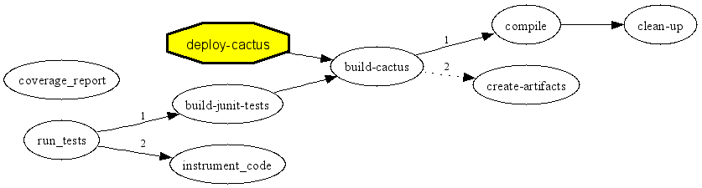
Figure 6 – Example Grand graph of Ant build.xml

Appendix G – Promoting a Build
The act of promoting a build means to move it from one environment to the next. For NCIA, this will mean that you will run a build in the DEV environment, using AntHill Pro (to create an SVN tag), the QA team will run a build (using the tag you created) in the QA environment, Systems will run a build using the same tag you created in DEV and in PROD as well.
- Run a build using a label in DEV using a tag
- Rename the tag in Subversion

DEV

Checklist
- Development Tech Lead informs build master they are ready to run a build
- Build master notifies the development team informing them a build will be run in the DEV environment
- Build master ensures the Dev-upgrade.properties file has been updated to match the ncia-property-template.properties file
- Build master launches AntHill Pro administration console and select the DEV track, while passing the tag name to the Build as Version: text box in the Build tab
- Once the build is successfully complete, the build master notifies the development team to perform testing
- Once testing in the DEV environment is complete, the tech lead notifies the build master
- The build master requests permission from the QA team to run a build in the QA environment
- The build master runs smoke tests to ensure the build has been run correctly in the QA environment
- Build master notifies the QA team that the build is ready to test and provides the SVN tag name and links to deployment request files

QA
Send email to QA with the AntHill Pro URL, SVN tag, Tag to Build, Track name

STAGE
Send email to Systems with the AntHill Pro URL, SVN tag, Tag to Build, Track name, Property attributes/values to change.

TODO: How to setup Hudson for NCIA
Grand can be downloaded at http://www.ggtools.net/grand/
GraphViz can be downloaded at http://www.graphviz.org/

