Clinical Trial Processor
Configuration Guide






Center for Bioinformatics

Contents
Introduction 3
CTP Server Configuration 3
1. Web Console 4
2. HTTP import service 4
3. Storage Service 4
4. Export Service 4
5. Anonymizer Service 4
CTP Client Configuration 5
1. CTP client Web Console 5
2. HTTP Import Service 5
3. Anonymizer Service for DICOM or(and) XML 6
4. Export Service 6
CTP Web Console 6
Screen shot for CTP server / CTP client web console 7
File Sender Application 7
Start CTP server and Client 8

Introduction
After installing the NCIA application with GUI installer, the user should have two directories under installation directory, called CTP-client / File Sender and CTP-server.
If users do not install NCIA application, CTP-client, and File Sender can be downloaded from https://gforge.nci.nih.gov/frs/?group_id=312. They only need to read CTP client configuration / File Sender configuration section.
Before starting CTP server and CTP client, the configuration needs to be modified if the user doesn’t use default setting. Let’s take a look of the config.xml in CTP server and CTP client.

CTP Server Configuration
CTP Server Config.xml
<?xml version="1.0" encoding="UTF-8"?>
<Configuration>
<Server port="23080" />
<Pipeline name="DICOM Pipeline">
<ImportService name="HTTP Import"
class="org.rsna.ctp.stdstages.HttpImportService"
root="roots/http-import"
port="23104"
acceptDicomObject="yes"
acceptXmlObject="yes"
acceptZipObject="yes"
acceptFileObject="yes"
quarantine="quarantines/http-import" />

<StorageService name="Storage"
id="storage"
class="org.rsna.ctp.stdstages.FileStorageService"
root="storage"
port="23204"
return-stored-file="yes"
quarantine="quarantines/storage">
<jpeg wmax="512" wmin="512" q="-1" />
</StorageService>

<ExportService name="Database Export"
class="org.rsna.ctp.stdstages.DatabaseExportService"
adapter-class="gov.nih.nci.ncia.util.NCIADatabase"
file-storage-service-id="storage"
root="roots/database-export"
quarantine="quarantines/database-export" />

<Anonymizer name="Anonymizer"
class="org.rsna.ctp.stdstages.DicomAnonymizer"
root="roots/anonymizer"
script="roots/anonymizer/scripts/da.script"
quarantine="quarantines/anonymizer" />
</Pipeline>
</Configuration>

Web Console
The server port=”23080” tells the user that the CTP server console is using port 23080. It means the user can monitor the CTP server processes by typing URL like http://server-url:23080 . The user can change it if he/she wants to use another port for CTP server console.

HTTP import service
This server will process all requests from CTP client. It can accept objects as configuration described, like DICOM Objects, XML objects, ZIP objects etc. Port number 23104 indicates the CTP client need to send all requests to URL like http://server-url:23104 . In case the files are sent from client are bad, server will quarantine these files and put them into quarantines/http-import. Port number 23104 can be changed by clients’ request. If the port has been changed, the CTP client also needs to change HTTP export URL.

Storage Service
Storage service will store incoming files into the NCIA File System after HTTP Import service. In the configuration, port number for storage service is used internally. It is not necessary to change it. Root attribute will determine where you need to storage DICOM files. In this example, the root is defined as “storage”, it will stores files into CTP_installation_directory/CTP-server/storage. The user can change it to point to someplace else, like “/usr/local/newPlace”. So storage service will store files outside the CTP server installation directory.
Like HTTP import service, quarantined files will be put into “quarantines/storage” directory under CTP server installation directory.

Export Service
This service will export DICOM file header information into database. Therefore, the configuration file need to specify adapter class, which class the user wants to use to insert data into database.
Based on this example, the quarantined files will go into “quarantines/database-export” directory.

Anonymizer Service
Anonymizer on the server side is to filter out header information which users think are not proper to publish to public from DICOM file. Users can modify the script file to determine which column in header need to be filtered out. The script file the service will use is defined in config.xml file, script="roots/anonymizer/scripts/da.script".
Same as storage service, quarantined files will be put into quarantines/anonymizer under CTP server direcoty.

CTP Client Configuration
CTP Client config.xml
<?xml version="1.0" encoding="UTF-8"?>
<Configuration>
<Server port="24080" />
<Pipeline name="DICOM Pipeline">

<ImportService name="HTTP Import"
class="org.rsna.ctp.stdstages.HttpImportService"
root="roots/http-import"
ssl="yes"
port="24104"
acceptDicomObject="yes"
acceptXmlObject="yes"
acceptZipObject="yes"
acceptFileObject="yes"
quarantine="quarantines/http-import" />

<Anonymizer name="Anonymizer"
class="org.rsna.ctp.stdstages.DicomAnonymizer"
root="roots/anonymizer"
script="roots/anonymizer/scripts/da.script"
quarantine="quarantines/anonymizer" />

<Anonymizer name="xmlAnonymizer"
id="xmlAnonymizer"
class="org.rsna.ctp.stdstages.XmlAnonymizer"
root="roots/xml-anonymizer"
script="roots/anonymizer/scripts/xml-anonymizer.script"
quarantine="quarantines/xml-anonymizer" />

<ExportService name="HTTP Export"
class="org.rsna.ctp.stdstages.HttpExportService"
root="roots/http-export"
url=" https://ctpsubmission-stage.nci.nih.gov" />

</Pipeline>

</Configuration>

CTP client Web Console
As this example shows, the CTP client web console is using port 24080. Users can use http://client-url:24080 to monitor all activities from client side.

HTTP Import Service
HTTP import service accepts DICOM, XML, ZIP, and File objects from the File Sender. The port HTTP import service uses is 24104. By using this configuration, the connection from the File Sender needs to be configured as https://client-url:24104. Notice, since CTP client import has been set to use SSL, the secure HTTP protocol needs to be used. If the CTP server sets SSL true, CTP client also needs to use the secure HTTP protocol.
If the CTP client HTTP import fails, the quarantine files will send to the quarantines/http-import directory.

Anonymizer Service for DICOM and/or XML
When the CTP client sends files to the CTP server, the file needs to be anonymized due to personal information privacy. There are two types of script for anonymization, DICOM file, and XML file. There are two types of script files need to be defined before using CTP client, da.script is for DICOM files, xml-anonymizer.script is for annotation files. How to define these two files is based on the user’s requirement. Please refer to CTP documentation http://mircwiki.rsna.org/index.php?title=The_CTP_DICOM_Anonymizer, and http://mircwiki.rsna.org/index.php?title=The_CTP_XML_Anonymizer.
Quarantine files for DICOM object will store in the quarantines/anonymizer directory, and for XML object will store in the quarantines/xml-anonymizer directory.

Export Service
CTP client export service is submitting the object such as DICOM, XML and ZIP object from client to CTP server. All quarantine files are stored in the roots/http-export directory.
<ExportService name="HTTP Export"
class="org.rsna.ctp.stdstages.HttpExportService"
root="roots/http-export"
url="CTP Server HttpImport Service URL" />

CTP Web Console
CTP Web console for server and client are the same. There are 10 functions and 4 documentation links.
Functions include the followings,
- Login
- User Manager
- Logs
- Configuration
- Status
- Quarantines
- System Properties
- DICOM anonymizer configuration
- Script editor
- Lookup table
Documentation links include the followings,
- CTP documentation
- DicomFilter script documentation
- DICOM anonymizer documentation
- XML anonymizer documentation

Screen shot for CTP server / CTP client web console
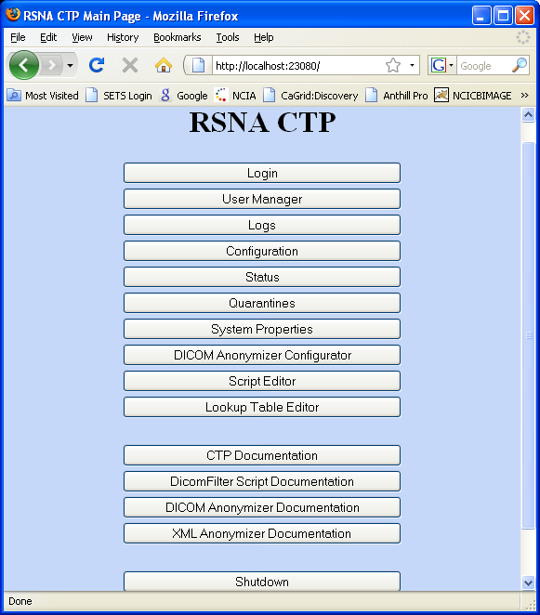

File Sender Application
File Sender is the utility tool for sending DICOM files, XML files and ZIP files to the CTP client. Before sending any file to the CTP client, the user needs to set File Sender environment correctly. The following screenshot is from the File Sender application.
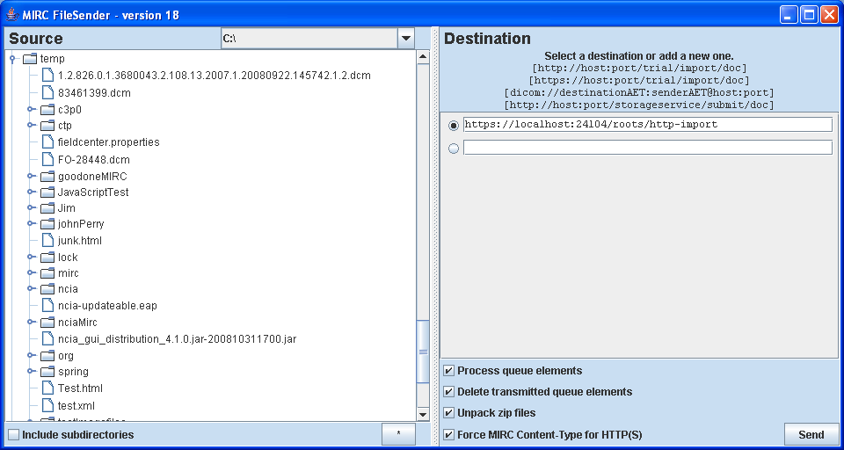
On the left side of application, the user can select a file or a directory (multiple file selections) to submit to the CTP client. On the right side, the user needs to enter CTP client URL. The URL can be obtained from the CTP client environment setting. In this example, the user is running CTP client on local box (localhost), CTP client is using HTTPS protocol and port number is 24104. Since CTP client sets http import directory to “roots/http-import”, therefore, this file path needs to append to the URL.
After selecting file(s) and entering the URL, the user can start sending files. If sending files are successfully, the File Sender should show a message, “no errors”.

Start CTP server and Client
CTP server and CTP client can be started by running two batch files in CTP client directory and CTP server directory and File Sender can be started by running one batch file in File Sender directory. The reason to start servers by running these three batch files is to give more heap memory to services.
The following screen shot indicates the location of three batch files.

CTP SERVER
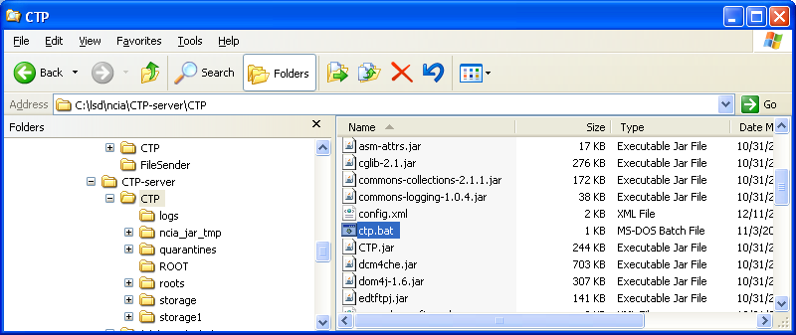
CTP CLIENT
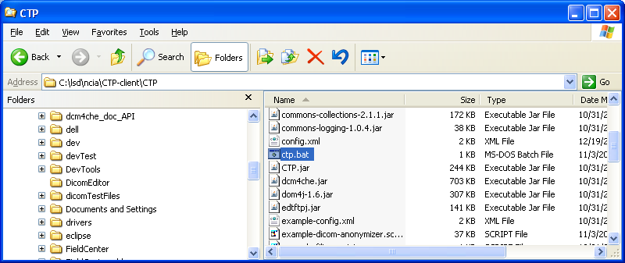
File Sender
