

I-Response MarkUP XML FormAT

Conformance Document

Document Number: 2007-012002006-00681
Revision: 3.0
Revision Type: Major
Document Status: Approved
Date: September 27, 2007
Author: Serguei Joukov, Software Developer

Abstract

Cedara I-Response serializes markups as DICOM Grayscale Presentation State IOD instances using either DICOM or XML encoding. To support markups over reconstructed 3D images a private extension of the DICOM Grayscale Presentation State IOD has been introduced. The document describes details of the private extension and the format of the presentation state XML encoding.

DICOM Presentation State IOD extensions

The extension is required to handle serialization of the presentation state of the derived images (3D rendering, segmentation) without generation of secondary capture images. The extension shall comply with the DICOM Grayscale Presentation State IOD definition to allow viewers without support for extension to represent at least “standard” use cases.

The application is expected to store presentation state aspects of “source” images using the standard Dicom Presentation State Relationship module. Presentation state aspects of derived image are stored using a new Referenced Pseudo Series Sequence.
The table below and represent the proposed changes to the Presentation State IOD.
Stored presentation state aspect also includes the generated Measurement sequence, calculated based on corresponding Graphic objects sequence of Graphic Annotation aspects. The attributes of Measurement module are given in Table 2 and the example of Measurement sequence instance is shown in Figure 3.

Table 1 Referenced Pseudo Series Module
Attribute Name | Tag | Type | Description
Referenced Pseudo Series Sequence | 2007,510A | 3
> Series Instance UID | 0020,000E | 1
> Referenced Pseudo Images Sequence | 2007,510B | 1
>> Instance Number | 0020,0013 | 1 | image ID – must be unique within the sequence
>> Rows | 0028,0010 | 1C | Number of the image rows
>> Columns | 0028,0011 | 1C | Number of the image columns
>> Render 3D Sequence | 2007,5101 | 1C | OpenEyes 3D model
>> Insert Measurement sequence contains the sequence of Measurement data sets, associated with specific Graphic and Image data sets. To create the unique relation between Measurement and corresponding Image and Graphic data sets the attributes Series Instance ID, Instance Number for Image and Graphic Number for Graphic are used. Each Graphic data set belongs to Graphic sequence from some Graphic Annotation, which is defined using Graphic Layer attribute.

The Referenced Pseudo Series Sequence data set contains an instance UID of the related image series and a Referenced Pseudo Images Sequence.

Each Referenced Pseudo Images Sequence data set is identified by a unique Instance Number and when used within Referenced Pseudo Series Sequence contains the description of the reconstruction operation performed to produce this “pseudo” image. When the data set is used within a presentation state aspect (e.g. the Graphic Annotation sequence) only the associated Instance Number attribute is present.

I-Response supports markups over planar reformatted image. The related 3D reconstruction operation is described using the OpenEyes 3D model. Measurement sequence contains the sequence of Measurement data sets, associated with specific Graphic and Image data sets. To create the unique relation between Measurement and corresponding Image and Graphic data sets the attributes Series Instance ID, Instance Number for Image and Graphic Number for Graphic are used. Each Graphic data set belongs to Graphic sequence from some Graphic Annotation, which is defined using Graphic Layer attribute. describes the “Reformat” subset of the model.

The related DICOM Private Creator Group codes are enumerated in Table 4.

Figure 1 Referenced Pseudo Series Module relationships

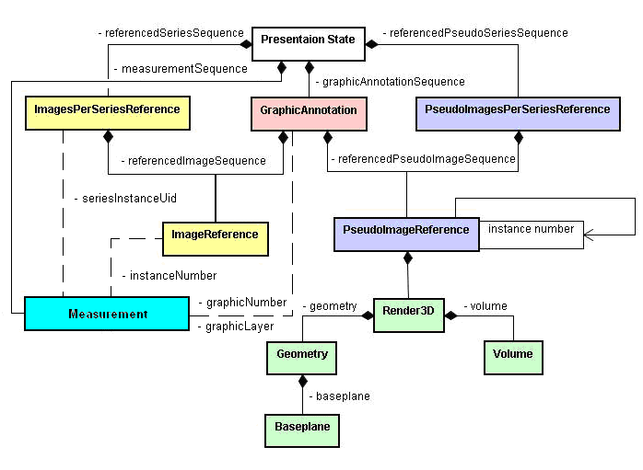

Table 2 Measurement Module

Attribute Name | Tag | Type | VR | VM | Description
Measurement Type | 6509,1802 | 1 | UL | 1 | Measurement Type. Defined Terms:  -1 (None)  0 (Recist)  1 (Crosshair)  2 (Volume)  3 (Nontarget)
Measurement Value | 6509,1803 | 1 | FL | 1-3 | Markup measurement values
Measurement Sequence | 6509,1801 | 1 | SQ | 1 | Measurement description
> Series Instance ID | 0020,000E | 1 | UI | 1
> Instance Number | 0020,0013 | 1 | IS | 1
> Graphic Layer | 0070,0002 | 1 | CS | 1
> Graphic Number | 2001,109B | 1 | UL | 1

Figure 3 Measurement sequence
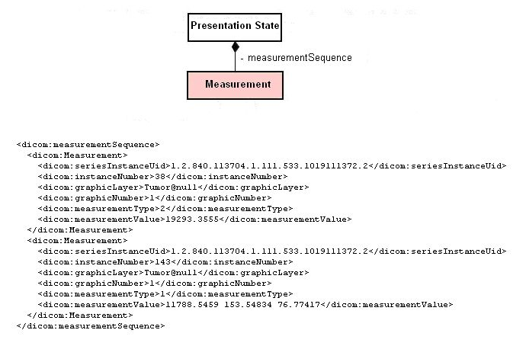
Measurement sequence contains the sequence of Measurement data sets, associated with specific Graphic and Image data sets. To create the unique relation between Measurement and corresponding Image and Graphic data sets the attributes Series Instance ID, Instance Number for Image and Graphic Number for Graphic are used. Each Graphic data set belongs to Graphic sequence from some Graphic Annotation, which is defined using Graphic Layer attribute.

The Measurement data set contains the measurement information using attributes Measurement Type (allowed values -1 (None), 0 (Recist), 1 (Crosshair), 2 (Volume), 3 (Nontarget)) and Measurement Value which contains the actual values of measurement as an array of floats. Volume measurement contains a value of volume in mm³, Recist measurement – a length in mm and Crosshair measurement contains an array of 3 floats – L₁*L₂, L₁, L₂, where L₁ and L₂ are the corresponding lengths in mm of the first and second lines. The measurement values for None and Nontarget measurement types are undefined.

Table 3 OpenEyes 3D Model (Reformat subset) Macro
Attribute Name | Tag | Type | VR | VM | Description
Rendering Type | 2007,5149 | 1 | CS | 1 | Rendering Type. Defined Terms:  REFORMAT
Geometry Sequence | 2007,5102 | 1 | SQ | 1 | Geometry Description
> Geometry Type | 2007,5104 | 1 | CS | 1 | Geometry Type. Defined Terms:  SLAB
> Geometry Interpolation | 20075105 | 1 | CS | 1 | Interpolation Type. Defined Terms:  NN = nearest neighbor in X, Y, and Z  LINEAR = linear in X, Y and Z  LINEAR_CUBIC = linear in X and Y, cubic in Z  NN_LINEAR = NN in X and Y, linear in Z
> Geometry Thickness | 2007,5107 | 1C | DS | 1 | Thickness of the rendered image
> Geometry Baseplane | 2007,5108 | 1C | SQ | 1 | Rendering Baseplane Description
>> Baseplane Center | 2007,5116 | 1C | DS | 3 | Rendered image center position in the patient coordinate system
>> Baseplane Normal | 2007,5117 |  | DS | 3 | The direction cosines of the normal to the image
>> Baseplane Up-Vector | 2007,5118 |  | DS | 3 | The direction cosines of the column of the image
Volume Sequence | 2007,5103 | 1 | SQ | 1 | Volume Description
> Volume Mode | 2007,5110 | 1 | CS | 1 | The projection algorithm. Defined terms:  MAXIP = maximum intensity  MINIP = minimum intensity  AVERAGE = average intensity
> Volume Background | 2007,5262 | 1 | IS | 1 | The density of the background of the image

Table 4 Private Group Creator Codes
Private Group Creator Code | Tag
Cedara_Openeyes_1_5 | 2007,0051
Cedara_Openeyes_1_3 | 2007,0052

XML encoding format

I-Response uses the default OpenEyes XML encoding for DICOM data sets. The “lossless” OpenEyes XML encoding is based on the DICOM dictionary. The dictionary provides definitions of the attribute, module, macro, nested dataset and IOD entities of the DICOM standard.

The dictionary is usually authored using the following XML syntax:

<infoset name="name">
<attribute name="name" {tag=“dicom-tag" | ptag=“dicom-tag"}
occurs = “min [-max]" [type="type-spec"] [vr=“dicom-vr"]
[creator =“private-group-creator-code"]
/>...
<module name="name">
<attribute name="name" mandatoriness="dicom-mandatoriness" /> ...
</module>...
<set name="name" [base="name”] >
<module name="name" rank="rank-code" /> ...
<set name="name" rank="rank-code" /> ...
</set>...
<node name="name" parent="name" [base="name”] >
<module name="name" rank="rank-code" /> ...
<set name="name" rank="rank-code" /> ...
</node>
</infoset>

The root infoset element defines the XML namespace of the dictionary as its name attribute.

The attribute element corresponds to the DICOM attribute and specifies its name, tag, multiplicity, value representation and optional run-time type of VR. Private attribute are identified using ptag and creator XML attributes.

The module element corresponds to either the DICOM module or the DICOM macro entities and specifies the sequences of the attributes tagged with the DICOM mandatorness value (1, 1C, 2…).

The set element corresponds to the DICOM dataset entity and is defined in terms of contained modules and other dataset. The set can be derived from an existing set when the latter name is specified as the base attribute value. The rank attributes tags the set as mandatory, conditional or user defined.

The node element defines a set which can have hierarchical relationships with other nodes to model real-world normalization of the DICOM IOD (e.g. a Series node can have Study node as its parent).

Dicom Presentation State IOD Dicom-pr.xml and 3D Reformat Reformat.xml , Reformat.xsd are the current definitions of the dictionaries used by I-Response for markup serialization.

The DICOM dataset XML encoding uses DICOM entity names defined by dictionaries as XML element names. The dictionaries are referenced using XML namespace mechanism.

The structure of the XML document is identical to the structure of the encoded DICOM dataset.

Each dataset XML element contains an ordered sequence of attribute XML elements. Each sequence attribute XML element contains an ordered sequence of nested datasets XML elements.

The DICOM attribute values are represented as either XML text or XML CDATA nodes. In case of multiple values they are separated using spaces or backslashes. If an attribute has a zero length value, it is indicated by the null XML attribute.

Sample Markup Markup.xml represents a sample XML encoded presentation state instance using the markup schema Markup.xsd.

