 | I-Response NIH  Teleconference Minutes  May 4, 2007

(c) Cedara Software Corp., all rights reserved.

Author: | Stuart Bennett

Attendees:

NIH Team |  | Cedara Team
Carl Blake (Project Manager) | X | Pinar Crombie (Engineering Manager) | X
Anand Basu (Program Manager) |  | Pavel Farberov (Developer) | X
Thai Le (Developer) |  | Leigh-Ann Hogan (Customer Operations) | X
Scott McCrimmon (Team Lead) | X | Firdaous Mirzoev (CTO Architect)
Qinyan Pan (Developer) |  | Jim Stapleton (Team Lead) | X
John Freymann (CIP Imaging Informatics Manager) | X | Steve Moore (Business Development Manager) | X
Carl Jaffe (CIP) | X | Stuart Bennett (Architect IResponse) | X
 |  | Carlos Leitao (Director Technology & Architecture)
 |  | Doug Hussey (Subject Matter Expert) | X

Legend:
Items in black are agenda items from the meeting.
Items in red are action items.

Purpose
A WebEx was scheduled with NIH to present the latest features for the I-Response NIH project.

Reviewing Multiple Series
NIH asked about the workflow for reviewing multiple series. The Statement of Work does not include this feature. Jim mentioned that Cedara plans to support at most 2 series in the scope of the Milestone #3 release.

Volume Measurements
There was some discussion on how to calculate volume measurements if the user draws contours for a specific item (ie, Tumor1) on several images, but leaves gaps on some intermediate images. I-Response NIH currently provides two solutions for this problem
- All contours are grouped to form a volume, even if there are intermediate slices with no contours
- ROIs are grouped into separate volumes if there are intermediate slices without contours.
These options are shown in the following image which shows a stack of images, with contours drawn on some of the images. The volume will be calculated based upon the contours.

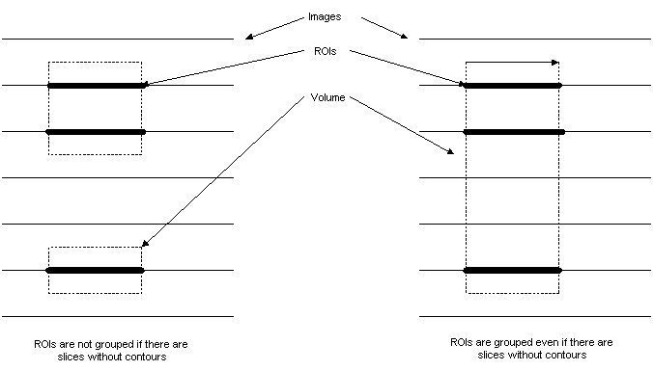

NIH stated that the second option (ROIs are grouped into separate volumes) is not necessary and may lead to confusion with users. I-Response NIH will always group contours with the same layer name into one volume.

RECIST Calculations for Volumes
Scott mentioned that it would be beneficial to have a RECIST value automatically calculated for all volumes. Ideally this would be shown as a line on one of the contours for the volume. There was some discussion as to whether the user should be able to modify the RECIST line or just have it update with the volume.

Metadata for Lesions
NIH mentioned that it would be extremely helpful to be able to associate some metadata with a lesion to provide more details. For example, the user could have a pick-list to select some labels to associate with the annotations, but they would probably still need to add their own text.

Non-target Lesions
NIH stated that they normally put a small crosshair to mark non-target lesions. They thought that the dashed lines might be a little hard to pick up. NIH also stated that they would like the non-target lesions to have a clear layer name. ie, use something like NT1 or NT_Tumor1 instead of Tumor1.

Results Table
NIH mentioned that it was very important to them to be able to dump the Results Table to a text file so that they could analyze the measurements outside of the application.

Identifying MPR Views
The current I-Response NIH displays “sagital/axial/coronal” on the three MPR views. Jim asked if this was an acceptable way to differentiate the views, given that input images may be oblique. NIH stated that they thought that this was a reasonable approach.

