Software Requirements Specification

National Cancer Imaging Archive (NCIA)

DOCUMENT REVISION HISTORY
Version Number | Date | Description
1.0 | October 2006 | Converted Release 2.0 use cases document to use the caBIG template
1.1 | November 2006 | Added grid enhancement for Release 2.2
1.2 | December 2007 | Added boolean search use case to section 7.2 (part of release 3.1)
1.3 | February 2008 | Modified section 14 for Cedara detection
1.4 | February 2008 | Modified section 7.2.6.1 for maintenance page
1.5 | February 2008 | Added MIRC Image Submission and Image Markup to sections 3 and 15
1.6 | March, 2008 | Update the use case for Login and Register for LDAP. Tracker ID 6482

Background/Summary
The National Cancer Imaging Archive (NCIA) is a searchable repository of in vivo cancer images. The system provides the cancer research community with public access to images in DICOM format as well as rich metadata, annotations and markup to be used in the development and validation of analytical software such as computer-aided diagnosis (CAD) tools.
Table of Content

Requirements Specification 1
National Cancer Imaging Archive (NCIA) 1
Background/Summary 1
1 Introduction 15
1.1 Overview 15
1.2 Related Documents 15
2 Actors and Goals 15
2.1 People 15
2.1.1 Submitter 15
2.1.2 Researcher 16
2.1.3 Report User 16
2.1.4 Administrator 16
2.1.5 QA Reviewer 16
2.1.6 Curator 16
2.1.7 Applications Support 16
2.2 Systems 16
2.2.1 MIRC Server Software 16
2.2.2 MIRC Field Center Software 17
2.2.3 MIRC File Sender Software 17
2.2.4 NCIA Software 17
2.2.5 Other Application 17
2.2.6 UPT Software 17
2.2.7 Different NCIA caGRID Node 17
2.2.8 Cedara I-Response Workstation (IRW) 18
2.2.9 Cedara Imaging Services Grid (ISG) server 18
3 Use Cases – Submission of Images and Annotation Files 18
3.1 Use Case for NCIA image submission 19
3.1.1 Brief Description 19
3.1.2 MIRC File Sender and Field Center must be used, as has been done in previous releases, to submit images and annotations to a MIRC server component of the NCIA. 19
3.1.3 Primary Actor 19
3.1.4 Secondary Actors 19
3.1.5 Tertiary Actors 19
3.1.6 Preconditions 19
3.1.7 Basic Flow of Events for Testing 20
3.1.8 Postconditions 20
3.1.9 Special Requirements 26
3.2 Receive DICOM File 26
3.2.1 Brief Description 26
3.2.2 Primary Actor 26
3.2.3 Secondary Actors 26
3.2.4 Preconditions 27
3.2.5 Basic Flow of Events 27
3.2.6 Alternate Courses 27
3.2.7 Postconditions 27
3.2.8 Special Requirements 28
3.3 Receive Annotation File 28
3.3.1 Brief Description 28
3.3.2 Primary Actor 28
3.3.3 Secondary Actors 28
3.3.4 Preconditions 28
3.3.5 Basic Flow of Events 28
3.3.6 Alternate Courses 29
3.3.7 Postconditions 29
3.3.8 Special Requirements 29
3.4 Parse and Store DICOM File 29
3.4.1 Brief Description 29
3.4.2 Primary Actor 29
3.4.3 Secondary Actors 29
3.4.4 Preconditions 30
3.4.5 Basic Flow of Events 30
3.4.6 Alternate Courses 30
If the image has not been previously submitted, it will be placed in quarantine because the trial data provenance information was not provided. 30
3.4.7 Postconditions 31
3.4.8 Special Requirements 31
3.5 Convert DICOM Image to Thumbnail 31
3.5.1 Brief Description 31
3.5.2 Primary Actor 31
3.5.3 Secondary Actors 31
3.5.4 Preconditions 31
3.5.5 Basic Flow of Events 31
3.5.6 Alternate Courses 32
3.5.7 Postconditions 32
3.5.8 Special Requirements 32
3.6 Verify that Submitted Files Were Received 32
3.6.1 Brief Description 32
3.6.2 Primary Actor 32
3.6.3 Secondary Actors 32
3.6.4 Preconditions 32
3.6.5 Basic Flow of Events 33
3.6.6 Alternate Courses 33
3.6.7 Postconditions 34
3.6.8 Special Requirements 34
4 Use Cases - Images and Annotation File Quality Assurance 35
4.1 Manage QA Status 35
4.1.1 Brief Description 35
4.1.2 Primary Actor 36
4.1.3 Secondary Actors 36
4.1.4 Preconditions 36
4.1.5 Basic Flow of Events 36
4.1.6 Alternate Courses 37
4.1.7 Postconditions 37
4.1.8 Special Requirements 37
4.2 Change Quality Assurance Status of Images 38
4.2.1 Brief Description 38
4.2.2 Primary Actor 38
4.2.3 Secondary Actors 38
4.2.4 Preconditions 38
4.2.5 Basic Flow of Events 38
4.2.6 Alternate Courses 39
4.2.7 Postconditions 39
4.2.8 Special Requirements 39
4.3 Change Quality Assurance Status of Series 39
4.3.1 Brief Description 39
4.3.2 Primary Actor 39
4.3.3 Secondary Actors 40
4.3.4 Preconditions 40
4.3.5 Basic Flow of Events 40
4.3.6 Alternate Courses 41
During the time period starting when the QA Reviewer loaded data for the image and ending when the QA Reviewer made the status change, another QA Reviewer has made a QA status change for the same image. Status change for that image is not saved and the following error message is displayed: “Could not change status of the image with SOP instance UID {0} because another user has made a status change to the same image.” where {0} represents the SOP instance UID of the image. 41
4.3.7 Postconditions 41
4.3.8 Special Requirements 41
4.4 Change Quality Assurance Status of Studies 41
4.4.1 Brief Description 41
4.4.2 Primary Actor 42
4.4.3 Secondary Actors 42
4.4.4 Preconditions 42
4.4.5 Basic Flow of Events 42
4.4.6 Alternate Courses 42
4.4.7 Postconditions 43
4.4.8 Special Requirements 43
4.5 Change Quality Assurance Status of Patients 43
4.5.1 Brief Description 43
4.5.2 Primary Actor 43
4.5.3 Secondary Actors 43
4.5.4 Preconditions 44
4.5.5 Basic Flow of Events 44
4.5.6 Alternate Courses 44
4.5.7 Postconditions 44
4.5.8 Special Requirements 45
4.6 View DICOM Header in Quality Assurance Tool 45
4.6.1 Brief Description 45
4.6.2 Primary Actor 45
4.6.3 Secondary Actors 45
4.6.4 Preconditions 45
4.6.5 Basic Flow of Events 46
4.6.6 Alternate Courses 46
4.6.7 Postconditions 46
4.6.8 Special Requirements 46
4.7 View Full Size JPEG in Quality Assurance Tool 46
4.7.1 Brief Description 46
4.7.2 Primary Actor 46
4.7.3 Secondary Actors 46
4.7.4 Preconditions 47
4.7.5 Basic Flow of Events 47
4.7.6 Alternate Courses 47
4.7.7 Postconditions 47
4.7.8 Special Requirements 47
4.8 View Quality Assurance History for an Image 47
4.8.1 Brief Description 47
4.8.2 Primary Actor 48
4.8.3 Secondary Actors 48
4.8.4 Preconditions 48
4.8.5 Basic Flow of Events 48
4.8.6 Alternate Courses 48
4.8.7 Postconditions 48
4.8.8 Special Requirements 48
5 Use Cases - Curation 49
5.1 Curator Enters Data about Images and Annotation Files 49
5.1.1 Brief Description 49
5.1.2 Primary Actor 49
5.1.3 Secondary Actors 49
5.1.4 Preconditions 49
5.1.5 Basic Flow of Events 50
5.1.6 Alternate Courses 50
5.1.7 Postconditions 50
5.1.8 Special Requirements 51
5.2 Upload Curation Spreadsheet 51
5.2.1 Brief Description 51
5.2.2 Primary Actor 51
5.2.3 Secondary Actors 51
5.2.4 Preconditions 51
5.2.5 Basic Flow of Events 51
5.2.6 Alternate Courses 52
5.2.7 Postconditions 52
5.2.8 Special Requirements 52
5.3 Process Curation Spreadsheet 52
5.3.1 Brief Description 52
5.3.2 Primary Actor 52
5.3.3 Secondary Actors 52
5.3.4 Preconditions 53
5.3.5 Basic Flow of Events 53
5.3.6 Alternate Courses 54
5.3.7 Postconditions 55
5.3.8 Special Requirements 55
6 Use Cases -- Data Curation Download 55
Figure 3-1 Download Curation Data Use Case Diagram 55
6.1 Download Curation Data (Download Selection using FTP, HTTP) 55
6.1.1 Brief Description 55
6.1.2 Primary Actor 56
6.1.3 Secondary Actors 56
6.1.4 Preconditions 56
6.1.5 Basic Flow of Events 56
7 Use Cases – Registration and Login 58
7.1 Register 58
7.1.1 Brief Description 58
7.1.2 Primary Actor 58
7.1.3 Secondary Actors 58
7.1.4 Preconditions 59
7.1.5 Basic Flow of Events 59
7.1.6 Alternate Courses 59
7.1.7 Post-conditions 59
7.1.8 Special Requirements 59
7.2 Login 59
7.2.1 Brief Description 59
7.2.2 Primary Actor 60
7.2.3 Secondary Actors 60
7.2.4 Preconditions 60
7.2.5 Basic Flow of Events 60
7.2.6 Alternate Courses 60
7.2.7 Post-conditions 60
7.2.8 Special Requirements 61
8 Use Cases – Search 61
8.1 Select Nodes to Search 61
8.1.1 Brief Description 61
8.1.2 Primary Actor 61
8.1.3 Secondary Actors 62
8.1.4 Preconditions 62
8.1.5 Basic Flow of Events 62
8.1.6 Alternate Courses 62
8.1.7 Postconditions 62
8.1.8 Special Requirements 62
8.2 Perform Simple/Advanced Search 63
8.2.1 Brief Description 63
8.2.2 Primary Actor 63
8.2.3 Secondary Actors 63
8.2.4 Preconditions 63
8.2.5 Basic Flow of Events 63
8.2.6 Alternate Courses 64
8.2.7 Alternate Course 3 – Remote Nodes are not Available 64
8.2.8 Postconditions 65
8.2.9 Special Requirements 65
8.3 Perform Search Based on Curation Data 65
8.3.1 Brief Description 65
8.3.2 Primary Actor 65
8.3.3 Secondary Actors 65
8.3.4 Preconditions 65
8.3.5 Basic Flow of Events 65
8.3.6 Alternate Courses 66
8.3.7 Alternate Course 2 – Remote Nodes are not Available 66
8.3.8 Postconditions 66
8.3.9 Special Requirements 66
8.4 Perform Search Based on Link from Other Application 67
8.4.1 Brief Description 67
8.4.2 Primary Actor 67
8.4.3 Secondary Actors 67
8.4.4 Preconditions 67
8.4.5 Basic Flow of Events 68
8.4.6 Alternate Courses 68
8.4.7 Postconditions 68
8.4.8 Special Requirements 68
8.5 Filter Collection List on Search Page Based on CSM Authorization 69
8.5.1 Brief Description 69
8.5.2 Primary Actor 69
8.5.3 Secondary Actors 69
8.5.4 Preconditions 69
8.5.5 Basic Flow of Events 69
8.5.6 Alternate Courses 69
8.5.7 Postconditions 69
8.5.8 Special Requirements 69
8.6 Filter Data in Results Based on CSM Authorization 70
8.6.1 Brief Description 70
8.6.2 Primary Actor 70
8.6.3 Secondary Actors 70
8.6.4 Preconditions 70
8.6.5 Basic Flow of Events 70
8.6.6 Alternate Courses 71
8.6.7 Postconditions 71
8.6.8 Special Requirements 71
8.7 Display Search Results 71
8.7.1 Brief Description 71
8.7.2 Primary Actor 71
8.7.3 Secondary Actors 71
8.7.4 Preconditions 72
8.7.5 Basic Flow of Events 72
8.7.6 Alternate Courses 73
8.7.7 Postconditions 73
8.7.8 Special Requirements 73
9 Use Cases – Download Data 73
9.1 Add to Data Basket 74
9.1.1 Brief Description 74
9.1.2 Primary Actor 74
9.1.3 Secondary Actors 74
9.1.4 Preconditions 74
9.1.5 Basic Flow of Events 74
9.1.6 Alternate Courses 74
9.1.7 Postconditions 75
9.1.8 Special Requirements 75
9.2 Manage Data Basket 75
9.2.1 Brief Description 75
9.2.2 Primary Actor 75
9.2.3 Secondary Actors 75
9.2.4 Preconditions 75
9.2.5 Basic Flow of Events 75
9.2.6 Alternate Courses 76
9.2.7 Postconditions 76
9.2.8 Special Requirements 76
9.3 Compress Images 76
9.3.1 Brief Description 76
9.3.2 Primary Actor 76
9.3.3 Secondary Actors 77
9.3.4 Preconditions 77
9.3.5 Basic Flow of Events 77
9.3.6 Alternate Courses 77
9.3.7 Postconditions 77
9.3.8 Special Requirements 77
9.4 Download Selection using FTP 78
9.4.1 Brief Description 78
9.4.2 Primary Actor 78
9.4.3 Secondary Actors 78
9.4.4 Preconditions 78
9.4.5 Basic Flow of Events 78
9.4.6 Alternate Courses 78
9.4.7 Postconditions 78
9.4.8 Special Requirements 78
9.5 Download Selection using HTTP 79
9.5.1 Brief Description 79
9.5.2 Primary Actor 79
9.5.3 Secondary Actors 79
9.5.4 Preconditions 79
9.5.5 Basic Flow of Events 79
9.5.6 Alternate Courses 79
9.5.7 Postconditions 79
9.5.8 Special Requirements 79
10 Use Cases – Saved Queries and Query History 80
10.1 Save Query 80
10.1.1 Brief Description 80
10.1.2 Primary Actor 80
10.1.3 Secondary Actors 80
10.1.4 Preconditions 81
10.1.5 Basic Flow of Events 81
10.1.6 Alternate Courses 81
10.1.7 Postconditions 81
10.1.8 Special Requirements 81
10.2 Manage Saved Queries 82
10.2.1 Brief Description 82
10.2.2 Primary Actor 82
10.2.3 Secondary Actors 82
10.2.4 Preconditions 82
10.2.5 Basic Flow of Events 82
10.2.6 Alternate Courses 82
10.2.7 Postconditions 82
10.2.8 Special Requirements 83
10.3 View New Data for Saved Query 83
10.3.1 Brief Description 83
10.3.2 Primary Actor 83
10.3.3 Secondary Actors 83
10.3.4 Preconditions 83
10.3.5 Basic Flow of Events 83
10.3.6 Alternate Courses 83
10.3.7 Postconditions 83
10.3.8 Special Requirements 84
10.4 Resubmit Saved Query 84
10.4.1 Brief Description 84
10.4.2 Primary Actor 84
10.4.3 Secondary Actors 84
10.4.4 Preconditions 84
10.4.5 Basic Flow of Events 84
10.4.6 Alternate Courses 84
10.4.7 Postconditions 85
10.4.8 Special Requirements 85
10.5 Edit Saved Query 85
10.5.1 Brief Description 85
10.5.2 Primary Actor 85
10.5.3 Secondary Actors 85
10.5.4 Preconditions 85
10.5.5 Basic Flow of Events 85
10.5.6 Alternate Courses 86
10.5.7 Postconditions 86
10.5.8 Special Requirements 86
10.6 Delete Saved Query 86
10.6.1 Brief Description 86
10.6.2 Primary Actor 86
10.6.3 Secondary Actors 86
10.6.4 Preconditions 87
10.6.5 Basic Flow of Events 87
10.6.6 Alternate Courses 87
10.6.7 Postconditions 87
10.6.8 Special Requirements 87
10.7 Mark Saved Query as Having New Data Available 87
10.7.1 Brief Description 87
10.7.2 Primary Actor 87
10.7.3 Secondary Actors 88
10.7.4 Preconditions 88
10.7.5 Basic Flow of Events 88
10.7.6 Alternate Courses 88
10.7.7 Postconditions 88
10.7.8 Special Requirements 88
10.8 Resubmit Query from History 88
10.8.1 Brief Description 88
10.8.2 Primary Actor 89
10.8.3 Secondary Actors 89
10.8.4 Preconditions 89
10.8.5 Basic Flow of Events 89
10.8.6 Alternate Courses 89
10.8.7 Postconditions 89
10.8.8 Special Requirements 90
11 Use Cases – Generic NCIA Query Over caGRID 91
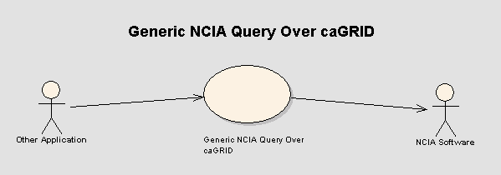 91
11.1 Query NCIA Generically Over caGRID 91
11.1.1 Brief Description 91
11.1.2 Primary Actor 91
11.1.3 Secondary Actors 91
11.1.4 Preconditions 91
11.1.5 Basic Flow of Events 91
11.1.6 Alternate Courses 92
11.1.7 Postconditions 92
11.1.8 Special Requirements 92
12 Use Cases – Reports 92
12.1 Summary Report 92
12.1.1 Brief Description 92
12.1.2 Primary Actor 93
12.1.3 Secondary Actors 93
12.1.4 Preconditions 93
12.1.5 Basic Flow of Events 93
12.1.6 Alternate Courses 93
12.1.7 Postconditions 93
12.1.8 Special Requirements 93
12.2 Query Criteria Report 94
12.2.1 Brief Description 94
12.2.2 Primary Actor 94
12.2.3 Secondary Actors 94
12.2.4 Preconditions 94
12.2.5 Basic Flow of Events 94
12.2.6 Alternate Courses 95
12.2.7 Postconditions 95
12.2.8 Special Requirements 95
12.3 User Login Report 95
12.3.1 Brief Description 95
12.3.2 Primary Actor 95
12.3.3 Secondary Actors 95
12.3.4 Preconditions 95
12.3.5 Basic Flow of Events 95
12.3.6 Alternate Courses 96
12.3.7 Postconditions 96
12.3.8 Special Requirements 96
13 Use Cases – Manage User Authorization 97
13.1 Manage Access to Collection Data 97
13.1.1 Brief Description 97
13.1.2 Primary Actor 97
13.1.3 Secondary Actors 98
13.1.4 Preconditions 98
13.1.5 Basic Flow of Events 98
13.1.6 Alternate Courses 98
13.1.7 Postconditions 98
13.2 Manage Access to Site Data 99
13.2.1 Brief Description 99
13.2.2 Primary Actor 99
13.2.3 Secondary Actors 99
13.2.4 Preconditions 99
13.2.5 Basic Flow of Events 99
13.2.6 Alternate Courses 99
13.2.7 Postconditions 100
13.3 Manage Access to Series Security Group 100
13.3.1 Brief Description 100
13.3.2 Primary Actor 100
13.3.3 Secondary Actors 100
13.3.4 Preconditions 100
13.3.5 Basic Flow of Events 100
13.3.6 Alternate Courses 101
13.3.7 Postconditions 101
14 Use Cases – Visualize Image 101
Figure 14-1 Visualize Image Use Case Diagram 102
14.1 Visualize Images (via Cedara I-Response workstation) 102
14.1.1 Brief Description 102
14.1.2 Primary Actor 102
14.1.3 Secondary Actors 102
14.1.4 Preconditions 103
14.1.5 Basic Flow of Events 103
14.1.6 Alternate Courses 103
14.1.7 Post Conditions 103
14.2 Formulate and Transform Client Request 103
14.3 Get File Path (Integration with Cedara Image Viewer) 104
14.3.1 Brief Description 104
14.3.2 Primary Actor 105
14.3.3 Secondary Actors 105
14.3.4 Preconditions 105
14.3.5 Basic Flow of Events 105
14.3.6 Alternate Courses 105
14.3.7 Post Conditions 105
14.3.8 Special Requirements 105
15 Use Cases – Image Markup and Retrieval 106
15.1 Markup Storage Use Case 106
15.1.1 Use Case Model 106
15.1.2 Brief Description 106
15.1.3 Primary Actor 106
15.1.4 Secondary Actors 106
15.1.5 Preconditions 107
15.1.6 Basic Flow of Events 107
15.1.7 Postconditions 107
15.1.8 Special Requirements 108
15.2 Markup Retrieval Use Case 108
15.2.1 Use Case Model 108
15.2.2 Brief Description 108
15.2.3 Primary Actor 108
15.2.4 Secondary Actors 108
15.2.5 Preconditions 109
15.2.6 Basic Flow of Events 109
15.2.7 Postconditions 109
15.2.8 Special Requirements 110
16 Overall Requirements 110
16.1 Requirements Prioritization 110
17 Data Definitions 112
17.1 Patient 113
17.2 Study 113
17.3 Series 113
17.4 Image 113

Introduction

Overview
NCIA provides the cancer research community, industry, and academia with access to Imaging Archives that can be used for many purposes including the potential to assist in the development and validation of analytical software tools supporting: lesion detection and classification software, accelerated diagnostic imaging decision, and quantitative imaging assessment of drug response. The repository provides access to imaging resources that will improve the use of imaging in today's cancer research and practice by: increasing the efficiency and reproducibility of imaging cancer detection and diagnosis, leveraging imaging to provide an objective assessment of therapeutic response, and ultimately enabling the development of imaging resources that will lead to improved clinical decision support.
Clinical trials submit images to NCIA so that they can be made available to others. Researchers may then access NCIA to search for and download images. Images are stored in the Digital Imaging and Communications in Medicine (DICOM) standard. A DICOM file stores the digital image along with a series of tags that contain metadata about the image such as patient ID, study ID, patient weight, anatomic site, and many more.

Related Documents
Related documents can be found in the ncia-image CVS repository under the documents directory or on the NCIA Intranet (http://ncicbextra.nci.nih.gov/ncia).

Actors and Goals

People

Submitter
A Submitter is a person or organization that has chosen to submit images and/or annotation files to NCIA. In many cases, a Submitter is someone from a cancer center, university or another non-NCI organization. In other cases, the Submitter is someone from inside NCI.

Researcher
A Researcher is a person that is using NCIA to search for and download images. Most NCIA users will be Researchers.

Report User
A Report User is a person that wants statistical information about NCIA and is able to run reports.

Administrator
An NCIA Administrator is a person that is authorized to manage the security rights of users in NCIA.

QA Reviewer
A QA Reviewer is someone that reviews images submitted to NCIA. The QA Reviewer makes a decision about whether or not each image will be made available for searching.

Curator
Curators are responsible for adding value to the NCIA data. Curators enter data about images that is not stored in the image header. This “curation data” could include a radiologist’s analysis, clinical outcomes and others data.

Applications Support
Applications Support is the organization that provides support for NCICB applications. For more information, see http://ncicb.nci.nih.gov/support.

Systems

MIRC Server Software
Medical Imaging Resource Center (MIRC) software was developed by the Radiological Society of North America (RSNA). The goal of MIRC is to provide tools for sharing radiological images for education and research purposes. MIRC offers a simple way to identify, index and retrieve images, teaching files and other radiology information.
For NCIA, MIRC handles the submission of images, storing images in the file system, and exporting images to the database. After images are submitted to the database, the private DICOM fields are anonymized so that they are not available to users who download the images.

MIRC Field Center Software
MIRC Field Center Software is used to submit images to the MIRC Server Software from the sites where they are generated (the “field center”). Typically, images are generated as part of a clinical trial. MIRC Field Center Software is used by researchers at hospitals, cancer centers, and universities to send their images to a MIRC site for sharing.
Due to privacy regulations, personally identifiable information must be removed from images before they can leave the field center. MIRC Field Center Software provides tools to anonymize any personally identifiable data that is found in the DICOM tags.

MIRC File Sender Software
MIRC File Sender Software facilitates the sending of images from a PC to the MIRC Field Center Software. Submitter uses both MIRC Field Center and MIRC File Sender to submit images.

NCIA Software
The National Cancer Imaging Archive (NCIA) application is a searchable repository of cancer images. It provides Researchers functionality for user registration, login, searching of images and download of images.
Administrative functions are also provided for verifying submission, uploading curation data, and managing the image quality assurance process.

Other Application
Other Application represents another system.

UPT Software
The User Provisioning Tool is a component of the Common Security Module that allows for administration of users and their security rights. The UPT provides a web based user interface.

Different NCIA caGRID Node
Another instance of the NCIA Software deployed on caGRID.

Cedara I-Response Workstation (IRW)
The image visualization client (Cedara) that allows users to visualize and manipulate a series of images or an individual image. The visualization client is a licensed software client.

Cedara Imaging Services Grid (ISG) server
The image visualization server that acts as the primary interface between the image visualization client and NCIA system.

Use Cases – Submission of Images and Annotation Files
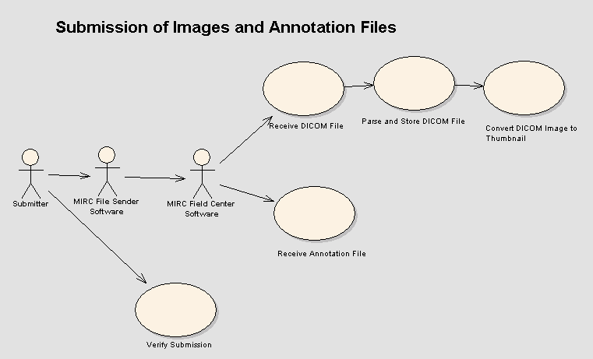

Use Case for NCIA image submission

Brief Description

MIRC File Sender and Field Center must be used, as has been done in previous releases, to submit images and annotations to a MIRC server component of the NCIA.

Primary Actor
Deployer

Secondary Actors
Analyst

Tertiary Actors
User

Preconditions

Precondition One – exist.war file

Deployer verifies that the exist.war file is present under the webapps directory after installation of MIRC.

Precondition Two – MIRC server version
Deployer verifies that version T32 of MIRC is installed.

Precondition Three – Anonymizer
Deployer copies the dicom-anonymizer.properties for using the TEST collection to your Field Center directory. This properties file can be downloaded from https://gforge.nci.nih.gov/plugins/scmcvs/cvsweb.php/ncia-mirc/submission/config/test/?cvsroot=ncia

Precondition Four – Reference Image Set
Confirm access to the directories containing the reference image set for image submission testing.
L:\NCICB\NCIA\Reference DataSet\
This parent directory has images with duplicate sop instance uid problems:
L:\NCICB\NCIA\Reference DataSet\Have duplicate sop instance uid \sd-vc-001\ has two subdirectories ( “p” and “s”) The images under “p” share same sop_instance_uid with images under “s”. If images under “p” submitted successfully, the images under “s” will be quarantined since the software will check for existing sop_instance_uid in NCIA repository. (The ncia.log will display error messages indicate reason these images are quarantined. This also applies to the following folder “L:\NCICB\NCIA\Reference DataSet\Have duplicate sop instance uid\VC-256M”
L:\NCICB\NCIA\Reference DataSet\Regular\ contains only good images that should not fail during transmission.

Basic Flow of Events for Testing
- User uses MIRC Field Center to submit images
- User verifies state of transmission with the Verify Submission Tool
- On error, analyst checks the logs to validate satisfactory behavior of the system.

Postconditions

Alternate Course 1 – User submits good data

Failures should not occur during transmission and the details of the submission should appear in the Verify Submission Tool.

Submit images that are good first, if these images failed on insert into the database, data in QA database for the TEST collection will need to be cleaned up as these images might have been submitted previously using different idtable. Work with development team (Thai Le) to have this done.

Alternate Course 1 – User submits erroneous data
If the user submits erroneous data, data typical of that bad data in the reference image set, the ncia.log will display error messages indicate reason these images are quarantined.

Specifically, verify in the log files and check the errors that are logged when there is any quarantined file. The log can be viewed using the admin service, under “Tomcat” heading, click on the “Log Viewer” button, this will launch log viever. There are 3 logs files:
  - Mirc.log – contains error or information coming from MIRC software
  - Ncia.log – contains error or information coming from ncia database adapter codes.
Notes: All words highlighted in yellow in the table below will be replaced with actual value at the time the error is generated and entered into the log file.

ERROR MESSAGES | INFORMATION | CORRECTIVE ACTIONS
1. SOP Instance UID (SOPInstanceUID ) has different patient information: patientID in database and thisPatient in the submitted image. | This error occurs when the submitting image has same SOP Instance UID with a different patient ID with an existing image in NCIA database. | User or whoever submitting the image needs to review the submitting image to ensure it belongs to correct patient information:  - Correct patient information in the image if it isn’t correct.  - If the submitting image contains correct patient information then the existing record in NCIA database needs to be investigated and possible removed from the system because an image cannot belong to 2 patients.
2. SOP Instance UID (SOPInstanceUID) has different study information: studyID in database and thisStudyID in the submitted image. | This error occurs when the submitting image has same SOP Instance UID with a different study Instance ID with an existing image in NCIA database. | User or whoever submitting the image needs to review the submitting image to ensure it belongs to correct study information:  - Correct study information in the image if it isn’t correct.  - If the submitting image contains correct study information then the existing record in NCIA database needs to be investigated and possible removed from the system because an image cannot belong to 2 studies.
3. SOP Instance UID (SOPInstanceUID) has different series information: seriesID in database and thisSeries in the submitted image. | This error occurs when the submitting image has same SOP Instance UID with a different series Instance ID with an existing image in NCIA database. | User or whoever submitting the image needs to review the submitting image to ensure it belongs to correct series information:  - Correct series information in the image if it isn’t correct.  - If the submitting image contains correct series information then the existing record in NCIA database needs to be investigated and possible removed from the system because an image cannot belong to 2 series.
4. SOP Instance UID (SOPInstanceUID) has different project/collection information: project in database and thisProject in the submitted image. | This error occurs when the submitting image has same SOP Instance UID belongs to different project with an existing image in NCIA database. | User or whoever submitting the image needs to review the submitting image to ensure it belongs to correct project information:  - Correct project information in the image if it isn’t correct.  - If the submitting image contains correct project information then the existing record in NCIA database needs to be investigated and possible removed from the system because an image cannot belong to 2 projects.
5. SOP Instance UID (SOPInstanceUID) has different site information: siteID in database and thisSiteID in the submitted image. | This error occurs when the submitting image has same SOP Instance UID belongs to different site information with an existing image in NCIA database. | User or whoever submitting the image needs to review the submitting image to ensure it belongs to correct site information:  - Correct site information in the image if it isn’t correct.  - If the submitting image contains correct site information then the existing record in NCIA database needs to be investigated and possible removed from the system before resubmitting the image.
6. SOP InstanceUID (SOPInstanceUID) belongs to 2 different series pk id series_pk_id from query (database), series.getId() from series in parameter (submitting image). | This means there are more than one series records with same seriesInstanceUID in NCIA database. | User needs to verify other information in the dicom header besides SOP Instance UID and Series Instance UID such as equipment and compare with existing records in NCIA database to determine which one contains accurate information: Possible actions  - Correct the submitting image if it contains incorrect information and resubmit.  - Removed existing image in NCIA database if it contains inaccurate information and resubmit the image.
7. Project: thisProject Site: thisSiteID Patient ID: thisPatient Study Instance UID: thisStudyID Series Instance UID: thisSeries has ret.size() duplicate records with same SOP Instance UID (SOPInstanceUID) | This error occurs when the submitting image has more than one with same SOP Instance UID in current NCIA Database. (This should not be the case when all duplicate images are cleaned up) | User needs to review the submitting image and possible remove images with same SOP Instance UID in NCIA Database before resubmitting the image.
8. Annotation file submitted: studyInstance UID ( studyInstanceUID ) is different with studyInstance UID in database (study.getStudyInstanceUID()) | This error occurs when the submitting annotation file contains a different study Instance UID than what already exists in NCIA Database. | User has to review the submitted annotation file to ensure that the Study Instance UID is correct.
9. Error in process(DicomObject,String) for file file.getFile().getAbsolutePath() | In addition to the error message, when a dicom file is quarantined, full path of the file name is entered into the log file. This information is to help developer or whoever is trying to resolve quarantine file to easier get the actual filename in the file system that causes the error. | N/A
10. Error in process(XMLObject,String) for file file.getFile().getAbsolutePath() | In addition to error message, when an xml file is quarantined, full path of the file name is entered into the log file. This information is to help developer or whoever is trying to resolve quarantine file to easier get the actual filename in the file system that causes the error. | N/A
11. No seriesInstanceUID or studyInstanceUID found for file file.getFile().getAbsolutePath() | This error occurs when an annotation file (either xml or zip file) does not contain series Instance UID or studyInstanceUID information. | User has to review the submitted annotation file (either xml or zip file) to ensure that series Instance UID and study Instance UID information are in the file.

  - Hibernate.log – contains error or information coming from Hibernate codes

See the screenshots below for details.

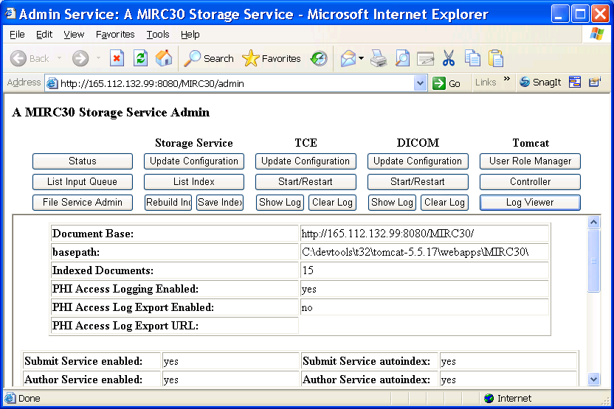

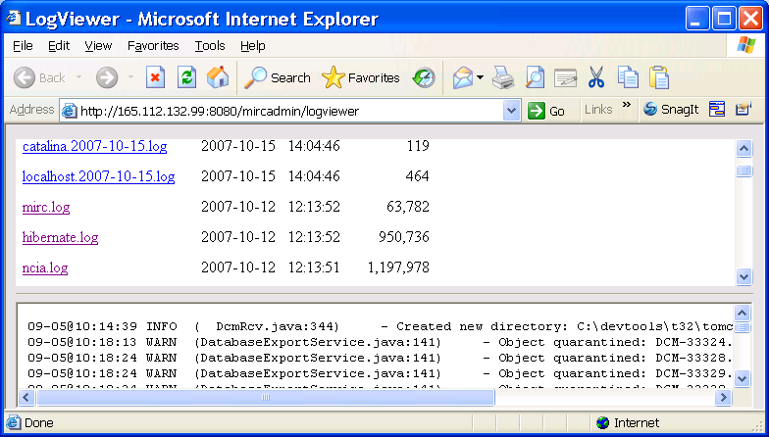

Postcondition
The markup performed by the user is saved into the database.

Special Requirements
NA

Receive DICOM File

Brief Description
This use case describes how DICOM images are submitted to NCIA, stored in the file system and parsed into the database. DICOM (Digital Communications in Medicine) is a standard for digital medical images. MIRC Server Software is used to manage image submission. Submitters use the MIRC client software (Field Center and File Sender) to submit files to MIRC Server Software.

Primary Actor
MIRC Server Software

Secondary Actors

- Submitter
- MIRC Field Center Software
- MIRC File Sender Software

Preconditions

Precondition 1 –Image File Submitted
The DICOM has been submitted in any of the following ways by the Submitter:
- Using MIRC File Sender Software and MIRC Field Center Software to submit via HTTP/HTTPS
- Using File Sender to submit directly to MIRC server via DICOM Storage Service protocol (within NIH firewall)
- Submit directly from image software that implements DICOM Storage Service to MIRC Server Software (within NIH firewall)

Precondition 2 – Deidentification
If required, private patient information has been removed from the DICOM file. For submissions via HTTP, this can be done by configuring Field Center Software.

Basic Flow of Events
- MIRC Server Software receives the DICOM file.
- The DICOM file is parsed and data about the image is stored in the database (see “Parse and Store DICOM File” use case).
- A thumbnail image of the DICOM file is created (see “Convert DICOM Image to thumbnail” use case).

Alternate Courses

Alternate Course 1 – File is Quarantined
An error occurred during the processing of the file. The MIRC Server Software places the file in a quarantine directory. Submitter can contact NCICB Application Support for assistance.

Postconditions

Postcondition 1 – DICOM File Stored in File System and Referenced in Database
The DICOM file and its thumbnail are stored in the file system. Data from the relevant DICOM header fields is stored in the database along with the path to the DICOM file.

Special Requirements
Not Applicable

Receive Annotation File

Brief Description
This use case describes how annotation files are submitted to NCIA, stored in the file system and parsed into the database. MIRC Server Software is used to manage annotation file submission. Annotation files are any non-image file that is submitted to MIRC. Annotation files must either be XML files containing the series instance UID or ZIP file that have an XML manifest that contains the series instance UID. Submitters use the MIRC client software (Field Center and File Sender) to submit files to MIRC Server Software.

Primary Actor
MIRC Server Software

Secondary Actors
- Submitter
- MIRC Field Center Software
- MIRC File Sender Software

Preconditions

Precondition 1 –Annotation File Submitted
The annotation file has been submitted by the Submitter using MIRC Field Center Software.

Precondition 2 – Deidentification
If required, private patient information has been removed from the annotation file. This can be done using MIRC Field Center Software. For submissions via HTTP/HTTPS, this can be done by configuring MIRC Field Center Software.

Basic Flow of Events
- MIRC Server Software receives the annotation file in XML or ZIP format.
- The Study Instance Unique Identifier (UID) is extracted from the annotation file. For XML files, it is extracted from the annotation file itself. For ZIP files, it is extracted from manifest.xml within the zip file.
- The Series Instance UID is extracted from the annotation file.
- The annotation file is stored in the file system in the same directory that series are stored in for the study with the Study Instance UID extracted from the file. The name of the file is the same as its Series Instance UID.
- A record is created in the database that stores the path to the annotation file and the Series Instance UID. No other data is stored in the database from the annotation file.

Alternate Courses

Alternate Course 1 – Series Does Not Exist
A series with the Series Instance UID does not exist yet. When the series is created, the annotation flag will be set to true and the annotation records will be updated to point to the series.

Alternate Course 2 – File is Quarantined
An error occurred during the processing of the file. The MIRC Server Software places the file in a quarantine directory. Submitter can contact NCICB Application Support for assistance.

Postconditions

Postcondition 1 – Annotation File Stored in File System and Referenced in Database
The Annotation file is stored in the file system. The corresponding series has been updated in the database.

Special Requirements
Not Applicable

Parse and Store DICOM File

Brief Description
DICOM header data needs to be stored in the database to facilitate searching. MIRC Software’s Database Export Module parses out the fields and stores them in the database.

Primary Actor
MIRC Server Software

Secondary Actors
Submitter
Applications Support

Preconditions

Precondition 1 - DICOM File Received by MIRC
DICOM image has been received by the MIRC Server Software.

Basic Flow of Events
- The MIRC Server Software’s DICOM parser reads the image file.
- The DICOM parser parses the header information based on a properties file
- Data provenance information is extracted from the DICOM header.
- The parser stores selected DICOM header information and the data provenance information in the database. If the subject, study, or series for this image does not exist yet, it will be created.
- If this image is the first image for its series, check to determine if there are any annotation files for the series. If there are, set the annotation flag for the series to true and set the annotation records to point to the series.
- The location of the image is stored in the database.
- QA Status for the image is set to Not Yet Reviewed in the database.
- The DICOM file is anonymized to remove data provenance information).

Alternate Courses

Alternate Course 1 – Trial Data Provenance Fields Are Not Included in the DICOM Header
MIRC Server Software determines whether the image has already been submitted. This will be true when there is an image in the database that matches the following fields in the header:
- Image SOP Instance UID
- Series Instance UID
- Study Instance UID
- Patient ID
If the image has been previously submitted, the existing image data is updated with the data from the newly submitted image.

If the image has not been previously submitted, it will be placed in quarantine because the trial data provenance information was not provided.

Alternate Course 2 – File is Quarantined
An error occurred during the processing of the file. The MIRC Server Software places the file in a quarantine directory. Submitter can contact NCICB Application Support for assistance.

Postconditions

Postcondition 1 – DICOM Image Stored in File System and Referenced in Database
Image is stored in file system. Data for the image is stored in database.

Special Requirements
Not Applicable

Convert DICOM Image to Thumbnail

Brief Description
A thumbnail must be created for every image that is stored in NCIA. The thumbnail is used for display purposes to allow users to easily look at a large set of images and choose the images that they want.

Primary Actor
MIRC Server Software

Secondary Actors
- Submitter
- Applications Support

Preconditions

Precondition 1 - DICOM File Received by MIRC Server Software
A DICOM image has been received by the MIRC Server Software.

Basic Flow of Events
- MIRC Server Software extracts the image from the DICOM file.
- MIRC Server Software creates a thumbnail from the image.
- The thumbnail is stored on the file system in the same directory as the DICOM file. The thumbnail file has the same name as the DICOM file, but has a different extension.

Alternate Courses

Alternate Course 1 – File is Quarantined
The conversion process fails and the images cannot be converted to thumbnail. The image file is place in a quarantine directory. Submitter can contact Applications Support for details.

Postconditions

Postcondition 1 – Thumbnail Created
Thumbnail image file is stored in file system.

Special Requirements
Not Applicable

Verify that Submitted Files Were Received

Brief Description
After submitting images and/or annotation files to NCIA, Submitters need a way to determine if the images were received successfully. This use case describes a process where users can run a report to show statistics about files submitted from their site.

Primary Actor
Submitter

Secondary Actors
- NCIA Software
- Applications Support

Preconditions

Precondition 1 - Files Submitted
Submitter has submitted images or annotation files

Precondition 2 – Submitter Authorized to Verify Submission
Submitter has been granted the VIEW_SUBMISSION_REPORT role for at least one protection element representing a site.

Basic Flow of Events
- Submitter navigates to the “Verify Submission” page.
- Submitter is presented with the following search fields:
- Date Range
- Submitter chooses a date range to search on and presses the Search button.
- Submitter is presented with the following search results grouped by site for each site for which they have the VIEW_SUBMISSION_REPORT role:
- Number of the following that were submitted successfully for the site on each day in the date range:
- Patients
- Studies
- Series
- Images (showing number of images with a QA status of Visible in parentheses)
- Annotation Files
      - Number of files that were quarantined that could be identified as coming from the site on each day in the date range. The NCIA Software will attempt to identify the site that each file belongs to.
      - For DICOM files, it will attempt to look at the header fields.
      - For XML files, it will attempt to parse out the series instance UID (“Receive Annotation File” use case). Based on the series instance UID, it will attempt determine the site that the file is associated with.
      - For ZIP files, it will attempt to parse out the series instance UID from the manifest XML file. Based on the series instance UID, it will attempt determine the site that the file is associated with.
- Submitter is also presented with the number of files that have been quarantined but for which the site cannot be determined (for example, invalid DICOM header, no manifest in zip file, etc).

Alternate Courses

Alternate Course 1 – Verify Submission Page Not Available Because of Security

Submitter has not been granted the VIEW_SUBMISSION_REPORT role for any protection elements representing a site. The link to the Verify Submission page does not appear.

Alternate Course 2 – Invalid Date Range

- Submitter entered a date range where the From date is greater than the To date. Instead of performing the search, display the following message: “To date must be after the From date”.
- Submitter entered a To date without a From date. Instead of performing the search, display the following message: “If a To date is included, a From date must be included.”
- Submitter entered an invalid From Date or To Date. Instead of performing the search, display the following message: “{0} is an invalid date”, where {0} indicates the field name.
- Submitter entered a From date or a To date that is later than today’s date. “{0} must be not be in the future”, where {0} indicates the field name.

Postconditions

Postcondition 1 – Verify Submission Report Displayed
Submitter analyzes results to determine whether all the files they submitted were received successfully. If there are any quarantined files or files that were not received, submitter calls Applications Support to resolve the issue.

Special Requirements
Not Applicable

Use Cases - Images and Annotation File Quality Assurance
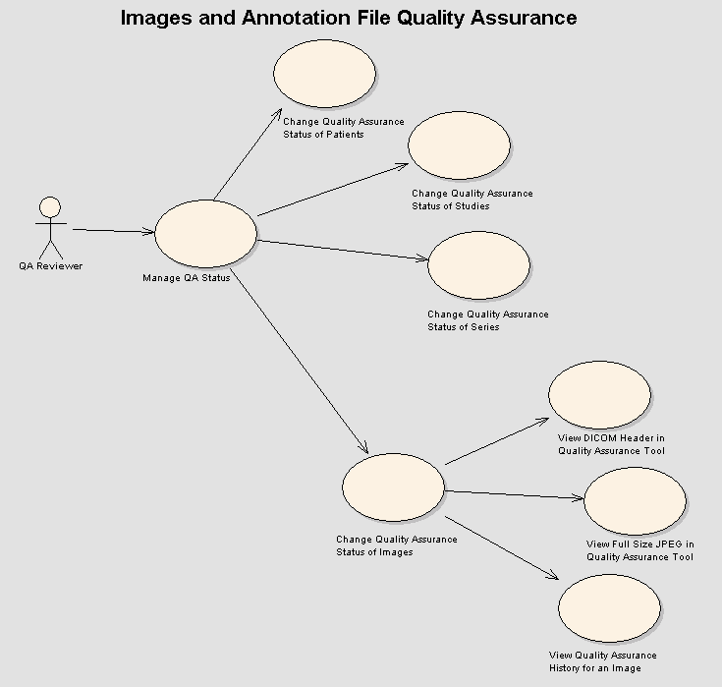

Manage QA Status

Brief Description
Images and annotation files submitted to NCIA go through a quality assurance process. This process ensures that the images are of high quality, are relevant and useful to researchers, and do not contain private health information. The QC Tool described in this use case allows the QA Reviewer to examine submitted images and annotation files and change their QA status as needed.

Primary Actor
QA Reviewer

Secondary Actors
NCIA Software

Preconditions

Precondition 1 – QA SOP Created
A NCIA image QA Standard Operating Procedure (SOP) for DICOM images has been developed in collaboration with the Cancer Imaging Program (CIP) and approved by National Cancer Institute Center for Bioinformatics (NCICB) and CIP.

Precondition 2 – Images Submitted
Images and/or annotation files have been submitted to NCIA and are ready for review by a QA Reviewer.

Precondition 3 – Security Rights
QA Reviewer has been granted the MANAGE_VISIBILITY_STATUS role for at least one protection element representing a collection, site or series security group.

Basic Flow of Events
- QA Reviewer navigates to Manage QA Status page.
- QA Reviewer is presented with a list of all QA statuses
- QA Reviewer clicks on a status
- QA Reviewer is presented with a list of all collections that have images in that status. The list does not include collections that the QA Reviewer does not have access to. Collections where at least one of its images has had its status changed during this HTTP session are highlighted.
- QA Reviewer clicks on a collection
- QA Reviewer is presented with a list of all patients in the collection that have images in the status selected earlier. Images that are part of sites or series security groups that the QA Reviewer does not have the MANAGE_VISIBILITY_STATUS role for are not considered when creating the list of patients. Patients where at least one of its images has had its status changed during this HTTP session are highlighted.
- QA Reviewer has the option to change the QA status of images for one or more patients (see “Change Quality Assurance Status of a Patient“ use case) in the collection.
- QA Reviewer clicks on a patient
- QA Reviewer is presented with a list of all studies for the patient that have images in the status selected earlier. Images that are part of sites or series security groups that the QA Reviewer does not have MANAGE_VISIBILITY_STATUS role for are not considered when creating the list of studies. Studies where at least one of its images has had its status changed during this HTTP session are highlighted.
- QA Reviewer has the option to change the QA status of images for one or more studies (see “Change Quality Assurance Status of Studies” use case) for the patient.
- QA Reviewer clicks on a study
- QA Reviewer is presented with a list of all series for the study that have images in the status selected earlier. Images that are part of sites or series security groups that the QA Reviewer does not have the MANAGE_VISIBILITY_STATUS role for are not considered when creating the list of studies. Series where at least one of its images has had its status changed during this HTTP session are highlighted.
- QA Reviewer has the option to change the QA status of images for one or more series (see “Change Quality Assurance Status of Series” use case) in the study.
- QA Reviewer clicks on a series under the study selected previously.
- QA Reviewer is presented with a list of annotation files for the series and a thumbnail for each image in the series.
- For one or more images, the QA Reviewer has the option to change the QA status (see “Change Quality Assurance Status of Images“ use case)
- For each image, the QA Reviewer has the option to:
- View a JPEG of the image (see “View Full Size JPEG in Quality Assurance Tool“ use case)
- View the history for the image (see “View Quality Assurance History for an Image“ use case)

Alternate Courses

Alternate Course 1 – Insufficient Security Rights
QA Reviewer has not been granted the MANAGE_VISIBILITY_STATUS role for any protection elements representing a collection, site or series security group. The link to the Manage Visibility Status page does not appear.

Alternate Course 2 – No Highlighting for “Not Yet Reviewed” Status
QA Reviewer is viewing data that has the “Not Yet Reviewed” QA status. For that status, no highlighting occurs.

Postconditions

Postcondition 1 – QA Process Complete
QA Reviewer has evaluated all relevant images and changed their status as needed.

Special Requirements
Not Applicable

Change Quality Assurance Status of Images

Brief Description
The QC Tool allows users to change the QA status at a number of levels in the DICOM hierarchy. This use case describes the QA process for a set of images.

Primary Actor
QA Reviewer

Secondary Actors
NCIA Software

Preconditions

Precondition 1 – Navigated to View Series in QC Tool
In the QC Tool, QA Reviewer has navigated to view the data for a series (see “Manage QA Status“ use case). The QC Tool displays a list of annotation files and the image thumbnails for all images in a series.

Precondition 2 – Security Rights
QA reviewer has the MANAGE_VISIBILITY_STATUS role for the collection, site, and series security group to which the series belongs.

Basic Flow of Events
- QA Reviewer selects one or more images
- QA Reviewer selects the new status from a list of available QA statuses:
- Not Yet Reviewed
- Visible
- Not Visible
- Resend
- Send to Curation
- If QA Reviewer wants to enter a comment about the image, they enter it in the field provided.
- QA Reviewer presses the “Change Status” button.

Alternate Courses

Alternate Course 1 – Concurrent Access
During the time period starting when the QA Reviewer loaded data for the image and ending when the QA Reviewer made the status change, another QA Reviewer has made a QA status change for the same image. Status change is not saved and the following error message is displayed: “Could not change status of the image because another user has made a status change to the same image.”

Postconditions

Postcondition 1 – QA Status Changed
QA Status of the selected image(s) is changed to the status selected.

Postcondition 2 – QA Status History Saved
A Curation Status record is added to the database that includes associations to each image, the QA Reviewer that made the change and any comment provided.

Postcondition 3 – Visibility Flags Updated
NCIA Software verifies that the visibility flags of the each image’s series, study and patient are correct. The visibility flag at each level is set to true if at least one image under that item is set to a QA status of Visible.

Postcondition 4 – Confirmation Message
QA Reviewer is presented with a message indicating that the change was successful: “Status changed to {0}” where {0} represents the new status.

Special Requirements
Not Applicable

Change Quality Assurance Status of Series

Brief Description
The QC Tool allows users to change the QA status at a number of levels in the DICOM hierarchy. This use case describes the QA process for a list of series.

Primary Actor
QA Reviewer

Secondary Actors
NCIA Software

Preconditions

Precondition 1 – Navigated to View Study in QC Tool
In the QC Tool, QA Reviewer has navigated to view the data for a study (see “Manage QA Status“ use case). The QC Tool displays a list of series in the study.

Precondition 2 – Security Rights
QA reviewer has the MANAGE_VISIBILITY_STATUS role for the collection, site, and series security group to which the series belongs.

Basic Flow of Events
- QA Reviewer selects one or more series
- QA Reviewer selects the new status from a list of available QA statuses:
- Not Yet Reviewed
- Visible
- Not Visible
- Resend
- Send to Curation
- If QA Reviewer wants to enter a comment, they enter it in the field provided.
- If QA Reviewer wants to assign the series to a series security group, they enter it in the field provided.
- QA Reviewer presses the “Change Status” button.

Alternate Courses

Alternate Course 1 – Concurrent Access

During the time period starting when the QA Reviewer loaded data for the image and ending when the QA Reviewer made the status change, another QA Reviewer has made a QA status change for the same image. Status change for that image is not saved and the following error message is displayed: “Could not change status of the image with SOP instance UID {0} because another user has made a status change to the same image.” where {0} represents the SOP instance UID of the image.

Postconditions

Postcondition 1 – QA Status Changed
NCIA Software determines the QA status from which the QA Reviewer navigated to get to the study. Images in the selected series with that status to which the QA Reviewer has access (MANAGE_VISBILITY_STATUS role) are changed to the newly selected status.

Postcondition 2 – QA Status History Saved
For each image, a Curation Status record is added to the database that includes associations to the image, the QA Reviewer that made the change and any comment provided. For each series, the series is assigned to the series security group (if provided).

Postcondition 3 – Visibility Flags Updated
NCIA Software verifies that the visibility flags of the series, its study and its patient are correct. The visibility flag at each level is set to true if at least one image under that item is set to a QA status of Visible.

Postcondition 4 – Confirmation Message
QA Reviewer is presented with a message indicating that the change was successful: “Status changed to {0}” where {0} represents the new status.

Special Requirements
Not Applicable

Change Quality Assurance Status of Studies

Brief Description
The QC Tool allows users to change the QA status at a number of levels in the DICOM hierarchy. This use case describes the QA process for a list of studies.

Primary Actor
QA Reviewer

Secondary Actors
NCIA Software

Preconditions

Precondition 1 – Navigated to View Patient in QC Tool
In the QC Tool, QA Reviewer has navigated to view the data for a patient (see “Manage QA Status“ use case).

Precondition 2 – Security Rights
QA reviewer has the MANAGE_VISIBILITY_STATUS role for the collection, site, and series security group to which at least one series of the study belongs.

Basic Flow of Events
- QA Reviewer selects one or more studies.
- QA Reviewer selects the new status from a list of available QA statuses:
- Not Yet Reviewed
- Visible
- Not Visible
- Resend
- Send to Curation
- If QA Reviewer wants to enter a comment, they enter it in the field provided.
- If QA Reviewer wants to assign the study’s series to a series security group, they enter it in the field provided.
- QA Reviewer presses the “Change Status” button.

Alternate Courses

Alternate Course 1 – Concurrent Access
During the time period starting when the QA Reviewer loaded data for the image and ending when the QA Reviewer made the status change, another QA Reviewer has made a QA status change for the same image. Status change for that image is not saved and QA Reviewer receives the following error message: “Could not change status of the image with SOP instance UID {0} because another user has made a status change to the same image.” where {0} represents the SOP instance UID of the image.

Postconditions

Postcondition 1 – QA Status Changed
NCIA Software determines the QA status from which the QA Reviewer navigated to get to the patient. Images in the selected studies with that status to which the QA Reviewer has access (MANAGE_VISBILITY_STATUS role) are changed to the newly selected status.

Postcondition 2 – QA Status History Saved
For each image, a Curation Status record is added to the database that includes associations to the image, the QA Reviewer that made the change and any comment provided. For each series, the series is assigned to the series security group (if provided).

Postcondition 3 – Visibility Flags Updated
NCIA Software verifies that the visibility flags of the study, the study’s patient and all child series are correct. The visibility flag at each level is set to true if at least one image under that item is set to a QA status of Visible.

Postcondition 4 – Confirmation Message
QA Reviewer is presented with a message indicating that the change was successful: “Status changed to {0}” where {0} represents the new status.

Special Requirements
Not Applicable

Change Quality Assurance Status of Patients

Brief Description
The QC Tool allows users to change the QA status at a number of levels in the DICOM hierarchy. This use case describes the QA process for a list of patients.

Primary Actor
QA Reviewer

Secondary Actors
NCIA Software

Preconditions

Precondition 1 – Navigated to View Patient in QC Tool
In the QC Tool, QA Reviewer has navigated to view the data for a collection (see “Manage QA Status“ use case).

Precondition 2 – Security Rights
QA reviewer has the MANAGE_VISIBILITY_STATUS role for the collection, site, and series security group to which at least one series for the patient belongs.

Basic Flow of Events
- QA Reviewer selects one or more patients.
- QA Reviewer selects the new status from a list of available QA statuses:
- Not Yet Reviewed
- Visible
- Not Visible
- Resend
- Send to Curation
- If QA Reviewer wants to enter a comment, they enter it in the field provided.
- If QA Reviewer wants to assign the patient’s series to a series security group, they enter it in the field provided.

Alternate Courses

Alternate Course 1 – Concurrent Access
During the time period starting when the QA Reviewer loaded data for the image and ending when the QA Reviewer made the status change, another QA Reviewer has made a QA status change to the same image. Status change for that image is not saved and QA Reviewer receives the following error message: “Could not change status of the image with SOP instance UID {0} because another user has made a status change to the same image.” where {0} represents the SOP instance UID of the image.

Postconditions

Postcondition 1 – QA Status Changed
NCIA Software determines the QA status from which the QA Reviewer navigated to get to the collection. Images for the selected patients with that status to which the QA Reviewer has access (MANAGE_VISBILITY_STATUS role) are changed to the newly selected status.

Postcondition 2 – QA Status History Saved
For each image, a Curation Status record is added to the database that includes associations to the image, the QA Reviewer that made the change and any comment provided. For each series, the series is assigned to the series security group (if provided).

Postcondition 3 – Visibility Flags Updated
NCIA Software verifies that the visibility flags of the patient, the child studies, and all child series are correct. The visibility flag at each level is set to true if at least one image under that item is set to a QA status of Visible.

Postcondition 4 – Confirmation Message
QA Reviewer is presented with a message indicating that the change was successful: “Status changed to {0}” where {0} represents the new status.

Special Requirements
Not Applicable

View DICOM Header in Quality Assurance Tool

Brief Description
During the QA process, the QA Reviewer looks at the fields of the DICOM header. This use case describes the functionality provided in the QC Tool for viewing the DICOM header.

Primary Actor
QA Reviewer

Secondary Actors
NCIA Software

Preconditions

Precondition 1 – Navigated to View Series in QC Tool
In the QC Tool, QA Reviewer has navigated to view the data for a series (see “Manage QA Status“ use case). The QC Tool displays the image thumbnails for all images in a series.

Precondition 2 – Security Rights
QA reviewer has the MANAGE_VISIBILITY_STATUS role for the collection, site, and series security group to which the image that is having its header viewed belongs.

Basic Flow of Events
- QA Reviewer clicks the “View DICOM Header” link for an image thumbnail.
- A new browser window opens that shows all non-empty DICOM tags in the image’s DICOM header.
- QA Reviewer examines the DICOM header values to determine if the image and its data pass the standards established in the SOP.
- QA Reviewer closes the second browser window.

Alternate Courses

Alternate Course 1 – Browser Window Already Open
A browser window showing the DICOM header for another image is already open. Instead of opening a new window, the QC Tool displays the DICOM header in the already open window.

Postconditions

Postcondition 1 – DICOM Header Reviewed
The QA Reviewer has reviewed the DICOM header using the QC Tool.

Special Requirements
Not Applicable

View Full Size JPEG in Quality Assurance Tool

Brief Description
During the QA process, the QA Reviewer needs to look at the image. A JPEG image is typically sufficient for QA. This use case describes the functionality provided in the QC Tool for viewing a JPEG for a DICOM image.

Primary Actor
QA Reviewer

Secondary Actors
NCIA Software

Preconditions

Precondition 1 – Navigated to View Series in QC Tool
In the QC Tool, QA Reviewer has navigated to view the data for a series (see “Manage QA Status“ use case). The QC Tool displays the image thumbnails for all images in a series.

Precondition 2 – Security Rights
QA reviewer has the MANAGE_VISIBILITY_STATUS role for the collection, site, and series security group to which the image that is being viewed belongs.

Basic Flow of Events
- QA Reviewer clicks the “View JPEG” link for an image thumbnail.
- A new browser window opens that displays a JPEG of the DICOM image.
- QA Reviewer examines the JPEG to determine if the image and its data pass the standards established in the SOP.
- QA Reviewer closes the second browser window.

Alternate Courses

Alternate Course 1 – Browser Window Already Open
A browser window showing the JPEG for another image is already open. Instead of opening a new window, the QC Tool displays the JPEG in the already open window.

Postconditions

Postcondition 1 – Image JPEG Reviewed
The QA Reviewer has reviewed the JPEG using the QC Tool.

Special Requirements
Not Applicable

View Quality Assurance History for an Image

Brief Description
This use cases describes how to view a record of changes to an image’s QA Status over time.

Primary Actor
QA Reviewer

Secondary Actors
NCIA Software

Preconditions

Precondition 1 – Navigated to View Series in QC Tool
In the QC Tool, QA Reviewer has navigated to view the data for a series (see “Manage QA Status“ use case). The QC Tool displays the image thumbnails for all images in a series.

Precondition 2 – Security Rights
QA reviewer has the MANAGE_VISIBILITY_STATUS role for the collection, site, and series security group to which the image that is having its history viewed belongs.

Basic Flow of Events
- QA Reviewer clicks the “Show History” link for an image thumbnail.
- The history related to QA is displayed for this image in a new browser window. The history includes the following:
- Date of submission
- Dates of all status changes and what the status was changed to
- Comments provided by QA Reviewer when status was changed

Alternate Courses

Alternate Course 1 – Browser Window Already Open
A browser window showing the history for another image is already open. Instead of opening a new window, the QC Tool displays the history in the already open window.

Postconditions

Postcondition 1 – Image JPEG Reviewed
The QA Reviewer has reviewed the JPEG using the QC Tool.

Special Requirements
Not Applicable

Use Cases - Curation
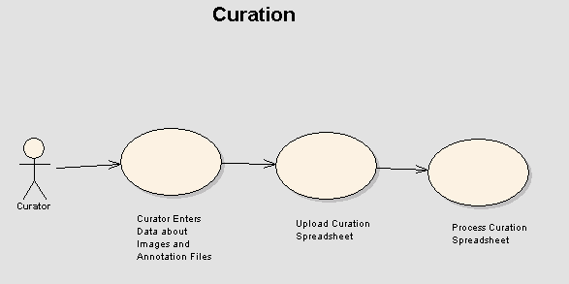

Curator Enters Data about Images and Annotation Files

Brief Description
Curators make the collection of images and annotation files more valuable by providing additional information about the images such as clinical outcomes. This use case describes the process for entering curation data in a spreadsheet.

Primary Actor
Curator

Secondary Actors
NCIA Software

Preconditions

Precondition 1 – SOP Created for Image Curation
A NCIA image curation SOP has been developed in collaboration with CIP and approved by NCICB and CIP.

Precondition 2 – CDEs Created for Curation Data
Common Data Elements (CDEs) that represent the curation data have been registered in the appropriate NCICB applications (i.e. caDSR).

Basic Flow of Events
- Curator reviews an image and wants to add searchable metadata about the image into the database.
- Curator enters the data into a formatted spreadsheet.
- For each piece of data being added, the following is specified in the spreadsheet:
  - Association to Images or Annotation File
    - Collection name
    - Patient ID
    - Study Instance UID
    - Series Instance UID
    - SOP Instance UID
    - Annotation File Name
  - Common Data Element (CDE) Name to describe the data being entered
  - Public ID of the CDE describing the data being entered
  - Version of the CDE describing the data being entered
  - Value for the data
- Action to take (Delete, or default – Insert)

Alternate Courses

Alternate Course 1 – Update Existing Curation Data
Curator wants to update curation data that already exists in the database. Curator includes two rows in the spreadsheet: one to delete the existing data and another to insert new data.

Alternate Course 2 – CDE does not already exist in caDSR
CDE does not already exist in caDSR. Curator must add the CDEs to caDSR prior to entering them in the spreadsheet.

Postconditions

Postcondition 1 – Spreadsheet Ready for Submission
The spreadsheet is ready to be submitted.

Special Requirements
Not Applicable

Upload Curation Spreadsheet

Brief Description
After entering curation data in a spreadsheet, users are able to upload the spreadsheet to NCIA.

Primary Actor
Curator

Secondary Actors
NCIA Software

Preconditions

Precondition 1 – Curation Data Entered in Spreadsheet
In accordance with the “Curator Enters Data about Images and Annotation Files“ use case, curation data has been entered into a spreadsheet in accordance with the NCIA Curation SOP.

Precondition 2 – Security Rights
Curator has been granted the CURATE role in the CSM for at least one protection element representing a collection, site or series security group.

Basic Flow of Events
- Submitter navigates to the “Upload Curation Data” page.
- Curator presses the “Browse” button
- Curator’s browser presents a dialog box that allows selection of a file
- Curator chooses the curation spreadsheet using the dialog box
- Curator presses the “Upload” button
- NCIA Software receives the file
- Curator is returned to the “Upload Curation Data” page with a message indicating that they will receive an email when the upload and parsing is complete.

Alternate Courses

Alternate Course 1 – Insufficient Security Rights
Curator has not been granted the CURATE role in the CSM for any protection elements representing a collection, site, or series security group. The link to the “Upload Curation Data” page does not appear

Alternate Course 2 – Uploaded File is not a Spreadsheet
Uploaded file is not an Excel spreadsheet. Curator is returned the “Upload Curation Data” page with the following message: “The uploaded file is not an Excel spreadsheet”.

Alternate Course 3 –Header Fields Incorrect

Uploaded file does not contain all header fields or the header fields are not in the correct order. The first row of the spreadsheet must contain the header fields in the correct order. Curator is returned the “Upload Curation Data” page with the following message: “Column headers are incorrect or in the incorrect order.”

Postconditions

Postcondition 1 – Spreadsheet Processing
NCIA Software is processing the curation spreadsheet. Control is passed to the “Upload and Parse Curation Spreadsheet“ use case.

Special Requirements
Not Applicable

Process Curation Spreadsheet

Brief Description
Once the spreadsheet has been uploaded, it is processed by NCIA and curation data is stored in the database.

Primary Actor
NCIA Software

Secondary Actors
Curator

Preconditions

Precondition 1 – Curation Spreadsheet Uploaded
In accordance with the “Upload and Parse Curation Spreadsheet“ use case, a spreadsheet containing curation data was uploaded to NCIA.

Basic Flow of Events
- For each row in the spreadsheet:
  - The NCIA Software determines the collection, patient, study, series, image or annotation file that the data is associated to. This can be specified by providing the following combination of columns of the spreadsheet:
- Collection:
  - Data is associated to a collection. NCIA Software verifies that the collection exists in the database using the collection name and that the QA Reviewer has the CURATE role for the collection.
- Collection and Patient ID
  - Data is associated to a patient. NCIA Software verifies that the patient exists in the database using the collection name and patient ID and that the QA Reviewer has the CURATE role for the collection and site that the patient belongs to.
- Collection, Patient, and Study Instance UID
  - Data is associated to a study. NCIA Software verifies that the study exists in the database using the collection name, patient ID, and study instance UID and that the QA Reviewer has the CURATE role for the collection and site that the patient belongs to.
- Collection, Patient, Study Instance UID and Series Instance UID
  - Data is associated to a series. NCIA Software verifies that the series exists in the database using the collection name, patient ID, study instance UID and series instance UID and that the QA Reviewer has the CURATE role for the collection, site and series security group (if any) that the series belongs to.
- Collection, Patient, Study Instance UID and Series Instance UID, SOP Instance UID
  - Data is associated to an image. NCIA Software verifies that the image exists in the database using the collection name, patient ID, study instance UID, series instance UID, and SOP instance UID and that the QA Reviewer has the CURATE role for the collection, site and series security group (if any) that the series belongs to.
- Collection, Patient, Study Instance UID and Series Instance UID, Annotation File Name
  - Data is associated to an annotation file. NCIA Software verifies that the image exists in the database using the collection name, patient ID, study instance UID, series instance UID, and annotation file name and that the QA Reviewer has the CURATE role for the collection, site and series security group (if any) that the series belongs to.
  - NCIA Software determines the CDE name, ID, version and value based on their respective columns
  - NCIA Software determines the action to be taken based on the Action column (Insert or Delete). If no action is provided, Insert will be used as the default.
  - If the action is Delete, NCIA Software finds the curation data with the same association, CDE name, ID, version and value as the data provided in the spreadsheet. NCIA Software deletes curation data.
  - If the action is Insert, NCIA Software creates curation data that is associated to the requested collection, patient, study, series, image, or annotation file. The Submitted By and Timestamp fields of the curation data are populated.
- Curator is sent an email with the results of the upload. The email includes the number of rows processed successfully. For each row where an error occurred, Curator is provided with the row number along with the error message (see alternative flows).

Alternate Courses

Alternate Course 1 – Insufficient Security Rights
The Curator does not have the CURATE role for the associated data. An error message is included in the email: “User does not have permission to access to the data being curated”.

Alternate Course 2 – Associated Data Could Not Be Found
Data could not be found in the database that matches the IDs specified for trial, patient, study, series, image, and/or annotation file in the spreadsheet. An error message is included in the email: “Based on the IDs specified, the associated data could not be located”.

Alternate Course 3 – Required Field Missing
Curator did not include all required fields (CDE name, ID, version and value) in the spreadsheet. An error message is included in the email: “Required field {0} is missing”, with {0} representing the field name.

Alternate Course 4 – Invalid Action
An invalid value was specified in the Action column of the spreadsheet. The only valid values are Insert, Delete, or blank. An error message is included in the email: “An invalid value was specified in the Action column”

Alternate Course 5 – Cannot Find Data to Delete
Data being deleted could not be found. An error message is included in the email: “Curation data to be deleted was not found.”

Alternate Course 6 – Curation Data Already Exists
When inserting new data, the NCIA Software discovers that curation data already exists with all of the same values. A warning message is included in the email: “Warning: The data to be inserted already exists, so no insert occurred”

Postconditions

Postcondition 1 – Spreadsheet Processing Complete
All items contained in the uploaded spreadsheet have been processed. Curator has been sent an email with the results.

Special Requirements
Not Applicable

Use Cases -- Data Curation Download
Figure 3-1 illustrates the high-level use case diagram for downloading curation data.
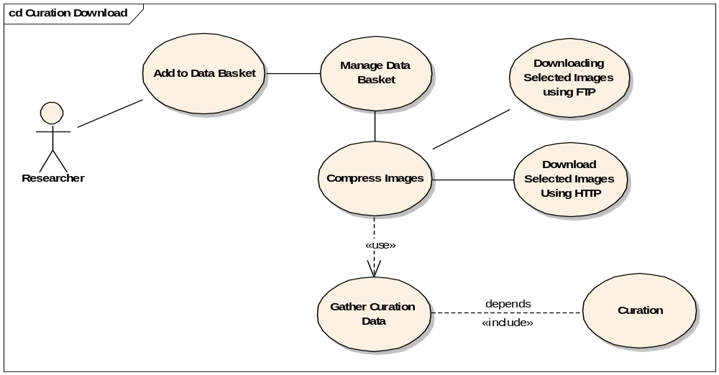
Figure 3-1 Download Curation Data Use Case Diagram

6.1 Download Curation Data (Download Selection using FTP, HTTP)

6.1.1 Brief Description
Once a curation data spreadsheet has been uploaded and processed by the NCIA system, the curation data is stored in the database. The curation data will then be added to any download of the curated collection, patient, study, series, image or annotation image, via an XML file populated from the information that was stored in the database and originated from the uploaded spreadsheet.

6.1.2 Primary Actor
NCIA System

6.1.3 Secondary Actors
User

6.1.4 Preconditions

6.1.4.1 Precondition 1 – Curation Spreadsheet Uploaded and Processed
In accordance with the “Upload and Parse Curation Spreadsheet“ use case, a spreadsheet containing curation data was uploaded to NCIA and processed into the database.

6.1.4.2 Precondition 2 – A data download has been created by the researcher
A researcher has added to the data basket, managed the data basket and has chosen to download the selected “Download All Data”.

6.1.5 Basic Flow of Events
1. For every patient, study, series, image or annotation image element in the download:
  - The NCIA Software determines the collection, patient, study, series, image or annotation file that the data is associated to and builds the XML file as follows:
- Collection:
  - <Is there Curation data for a collection?>
- Patient ID
  - Selected download data is a patient. NCIA software looks for and gathers any curation data for that patient, and places it in and XML element for that patient. Additionally, any curation data for any study, series, image or annotation associated with that patient will be included in individual XML elements that will be contained inside the associated “patient” XML.
- Study Instance UID
  - Selected download data is a study. NCIA software looks for and gathers any curation data for that study and places it in and XML element for that study. Additionally, any curation data that is related to any series, image or annotation associated with that study will be included in individual XML elements contained in the “study” XML element which will be contained in an associated “patient” XML element.
- Series Instance UID
  - Selected download data is a series. NCIA Software looks for and gathers any curation data for that series and places it in and XML element for that series. Additionally, any curation data that is related to any image or annotation associated with that series will be included in individual XML elements contained in the “series” XML element that is contained inside the XML element for the associated study which resides inside the XML element for the associated patient.
- SOP Instance UID
  - Selected download data is an image. NCIA Software looks for and gathers any curation data for that image and places it in and XML element for that image. Additionally, any curation data that is related to an annotation file will be included in an individual XML element located inside the “image” XML element, inside an XML element for the associated study, inside the XML element for the associated patient.

6.1.4.4 Alternate Course 1 – No Curation Data Available for Selected Data
In the instance that there can be no curation data found for the associated data, no file will be included.

6.1.4.5 Post Conditions

6.1.4.5.1 Post Condition 1 – XML is generated, validated
The XML file is labeled curation_data.xml and then made available for the current packaging software to include in with downloaded data. The Schema document (.XSD) will also be included with the download.

6.1.4.5.2 Post Condition 2 – There is no curation data found for the selected data
An xml file will not be generated or included in the download.

6.1.4.6 Special Requirements
A public XML Schema definition should be created and made publicly available.
This schema should contain the following XML elements that are based on the common NCIA hierarchy: Patient, Study, Series, Image and CDE.

Use Cases – Registration and Login
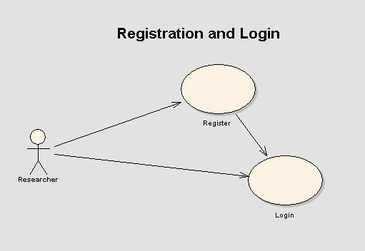

Register

Brief Description
Prior to using NCIA, users must register. Registration in NCIA is open to the public.

Primary Actor
Researcher

Secondary Actors
- NCIA Software
- Applications Support

Preconditions

Precondition 1 – Researcher Has Access to NCIA Site
Researcher has access to the NCIA web site using a web browser that supports SSL and Javascript.

Basic Flow of Events
- Researcher is presented with the following fields: Title (*), First Name (*), Last Name (*), Email (*), Phone (*), Organization (*) Name, Fax. Fields marked with (*) are required.
- Researcher submits the form.
- User will receive an email about the account is being created immediately.
- User will receive emails that contain NCIA username and password separately.

Alternate Courses

Alternate Course 1 – Data Validations
If required fields are not filled on the form, an error message is displayed and then the Registration page is redisplayed.
If email address is not correct, an error message is displayed and asks Researcher to fill out a valid email address.

Post-conditions

Post-condition 1 – Registration Data Stored
Registration data is sent to a predefined administrator (Application Support in NCI). The administrator will create user account in LDAP/UPT and automatically add the user to the public group, allowing access to public collections, sites and series security groups.

Post-condition 2 – Request Access to Non-Public Collections
If applicable, Researcher contacts Applications Support to be granted appropriate permissions to view data for non-public collections, sites, and series security groups.

Special Requirements
Not Applicable

Login

Brief Description
Before users can use NCIA, they must be authenticated by entering a login ID and password.

Primary Actor
Researcher

Secondary Actors
NCIA Software

Preconditions

Precondition 1 – Researcher Has Access to NCIA Site
Researcher has access to the NCIA web site using a web browser that supports SSL and Javascript.

Basic Flow of Events
- Researcher enters Login ID and Password and presses the Login button
- NCIA Software validates login information against the LDAP/database.
- If the login ID/password matches an entry in valid, the Researcher is logged in and displays the home page.
- An entry is created in the login history table containing the date and time, the login source (defaults to NCIA) along with the IP address of the Researcher.

Alternate Courses

Alternate Course 1 – Invalid Login Credentials
If an invalid login ID or password error is thrown, the login form is redisplayed and the Researcher is asked to reenter login ID/password.
User will be locked out after 3 failed login for 30 minutes. A message will be displayed to notify user that he/she is not going to be able to login the application for the next 30 minutes.

Alternate Course 2– Access NCIA from Other Application
Researcher accesses NCIA by clicking a link in another application (see “Perform Search Based on Link from Another Application“ use case). The login history record that is created will contain the value passed as the source in the URL.

Post-conditions

Post-condition 1 – Login Successful
Researcher is granted access to the NCIA Software and the Home Page is displayed.

Special Requirements
Not Applicable

Use Cases – Search
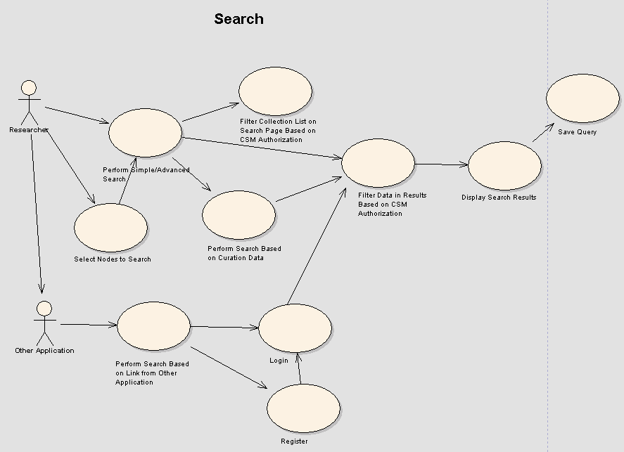

Select Nodes to Search

Brief Description
In addition to the NCIA instance they are logged into, Researchers can search for images in one or more Different NCIA caGRID Nodes. Prior to performing a search, a user must select the node or nodes that they want to search.

Primary Actor
Researcher

Secondary Actors
NCIA Software, Different NCIA caGRID Nodes

Preconditions

Precondition 1 – Navigation to Search Page
Researcher has logged in to NCIA.

Basic Flow of Events
- Researcher clicks the Remote Search link on the menu bar or one of the Remote Search links on the home page.
- A list of nodes to be searched is displayed. The list always includes the node the user is logged in to (already checked and disabled).
- NCIA Software attempts to connect to each node in the list to determine if it is available at this time. If no response is received, the node name is disabled in the list.
- Researcher selects the nodes that they want to search.
- Researcher presses the “Continue” button.
- Control is passed to the “Simple/Advanced Search” use case.

Alternate Courses

Alternate Course 1 – No Grid Nodes Available
The NCIA software has not been configured to access any nodes on caGRID. The “Remote Search” links do not appear. Because of this, the Researcher has implicitly selected that they only want to search the node they are logged into. Control is passed to the “Simple/Advanced Search” use case.

Alternate Course 2 – Researcher Implicitly Chooses Local Node Only
Researcher clicks the Simple Search or Advanced Search link from the home page or the Search link in the menu bar. By clicking one of these links, the Researcher has implicitly selected that they only want to search the node they are logged into. Control is passed to the “Simple/Advanced Search” use case.

Postconditions

Postcondition 1 – Display Search Page
Control has been passed to the “Simple/Advanced Search” use case.

Special Requirements
Not Applicable

Perform Simple/Advanced Search

Brief Description
Researchers search for images in NCIA by entering criteria on the Simple or Advanced Search pages. These pages contain search files based on DICOM header fields. Results are filtered based on the Researcher’s security rights.

Primary Actor
Researcher

Secondary Actors
NCIA Software, Different NCIA caGRID Nodes

Preconditions

Precondition 1 – Nodes Selected for Searching
Researcher has explictly or implicitly chosen the nodes to be searched (see the “Select Nodes to Search” use case).

Basic Flow of Events
- Researcher clicks on the Simple or Advanced Search link from the main page.
- Researcher is presented with a list of search fields to fill out. For search fields that present a list of options, the search options are populated with the available values from all of the nodes selected for searching. The following fields will be presented:
  - Simple Search - image modality, contrast, anatomic site, image slice thickness, presence of annotations and collection. The Collection field is filtered based on the “Filter Collection List on Search Page Based on CSM Authorization “ use case.
  - Advanced Search – image modality, contrast, anatomical site, image slice thickness, minimum number of studies, number of months between baseline and final study, collection, manufacturer, model, equipment software version, series description, Convolution Kernel Type, Kilo Voltage Peak Distribution, Acquisition Matrix, Reconstruction Diameter, Data Collection Diameter (DX) and Data Collection Diameter (CT).
- Researcher enters the fields to be searched and the condition for search (if any).
- Researcher clicks on the submit button.
- NCIA Software then
- Validates the data entered and
- Queries each selected node with the criteria chosen. For the node the user is logged into, NCIA Software calls the “Filter Data in Results Based on CSM Authorization” use case. For remote nodes, a filter is added so that only publicly available data is returned from those nodes. Each type of criteria is ANDed with the other criteria. For example, if collections and slice thickness were chosen as criteria, data returned must match one of the collections and be within the slice thickness parameters. GForge feature request 8478 contains the new requirement allowing modalities to be either ANDed or ORed. The user will specify through a new radio button below list of modalities which condition should be applied to the query.
- Displays the search results from all nodes that were queried.
- Saves the query (including the selected nodes), the elapsed time to run the query and a timestamp of what was run in the Researcher’s query history.

Alternate Courses

Alternate Course 1 – Add Curation Data Criteria
Instead of clicking the submit button, Researcher clicks another button that allows them to also search by curation data. NCIA Software validates the data entered and then calls the “Perform Search Based on Curation Data” use case.

Alternate Course 2– Search Criteria Validation
For all fields that require enter of a number, validate that the entered search criteria is a number. If it is not, the following message is displayed: “Please enter a valid number”.
For search fields that allow specification of a range (such as image slice thickness), validate the following:
- If the field’s checkbox is checked, verify that range criteria have been entered. If it has not, display the following message: “Please select a range.”
- Verify that a value is entered for each operator. If it is not, the following message is displayed: “Please select an operator and a value.”
- Make sure that if the equals operator or the less than operator is used on the left side of the range, that no criteria is used on the right side. If that is not the case, the following message is displayed: “Please deselect right operator and value if you wish to use less than.”
- For image slice thickness, verify that Researcher is not searching for negative slice thicknesses. If they are, the following message is displayed: “Image slice thickness cannot be less than or equal to zero.”
- Verify that the value chosen for the right side of the range is greater than the value chosen for the left side. If it is not, the following message is displayed: “Right value must be greater than left value.”

Alternate Course 3 – Remote Nodes are not Available
If a remote node is not available (e.g. it is down for some reason), a message is displayed indicating that the node is not available. Search results from all other nodes are displayed.

Postconditions

Postcondition 1 – Search Results Displayed
Researcher is presented with the search results screen to view the results. Control is passed to the “Display Search Results” use case.

Special Requirements
Not Applicable

Perform Search Based on Curation Data

Brief Description
In addition to searching using criteria based on DICOM header fields, Researchers can also search based on curation data that was provided to NCIA by a curator.

Primary Actor
Researcher

Secondary Actors
NCIA Software, Different NCIA caGRID Node

Preconditions

Precondition 1 – Navigation to Curation Data Search Page
Researcher has navigated to the Curation Data Search page as described in Alternate Course 1 of the “Perform Simple/Advanced Search” use case.

Basic Flow of Events
- Researcher is presented with a read only list of criteria that have already been selected on the Simple / Advanced Search page.
- Researcher is presented with a distinct list of the CDE names of all curation data in the database for the collections selected on the previous page. This includes CDEs from all selected nodes. If no collections were specified, the list displays CDEs for all collections that Researcher has access to across all of the selected nodes.
- Researcher selects the CDEs that they want to search on.
- NCIA Software determines the values currently in the database for each selected CDE.
- NCIA Software determines the data type (string, or number) of each selected CDEs based on the values currently in the database for the CDE.
- For each CDE selected, Researcher is presented fields to specify how to search based on the CDE.
  - String CDEs: Researcher is presented with a list of all values for the CDE that are currently in the database. Researcher can select multiple values as criteria.
  - Number CDEs: Researcher is presented with fields that allow for the selection of a range based on the numbers (for example, > 4 and < 6).
- Researcher clicks on the submit button.
- NCIA Software then
- Validates the range criteria entered to ensure that valid values were entered
- Saves the query, the elapsed time to run the query and a timestamp of what was run in the Researcher’s query history.
- Queries each selected node with the criteria selected. For the node the user is logged into, the “Filter Data in Results Based on CSM Authorization” use case is called. For remote nodes, a filter is added so that only publicly available data is returned.
- Displays the search results based on the selected criteria. Each type of criteria is ANDed with the other criteria. For example, if collections, slice thickness, and three CDEs were chosen as criteria, data returned must match one of the collections, be within the slice thickness parameters, and match at the values selected for each of the CDEs.

Alternate Courses

Alternate Course 1 – Back to Simple / Advanced Search Page
Researcher clicks a link to return to the Simple / Advanced Search page. Control is passed to the “Perform Simple / Advanced Search” use case.

Alternate Course 2 – Remote Nodes are not Available
If a remote node is not available (e.g. it is down for some reason), a message is displayed indicating that the node is not available. Search results from all other nodes are displayed.

Postconditions

Postcondition 1 – Search Results Displayed
Researcher is presented with the search results screen to view the results. Control is passed to the “Display Search Results” use case.

Special Requirements
Not Applicable

Perform Search Based on Link from Other Application

Brief Description
NCIA provides the ability to integrate with other applications. This is achieved by supporting running a search based on data submitted in a HTTP link. The Other Application builds a link containing the required parameters. The Researcher then clicks the link and is directed to the search results in NCIA.

Primary Actor
Researcher

Secondary Actors
- Other Application
- NCIA Software

Preconditions

Precondition 1 – Link Created in Other Application
The Other Application has created a link to NCIA and passed the following in the URL:
- Source (i.e. “I-Spy”)
- Image 1 Data
  - Label
  - Trial ID
  - Patient ID
  - Study Instance UID
  - Series Instance UID
  - Image SOP Instance UID
  - Field Name (zero to many)
  - Field Value (zero to many)
- Image 2 Data (optional)
  - Label
  - Trial ID
  - Patient ID
  - Study Instance UID
  - Series Instance UID
  - Image SOP Instance UID
  - Field Name (zero to many)
  - Field Value (zero to many)

Basic Flow of Events
  - Researcher clicks link to NCIA in the Other Application.
  - Login Page is displayed.
  - Researcher logs into NCIA
  - A query is built based on the trial ID, patient ID, study instance UID, Image SOP instance UID passed in the URL. The query is configured to only run against the local node.
  - Calls the “Filter Data in Results Based on CSM Authorization” use case to enforce authorization rules for the Researcher.
  - One or both of the images requested along with name value pairs passed in the URL are displayed.
  - Researcher clicks the “View Full Size JPEG” button.
  - Another browser window opens displaying a full size JPEG of the image.
  - Researcher clicks the “View Series” link. NCIA Software calls the “Display Search Results” use case to display the images for the series.

Alternate Courses

Alternate Course 1 – Researcher Not Registered
Researcher has not previously registered in NCIA. Researcher clicks the Register button and registers. After registration is successful, query is built and executed and results displayed as described above.

Alternate Course 2 – Researcher Not Authorized
Researcher is not authorized to view the search results. The results list is empty.

Alternate Course 3 – Researcher Already Logged In
Researcher clicks the link after they have already logged into NCIA. As long as their session has not expired and they have not closed their browser, they are immediately presented with the results page instead of having to log in.

Postconditions

Postcondition 1 – Images Displayed
The page has links to add the images to the data basket or navigate to the results page for the series containing the images.

Special Requirements
Not Applicable

Filter Collection List on Search Page Based on CSM Authorization

Brief Description
Researchers are restricted by their security rights as to the data that they can search. This use case describes the process of filtering the collection list search field to only contain collections that the Researcher is allowed to search.

Primary Actor
Researcher

Secondary Actors
NCIA Software, Different NCIA caGRID Node

Preconditions

Precondition 1 – Navigation to Search Page
Researcher has logged in and has clicked on the Simple or Advanced Search link from the home page or menu bar.

Basic Flow of Events
- NCIA Software determines which protection elements representing collections that Researcher has the READ role for. This list will include collections that are in the public group that all Researchers have access to.
- The collections field is filtered to include only those collections that the Researcher has access to on the local node.

Alternate Courses
Not Applicable

Postconditions

Postcondition 1 – Collection List Filtered
The collection list is filtered based on the Researcher’s security rights. Control is returned to calling use case.

Special Requirements
Not Applicable

Filter Data in Results Based on CSM Authorization

Brief Description
Search results must be filtered based on the Researcher’s security rights. When the query is performed for a set of criteria, NCIA filters the results.

Primary Actor
NCIA Software

Secondary Actors
Researcher

Preconditions

Precondition 1 – Performing a Search
Researcher has chosen to perform a search based on criteria selected.

Basic Flow of Events
Filter Collections
- If Researcher has selected collections as part of the query’s criteria:
- Application verifies that Researcher has access to each collection (including public collections) chosen as part of the criteria.
  - Even though the UI is being filtered to prevent this in most cases (see “Filter Collection List on Search Page Based on CSM Authorization“ use case), it must still be verified for situations where a Researcher saved a query when they had permission, but tries to resubmit it after they no longer have permission.
- Any collections included in the original criteria that Researcher now does not have access to are removed from the criteria. This verifies that data from inaccessible collections is not included in the results (see Alternative Flow).
- If Researcher did not select any collections as part of the query’s criteria:
    - Criteria are added to the query to ensure that the only collections included in the results are those that the Researchers has access to.
- When querying a remote node, only public collections are returned.

Filter Sites
- NCIA Software determines which protection elements representing sites that Researcher has the READ role for. This list will include sites that are in the public group that all Researcher have access to. When querying a remote node, the list includes only public sites.
- Criteria are added to the query to ensure that the results include only the sites that the Researcher is allowed to access.
Filter Series Security Groups
- NCIA Software determines which protection elements representing series security groups (SSGs) the Researcher has the READ role for. This list will include SSGs that are in the public group that all Researchers have access to. When querying a remote node, the list of SSGs will be empty.
7. Criteria are added to the query to ensure that the results include only the series that the Researcher is allowed to access along with series that do not belong to a series security group.

Alternate Courses

Alternate Course 1 – Insufficient Security Rights
If Researcher is attempting to access collections they don’t have permission to access, they will be presented results with the disallowed collections excluded. An information message will appear on the results page indicating that the data is not available for that collection because they no longer have permission to view it.

Postconditions

Postcondition 1 – Results Filtered
The results are filtered based on the Researcher’s security rights. Control is returned to calling use case.

Special Requirements
Not Applicable

Display Search Results

Brief Description
After running a search, results are displayed to the Researcher. Initially, results are displayed as a list of patients. The Researcher can then drill down to view the studies for each patient, then into each of the patient’s series.

Primary Actor
Researcher

Secondary Actors
NCIA Software

Preconditions

Precondition 1 – Search Has Been Performed
A search has been performed successfully and results are ready for display to the Researcher.

Basic Flow of Events
- NCIA Software retrieves the data requested by Researcher.
- The search results page includes a list of subjects sorted by Subject ID that have at least one visible series matching the criteria. For each subject, the results include:
- NCIA Node Name
- Subject ID
- Trial ID
- The number of studies and series for the patient that contain at least one visible image meeting the criteria.
- The total number of studies and series for the patient.
- A “Show Studies” link.
- Researcher can click on the Show Studies link to “drill down” to the study level.
- The Search Results (Studies for Subject) page is displayed. It includes a list of all of the studies for the selected subject (sorted by study date) that contain at least one visible series matching the criteria. For each study, the following is displayed:
- NCIA Node Name
- Study ID
- Study Description
- Study Date
For each study, a list of series (ordered by series number) for the study that have been marked as visible matching the criteria is displayed. For each series, the following is displayed:
- Series ID
- Total Number of Images in the Series
  - Note: This number includes both visible images that meet the criteria and those that don’t.
- Series Description
- Series Modality
- Series Equipment Manufacturer
- Whether or not annotations exist for the series. If curation data exists to describe the content type of the series’ annotation files, display all available content types.
- A “Show Images” Link
- Researcher clicks the “Show images” link to display the visible images in that series.
- A set of thumbnails are displayed for all the images in the series with a QA status of Visible sorted by the image date. (Thumbnails for visible images that do not match the criteria are displayed also). A summary of the series is also displayed that includes whether or not the series has annotations and the content types of the annotation files if there is available curation data to describe the content type.

Alternate Courses

Alternate Course 1 – Sorting Columns
On the Subject Results page, Researcher clicks on the icon in a column title to sort the list by the data in that column.

Alternate Course 2 - Breadcrumbs
Researcher clicks a link to go back and view the search page. Control is passed to the “Perform Simple/Advanced Search” use case. This option is not available if the search results were created by linking from another application (see the “Perform Search Based on Link from Other Application” use case).

Postconditions

Postcondition 1 – Researcher Has Reviewed Results
Researcher has reviewed the results.

Special Requirements
Not Applicable

Use Cases – Download Data
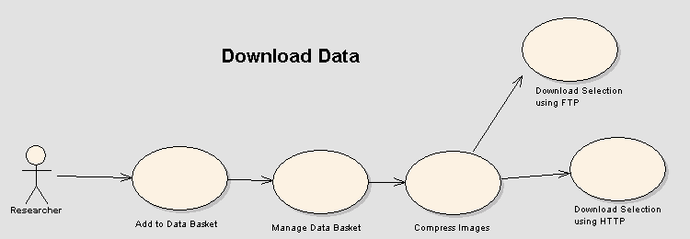

Add to Data Basket

Brief Description
Researchers can select which images they want to download by adding images (or groups of images) to their data basket.

Primary Actor
Researcher

Secondary Actors
NCIA Software

Preconditions

Precondition 1 – Viewing Search Results
A query has been executed and Researcher is viewing the results.

Basic Flow of Events
  - Researcher can choose to download all the images for a subject by clicking on the checkbox next to each subject and clicking on the “Add to Basket” button. When a Researcher chooses to download a subject, NCIA Software finds all of the subject’s series that match the criteria. Then, it adds all images with a QA status of Visible in those series (whether they match the criteria or not) to the data basket.
  - Researcher can also drill down into each study by clicking on the “Show Studies” link.
  - Researcher can choose to download all the images at the series level or for a particular study by clicking on the appropriate checkbox and then clicking on the “Add to Basket” button. When Researcher chooses to download a series, NCIA Software adds all visible images in the series (whether they match the criteria or not) to the data basket.
  - Researcher can also click on the “Show Images” link to show all the thumbnail images for a particular series. Researcher can then choose the images they want to download by clicking on the checkbox next to the thumbnail and clicking on the “Add to Basket” button.

Alternate Courses

Alternate Course 1 – Remove Series from Data Basket
The Researcher removes an image or set of images from the data basket.

Postconditions

Postcondition 1 – Data Added to Data Basket
All the images or set of images are placed in the data basket that can then be managed using the “Manage Data Basket” use case.

Special Requirements
Not Applicable

Manage Data Basket

Brief Description
Once images have been added to the data basket, the Researcher can download the images.

Primary Actor
Researcher

Secondary Actors
NCIA Software

Preconditions

Precondition 1 – Navigated to Data Basket Page
Researcher clicks on the “Manage Data Basket” link to manage the data basket.

Precondition 2 – Data Has Been Added to Basket
Researcher has added images and sets of images of interest to the data basket and is ready to download the images.

Basic Flow of Events
- Researcher is presented with a list of the series that are currently in the data basket. For each series, the following data is displayed:
- NCIA Node Name
- Subject ID
- Study ID
- Series ID
- Number of Images Selected out of Number Available
- Whether or not the Series has annotations
- Size of all DICOM file and annotation files (in MB)
- If desired, Researcher can remove images from the data basket.
- Researcher is shown the approximate total size of the download and the approximate time it will take for the download.
- Researcher clicks the “Download” button to begin the download process.
- If total size of the images and annotation files is below the HTTP download threshold and all series in the data basket are from the local node, a progress bar is displayed to show the progress of the file being zipped. Control is passed to the “Compress Images” use case. As the file is zipped, the progress bar is updated.
- If the size of the images and annotation files is above the HTTP download threshold or if any of the series in the data basket are from a remote node, a message is displayed indicating that they should expect an email from each node with a link to download the file via FTP. NCIA Software executes the “Compress Images” use case in the background for each node with data in the data basket while Researcher is able to continue using the application.
7. Researcher has the option to cancel the download process.

Alternate Courses

Alternate Course 1 – Annotation Files Not Downloaded
Researcher indicates that they only want to download image files. Annotation files are not included in the download.

Postconditions

Postcondition 1 – Request for Download Complete
Either the download is successful without any errors or Researcher waits for an email with a link to the FTP site while NCIA Software zips the data. If the series are coming from multiple nodes, the user will receive one email from each node.

Special Requirements
Not Applicable

Compress Images

Brief Description
To reduce download time, images and annotation files are compressed prior to being downloaded.

Primary Actor
NCIA Software

Secondary Actors
Researcher

Preconditions

Precondition 1 – Downloading Data
Researcher has added all the images and set of images of interest to the data basket and has clicked on the “Download” button.

Basic Flow of Events
- NCIA Software then compresses all the images and annotation files in the data basket using the zip format.
- If downloading via FTP, Researcher is sent an email indicating that the file is now ready for them.
- If downloading via HTTP, control is then passed over to the Download Selection using HTTP” use case.

Alternate Courses

Alternate Course 1 – Annotation Files Not Compressed
Researcher indicates that they only want to download image files. Annotation files are not compressed.

Postconditions

Postcondition 1 – Zip File Created
The images and annotation files have been successfully zipped and are ready to be downloaded.

Postcondition 2 – Download History Saved
A record has been added to the download history table. The table contains the date/time when the zipping was completed, the size of the data that was zipped (not the size of the file), the amount of time it took to zip the file and a reference to the Researcher that requested the download.

Special Requirements
Not Applicable

Download Selection using FTP

Brief Description
For large downloads, Researchers can download their data from the NCIA FTP site.

Primary Actor
Researcher

Secondary Actors
NCIA Software

Preconditions

Precondition 1 – Data Ready for Download
NCIA Software has collected and zipped all the images that have to be downloaded. The data being downloaded is larger than the FTP threshold.

Precondition 2 – Researcher Receives Email
Researcher has received an email indicating that the file is ready to download. The email contains a link to the file that is ready for download on the FTP site.

Basic Flow of Events
- Researcher clicks on the link provided in the email they received.
- Researcher can then download the file from the FTP site using a FTP client of their choice.

Alternate Courses
Not Applicable

Postconditions

Postcondition 1 – File Downloaded
Researcher has downloaded the zip file.

Special Requirements
Not Applicable

Download Selection using HTTP

Brief Description
For small downloads, Researchers can download their data directly in their browser.

Primary Actor
Researcher

Secondary Actors
NCIA Software

Preconditions

Precondition 1 – Data Ready for Download
NCIA Software has collected and zipped all the images that have to be downloaded. The data being downloaded is smaller than the FTP threshold.

Basic Flow of Events
- Researcher is asked where on their local workstation the file should be downloaded.
- NCIA Software starts the download process.
- NCIA Software continually informs the Researcher regarding the status of the download including the percent downloaded.
- Researcher is notified when the download has been completed.

Alternate Courses
Not Applicable

Postconditions

Postcondition 1 – File Downloaded
Researcher has downloaded the zip file.

Special Requirements
Not Applicable

Use Cases – Saved Queries and Query History
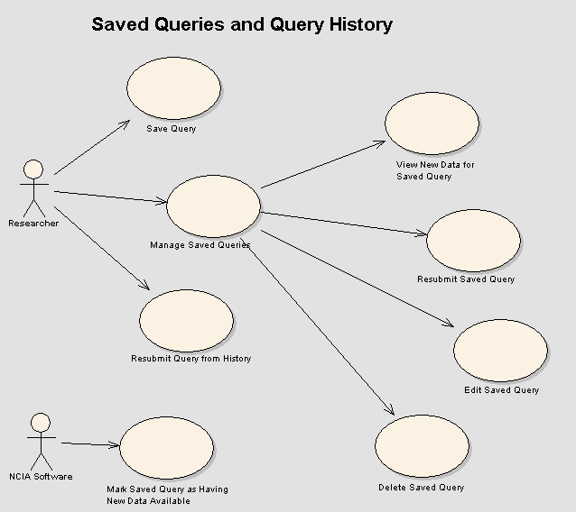

Save Query

Brief Description
Researchers can save queries to be run at a later time.

Primary Actor
Researcher

Secondary Actors
NCIA Software

Preconditions

Precondition 1 – Viewing Search Results
Researcher has performed a search (simple or advanced) and is viewing the results of the search on the Search Results page. The search was conducted using a query that is not already saved.

Basic Flow of Events
1. Researcher enters a name to call the saved query.
2. Researcher presses the “Save Query” button.

Alternate Courses

Alternate Course 1 – Query Name Already Exists
A query with that name already exists for this Researcher. Researcher is returned to the Search Results page with an error message displayed. The query is not saved, but Researcher has the opportunity to enter a new name for the query.

Alternate Course 2 – Required Field Validation
Researcher does not enter a name for the query and presses the “Save Query” button. Researcher is returned to the Search Results page with an error message indicating that the query name is required. The query is not saved, but Researcher has the opportunity to enter a name for the query.

Alternate Course 3 – Executed Query from Link in Other Application
Researcher executed the query by linking from Other Application (see the “Perform Search Based on Link from Other Application” use case). The option to save the query is not displayed.

Postconditions

Postcondition 1 – Query Saved
The query criteria (including the nodes to be queried) is saved in the database for the Researcher. Researcher is returned to the Search Results page with a message indicating that the query has been saved successfully. The message includes the name of the query. The last executed time for the saved query is updated to the current date and time. The new data flag for the saved query is set to false.

Special Requirements
Not Applicable

Manage Saved Queries

Brief Description
After saving queries, Researchers can perform various actions using the saved queries including viewing new data, resubmitting the query, editing the query or deleting the query.

Primary Actor
Researcher

Secondary Actors
NCIA Software

Preconditions

Precondition 1 – Navigation to Saved Queries Page
Researcher has either clicked on the “View Saved Queries” link in the side navigation bar from any page or has clicked the “Saved Queries” button while on the “Query History” page

Basic Flow of Events
- Researcher is presented with a list (sorted alphabetically by query name) of all of their saved queries. For each query, the following is displayed:
- Query name
- When the query was last executed (specifying time zone of EST)
- Link to view new data for the query (if query has been marked as having new data available – see the “Mark Saved Query as Having New Data Available” use case)
- Button to resubmit the query
- Button to edit the query
- Researcher clicks on the query name to view details about the query’s criteria.
- Researcher performs an action related to the saved queries (see related use cases).

Alternate Courses
Not applicable.

Postconditions

Postcondition 1 – Saved Queries Displayed
List of saved queries is displayed.

Special Requirements
Not Applicable

View New Data for Saved Query

Brief Description
Researchers can view new results for a saved query. New results are defined as those images that have been submitted since the last time the saved query was executed.

Primary Actor
Researcher

Secondary Actors
NCIA Software, Different NCIA caGRID Node

Preconditions

Precondition 1 – Query Marked as Having New Data Available
The saved query has been marked as having new data available (see the “Mark Saved Query as Having New Data Available” use case) since the last time it was executed.

Basic Flow of Events
1. Researcher navigates to the View Saved Queries page.
2. Researcher presses the “New Data” link for the saved query.

Alternate Courses

Alternate Course 1 – Security Rights Change Over Time
Researcher has previously saved a query that included criteria for collections ABC and XYZ. Then, some time later, they are granted access to collection PQR. Researcher then wants to view new data for all three collections (ABC, XYZ, and PQR). In this situation, they must run two queries: the saved query to view new data (which will include only ABC and XYZ as saved) and then another query to view PQR data.

Postconditions

Postcondition 1 – New Results Displayed
Researcher is taken to the Search Results page with the results of the query displayed. The display includes results from the local nodes as well as any remote nodes that were saved as criteria of the query. In addition to the saved query’s criteria, the results are filtered to include only those images (and associated data) that have a curation status date later than the last execute time of the saved query. If the query has previously been run during the Researcher’s session, NCIA Software will use the same last execution date it used the first time it ran the saved query (instead of the current last execution date) for new data during the Researcher’s session. The name of the saved query is displayed on the Search Results page. The last executed time for the saved query is updated to the current date and time.

Postcondition 2 – Saved Query New Data Flag Reset
The new data flag for the saved query is set to false when Researcher logs out or their session expires.

Special Requirements
Not Applicable

Resubmit Saved Query

Brief Description
Researchers can resubmit a query that has been saved.

Primary Actor
Researcher

Secondary Actors
NCIA Software, Different NCIA caGRID Node

Preconditions

Precondition 1 – Queries Have Been Saved
Researcher has saved one or more queries.

Basic Flow of Events
- Researcher navigates to the View Saved Queries page.
2. Researcher presses the “Resubmit Query” button for the saved query that they want to run.

Alternate Courses
Not Applicable.

Postconditions

Postcondition 1 – Results of Saved Queries Displayed
Researcher is taken to the Search Results page with the results of the query displayed. The display includes results from the local nodes as well as any remote nodes that were saved as criteria of the query. The results are current as of the time when the query is run. The name of the saved query is displayed on the Search Results page. The last executed time for the saved query is updated to the current date and time.

Postcondition 2 – Saved Query New Data Flag Reset
The new data flag for the saved query is set to false when Researcher logs out or their session expires.

Special Requirements
Not Applicable

Edit Saved Query

Brief Description
Researchers can edit a query that has been saved. They can choose to save it with a new name or with the same name.

Primary Actor
Researcher

Secondary Actors
NCIA Software

Preconditions

Precondition 1 – Queries Have Been Saved
Researcher has saved one or more queries.

Basic Flow of Events
1. Researcher navigates to the View Saved Queries page.
2. Researcher presses the “Edit Query” button for the saved query that they want to edit.
3. Researcher is taken to the “Simple Search” page. The saved criteria for the query are selected as criteria on the page.
4. Researcher changes the criteria.
5. Researcher presses the “Submit” button to run the query.
6. Researcher checks the results and confirms that they want to save the query.
7. Researcher selects that they want to update the query with the new criteria and presses the “Save Query” button.

Alternate Courses

Alternate Course 1 – Save Query With New Name
Researcher chooses to save the query with a new name. Researcher enters a name for the query and presses the “Save Query” button (see the “Save Query” use case).

Alternate Course 2 – Saved Query with Advanced Search Criteria
When the query was originally saved, it included criteria that are only available on the advanced search page. If that is the case, Researcher is taken to the “Advanced Search” page instead of the “Simple Search” page when they press the “Edit Query” button.

Alternate Course 3 – No Changes Made When Navigating Off Page
Researcher navigates off of the “Search Results” page to another page. No changes are made to the saved query.

Postconditions

Postcondition 1 – Edited Query Saved
Query is saved under the same name with new criteria. See the “Save Query” use case.

Special Requirements
Not Applicable

Delete Saved Query

Brief Description
Researchers can delete a query that had previously been saved.

Primary Actor
Researcher

Secondary Actors
NCIA Software

Preconditions

Precondition 1 – Queries Have Been Saved
Researcher has saved one or more queries.

Basic Flow of Events
1. Researcher navigates to the View Saved Queries page.
2. Researcher selects saved queries for deletion by checking the checkboxes for each query.
3. Researcher presses the “Remove Selected Items” button.

Alternate Courses

Alternate Course 1 – No Queries Selected for Deletion
No queries were selected for deletion. Researcher is taken back to the “View Saved Queries” page with an error message indicating that at least one query must be selected.

Postconditions

Postcondition 1 – Saved Queries Deleted
The selected saved queries are deleted from the database. Researcher is taken back to the “View Saved Queries” page. A message displays indicating that the selected queries were deleted.

Special Requirements
Not Applicable

Mark Saved Query as Having New Data Available

Brief Description
To facilitate Researchers being able to view new data for a query, NCIA must mark saved queries as having new data when images are submitted. A nightly process runs that executes saved queries to determine if new images have been submitted since the last time the saved query was executed.

Primary Actor
NCIA Software

Secondary Actors
Not Applicable

Preconditions

Precondition 1 – Queries Have Been Saved
One or more queries have been saved.

Precondition 2 – New Data Flag Process is Scheduled to Run
The scheduler has been configured to run the Update New Data Flag process once per day.

Basic Flow of Events
1. NCIA Software loops through each saved query that is not marked as having new data.
2. NCIA Software executes the saved query with two modifications:
- Add a filter to only return results that have a curation status date that is greater than the last execute date of the saved query.
- Only return a count instead of the full results.
3. If the count is greater than zero, mark the query as having new data. If there are no new results, skip to the next saved query.

Alternate Courses
Not applicable

Postconditions

Postcondition 1 – New Data Flag Set
Saved queries with new data have their new data flag set to true.

Special Requirements
Not Applicable

Resubmit Query from History

Brief Description
Researchers can resubmit a query that has been saved.

Primary Actor
Researcher

Secondary Actors
NCIA Software, Different NCIA caGRID Node

Preconditions

Precondition 1 – Navigation to Query History Page
Researcher has either clicked on the “View Query History” link in the side navigation bar from any page in NCIA or has clicked the “Query History” button while on the “Saved Queries” page

Precondition 2 – Queries Stored in Query History
Researcher has previously submitted one or more searches.

Basic Flow of Events
- Researcher is presented with a list of the last 20 queries that they have run. The list includes queries that are saved queries as well as queries that are not. If a saved query has been run multiple times, it appears in the list multiple times. The list is sorted in descending order by Execution Date (most recent first).
- For each query, the following is displayed:
- “Execution Date” - when the query was last executed (specifying time zone of EST)
- “Query Name” - Either the name of the saved query or “No Name Provided”.
- “Resubmit” button
- Researcher clicks on the query name to view details about the query’s criteria.
- Researcher clicks the “Resubmit” button.

Alternate Courses

Alternate Course 1 – Changed Saved Query in History
One or more of the queries listed in the Researcher’s query history is a saved query that has been edited since that query history entry was run. An asterisk will be placed after the query name to indicate that the query criteria have changed.

Postconditions

Postcondition 1 – Search Results Displayed
Researcher is taken to the Search Results page with the results of the query displayed. The display includes results from the local nodes as well as any remote nodes that were queried when the query was first run. The results are current as of that point in time. If the query is a saved query, the last executed time for the saved query is updated to the current date and time.

Postcondition 2 – Saved Query New Data Flag Reset
The new data flag for the saved query is set to false when Researcher logs out or their session expires.

Special Requirements
Not Applicable

Use Cases – Generic NCIA Query Over caGRID

Query NCIA Generically Over caGRID

Brief Description
Other Applications can query NCIA’s data generically over caGRID.

Primary Actor
NCIA Software

Secondary Actors
Other Application

Preconditions

Basic Flow of Events
- Other Application discovers the data that is available in NCIA using caDSR and grid utilites.
- Other Application constructs a CQL (Common Query Language) query to request domain objects from NCIA.
- Other Application calls the NCIA generic data service using the CQL.
- NCIA Application’s data service passes the query to the NCIA caCORE API.
- NCIA Application filters the results so that only public data is returned. If the GeneralImage object is queried, the object returned will include an array of bytes that represents the image’s binary data.

Alternate Courses
Not Applicable

Postconditions

Postcondition 1 – Public Results Displayed
Results are returned as domain objects over caGRID to the Other Application.

Special Requirements
Not Applicable

Use Cases – Reports
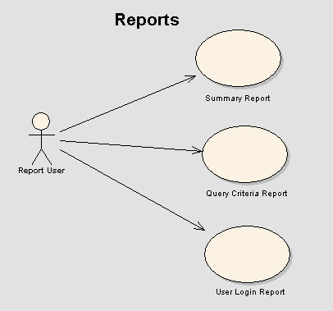

Summary Report

Brief Description
Report Users can run a report displaying general statistics about NCIA.

Primary Actor
Report User

Secondary Actors
Not Applicable

Preconditions

Precondition 1 – Access to Reporting Tool
Report User has access to external reporting tool

Precondition 2 – Report Created
The Summary Report has been created.

Basic Flow of Events
1. Report User logs into external reporting tool and chooses to view the Summary Report.
2. The following data is displayed for the Summary Report:
- Number of queries executed in the last 30 days, year to date and total (since beginning).
- Average download size during the last 30 days, year to date and total (since beginning). The page will display a note clarifying that this represents files made available for download. There is no way to keep track of the number of files that are actually downloaded by users.
- Number of logins during the last 30 days, year to date and total.

Alternate Courses
Not applicable.

Postconditions

Postcondition 1 – View Report
Report User views the report.

Special Requirements
Not Applicable

Query Criteria Report

Brief Description
Report Users can run a report displaying statistics about queries that have been run.

Primary Actor
Report User

Secondary Actors
Not Applicable

Preconditions

Precondition 1 – Access to Reporting Tool
Report User has access to external reporting tool

Precondition 2 – Report Created
The Query Criteria Report has been created.

Basic Flow of Events
  - Report User logs into external reporting tool and chooses to view the Query Criteria Report.
  - The following data is displayed for the Modality Report:
    - Last 30 Days – Number of queries executed in the last 30 days using the modality as a criterion.
    - Year to Date – Number of queries executed so far this year. using the modality as a criterion.
    - Total – Number of queries executed using the modality as a criterion.
  - The following data is displayed for the Collections Report:
    - Last 30 Days – Number of queries executed in the last 30 days using the collection as a criterion.
    - Year to Date – Number of queries executed so far this year using the collection as a criterion.
    - Total – Number of queries executed using the collection as a collection.
  - The following data is displayed for the Anatomic Site Report:
    - Last 30 Days – Number of queries executed in the last 30 days using the anatomic site as a criterion.
    - Year to Date – Number of queries executed so far this year using the anatomic site as a criterion.
- Total – Number of queries executed using the anatomic site as a criterion.

Alternate Courses
Not applicable.

Postconditions

Postcondition 1 – View Report
Report User views the report.

Special Requirements
Not Applicable

User Login Report

Brief Description
Report Users can run a report displaying logins.

Primary Actor
Report User

Secondary Actors
Not Applicable

Preconditions

Precondition 1 – Access to Reporting Tool
Report User has access to external reporting tool

Precondition 2 – Report Created
The User Login Report has been created.

Basic Flow of Events
1. Report User logs into external reporting tool and chooses to view the User Login Report.
2. A report is displayed that consists of a list of login histories. Each entry contains the IP address of the user and a timestamp (with EST time zone specified) of when they logged in. The list is sorted in descending order with the most recent login first.

Alternate Courses
Not applicable.

Postconditions

Postcondition 1 – View Report
Report User views the report.

Special Requirements
Not Applicable

Use Cases – Manage User Authorization
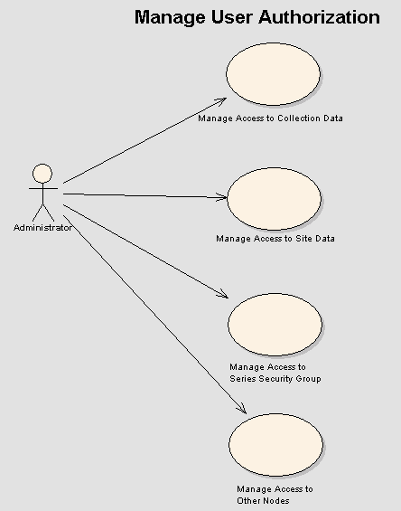

Manage Access to Collection Data

Brief Description
Administrators can manage a user’s security rights using the User Provisioning Tool (UPT). This use case describes the process for administering a user’s access to collections.

Primary Actor
Administrator

Secondary Actors
UPT Software

Preconditions

Precondition 1 – Access to UPT
Administrator has been granted access to the NCIA UPT Software.

Precondition 2 – Protection Element Created
A protection element has been created to represent the collection for which access is being managed.

Basic Flow of Events
- Administrator logs in to the UPT Software.
- Administrator navigates to the User Home Page.
- Administrator clicks Select an Existing User to find the user that is being granted access.
- Administrator grants the user the READ role for the protection element representing the collection.
- If the user also needs permission to manage curation data for the collection, the Administrator will grant the user the CURATE role for the protection element representing the collection.
- If the user also needs permission to manage the visibility status of the collection, the Administrator will grant the user the MANAGE_VISBILITY_STAUS role for the protection element representing the collection.

Alternate Courses

Alternate Course 1 – Remove Access to a Site
User needs to have access to a site removed. Administrator finds the user in UPT then removes the READ role for the collection’s protection element.

Alternate Course 2 – Make Collection Public
A decision has been made to grant all users the ability to view a collection’s data. The protection element is placed in the public group, making it accessible to all users.

Postconditions

Postcondition 1 – Security Rights Changed
User is able to access data for the collection.

Manage Access to Site Data

Brief Description
Administrators can manage a user’s security rights using the User Provisioning Tool (UPT). This use case describes the process for administering a user’s access to sites.

Primary Actor
Administrator

Secondary Actors
UPT Software

Preconditions

Precondition 1 – Access to UPT
Administrator has been granted access to the User Provisioning Tool (UPT) for NCIA.

Precondition 2 – Protection Element Created
A protection element has been created to represent the site for which access is being managed.

Basic Flow of Events
- Administrator logs in to the CSM UPT application for NCIA.
- Administrator goes to the User Home Page
- Administrator clicks Select an Existing User to find the user that is being granted access
- Administrator grants the user the READ role for the protection element representing the site.
- If the user also needs permission to view the Submission Report for the site, the Administrator will grant the user the VIEW_SUBMISSION_REPORT role for the protection element representing the site.
- If the user also needs permission to manage curation data for the site, the Administrator will grant the user the CURATE role for the protection element representing the site.
- If the user also needs permission to manage the visibility status of the site, the Administrator will grant the user the MANAGE_VISBILITY_STATUS role for the protection element representing the site.

Alternate Courses

Alternate Course 1 – Remove Access to a Site
User needs to have access to a site removed. Administrator finds the user in UPT then removes the READ role for the collection’s protection element.

Alternate Course 2 – Make Site Public
A decision has been made to grant all users the ability to view a site’s data. The protection element is placed in the public group, making it accessible to all users.

Postconditions

Postcondition 1 - Security Rights Changed
User is able to access data for the site.

Manage Access to Series Security Group

Brief Description
Administrators can manage a user’s security rights using the User Provisioning Tool (UPT). This use case describes the process for administering a user’s access to series using series security groups.

Primary Actor
Administrator

Secondary Actors
UPT Software

Preconditions

Precondition 1 – Access to UPT
Administrator has been granted access to the User Provisioning Tool (UPT) for NCIA.

Precondition 2 – Protection Element Created
A protection element has been created to represent the series security group for which access is being managed.

Basic Flow of Events
  - Administrator logs in to the CSM UPT application for NCIA.
  - Administrator goes to the User Home Page.
  - Administrator clicks Select an Existing User to find the user that is being granted access.
  - Administrator grants the user the READ role for the protection element representing the series security group.
  - If the user also needs permission to manage curation data for the series in the series security group, the Administrator will grant the user the CURATE role for the protection element representing the series security group.
  - If the user also needs permission to manage the visibility status of the series in the series security group, the Administrator will grant the user the MANAGE_VISBILITY_STATUS role for the protection element representing the series security group.

Alternate Courses

Alternate Course 1 – Remove Access to a Series Security Group
User needs to have access to a site removed. Administrator finds the user in UPT then removes the READ role for the series security group’s protection element.

Alternate Course 2 – Make Series Security Group Public
A decision has been made to grant all users the ability to view a series security group’s data. The protection element is placed in the public group, making it accessible to all users.

Postconditions

Postcondition 1 - Security Rights Changed
User is able to access data for the series security group.

Use Cases – Visualize Image
Figure 14-1 illustrates the high-level use case diagram for the visualize image functionality.
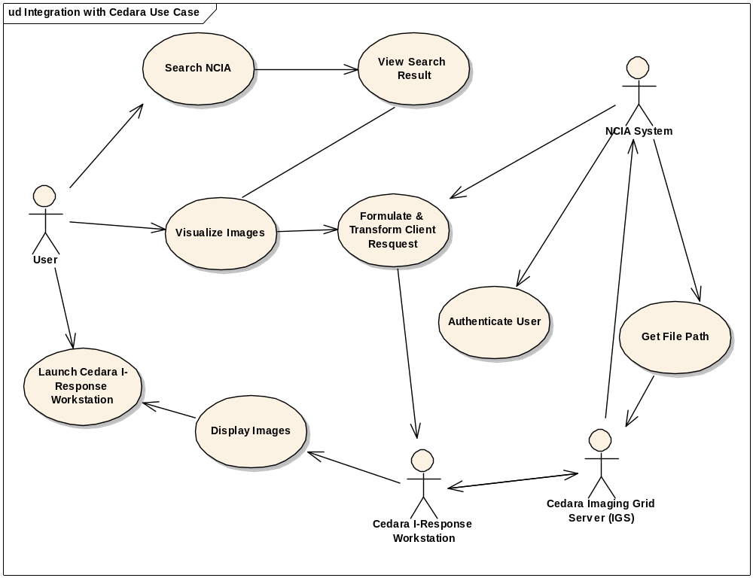
Figure 14-1 Visualize Image Use Case Diagram

14.1 Visualize Images (via Cedara I-Response workstation)

14.1.1 Brief Description
User searches for images in NCIA and selects them for viewing in Cedara I-Response workstation client.

14.1.2 Primary Actor
User

14.1.3 Secondary Actors
User

14.1.4 Preconditions

14.1.4.1 Precondition 1 – Login to NCIA
The user has logged into NCIA and has searched for images to be viewed by I-Response workstation (IRW)

14.1.4.1 Precondition 2 – Launch I-Reach Client
User has started IRW and leaves it running.

14.1.5 Basic Flow of Events
- User logs into NCIA
- User navigates to search page and submit a search
- User selects a subject/patient from search result page
- User selects one or more series by selecting checkbox on the Study result page
- User clicks the “Visualize Image” button
- The system will get the parameters regarding each selected series. (See Use case Formulate Client Request)
- The system will then build the URL to be send to IRW

14.1.6 Alternate Courses

14.1.6.1 Alternate Course 1 – IRW is not running
User has not started the IRW application. Upon clicking the “Visualize Image” button, a browser window will popup, instructing the user how to proceed.

14.1.6.1 Alternate Course 2 –Correct version of IRW is not running
User has an older version of the IRW application installed. Upon clicking the “Visualize Image” button, a browser window will popup, instructing the user to install a newer version of IRW.

14.1.7 Post Conditions

14.1.7.1 Post Condition 1 – IRW displays images
IRW gets a list of images file path from I-Reach Server and renders the images on the browser.

14.2 Formulate and Transform Client Request
14.2.1 Brief Description
The NCIA System obtains the information the user has selected and build the request for IRW application
14.2.2 Primary Actor
NCIA System
14.2.3 Preconditions

14.2.3.1 Precondition 1 – View Images using Cedara IRW

14.2.3.2 Precondition 2 – Cedara Imaging Grid Server URL is known and the IRW URL is also known.
14.2.4 Basic Flow of Events
- The system obtains user credential information, UID and username
- The system obtains a list of series UID
- The system obtains the Cedara Imaging Grid Server URL
- The system build the URL to be send to IRW with the following syntax:
host=<url>[&uid=<series-uid>]..[&usr=<username>][&sid=<userid>]
example: host=http://192.168.0.1:6509&uid=1.2.840.123333.2.3333.1&usr=foo&sid=PDtest
14.2.5 Alternate Courses

14.2.5.1 Alternate Course 1 – server URL is not available
Server URL is not available. An error message is displayed.

14.2.5.2 Alternate Course 2 – no series uid is selected
User doesn’t select any series uid. A message is returned and displayed to warn user that he/she needs to select a series.
14.2.6 Post Conditions

14.2.6.1 Post Condition 1 –
The URL is built and sent to IRW

14.3 Get File Path (Integration with Cedara Image Viewer)

14.3.1 Brief Description
The user may want to visualize the image using Cedara Image viewer after the user searched and has a list of image series. The integration of Cedara Image Viewer and NCIA software provides the image viewing functionality needed. This use case describes the process that NCIA software takes the request from Cedara Imaging Grid Server and returns a list of the DICOM file paths that Cedara Image viewer can use to render the images.

14.3.2 Primary Actor
Cedara Imaging Grid Server

14.3.3 Secondary Actors
NCIA-Cedara Integration Servlet.

14.3.4 Preconditions

14.3.4.1 Precondition 1 – Imaging Grid Server Ready to Send Request
Cedara Imaging Grid Server (IGS) is up running and has the ID of the user and the ID of the series that needs to be visualized.

14.3.4.2 Precondition 2 – Security Rights
The user has been granted “READ” privilege for the series requested to view.

14.3.5 Basic Flow of Events
- IGS send a request to NCIA-Cedara Integration Servlet.
- The Servlet parses the request to get the user ID and the series ID.
- The Servlet checks to see if the user is allowed to view the requested series.
- If the user has the permission, get all DICOM paths for specific series ID.
- Constructs the response and returns it.

14.3.6 Alternate Courses

14.3.6.1 Alternate Course 1 – A bad Request
If the request cannot be parsed or missing necessary parameters, a response indicating the error condition is returned.

14.3.6.2 Alternate Course 2 – Security Violation
If the user is not allow to view the specified series, authorization failed message will be returned.

14.3.7 Post Conditions

14.3.7.1 Post Condition 1 – DICOM Image visualized
Cedara Image Viewer renders the DICOM images.

14.3.8 Special Requirements
Not Applicable

Use Cases – Image Markup and Retrieval

Markup Storage Use Case
Figure 1-1 illustrates the high-level use case diagram for the markup storage functionality.

Use Case Model
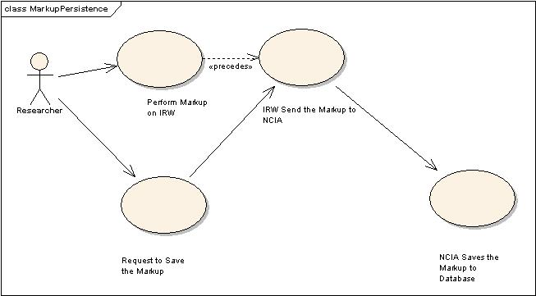
Figure 1-31 Markup Persistence

Brief Description
The user may want to perform markup on the image and save the markup for later retrieval. The integration of Cedara I-Response Workstation (IRW) and NCIA software provides the markup storage functionality needed. This use case describes the process that NCIA software takes the request from Cedara I-Response and saves the markup info on NCIA database.

Primary Actor
Researcher.

Secondary Actors
NA.

Preconditions

Precondition One – Login to NCIA
The user has logged into NCIA and has searched for images to be viewed by I-Response workstation (IRW)

Precondition Two – Launch IRW
User has started I-Response. Response client available on GForge Files tab accessible from the NCICB Download Center (DLC).

Precondition Three – View Image
User has selected (checked) one or two series and clicked the “Visualize Image” button. The Image(s) has been displayed on I-Response.

Basic Flow of Events
- User uses the tools in I-Response to draw markup on the image
- User clicks a save button on the right-hand side of I-Response.
- IRW sends the user’s markup to NCIA MarkupSaveServlet
- MarkupSaveServlet calls corresponding classes to save the user’s markup on the database.

Postconditions

Alternate Course 1 – I-Response is closed without saving the Markup
User decides not to save the markup and closes I-Response.

Alternate Course 1 – Clean the markup.
User decides to clean the I-Response screen without saving the markup he/she did. (User may load new images into I-Response, for example)

Postcondition
The markup performed by the user is saved into the database.

Special Requirements

First Special Requirement
If there are multiple users who want to perform the markup on same series, the first user has to save his/her markup before subsequent users can start to apply markup. No support for concurrent access to the same series is required by the Cancer Imaging Program (CIP). Essentially, users apply markup on a series at distinct, non-overlapping time intervals, saving the markup before exiting.
It’s acknowledged by both the NCIA team and the CIP that concurrent markup storage and retrieval by multiple users on a single series is outside the scope of the current use case.

Markup Retrieval Use Case
Figure 1-2 illustrates the high-level use case diagram for the markup retrieval functionality.

Use Case Model
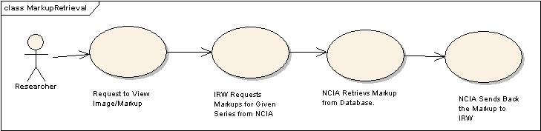
Figure 1-2 Markup Retrieval

Brief Description
The integration of Cedara I-Response and NCIA software provides the needed visualization and markup storage and retrieval mechanism. This use case describes the requirement for users to view, apply and store markup annotations from within the NCIA system.

Primary Actor
Researcher

Secondary Actors
N/A

Preconditions

Precondition One – Login to NCIA
The user has logged into NCIA and has searched for images to be viewed by I-Response workstation (IRW)

Precondition Two – Launch IRW
User has started I-Response

Precondition Three – View Image
User has selected (checked) one or two series and clicked the “Visualize Images” button. The Image(s) display on I-Response.

Basic Flow of Events
User logs into NCIA
User navigates to search page and submit a search.
User selects a subject/patient from search result page (link).
User selects (checks) one or more series on the Study result pages
User clicks the “Visualize Images” button
User observes “OK” in popup browser window.
User closes window.
Images appear in IRW.
Internally, IRW sends the request to NCIA MarkupReadServlet
MarkupReadServlet calls corresponding classes to get the user’s markup on the database and sends it to IRW

Postconditions

Alternate Course 1 – No existing markup on selected series
NCIA will perform a check for the requested series to see if there is any existing markup. If not, NCIA will inform the I-Response and I-Response will display the image without any markup.

Postcondition
Markup shows up on top of the images on the IRW.

Special Requirements

First Special Requirement
For this release, every user has the privilege to view everyone else’s markup. The decision was made to not impose security restrictions due to bugs encountered with the original milestone release of I-Response.

Overall Requirements

Requirements Prioritization

Priority  (Release) | Use Case Name | Supp Requirement Ref #
1.0 | Receive DICOM File
1.2 | Receive Annotation File
1.0 | Parse and Store DICOM File
1.0 | Convert DICOM Image to Thumbnail
2.0 | Verify that Submitted Files Were Received
2.0 | Manage QA Status
2.0 | Change Quality Assurance Status of Images
2.0 | Change Quality Assurance Status of Series
2.0 | Change Quality Assurance Status of Studies
2.0 | Change Quality Assurance Status of Patients
2.0 | View DICOM Header in Quality Assurance Tool
2.0 | View Full Size JPEG in Quality Assurance Tool
2.0 | View Quality Assurance History for an Image
2.0 | Curator Enters Data about Images and Annotation Files
2.0 | Upload Curation Spreadsheet
2.0 | Process Curation Spreadsheet
1.0 | Register
1.0 | Login
2.2 | Select Nodes to Search
1.0 | Perform Simple/Advanced Search
2.0 | Perform Search Based on Curation Data
2.0 | Perform Search Based on Link from Other Application
1.2 | Filter Collection List on Search Page Based on CSM Authorization
1.2 | Filter Data in Results Based on CSM Authorization
1.0 | Display Search Results
1.0 | Add to Data Basket
1.0 | Manage Data Basket
1.0 | Compress Images
1.0 | Download Selection using FTP
1.0 | Download Selection using HTTP
1.2 | Save Query
1.2 | Manage Saved Queries
1.2 | View New Data for Saved Query
1.2 | Resubmit Saved Query
1.2 | Edit Saved Query
1.2 | Delete Saved Query
1.2 | Mark Saved Query as Having New Data Available
1.2 | Resubmit Query from History
1.2 | Summary Report
1.2 | Query Criteria Report
1.2 | User Login Report
1.2 | Manage Access to Collection Data
1.2 | Manage Access to Site Data
1.2 | Manage Access to Series Security Group
The table below identifies the requirements for the NCIA 2.3 effort.

Req # | Requirement | Use Case Name |  | Release #
1.0 | MIRC Image Submission
1.1 | The NCIA supported DICOM fields (92 CDEs) will be validated against the NCIA DICOM object model and database schema |  | N/A | 2.3
1.1.1 | A spreadsheet containing the mapping of the DICOM standard (2007) to the NCIA object model and database schema shall be provided |  | N/A | 2.3
1.2 | A Standard Operating Procedure (SOP) shall be established for validating the NCIA MIRC installation |  | N/A | 2.3
1.3 | An automated test case suite shall be implemented to verify that the images submitted have been correctly persisted in the database and file system |  | N/A | 2.3
1.3.1 | The automated test case shall generate a spreadsheet containing the NCIA supported DICOM fields from the original DICOM file prior to image submission, the database record for these fields after image submission, and the anonymized DICOM file persisted in the file system |  | N/A | 2.3
1.4 | A Reference image set shall be identified to verify image submission, retrieval, and download |  | N/A | 2.3
1.4.1 | The reference image set shall include a representative set of image series from each modality (CT, MRI, etc.) and each collection (RIDER) and project site (MD Anderson) |  | N/A | 2.3+
1.4.2 | Test cases shall be updated to leverage the reference image set for test case verification |  | N/A | 2.3
1.5 | Continued support for image submission shall be provided |  | N/A | 2.3+
2.0 | Curation Data Download
2.1 | The system shall allow a user to download previously submitted curation data associated with a patient, study, series, image or annotation image element |  | Download Curation Data | 2.3
2.2 | The curation data shall be available to users in XML format |  | Download Curation Data | 2.3
2.3 | The curation data shall be included in the download zip file for any image or image series that contains curation data |  | Download Curation Data | 2.3
3.0 | Image Visualization
3.1 | The system shall allow a user to visualize an image or image series in the selected third party visualization tool (Cedara) |  | Visualize Images | 2.3
3.2 | The system shall allow the third party visualization server to access images |  | Get File Path | 2.3
3.2.1 | The system shall process an incoming request which includes a username, user id, and images series ID and return an image file path |  | Get File Path

Data Definitions
The NCIA object model is based on the DICOM standard. The following section provides definitions for key classes in the NCIA object model:

Patient
Defines the characteristics of a patient who is the subject of one or more medical studies that produce medical images.

Study
Defines the characteristics of a medical study performed on a patient. A study is a collection of one or more series of medical images, presentation states, and/or SR documents that are logically related for the purpose of diagnosing a patient. Each study is associated with exactly one patient. A study may include composite instances that are created by a single modality, multiple modalities or by multiple devices of the same modality.

Series
A set of images. Typically, a series is made up of all of the slice generated from a scan. Each series is associated with exactly one Study.

Image
An in vivo image of a human being. In cases where imaging modalities produce multiple slices (e.g. CT or MR scans), this represents one slice.

