

NCIA Continuous Integration and System Availability Test Plan
(non-image submission specific components and devices)

Release 3.0

July 3, 2007

Table of Contents
i. Sign Off Sheet iii
ii. Document Overview iv
1. Purpose of this Document 1
2. Technical Overview 2
I. The Use of Web Based UI Test Scripts 2
II. The JUnit API 2
III. Automated Build and Testing, CruiseControl 2
IV. Manual Testing 3
3. NCIA Defined Hardware and Devices 4
I. Production Tier Specific Hardware 5
II. Development Tier Specific Hardware 7
III. Quality Assurance (QA) Tier Specific Hardware 9
IV. Staging Tier Specific Tier Hardware 11
V. NCIA All-Tiers Shared Hardware 13
VI. Other External Hardware 14
4. The NCIA 3.0 Architecture 15
5. NCIA Defined System Components 16
6. Technical Details: Externally and Commercially Developed NCIA System Components/Execution/Servers Environments 20
I. Servers 20
7. Testing Overview 21
I. caCORE Interfaces 25
II. Cedara Interfaces 26
III. caGrid Interfaces 26
IV. caCORE CSM Interfaces 27
V. Hardware Interfaces 27
8. Testing Details Automated Availability Tests 30
I. ApacheLoginTestCase.java 30
II. ReferencedImagesTestCase.java 30
III. CedaraIGSVisualizationTestCase.java 31
IV. VSFTPDFileDownloadTestCase.java 31
V. CurationDataUploadMDBTestCase.java 31
VI. COREGridServicesTestCase.java 31
VII. COREGridServiceGridFTPTestCase.java 32
VIII. NCIAIncomingGridServicesTestCase.java 32
IX. NCIAOutgoingGridServicesTestCase.java 32
9. Testing Details: Non-Automated Availability Tests 33
I. Cedera Visualization Java Script Test 33
10. Testing Details: Components and Interfaces Tested By 34

Sign Off Sheet

ACCEPTANCE: Signature indicates that you accept the NCIA Systems Test Plan.

_________________________________________________________ DATE: __/___/___
John Freymann, Title, Organization

_________________________________________________________ DATE: ___/___/___
Anand Basu, Director, Applications

_________________________________________________________ DATE: ___/___/___
David Palmer, Company, Title, Organization

_________________________________________________________ DATE: ___/___/___
Carl Blake, SAIC, Contractor, Project Manager, NCIA

_________________________________________________________ DATE: ___/___/___
Scott McCrimmon, SAIC, Contractor, Team Lead, NCIA

Document Overview

Change Record

Date | Author(s) | Document  Version | Change Reference  (Major Changes)
7/04/2007 | David C Bauer | 1.0

Reviewers

Name | Position | Document Version | Date Reviewed

Purpose of this Document
The purpose of this document is to provide a detailed description of a mechanism for determining the National Cancer Imaging Archive release 3.0 (NCIA 3.0) systems availability while in production. In addition, this system test plan will provide a description of the NCIA 3.0 Continuous Integration activities, architecture and processes at complete system development. This document will also provide information regarding the gaps that exist in our current test suite as well as an estimated effort to fill that gap.

It is important to note that system availability testing will not be considered the same as production release testing, and thus may not be as thorough or complete as is required for full system functional testing, such as that performed at every release. However, because we are leveraging Cruise Control for continuous integration, there is nothing to say that our system availability tests can not overlap our functional testing and vice versa.

Technical Overview
The NCIA 3.0 system contains 30 identified potential failure points related to system component interoperability that is not associated with image submission functionality.

These potential failure points consist of interdependencies in the form of API usage, FTP requests, Symbolic Links, HTTP/HTTPS communication, and various software and hardware configuration requirements, to name a few. The varying ways of bringing NCIA components together requires different and creative approaches to testing to ensure complete system availability.

The Use of Web Based UI Test Scripts
For UI tests that are web based, we utilize the testing API Selenium. Briefly, Selenium allows us to create scripted browser tests in various forms (HTTP, JavaScript, C#, Java) for both Explorer and Firefox that can be run through any number of automated processes. These scripts simulate the activities of a user as they move through the application and allow us to verify underlying functionality within not just the dynamic pages, but also the supporting classes and infrastructure that those pages rely on. These sorts of tests can be very useful in determining large areas of sub-component interoperability and thus are leveraged heavily by our testing plan.

The JUnit API
Often times it is not possible or practical to rely on a web based user interface to test certain parts of a system. In fact, in much of our application there is no UI with which to interact to create these Selenium scripts, and as such we require a more programmatic approach. To handle this sort of situation, we utilize JUnit. JUnit is a testing API that allows us to write detailed tests in Java that can be run against nearly any type of API or other type of exposed. It is important to note that JUnit tests are also easily automated for continuous testing.

Automated Build and Testing, CruiseControl
To facilitate our need for constant automated testing we require a job scheduler that can not only run chronological jobs, but also perform complex tasks like checking out the code base and initiate any new tests as they are checked in. For this we have utilized CruiseControl, an open source application that runs as a server and is configurable to allow the reuse of our currently existing ant build scripts.

Manual Testing
There are elements of NCIA functionality that do not map well to automated testing. For instance, the NCIA Cedara Integration Java Script, Component 1.1.3 C, is something that can only be executed on a clients machine for verification. It is not possible to automate such a test from CruiseControl, and thus must be performed by hand by an interested person. In instances like this a formal test script written in text, with an accompanying Use Case will be written and provided to our Quality Assurance support team to be executed on a scheduled basis. When the test is run, a report stating information such as when the test was run and the results of the test will be sent to the NCIA System Architect, the NCIA Technical Lead and the NCIA Project Manager for auditing and verification that the system is running as expected.

NCIA Defined Hardware and Devices
Figure 1 - Current NCIA Hardware Architecture illustrates the current hardware that is locally hosted and maintained at the NCI. It provides a brief explanation of the production and staging tiers. The Development and Quality Assurance tiers are similar in nearly every regard, except that they are not exposed through the NIHNet firewall. Details and specifics regarding each hardware tier are provided in the subsections below. The figure is provided here only as a reference for the reader and definitions of each hardware element does not necessarily map to the NCIA architecture documents. However mapping between the two should be trivial. If not then, by all means, please let the author know and he will update this diagram.

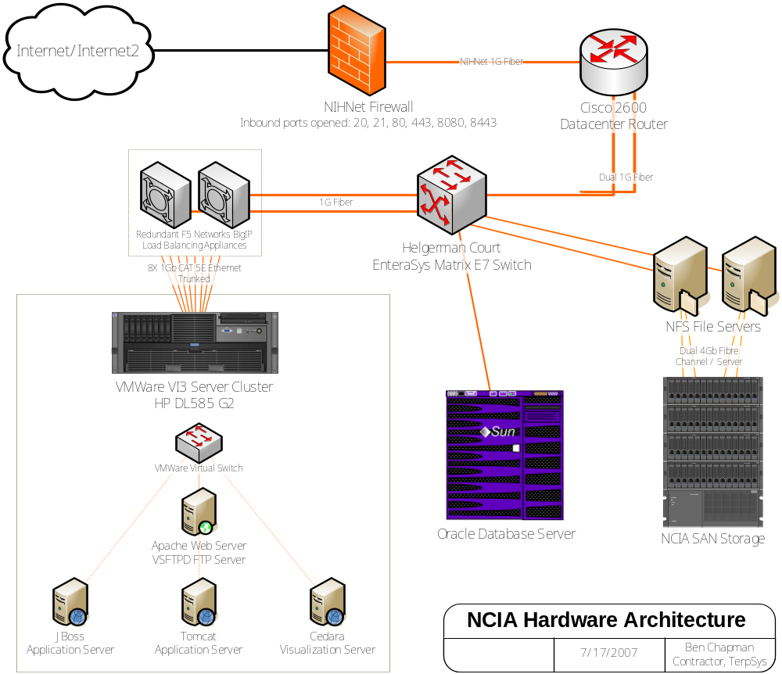
Figure 1 - Current NCIA Hardware Architecture

Production Tier Specific Hardware
The following section provides detailed information regarding each device that is required for complete availability of the NCIA system. It is very similar to what is found in each of the other three tiers except in regards to the logical names and physical hardware.

JBoss\Globus Server
This machine currently hosts both our JBoss J2EE container and our Globus “grid” container. It is the primary machine of our system in that it is responsible for handling all incoming requests to NCIA application and caGrid requests and responses.

Device Details
OS | Linux, RedHat Enterprise 32-bit | 4
Server | JBoss | 4.0.4
Server | Globus | 4.0.3
DNS | nciavjbossprod5001.nci.nih.gov
Memory Available | 2 GB
Processor(s) | AMD 64-bit Opteron (VM 32-bit)
Ports of Interest | 59080 | JBoss HTTP
 | 51099 | JBoss Message Queue
 | 8080 | Globus HTTP
 | 8443 | Globus HTTPS

Apache\VSFTP Server
The device that contains our Apache web server also hosts our FTP server. It handles all incoming HTTP/HTTPS/FTP requests for the NCIA web application. The Apache server forwards on any incoming HTTP/HTTPS requests (configured via mod_proxy) to the JBoss\Globus Server which performs all the rendering of JSPs for dynamic content as well as serves out all of the NCIA static web content.

Device Details
OS | Linux, RedHat Enterprise 32-bit | 4
Server | Apache Web Server | 2.2.3
Server | VSFTPD FTP Server | 2.0.1
DNS (Apache) | nciavapacheprod5001.nci.nih.gov
Memory Available | 2 GB
Processor(s) | AMD 64-bit Opteron (VM 32-bit)
Ports of Interest | 20 | VSFTPD Control
 | 21 | VSFTPD Transfer
 | 80 | Apache HTTP
 | 443 | Apache HTTPS

Cedara IGS Server
The NCIA system currently depends on the Cedara IGS server for serving out our images for visualization through the Cedara IRW. This machine receives any incoming request via HTTP from a client workstation running the Cedara IRW and then uses that information to access images from the NCIA file store

Device Details
OS | MS Windows | Server 2003 64-bit
Server | Cedara IGS | (Version)
DNS (Apache) | hc-nciacedara-2.nci.nih.gov | Shared with Stage
IP | 137.187.67.7
Memory Available | 2 GB
Processor(s) | AMD Opteron 64-bit
Ports of Interest | 8080 | HTTP

Oracle RDBMS Server
The machines that hold the NCIA data other than binary files are running an Oracle RDBMS. They are discrete for every tier and are not virtual machines.

Device Details
OS | Solaris 8
Server | Oracle RDBMS | 10g
Database | CAPROD
DNS (Apache) | cbiodb10.nci.nih.gov
Memory Available | 2 GB
Processor(s) | Sun V1280
Ports of Interest | 1521 | JDBC Connection Port

Development Tier Specific Hardware
The Development tier is similar to other tiers except that it is not exposed to the internet through the firewall.

JBoss\Globus Server
See Production Tier Specific Hardware for a textual description of this hardware.

Device Details
OS | Linux, RedHat Enterprise 32-bit | 4
Server | JBoss | 4.0.4
Server | Globus | 4.0.3
DNS | nciavjbossdev5001.nci.nih.gov
Memory Available | 2 GB
Processor(s) | AMD 64-bit Opteron (VM 32-bit)
Ports of Interest | 59080 | JBoss HTTP
 | 51099 | JBoss Message Queue
 | 8080 | Globus HTTP
 | 8443 | Globus HTTPS

Apache\VSFTP Server
See Production Tier Specific Hardware for a textual description of this hardware.

Device Details
OS | Linux, RedHat Enterprise 32-bit | 4
Server | Apache Web Server | 2.2.3
Server | VSFTPD FTP Server | 2.0.1
DNS (Apache) | nciavapachedev5001.nci.nih.gov
Memory Available | 2 GB
Processor(s) | AMD 64-bit Opteron (VM 32-bit)
Ports of Interest | 20 | VSFTPD Control
 | 21 | VSFTPD Transfer
 | 80 | Apache HTTP
 | 443 | Apache HTTPS

Cedara IGS Server
See Production Tier Specific Hardware for a textual description of this hardware.

Device Details
OS | MS Windows | Server 2003 64-bit
Server | Cedara IGS | (Version)
DNS | hc-nciacedara-1.nci.nih.gov
Memory Available | 2 GB
Processor(s) | AMD 64-bit Opteron (VM 32-bit)
Ports of Interest | 8080 | HTTP

Oracle RDBMS Server
See Production Tier Specific Hardware for a textual description of this hardware.

Device Details
OS | Solaris 8
Server | Oracle RDBMS | 10g
Database | CADEV
DNS (Apache) | cbiodb2-d.nci.nih.gov
Memory Available | 2 GB
Processor(s) | Sun v1280
Ports of Interest | 1521

Quality Assurance (QA) Tier Specific Hardware

JBoss\Globus Server
See Production Tier Specific Hardware for a textual description of this hardware.

Device Details
OS | Linux, RedHat Enterprise 32-bit | 4
Server | JBoss | 4.0.4
Server | Globus | 4.0.3
DNS | nciavjbossqa5001.nci.nih.gov
Memory Available | 2 GB
Processor(s) | AMD 64-bit Opteron (VM 32-bit)
Ports of Interest | 59080 | JBoss HTTP
 | 59099
 | 8080 | Globus HTTP
 | 8443 | Globus HTTPS

Apache\VSFTP Server
See Production Tier Specific Hardware for a textual description of this hardware.

Device Details
OS | Linux , RedHat Enterprise 32-bit | 4
Server | Apache Web Server | 2.2.3
Server | VSFTPD FTP Server | 2.0.1
DNS (Apache) | nciavapacheqa5001.nci.nih.gov
Memory Available | 512 MB
Processor(s) | AMD 64-bit Opteron (VM 32-bit)
Ports of Interest | 20 | VSFTPD Control
 | 21 | VSFTPD Transfer
 | 80 | Apache HTTP
 | 443 | Apache HTTPS

Cedara IGS Server
This Server is shared with the Development Tier. See Production Tier Specific Hardware for a textual description of this hardware.

Device Details
OS | MS Windows | Server 2003 64-bit
Server | Cedara IGS | (Version)
DNS (Apache) | hd-nciacedara-1.nci.nih.gov | Shared with Development
Memory Available | 2 GB
Processor(s) | AMD 64-bit Opteron
Ports of Interest | 8080 | HTTP

Oracle RDBMS Server
See Production Tier Specific Hardware for a textual description of this hardware.

Device Details
OS | Solaris 8
Server | Oracle RDBMS | 10g
Database | CAQA
DNS (Apache) | cbiodb30.nci.nih.gov
Memory Available | 2 GB
Processor(s) | Sun v1280
Ports of Interest | 1521

Staging Tier Specific Tier Hardware

JBoss\Globus Server
See Production Tier Specific Hardware for a textual description of this hardware.

Device Details
OS | Linux , RedHat Enterprise 32-bit | 4
Server | JBoss | 4.0.4
Server | Globus | 4.0.3
DNS | nciavjbossstage5001.nci.nih.gov
Memory Available | 2 GB
Processor(s) | AMD 64-bit Opteron 280 (VM 32-bit)
Ports of Interest | 59080 | JBoss HTTP
 | 51099 | JBoss Message Queue
 | 8080 | Globus HTTP
 | 8443 | Globus HTTPS

Apache\VSFTP Server
See Production Tier Specific Hardware for a textual description of this hardware.

Device Details:
Device Details
OS | Linux , RedHat Enterprise 32-bit | 4
Server | Apache Web Server | 2.2.3
Server | VSFTPD FTP Server | 2.0.1
DNS (host) | nciavapachestage5001.nci.nih.gov
C Name | imaging.nci.nih.gov
Memory Available | 512 MB
Processor(s) | AMD 64-bit Opteron 280 (VM 32-bit)
Ports of Interest | 20 | VSFTPD Control
 | 21 | VSFTPD Transfer
 | 80 | Apache HTTP
 | 443 | Apache HTTPS

Cedara IGS Server
This Server is shared with the Development Tier. See Production Tier Specific Hardware for a textual description of this hardware.

Device Details:
Device Details
OS | MS Windows | Server 2003 64-bit
Server | Cedara IGS | (Version)
DNS | hc-nciacedara-2.nci.nih.gov | Shared with Production
Memory Available | 2 GB
Processor(s) | AMD 64-bit Opteron 280
Ports of Interest | 8080

Oracle RDBMS Server
See Production Tier Specific Hardware for a textual description of this hardware.

Device Details
OS | Solaris 8
Server | Oracle RDBMS | 10g
Database | CASTG
DNS (Apache) | cbiodb20.nci.nih.gov
Memory Available | 2 GB
Processor(s) | Sun V1280
Ports of Interest | 1521

NCIA All-Tiers Shared Hardware

NFS Files Servers
The NCIA archived files are stored in and accessed through a Network File System (NFS) which serve out the files stored in the NCIA Storage Area Network (SAN) Storage.

Device Details
OS | Linux | RedHat version4
Server | NFSD (Linux) | Linux OS Module
Processor(s) | Intel Xeon

Continuous Integration Server (CruiseControl)
To implement a policy of continuous integration (insert footnote here) the NCIA development team maintains hardware specific for checking out and performing periodic builds of the NCIA system software that is maintained in CVS. This machine has a CruiseControl server installed that handles the automation of the continuous integration build and tests. In addition, and in the interest of simplification, it also hosts a full and version matching JBoss J2EE container that will hold and run the NCIA application that is to be built and tested.

Device Details
OS | MS Windows | XP
Server | JBoss | 4.0.4
Server | CruiseControl | (Version)
Server | F-Secure
IP | 137.187.182.222
DNS | cbiovwdev5002.nci.nih.gov
Memory Available | 2 GB, 40GB HDD
Processor(s) | VM Ware
Ports of Interest | 5180 | SeleniumRC Jetty HTTP
 | 59080 | JBoss HTTP

Other External Hardware
There are several hardware elements that, though not under the auspices of the NCI are still of interest to the NCIA system as a whole. These pieces of hardware are those that will be utilized by external NCI nodes as well as the machines that are being utilized by the NCIA web user.

The Client Workstation
This represents nearly any sort of personal PC that is available today. For complete functionality and use of the NCIA system however, there are certain requirements. These requirements include the installation of the correct version of Cedara IRW for image visualization, an NCIA compliant web browser with JavaScript enabled, and internet access with correct port/socket configurations to allow communication between the NCIA web application (via JavaScript) and the Cedara IRW visualization software. In addition, the clients Cedara IRW must be able to send outgoing requests to the NCIA Cedara IGS server to receive the images that the user would like to view and markup.

Device Details
OS | Any
Software (alternative) | Internet Browser: Mozilla Firefox | (version)
Software (alternative) | Internet Browser: Microsoft Internet Explorer | (version)
Software | Cedara IRW | (version)
Memory Available | X GB | (are there requirements here)
Ports of Interest | 8081 | Cedara IRW Communication Port (Fixed)

The NCIA 3.0 Architecture
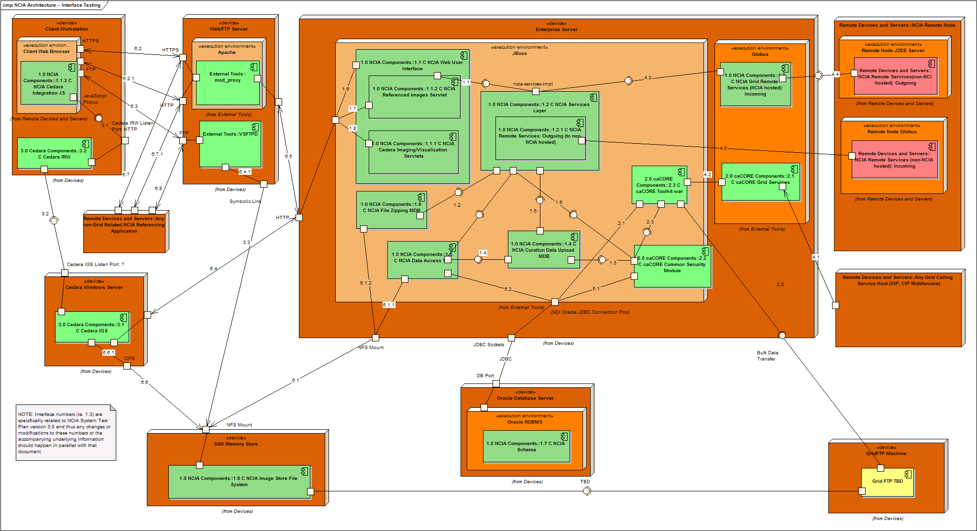
Figure 2 NCIA Architecture (non-image submission components) as of 7-17-07

The complexity of the NCIA non-image submission related software and hardware can not be over emphasized. Currently the NCIA is comprised of 19 components that are brought together with over 30 defined interfaces between them. There are also currently 8 different hardware devices that are of interest for any single deployment tier.

NCIA Defined System Components
This section describes the various logical and physical components that comprise the NCIA system as of release 3.0. It also mentions components that are not directly part of the NCIA team’s development efforts, but that are dependencies the NCIA system currently has for complete system operability. Again, it is important to note that this does not include any functionality that is specifically related to image submission. That is covered under another document (that probably should be mentioned now).

Important Note: The numbering and naming of these components is tied to the current architectural drawing which was developed in Enterprise Architect and rests within the NCIA EA design and drawing package. The numbering of these subcomponents should not be modified in this document without coordinating any numbering or naming changes with the architectural document.

- NCIA Internal Components
These are the internal components that the NCIA development team designs, develops and controls. It does not contain third party or internal NCI APIs, as these are captured under other component designations.

  - NCIA Web User Interface
This is the software and supporting APIs that comprise the web exposed front end of the NCIA system. It includes a HMI based interface as well as several servlets to support the integration with third party tools such as the Cedara image visualization software (components 3.0 C).

    - NCIA Imaging/Visualization Servlets
These are servlets specifically written to accommodate Cedara related functionality related to accessing and processing images that are served out by the NCIA. In addition it also includes servlets that are in place to accommodate image markup information that is being passed from the Cedara IRW running on a client’s individual machine.

    - NCIA Referenced Images Servlet
These are the servlets that are in place to allow outside applications to programmatically access collections that they may have submitted or that are pertinent to them.

    - NCIA Cedara Integration JavaScript/JSPs
These are the JavaScript or JSPs that are specifically in place to accommodate the integration with Cedara. They represent the launching point for getting to the a parallel running Cedara IRW from within the NCIA Web User Interface.

  - NCIA Service Layer
This component contains the interfaces and implementations as well as supporting APIs that encapsulate the handling of business logic within the NCIA application. It does not provide control over the image file or data store. However it acts as the access point for all NCIA related services calls, incoming and outgoing, for the system as a whole.

    - NCIA Outgoing Remote Services
This is the portion of the system that handles the outbound grid related calls to other, remote NCIA systems.

  - NCIA Remote Service Layer
This represents the software, APIs and configuration information that is used to implement and expose caGrid services that are leveraged by other remote NCIA nodes.

  - NCIA Curation Data Upload MDB
This J2EE MDB is responsible for handling the submittal curation data by a user for a particular entity within the NCIA system.

  - NCIA Data Access Tier
The data access tier acts as the portal for access of the NCIA Service Layer (1.2 C) to the underlying data that is stored in the supporting NCIA data schema (1.7 C). It contains the Hibernate mappings, objects and other related classes that provide the Object Relational Mapping for the NCIA system. It also provides the classes that allow access to the images that are stored in the Image File Store.

  - NCIA File Zipping MDB
When images are requested for download this is the component that performs the asynchronous gathering and compilation of those images and makes them available for the system/user who requested them.

  - NCIA Database Schema and Data
This represents the schema of the NCIA data that is located inside the database implementation for that tier.

  - NCIA Image Store File System
This is the file system that contains the images and other files that have been submitted for archival.

- caCORE Components
These are the components of the system that are largely comprised of existing caCORE related APIs. Represented in this grouping of components are those that are primarily developed inside the NCICB and that are related to the caCORE suite of applications.

  - caCORE Grid Services
This module represents the caGrid services that are created through the caCORE SDK and are exposed for users who will be leveraging the CQL query capabilities that are enabled. It is a grid service that is leveraged strictly by external applications who wish to access the underlying NCIA data that is strictly defined per the NCIA caBIG Silver Compliant DICOM object model.

  - caCORE Common Security Module (CSM)
This component is an configurable API that provides a User Provisioning Tool (UPT) web interface. The UPT utilizes security related user tables that are located in the NCIA database to create and delete users as well as control various access permissions that are utilized by the NCIA system.

  - caCORE Toolkit war
The caCORE toolkit war is responsible for receiving and responding to requests that are coming from the caCORE Grid services component. It accesses the NCIA database directly and provides the necessary glue to tie the caCORE Grid Service to the underlying NCIA data. It is generated, configured and the underlying code is modified by the NCIA development team. It is deployed, developed and tested in conjunction with NCIA releases.

- Cedara Components
Cedara components represent those elements of the system that are developed and made available by the Cedara Software Company.
These he potential failure points that lay within the JBoss Server
and are related specifically to the NCIA code that will sit within the JBoss
container.

  - Cedara IGS
The Cedara IGS is a server that interacts with the NCIA images and database to return selected images requested from an authorized Cedara IRW workstation. It also interacts with the NCIA Web User Interface through servlets that are in place to authenticate the Cedara IGS request as well as provide specific file location information. It can also post image markup information to the NCIA Database through a similar servlet implementation that pushes the information to the NCIA Database.

  - Cedara IRW
The Cedara IRW is a stand alone application that is used to visualize DICOM images. The NCIA Web User Interface interacts with this application when it is running on the users workstation through very specific JavaScript that runs in the users browser and looks for the application running on an HTTP socket, and then enables the user to pass user selected image information from the NCIA Web User Application to the Cedara IRW which then utilizes the connection the Cedara IGS to retrieve and view those images.

Technical Details: Externally and Commercially Developed NCIA System Components/Execution/Servers Environments
These are system elements that are developed outside the NCIA team and are also not commissioned or under the purview of the NCI or the CIP. However the proper installation, configuration and interoperability of these components is required for complete system availability of the NCIA.

Servers

Apache
The open source Apache server stands in front of our application server and handles incoming HTTP/HTTPS requests coming from outside the system. It is a pretty standard part of most any web exposed system and more information is available at the Apache site: http://httpd.apache.org/.

JBoss J2EE Container
JBoss is our application server which acts as the container for all of our NCIA J2EE components. It provides a Java environment for things like our Message Driven Beans, our NCIA Web User Interface, as well as any other NCIA associated web applications that make up the NCIA System.

VSFTPD
The VSFTPD our FTP server that serves out user selected images and files. It is an open source implementation that runs within Linux.

Globus
Globus is another container that implements and utilizes specific libraries and APIs that allow the NCIA application to expose grid enabled services for caGrid enabled systems. Our caCORE grid services, as well as our NCIA specific grid services utilize this container to facilitate grid communication/transmissions while Spring Remoting back into the JBoss container for actual business logic handling and NCIA data and file access.

Testing Overview
Below are the identified and defined interfaces that exist in the NCIA system as it relates to complete NCIA system availability. The interfaces are numbered and defined as related to each defined major system component within the entire NCIA system. As such the numbered designations are not arbitrary and are tied intimately with the NCIA EA design and drawing package. Any modifications to these definitions should be cross referenced with that package to ensure the veracity of both documents.

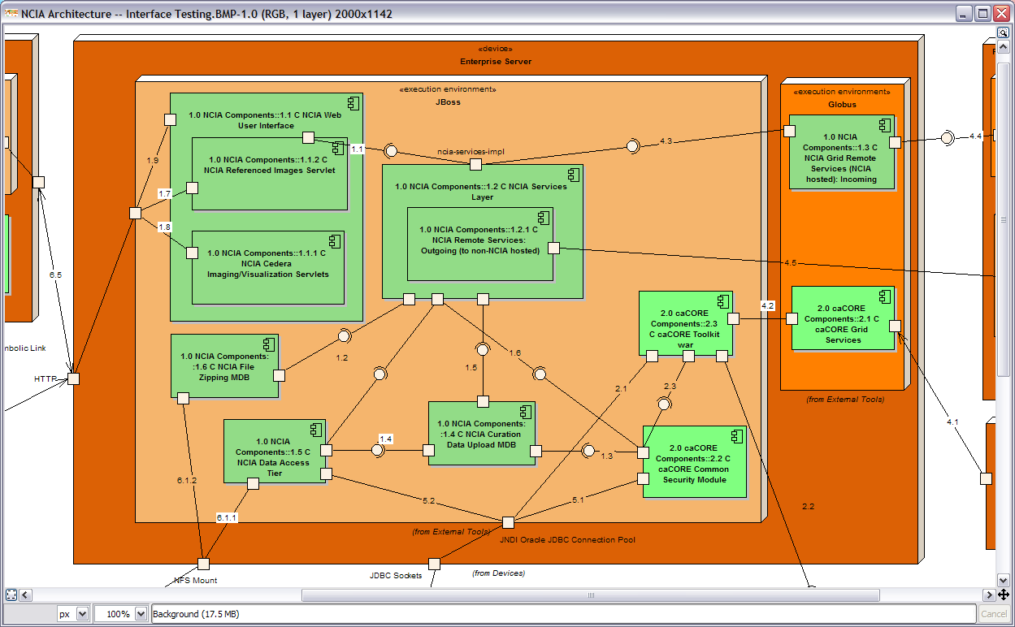
Figure 3 - NCIA Components and Interfaces (Partial)

It is also important to point out that these tests are run within the NIHnet firewall, and thus can not test access any device, server or service that should be exposed to the internet. In the past there has been an issue with this given that we have so many different devices and ports that need to be accessible through the firewall for complete system availability. This is to say, that although the system appears to pass all availability tests, it is not necessarily assured that the application is exposed externally. At the time of this writing, alternatives were being discussed to fix this issue, but until this is resolved full external access to the NCIA requires an external test that has not yet been determined or formalized.
NCIA Interfaces
These are the interfaces that are specifically related to the NCIA code base that is specifically designed, developed, tested and managed by the NCIA development team. Figure 3 - NCIA Components and Interfaces (Partial) shows the NCIA components that will be running within the JBoss J2EE container, but does not include the components that lie outside that container.

  - NCIA Web Interface to the NCIA Service Layer
This is the connection that lies between the servlets, JSPs, and their supporting APIs and the actual code that performs the business process of the NCIA system. It is defined for the NCIA Web Interface through a set of interfaces that are in turn dynamically associated through the use of the Spring Framework and the dependency injection design pattern with implementing classes that lay in the NCIA Service Layer code base.

  - NCIA Services Layer to the NCIA Zipping Message Driven Bean (MDB)
When a user selects a set of files that they would like for later use, the request comes to the service layer which then passes the file information to the Zipping Message Driven Bean to asynchronously create the download file. This represents that communication.

<Should I provide technical details regarding how the communication happens for an MDB? Probably.>

  - NCIA Curation Data Upload MDB to the Common Security Module (CSM)
If a user would like to upload to the NCIA system a particular key/value set that is associated with some element in the NCIA data system (currently patients, studies, series or images) the Curation Data Upload MDB must use the security information that is available through the CSM, and which is stored in the NCIA database, to determine if the user is authorized to perform this action. This link represents those calls from the MDB to the CSM.

<Should I provide technical details regarding how the communication happens for an MDB? Probably.>

  - NCIA Curation Data Upload MDB to the NCIA Data Access Tier
<How does the Curation Data Upload MDB access the DB?>

  - NCIA Services Layer to the NCIA Curation Data Upload Message Driven Bean
If a user would like to upload to the NCIA system a particular key/value set that is associated with some element in the NCIA data system (currently patients, studies, series or images) the Curation Data Upload MDB asynchronously performs this action when requested to do so by the NCIA Services Layer. This link represents that call from the NCIA Services Layer.

  - NCIA Services Layer to the Common Security Module (CSM)
When accessing the NCIA System whether programmatically or through one of the user interfaces, the user must be authenticated and authorized. The CSM is the mechanism that facilitates that process. This access to the CSM is actually programmatic API calls that are run from within the same JVM as the NCIA Services Layer is running in. This link represents those programmatic calls.

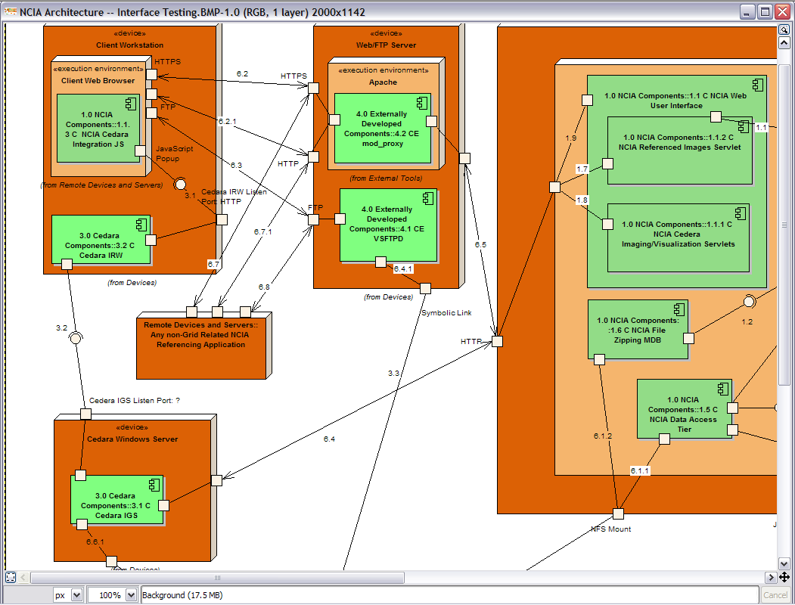
Figure 4 - NCIA Interfaces: Cedara, Non-Grid Remote Services, etc

  - NCIA Referenced Images Servlet via HTTP
When an external system, such as I-Spy, wishes to access images that are stored in the NCIA, they can utilize the NCIA Referenced Images Servlet provided they have correct credentials. This link represents that call coming in via an HTTP request.

  - NCIA Cedara Imaging/Visualization Servlets via HTTP
The NCIA System interacts with the Cedara components via two mechanisms. The first is JavaScript that is transferred to the client machine running the Cedara IRW and that is simultaneously accessing the NCIA Web User Interface. The other is through direct requests coming from the Cedara IGS that are directed to servlets that are running in the NCIA Web User Interface. This represents the calls coming to those servlets.

  - NCIA Web User Interface via HTTP
The dominant point of interaction with the NCIA System is through the NCIA Web User Interface, and as such it is the most extensive and complex component of the system. This link represents any incoming HTTP request that is received by the NCIA Web User Interface and then handled by either the User Interface implemented through JSPs or the NCIA servlet APIs represented above.

  - NCIA Service Layer to the NCIA Data Access Tier
This is the connection that provides the NCIA data to the NCIA services. It is a critical interface in that if this is not configured correctly, then the system is entirely able to operate. It can not access user information nor the data or files that are stored in the NCIA Database.

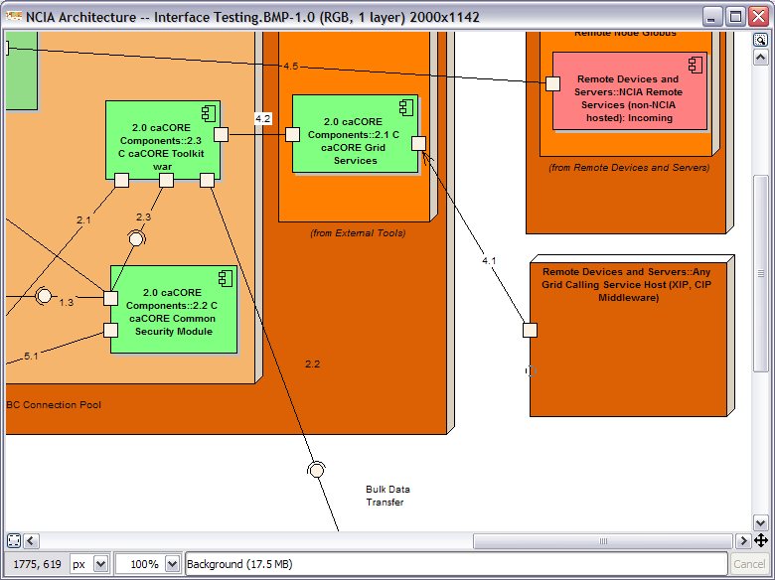
Figure 5 - caCORE Components and Interfaces

caCORE Interfaces
  - caCore Toolkit war to the JBoss JNDI JDBC Connection Pool
To access the NCIA System Data the caCORE toolkit war utilizes a hibernate mapping that requires access to a JNDI data source that is registered within JBoss. This interface represents the ability of the caCORE Toolkit war to acquire and utilize that datasource.

  - caCore Toolkit war to the GridFTP Machine (Bulk Data Transfer)
This has yet to be designed and defined.

  - caCore Toolkit war to the Common Security Model
As of this writing, the caCORE Toolkit war will only access public data within the NCIA database system. So this connection has yet to be defined or utilized.

Cedara Interfaces
These are the interfaces that make up the visualization and markup functionality of the NCIA. It is comprised of JavaScript, Servlets, and Cedara commercial non-open source code that is developed outside the NCI.

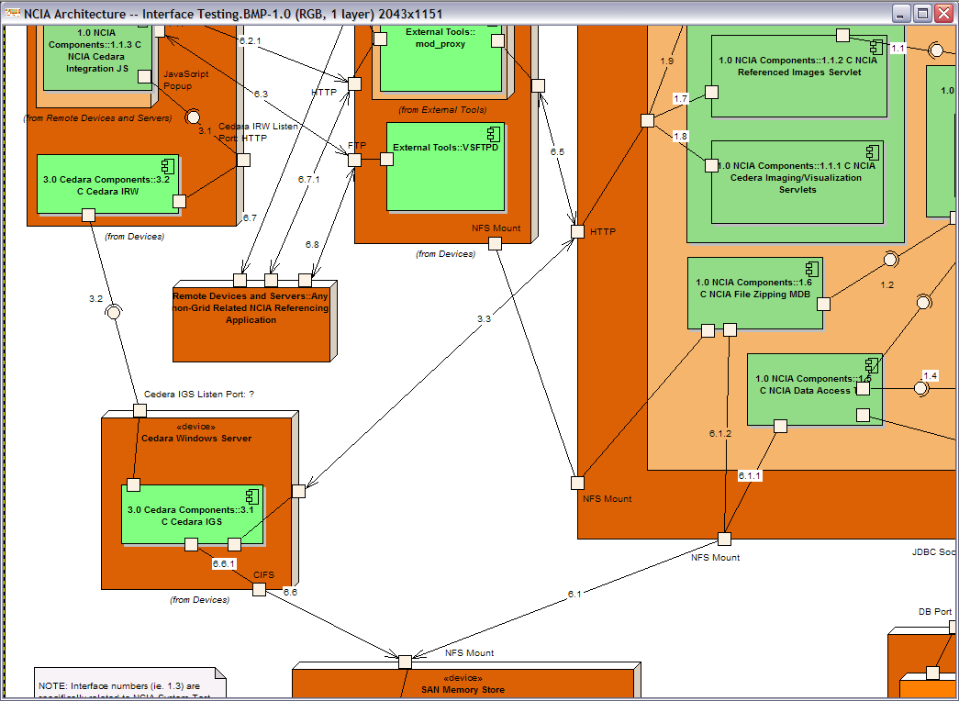
Figure 6 Missing Meaningful Caption Here

  - Cedara Integration JavaScript to Cedara IRW
This represents the communication and calls to the Cedara IRW running on a client’s workstation from the NCIA Web User Interface through JavaScript that is loaded and executed within the client workstations active internet browser.

  - Cedara IRW to Cedara IGS Server
The Cedara IRW in order to access images that are available in the NCIA requires that these files be passed to it from the Cedara IGS running at the NCIA site. This communication is not defined for us at this point. (We need more information regarding this)

  - Cedara IGS Server to the NCIA Image Servlet
The Cedara IGS Server must communicate with the NCIA Web User Interface to gather specific file location information after it has received a request from the Cedara IRW. This represents that HTTP call to the NCIA Web User Interface from the Cedara IGS.

caGrid Interfaces
These are the interfaces to the NCIA System from the caGrid and caGrid related components.

  - caGrid Remote Node to the Globus Server: Generic Grid Service
This connection essentially represents the availability of the caCORE Generic Grid data services that are available on caGrid.

  - Generic Grid Services to the caCORE toolkit war
This is the connection that lies between the deployed caCORE generic grid service handlers that lay in the Globus container to the actual underlying business and data access logic that is resting in the JBoss container and running through the caCORE Toolkit web application. This communication currently happens via Spring Remoting.

  - NCIA Remote Services (NCIA hosted) to the NCIA Services Layer
This is the connection that ties the NCIA specific caGrid services stubs and handlers that are running in the Globus container to the NCIA Service Layer via Spring Remoting.

  - Any NCIA Remote Node to the Globus Server: NCIA Remote Service
This is nothing more than the complete availability of the NCIA Remote caGrid services running in Globus for utilization by primarily other, remote NCIA nodes.

  - NCIA Remote Services: Outgoing (to non-NCIA hosted services) Remote Services to NCIA Remote Node
When an NCIA node is accessing and retrieving information and files that are running on a remote node of the NCIA, communication happens through caGrid. This communication is separate from the incoming caGrid calls that happen for a particular node in that they do no go out the Globus server that handles incoming caGrid NCIA calls.

caCORE CSM Interfaces
  - Common Security Module to the JBoss JNDI JDBC Connection
To access user and image collection security information stored in the NCIA database the CSM needs to get a handle on a connection to the NCIA database. This happens through a registered JNDI data source handle that is made available in JBoss. This represents the ability of the CSM to acquire that handle and execute queries through the established JDBC connection.

Hardware Interfaces
Hardware interfaces are those interfaces of the NCIA System that are not software related but non-the-less have proven to be potential critical failure points for the system as a whole. The NCIA System is dependent on network connections between Virtual Machine Clusters, Network File Systems, and Storage Area Networks whose reliability has proven less than sure. For this reason, we capture these links here as a concern for testing to ensure that the NCIA system is operational.

  - JBoss Server to the Image File Store
Currently the NCIA Image file store Storage Area Network (SAN) is made available to other devices through a Network File System (NFS). This connection to the NFS is a requirement for the NCIA components to access display and serve out the files that are stored in the NCIA Storage Area Network (SAN).

    - NCIA Services Data Access Tier to Image File Store
This is the access that is available to the NCIA Data Access Tier to the image files stored in the SAN. A successful test of this connection would demonstrate the availably of 6.1 I.

    - Zipping MDB to the Image File Store
This connection is similar to 6.1 I and 6.1.1 I. It is also true that a successful test of this connection implies a successful connection for 6.1 I.

  - Client Browser to Apache Server via HTTPS
For external clients to access the production or stage NCIA Web User Interfaces, they must access the systems through the Apache server which has been exposed through the firewall. Development and QA are not available through the firewall however an Apache Server is also available for handling those requests as well. This connection represents a connection between the Apache Server and the requesting workstation.

This protocol for this communication is handled via HTTPS, there for there are requirements that the Security Certificate be available and valid for that server.

    - Client Browser to the Apache Server via HTTP
To establish the HTTPS connection to the Apache server the HTTP socket must be available for communication. This represents that link of the initial communication between an outside user and the Apache server.

  - Client Browser to VSFTPD via FTP
To handle the transfer of large files from the NCIA system, we utilize the VSFTPD FTP server. This is the connection that lies between the clients workstation and our instance of VSFTPD.

  - NCIA JBoss Server to the Apache Server
The Zipping MDB requires access to the machine that is running the VSFTPD server so as to place files that are created for user downloads. This is accomplished via an NFS mount that exposes a shared file system between the two machines. This link represents that shared file system.

    - Zipping MDB to the Symbolic Link for the Apache Server File System
This represents the connection of the Zipping MDB to the actual symbolic link that represents the shared NFS between the Apache and JBoss machines.

  - Apache Server to NCIA JBoss Server via HTTP
This is a connection that is configurable and thus should be watched and maintained to ensure that the connection is available. The Apache Server redirects incoming HTTPS/HTTP calls to the NCIA application to the JBoss machine and server that are running the associated instance of NCIA. This is configured currently using mod_proxy, and Apache HTTP Server plug-in.

  - Cedara Windows Server Hardware to SAN Memory Store
In order to server out the images that are selected for viewing and markup by the Cedara IRW, the Cedara IGS must be able to access those files. The file path and information are transferred to the Cedara IGS server through the NCIA Web User Interfaces Image Servlets, and then used to grab the files directly. This represents the connection created for the actual machine the Cedara IGS is running on to access that file system.
    - 6.6.1 Cedara IGS to Image File Store
This is the use of the connection mentioned in the interface “6.6 I” by the Cedara IGS.

  - Non-Grid NCIA dependent applications to the Apache Server via HTTPS
These are incoming requests from applications such as I-Spy that wish to leverage functionality within the NCIA System in some other way than through caGrid and through HTTPS. In order to access that functionality they must work through our Apache server which then forwards on any requests to the JBoss machine that is hosting the NCIA Web User Interface.

    - Non-Grid NCIA dependent applications to the Apache Server via HTTP
To access the service through HTTPS, an initial request must come in through HTTP. This interface is the availability of the Apache server to receive and respond to incoming HTTP requests.

Testing Details Automated Availability Tests
The following is a list of tests that we use to ensure that the system is operating. Each of these tests can currently be found in the ncia-image source code package within CVS or GForge. Specifically, they are all found under the package gov.nih.nci.ncia.test.availability.

Important Note: The columns in the tables listed below have no X- Axis relationship, that is to say one column does not relate to any of its neighbors, except that they are all tested by the test case.

ApacheLoginTestCase.java
This test case performs a log in to the system. However this simple test actually touches several important pieces of the system. It verifies the hand off of the Apache server to the JBoss server as well as the underlying connections between the most significant components of the NCIA application: the NCIA Web User Interface, the NCIA Services Layer, the NCIA Data Access Tier, and the NCIA Database. It also verifies the operation of the JBoss Oracle connection pool.

Table 1 - ApacheLoginTestCase tested components, interfaces, devices and servers
Components (C) | Interfaces (I) | Devices | Servers
1.1 C | 6.2 I | Apache Web/FTP Server | Apache
1.2 C | 6.5 I | JBoss Application Server | JBoss
1.5 C | 1.9 I | Oracle Database Server | Oracle RDBMS
1.7 C | 1.1 I
2.2 C | 1.10 I
 | 5.1 C
 | 5.2 I

ReferencedImagesTestCase.java
This test exercises the functionality of the NCIA Web User Interface that allows an external application to access preexisting images in the database through the NCIA Referenced Images Servlet. It also requires a log in as found in the ApacheLoginTestCase, but goes further into the NCIA application and verifies access to images, thumbnails, as well as session persistence between the Referenced Images Servlet and the rest of the NCIA Web User Interface.

Table 2 - ReferencedImagesTestCase tested components, interfaces, devices and serversª
Components (C) | Interfaces (I) | Devices | Servers
1.1.2 C | 1.7 I | SAN Memory Store
1.8 C | 6.1 I | NFS Servers
 | 6.1.1 I

CedaraIGSVisualizationTestCase.java
This comprehensive test case sends a similar request to the Cedara IGS as the Cedara IRW would to access images for visualization. It ensures that images can be served out to a Cedara IRW client.

Table 3 - CedaraIGSVisualizationTestCase tested components, interfaces, devices and serversª
Components (C) | Interfaces (I) | Devices | Servers
1.1 C | 1.1 I | Cedara IGS Server | Cedara IGS
1.1.2 C | 1.7 I | NFS Servers | Oracle RDBMS
1.2 C | 1.10 I | JBoss\Globus Server | JBoss
1.6 C | 3.2 I | Oracle Database Server
1.7 C | 3.3 I
1.8 C | 5.2 I
3.1 C | 6.1 I
 | 6.1.1 I

VSFTPDFileDownloadTestCase.java
This test case is under construction

Table 4 - VSFTPDFileDownloadTestCase tested components, interfaces, devices and serversª
Components (C) | Interfaces (I) | Devices | Servers

CurationDataUploadMDBTestCase.java
This test case is under construction
Table 5 - CurationDataUploadMDBTestCase tested components, interfaces, devices and serversª
Components (C) | Interfaces (I) | Devices | Servers

COREGridServicesTestCase.java
Yet to be implemented

Table 6 - COREGridServicesTestCase tested components, interfaces, devices and serversª
Components (C) | Interfaces (I) | Devices | Servers

COREGridServiceGridFTPTestCase.java
This test has not been implemented yet as the design documentation for the task has not been completed.

Table 7 - COREGridServiceGridFTPTestCase tested components, interfaces, devices and serversª
Components (C) | Interfaces (I) | Devices | Servers

NCIAIncomingGridServicesTestCase.java
Not yet implemented

Table 8 - NCIAIncomingGridServicesTestCase tested components, interfaces, devices and serversª
Components (C) | Interfaces (I) | Devices | Servers

NCIAOutgoingGridServicesTestCase.java
Not yet implemented

Table 9 - NCIAOutgoingGridServicesTestCase tested components, interfaces, devices and serversª
Components (C) | Interfaces (I) | Devices | Servers

Testing Details: Non-Automated Availability Tests
These are the tests that currently must be performed by hand to ensure that the system devices, components and interfaces are available and running as expected. These the tests that are not currently run within CruiseControl, and are run on a schedule by the NCIA Quality Assurance Team.

Cedera Visualization Java Script Test
The script for this is already written someplace, and I just need to find it.

Testing Details: Components and Interfaces Tested By
The following section will break down each of the Components and Interfaces and describe which tests verify the above

More information regarding Selenium can be found at the following URL http://www.openqa.org/selenium/
For more information regarding JUnit please refer to the following location http://www.junit.org/index.htm
CruiseControl is a framework that enables a continuous build process. It includes, but is not limited to, plug-ins for email notification, Ant, and various source control tools. A web interface is provided to view the details of the current and previous builds. More information and details can be found at: http://cruisecontrol.sourceforge.net/
At the time of the writing of this document, this is really a policy suggestion that will need to be roughed out with all interested parties. But until new APIs can be found and time afforded for the development of these automated tests, complete system availability and functionality is not 100% assured with out at least some human interaction with the system on production and stage.
Continuous Integration was a term coined by, or at least credited to, Martin Fowler. It is essentially a philosophy of conducting regular system builds during development to ensure that any new implemented code changes do not adversely affect the any other component of the system. It gives the development team the benefit of nearly real time integration/regression testing during development, and should make it more obvious when contracts between components have been violated. Please see the following site for more details: http://martinfowler.com/articles/continuousIntegration.html
It is understood that EA could generate this documentation for us, however we do not currently have the time to develop the necessary knowledge to make that happen. At the time of writing this document we are scheduling training for the NCIA team to allow us to document our design more fully in EA and not through two physically disconnected and difficult to coordinate documents.
Add Hibernate information here for future readers.
A message driven bean is a specific type of J2EE bean that enables asynchronous communication between two J2EE enabled systems. For details and more information go here: http://java.sun.com/j2ee/tutorial/1_3-fcs/doc/MDB.html
The Spring Framework provides many APIs for simplified and quick implementation of distributed J2EE based applications. The NCIA team utilizes several design patterns that have been simplified through the use of the Spring Framework APIs, Dependency Injection and HTTP Remoting being just a couple of examples. Go here for more details: http://www.springframework.org/
This isn’t to say that the NCIA team and the interested members of the CIP do not check the NCIA for external firewall availability from time to time, e.g. at stage and production release deployment. But it is difficult to put any sort of confidence on the current method of random spot checks from home or external office by NCIA interested parties. This should probably be incorporated into our manual testing mentioned in the section that describes Manual Testing.
JNDI: The Java Naming and Directory Interface (JNDI) is part of the Java platform, providing applications based on Java technology with a unified interface to multiple naming and directory services. (from http://java.sun.com/products/jndi/)
The actual file location information for these test cases when browsing through the GForge source tree is as follows: ncia-image\src\gov\nci\nih\ncia\test\availability.

