Larry Holeman
Wednesday, May 14, 2008
Conducted internal testing for 12970-NCIA rel 3.6

Item tested:
- 13750 – QC Tool view image -- The number of images per page displayed in QC Tool is not consistent
Evaluation: The row/column values defaults to 5 and 3 respectively. The values of the row/col remains persistent as you navigate from one group of images to another while in a session. It resets to 5/3 after a logout and log back in.
The requirement is: The system shall display 5 thumbnails across wherever thumbnails are displayed.
Also the simple and advanced search displays 3 across instead of 5.

- 13768-- FireFox viewing the search result – In Firefox, data overflows into neighboring columns in all results tables.
Evaluation: This issue appears to be corrected.
Other observations:
- FireFox remembers the Userid and Password
- Do not display the security screen when clicking on the DICOM Tools --- It is displayed when using the Internet Explorer --- see screen shots
- When using IE to navigate the DICOM Tools, if you click “No” to the security message, you will get a blank screen.

- 13766 --- Remote search from two users--- One user’s selection of the remote search affects the other user’s selection
Evaluation: This issue appears to be corrected.
Other observations:
- 13976 – Deploy caGrid 1.1 Query Service on JBoss and CORE service on Tomcat
13756 – Cannot configure index server URL and port number for NCIAQueryService
There is no test case for these trackers (13976 and 1356) from QA.
Evaluation: remote nodes are available and functional --- you can drill to the image level
caGrid 1.1 CORE Service is listed on the left side of the portal page as NCIACoreService
http://cagrid-portal.nci.nih.gov/web/guest/home
- 13792 – Date range validation -- Form validation on visibility data range in search page doesn’t catch all invalid dates.
Evaluation: Data validation appears to work
Conditions checked:
- Valid date in mm/dd/yyyy
- Invalid month (00,13)
- Invalid day (00,32)
- Year two digits (07,08)
- Leap Year (02/29/07, 02/29/08)
- From date =< To Date
- “To Date” needs a “From Date”

- 13779 – Text for Emails --- When downloading from 2+ remote sites, text on manage data basket notes 1 email(s) instead of 2 email(s)
Evaluation: Text was changed to refer to an email for each note data was select.

- 13778 – Not Visualize images from remote site – Visualize Images text on study results page shouldn’t be displayed when viewing remote site results.
Evaluation: The text has been removed
Other observation:
The Study Id is miss labeled.
On the study page the Study Instance UID is displayed as the Study ID. However, the DICOM Header has the Study ID as a different value.
Example:
Study Instance UID → 1.3.6.1.4.1.9328.50.1.10451
Study ID → 3
There are no test cases for 13976 and 13756 from QA
When clicking on an Image Viewer from the DICOM Image Viewers link you will get a security page. If you click no a blank page is displayed (no message). If you are using FireFox, you will not get the security page. Plus, FireFox remembers the User Id and password. The reason I am flagging the User Id and Password is because the new security requirements after the lost of the laptop is to disable that function. ( They did that with IE)
DICOM Tools

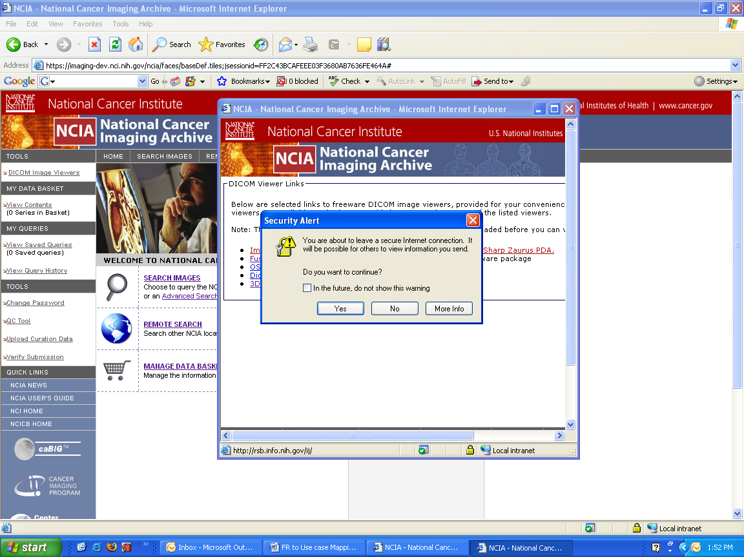

Click no—get a blank page
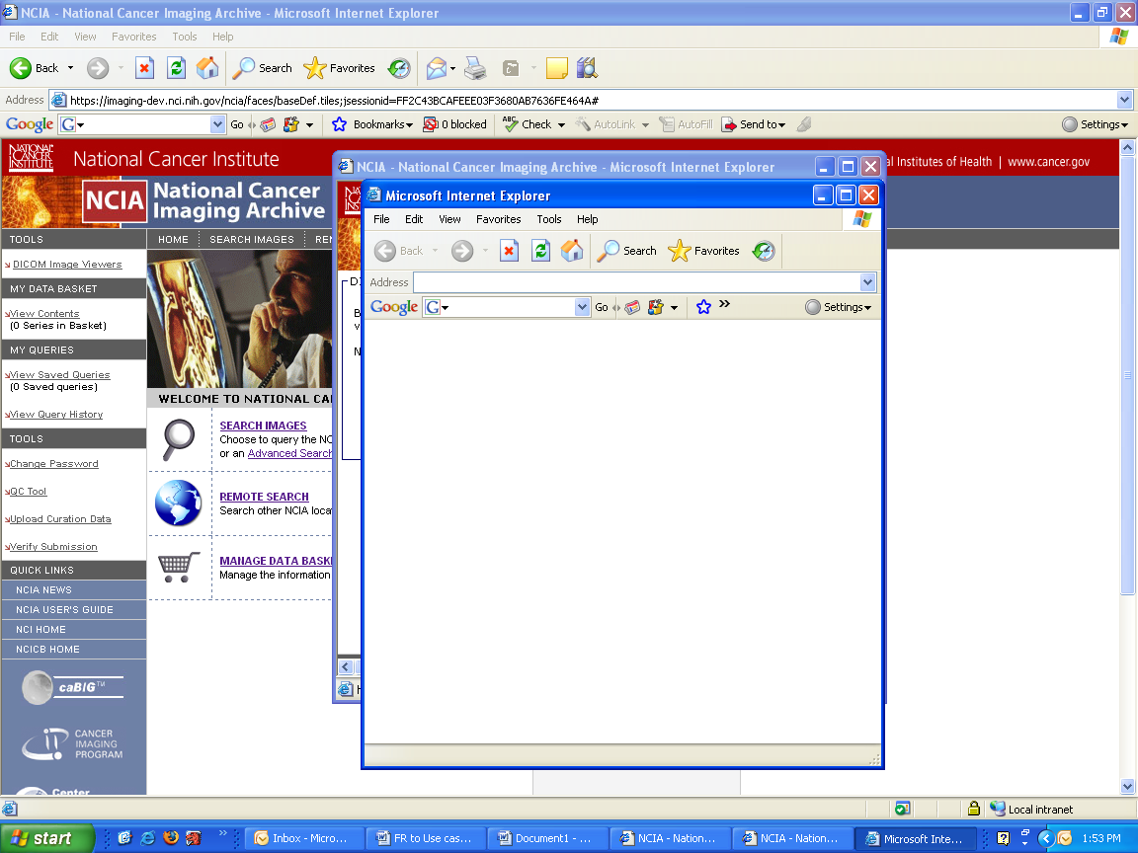

Firefox remembers the User Id and Password
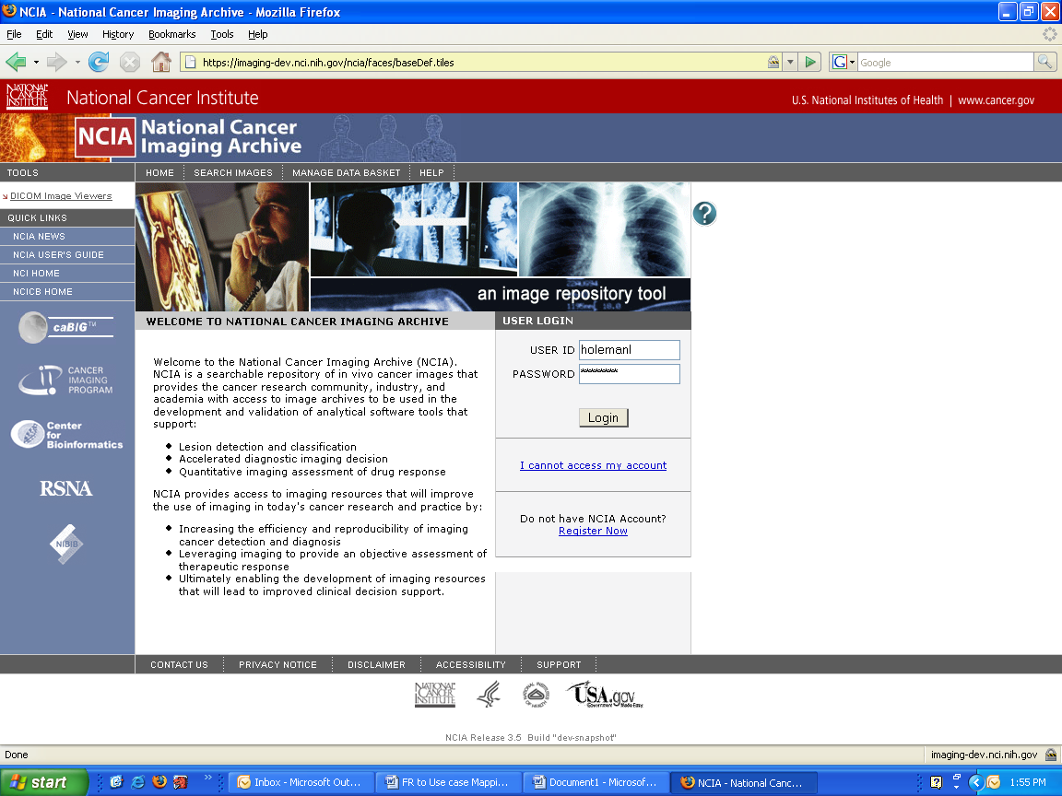

Firefox does not display security screen
