NBIA Data Basket
Last Revised: | Dec 14 2010
Produced By: | NBIA Team
Version: | 1.0

Document Approvals
The list contains the name and contact information for the core project team and any key stakeholders who have an interest in the success of the project. An “S” identifies persons responsible for approval from the stakeholder groups. Sign off of the document would be required when a decision is made not to take action for defined gaps.

S | Name | Role
S | Robert Shirley | NCICBIIT
S | Peter Yan | COTR/PM
 | Eric Kascic | Technical Lead
Revision History
When you make a change to a document, you must add an entry to this Revision History table and you must manually type the Last Revised Date on the front cover.

Date | Version | Description | Revised by
Copyrights and Trademarks
© Copyright 2010 by CBIIT, caBIGTM. All rights reserved.

Table of Contents
1. Introduction 1
2. Summary of Module 1
3. Architectural Diagram 1
4. Example 1 1
5. Example 2 1

Introduction
The purpose of this document is to describe the design & architecture by discussing about the data basket and the options available to access the data within the data basket. The data basket lists all the series selected from the search results. This acts kind of like a Shopping cart. The user can keep going back to search screen, run a new search and keep adding more series to the data basket. Once the user is done, the user can navigate to the ‘My Data basket’ screen using the ‘Manage data Basket’ link on the top for more options.

Summary of Feature
In this module, the following options are available.
- Download All Items
- Download Manager
- Create a Shared List
- Export Series ID
- Visualize Images
- View Images

    - Resources used
      - Managed Bean – BasketBean.java
      - View – dataBasket.xhtml

- Download All Items
This option is used to download the selected series locally to the Desktop. Based on the total file size, the system decides whether to do an Http download or ftp download. Properties-service.xml holds the attribute ‘ftp_threshold’ which determines whether to do an http download or ftp download.

- Download Manager
The purpose of this implementation is to allow the user to download data from NBIA data basket page with NBIA download client. Currently user can download from data basket by either HTTP request when the data basket size is less than 3GB or by FTP when data in the data basket is larger than 3GB. This download client allows user to download their current data basket regardless of size directly to a user’s specified location. This client is a Java Web Start application.

- Create a Shared List
This option is used to create a shared list based on the series in the data basket. The series list in the basket is passed on to CustomSeriesListBean. When the user types in a name and hits ‘Submit’, the series is passed on to CustomSeriesListProcessor as DTOs. Next, CustomSeriesListDAO object accepts the series list DTOs and inserts the shared list as CustomSeriesList objects. Once the shared list is created, this is available to any user who uses NBIA. The user can click on the ‘Search Shared List’ link on the left and search based on the Shared List name. Once the user clicks on any of the item in the list, the selected series list will be populated into the user’s data basket.

    - Export Series ID
This option is used to save the list of Series UIDs in a .CSV file. This is handled by the ice:outputResource element declared within dataBasket.xhtml which behaves like a link. When the user clicks on the link, BasketBean generates an Icefaces ByteArrayResource object which holds the list of series UIDs. This resource is used by the ice:outputResource element to stream the .csv file.

    - Visualize Images
This option is used to view the images of the selected series on the Cedara Viewer. If the Viewer is not installed on the user’s PC, an error message is displayed. If the Cedara client is installed and running properly, NBIA shows an Information Page. When the user clicks the ‘Continue’ button, a javascript function (sendReqToIRW) is called which in turn, submits a hidden form pointing to port 8889. The form submits the user, host address and the list of series UIDs. This gets picked up by Cedara Viewer and displays the images.

For more information, please refer to the following document.
https://ncisvn.nci.nih.gov/svn/nbia/trunk/docs/analysis_and_design/4.2/Visualizing_Images_from_Data_Basket_Design.doc

- View Images
Please refer to the following document.
https://ncisvn.nci.nih.gov/svn/nbia/trunk/docs/analysis_and_design/4.2/View_Images_in_Data_Basket_Design.doc

External Data Basket
The link below describes a generic approach for other applications to connect to NCIA. Through this connection, the user can obtain the search results by providing search criteria. The NCIA will add results into NCIA data basket. From data basket, the user can view images, search images, add/delete images into/from data basket and download selected images from NCIA application.
https://ncisvn.nci.nih.gov/svn/nbia/trunk/docs/analysis_and_design/4.2/DataBasket_Design.doc

Architectural Diagram
The following diagram provides the work flow process while adding a series list into the data basket.
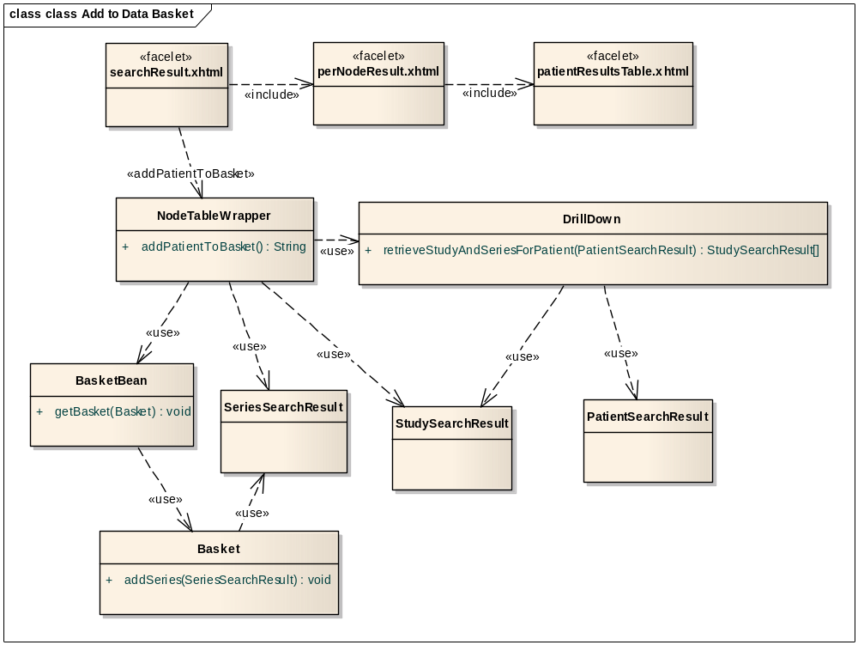
While adding the series to the data basket, NodeTableWrapper class is used to pass on the selected patients to the DrillDown object. The DrillDown object will retrieve an array of StudySearchResult objects based on the selected patients. Next, the series list is retrieved from the StudySearchResult objects. Finally, the SeriesSearchResult objects are passed on to the BasketBean, which in turn, updates the Basket object with the series List. This series list will be displayed when the user navigates to the ‘My Data Basket’ page.

Change Example 1
Describe in very deep detail the act of making some small (artificial, simplified) change against this feature.

Change Example 2

