NBIA Http/Ftp Download
Last Revised: | Dec 14 2010
Produced By: | NBIA Team
Version: | 1.0

Document Approvals
The list contains the name and contact information for the core project team and any key stakeholders who have an interest in the success of the project. An “S” identifies persons responsible for approval from the stakeholder groups. Sign off of the document would be required when a decision is made not to take action for defined gaps.

S | Name | Role
S | Robert Shirley | NCICBIIT
S | Peter Yan | COTR/PM
 | Eric Kascic | Technical Lead
Revision History
When you make a change to a document, you must add an entry to this Revision History table and you must manually type the Last Revised Date on the front cover.

Date | Version | Description | Revised by
Copyrights and Trademarks
© Copyright 2010 by CBIIT, caBIGTM. All rights reserved.

Table of Contents
1. Introduction 1
2. Summary of Module 1
3. Architectural Diagram 1
4. Example 1 1
5. Example 2 1

Introduction
The purpose of this document is to describe the design & architecture by discussing about the http/ftp download options available to download the series data from the Data basket page.

Summary of Feature
The following options are available to download the series data.
- Download All Items
- Http Download ( Default – less than 3GB)
- Ftp Download ( Default – 3GB and greater)

    - Resources used
      - Managed Bean – BasketBean.java
      - View – dataBasket.xhtml

The ‘Download All Items’ option is used to download the selected series locally to the Desktop. Based on the total file size, the system decides whether to do an Http download or ftp download. Properties-service.xml holds the attribute ‘ftp_threshold’ which determines the download option.

- Http Download
When the total download size is less than 3GB, http download is going to kick in. Visually, the user sees a Progress Bar on the page. NBIA uses the Icefaces Ajax Push technology to show the Zip progress. < ice:outputProgress> within the databasket.xhtml shows the zip progress as it is happening using the Icefaces push technology. Once the progress reaches 100%, a javascript call (completeDownloadButton.click()) kicks in to show a popup, so that the user can save the zipped file into his local desktop.

- Ftp Download
When the total download size is greater than 3GB, ftp download is going to kick in. This is an asynchronous call so that the user can continue working. In the backend, the system sends a JMS message to start the Zipping process and store the file on the server. Once the zipping process is complete, an email is sent to the user with the download link.

Architectural Diagram
The following diagram provides the work flow process while doing an Http Download. This process kicks in if the total download size is less than 3 GB. This is based on the ‘ftp_threshold’ attribute set in Properties-service.xml.

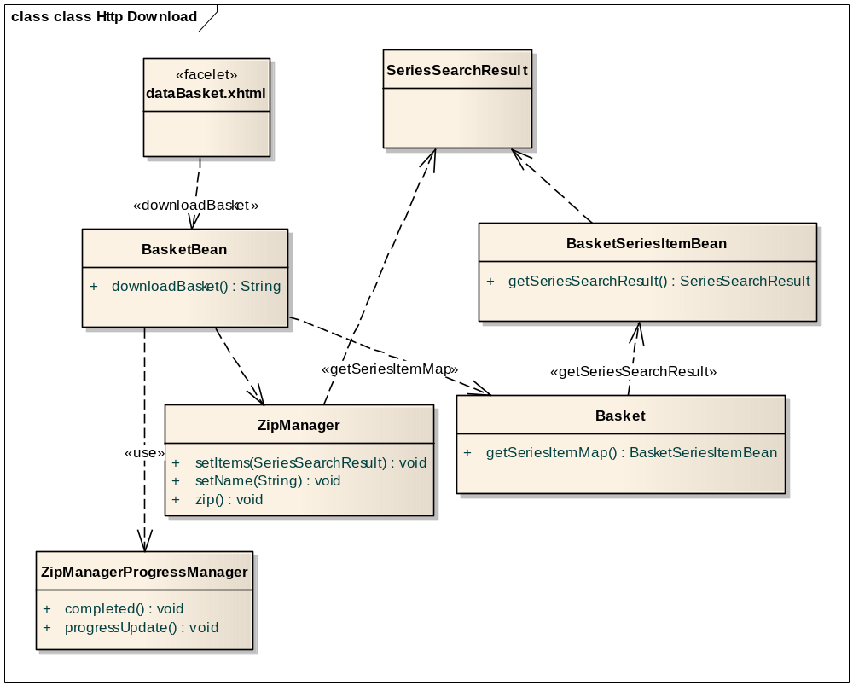
When ‘Download All Items’ link is selected, the downloadBasket method within the BasketBean is called. BasketBean retrieves the SeriesSearchResult objects from the Basket class and passes it on to the ZipManager to zip them. ZipManager’s responsibility is to create the Zip file and keep it on the server. ZipManagerProgressManager is used to show the Zip progress on the screen. Once the Zipping process is done, a popup shows up with an option for the user to download locally.

The following diagram provides the work flow process while doing an Ftp Download. This process kicks in if the total download size is greater than 3 GB.
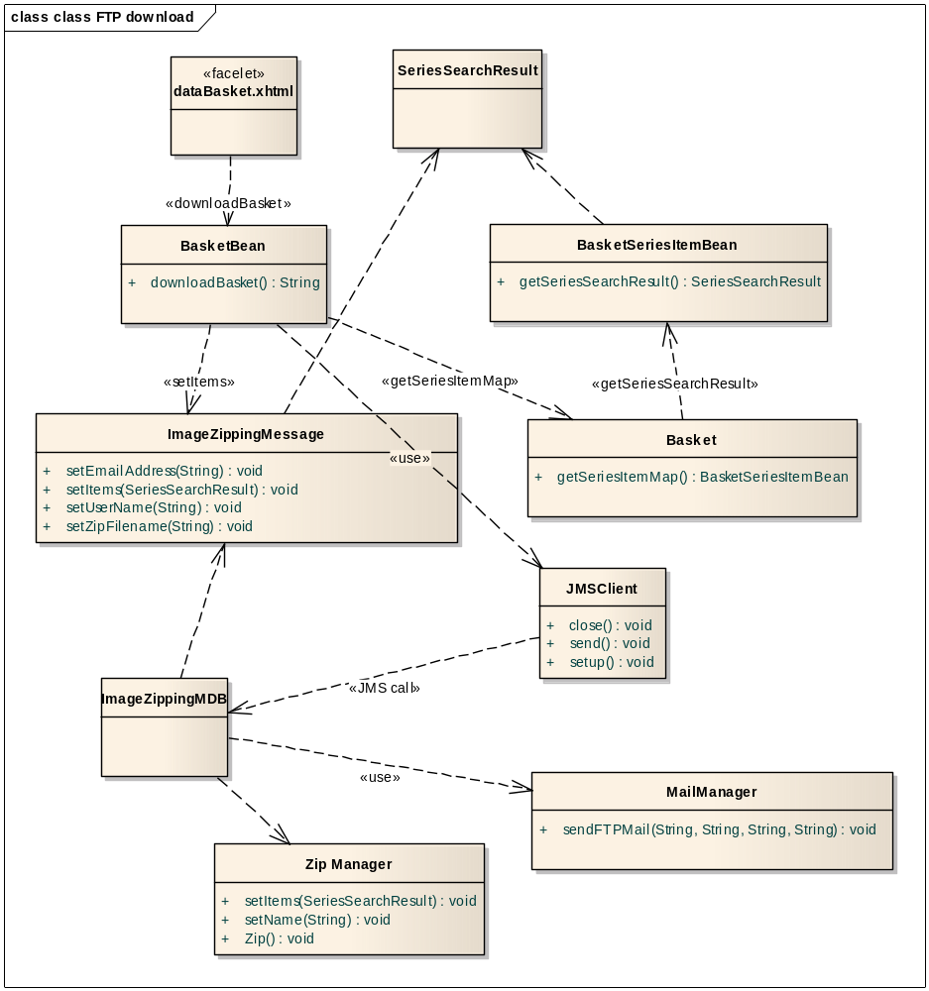
When ‘Download All Items’ link is selected, the downloadBasket method within the BasketBean is called. BasketBean retrieves the SeriesSearchResult objects from the Basket class and passes it on to the ImageZippingMessage object. ImageZippingMessage holds the User Name, email address, Zip file location and the SeriesSearchResult objects. The JMSClient object then sends the ImageZippingMessage to the message queue. ImageZippingMDB picks up the message object and retrieves the SeriesSearchResult objects. These SeriesSearchResult objects are then passed on to the ZipManager to zip them. ZipManager’s responsibility is to create the Zip file and keep it on the server. Finally, MailManager is called to send an email to the user with the link to the Zip file so that the user can download the file.

Change Example 1
To change the file size threshold which determines whether to do an Http or Ftp download, follow these steps.
- Search for properties-service.xml
- Open the XML file and search for ‘ftp_threshold ‘ attribute.
- The default size is 3000.0 ( 3GB)
- For example, if the FTP download needs to kick in starting at 100 MB, change the value to 100 and save.

Change Example 2

