Software Architecture Document
NCI OCR

Last Revised: | January 17, 2013
Produced By: | 5AM Solutions, Inc.
Version: | 1.7

Document Approvals
The list contains the name for the core project team and any key stakeholders who have an interest in the success of the project. An “S” identifies persons responsible for approval from the Business and Development. Sign off of the document would be required when a decision is made not to take action for defined gaps.

S | Name | Role | S | Name | Role
S
 | Rashmi Srinivasa | Project Manager
 | Eric Tavela | Architect
Revision History
When you make a change to a document, you must add an entry to this Revision History table and you must manually type the Last Revised Date on the front cover.

Date | Version | Description | Revised by
7/26/10 | 0.1 | Initial draft. | Scott Miller
7/28/10 |  | Added domain and class model details | Tanya Shedrick
4/4/11 | 1.0 | Revised based on current architecture | Eric Tavela
4/26/11 | 1.1 | Revised based on initial feedback | Eric Tavela
5/16/11 | 1.2 | Revised based on feedback from architecture review (Dan Kokotov and Todd Parnell) | Eric Tavela
3/8/12 | 1.3 | Updated to align with 3.0.0 release | Eric Tavela
4/3/12 | 1.4 | Updated based on feedback from 3/26/2012 Document Readiness Review | Eric Tavela
5/7/12 | 1.5 | Added description of NES entity refresh | Eric Tavela
8/28/12 | 1.6 | Rebranded from FIREBIRD to NCI OCR | Eric Tavela
1/17/13 | 1.7 | Incorporated architectural changes related to release 3.2
Copyrights and Trademarks
© Copyright 2011 by 5AM Solutions, Inc. All rights reserved.
Table of Contents
1. Introduction 3
1.1. Purpose 3
1.2. Scope 3
1.3. Definitions, Acronyms, and Abbreviations 3
1.4. References 4
2. Overview of Architectural Representation 4
3. Architectural Goals and Constraints 4
4. Use-Case Model 4
5. Domain Model 6
5.1. Overview 6
5.2. Localization of the BRIDG Model 8
6. Design Model 8
6.1. Overview 8
6.2. Dependency Injection 10
6.3. Authentication and Authorization 11
6.4. User Interface Layer 14
6.5. Services Layer 14
7. Deployment Model 31
7.1. Overview 31
7.2. Artifacts 31
7.3. Deployment 32

Introduction

Purpose
This document provides a comprehensive architectural overview of the NCI Online Credentialing Repository (NCI OCR) system, using a number of different architectural views to depict different aspects of the system. It is intended to capture and convey the significant architectural decisions that have been made for the system’s design.

Scope
This document describes the aspects of the design that are considered to be architecturally significant, those elements and behaviors that are most fundamental for guiding the construction of NCI OCR and for understanding the project as a whole. Stakeholders who require a technical understanding of NCI OCR are encouraged to start by reading this document, and then by reviewing the source code. Please note that all diagrams represented in this document are taken from the NCI OCR UML Models [NCI_OCR_UML]; for more details about the elements in these diagrams, please consult the source model.
For some of the references to technical artifacts to follow, it would be helpful to note that the application has undergone a rebranding from its original name of FIREBIRD to the new name NCI OCR. Certain internal references to the old name have been left in place where it would have incurred too much overhead to change them. Examples of these include artifact names (e.g. firebird.ear), Subversion paths and other internal project constructs not visible to external users. All user visible artifacts employ the new name.

Definitions, Acronyms, and Abbreviations
- CTEP - Cancer Therapy Evaluation Program
- DAO – Data Access Object
- DCP – Department of Cancer Prevention
- EJB – Enterprise JavaBeans
- IRB – Institutional Review Board
- NCI – National Cancer Institute
- NCI OCR – NCI Online Credentialing Repository
- Java EE – Java Enterprise Edition
- Java SE – Java Standard Edition
- JDK – Java Development Kit
- JSP – JavaServer Pages
- NES – NCI Enterprise Services
- POJO – Plain Old Java Object
- UML – Unified Modeling Language

References
[NCI_OCR_UML] NCI OCR UML Models
https://ncisvn.nci.nih.gov/svn/firebird/docs/analysis_and_design/architecture/nci_ocr_uml_models.eap
[NCI_OCR_ARCH_ATTRIBUTES] NCI OCR Architectural Quality Attribute Scenarios
https://wiki.nci.nih.gov/display/FIREBIRD/NCI+OCR+Architectural+Quality+Attribute+Scenarios

Overview of Architectural Representation
The NCI OCR architecture is represented in this document and in the NCI OCR UML models as a set of views of the system from different but complementary perspectives. These perspectives are presented in order of specificity from requirements to the deployment architecture.
- Architectural Goals and Constraints – Describes the non-functional requirements that guide the architectural choices made for the system.
- Use Case Model – Describes the architecturally significant functional requirements.
- Domain Model – Describes the key business concepts that NCI OCR functionality is built to support.
- Design Model – Describes the architecturally significant software components and how they are structured in the overall system design.
- Deployment Model – Describes the software artifacts that comprise the system, how those artifacts are deployed to various software and hardware environments and the communication pathways between these environments.

Architectural Goals and Constraints
The architectural qualities that NCI OCR is being engineered to meet are documented in the Architectural Quality Attributes Scenarios in the NCI OCR Wiki [NCI_OCR_ARCH_ATTRIBUTES].

Use-Case Model
The use cases represented in Figure 1 below contain the functionalities that have the greatest impact on the design of the NCI OCR architecture. These use cases exercise authentication and authorization, communication with NES grid services, digital document signing, user notification email functionality and the overall layering and integration of the application.
To briefly describe how the major functional areas of NCI OCR work, first users must request and establish accounts to use NCI OCR. There are two major classifications of users: Sponsor Representatives who establish Protocols and Investigators who are assigned to Protocols and must complete the Registrations for these protocols. Investigators create Profiles that contain the elements that go into a Registration. When completing a Registration Packet, an Investigator pulls information from his Profile to complete the Registration. Additionally there are Sponsor Delegates who act on behalf of Sponsor Representatives and who have access to a limited subset of functionality. Similarly, there are Registration Coordinators who may act on behalf of Investigators. The flow diagram shown in Figure 2 describes how the activities represented by the use cases work together in logical order.

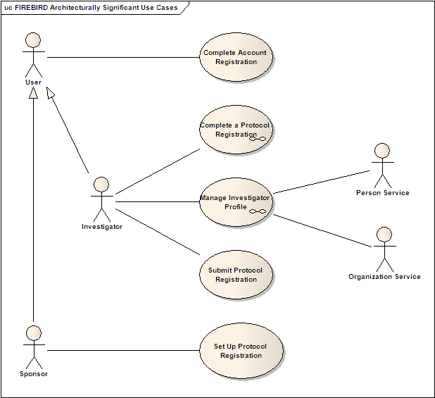
Figure 1: NCI OCR Architecturally Significant Use Cases
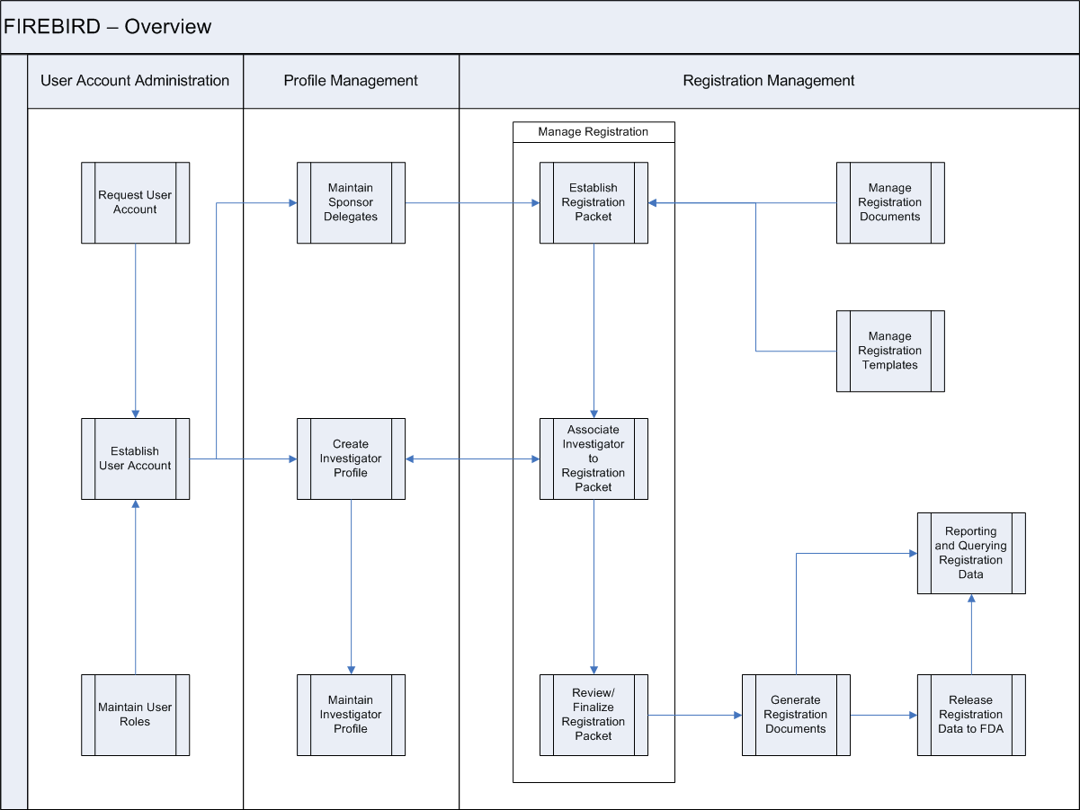
Figure 2 - Flow of activities within NCI OCR

Domain Model

Overview
The purpose of the Domain Model is to illustrate the key business entities and their relationships to promote a shared understanding of these concepts when discussing the application. The Domain Model is intentionally informal so that the core concepts can be easily comprehended without being mired with the detail necessary for their implementation. Readers who would prefer a view of how these objects have been implemented are encouraged to review the Domain Object Implementation diagram in the NCI OCR UML model or to review the implementation code in the gov.nih.nci.firebird.data Java package. The core Domain Model classes for NCI OCR are shown below in Figure 3.
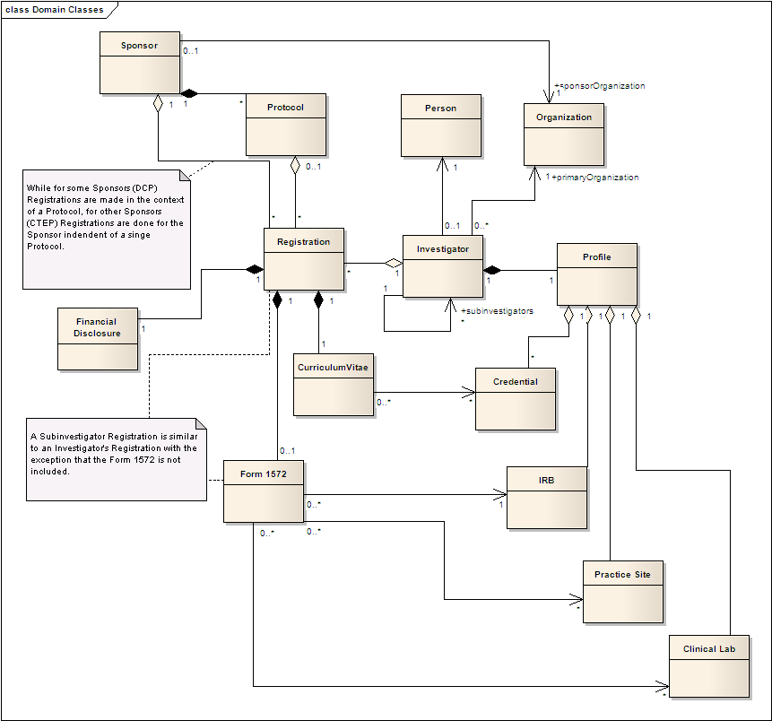
Figure 3 – NCI OCR Domain Model
Sponsors are organizations that sponsor clinical trials Protocols and as such they must collect the requisite Registrations from Investigators for submission to the FDA. A Registration is made up of a collection of signed documents provided by the Investigator. The key documents are a Financial Disclosure, a Curriculum Vitae listing relevant credentials and experience and Form 1572 which is a signed statement by the Investigator providing information about the facilities and IRB associated with the clinical investigation as well as a list of Sub-investigators working under the investigator.
Each Sub-investigator must also produce a similar Registration with the exception that the Form 1572 is not required.
The fundamental capability of NCI OCR is to make the submission of these Registrations and review by Sponsors as simple as possible. In the current paper-based approach Investigators must fill out registration documents for each protocol with each containing a lot of repeated information. The NCI OCR approach is to collect this information in a Profile associated with the investigator so that the investigator may easily pull this reusable information into each new Registration.
In the general case, Registrations are associated to a specific protocol. There is a special case being incorporated for the Cancer Therapy Evaluation Program (CTEP), where a registration is considered an annual registration that covers all protocols sponsored by CTEP for the period the annual registration is considered approved and active.

Localization of the BRIDG Model
It is important to note that since many of the concepts in NCI OCR come from existing NCI Enterprise Services, NCI OCR in fact leverages a subset of the BRIDG model. This subset can be seen in Figure 4.
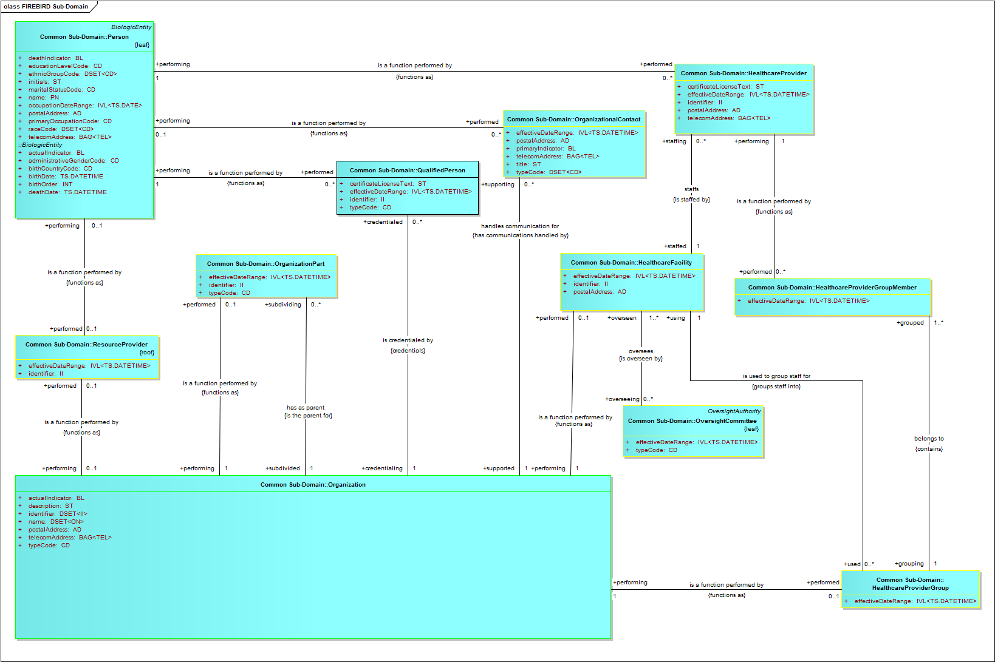
Figure 4 – NCI OCR Localization of the BRIDG Model

Design Model

Overview
The Design Model is the most significant model for understanding NCI OCR’s technical structure. This section of the document first describes the structural hierarchy of the system in layers, packages, and components and then goes on to describe how these elements collaborate to provide the most architecturally significant functionality. Figure 5 shows the organization of the system into layers and highlights the most important components and dependencies. NCI OCR is implemented as a Java EE 5 application consistent with the NCI CBIIT current and future tech stacks. The sections that follow will provide greater detail about the core components and their supporting technologies.
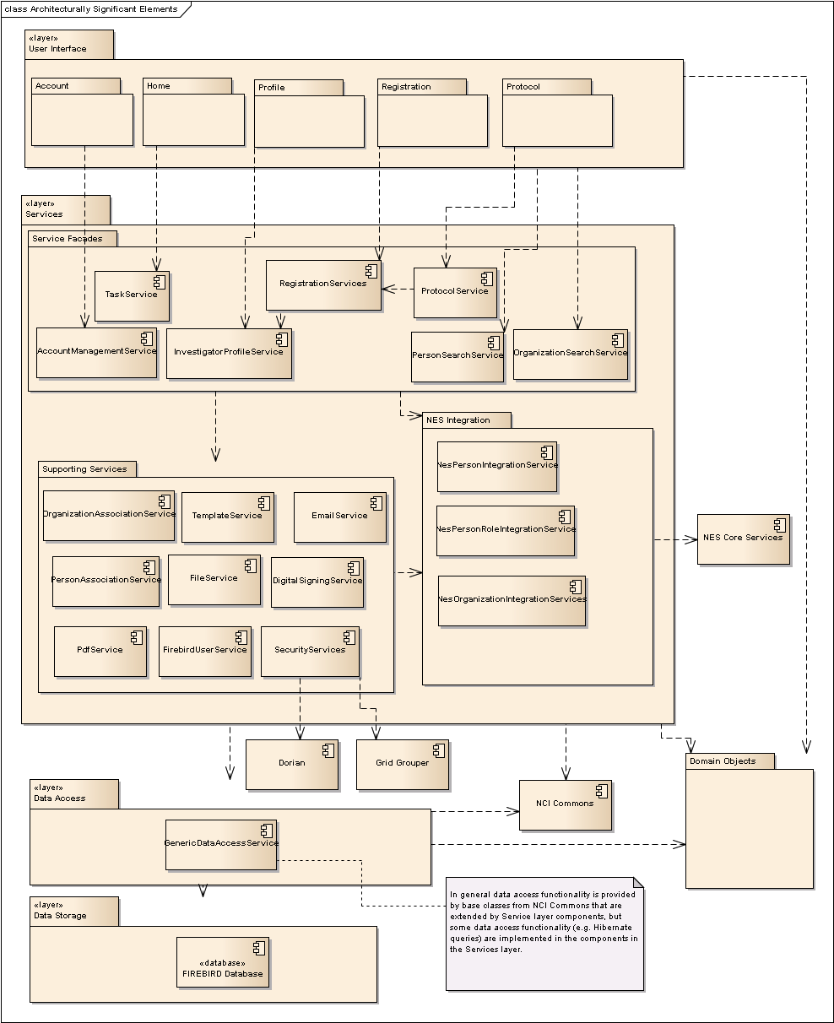
Figure 5: System Architecture

Dependency Injection
Before describing the contents of the various NCI OCR components, it would be helpful to describe the mechanism used to provide all the various components’ dependencies. As one would expect, components expose functionality through Java interfaces and dependencies between components are via the exposed interfaces. This approach leads to better modularity and improved testability.
The provision of depended-upon interfaces is done with dependency injection provided by Guice 2.0. This framework allows the declaration of modules that provide interface implementations and then uses annotations in client classes to provide the necessary interfaces. Figure 6 below shows the modules used to provide implementations for necessary component interfaces. The dependencies shown between modules are not actual declarative Java dependencies; they are shown for illustrative purposes to indicate which modules and artifacts provide lower level dependencies that are required by higher-level modules.
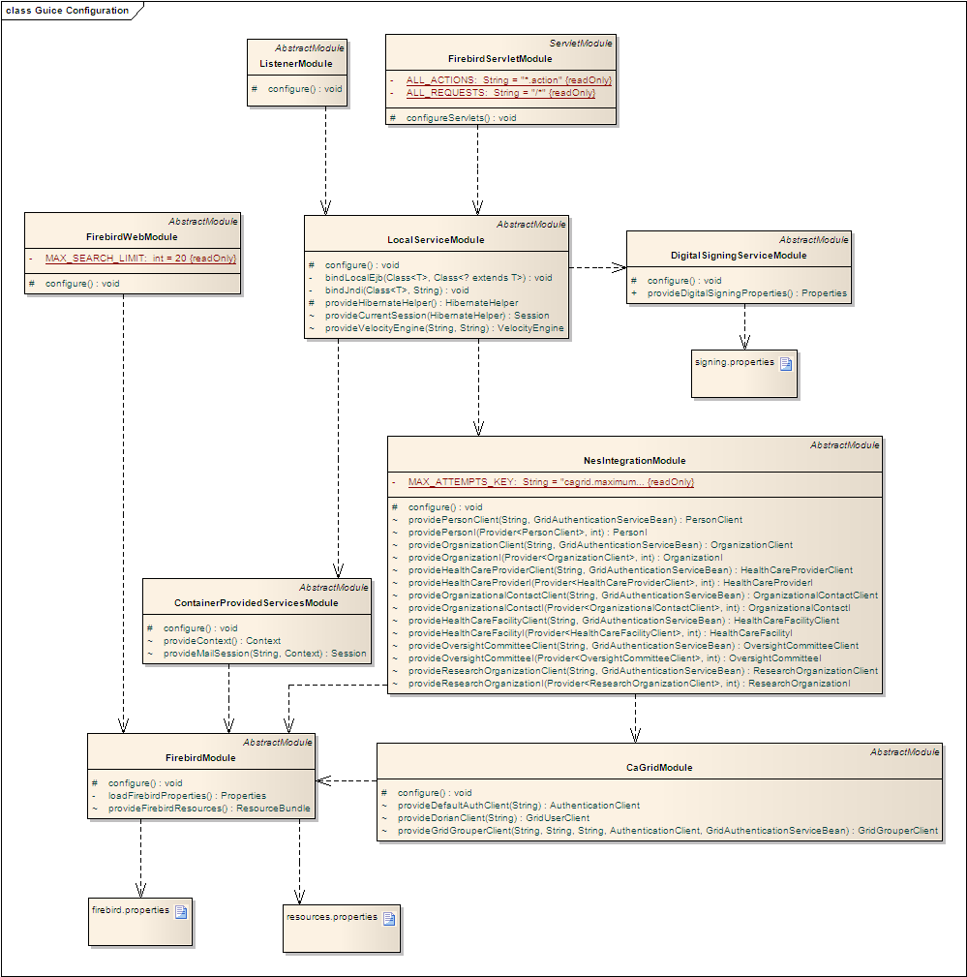
Figure 6 – Indirect Guice Module Relationships
EJB dependencies are provided through use of a custom EJB interceptor (GuiceEjbInterceptor) that ensures that all Guice provided dependencies are injected into a target EJB before a business method is invoked.

Authentication and Authorization
Currently All NCI OCR users are authenticated using credentials via a trusted identity provider in the caGrid trust fabric retrieved from Dorian. The sole identity provider allowed for our production instance delegates to NCI’s LDAP and as such NCI OCR’s authentication security policy is provided by the policy enforced by NCI’s LDAP. User roles are stored in Grid Grouper.
In anticipation of supporting authentication and authorization from multiple sources (caGrid and CTEP IAM), these functions have been abstracted to a common interface that has different implementations based on the security provider. This design, along with the current IAM stub implementation is show in Figure 7 below.
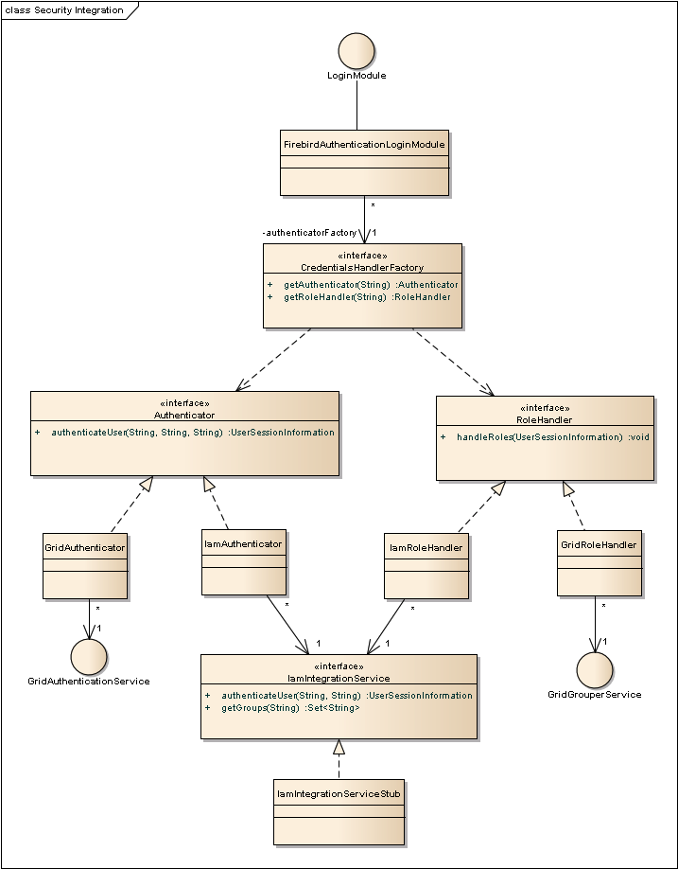
Figure 7 - Authentication and Authorization Integration
In this design, the FirebirdAuthenticationLoginModule provides an implementation of the standard JAAS LoginModule interface that provides the security integration point for JBoss. The FirebirdAuthenticationLoginModule uses a provided CredentialsHandlerFactory to access the Authenticator or RoleHolder (for authorization) appropriate for the set of login credentials that are provided. If the user provides caGrid credentials, the GridAuthenticator and GridRoleHandler will be used to verify credentials and roles. If IAM credentials are provided, the IamAuthenticator and IamRoleHandler will be used. As shown above, these depend on an IamIntegrationService interface, which is currently implemented by a simple stubbed implementation. If integration proceeds, the IamIntegrationService implementation will retrieve a SAML assertion from the actual IAM authentication service. If it is decided that integration will not proceed, we will remove the IAM classes and interfaces while leaving the security framework in place should we need to support additional security providers in the future.

User Interface Layer
The User Interface layer provides a web-application front-end to NCI OCR. This is the only subsystem that is currently accessible to external users or systems. All components implemented in the Services layer are internal to the application and do not expose remote interfaces. The User Interface layer is accessible to web clients via HTTPS.
The User Interface layer is implemented using standard Java EE 5 web technologies including JSP 2.1 and Servlet 2.5. NCI OCR’s web tier also employs Struts 2.1 to provide the basic request and response-handling framework. This layer provides presentation, navigation and validation functionality only; all application logic is implemented in the Services layer.
For page layout template functionality, NCI OCR uses Sitemesh 2.4. To provide a richer “Web 2.0” user experience, NCI OCR makes use of jQuery, typically via the Struts 2 jQuery plug-in version 2.5. The user interface has been designed to meet Section 508 compliance requirements and has been verified to be in compliance. Furthermore, a bridge from Struts 2 validation to the Hibernate Validator framework is included that allows the definition of these constraints to come straight from the data model.
As can be seen in the architecture diagram, JSPs and Struts actions are divided along functional lines (e.g. Profile management, Registration handling, etc.) to keep a clear separation of functionality and to support role-based access restrictions.
The pages presented to the web client use HTML and JavaScript only; no applets or other client-side component technologies are used. Many pages are dynamically updated based on user input without a complete page refresh using Ajax. This allows us to improve responsiveness, implement tabbed interfaces, and improve application usability.

Services Layer
The Services layer encapsulates all the business functionality of the application. User Interface layer objects access the services layer through a limited set of the service interfaces identified in the Services Façade package in the architecture diagram. Functionality that is not directly implemented by these components is handled by the Supporting Service components, NES Integration components or by lower layers of the application. Generally speaking, services are implemented as EJB 3.0 stateless session beans that expose local interfaces. Exceptions will be noted in the sections that follow (typically these are implemented as POJOs that don’t require the services that are provided by the EJB container).

Services Façade
These services provide access to the higher-level business functionality required by the User Interface tier and provide a simplified interface to the complete set of business functionality.

Task Service
This service iterates through the various domain objects attached to a user’s roles and identifies tasks that are either not yet started or are incomplete and formats a list of Task objects that can be presented to the user as requiring attention.

Investigator Profile Service
This service provides methods for an Investigator (or Sub-investigator) to retrieve and update the profile information that will be used to complete Registrations. Examples of the sort of information that are maintained in a Profile include the Investigator’s contact information, associated organizations (practice sites, clinical laboratories, etc.), and academic and experiential credentials.

Protocol Service
The Protocol service provides methods for a Sponsor organization representative to add and edit Protocols for which Investigators must provide Registrations. This component also provides the functionality for Sponsor representatives to look up Investigators and associate and invite them to submit their Protocol Registrations.

Registration Services
In anticipation of supporting annual registrations for CTEP, the registration services have been broken out into a hierarchy where common functionality is provided by base implementation and interface and then further specialized to handle protocol based and annual registrations. The hierarchy of interfaces and their implementations are shown below in Figure 8.
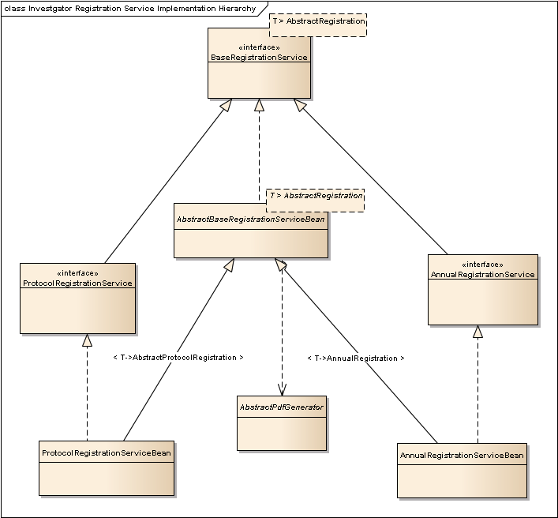
Figure 8- Registration Service Hierarchy
A common base implementation AbstractBaseRegistrationServiceBean provides functionality common to all registration types including core PDF generation and signing capabilities. Specializations of this base implementation provide the extended functionality specified by the ProtocolRegistrationService and AnnualRegistrationService interfaces as well as providing special handling of any common elements required for a given registration type.

Person and Organization Search Services
The Person Search Service and Organization Search Services provide a unified façades to searching both the local NCI OCR data store and the NES PO services for records. Records from both sources are combined, duplicates filtered out and the results sorted by name. In cases where the record is found locally, this record is presented rather than the NES result as the NES result may not include pending updates from NCI OCR (updates are not visible until curated). The design for the Person Search Service is shown in Figure 9 below. The Organization Search Service follows a similar design.
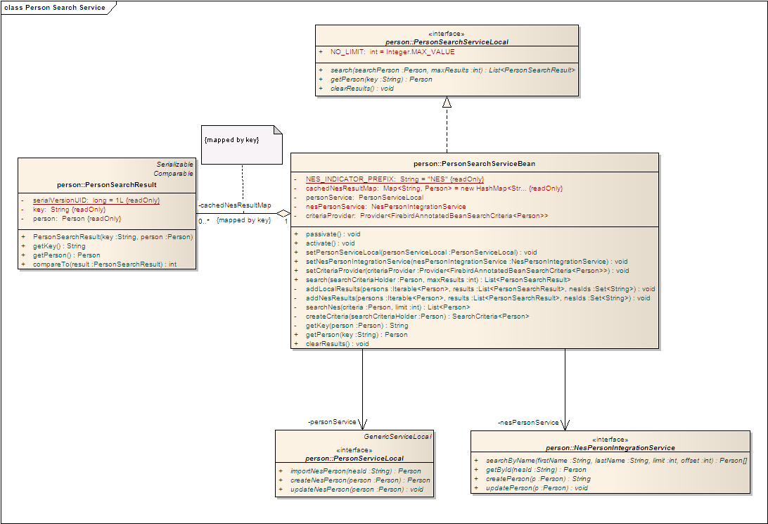
Figure 9 – Person Search Service Design

Supporting Services

Email Service
Certain application events, for example notifying Investigators that they have been invited to register for a given Protocol, require email notification. The Email Service component provides the functionality to email recipients. This component uses both the javax.mail API and Apache Commons Email 1.2 to simplify mail handling.
The Email Service component is implemented as a simple POJO as it doesn’t require any of the services provided by the EJB container.

Template Service
Some elements in the application (including the email service above) require content in the service tier that includes template placeholders and requires externalization. To provide this functionality, NCI OCR includes a Template Service component that provides several operations to generate content from templates providing the necessary parameter substitutions. The Template Service uses Velocity 1.7 as the underlying template parameter replacement mechanism.
The Template Service component is implemented as a simple POJO as it doesn’t require any of the services provided by the EJB container. Templates are specified as enums that list their required parameters (also enums) which allows for runtime checking to ensure that all necessary parameters have replacement values. Figure 8 shows the design of this component.
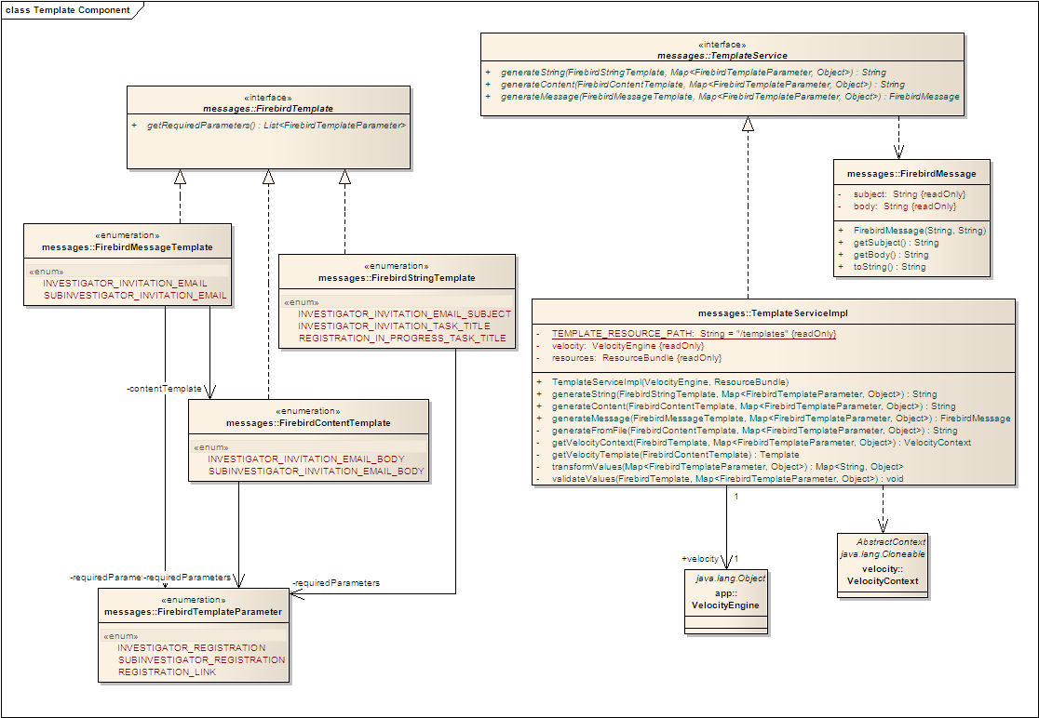
Figure 10 - Template Component Design

File Service
The File Service is a general-purpose file content handling service. This service provides methods to read and persist files from InputStreams that are passed in and methods to write file content to OutputStreams.

Digital Signing Service
The Digital Signing Service component provides all the necessary functionality to securely electronically sign PDF documents. The functionality includes key generation, PDF signing and PDF flattening and appending. The service uses the BouncyCastle cryptographic provider to provide SHA-2 strength cryptographic hash functions. Figure 10 below shows the contents of this component. The iText 5.0 framework provides PDF manipulation capabilities.
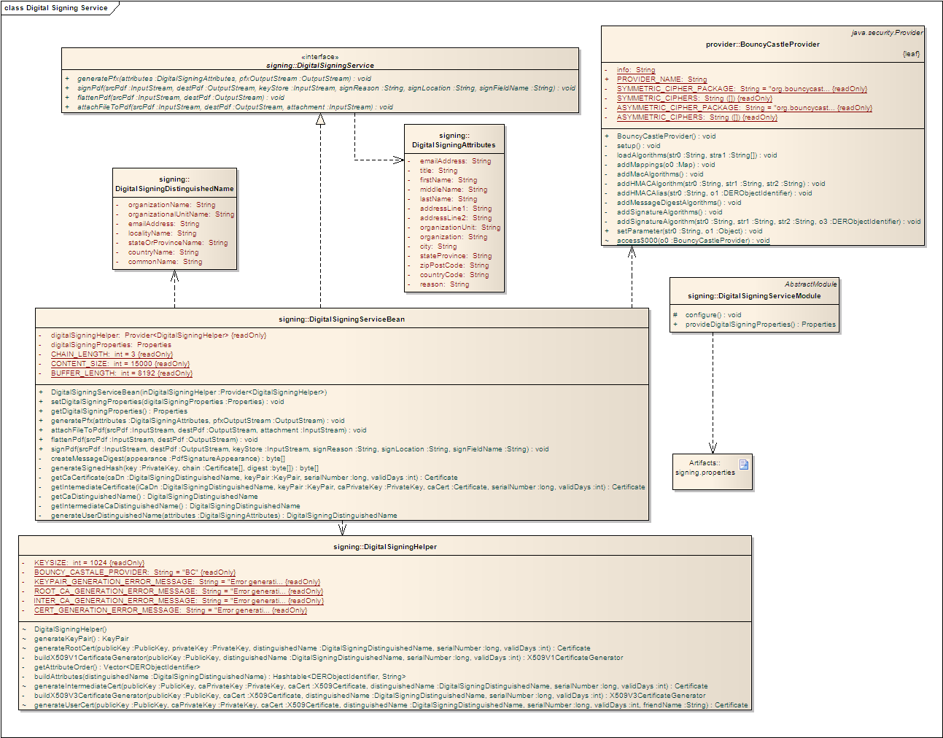
Figure 11 – Digital Signing Service Component Design

Person Association Service
The Person Association service provides simple functionality to ensure that associations from a Profile to an associated person (e.g. a Sub-investigator or Shipping Designee) are persisted and that any necessary NES records are created via the NesPersonIntegrationService.

Organization Association Service
The Organization Association service ensures that associations between Profiles and Organizations are persisted and correctly recorded in the NES Organization and structural role services. This component requires translation between NCI OCR organization roles and NES Organization Roles as the mapping is not entirely straightforward. The Organization Association Service uses an internal mapping and additional information when necessary to determine how to translate Practice Sites, Labs and IRBs in NCI OCR into HealthCareFacilities, ResearchOrganizations and OversightCommittees in NES. Figure 12 below shows the service methods exposed by the service and the implementation’s relationship to the objects and NES integration services it must work with to effect the necessary translations and storage in NES.
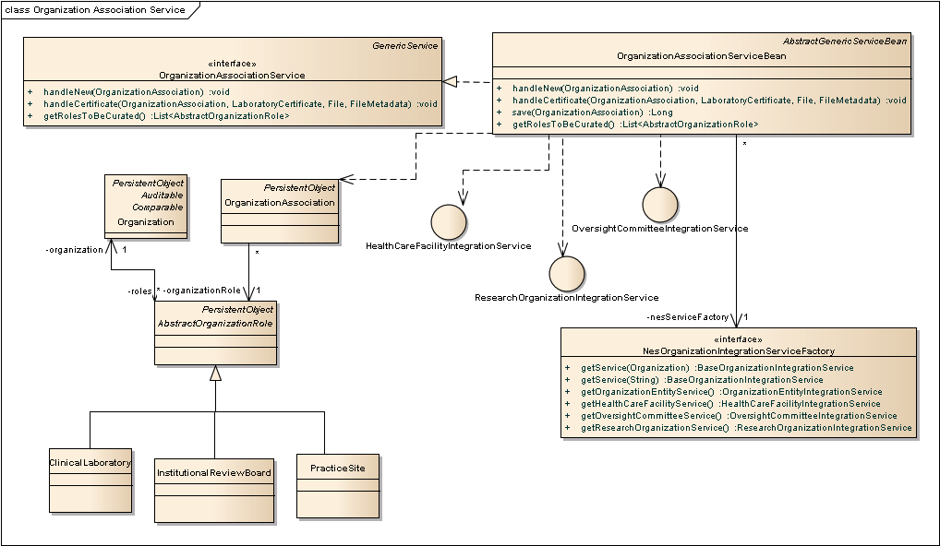
Figure 12 – Organization Association Service and Dependencies

NES Integration
The components in the gov.nih.nci.firebird.nes sub-packages provide facades for the integration with the NES services required by NCI OCR (Person, Organization and various Correlation services). They manage the translation between the NES ISO 21090 data models and our local persistence model and make the calls to the NES grid services when invoked. Prior to describing the design of these components, Figure 13 below shows the NES entities and roles used within NCI OCR and our localization to help provide context.
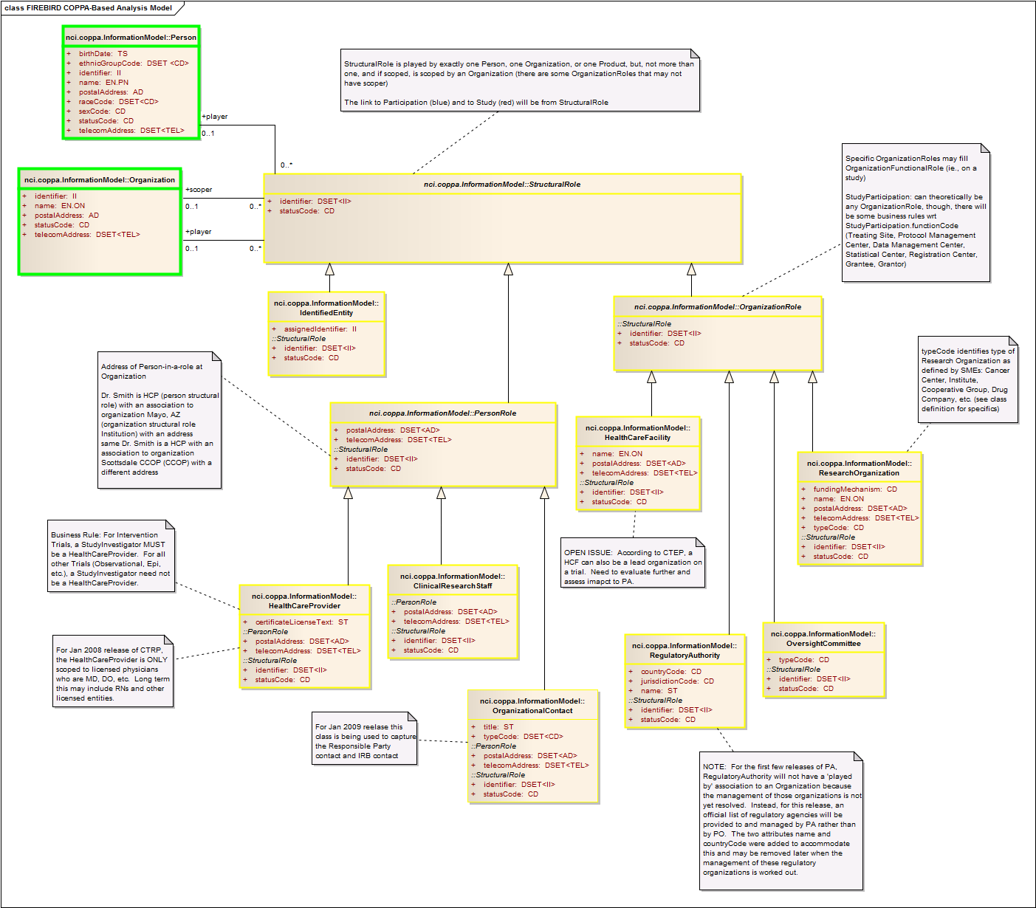
Figure 13 – NCI OCR Localization of the COPPA (NES) Model
The retrieval, creation and update of NES persons are handled by a single component: the NesPersonIntegrationService. The implementation of this service is shown in Figure 13. Management of Organization entities and their structural roles are handled through a common hierarchy of internal NES integration services. This allows for common handling of organizations and structural roles in terms of a common NCI OCR Organization class. These components are shown in Figure 13. All of these integration components are implemented as POJOs encapsulated behind interfaces, as none of the services provided by the EJB framework are necessary for their functionality.
Because Person and Organization records are subject to external data and curation changes, NCI OCR needs to ensure that the locally cached representations of these entities are kept up to date. In order to support this requirement while not negatively affecting usability, an asynchronous service call is made to ProfileNesRefreshService when an investigator or registration coordinator logs in. For maximum assurance, all referenced entities are refreshed from NES when an investigator digitally signs a protocol registration.
The Person, Organization and Structural Role objects retrieved via these NES services are translated to a local object representation and persisted locally. New or updated objects are translated from the NCI OCR object representation to the corresponding NES service object representation and sent to the corresponding service. The translation allows NCI OCR to work more easily and naturally with the objects in question and the local persistence of these entities facilitates the performance needs of the application. Translation is performed using custom NCI OCR classes that can translate between the two formats.
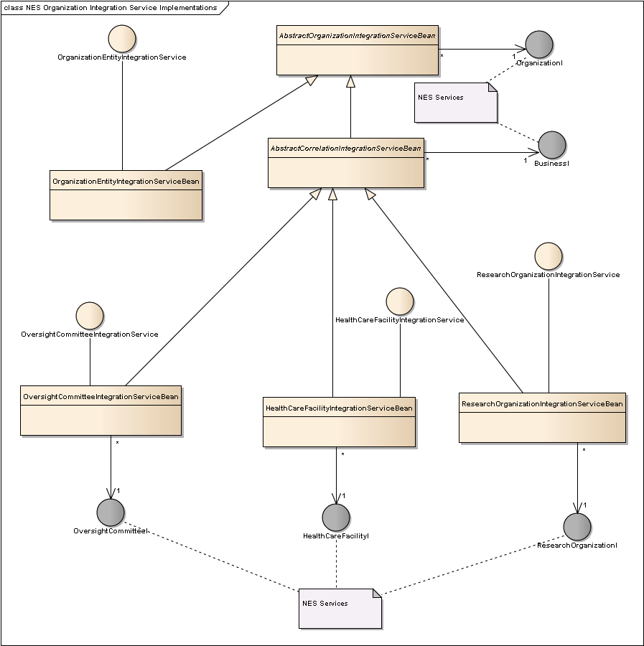
Figure 14 – NES Person and Organization Integration Components
A common BaseOrganizationIntegrationService interface defines methods common to all NES organization integration services. Specializations of this interface are provided for the NES Organization entity service and for each structural role service that we interact with, these being the HealthCareFacility, Oversight Committee and ResearchOrganization services. These can be considered facades that provide a shared method for accessing the underlying NES services. A supporting service, IdentifiedOrganizationIntegrationService is provided to handle working with CTEP identifiers and a factory interface (NesOrganizationIntegrationServiceFactory) is provided for clients to access the services they depend on.
Because the NES grid services are network based and prone to various possible non-programming related failures (for example, network failures causing communication to drop during a method call), all references to NES service interfaces are wrapped in a Java dynamic proxy with an invocation handler that is able to retry failed calls a configurable number of times. Figure 15 below shows the design that supports this fault-tolerant approach. Also, as concurrent access via a single NES client (e.g. PersonClient) is serialized we have adopted Apache Commons Pool as a pooling provider for client instances.
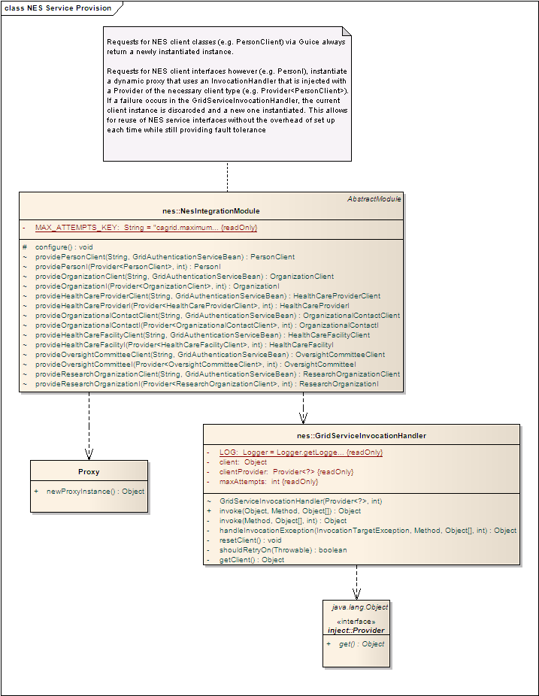
Figure 15 – NES Service Interface Provisioning

Data Access Layer
Data access is configured and performed using Hibernate 3.3 framework. The persistence layer also makes use of common reusable persistence functionality provided by the nci-commons-core persistence framework. This framework provides common functionality via base classes and interfaces that take application classes as formal parameters to generics defined in these elements. The nci-commons-core package also provides the @Searchable framework. The @Searchable framework is a Query-By-Example (QBE) mechanism that uses Java annotations to specify behavior for individual fields. It is integrated with the nci-commons-struts2 package at the UI tier.
As noted in the diagram, while most persistence functionality is provided by the base classes from nci-commons-core, some persistence logic (generally service-specific Hibernate queries) are implemented directly in the service components in the Services layer.

Domain Objects
All of the components described so far use the NCI OCR Domain Objects that are defined in the gov.nih.nci.firebird.data package to communicate and manage data and state changes. These objects are persistent with persistence mapping defined via JPA and Hibernate annotations on classes in this package. As was noted earlier, NES entities (e.g. Persons and Organizations) have corresponding representations in the NCI OCR domain model and are translated between formats when communicating with NES.

NCI OCR Database
The application database component represents the PostgreSQL database schema that is used to store all of NCI OCR’s persistent data. The schema is generated directly from Hibernate annotations recorded in the NCI OCR Domain Classes so that the schema and domain classes are kept easily synchronized. NCI OCR supports PostgreSQL version 8.4.x. Several data diagrams follow below as Figures 16 – 20 illustrating the underlying tables and relationships in the data layer.
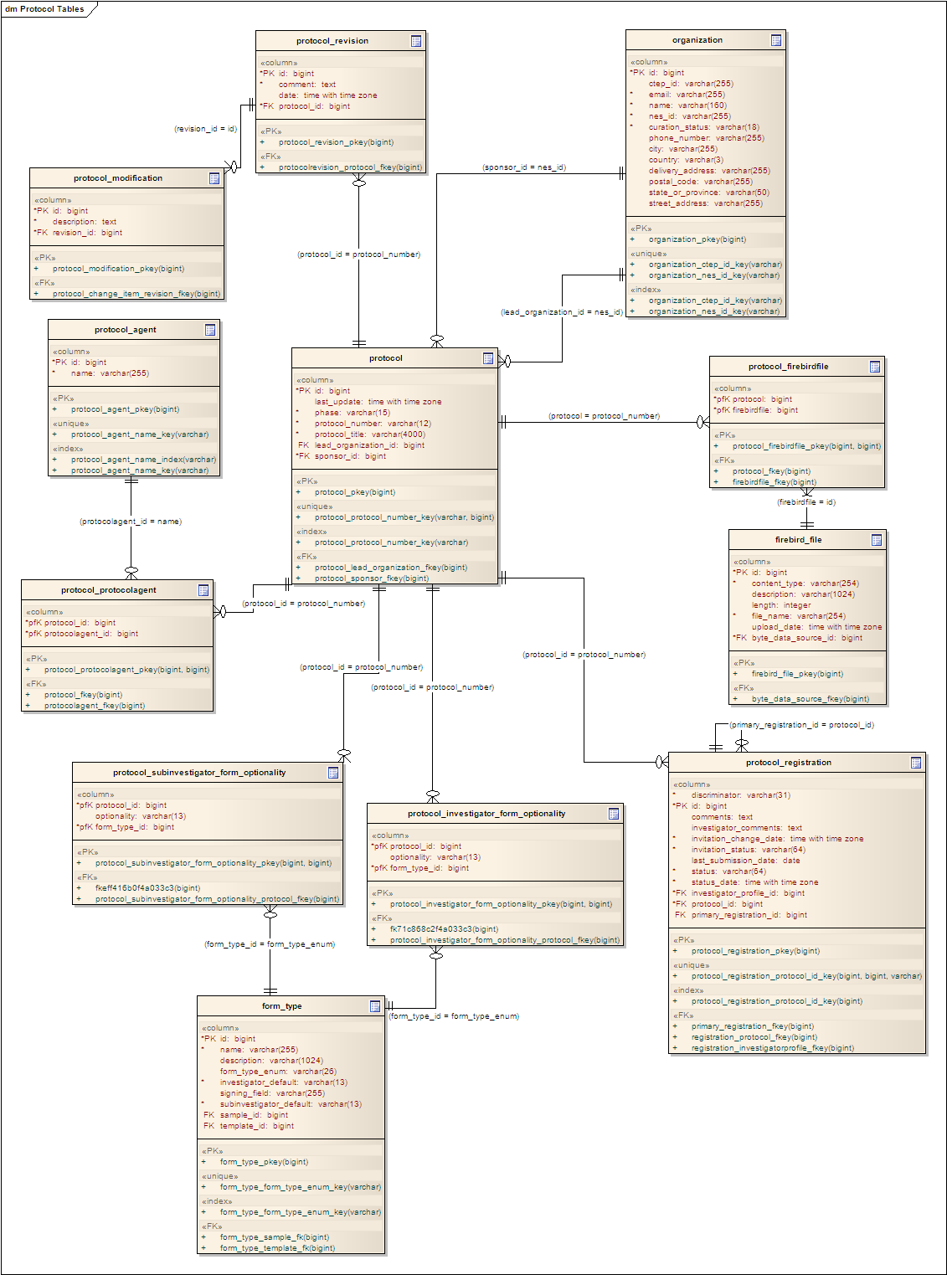
Figure 16 – Protocol Tables
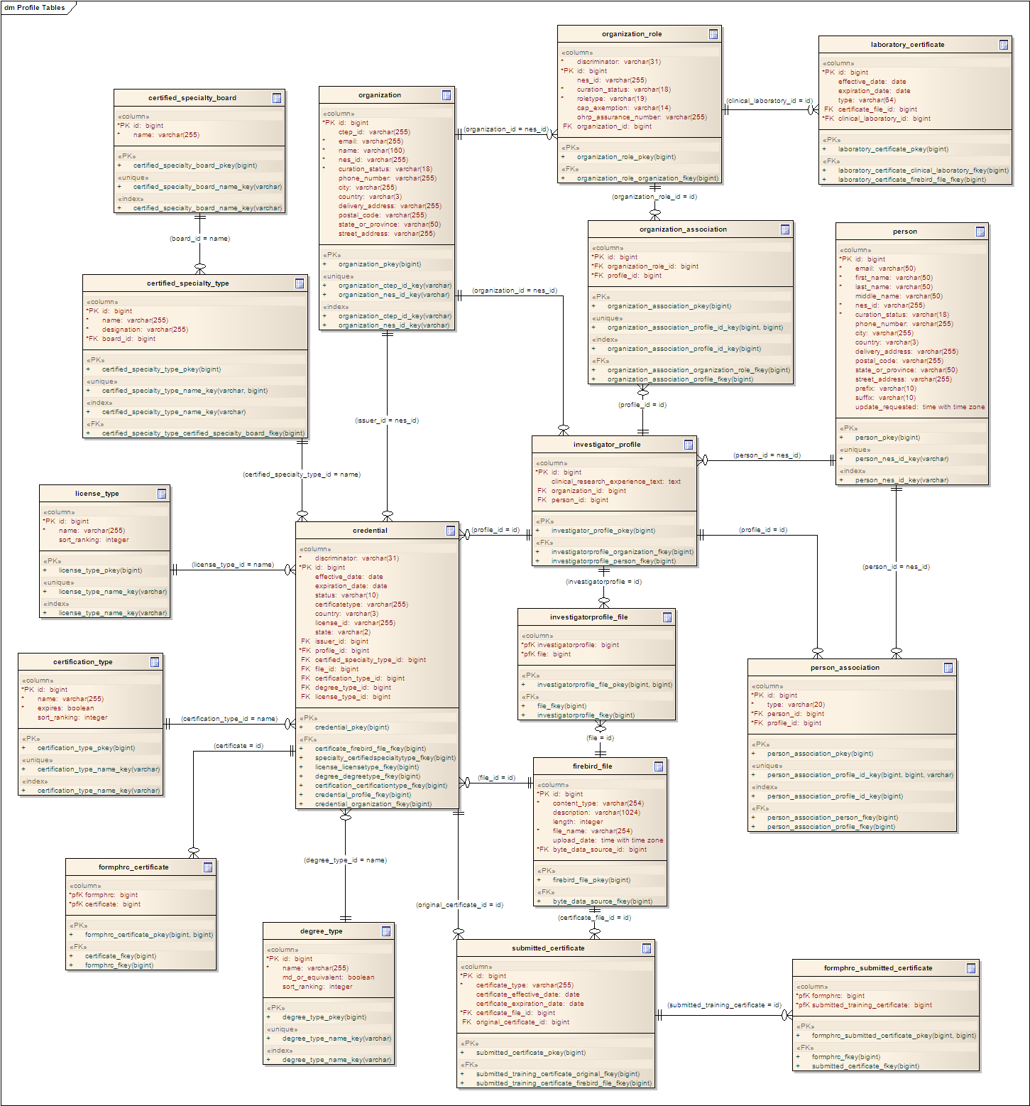
Figure 17 – Investigator Profile Tables
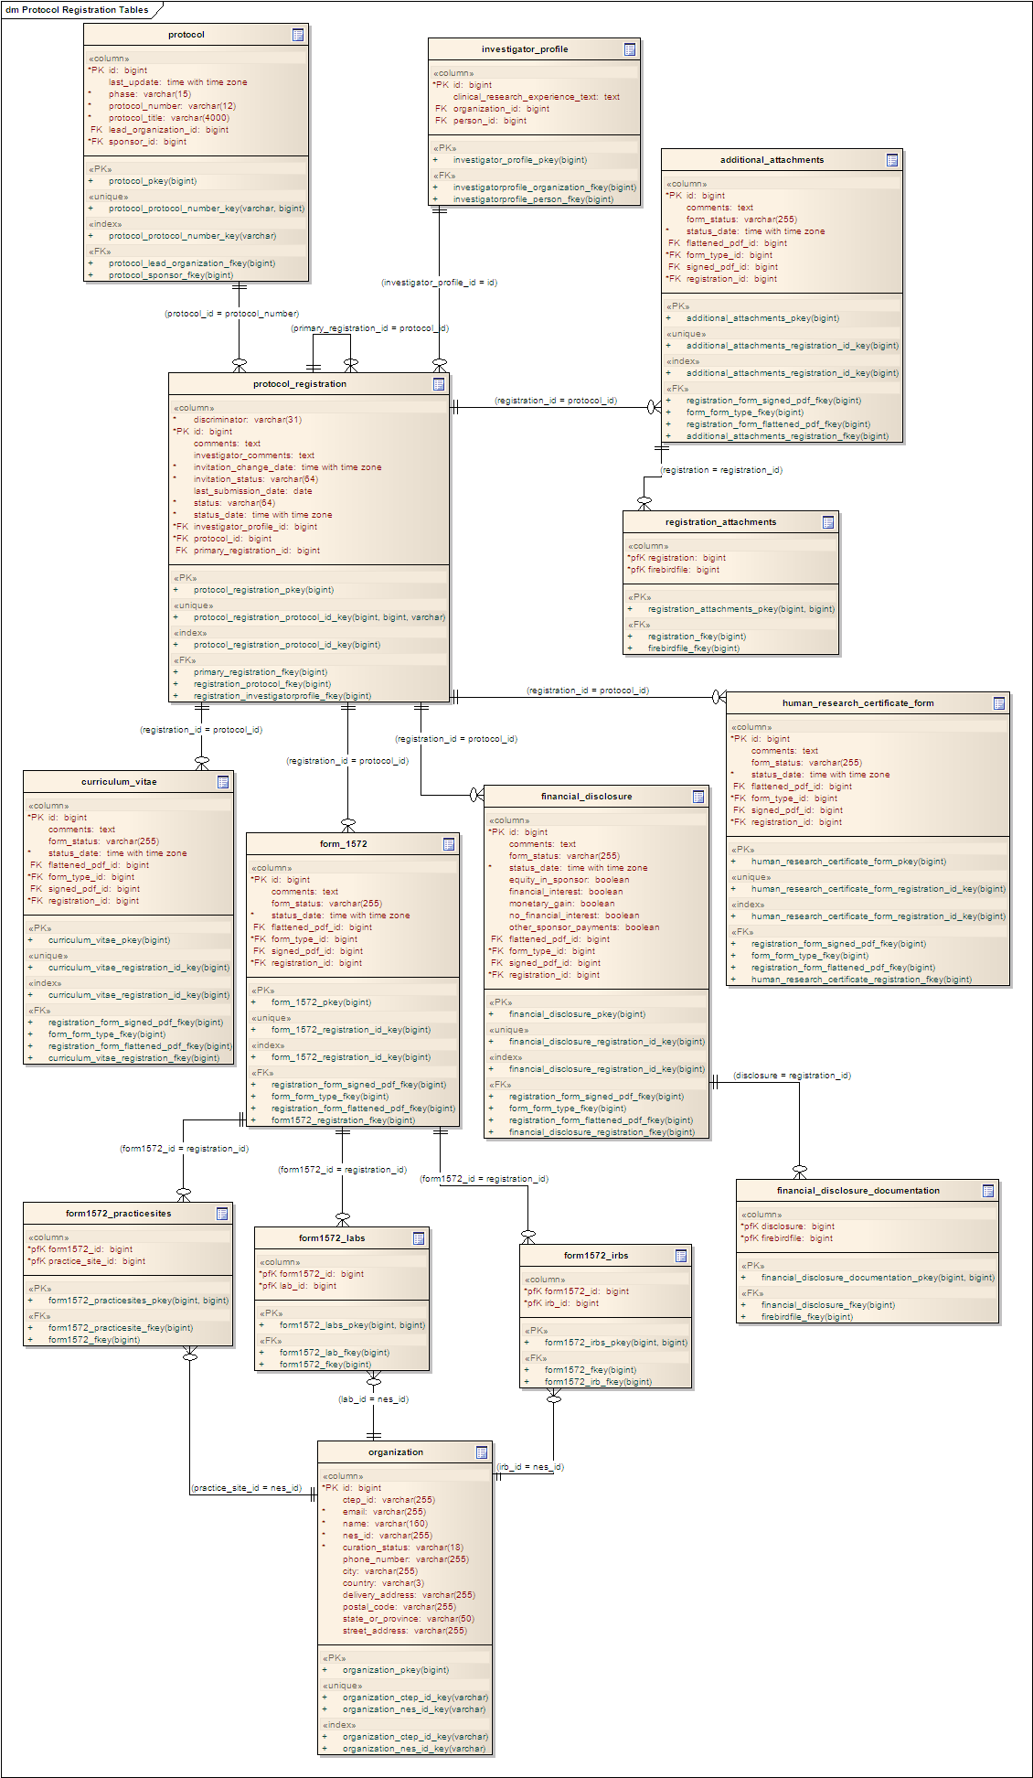
Figure 18 – Protocol Registration Tables
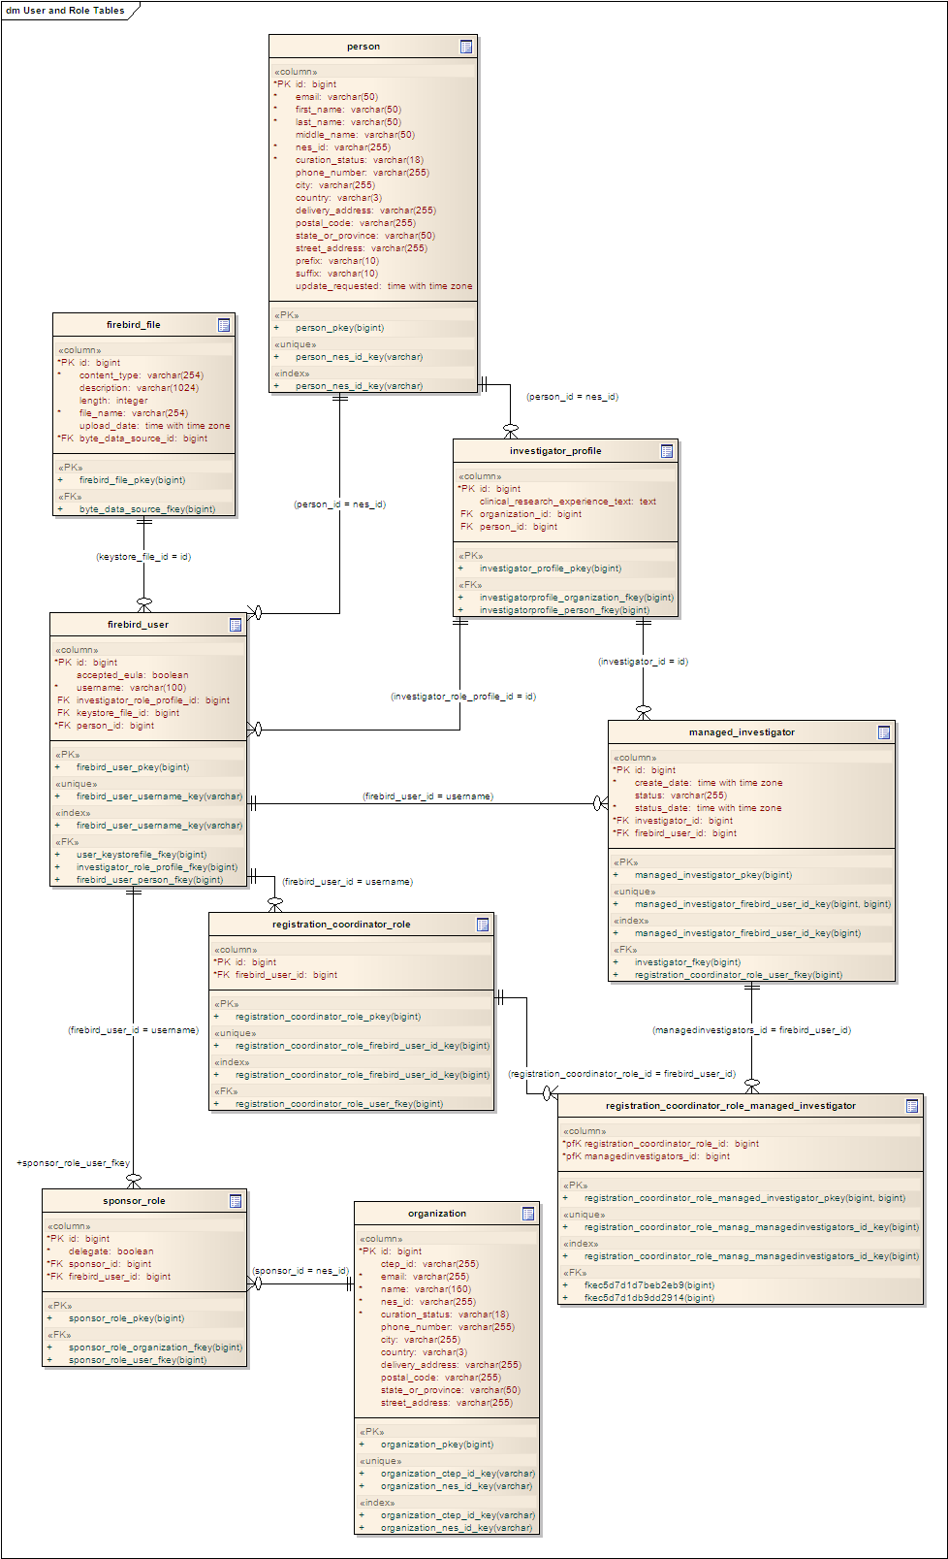
Figure 19 – User and Role Tables
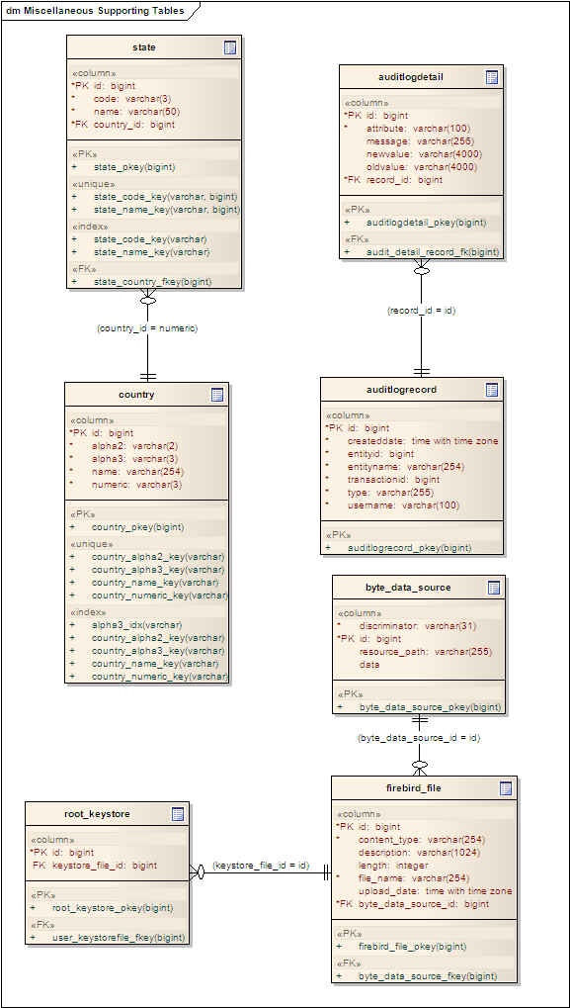
Figure 20 – Miscellaneous Supporting Tables

Deployment Model

Overview
Figure 21 below illustrates the major physical artifacts that comprise the NCI OCR software deployment units. The major artifacts and their relationships to the subsystems they realize are described in Section 7.2.
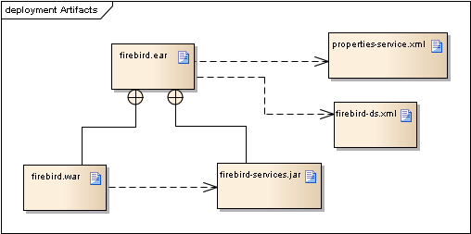
Figure 21 – NCI OCR Deployment Artifacts

Artifacts

firebird.ear
The firebird.ear artifact is the Java EE 5 Enterprise Application Archive (EAR) that contains all of the web portal application and EJB components that make up the User Interface, Application Logic, and Business Logic layers of the application. The EAR also contains the third-party JARs necessary to support the Application and Business Logic Layers of the application. Hibernate (annotations and core) are the core ORM tools. The nci-commons-core jar provides 5am-developed utility classes.
The firebird.ear artifact depends on two files with externalized configuration information. The firebird-ds.xml file defines the database connection pool and database connection information. The firebird-ds.xml file contains all the externalized configurable properties necessary for the application’s configuration in a particular deployment environment.

firebird.war
The firebird.war artifact packages the JSPs and the NCI OCR Struts 2 classes that comprise the User Interface layer of NCI OCR. The WAR also contains the Struts 2 third-party JARs and necessary supporting JARs.

firebird-services.jar
The firebird-services.jar contains the NCI OCR Domain Classes packages and service tier. The major third-party component dependencies noted are hibernate3.jar and hibernate-annotations.jar to support annotation-based Hibernate ORM mapping.

Deployment
Figure 21 below shows the expected deployment scenario for NCI OCR including dependencies on an external database server and NES services. Service URLs for NES services and authentication providers are externalized into properties files that are used at deployment time to properly configure the deployed NCI OCR installation. There are no special deployment configurations are required to ensure fault tolerance; these are instead designed into the application in its use of container provided services and the fault tolerant proxies employed for remote service access.
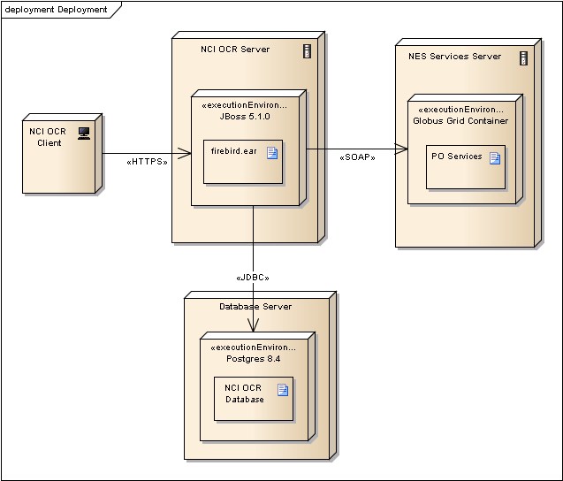
Figure 22 – NCI OCR Deployment Architecture

