Event Log 1:00:40 PM 12/10/2010
Spreadsheet: Verfiry_HUGO_Hierarchy.xls
Spreadsheet Row: 6
Expected value:
withdrawn_group(Codewithdrawn_group)
Did not match actual value:
Found in page text: HUGOVersion:July2010ExactMatchBeginsWithContainsName/CodePropertyRelationshipHome|ViewHierarchy|HelpEVSHomeNCIMetathesaurusBrowserNCIThesaurusBrowserNCITermBrowserNCITerminologyResourcesWelcomeHumanGenomeOrganisation(HUGO)GeneNomenclatureCommitteeattheEuropeanBioinformaticsInstituteapprovesagenenameandsymbol(short-formabbreviation)foreachknownhumangene.AllapprovedsymbolsarestoredintheHGNCdatabase.Eachsymbolisuniqueandeachgeneisonlygivenoneapprovedgenesymbol.Thisfacilitateselectronicdataexchangeandretrieval.Inpreferenceeachsymbolmaintainsparallelconstructionindifferentmembersofagenefamilyandcanalsobeusedinotherspecies,especiallythemouse.HUGOhasalreadyapprovedover28,000symbols;thevastmajorityoftheseareforprotein-codinggenes,butalsoincludesymbolsforpseudogenes,non-codingRNAs,phenotypesandgenomicfeatures.HUGOassignsnomenclaturetogenessubmittedbytheHumanGenomeProject,aswellasbyscientists,journals(e.g.Genomics,NatureGenetics),databases(e.g.Ensembl,EntrezGene,MGD,RGDandOMIM),andresearchersworkingongenefamilies,chromosomesegmentsorwholechromosomes.Inallcases,considerableeffortsaremadetouseasymbolacceptabletoworkersinthefield.Seehttp://www.genenames.orgfordetails.SourceHomePage:http://www.genenames.org/cgi-bin/hgnc_stats.plcaBIGVKCLink:https://cabig-kc.nci.nih.gov/Vocab/KC/index.php/Human_Genome_Organisation_OntologyNCIEnterpriseVocabularyServices:TerminologyresourcesandservicesforNCIandthebiomedicalcommunity.NCIMetathesaurus:Comprehensivedatabaseof3,600,000termsfrom76terminologies.NCITermBrowser:NCIandotherterminologiesinanintegratedenvironment.NCITerminologyResources:MoreinformationonNCIdictionariesandresources.NCIHome|ContactUs|Policies|Accessibility|FOIAAServiceoftheNationalCancerInstitute
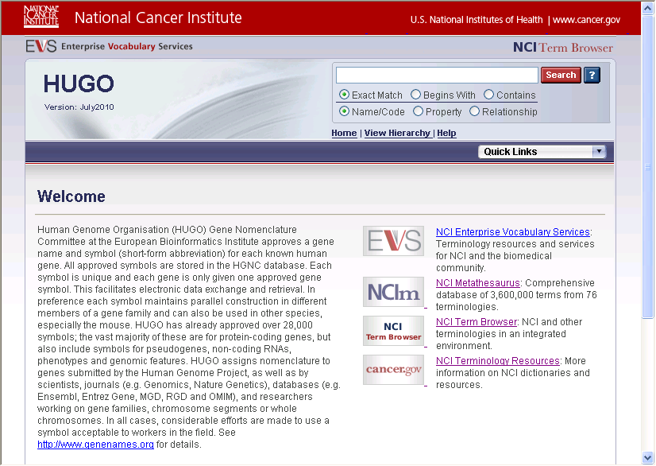
Failed

Event Log 1:02:28 PM 12/10/2010
Spreadsheet: Verfiry_HUGO_Hierarchy.xls
Spreadsheet Row: 6
Expected value:
withdrawn_group(Codewithdrawn_group)
Did not match actual value:
Found in page text: HUGOVersion:July2010ExactMatchBeginsWithContainsName/CodePropertyRelationshipHome|ViewHierarchy|HelpEVSHomeNCIMetathesaurusBrowserNCIThesaurusBrowserNCITermBrowserNCITerminologyResourcesWelcomeHumanGenomeOrganisation(HUGO)GeneNomenclatureCommitteeattheEuropeanBioinformaticsInstituteapprovesagenenameandsymbol(short-formabbreviation)foreachknownhumangene.AllapprovedsymbolsarestoredintheHGNCdatabase.Eachsymbolisuniqueandeachgeneisonlygivenoneapprovedgenesymbol.Thisfacilitateselectronicdataexchangeandretrieval.Inpreferenceeachsymbolmaintainsparallelconstructionindifferentmembersofagenefamilyandcanalsobeusedinotherspecies,especiallythemouse.HUGOhasalreadyapprovedover28,000symbols;thevastmajorityoftheseareforprotein-codinggenes,butalsoincludesymbolsforpseudogenes,non-codingRNAs,phenotypesandgenomicfeatures.HUGOassignsnomenclaturetogenessubmittedbytheHumanGenomeProject,aswellasbyscientists,journals(e.g.Genomics,NatureGenetics),databases(e.g.Ensembl,EntrezGene,MGD,RGDandOMIM),andresearchersworkingongenefamilies,chromosomesegmentsorwholechromosomes.Inallcases,considerableeffortsaremadetouseasymbolacceptabletoworkersinthefield.Seehttp://www.genenames.orgfordetails.SourceHomePage:http://www.genenames.org/cgi-bin/hgnc_stats.plcaBIGVKCLink:https://cabig-kc.nci.nih.gov/Vocab/KC/index.php/Human_Genome_Organisation_OntologyNCIEnterpriseVocabularyServices:TerminologyresourcesandservicesforNCIandthebiomedicalcommunity.NCIMetathesaurus:Comprehensivedatabaseof3,600,000termsfrom76terminologies.NCITermBrowser:NCIandotherterminologiesinanintegratedenvironment.NCITerminologyResources:MoreinformationonNCIdictionariesandresources.NCIHome|ContactUs|Policies|Accessibility|FOIAAServiceoftheNationalCancerInstitute
Failed

Event Log 1:02:28 PM 12/10/2010
Spreadsheet: Verfiry_HUGO_Hierarchy.xls
Spreadsheet Row: 7
Expected value:
TermsandProperties
Did not match actual value:
Found in page text: HUGOVersion:July2010ExactMatchBeginsWithContainsName/CodePropertyRelationshipHome|ViewHierarchy|HelpEVSHomeNCIMetathesaurusBrowserNCIThesaurusBrowserNCITermBrowserNCITerminologyResourcesWelcomeHumanGenomeOrganisation(HUGO)GeneNomenclatureCommitteeattheEuropeanBioinformaticsInstituteapprovesagenenameandsymbol(short-formabbreviation)foreachknownhumangene.AllapprovedsymbolsarestoredintheHGNCdatabase.Eachsymbolisuniqueandeachgeneisonlygivenoneapprovedgenesymbol.Thisfacilitateselectronicdataexchangeandretrieval.Inpreferenceeachsymbolmaintainsparallelconstructionindifferentmembersofagenefamilyandcanalsobeusedinotherspecies,especiallythemouse.HUGOhasalreadyapprovedover28,000symbols;thevastmajorityoftheseareforprotein-codinggenes,butalsoincludesymbolsforpseudogenes,non-codingRNAs,phenotypesandgenomicfeatures.HUGOassignsnomenclaturetogenessubmittedbytheHumanGenomeProject,aswellasbyscientists,journals(e.g.Genomics,NatureGenetics),databases(e.g.Ensembl,EntrezGene,MGD,RGDandOMIM),andresearchersworkingongenefamilies,chromosomesegmentsorwholechromosomes.Inallcases,considerableeffortsaremadetouseasymbolacceptabletoworkersinthefield.Seehttp://www.genenames.orgfordetails.SourceHomePage:http://www.genenames.org/cgi-bin/hgnc_stats.plcaBIGVKCLink:https://cabig-kc.nci.nih.gov/Vocab/KC/index.php/Human_Genome_Organisation_OntologyNCIEnterpriseVocabularyServices:TerminologyresourcesandservicesforNCIandthebiomedicalcommunity.NCIMetathesaurus:Comprehensivedatabaseof3,600,000termsfrom76terminologies.NCITermBrowser:NCIandotherterminologiesinanintegratedenvironment.NCITerminologyResources:MoreinformationonNCIdictionariesandresources.NCIHome|ContactUs|Policies|Accessibility|FOIAAServiceoftheNationalCancerInstitute
Failed

Event Log 1:04:01 PM 12/10/2010
Spreadsheet: Verfiry_HUGO_Hierarchy.xls
Spreadsheet Row: 6
Expected value:
withdrawn_group(Codewithdrawn_group)
Did not match actual value:
Found in page text: HUGOVersion:July2010ExactMatchBeginsWithContainsName/CodePropertyRelationshipHome|ViewHierarchy|HelpEVSHomeNCIMetathesaurusBrowserNCIThesaurusBrowserNCITermBrowserNCITerminologyResourcesWelcomeHumanGenomeOrganisation(HUGO)GeneNomenclatureCommitteeattheEuropeanBioinformaticsInstituteapprovesagenenameandsymbol(short-formabbreviation)foreachknownhumangene.AllapprovedsymbolsarestoredintheHGNCdatabase.Eachsymbolisuniqueandeachgeneisonlygivenoneapprovedgenesymbol.Thisfacilitateselectronicdataexchangeandretrieval.Inpreferenceeachsymbolmaintainsparallelconstructionindifferentmembersofagenefamilyandcanalsobeusedinotherspecies,especiallythemouse.HUGOhasalreadyapprovedover28,000symbols;thevastmajorityoftheseareforprotein-codinggenes,butalsoincludesymbolsforpseudogenes,non-codingRNAs,phenotypesandgenomicfeatures.HUGOassignsnomenclaturetogenessubmittedbytheHumanGenomeProject,aswellasbyscientists,journals(e.g.Genomics,NatureGenetics),databases(e.g.Ensembl,EntrezGene,MGD,RGDandOMIM),andresearchersworkingongenefamilies,chromosomesegmentsorwholechromosomes.Inallcases,considerableeffortsaremadetouseasymbolacceptabletoworkersinthefield.Seehttp://www.genenames.orgfordetails.SourceHomePage:http://www.genenames.org/cgi-bin/hgnc_stats.plcaBIGVKCLink:https://cabig-kc.nci.nih.gov/Vocab/KC/index.php/Human_Genome_Organisation_OntologyNCIEnterpriseVocabularyServices:TerminologyresourcesandservicesforNCIandthebiomedicalcommunity.NCIMetathesaurus:Comprehensivedatabaseof3,600,000termsfrom76terminologies.NCITermBrowser:NCIandotherterminologiesinanintegratedenvironment.NCITerminologyResources:MoreinformationonNCIdictionariesandresources.NCIHome|ContactUs|Policies|Accessibility|FOIAAServiceoftheNationalCancerInstitute
Failed

Event Log 1:04:01 PM 12/10/2010
Spreadsheet: Verfiry_HUGO_Hierarchy.xls
Spreadsheet Row: 7
Expected value:
TermsandProperties
Did not match actual value:
Found in page text: HUGOVersion:July2010ExactMatchBeginsWithContainsName/CodePropertyRelationshipHome|ViewHierarchy|HelpEVSHomeNCIMetathesaurusBrowserNCIThesaurusBrowserNCITermBrowserNCITerminologyResourcesWelcomeHumanGenomeOrganisation(HUGO)GeneNomenclatureCommitteeattheEuropeanBioinformaticsInstituteapprovesagenenameandsymbol(short-formabbreviation)foreachknownhumangene.AllapprovedsymbolsarestoredintheHGNCdatabase.Eachsymbolisuniqueandeachgeneisonlygivenoneapprovedgenesymbol.Thisfacilitateselectronicdataexchangeandretrieval.Inpreferenceeachsymbolmaintainsparallelconstructionindifferentmembersofagenefamilyandcanalsobeusedinotherspecies,especiallythemouse.HUGOhasalreadyapprovedover28,000symbols;thevastmajorityoftheseareforprotein-codinggenes,butalsoincludesymbolsforpseudogenes,non-codingRNAs,phenotypesandgenomicfeatures.HUGOassignsnomenclaturetogenessubmittedbytheHumanGenomeProject,aswellasbyscientists,journals(e.g.Genomics,NatureGenetics),databases(e.g.Ensembl,EntrezGene,MGD,RGDandOMIM),andresearchersworkingongenefamilies,chromosomesegmentsorwholechromosomes.Inallcases,considerableeffortsaremadetouseasymbolacceptabletoworkersinthefield.Seehttp://www.genenames.orgfordetails.SourceHomePage:http://www.genenames.org/cgi-bin/hgnc_stats.plcaBIGVKCLink:https://cabig-kc.nci.nih.gov/Vocab/KC/index.php/Human_Genome_Organisation_OntologyNCIEnterpriseVocabularyServices:TerminologyresourcesandservicesforNCIandthebiomedicalcommunity.NCIMetathesaurus:Comprehensivedatabaseof3,600,000termsfrom76terminologies.NCITermBrowser:NCIandotherterminologiesinanintegratedenvironment.NCITerminologyResources:MoreinformationonNCIdictionariesandresources.NCIHome|ContactUs|Policies|Accessibility|FOIAAServiceoftheNationalCancerInstitute
Failed

Event Log 1:10:41 PM 12/10/2010
Spreadsheet: Verfiry_HUGO_Hierarchy.xls
Spreadsheet Row: 6
Expected value:
withdrawn_group(Codewithdrawn_group)
Did not match actual value:
Found in page text: HUGOVersion:July2010ExactMatchBeginsWithContainsName/CodePropertyRelationshipHome|ViewHierarchy|HelpEVSHomeNCIMetathesaurusBrowserNCIThesaurusBrowserNCITermBrowserNCITerminologyResourcesWelcomeHumanGenomeOrganisation(HUGO)GeneNomenclatureCommitteeattheEuropeanBioinformaticsInstituteapprovesagenenameandsymbol(short-formabbreviation)foreachknownhumangene.AllapprovedsymbolsarestoredintheHGNCdatabase.Eachsymbolisuniqueandeachgeneisonlygivenoneapprovedgenesymbol.Thisfacilitateselectronicdataexchangeandretrieval.Inpreferenceeachsymbolmaintainsparallelconstructionindifferentmembersofagenefamilyandcanalsobeusedinotherspecies,especiallythemouse.HUGOhasalreadyapprovedover28,000symbols;thevastmajorityoftheseareforprotein-codinggenes,butalsoincludesymbolsforpseudogenes,non-codingRNAs,phenotypesandgenomicfeatures.HUGOassignsnomenclaturetogenessubmittedbytheHumanGenomeProject,aswellasbyscientists,journals(e.g.Genomics,NatureGenetics),databases(e.g.Ensembl,EntrezGene,MGD,RGDandOMIM),andresearchersworkingongenefamilies,chromosomesegmentsorwholechromosomes.Inallcases,considerableeffortsaremadetouseasymbolacceptabletoworkersinthefield.Seehttp://www.genenames.orgfordetails.SourceHomePage:http://www.genenames.org/cgi-bin/hgnc_stats.plcaBIGVKCLink:https://cabig-kc.nci.nih.gov/Vocab/KC/index.php/Human_Genome_Organisation_OntologyNCIEnterpriseVocabularyServices:TerminologyresourcesandservicesforNCIandthebiomedicalcommunity.NCIMetathesaurus:Comprehensivedatabaseof3,600,000termsfrom76terminologies.NCITermBrowser:NCIandotherterminologiesinanintegratedenvironment.NCITerminologyResources:MoreinformationonNCIdictionariesandresources.NCIHome|ContactUs|Policies|Accessibility|FOIAAServiceoftheNationalCancerInstitute
Failed

Event Log 4:30:19 PM 12/17/2010
Spreadsheet: Verfiry_HUGO_Hierarchy.xls
Spreadsheet Row: 6
Expected value:
withdrawn_group(Codewithdrawn_group)
Did not match actual value:
Found in page text: HUGOVersion:July2010ExactMatchBeginsWithContainsName/CodePropertyRelationshipHome|ViewHierarchy|HelpEVSHomeNCIMetathesaurusBrowserNCIThesaurusBrowserNCITermBrowserNCITerminologyResourcesWelcomeHumanGenomeOrganisation(HUGO)GeneNomenclatureCommitteeattheEuropeanBioinformaticsInstituteapprovesagenenameandsymbol(short-formabbreviation)foreachknownhumangene.AllapprovedsymbolsarestoredintheHGNCdatabase.Eachsymbolisuniqueandeachgeneisonlygivenoneapprovedgenesymbol.Thisfacilitateselectronicdataexchangeandretrieval.Inpreferenceeachsymbolmaintainsparallelconstructionindifferentmembersofagenefamilyandcanalsobeusedinotherspecies,especiallythemouse.HUGOhasalreadyapprovedover28,000symbols;thevastmajorityoftheseareforprotein-codinggenes,butalsoincludesymbolsforpseudogenes,non-codingRNAs,phenotypesandgenomicfeatures.HUGOassignsnomenclaturetogenessubmittedbytheHumanGenomeProject,aswellasbyscientists,journals(e.g.Genomics,NatureGenetics),databases(e.g.Ensembl,EntrezGene,MGD,RGDandOMIM),andresearchersworkingongenefamilies,chromosomesegmentsorwholechromosomes.Inallcases,considerableeffortsaremadetouseasymbolacceptabletoworkersinthefield.Seehttp://www.genenames.orgfordetails.SourceHomePage:http://www.genenames.org/cgi-bin/hgnc_stats.plcaBIGVKCLink:https://cabig-kc.nci.nih.gov/Vocab/KC/index.php/Human_Genome_Organisation_OntologyNCIEnterpriseVocabularyServices:TerminologyresourcesandservicesforNCIandthebiomedicalcommunity.NCIMetathesaurus:Comprehensivedatabaseof3,600,000termsfrom76terminologies.NCITermBrowser:NCIandotherterminologiesinanintegratedenvironment.NCITerminologyResources:MoreinformationonNCIdictionariesandresources.NCIHome|ContactUs|Policies|Accessibility|FOIAAServiceoftheNationalCancerInstitute
Failed

Event Log 3:56:49 PM 12/20/2010
Spreadsheet: Verfiry_HUGO_Hierarchy.xls
Spreadsheet Row: 6
Expected value:
withdrawn_group(Codewithdrawn_group)
Did not match actual value:
Found in page text: HUGOVersion:July2010ExactMatchBeginsWithContainsName/CodePropertyRelationshipHome|ViewHierarchy|HelpEVSHomeNCIMetathesaurusBrowserNCIThesaurusBrowserNCITermBrowserNCITerminologyResourcesWelcomeHumanGenomeOrganisation(HUGO)GeneNomenclatureCommitteeattheEuropeanBioinformaticsInstituteapprovesagenenameandsymbol(short-formabbreviation)foreachknownhumangene.AllapprovedsymbolsarestoredintheHGNCdatabase.Eachsymbolisuniqueandeachgeneisonlygivenoneapprovedgenesymbol.Thisfacilitateselectronicdataexchangeandretrieval.Inpreferenceeachsymbolmaintainsparallelconstructionindifferentmembersofagenefamilyandcanalsobeusedinotherspecies,especiallythemouse.HUGOhasalreadyapprovedover28,000symbols;thevastmajorityoftheseareforprotein-codinggenes,butalsoincludesymbolsforpseudogenes,non-codingRNAs,phenotypesandgenomicfeatures.HUGOassignsnomenclaturetogenessubmittedbytheHumanGenomeProject,aswellasbyscientists,journals(e.g.Genomics,NatureGenetics),databases(e.g.Ensembl,EntrezGene,MGD,RGDandOMIM),andresearchersworkingongenefamilies,chromosomesegmentsorwholechromosomes.Inallcases,considerableeffortsaremadetouseasymbolacceptabletoworkersinthefield.Seehttp://www.genenames.orgfordetails.SourceHomePage:http://www.genenames.org/cgi-bin/hgnc_stats.plcaBIGVKCLink:https://cabig-kc.nci.nih.gov/Vocab/KC/index.php/Human_Genome_Organisation_OntologyNCIEnterpriseVocabularyServices:TerminologyresourcesandservicesforNCIandthebiomedicalcommunity.NCIMetathesaurus:Comprehensivedatabaseof3,600,000termsfrom76terminologies.NCITermBrowser:NCIandotherterminologiesinanintegratedenvironment.NCITerminologyResources:MoreinformationonNCIdictionariesandresources.NCIHome|ContactUs|Policies|Accessibility|FOIAAServiceoftheNationalCancerInstitute
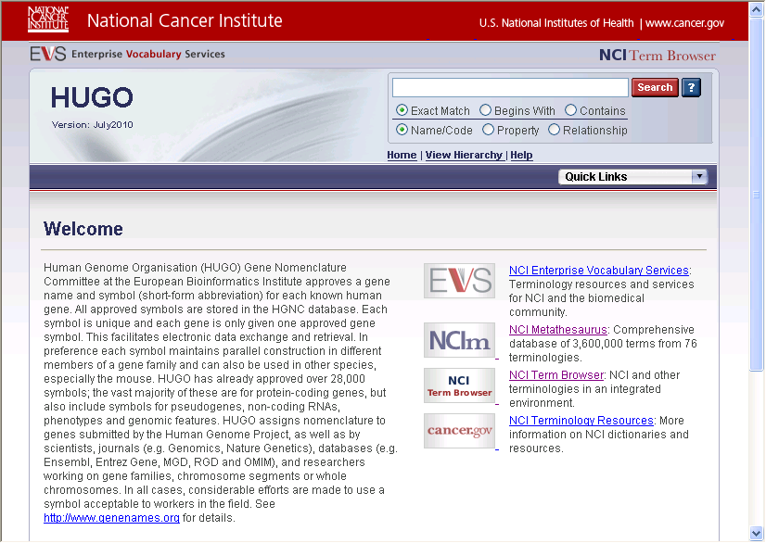
Failed

Event Log 4:03:26 PM 12/20/2010
Spreadsheet: Verfiry_HUGO_Hierarchy.xls
Spreadsheet Row: 6
Expected value:
withdrawn_group(Codewithdrawn_group)
Did not match actual value:
Found in page text: HUGOVersion:July2010ExactMatchBeginsWithContainsName/CodePropertyRelationshipHome|ViewHierarchy|HelpEVSHomeNCIMetathesaurusBrowserNCIThesaurusBrowserNCITermBrowserNCITerminologyResourcesWelcomeHumanGenomeOrganisation(HUGO)GeneNomenclatureCommitteeattheEuropeanBioinformaticsInstituteapprovesagenenameandsymbol(short-formabbreviation)foreachknownhumangene.AllapprovedsymbolsarestoredintheHGNCdatabase.Eachsymbolisuniqueandeachgeneisonlygivenoneapprovedgenesymbol.Thisfacilitateselectronicdataexchangeandretrieval.Inpreferenceeachsymbolmaintainsparallelconstructionindifferentmembersofagenefamilyandcanalsobeusedinotherspecies,especiallythemouse.HUGOhasalreadyapprovedover28,000symbols;thevastmajorityoftheseareforprotein-codinggenes,butalsoincludesymbolsforpseudogenes,non-codingRNAs,phenotypesandgenomicfeatures.HUGOassignsnomenclaturetogenessubmittedbytheHumanGenomeProject,aswellasbyscientists,journals(e.g.Genomics,NatureGenetics),databases(e.g.Ensembl,EntrezGene,MGD,RGDandOMIM),andresearchersworkingongenefamilies,chromosomesegmentsorwholechromosomes.Inallcases,considerableeffortsaremadetouseasymbolacceptabletoworkersinthefield.Seehttp://www.genenames.orgfordetails.SourceHomePage:http://www.genenames.org/cgi-bin/hgnc_stats.plcaBIGVKCLink:https://cabig-kc.nci.nih.gov/Vocab/KC/index.php/Human_Genome_Organisation_OntologyNCIEnterpriseVocabularyServices:TerminologyresourcesandservicesforNCIandthebiomedicalcommunity.NCIMetathesaurus:Comprehensivedatabaseof3,600,000termsfrom76terminologies.NCITermBrowser:NCIandotherterminologiesinanintegratedenvironment.NCITerminologyResources:MoreinformationonNCIdictionariesandresources.NCIHome|ContactUs|Policies|Accessibility|FOIAAServiceoftheNationalCancerInstitute
Failed

Event Log 4:45:42 PM 12/20/2010
Spreadsheet: Verfiry_HUGO_Hierarchy.xls
Spreadsheet Row: 7
Expected value:
withdrawn(Codewithdrawn)
Did not match actual value:
Found in page text: HUGOVersion:July2010ExactMatchBeginsWithContainsName/CodePropertyRelationshipHome|ViewHierarchy|HelpEVSHomeNCIMetathesaurusBrowserNCIThesaurusBrowserNCITermBrowserNCITerminologyResourcesWelcomeHumanGenomeOrganisation(HUGO)GeneNomenclatureCommitteeattheEuropeanBioinformaticsInstituteapprovesagenenameandsymbol(short-formabbreviation)foreachknownhumangene.AllapprovedsymbolsarestoredintheHGNCdatabase.Eachsymbolisuniqueandeachgeneisonlygivenoneapprovedgenesymbol.Thisfacilitateselectronicdataexchangeandretrieval.Inpreferenceeachsymbolmaintainsparallelconstructionindifferentmembersofagenefamilyandcanalsobeusedinotherspecies,especiallythemouse.HUGOhasalreadyapprovedover28,000symbols;thevastmajorityoftheseareforprotein-codinggenes,butalsoincludesymbolsforpseudogenes,non-codingRNAs,phenotypesandgenomicfeatures.HUGOassignsnomenclaturetogenessubmittedbytheHumanGenomeProject,aswellasbyscientists,journals(e.g.Genomics,NatureGenetics),databases(e.g.Ensembl,EntrezGene,MGD,RGDandOMIM),andresearchersworkingongenefamilies,chromosomesegmentsorwholechromosomes.Inallcases,considerableeffortsaremadetouseasymbolacceptabletoworkersinthefield.Seehttp://www.genenames.orgfordetails.SourceHomePage:http://www.genenames.org/cgi-bin/hgnc_stats.plcaBIGVKCLink:https://cabig-kc.nci.nih.gov/Vocab/KC/index.php/Human_Genome_Organisation_OntologyNCIEnterpriseVocabularyServices:TerminologyresourcesandservicesforNCIandthebiomedicalcommunity.NCIMetathesaurus:Comprehensivedatabaseof3,600,000termsfrom76terminologies.NCITermBrowser:NCIandotherterminologiesinanintegratedenvironment.NCITerminologyResources:MoreinformationonNCIdictionariesandresources.NCIHome|ContactUs|Policies|Accessibility|FOIAAServiceoftheNationalCancerInstitute
Failed

Event Log 4:45:42 PM 12/20/2010
Spreadsheet: Verfiry_HUGO_Hierarchy.xls
Spreadsheet Row: 8
Expected value:
TermsandProperties
Did not match actual value:
Found in page text: HUGOVersion:July2010ExactMatchBeginsWithContainsName/CodePropertyRelationshipHome|ViewHierarchy|HelpEVSHomeNCIMetathesaurusBrowserNCIThesaurusBrowserNCITermBrowserNCITerminologyResourcesWelcomeHumanGenomeOrganisation(HUGO)GeneNomenclatureCommitteeattheEuropeanBioinformaticsInstituteapprovesagenenameandsymbol(short-formabbreviation)foreachknownhumangene.AllapprovedsymbolsarestoredintheHGNCdatabase.Eachsymbolisuniqueandeachgeneisonlygivenoneapprovedgenesymbol.Thisfacilitateselectronicdataexchangeandretrieval.Inpreferenceeachsymbolmaintainsparallelconstructionindifferentmembersofagenefamilyandcanalsobeusedinotherspecies,especiallythemouse.HUGOhasalreadyapprovedover28,000symbols;thevastmajorityoftheseareforprotein-codinggenes,butalsoincludesymbolsforpseudogenes,non-codingRNAs,phenotypesandgenomicfeatures.HUGOassignsnomenclaturetogenessubmittedbytheHumanGenomeProject,aswellasbyscientists,journals(e.g.Genomics,NatureGenetics),databases(e.g.Ensembl,EntrezGene,MGD,RGDandOMIM),andresearchersworkingongenefamilies,chromosomesegmentsorwholechromosomes.Inallcases,considerableeffortsaremadetouseasymbolacceptabletoworkersinthefield.Seehttp://www.genenames.orgfordetails.SourceHomePage:http://www.genenames.org/cgi-bin/hgnc_stats.plcaBIGVKCLink:https://cabig-kc.nci.nih.gov/Vocab/KC/index.php/Human_Genome_Organisation_OntologyNCIEnterpriseVocabularyServices:TerminologyresourcesandservicesforNCIandthebiomedicalcommunity.NCIMetathesaurus:Comprehensivedatabaseof3,600,000termsfrom76terminologies.NCITermBrowser:NCIandotherterminologiesinanintegratedenvironment.NCITerminologyResources:MoreinformationonNCIdictionariesandresources.NCIHome|ContactUs|Policies|Accessibility|FOIAAServiceoftheNationalCancerInstitute
Failed

Event Log 5:03:16 PM 12/20/2010
Spreadsheet: Verfiry_HUGO_Hierarchy.xls
Spreadsheet Row: 7
Expected value:
withdrawn(Codewithdrawn)
Did not match actual value:
Found in page text: HUGOVersion:July2010ExactMatchBeginsWithContainsName/CodePropertyRelationshipHome|ViewHierarchy|HelpEVSHomeNCIMetathesaurusBrowserNCIThesaurusBrowserNCITermBrowserNCITerminologyResourcesERROR:Invalidcode-withdrawn.NCIHome|ContactUs|Policies|Accessibility|FOIAAServiceoftheNationalCancerInstitute
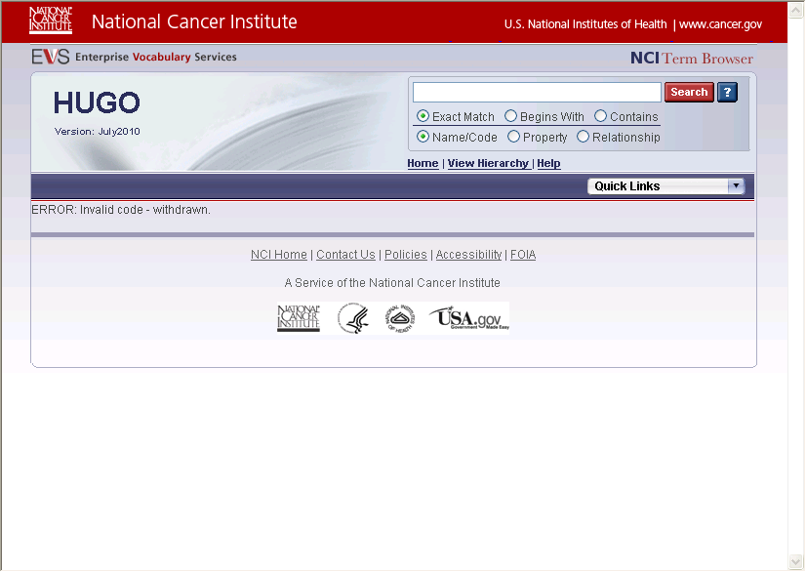
Failed

Event Log 5:03:16 PM 12/20/2010
Spreadsheet: Verfiry_HUGO_Hierarchy.xls
Spreadsheet Row: 8
Expected value:
TermsandProperties
Did not match actual value:
Found in page text: HUGOVersion:July2010ExactMatchBeginsWithContainsName/CodePropertyRelationshipHome|ViewHierarchy|HelpEVSHomeNCIMetathesaurusBrowserNCIThesaurusBrowserNCITermBrowserNCITerminologyResourcesERROR:Invalidcode-withdrawn.NCIHome|ContactUs|Policies|Accessibility|FOIAAServiceoftheNationalCancerInstitute
Failed

Event Log 9:54:10 AM 12/21/2010
Spreadsheet: Verfiry_HUGO_Hierarchy.xls
Spreadsheet Row: 7
Expected value:
withdrawn(Codewithdrawn)
Did not match actual value:
Found in page text: HUGOVersion:July2010ExactMatchBeginsWithContainsName/CodePropertyRelationshipHome|ViewHierarchy|HelpEVSHomeNCIMetathesaurusBrowserNCIThesaurusBrowserNCITermBrowserNCITerminologyResourcesWelcomeHumanGenomeOrganisation(HUGO)GeneNomenclatureCommitteeattheEuropeanBioinformaticsInstituteapprovesagenenameandsymbol(short-formabbreviation)foreachknownhumangene.AllapprovedsymbolsarestoredintheHGNCdatabase.Eachsymbolisuniqueandeachgeneisonlygivenoneapprovedgenesymbol.Thisfacilitateselectronicdataexchangeandretrieval.Inpreferenceeachsymbolmaintainsparallelconstructionindifferentmembersofagenefamilyandcanalsobeusedinotherspecies,especiallythemouse.HUGOhasalreadyapprovedover28,000symbols;thevastmajorityoftheseareforprotein-codinggenes,butalsoincludesymbolsforpseudogenes,non-codingRNAs,phenotypesandgenomicfeatures.HUGOassignsnomenclaturetogenessubmittedbytheHumanGenomeProject,aswellasbyscientists,journals(e.g.Genomics,NatureGenetics),databases(e.g.Ensembl,EntrezGene,MGD,RGDandOMIM),andresearchersworkingongenefamilies,chromosomesegmentsorwholechromosomes.Inallcases,considerableeffortsaremadetouseasymbolacceptabletoworkersinthefield.Seehttp://www.genenames.orgfordetails.SourceHomePage:http://www.genenames.org/cgi-bin/hgnc_stats.plcaBIGVKCLink:https://cabig-kc.nci.nih.gov/Vocab/KC/index.php/Human_Genome_Organisation_OntologyNCIEnterpriseVocabularyServices:TerminologyresourcesandservicesforNCIandthebiomedicalcommunity.NCIMetathesaurus:Comprehensivedatabaseof3,600,000termsfrom76terminologies.NCITermBrowser:NCIandotherterminologiesinanintegratedenvironment.NCITerminologyResources:MoreinformationonNCIdictionariesandresources.NCIHome|ContactUs|Policies|Accessibility|FOIAAServiceoftheNationalCancerInstitute

Failed

Event Log 9:54:10 AM 12/21/2010
Spreadsheet: Verfiry_HUGO_Hierarchy.xls
Spreadsheet Row: 8
Expected value:
TermsandProperties
Did not match actual value:
Found in page text: HUGOVersion:July2010ExactMatchBeginsWithContainsName/CodePropertyRelationshipHome|ViewHierarchy|HelpEVSHomeNCIMetathesaurusBrowserNCIThesaurusBrowserNCITermBrowserNCITerminologyResourcesWelcomeHumanGenomeOrganisation(HUGO)GeneNomenclatureCommitteeattheEuropeanBioinformaticsInstituteapprovesagenenameandsymbol(short-formabbreviation)foreachknownhumangene.AllapprovedsymbolsarestoredintheHGNCdatabase.Eachsymbolisuniqueandeachgeneisonlygivenoneapprovedgenesymbol.Thisfacilitateselectronicdataexchangeandretrieval.Inpreferenceeachsymbolmaintainsparallelconstructionindifferentmembersofagenefamilyandcanalsobeusedinotherspecies,especiallythemouse.HUGOhasalreadyapprovedover28,000symbols;thevastmajorityoftheseareforprotein-codinggenes,butalsoincludesymbolsforpseudogenes,non-codingRNAs,phenotypesandgenomicfeatures.HUGOassignsnomenclaturetogenessubmittedbytheHumanGenomeProject,aswellasbyscientists,journals(e.g.Genomics,NatureGenetics),databases(e.g.Ensembl,EntrezGene,MGD,RGDandOMIM),andresearchersworkingongenefamilies,chromosomesegmentsorwholechromosomes.Inallcases,considerableeffortsaremadetouseasymbolacceptabletoworkersinthefield.Seehttp://www.genenames.orgfordetails.SourceHomePage:http://www.genenames.org/cgi-bin/hgnc_stats.plcaBIGVKCLink:https://cabig-kc.nci.nih.gov/Vocab/KC/index.php/Human_Genome_Organisation_OntologyNCIEnterpriseVocabularyServices:TerminologyresourcesandservicesforNCIandthebiomedicalcommunity.NCIMetathesaurus:Comprehensivedatabaseof3,600,000termsfrom76terminologies.NCITermBrowser:NCIandotherterminologiesinanintegratedenvironment.NCITerminologyResources:MoreinformationonNCIdictionariesandresources.NCIHome|ContactUs|Policies|Accessibility|FOIAAServiceoftheNationalCancerInstitute
Failed

