Event Log 8:28:14 PM 12/6/2010
Verify Text
Spreadsheet: Verify_Link_NewBrowser.xls
Spreadsheet Row: 4
Expected value:
GOHierarchy
Did not match actual value:
Found in page text: GOVersion:November2010ExactMatchBeginsWithContainsName/CodePropertyRelationshipHome|ViewHierarchy|HelpEVSHomeNCIMetathesaurusBrowserNCIThesaurusBrowserNCITermBrowserNCITerminologyResourcesWelcomeGeneOntology(GO)isacollaborativeeffortwiththeaimofstandardizingtherepresentationofgeneandgeneproductattributesacrossspeciesanddatabases.GOcoversthreemainsubjectareas:molecularfunction,biologicalprocess,andcellularcomponent.GOdoesnotnamegenesorgeneproducts,nordoesitattempttoprovidestructuredterminologybeyonditsthreedomains.SourceHomePage:http://www.geneontology.org/index.shtmlcaBIGVKCLink:https://cabig-kc.nci.nih.gov/Vocab/KC/index.php/Gene_OntologyNCIEnterpriseVocabularyServices:TerminologyresourcesandservicesforNCIandthebiomedicalcommunity.NCIMetathesaurus:Comprehensivedatabaseof3,600,000termsfrom76terminologies.NCITermBrowser:NCIandotherterminologiesinanintegratedenvironment.NCITerminologyResources:MoreinformationonNCIdictionariesandresources.NCIHome|ContactUs|Policies|Accessibility|FOIAAServiceoftheNationalCancerInstitute
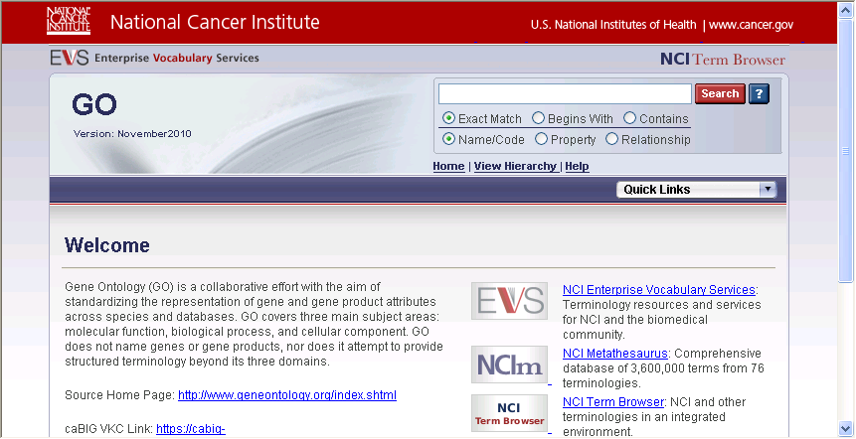
Failed

Event Log 8:31:22 PM 12/6/2010
Verify Text
Spreadsheet: Verify_Link_NewBrowser.xls
Spreadsheet Row: 4
Expected value:
GOHierarchy
Did not match actual value:
Found in page text: GOVersion:November2010ExactMatchBeginsWithContainsName/CodePropertyRelationshipHome|ViewHierarchy|HelpEVSHomeNCIMetathesaurusBrowserNCIThesaurusBrowserNCITermBrowserNCITerminologyResourcesWelcomeGeneOntology(GO)isacollaborativeeffortwiththeaimofstandardizingtherepresentationofgeneandgeneproductattributesacrossspeciesanddatabases.GOcoversthreemainsubjectareas:molecularfunction,biologicalprocess,andcellularcomponent.GOdoesnotnamegenesorgeneproducts,nordoesitattempttoprovidestructuredterminologybeyonditsthreedomains.SourceHomePage:http://www.geneontology.org/index.shtmlcaBIGVKCLink:https://cabig-kc.nci.nih.gov/Vocab/KC/index.php/Gene_OntologyNCIEnterpriseVocabularyServices:TerminologyresourcesandservicesforNCIandthebiomedicalcommunity.NCIMetathesaurus:Comprehensivedatabaseof3,600,000termsfrom76terminologies.NCITermBrowser:NCIandotherterminologiesinanintegratedenvironment.NCITerminologyResources:MoreinformationonNCIdictionariesandresources.NCIHome|ContactUs|Policies|Accessibility|FOIAAServiceoftheNationalCancerInstitute
Failed

Event Log 8:41:22 PM 12/6/2010
Verify Text
Spreadsheet: Verify_Link_NewBrowser.xls
Spreadsheet Row: 4
Expected value:
GOHierarchy
Did not match actual value:
Found in page text: GOVersion:November2010ExactMatchBeginsWithContainsName/CodePropertyRelationshipHome|ViewHierarchy|HelpEVSHomeNCIMetathesaurusBrowserNCIThesaurusBrowserNCITermBrowserNCITerminologyResourcesWelcomeGeneOntology(GO)isacollaborativeeffortwiththeaimofstandardizingtherepresentationofgeneandgeneproductattributesacrossspeciesanddatabases.GOcoversthreemainsubjectareas:molecularfunction,biologicalprocess,andcellularcomponent.GOdoesnotnamegenesorgeneproducts,nordoesitattempttoprovidestructuredterminologybeyonditsthreedomains.SourceHomePage:http://www.geneontology.org/index.shtmlcaBIGVKCLink:https://cabig-kc.nci.nih.gov/Vocab/KC/index.php/Gene_OntologyNCIEnterpriseVocabularyServices:TerminologyresourcesandservicesforNCIandthebiomedicalcommunity.NCIMetathesaurus:Comprehensivedatabaseof3,600,000termsfrom76terminologies.NCITermBrowser:NCIandotherterminologiesinanintegratedenvironment.NCITerminologyResources:MoreinformationonNCIdictionariesandresources.NCIHome|ContactUs|Policies|Accessibility|FOIAAServiceoftheNationalCancerInstitute
Failed

Event Log 8:45:58 PM 12/6/2010
Verify Text
Spreadsheet: Verify_Link_NewBrowser.xls
Spreadsheet Row: 4
Expected value:
GOHierarchy
Did not match actual value:
Found in page text: GOVersion:November2010ExactMatchBeginsWithContainsName/CodePropertyRelationshipHome|ViewHierarchy|HelpEVSHomeNCIMetathesaurusBrowserNCIThesaurusBrowserNCITermBrowserNCITerminologyResourcesWelcomeGeneOntology(GO)isacollaborativeeffortwiththeaimofstandardizingtherepresentationofgeneandgeneproductattributesacrossspeciesanddatabases.GOcoversthreemainsubjectareas:molecularfunction,biologicalprocess,andcellularcomponent.GOdoesnotnamegenesorgeneproducts,nordoesitattempttoprovidestructuredterminologybeyonditsthreedomains.SourceHomePage:http://www.geneontology.org/index.shtmlcaBIGVKCLink:https://cabig-kc.nci.nih.gov/Vocab/KC/index.php/Gene_OntologyNCIEnterpriseVocabularyServices:TerminologyresourcesandservicesforNCIandthebiomedicalcommunity.NCIMetathesaurus:Comprehensivedatabaseof3,600,000termsfrom76terminologies.NCITermBrowser:NCIandotherterminologiesinanintegratedenvironment.NCITerminologyResources:MoreinformationonNCIdictionariesandresources.NCIHome|ContactUs|Policies|Accessibility|FOIAAServiceoftheNationalCancerInstitute
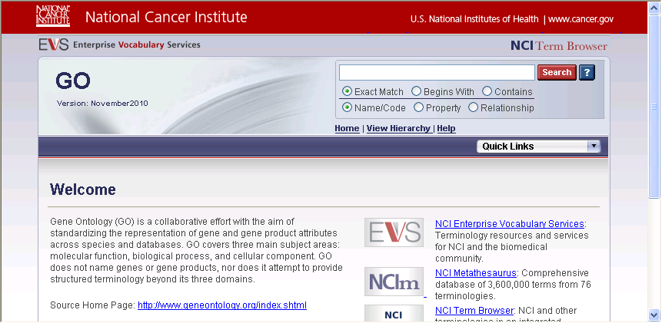
Failed

Event Log 3:56:29 PM 12/8/2010
Verify Text
Spreadsheet: Verify_Link_NewBrowser.xls
Spreadsheet Row: 4
Expected value:
GOHierarchy
Did not match actual value:
Found in page text: ExactMatchBeginsWithContainsName/CodePropertyRelationshipHome|Sources|HelpEVSHomeNCIMetathesaurusBrowserNCIThesaurusBrowserNCITermBrowserNCITerminologyResourcesSelectNCIhostedterminologiestosearch,orclickonasourcenametogotoitsbrowserhomepage.(WARNING:SelectAllsearcheswiththousandsofhitsmaybeslow;tryNCIMetathesaurusseparately.)NCIMetathesaurus(201008)NCIThesaurus(10.10d)*BiomedGT:BiomedicalGridTerminology(09.11b)CTCAE:CommonTerminologyCriteriaforAdverseEvents(4.03)GO:GeneOntology(November2010)*HL7RIM:HL7ReferenceInformationModel(V02-31)HUGO:HumanGenomeOrganization(July2010)ICD-10:InternationalClassificationofDiseases,TenthRevision(2009)*ICD-9-CM:InternationalClassificationofDiseases,NinthRevision,ClinicalModification(2011)LOINC:LogicalObservationIdentifiersNamesandCodes(232)*MedDRA:MedicalDictionaryforRegulatoryActivitiesTerminology(13)*MGEDOntology:MicroarrayGeneExpressionDataOntology(1.3.1)NCIThesaurusDraft:NationalCancerInstituteThesaurusDraft(10.10d)NDF-RT:NationalDrugFileReferenceTerminologyPublicInferredEdition(October2010)NPO:NanoParticleOntology(1.0_Oct_31_2010)OBI:OntologyforBiomedicalInvestigations(rc1)PDQ:PhysicianDataQuery(Aug_2010)RadLex:RadiologyLexicon(2.01)*SNOMEDCT:SystematizedNomenclatureofMedicine-ClinicalTerms(2010_0731)*UMLSSemanticNetwork:UMLSSemanticNetwork(3.2)Zebrafish:ZebrafishModelOrganismDatabase(1.2_Sep_29_2010)*caBIGapproved.NCIHome|ContactUs|Policies|Accessibility|FOIAAServiceoftheNationalCancerInstitute
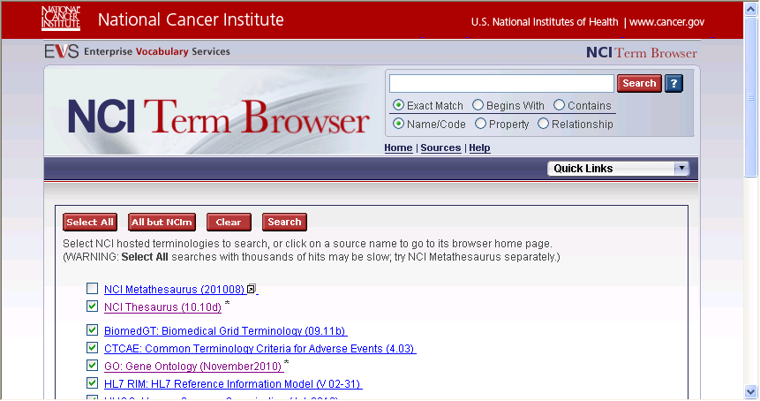
Failed

Event Log 4:45:42 PM 12/8/2010
Verify Text
Spreadsheet: Verify_Link_NewBrowser.xls
Spreadsheet Row: 4
Expected value:
GOHierarchy
Did not match actual value:
Found in page text: ExactMatchBeginsWithContainsName/CodePropertyRelationshipHome|Sources|HelpEVSHomeNCIMetathesaurusBrowserNCIThesaurusBrowserNCITermBrowserNCITerminologyResourcesSelectNCIhostedterminologiestosearch,orclickonasourcenametogotoitsbrowserhomepage.(WARNING:SelectAllsearcheswiththousandsofhitsmaybeslow;tryNCIMetathesaurusseparately.)NCIMetathesaurus(201008)NCIThesaurus(10.10d)*BiomedGT:BiomedicalGridTerminology(09.11b)CTCAE:CommonTerminologyCriteriaforAdverseEvents(4.03)GO:GeneOntology(November2010)*HL7RIM:HL7ReferenceInformationModel(V02-31)HUGO:HumanGenomeOrganization(July2010)ICD-10:InternationalClassificationofDiseases,TenthRevision(2009)*ICD-9-CM:InternationalClassificationofDiseases,NinthRevision,ClinicalModification(2011)LOINC:LogicalObservationIdentifiersNamesandCodes(232)*MedDRA:MedicalDictionaryforRegulatoryActivitiesTerminology(13)*MGEDOntology:MicroarrayGeneExpressionDataOntology(1.3.1)NCIThesaurusDraft:NationalCancerInstituteThesaurusDraft(10.10d)NDF-RT:NationalDrugFileReferenceTerminologyPublicInferredEdition(October2010)NPO:NanoParticleOntology(1.0_Oct_31_2010)OBI:OntologyforBiomedicalInvestigations(rc1)PDQ:PhysicianDataQuery(Aug_2010)RadLex:RadiologyLexicon(2.01)*SNOMEDCT:SystematizedNomenclatureofMedicine-ClinicalTerms(2010_0731)*UMLSSemanticNetwork:UMLSSemanticNetwork(3.2)Zebrafish:ZebrafishModelOrganismDatabase(1.2_Sep_29_2010)*caBIGapproved.NCIHome|ContactUs|Policies|Accessibility|FOIAAServiceoftheNationalCancerInstitute
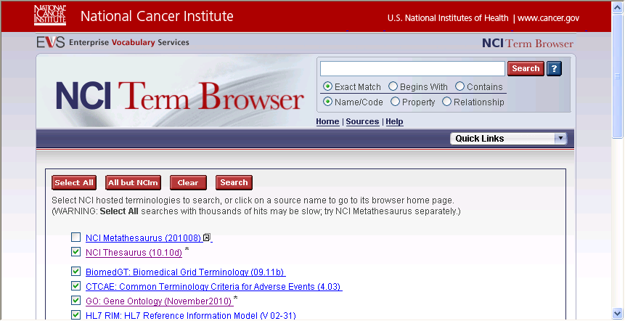
Failed

Event Log 4:49:06 PM 12/8/2010
Verify Text
Spreadsheet: Verify_Link_NewBrowser.xls
Spreadsheet Row: 4
Expected value:
GOHierarchy
Did not match actual value:
Found in page text: ExactMatchBeginsWithContainsName/CodePropertyRelationshipHome|Sources|HelpEVSHomeNCIMetathesaurusBrowserNCIThesaurusBrowserNCITermBrowserNCITerminologyResourcesSelectNCIhostedterminologiestosearch,orclickonasourcenametogotoitsbrowserhomepage.(WARNING:SelectAllsearcheswiththousandsofhitsmaybeslow;tryNCIMetathesaurusseparately.)NCIMetathesaurus(201008)NCIThesaurus(10.10d)*BiomedGT:BiomedicalGridTerminology(09.11b)CTCAE:CommonTerminologyCriteriaforAdverseEvents(4.03)GO:GeneOntology(November2010)*HL7RIM:HL7ReferenceInformationModel(V02-31)HUGO:HumanGenomeOrganization(July2010)ICD-10:InternationalClassificationofDiseases,TenthRevision(2009)*ICD-9-CM:InternationalClassificationofDiseases,NinthRevision,ClinicalModification(2011)LOINC:LogicalObservationIdentifiersNamesandCodes(232)*MedDRA:MedicalDictionaryforRegulatoryActivitiesTerminology(13)*MGEDOntology:MicroarrayGeneExpressionDataOntology(1.3.1)NCIThesaurusDraft:NationalCancerInstituteThesaurusDraft(10.10d)NDF-RT:NationalDrugFileReferenceTerminologyPublicInferredEdition(October2010)NPO:NanoParticleOntology(1.0_Oct_31_2010)OBI:OntologyforBiomedicalInvestigations(rc1)PDQ:PhysicianDataQuery(Aug_2010)RadLex:RadiologyLexicon(2.01)*SNOMEDCT:SystematizedNomenclatureofMedicine-ClinicalTerms(2010_0731)*UMLSSemanticNetwork:UMLSSemanticNetwork(3.2)Zebrafish:ZebrafishModelOrganismDatabase(1.2_Sep_29_2010)*caBIGapproved.NCIHome|ContactUs|Policies|Accessibility|FOIAAServiceoftheNationalCancerInstitute
Failed

Event Log 8:39:56 AM 12/9/2010
Verify Text
Spreadsheet: Verify_Link_NewBrowser.xls
Spreadsheet Row: 4
Expected value:
GOHierarchy
Did not match actual value:
Found in page text: GOVersion:November2010ExactMatchBeginsWithContainsName/CodePropertyRelationshipHome|ViewHierarchy|HelpEVSHomeNCIMetathesaurusBrowserNCIThesaurusBrowserNCITermBrowserNCITerminologyResourcesWelcomeGeneOntology(GO)isacollaborativeeffortwiththeaimofstandardizingtherepresentationofgeneandgeneproductattributesacrossspeciesanddatabases.GOcoversthreemainsubjectareas:molecularfunction,biologicalprocess,andcellularcomponent.GOdoesnotnamegenesorgeneproducts,nordoesitattempttoprovidestructuredterminologybeyonditsthreedomains.SourceHomePage:http://www.geneontology.org/index.shtmlcaBIGVKCLink:https://cabig-kc.nci.nih.gov/Vocab/KC/index.php/Gene_OntologyNCIEnterpriseVocabularyServices:TerminologyresourcesandservicesforNCIandthebiomedicalcommunity.NCIMetathesaurus:Comprehensivedatabaseof3,600,000termsfrom76terminologies.NCITermBrowser:NCIandotherterminologiesinanintegratedenvironment.NCITerminologyResources:MoreinformationonNCIdictionariesandresources.NCIHome|ContactUs|Policies|Accessibility|FOIAAServiceoftheNationalCancerInstitute
Failed

