Event Log 10:53:53 AM 12/21/2010
Verify Text
Spreadsheet: ArthursTest.xls
Spreadsheet Row: 7
Expected value:
biological_process(CodeGO:0008150)
Did not match actual value:
Found in page text: GOVersion:October2010ExactMatchBeginsWithContainsName/CodePropertyRelationshipHome|ViewHierarchy|HelpEVSHomeNCIMetathesaurusBrowserNCIThesaurusBrowserNCITermBrowserNCITerminologyResourcescellular_component(CodeGO:0005575)TermsandPropertiesGOCDefinition:Thepartofacelloritsextracellularenvironmentinwhichageneproductislocated.Ageneproductmaybelocatedinoneormorepartsofacellanditslocationmaybeasspecificasaparticularmacromolecularcomplex,thatis,astable,persistentassociationofmacromoleculesthatfunctiontogether.GeneOntologyCode:GO:0005575Synonyms&Abbreviations:(seeSynonymDetails)cellular_componentcellularcomponentcellularcomponentunknownExternalSourceCodes:OtherProperties:commentNotethat,inadditiontoformingtherootofthecellularcomponentontology,thistermisrecommendedforusefortheannotationofgeneproductswhosecellularcomponentisunknown.Notethatwhenthistermisusedforannotation,itindicatesthatnoinformationwasavailableaboutthecellularcomponentofthegeneproductannotatedasofthedatetheannotationwasmade;theevidencecodeND,nodata,isusedtoindicatethis.subsetgosubset_proksubsetgoslim_candidasubsetgoslim_genericsubsetgoslim_goasubsetgoslim_pirsubsetgoslim_plantsubsetgoslim_yeastalt_idGO:0008372xrefNIF_Subcellular:sao1337158144AdditionalConceptData:URL:http://nciterms-qa.nci.nih.gov/ncitbrowser/ConceptReport.jsp?dictionary=Gene%20Ontology&code=GO:0005575NCIHome|ContactUs|Policies|Accessibility|FOIAAServiceoftheNationalCancerInstitute
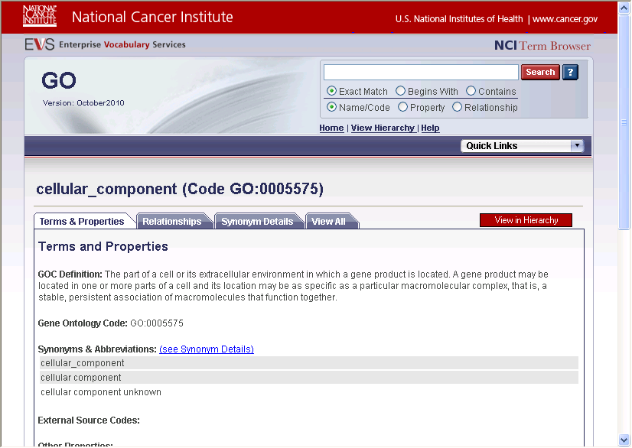
Failed

Event Log 11:03:27 AM 12/21/2010
Verify Text
Spreadsheet: ArthursTest.xls
Spreadsheet Row: 7
Expected value:
biological_process(CodeGO:0008150)
Did not match actual value:
Found in page text: GOVersion:October2010ExactMatchBeginsWithContainsName/CodePropertyRelationshipHome|ViewHierarchy|HelpEVSHomeNCIMetathesaurusBrowserNCIThesaurusBrowserNCITermBrowserNCITerminologyResourcescellular_component(CodeGO:0005575)TermsandPropertiesGOCDefinition:Thepartofacelloritsextracellularenvironmentinwhichageneproductislocated.Ageneproductmaybelocatedinoneormorepartsofacellanditslocationmaybeasspecificasaparticularmacromolecularcomplex,thatis,astable,persistentassociationofmacromoleculesthatfunctiontogether.GeneOntologyCode:GO:0005575Synonyms&Abbreviations:(seeSynonymDetails)cellular_componentcellularcomponentcellularcomponentunknownExternalSourceCodes:OtherProperties:commentNotethat,inadditiontoformingtherootofthecellularcomponentontology,thistermisrecommendedforusefortheannotationofgeneproductswhosecellularcomponentisunknown.Notethatwhenthistermisusedforannotation,itindicatesthatnoinformationwasavailableaboutthecellularcomponentofthegeneproductannotatedasofthedatetheannotationwasmade;theevidencecodeND,nodata,isusedtoindicatethis.subsetgosubset_proksubsetgoslim_candidasubsetgoslim_genericsubsetgoslim_goasubsetgoslim_pirsubsetgoslim_plantsubsetgoslim_yeastalt_idGO:0008372xrefNIF_Subcellular:sao1337158144AdditionalConceptData:URL:http://nciterms-qa.nci.nih.gov/ncitbrowser/ConceptReport.jsp?dictionary=Gene%20Ontology&code=GO:0005575NCIHome|ContactUs|Policies|Accessibility|FOIAAServiceoftheNationalCancerInstitute

Failed

Event Log 12:03:56 PM 12/21/2010
Verify Text
Spreadsheet: ArthursTest.xls
Spreadsheet Row: 7
Expected value:
biological_process(CodeGO:0008150)
Did not match actual value:
Found in page text: GOVersion:October2010ExactMatchBeginsWithContainsName/CodePropertyRelationshipHome|ViewHierarchy|HelpEVSHomeNCIMetathesaurusBrowserNCIThesaurusBrowserNCITermBrowserNCITerminologyResourcescellular_component(CodeGO:0005575)TermsandPropertiesGOCDefinition:Thepartofacelloritsextracellularenvironmentinwhichageneproductislocated.Ageneproductmaybelocatedinoneormorepartsofacellanditslocationmaybeasspecificasaparticularmacromolecularcomplex,thatis,astable,persistentassociationofmacromoleculesthatfunctiontogether.GeneOntologyCode:GO:0005575Synonyms&Abbreviations:(seeSynonymDetails)cellular_componentcellularcomponentcellularcomponentunknownExternalSourceCodes:OtherProperties:commentNotethat,inadditiontoformingtherootofthecellularcomponentontology,thistermisrecommendedforusefortheannotationofgeneproductswhosecellularcomponentisunknown.Notethatwhenthistermisusedforannotation,itindicatesthatnoinformationwasavailableaboutthecellularcomponentofthegeneproductannotatedasofthedatetheannotationwasmade;theevidencecodeND,nodata,isusedtoindicatethis.subsetgosubset_proksubsetgoslim_candidasubsetgoslim_genericsubsetgoslim_goasubsetgoslim_pirsubsetgoslim_plantsubsetgoslim_yeastalt_idGO:0008372xrefNIF_Subcellular:sao1337158144AdditionalConceptData:URL:http://nciterms-qa.nci.nih.gov/ncitbrowser/ConceptReport.jsp?dictionary=Gene%20Ontology&code=GO:0005575NCIHome|ContactUs|Policies|Accessibility|FOIAAServiceoftheNationalCancerInstitute
Failed

Event Log 12:57:48 PM 12/21/2010
Verify Text
Spreadsheet: ArthursTest.xls
Spreadsheet Row: 7
Expected value:
biological_process(CodeGO:0008150)
Did not match actual value:
Found in page text: GOVersion:October2010ExactMatchBeginsWithContainsName/CodePropertyRelationshipHome|ViewHierarchy|HelpEVSHomeNCIMetathesaurusBrowserNCIThesaurusBrowserNCITermBrowserNCITerminologyResourcescellular_component(CodeGO:0005575)TermsandPropertiesGOCDefinition:Thepartofacelloritsextracellularenvironmentinwhichageneproductislocated.Ageneproductmaybelocatedinoneormorepartsofacellanditslocationmaybeasspecificasaparticularmacromolecularcomplex,thatis,astable,persistentassociationofmacromoleculesthatfunctiontogether.GeneOntologyCode:GO:0005575Synonyms&Abbreviations:(seeSynonymDetails)cellular_componentcellularcomponentcellularcomponentunknownExternalSourceCodes:OtherProperties:commentNotethat,inadditiontoformingtherootofthecellularcomponentontology,thistermisrecommendedforusefortheannotationofgeneproductswhosecellularcomponentisunknown.Notethatwhenthistermisusedforannotation,itindicatesthatnoinformationwasavailableaboutthecellularcomponentofthegeneproductannotatedasofthedatetheannotationwasmade;theevidencecodeND,nodata,isusedtoindicatethis.subsetgosubset_proksubsetgoslim_candidasubsetgoslim_genericsubsetgoslim_goasubsetgoslim_pirsubsetgoslim_plantsubsetgoslim_yeastalt_idGO:0008372xrefNIF_Subcellular:sao1337158144AdditionalConceptData:URL:http://nciterms-qa.nci.nih.gov/ncitbrowser/ConceptReport.jsp?dictionary=Gene%20Ontology&code=GO:0005575NCIHome|ContactUs|Policies|Accessibility|FOIAAServiceoftheNationalCancerInstitute
Failed

Event Log 1:51:35 PM 12/21/2010
Verify Text
Spreadsheet: ArthursTest.xls
Spreadsheet Row: 7
Expected value:
biological_process(CodeGO:0008150)
Did not match actual value:
Found in page text: GOVersion:October2010ExactMatchBeginsWithContainsName/CodePropertyRelationshipHome|ViewHierarchy|HelpEVSHomeNCIMetathesaurusBrowserNCIThesaurusBrowserNCITermBrowserNCITerminologyResourcescellular_component(CodeGO:0005575)TermsandPropertiesGOCDefinition:Thepartofacelloritsextracellularenvironmentinwhichageneproductislocated.Ageneproductmaybelocatedinoneormorepartsofacellanditslocationmaybeasspecificasaparticularmacromolecularcomplex,thatis,astable,persistentassociationofmacromoleculesthatfunctiontogether.GeneOntologyCode:GO:0005575Synonyms&Abbreviations:(seeSynonymDetails)cellular_componentcellularcomponentcellularcomponentunknownExternalSourceCodes:OtherProperties:commentNotethat,inadditiontoformingtherootofthecellularcomponentontology,thistermisrecommendedforusefortheannotationofgeneproductswhosecellularcomponentisunknown.Notethatwhenthistermisusedforannotation,itindicatesthatnoinformationwasavailableaboutthecellularcomponentofthegeneproductannotatedasofthedatetheannotationwasmade;theevidencecodeND,nodata,isusedtoindicatethis.subsetgosubset_proksubsetgoslim_candidasubsetgoslim_genericsubsetgoslim_goasubsetgoslim_pirsubsetgoslim_plantsubsetgoslim_yeastalt_idGO:0008372xrefNIF_Subcellular:sao1337158144AdditionalConceptData:URL:http://nciterms-qa.nci.nih.gov/ncitbrowser/ConceptReport.jsp?dictionary=Gene%20Ontology&code=GO:0005575NCIHome|ContactUs|Policies|Accessibility|FOIAAServiceoftheNationalCancerInstitute
Failed

